Trevor Bramwell
Lecture Session 002
Lab Section 016
October 16, 2012

Report on the Baotite Mineral

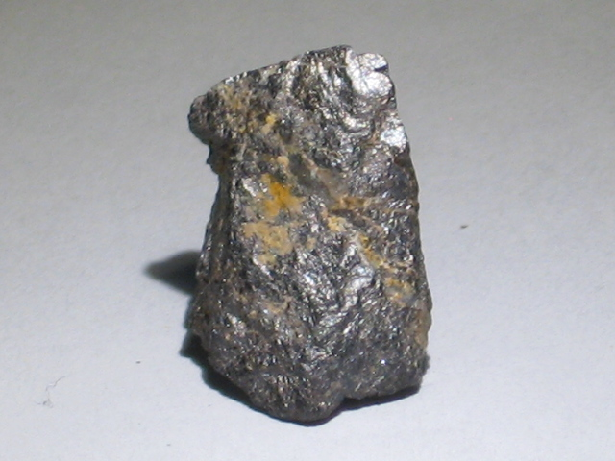 | 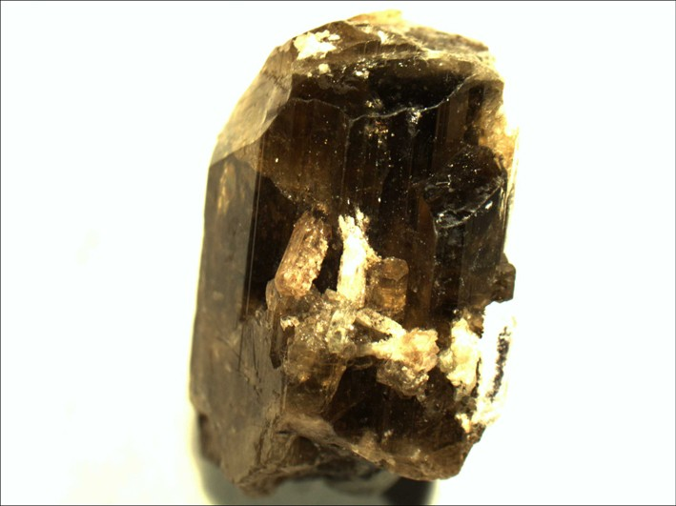
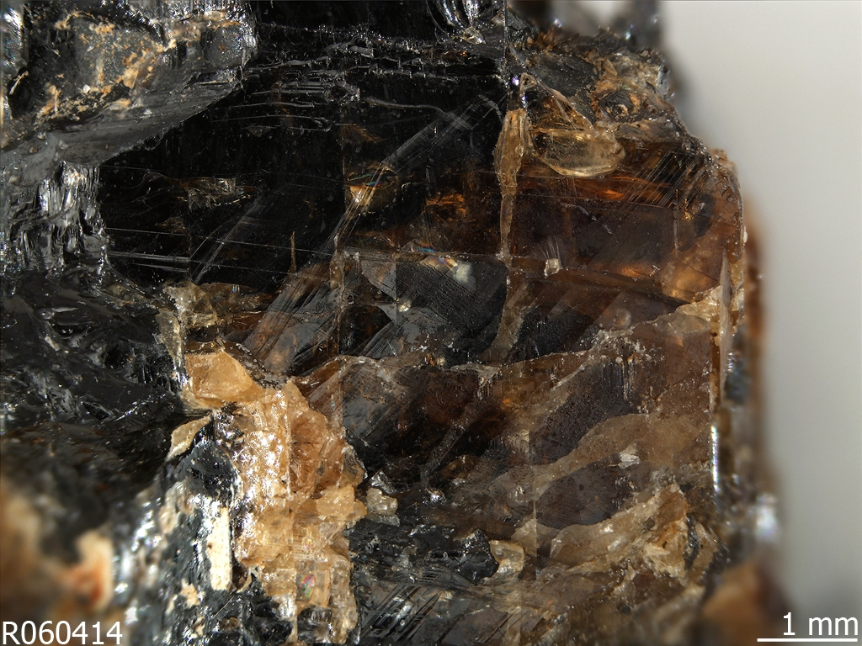 | 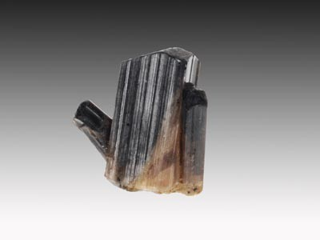

INTRODUCTION
This report is an overview of the characteristics of the Baotite mineral. It is intended as an overview of the Baotite mineral and contains information regarding its arrangement of atoms, physical and chemical properties, natural occurrence, and origin.

CHEMICAL PROPERTIES
Baotite is composed of Barium, Titanium, Niobium, Silicon, Oxygen, and Chlorine. It is chemically composed as Ba₄(Ti,Nb)₈Si₄O₂₈Cl. Its atoms are arranged in a tetragonal dipyramid.

PHYSICAL PROPERTIES
With an average density of 4.57 g/mL, it is between Paradamite and Gallobeudantite. It is a 6 on the Mohs hardness scale, meaning it is as hard as Orthoclase. It is found to be colored from a range of yellowish light brown to black, and its luster ranges from vitreous to semimetallic. It has a cleavage that breaks fair on the {110}. A unique characteristic of Baotite is that its crystal structure takes of the form of a fourfold silicate ring.

ORIGIN
Baotite was initially found in 1961 in quartz veins in the Baiyun-Obo mine, near Pao-t'ou, Inner Mongolia. Since its discovery, it is has also been found in Ravalli Co., Montana, USA; San Benito Co., California, USA; Sebkovice, Czech Republic; and Pierrefitte, Hautes-Pyrenees, France.

