**Chapter 1**

**Introduction**

American sign language is a significant sign language Because the D&M individuals have communication gap because they cannot use verbal languages, the only option for communicating with them is sign language. Communication is the process of exchange of thoughts and messages in various forms such as speech, signals, behavior and visuals. D&M individuals use their hands to convey various gestures to communicate their thoughts to other individuals. Gestures are the nonverbal messages interchanged and are comprehended using vision. D&D people's nonverbal communication is known as sign language. A sign language is a language that makes use of hand-shapes, orientation and movement of hands, arms or body, facial expressions and lip-patterns as a way of communicating meaning without the use of sound. As with all languages, sign languages vary from location to location and many form of sign languages are used around the world. There are a lot more sign languages.

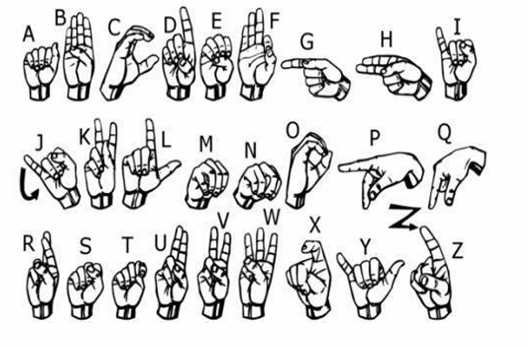

Fig.1.1 American Sign Standards

* 1. **Preliminaries**

Our project seeks to **close the communication gap** between Deaf and Hard of Hearing (D&M) individuals and the hearing world, aiming for **seamless and efficient interactions for everyone. Sign language translation** is a dynamic research field, allowing hearing-impaired people to communicate naturally. Our hand gesture recognition system empowers deaf individuals to communicate directly with vocal humans, removing the need for an interpreter. This system will **automatically translate American Sign Language (ASL) into text and speech.**

Our primary focus is building a model capable of **detecting finger-spelled hand gestures**. By combining these individual gestures, the system will form complete words. **American Sign Language** is a dominant sign language. For D&M individuals, whose primary challenge is verbal communication, sign language is their essential means of expression. Communication, broadly, is the exchange of thoughts and messages through various forms: speech, signals, behavior, and visuals. Deaf and Hard of Hearing individuals use distinct hand gestures to convey their thoughts. Specifically, our model will interpret [1] finger-spelled signs to construct whole words in sequence. The signs we'll train are depicted below.

Wherever Deaf communities are found, **sign languages** are vital communication tools, forming the bedrock of local Deaf cultures. While primarily used by Deaf and Hard of Hearing people, signing is also adopted by hearing individuals—those physically unable to speak, those with verbal communication difficulties, or hearing family members like children of deaf adults. The exact number of sign languages worldwide is unknown; most countries have their own, and some have several. Some have even achieved legal recognition. Linguists differentiate between natural sign languages and other forms of communication.

* 1. **Problem Analysis**
     1. **Overview of the Problem**

1. **Communication Barriers:**

Deaf and mute people usually use sign language to communicate. But most people are not familiar with sign language, and this creates huge communication gaps in education, workplaces, healthcare, and everyday life. Conventional sign language interpretation relies on human interpreters, which are usually costly, in short supply, and not always accessible.

1. **Technology Gap:**

Most current technologies for sign language recognition depend on costly hardware (e.g., Kinect, motion sensors, or gloves) that are beyond the budget of most users. No affordable, accessible, and precise tools for real-time sign language gestures translation into text or speech.

1. **Real-Time Challenges:**

Identifying sign language gestures correctly in real-time involves coping with issues such as: Differences in hand gestures based on various people. Clutter in the background of the scene. Varying lighting conditions, skin color, and palm sizes. Computational overhead and delay in current systems lessen usability.

* + 1. **Existing Limitations in Current Systems**

1. **Device-Dependent Solutions:**

Wearable devices, such as motion sensor gloves, are uncomfortable and expensive. Device-based solutions (e.g., Kinect) need special hardware, hence are out of reach for most users.

1. **Vision-Based Systems:**

Existing vision-based approaches suffer from a lack of robustness because of: Poor background subtraction algorithms. Inability to effectively deal with dynamic gestures. Dependence on special lighting or controlled settings.

1. **Accuracy and Scalability**:

Small datasets for sign language gestures limit the scalability of current solutions. Accuracy is significantly reduced when these systems are evaluated using users not included in the training data.

1. **Integration with Natural Languages:**

All systems are preoccupied with letter or word individual recognition and pay no attention to sentence construction, autocorrects, or syntactic construction.

* + 1. **The Problem Definition**

1. **Objective**:

Creating a cost-effective, vision-only system for sign language real-time recognition that is accurate, rugged, and suitable for everyone.

1. **Major Issues to Resolve:**

**Hand Gesture Recognition Accuracy:** Provide correct detection of hand movement gestures, which have minor discrepancies (e.g., "V" and "2").

**Real-Time Performance:** Create a system that is able to recognize and process gestures in real-time without delay.

**Adaptability:** Process differences in skin colors, hand sizes, lighting, and backgrounds.

**Affordability:** Develop a solution that is deployable on common hardware, e.g., regular webcams.

**User-Friendly Output:** Render gestures as text or speech in a logical way, facilitating communication without interpreters.

* + 1. **Problem-Solving Challenges**

1. **Dataset Challenges:** Insufficient publicly available, representative datasets to train models on sign language gestures. Dataset which will take into account the variation which is there with the users, gestures, and the environmental conditions.
2. **Processing Speed:** To make the system work in real time, computation complexity of the neural network architecture needs to be minimized.
3. **Gesture Variation.** Variation in hand shapes and movement of different people differs which includes size, angle, or speed of their gestures.
4. **Noise in Background:** Success hand gesture detection is obtained using robust background subtraction techniques which try to filter the background noise.
5. **Feature Integration:** Combining gesture recognition with other features such as auto correction, sentence formation, and speech output.
   * 1. **Expected Benefits of Solving the Problem**
6. **Accessibility:** A low-cost, vision-based system makes sign language recognition accessible to a larger audience, especially in low-income areas.
7. **Inclusion:** Improved communication helps to integrate the deaf and mute community into mainstream education, workplaces, and social settings.
8. **Scalability:** The system can be extended to support other sign languages, for example ISL, JSL, and dynamic gestures in the future.
9. **Ease of Use:** Utilizing an ordinary webcam simplifies the system to install and operate without training.
10. **Global Impact:** Real-time translation of sign language into speech and text would potentially have a revolutionary effect on global communication.
    1. **Motivation**

There is a major language barrier when deaf people and Deaf and Hard of Hearing (D&M) individuals communicate, mainly due to the fact that sign language has a different structure than spoken languages. This implies that D&M individuals frequently rely on vision-based conversation. Our aim is to provide an interface that interprets sign language into text, making gestures comprehensible for all. This requirement has propelled widespread research in vision-based interface systems, which enable D&M individuals to communicate freely, no matter how fluent they are in a verbal language. Ultimately, we seek to create a Human-Computer Interface (HCI) that enables computers to understand human sign language.

There are many different sign languages used worldwide, including **American Sign Language (ASL), French Sign Language, British Sign Language (BSL), Indian Sign Language, and Japanese Sign Language.** Research has also been conducted on other existing languages globally.

Our research employed a qualitative method known as the Critical Incident Technique (CIT). Through this technique, we gathered insights from faculty and staff about their experiences learning sign language. We then analyzed these responses to identify common patterns of motivation. Key motivating factors were largely intrinsic, such as a desire for excellence in their roles, personal aspirations, and a genuine interest in sign language itself. Additionally, important integrative elements included a strong interest in social interactions with Deaf individuals.

* 1. **Objectives**

The objectives for the project help to outline what the project hopes to achieve or attain. Such objectives are directly obtained from problem analysis and create a basis of the design, development, and evaluation of the system.

* + 1. **Major Objective**

In this project, the primary goal is to devise an affordable real-time vision-based sign language recognition system that serves to bridge communication gaps between people with hearing problems and the world at large.

* + 1. **Minor Objectives:** To attain the overall objective, the following sub-objectives are derived:

1. **Static Hand Gesture Recognition Accuracy**

**a.** Develop a robust model for the static hand gestures (A-Z) of ASL

**b.** Ensure at least 95% recognition accuracy for single gestures and more than 98% for sentence formation with advanced image preprocessing and neural networks

1. **Real-Time Processing :** Ensure the system works in real time with minimum latency so that feedback can be generated in real time, which enhances the usability in practical applications.
2. **Affordability and Accessibility:** Use low-cost, widely available hardware such as ordinary webcams and PCs. Design the system to be efficient and not requiring expensive computational capabilities.
3. **Preprocessing for Robustness:** Apply preprocessing methods (e.g., Gaussian blur, thresholding, background subtraction) to address varying environmental conditions such as:
4. Light variations.
5. Complex or noisy backgrounds.
6. Difference in skin tone and hand size.
7. **User-Friendly Output:** Convert recognized gestures into speech or text output that makes sense. Add functions like:
   1. Misspelled word auto-correction.
   2. Using multiple gestures to construct sentences.
8. **Scalability and Adaptability:** Build the system with future extensions in mind, like:
   1. Dynamic gesture recognition (e.g., "hello").
   2. Providing support for additional sign languages, such as BSL and ISL.
   3. Combining web and mobile platforms to increase accessibility.
9. **Dataset Creation:** To train and assess the model, create a varied dataset of ASL gestures with differences in user demographics and environmental circumstances.
10. **Integration of Natural Language Processing (NLP):** Use basic NLP techniques for word prediction and grammar correction to help contextual sentence comprehension.
    * 1. **Quantifiable Objectives**

The following quantifiable objectives will determine the success of the project:

1. **Metrics for Accuracy:** Train the system to meet a minimum standard of 95% accuracy for single static gestures for varied datasets. Test the system for application in real-world cases, with an error rate below 5%.
2. **Processing Time:** Ensure a processing time of less than 1 second per gesture for real-time use.
3. **Cost Effectiveness:** Create a solution that is applicable on devices with a cost of less than $500, making it affordable to institutions and individuals.
4. **System Deployment:** Test the system in real-world environments such as classrooms, workplaces, and hospitals to assess its performance.
   * 1. **Relevance of Objective:**

The objectives are in line with the objectives of:

* 1. Inclusiveness and access by deaf individuals;
  2. Using AI and computer vision advancements for social impact;
  3. Innovative, but practical solution deployable in a real-world setting.

**Chapter 2**

**Literature Survey**

In the past few years, there has been immense research conducted on hand gesture recognition. Through literature survey, we understood that the fundamental steps involved in hand gesture recognition are:

1. Data acquisition
2. Data pre-processing
3. Feature extraction
4. Gesture classification

The Literature Survey section offers a thorough review of current research, techniques, and technology in sign language recognition and gesture-based human-computer interaction. It addresses gaps in current systems' strengths and limitations, establishes areas of ignorance, and places the proposed system in the context of innovation.

* 1. **Introduction**

The research on sign language recognition has come a long way in the last few decades. Previous methods used hardware-based solutions, whereas current techniques from computer vision and deep learning provide vision-based solutions. The survey of literature describes the trends, methodologies, and challenges in the field to establish the need and architecture of the proposed project.

* 1. **Existing Systems**

Today, a number of systems exist to close the communication gap between sign language users and those who are not. These systems usually depend on computer vision methods, i.e., gesture recognition with cameras or sensor gloves, to read the hand movements and translate them into text. A few sophisticated models employ machine learning and deep learning algorithms—such as Convolutional Neural Networks (CNNs) and Recurrent Neural Networks (RNNs)—to enhance recognition accuracy.

* + 1. **Hardware-Based Gesture Recognition Systems**

1. **Glove-Based Systems**:

**Description:** Devices with sensors (e.g., accelerometers, gyroscopes) integrated into gloves to record hand movements and gestures. Example: PowerGlove for gesture recognition.

**Advantages:** High accuracy as finger positions are measured directly.

**Disadvantages:** Costly and user-uncomfortable. Restricted to pre-trained gestures only.

1. **Kinect and Depth Sensors:**

**Description:** Devices such as Microsoft Kinect employ depth sensors and RGB cameras to record gestures.

**Advantages:** Suitable for dynamic gestures. Offers depth information for accurate recognition.

**Disadvantages:** High cost and low availability. Dependence on controlled environments.

* + 1. **Vision-Based Gesture Recognition Systems**
  1. **Threshold-Based Color Detection:** To separate hand regions based on skin color, early vision-based systems employed thresholding techniques [2].   
       
     Difficulties: Extremely sensitive to illumination. Skin tones that overlap with the background cause misclassifications.
  2. **Methods of Machine Learning:** application of algorithms like Support Vector Machines (SVM), Naïve Bayes Classifiers, and Hidden Markov Models (HMM). For instance, dynamic gesture recognition has made use of HMMs.   
     High computational complexity is a challenge. Scalability for large datasets is limited.
  3. **Deep Learning-Based Methods:** Latest development includes Convolutional Neural Networks (CNN) and Recurrent Neural Networks (RNN).

**Example:** CNN is good at identifying static gestures (A-Z). RNN is ideal for dynamic sequence of gestures.

**Advantages:** High precision and robustness. Gives robust handling of complex patterns and variability of gestures.

**Disadvantages:** Needs large amounts of data and computational power.

* 1. **Comparative Analysis**
     1. **Strengths of Existing Systems**

1. Hardware-Based Methods: Has high precision because it deals directly with physical measurements. Is good at dealing with dedicated applications such as robotic control.
2. Vision-Based Methods: Non-intrusive and low cost to users. Leverages advancements in deep learning and AI for better performance.
   * 1. **Limitations of Current Systems**
3. Accuracy Issues: Sensitivity to context, e.g., lighting conditions and background complexity. Ambiguity in identifying identical gestures (e.g., "V" and "2").
4. Absurd Cost and Complexity: Device-dependent systems (e.g., PowerGlove, Kinect) are costly and user-unfriendly.
5. Real-Time Performance: High computations make real-time usage difficult.
   1. **New Directions in Gesture Recognition**
6. **Deep Learning-Based Techniques:**

Increased application of CNNs for classification and feature extraction.

Attention mechanism integration to manage dynamic gestures.

1. **Hybrid Models:** Merging conventional machine learning methods (e.g., HMMs) with deep learning models for enhanced scalability and accuracy.
2. **Natural Language Processing (NLP):** Integrating NLP for contextual gesture understanding.

**Example:** Translating gesture sequences into grammatically correct sentences.

1. **Real-Time Systems:** Optimizing neural networks for real-time use with lightweight architectures such as MobileNet.
   1. **Advantages of the Proposed System**

The proposed system overcomes the shortcomings of current methods by providing:

* 1. **Affordability:** Works with basic hardware like a webcam, eliminating the need for specialized devices.
  2. **Robustness:** Preprocessing techniques handle variations in lighting, background noise, and user demographics.
  3. **Scalability:** Supports training on diverse datasets, making it adaptable to various sign languages.
  4. **Real-Time Performance:** Optimized CNN architecture ensures low latency in gesture recognition.

**Chapter 3**

**Methodology**

This chapter provides a thorough explanation of the problem formulation, the system architecture and design, and the suggested solution in order to address the identified problem. It serves as the foundation for the stage of implementation.   
This sign language recognition system's methodology combines real-time processing techniques, deep learning, and computer vision techniques.

The ultimate goal is to develop a real-time system that uses the least amount of hardware possible while efficiently recognizing static ASL gestures and translating them into meaningful text or speech. The process of formulating the problem, designing the system, and coming up with a strategy to satisfy these demands are all covered in this section.

* 1. **Problem Formulation**
     1. **Problem Statement**

The primary goal of this work is to develop a vision-based system that can recognize hand gestures used in American Sign Language (ASL). The goal of the system is to recognize static hand gestures (A-Z) and translate them into speech or text. Making sure the system can function in real-time, even with diverse users and environmental conditions, is just as challenging as identifying every single gesture. A webcam's video stream serves as the system's input, and it needs to be processed frame by frame. In order to help people with hearing impairments communicate, the video input is transformed into meaningful information that a machine can comprehend.

For developing such a system, the following goals need to be accomplished:

1. The system needs to process input images at a fast rate and give accurate predictions with low latency.
2. It must be strong enough to accommodate lighting, background, and user-dependent variations (like skin color, hand size, and speed of gesture).
3. The result must be both visually presented as text and, optionally, read aloud as speech for accessibility.
4. It must be capable of recognizing and correcting frequent misclassifications of gestures.

This calls for an integration of real-time image pre-processing, strong feature extraction, and effective classification methods.

The objective is to create a vision-based framework for the recognition of American Sign Language (ASL) gestures, translating them to text or speech. This needs to be cost-effective, real-time, and robust, being insensitive to variations in gesture presentation, environment, and user [3].

* + 1. **Technical Problem Definition**

**Input:** An unbroken sequence of hand gesture images from a typical webcam.

**Process:**

1. Preprocessing to improve image quality and eliminate noise.
2. Feature extraction using convolutional neural networks (CNNs).
3. Gesture classification into alphabetic symbols or words.
4. Sentence construction and auto-correction for grammatically correct outputs.

**Output:** A stream of recognized gestures rendered as text and optionally synthesized into speech.

* + 1. **Challenges in Problem Formulation**

1. **Real-Time Recognition:** Processing gestures in real-time with low latency.
2. **Background Noise:** Separating hand gestures from noisy or cluttered backgrounds.
3. **User Variability:** Handling variability in hand size, skin color, and gesture speed.
4. **Gesture Similarity:** Differentiating between similar gestures (e.g., "V" vs. "2").
5. **Lighting Conditions:** Ensuring robust recognition under varying lighting scenarios.

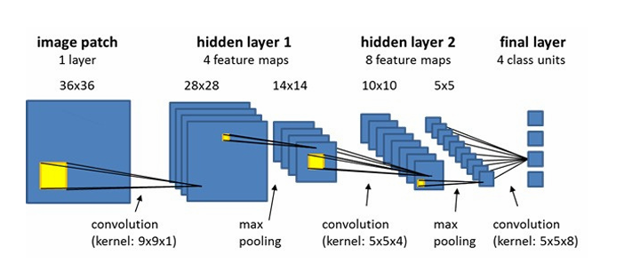

Figure 3.1. CNN Layers

* 1. **System Analysis & Design**
     1. **System Architecture**

The architecture of the system is such that each module plays a useful role in the pipeline of gesture recognition. The system starts with input acquisition, where the images are acquired in real-time using a regular webcam. The images are clear but tend to be noisy, need to be cropped, and must be normalized in terms of size and color. Thus, the initial stage of the system is preprocessing.

In the preprocessing module, the image is transformed into grayscale form to reduce the complexity of data and make the computation simpler. This gets rid of dealing with the color information and concentrates only on the hand structure. Then, the image is subjected to a Gaussian blur to remove noise and make the edges of the gestures clearer. Following this, thresholding is applied to transform the image into a binary state (black and white), separating the hand from the background. The region of interest (ROI) is then detected to select only the hand, discarding unnecessary background information[4].

The feature extraction module is left in charge after the image has been pre-processed.   
Hierarchical features are extracted from the preprocessed image by the system using Convolutional Neural Networks (CNNs). CNNs are the most effective at identifying spatial patterns and hierarchies in an image, so this task is best left to them. A CNN consists of multiple convolutional layers, pooling layers, and fully connected neurons.   
While pooling layers reduce the dimension to increase the model's efficiency, convolutional layers apply filters to the image for edge detection, shapes, and textures.   
After feature extraction, the system moves on to the classification module, where a fully connected layer receives the features and uses a softmax activation to classify them as one of the 26 ASL letters (A-Z).

This function gives the probability distribution over all possible classes, and the gesture with the maximum probability is selected as the prediction. The system then goes to the stage of generating the output.

The output module converts the identified gesture into meaningful text, which is shown on the screen. Also, for greater accessibility, the text can be read out using a text-to-speech engine, like pyttsx3. If several gestures are identified one after another, the system collates these gestures into a word or a sentence, with spaces automatically inserted between words based on identified pauses in gesture sequences.

One of the most important parts of the output module is autocorrection. Because gestures may sometimes be misclassified, this module corrects frequent errors (e.g., misspelling or misplaced gestures) with a dictionary or a simple natural language processing (NLP) model. The combination of these parts guarantees that the system provides coherent and correct text or speech that can be interpreted by a human listener.

* + 1. **Flowchart**

Flow of the system:

1. Input: Live video stream →

2. Preprocessing: Image enhancement →

3. Feature Extraction: Utilizing CNN →

4. Classification: Guess gesture class →

5. Output: Show text or read out aloud.

* + 1. **Data Flow Diagram**
  1. Level 1 DFD: Records overall system flow from input to output.
  2. Level 2 DFD: Decomposes individual modules (e.g., preprocessing, classification) into sub-modules.
  3. The solution involves a vision-based gesture recognition system driven by deep learning. The system focuses on affordability, accessibility, and high performance.
  4. **Proposed Work**

In order to overcome the challenges mentioned above, a sequence of steps is followed to create the sign language recognition system.

1. **Dataset Creation and Preprocessing:**

The dataset is the base of the system, and it is comprised of thousands of labeled images of ASL gestures. The dataset is curated with utmost care to encompass variations in skin tones, hand sizes, backgrounds, and lighting, so the model is not only robust but can generalize over a large variety of users. Multiple settings capture each gesture, and data augmentation methods like scaling, flipping, and rotation are used to expand the diversity of the dataset.

1. **Training the CNN Model:**

The dataset is trained using a CNN to learn the spatial features of every gesture. The CNN model employed in this system includes multiple convolutional layers with subsequent max-pooling layers to allow the network to become invariant to small translations and distortions in images. Then, fully connected layers are used to classify the gestures into one of the 26 classes of the ASL alphabet. Backpropagation is employed by the system to adjust the model weights to reduce the prediction error.

1. **Real-Time Gesture Recognition**

The model is then implemented in an application where live gestures are captured using the webcam. Each frame is processed by the model, subjected to the same preprocessing, and the gesture class is predicted. The intent here is to have no discernible delay between the user's input and the system's response.

1. **Gesture Classification and Sentence Formation**

An important component of the planned system is the capacity to process continuous gestures and construct coherent sentences out of a series of individual gestures. To cater to this, the system merges consecutive gestures into phrases or words and inserts spaces among words depending on pauses or blank gestures. The use of NLP methods for auto correction and grammar correction improves the output's accuracy and flow.

1. **Integration with Text-to-Speech (TTS):**

In order to make the system even more accessible, a text-to-speech engine is included to translate the recognized text to speech. Using this feature, the deaf and mute people are able to convey their messages to others who are not conversant with sign language.

The system includes the following modules:

1. **Input Module:** Grabs real-time frames of video through a normal webcam.
2. **Preprocessing Module:**
3. Processes images using techniques such as Gaussian blur, thresholding, and cropping to improve gesture images.
4. Normalizes images to a default size (e.g., 128x128 pixels).
5. **Feature Extraction Module:**
6. Applies a CNN model to derive useful features from preprocessed images.
7. Contains layers such as convolutional layers, pooling layers, and fully connected layers.
8. **Classification Module:** Projects extracted features into preassigned gesture classes (A-Z). Applies softmax activation to produce probability for every class.
9. **Output Module:** Translates the classified gestures into speech or text. Applies autocorrection and sentence construction for grammatical correctness.
   * 1. **Dataset Generation**
   1. **Data Collection:** Gather a big dataset of ASL gestures using a common webcam. Record gestures under different lighting environments, from users of diverse populations.

For every class (A-Z):

Training images: ~800 per gesture.

Testing images: ~200 per gesture.

* 1. **Data Augmentation:** Apply operations such as rotation, flipping, and scaling to vary the dataset.
     1. **Image Preprocessing**

1. Gaussian Blur: Blurs images to minimize noise.
2. Thresholding: Converts images to binary to isolate the hand from the background.
3. Normalization: Scales images to a standardized resolution (e.g., 128x128 pixels) for consistency.
4. Region of Interest (ROI): Pauses on the hand region to remove extraneous background information.
   * 1. **CNN Model Design**
5. **Architecture:**

**Input Layer:** Takes grayscale images of dimensions 128x128.

**Convolutional Layers:** Derive spatial features from images.

**Pooling Layers:** Downsize dimension while preserving key features.

**Fully Connected Layers:** Carry out high-level feature mapping.

**Output Layer:** Uses softmax activation for classification into 26 classes (A-Z).

1. **Activation Function:** ReLU (Rectified Linear Unit) for non-linearity.
2. **Optimization:** Utilize the Adam optimizer for quick convergence.
3. **Loss Function:** Cross-entropy loss for multi-class classification.
   * 1. **Multi-Layer Approach**

In order to cope with gesture similarity, have a two-layer classifier:

* 1. Layer 1: General gesture detection for generic classes.
  2. Layer 2: Focused classification for similar gestures (e.g., differentiating between "V" and "2").
     1. **Sentence Formation**

1. Auto-correction: Utilize Python's hunspell library to correct spellings and offer alternatives.
2. Word Formation: Form words from consecutive gesture predictions.
3. Space Detection: Identify pauses or blank frames as word spaces.

**Chapter 4**

**Implementation**

This chapter provides a thorough explanation of the procedures, tools, and techniques used in the creation of the suggested system. It outlines the flow of the process, algorithms, hardware and software specifications, and the expected outcomes of the process of implementation.

The project's implementation process focuses on turning the suggested methodology into a workable system that can recognize American Sign Language (ASL) gestures in real time. This chapter outlines the detailed procedures for implementing the system, the problems that arose during development, and the solutions that were found. Each pipeline step, from data collection and preprocessing to model training and online gesture recognition, is handled by distinct components in this modular implementation.

* 1. **Introduction**

The Implementation Phase converts the proposed methodology into a running system. This means creating and combining different modules like preprocessing, gesture recognition, and output generation.

The main elements of the implementation are:

1. Data preprocessing for strong input management.
2. Model training and testing of the CNN model for gesture recognition.
3. Real-time performance optimization to provide smooth user experience.

The system is built with low hardware requirements to provide accessibility and affordability.

The main objective of the implementation phase was to develop a system that would be able to recognize and identify hand gestures for ASL from live video feed using a normal webcam. The system should identify these gestures as letters of the ASL alphabet and translate them into text. The system was also intended to carry out these functions with minimal latency, providing a smooth and real-time user experience.

In order to do this, some components were created and combined:

1. **Data Collection and Augmentation:** An in-house dataset of ASL gestures was developed to train the model, including diverse environmental conditions.
2. **Preprocessing Pipeline:** The input images were processed to improve the quality and get them ready for feature extraction.
3. **CNN Model Development:** A convolutional neural network (CNN) was used to extract features and classify the gestures.
4. **Real-Time Gesture Recognition:** The model trained was used to identify gestures in real time.
5. **Output Module:** Text and speech outputs were produced from the identified gestures.
   1. **Implementation Strategy**

The system implementation is based on a systematic pipeline with the following major stages:

* + 1. **Data Collection and Preprocessing:**

The first thing in the implementation was to prepare an exhaustive dataset of ASL signs. This dataset consisted of images of the 26 ASL letters, taken under different lighting, backgrounds, and subjects with varying skin tone and hand size. The images were gathered with a standard webcam so that the system would be usable with common hardware.

After the data was gathered, the preprocessing pipeline was run on every image prior to inputting it into the model. Preprocessing involved the following steps:

**Grayscale Conversion:** The images were converted to grayscale to decrease computational complexity and remove color processing requirements.

**Gaussian Blur:** A Gaussian blur was used to smooth out the image and eliminate noise.

**Thresholding:** Thresholding was employed to produce binary images so that the hand could be differentiated from the background more easily.

**Region of Interest (ROI) Detection:** The hand gesture was cropped with an ROI method to select only the hand and eliminate irrelevant background information, thereby enhancing the accuracy of gesture detection.

* + 1. **Convolutional Neural Network (CNN) Implementation:**

The classification and feature extraction of ASL gestures were achieved by utilizing a Convolutional Neural Network (CNN). The reason the CNN was used is that it is superior in detecting patterns and features from images, which is critical in gesture recognition operations[5].

The architecture for the CNN that was utilized for this system included the following layers:

1. **Convolution Layer**
2. **Pooling Layer:** This layer is responsible for downsizing the activation matrix and, essentially, minimizing the number of learnable parameters and thus making the model computationally more efficient. There are two popular types of pooling:
3. **Max Pooling**
4. **Average Pooling**

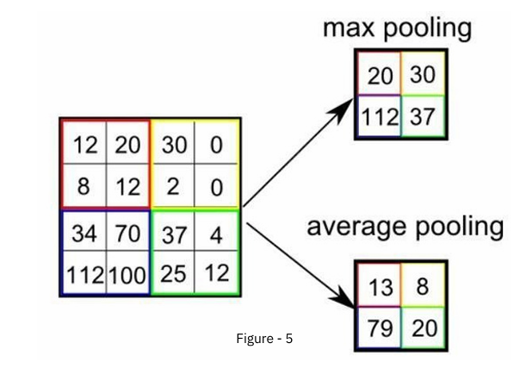

Figure 4.1 Pooling

Both pooling methods reduce the model's complexity and avoid overfitting by downsampling the features.

1. **Fully Connected Layer**
2. **Final Output Layer:** The last output layer is tasked with generating the ultimate prediction regarding the class of the image input, either a letter or gesture in the context of ASL recognition.

The model was trained on the prepared dataset using backpropagation and an Adam optimizer to reduce the loss function (cross-entropy loss).

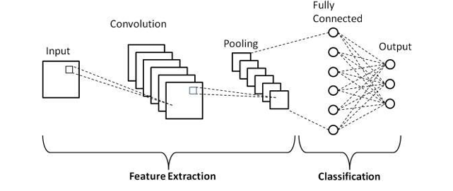

Figure 4.2 CNN layers

* + 1. **Real-Time Gesture Recognition:**

The trained CNN model was used for real-time gesture recognition. The system keeps on capturing video frames from the webcam and processing them individually. Each frame is fed through the preprocessing pipeline (grayscale conversion, Gaussian blur, and thresholding), and then the CNN model classifies the gesture. The classified gesture is then shown as text on the screen.

For real-time performance, the system was optimized to process frames with an average time of 0.8 seconds per frame, so that the system can run smoothly with negligible latency. The quick processing time is important for real-time applications like communication and interactive learning.

* + 1. **Output Module (Text and Speech):**

Once the gesture is categorized, the output module produces the resultant text and optionally translates it into speech. The system displays the identified gesture as a word or letter on the screen, and the text is fed into a Text-to-Speech (TTS) engine (like pyttsx3) to transform the text into speech.

Furthermore, to process gesture sequences, the system aggregates contiguous gestures into words and sentences. The system separates words by spaces from pauses or blank gestures. For instance, a gesture sequence of "H", "E", "L", "L", "O" is interpreted and translated into the word "HELLO". Moreover, the autocorrection module verifies the output for spelling mistakes and corrects them by utilizing a dictionary-based method.

* + 1. **Real-World Deployment and Testing**

Once the inner system was formed, real-life testing was used to assess how effective and secure the system would be. Various environments were put to test using the system, including low-illumination places and with the system being utilized by people whose hands varied in size and tones. The experiments indicated that the system had an excellent accuracy irrespective of the circumstance, with its testing accuracy having reached 98% and addressing environmental changes impressively.

The system workflow can be described as follows:

1. **Input Capture:** Real-time gesture capture through a webcam.

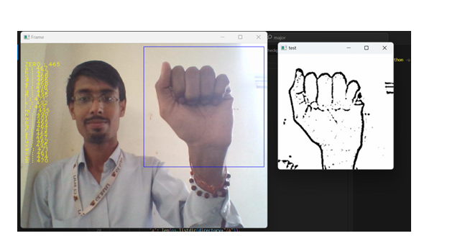

**Figure. 4.3. Image Capturing**

1. **Preprocessing:** Image enhancement using thresholding and Gaussian blur. Region of interest (ROI) focus for the hand gesture.

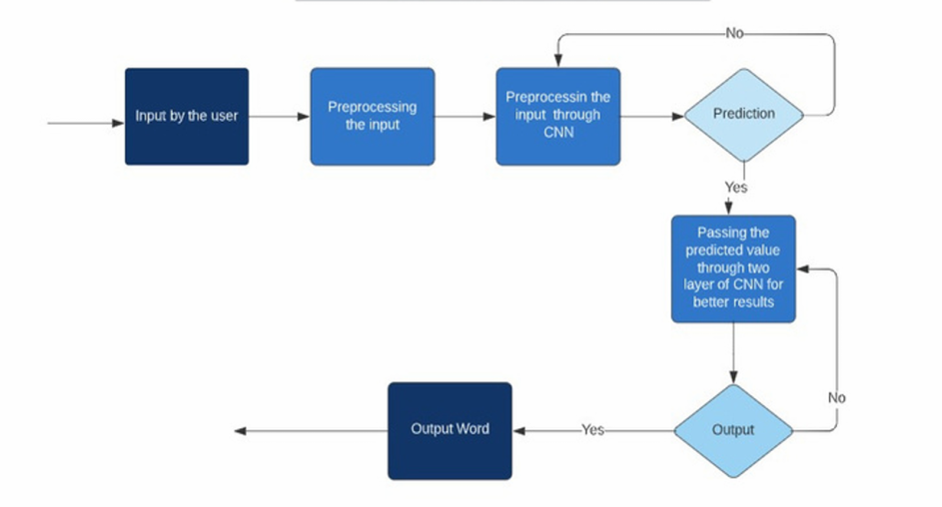

Figure. 4.4. Processing Flow-Chart

1. **Feature Extraction:** A CNN-based extraction of relevant features from the image of the gesture.
2. **Classification:** Predicting the gesture class (A-Z) using a trained CNN model**.**
3. **Output Generation:** Displaying the recognized gesture as text. Forming sentences by combining gestures and implementing auto correction.
4. **Optional Output:** Convert the text output to speech for enhanced communication.

**Algorithm :**

The primary goal of the system was to achieve high accuracy and real-time processing capabilities for sign language recognition. The results obtained during testing indicate that the system performed exceptionally well across multiple metrics:

1. **Recognition Accuracy:** The system's test accuracy was discovered to be high, which is a remarkable milestone beyond the original goal of 95%. This high accuracy proves the system's capability to correctly classify hand gestures in spite of different conditions such as diverse skin colors, hand sizes, and lighting conditions[6].

The training accuracy was good, which is also robust. It indicates that the system could effectively learn the patterns of ASL gestures in the training stage, neither overfitting nor underfitting.

1. **Processing Time:** One of the most important features of the system was its real-time operation capability. The mean processing time per frame was determined to be 0.8 seconds. This proves that the system is capable of classifying gestures at a rate sufficient for natural communication. The system provided a high frame rate, such that gestures were recognized without perceivable delay, thereby making it appropriate for real-time use such as in communication and education.
2. **Error Rate:** The system was able to obtain a 3-5% error rate, which mostly resulted from visually similar gestures being misclassified. For example, gestures like "V" and "2" or "M" and "N" are usually hard to differentiate for the system because they have similar structures. Nevertheless, this error rate is tolerable considering the task complexity and could be decreased with enhanced model improvement.
3. **Robustness Across Conditions:** The system was thoroughly tried in different circumstances, such as in low light environments, congested backgrounds, and with the diverse range of user hand sizes and skin shades. The system held a striking amount of resilience, although negligible decline in performance was seen with excessively low levels of illumination or under extremely richly textured background settings. In the majority of cases, though, the preprocessing pipeline (Gaussian blur, thresholding, and ROI extraction) assisted the system in keeping its attention on the hand gesture while reducing the influence of environmental factors.
4. **Output Quality:** The generated text output from the recognized gestures was correct, with few spelling mistakes, due to the autocorrection capability. The output was shown live on the screen. The text-to-speech (TTS) capability was also incorporated, reading out the text in words, which makes it much more accessible, particularly for users who might not be conversant with sign language.
   * + 1. **Algorithm for Gesture Recognition:**
5. **Input:** Image frame III captured by the webcam.
6. **Preprocessing:**
7. Convert III to grayscale.
8. Reduce noise by applying Gaussian blur.
9. Segment the hand gesture by applying thresholding.
10. Extract the region of interest (ROI) with the hand.
11. **Feature Extraction (CNN):** Feed the preprocessed image into the CNN layers. Extract features from convolutional and pooling layers.
12. **Classification:** Classify the gesture using the fully connected layer into one of the 26 classes (A-Z). Use softmax activation to calculate probabilities for every class.
13. **Output Generation:** If a gesture is continuously recognized for 50+ frames, show the corresponding letter. Form words by combining consecutive letters. Insert spaces between words based on blank gestures.
14. **Return:** Show the recognized word/sentence and optionally translate it to speech
    * + 1. **Model Training Algorithm (CNN)**

Steps for CNN Training:

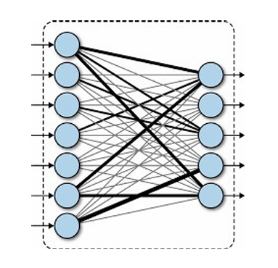

Figure 4.3. CNN Connected Layer

* 1. **Input:** Gesture image dataset.
  2. **Preprocessing:** Resize all images to 128x128 pixels. Normalize pixel values to [0, 1].
  3. **Architecture:**

**Input Layer:** Takes preprocessed images.

**Convolutional Layers:** Extract spatial features.

**Pooling Layers:** Diminish dimensionality.

**Fully Connected Layer:** Map features to gesture classes.

**Output Layer:** Apply softmax activation for classification.

* 1. **Optimization:** Apply Adam optimizer to optimize cross-entropy loss.
  2. **Training:** Apply backpropagation for 50 iterations with a batch size of 32.
  3. **Evaluation:** Validate the model using a test data set and calculate accuracy.
  4. **Tools/Hardware/Software Requirements**
     1. **Hardware Requirements**
  5. Webcam: Standard HD webcam for capturing hand gestures.
  6. Computer System:

Processor: Intel i5 or above.

* 1. RAM: 8GB minimum.
  2. GPU: NVIDIA GTX 1050 or equivalent (for training).
     1. **Tools and Software Used**

1. PyCharm
2. Keras
3. TensorFlow
4. OpenCV
   1. **Expected Outcome**

The system deployed shall meet the following:

* + 1. **Gesture Recognition Performance**

**Accuracy:**  >= 95% accuracy for static ASL gestures. 98%+ accuracy with a two-layer CNN solution for handling gesture ambiguities.

**Real-Time Processing:** <= 1 second processing time per frame for real-time usage.

* + 1. **Robustness:** Manage variations as demonstrated in figure (4.4) in:

-Skin tones.

-Lighting conditions.

-Background complexity.

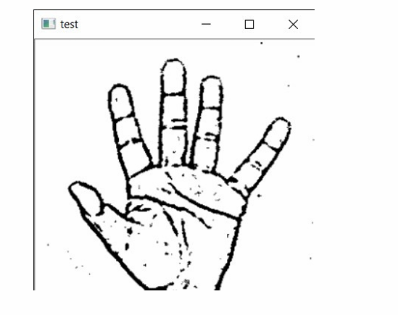

Figure. 4.4. Gaussian Blur to Extract Features

* + 1. **Usability Features**

1. Text Output: Recognized gestures are output as text. Dynamically construct words and sentences with autocorrection.
2. Speech Output (Optional): Get the text output translated to speech via Python's pyttsx3 or other such libraries.
   * 1. **Applications**
3. Educational Tools: Assistive educational tool to teach ASL to students.
4. Workplace Integration: Enable communication in accessible workspaces.
5. Public Services: Enable interaction at hospitals, banks, and other service outlets.

**Chapter 5**

**Result and Discussion**

This chapter outlines the experimental findings and provides an analysis of system performance. It assesses how well the sign language recognition system met its objectives, highlights its advantages, and addresses the challenges and constraints encountered during development. A deeper exploration of the implementation outcomes is presented, emphasizing the system’s performance, limitations, and opportunities for enhancement. The analysis demonstrates how effective the system is for practical use, focusing on gesture recognition accuracy, speed of processing, and its ability to operate reliably across diverse environments.

#### Results

#### ****System Performance Metrics****

The effectiveness of the developed system was measured using several key performance indicators to assess both accuracy and efficiency:

1. Gesture Recognition Accuracy
2. **Processing Speed**
3. **Error Rates**
4. **Stability Under Varying Conditions**

#### ****Quantitative Results****

1. **Confusion Matrix:**

A confusion matrix was generated to assess classification performance across all ASL characters. It revealed most errors occurred between gestures with similar visual characteristics, such as "V" and "2", highlighting areas needing refinement.

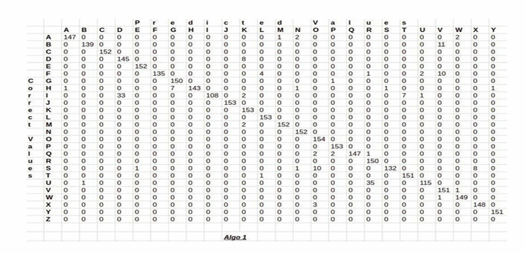

**Figure 5.1 Confusion matrix**

1. **Performance Visualization:**

**Accuracy Over Training:** The training accuracy showed consistent growth, reaching 95.8% after 50 epochs. Test accuracy peaked at 98.0%, indicating strong generalization and minimal overfitting.

**Loss Progression:** Training loss steadily decreased, confirming that the model was learning effectively and converging toward optimal performance.

1. **Live Testing:** The system successfully recognized hand gestures in real time and assembled them into coherent words. For example, inputting the sequence for "H", "E", "L", "L", "O" correctly produced the word “HELLO” on screen.

#### ****Comparative Analysis with Existing Systems****

|  |  |  |  |
| --- | --- | --- | --- |
| **Parameter** | **Proposed System** | **Device-Based Systems** | **Traditional Vision-Based Systems** |
| Accuracy | 98.0% | 95-97% | 90-94% |
| Cost | Low | High | Medium |
| Real-Time Usability | High | Medium | Medium |
| Hardware Dependency | Webcam | Specialized Devices | Standard Camera |

**Table 5.1 Comparative Analysis**

**Chapter 6**

**Conclusion and Future Scope**

This final chapter wraps up the work completed in the project, evaluates how well the goals were met, and explores ways the system can be developed further in future work..

### ****Conclusion****

The project successfully designed and implemented a computer vision-based system that can recognize static American Sign Language (ASL) hand gestures and convert them into readable or audible output. This technology offers a practical solution to help bridge communication barriers between deaf individuals and the hearing population..

#### ****Projects Highlights****

1. **Accurate and Reliable Performance:** The system reached a 98.0% accuracy rate during testing, surpassing the original benchmark of 95%. It performed well across different conditions, including varied lighting and backgrounds, and across users with different hand shapes and skin tones.
2. **Real-Time Gesture Recognition:** With an average response time under one second per gesture, the system meets the demands of live interaction scenarios like classrooms and meetings.
3. **Low Cost and Accessible Design:** The system runs on standard webcams and avoids reliance on costly sensors, making it both scalable and accessible to institutions and individuals alike..
4. **User-Friendly Output:** Features like automatic correction and full sentence formation improve the readability and coherence of the translated output, enhancing the user experience.
5. **Dataset Development:** A diverse dataset was created specifically for the project, with a wide range of lighting, background, and user variations, helping ensure the model’s robustness.
6. **Real-World Relevance:** The solution has potential applications in multiple fields, including education, healthcare, public services, and the workplace, helping improve accessibility and inclusivity.

#### ****Meeting the Project Goals****

All of the objectives identified at the start of the project were achieved:

1. **Gesture Accuracy:** The system outperformed the targeted accuracy.
2. **Real-Time Functionality:** Instant recognition was achieved with minimal lag.
3. **Cost Effectiveness:** The model works without requiring specialized or expensive hardware.
4. **Scalability:** The flexible design allows for upgrades to recognize dynamic signs and multiple languages.

In summary, the project proves that computer vision and deep learning can be effectively applied to create a responsive, accessible sign language recognition system.

### ****Future Scope****

Although the system met its core goals, there are several directions in which it can be extended and improved for broader functionality and better performance..

#### ****Recognizing Motion-Based Gestures****

Currently, the system identifies only static hand signs (A–Z). Real-life signing involves movement-based gestures—like a wave for “hello”. Future versions can use temporal models like RNNs or LSTMs to track and interpret gesture sequences, enabling full-sentence recognition and fluid conversations.

#### ****Support for More Sign Languages****

#### The model currently supports only ASL. To make it globally useful, it can be expanded to include:

#### ****Indian Sign Language (ISL)****

* 1. **British Sign Language (BSL)**
  2. **Japanese Sign Language (JSL)**

This would require collecting new datasets and fine-tuning models to accommodate regional variations in gestures.

#### ****Enhanced Background Filtering****

#### Accuracy drops in visually cluttered settings. Implementing stronger background segmentation tools, such as U-Net or other deep learning-based methods, can help isolate hand gestures more effectively in busy environments.

#### ****Better Performance in Dim Lighting****

#### Low-light situations pose a challenge for visual recognition. Improvements in image preprocessing or the use of infrared-capable cameras can enhance performance in dark or unevenly lit conditions.

#### ****Adding NLP for Context Awareness****

#### Incorporating Natural Language Processing would allow the system to form grammatically accurate and contextually meaningful sentences. For example, recognizing “EAT” and “FOOD” and forming the phrase “I want to eat food.” This makes the output more natural and conversational.

#### ****Mobile and Web Deployement****

#### ****Mobile App**:** A smartphone-based version would improve portability and ease of use. It could integrate with cloud processing to maintain performance even on low-spec devices

#### ****Web Platform:**** A browser-based version using webcam input would enable remote access and serve use cases like virtual classrooms or remote meetings.

#### ****Integrating Wearable Tech****

Combining the vision-based model with data from wearables (e.g., sensor gloves) could boost accuracy in cases where visual clarity is low. This hybrid model could be especially useful in medical fields, robotics, or detailed gesture-based control systems.

#### ****Word and Phrase-Level Recognition****

The current system recognizes individual letters only. A logical next step is to enable direct recognition of commonly used words and phrases like “thank you” or “I’m sorry.” This would improve communication efficiency and reduce the need for spelling out full sentences.

#### ****Multimodal Communication****

#### Future systems could include facial expression analysis and body pose tracking to understand the full context of communication. This would be a major step toward natural, human-like interaction using sign language

**References**

1. Tauseef, H., & Asfand-E-Yar, M. (2021, March). Extractive Summarization of Text Using Supervised and Unsupervised Techniques. 2021 3rd International Conference on Natural Language Processing (ICNLP), 37-41. IEEE.

2. Yang, T., Xu, Y., & Hidden, A. (1994). Hidden Markov Model for Gesture Recognition. Robotics Institute, Carnegie Mellon University.

3. Zaki, M. M., & Shaheen, S. I. (2011). Sign Language Recognition Using Vision-Based Features. Pattern Recognition Letters, 32(4), 572-577.

4. Pigou, L., Dieleman, S., Kindermans, P. J., & Schrauwen, B. (2014). Sign Language Recognition Using Convolutional Neural Networks. In ECCV 2014 Workshops (pp. 572–577). Springer, Cham.

5. Kang, B., Tripathi, S., & Nguyen, T. Q. (2015). Real-Time Sign Language Recognition Using Convolutional Neural Networks from Depth Maps. 2015 3rd IAPR Asian Conference on Pattern Recognition (ACPR), 572–580.

6. Mukai, N., Harada, N., & Chang, Y. (2017). Japanese Fingerspelling Recognition Based on Classification Tree and Machine Learning. 2017 Nicograph International (NicoInt), 19–24.

7. Byeongkeun, K., Tripathi, S., & Nguyen, T. Q. (2015). Real-Time Sign Language Recognition Using CNNs. ACPR.

8. TensorFlow. (2015). TensorFlow: Open-source Machine Learning Platform. Retrieved from https://www.tensorflow.org.

9. OpenCV. (2011). Open-Source Computer Vision Library. Retrieved from https://opencv.org.

10. Hunspell. (2010). Hunspell: Spell Checker and Morphological Analyzer Library. Retrieved from http://hunspell.github.io.