**Introduction to service-oriented design**

Definition: Service-oriented design is the process by which concrete physical service designs are derived from logical service candidates and then assembled into abstract compositions that implement a business process.

The overall goals of performing a service-oriented design are as follows:

* Determine the core set of architectural extensions.
* Set the boundaries of the architecture.
* Identify required design standards.
* Define abstract service interface designs.
* Identify potential service compositions.
* Assess support for service-orientation principles.
* Explore support for characteristics of contemporary SOA.

A high-level service-oriented design process:

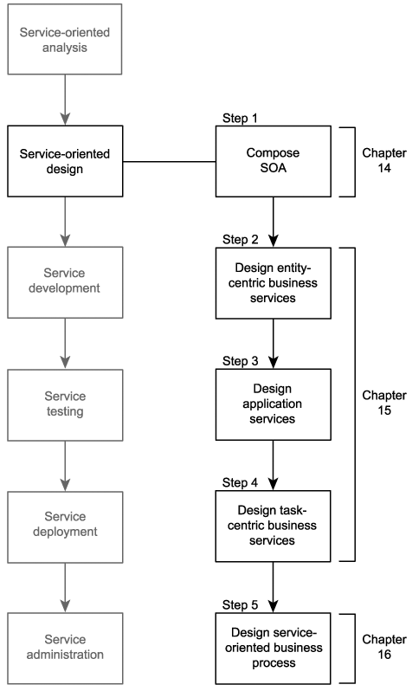

Step 1: Compose SOA

A fundamental quality of SOA is that each instance of a service-oriented architecture is uniquely composable. Although most SOAs will implement a common set of shared technologies based on key XML and first-generation Web services specifications, the modular nature of the WS-* specification landscape allows for extensions to this core architecture to be added as required.

This step consists of the following three further steps that are explained in Chapter 14:

|  |  |
| --- | --- |
| **1.** | Choose service layers. |
| **2.** | Position core SOA standards. |
| **3.** | Choose SOA extensions. |

Steps 2 to 4: Design services

These steps are represented by the following three separate processes provided in Chapter 15:

* Entity-centric business service design process.
* Application service design process.
* Task-centric business service design process.

Our primary input for each of these service design processes is the corresponding service candidates we produced in the service modeling process during the service-oriented analysis.

Step 5: Design service-oriented business process

Upon establishing an inventory of service designs, we proceed to create our orchestration layerthe glue that binds our services with business process logic. This step results in the formal, executable definition of workflow logic, which translates into the creation of a WS-BPEL process definition (as explained in Chapter 16).

13.1.4. Prerequisites

Before we get into the details of the service-oriented design process, we should make sure that we have a sufficient understanding of key parts of the languages required to design services.

Figure 13.2. Three core specifications associated with service design.

