**Exercise Number - 3**

**Dashboard in R**

**Q1. Create a Simple dashboard using Shiny.**

**Aim:** To create a simple dashboard in R using the Shiny library

**Code:**

**ui.R**

install.packages("shiny")

install.packages("shinydashboard")

library(shiny)

library(shinydashboard)

shinyServer(

pageWithSidebar(

headerPanel("My First App 20BDS0162"),

sidebarPanel(

selectInput("Distribution",'Pls.Select Distribution type',

choices =c('Normal','Exponential')),

sliderInput("sampleSize",

'Pls.Select Sample Size',

min =100,max=5000,

value=1000,step=100),

conditionalPanel(condition="input.Distribution=='Normal'",

textInput("mean","Pls.Select mean:",10),

textInput("sd","Pls.Select SD:",3)),

conditionalPanel(condition="input.Distribution=='Exponential'",

textInput("lambda","Pls.Select Exp lamda:",1))

),

mainPanel(plotOutput('myPlot'))

)

)

**server.R**

shinyServer(

function(input,output,session){

output$myPlot<-renderPlot({

distType = input$Distribution

size <-input$sampleSize

if(distType=="Normal"){

randomVec <- rnorm(size,mean=as.numeric(input$mean),

sd=as.numeric(input$sd))

}else{

randomVec <- rexp(size,rate=1/as.numeric(input$lambda))

}

hist(randomVec,col ="pink")

})

}

)

**Output:**

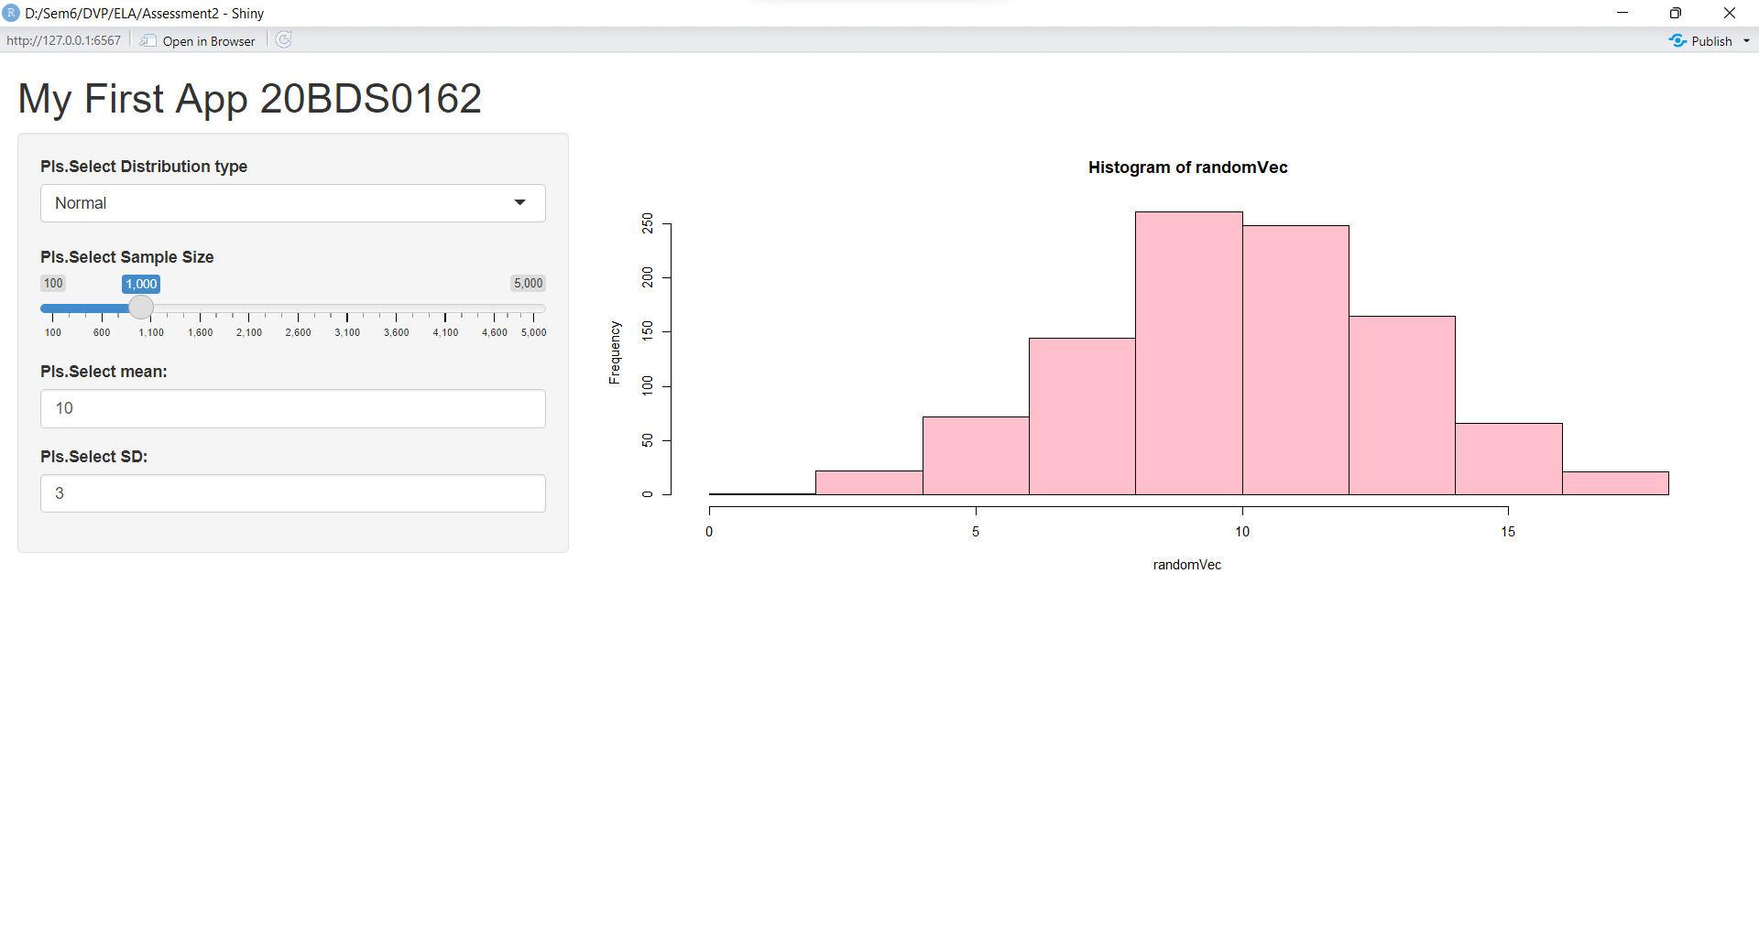

**Result:**

Successfully created a straightforward dashboard in R using the Shiny package. The dashboard shows a randomVec histogram, and the user may select the normal or exponential distribution type, as well as the sample size, mean, and standard deviation for each distribution.