**Exercise Number – 1**

**K-Means Clustering**

**Q1. K-mean Clustering using Social_Network_Ads dataset.**

**Aim:** To use the Social_Network_Ads dataset with the K-Means Clustering Algorithm and visualise the clusters

**Code:**

library(arules)

library(dplyr)

#k means clustering

df2 = read.csv("D:\\Sem6\\DVP\\ELA\\Assessment2\\Social_Network_Ads.csv")

df2 = df2[4:5]

df2

library(cluster)

set.seed(5000)

wcss = vector()

wcss

for(i in 1:50)

wcss[i] = sum(kmeans(df2, i)$withinss)

plot(1:50, wcss, type = 'b') #5 cluster reqd

kmeans = kmeans(x = df2, centers = 5)

y_kmeans = kmeans$cluster

z=clusplot(df2, y_kmeans,main = "20BDS0162")

z

**Output:**

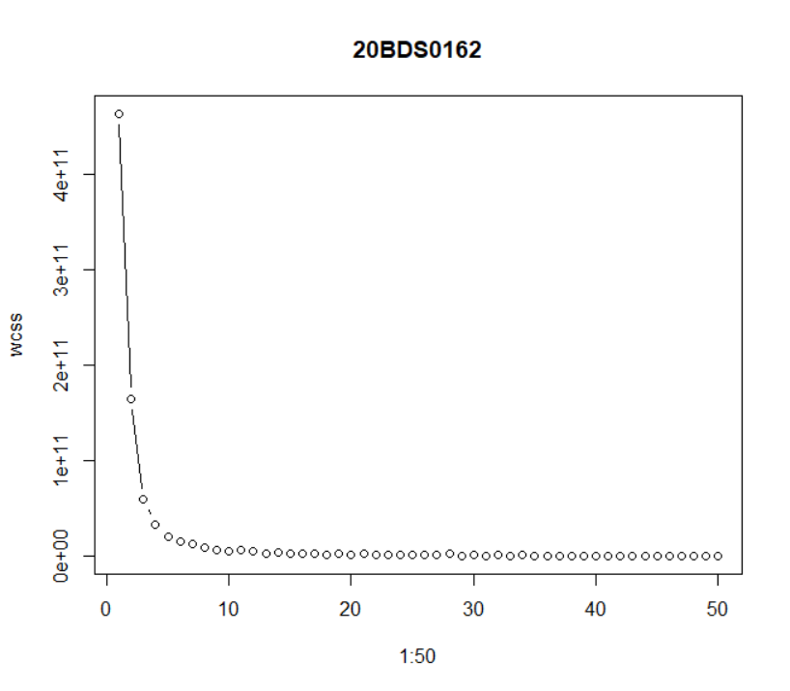

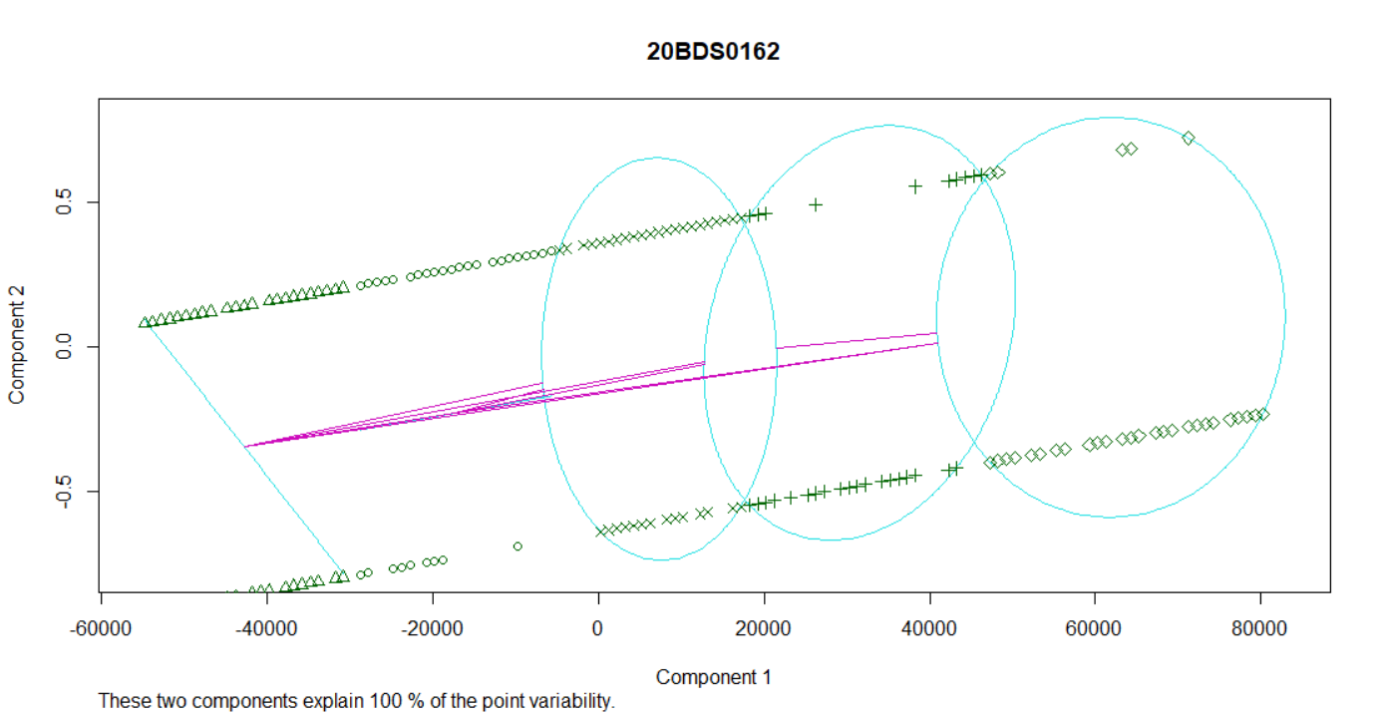

**Result:**

K-Means Clustering for the dataset Social Network Ads was completed successfully. Based on the Estimated Salary column, I had first put the cluster centroid at 5000. (4th). I used the algorithm to produce five clusters. Following that, all of the clusters are shown, and it is also indicated which data points belong to particular clusters and how far away they are from each other.

**Exercise Number - 2**

**Market Basket Analysis**

**Q1. Market-Basket Data analysis Visualization**

**Aim:** To perform Market-Basket-Data-Analysis Visualization using Apriori Algorithm and visualize the results

**Code:**

install.packages("dplyr")

install.packages("arules")

library(arules)

library(dplyr)

df1 = read.csv("D:\\Sem6\\DVP\\ELA\\Assessment2\\Market_Basket_Optimisation.csv", header = FALSE)

summary(df1)

dim(df1)

str(df1)

#sparse matrix

df1 = read.transactions(file = "D:\\Sem6\\DVP\\ELA\\Assessment2\\Market_Basket_Optimisation.csv",

sep = ",",

rm.duplicates = T)

summary(df1)

itemFrequencyPlot(x = df1, topN = 10,main = "20BDS0162",col = "red", border = "blue")

#apriori algo

rules = apriori(data = df1,

parameter = list(support = 0.004,

confidence = 0.2))

#visualizing

inspect(sort(rules, by = 'lift')[1:10])

**Output:**

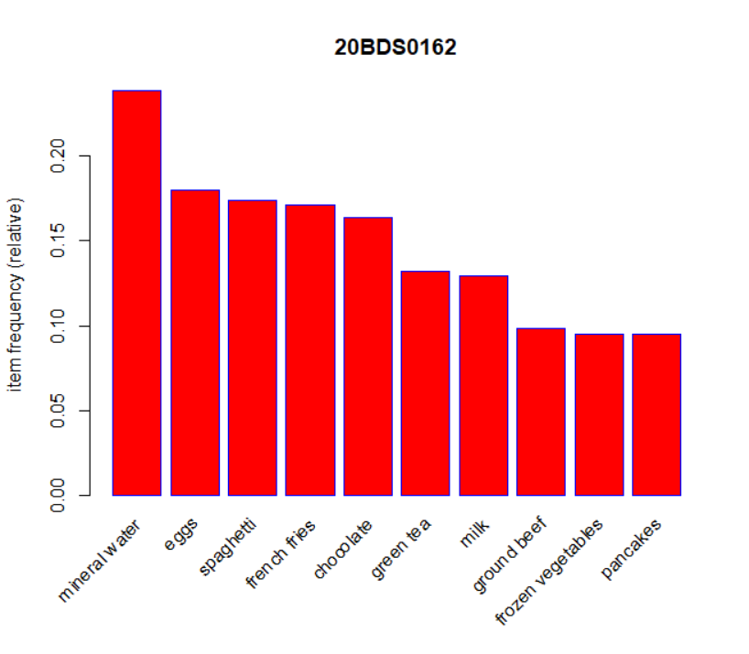

**Result:**

Calculated the necessary support and confidence that properly suit the provided dataset in order to successfully use the Apriori algorithm and visualize the results. According to the findings, one can predict what a person would purchase in total while visiting the market based on the things they initially choose.

**Exercise Number - 3**

**Dashboard in R**

**Q1. Create a Simple dashboard using Shiny.**

**Aim:** To create a simple dashboard in R using the Shiny library

**Code:**

**ui.R**

install.packages("shiny")

install.packages("shinydashboard")

library(shiny)

library(shinydashboard)

shinyServer(

pageWithSidebar(

headerPanel("My First App 20BDS0162"),

sidebarPanel(

selectInput("Distribution",'Pls.Select Distribution type',

choices =c('Normal','Exponential')),

sliderInput("sampleSize",

'Pls.Select Sample Size',

min =100,max=5000,

value=1000,step=100),

conditionalPanel(condition="input.Distribution=='Normal'",

textInput("mean","Pls.Select mean:",10),

textInput("sd","Pls.Select SD:",3)),

conditionalPanel(condition="input.Distribution=='Exponential'",

textInput("lambda","Pls.Select Exp lamda:",1))

),

mainPanel(plotOutput('myPlot'))

)

)

**server.R**

shinyServer(

function(input,output,session){

output$myPlot<-renderPlot({

distType = input$Distribution

size <-input$sampleSize

if(distType=="Normal"){

randomVec <- rnorm(size,mean=as.numeric(input$mean),

sd=as.numeric(input$sd))

}else{

randomVec <- rexp(size,rate=1/as.numeric(input$lambda))

}

hist(randomVec,col ="pink")

})

}

)

**Output:**

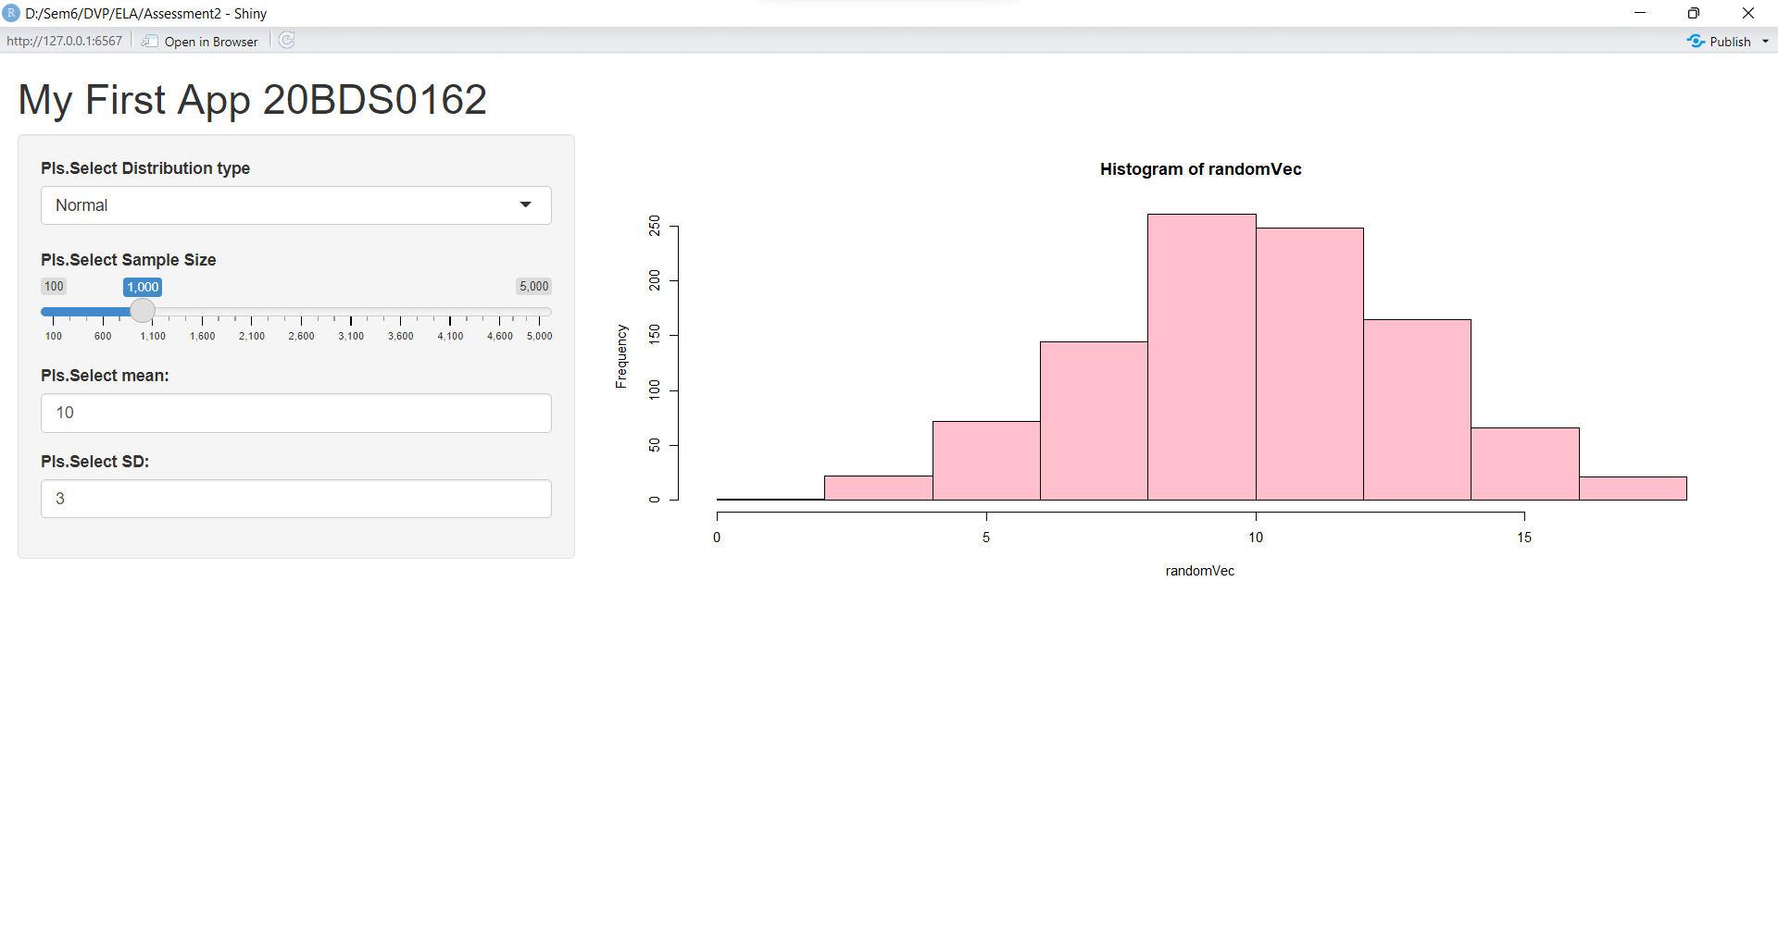

**Result:**

Successfully created a straightforward dashboard in R using the Shiny package. The dashboard shows a randomVec histogram, and the user may select the normal or exponential distribution type, as well as the sample size, mean, and standard deviation for each distribution.