**Color Map Visualization**

**Q. Draw the various plot for the given dataset. Use various color set options like Categorical, Sequential, Diverging, bivariate.**

**Aim:** To draw various plots using ggplot2 like Barplots, Stacked Barplots, Scatter plot with different shapes and use sequential, diverging, categorical and bivariate colors for the given dataset (ForestFires).

**Code:**

data = read.csv("D:\\Sem6\\DVP\\ETH\\forestfires.csv")

data

View(data)

library(ggplot2)

ggplot(data=data, aes(x=area, y=month,fill=month)) +

geom_bar(stat="identity")+

theme_minimal()+ggtitle("Monthly Area Burnt 20BDS0162")+xlab("Area")+ylab("Month")

ggplot(data=data, aes(x=area, y=month,fill=month)) +

geom_bar(stat="identity")+

theme_minimal()+ggtitle("Monthly Area Burnt with Coordinate Flip 20BDS0162")+xlab("Area")+ylab("Month") +coord_flip()

library(dplyr)

data1 = data %>%

group_by(month) %>%

summarise(RH = mean(RH))

data1 = mutate(data1,StdError = sd(RH))

data1

ggplot(data=data1, aes(x=month, y=RH, fill = month)) +

geom_bar(stat="identity")+

theme_minimal()+ggtitle("Monthly Relative Humidity with Error Bars 20BDS0162")+xlab("Month")+ylab("Relative Humidity") +

geom_errorbar(aes(ymin = RH-StdError,ymax = RH+StdError),width = 0.2,color = "red",size = 1)

ggplot(data=data, aes(x=month, y=area,fill = day)) +

geom_bar(stat="identity")+

theme_minimal()+ggtitle("Monthly Area Burnt with Days as Stacks 20BDS0162")+xlab("Month")+ylab("Area Burnt")+scale_fill_brewer()

ggplot(data, aes(x = month, y = rain,color = as.factor(day))) +

geom_point(shape = 5, size = 2)+

theme_minimal()+xlab("Month")+ylab("Rain")+ggtitle("Monthly Rain with Empty Diamond Shape 20BDS0162")

ggplot(data, aes(x = month, y = rain)) +

geom_point(shape = 25, size = 4,color = "red",fill = "yellow")+

theme_minimal()+xlab("Month")+ylab("Rain")+ggtitle("Monthly Rain with shape filled 180 degree rotated triangle 20BDS0162")

library(reshape2)

data2 <- cor(data[sapply(data, is.numeric)])

data3 <- melt(data2)

data3

ggplot(data3, aes(x = Var1,

y = Var2,

fill = value))+geom_tile()+ggtitle("Heatmap with Scalar 20BDS0162")

ggplot(data3, aes(x = Var1,

y = Var2,

fill = value))+geom_tile()+scale_fill_gradient2(low="cyan", high="red", mid = "white")+ggtitle("Heatmap with divergence 20BDS0162")

library(plotrix)

month_counts <- table(data$month)

labels=unique(data$month)

pie3D(month_counts,main="3D Pie Chart of Month Counts 20BDS0162",col = hcl.colors(length(labels), "Spectral"),

border = "white",labels = labels,labelcol = "blue",

labelcex = 1,explode = 0.1)

**Output:**

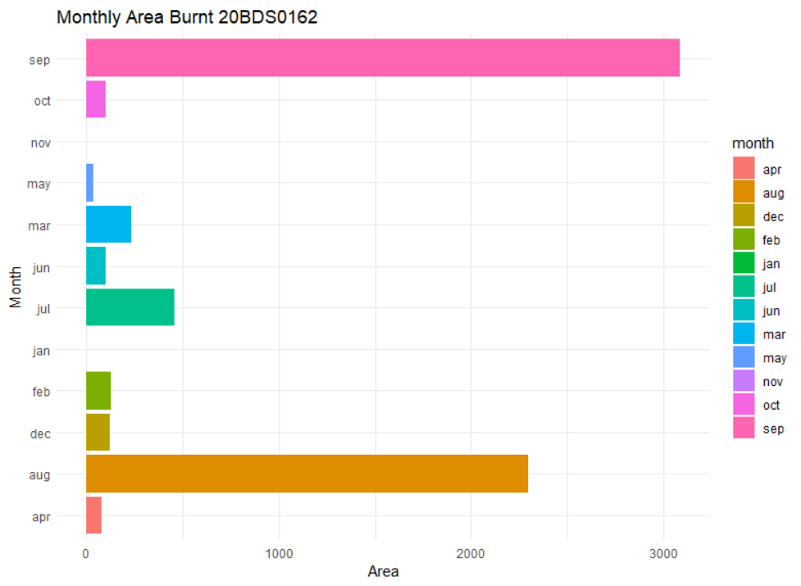

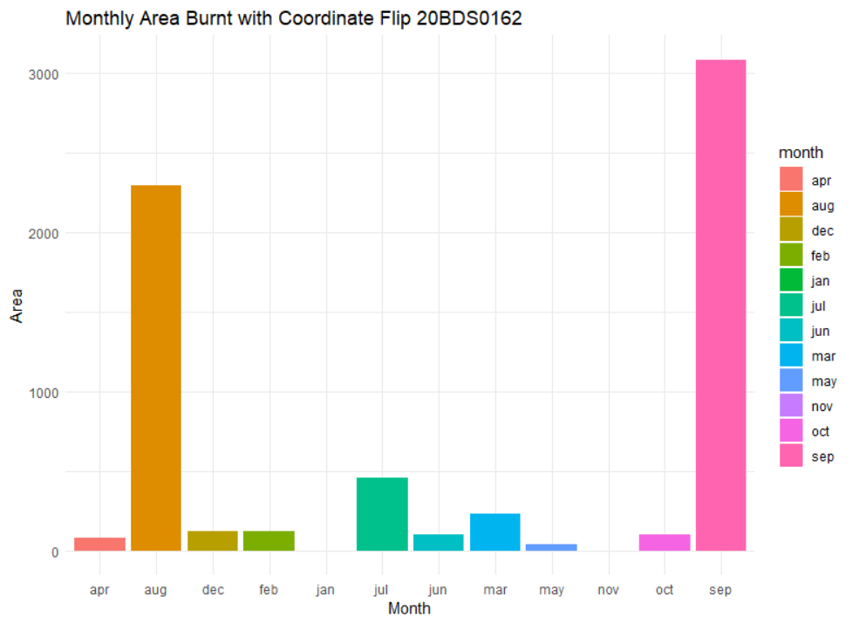

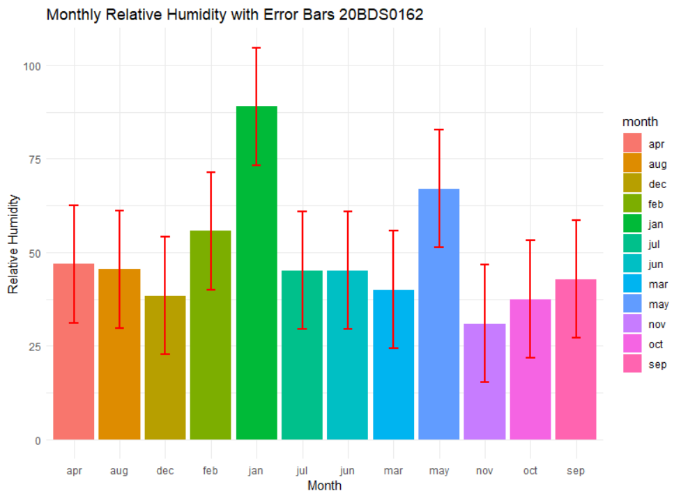

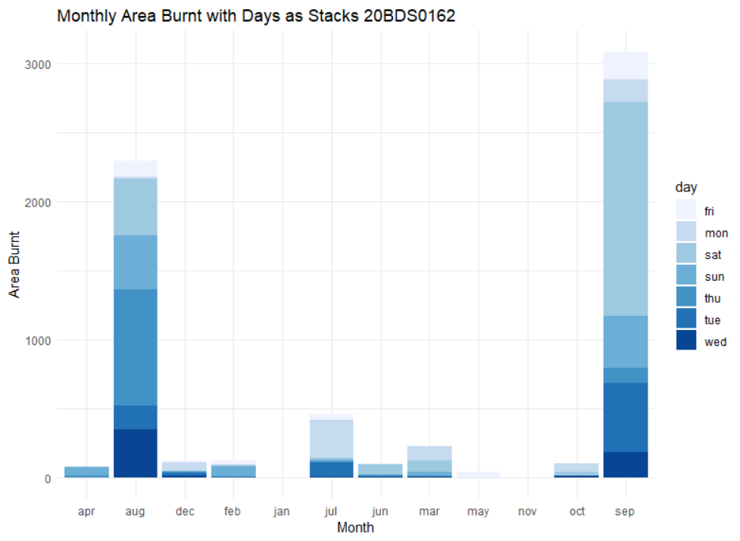

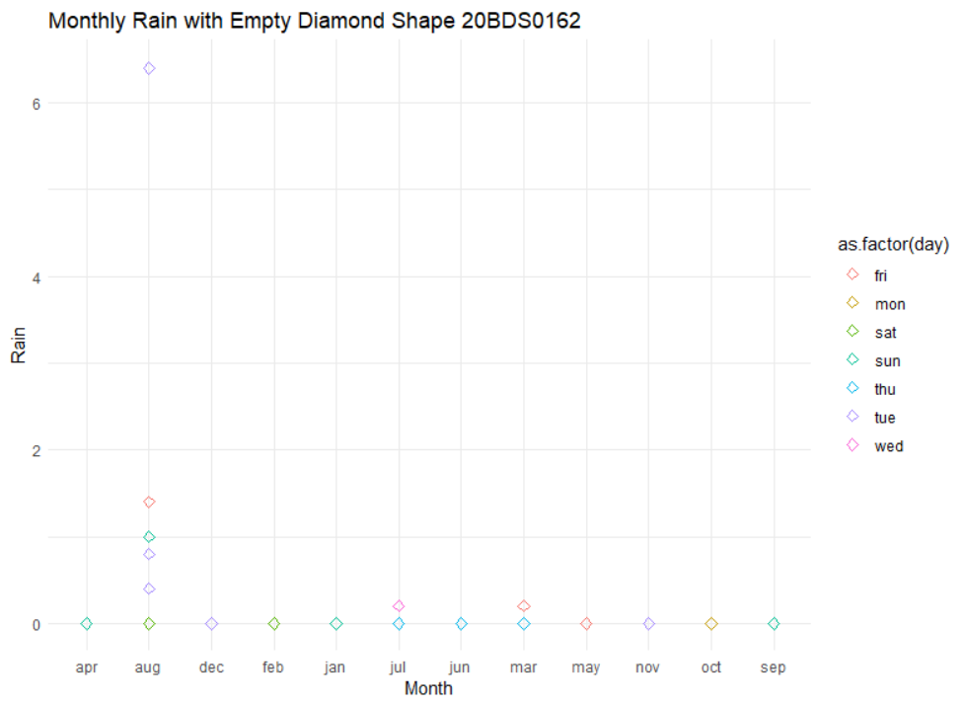

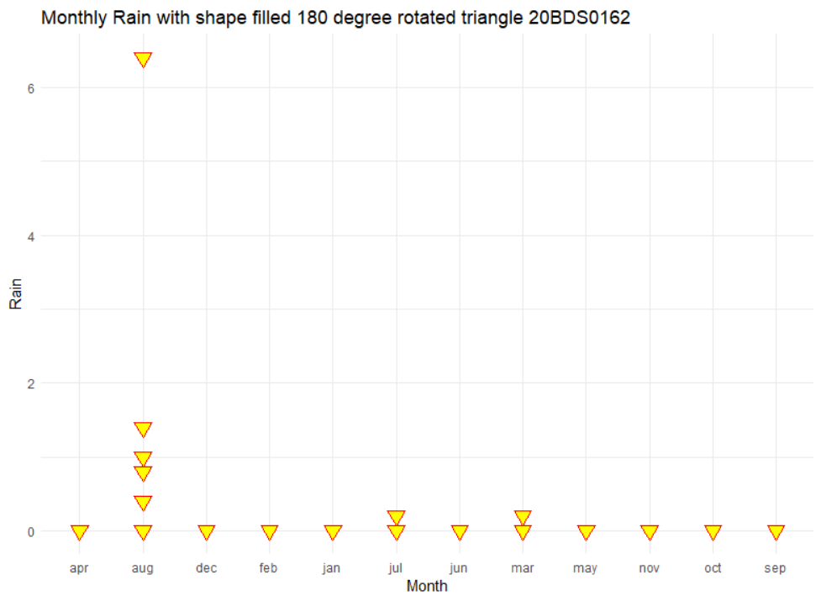

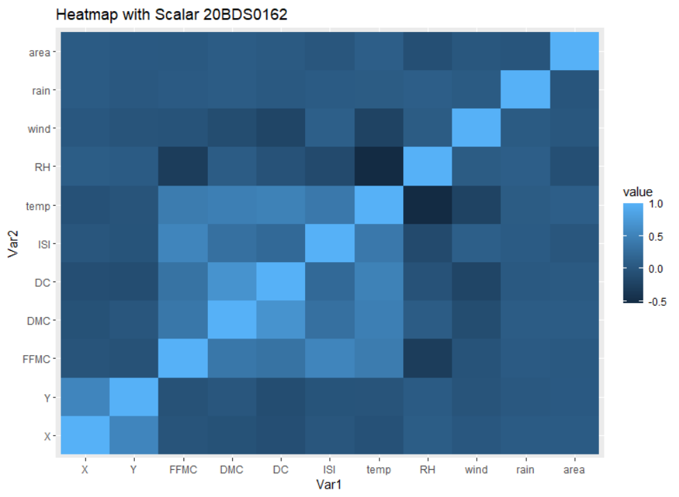

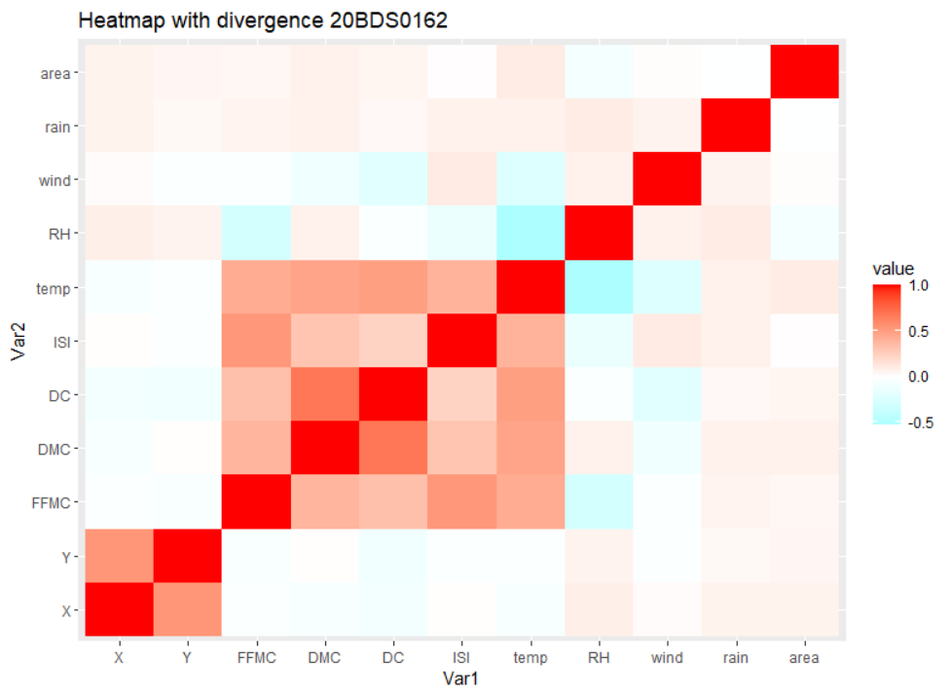

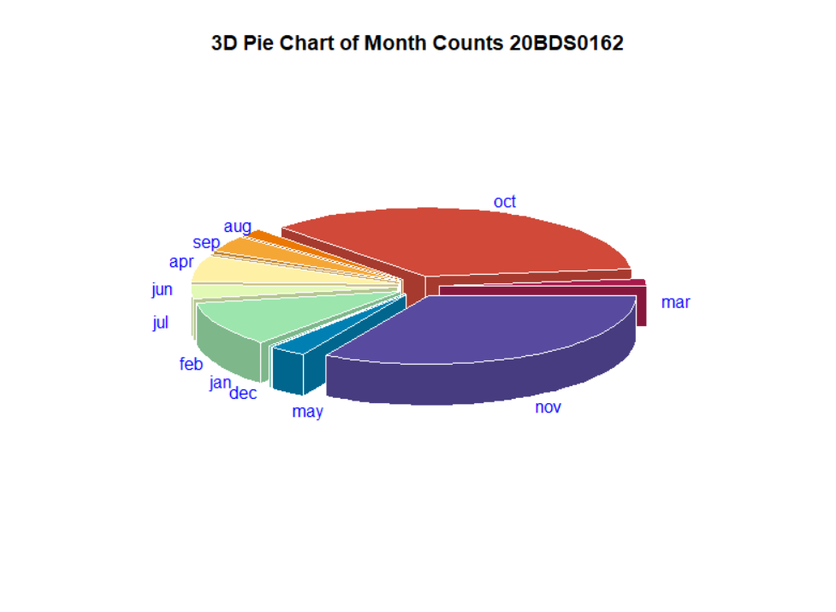

**Result:**

Successfully plotted various plots like bar plots, bar plots with flipped coordinates, scatter plots with different shapes, heatmaps and 3D pie chart and used various color setting options like stacked bar chart with sequential colors, heatmap with diverging colors.

**Dashboard Creation using Looker**

**Q. The dataset from looker needs to be taken and create the visualization using looker studio.**

**Aim:** To create a dashboard on Looker Studio for the given dataset(Space Missions)

**Dashboard Screenshot:**

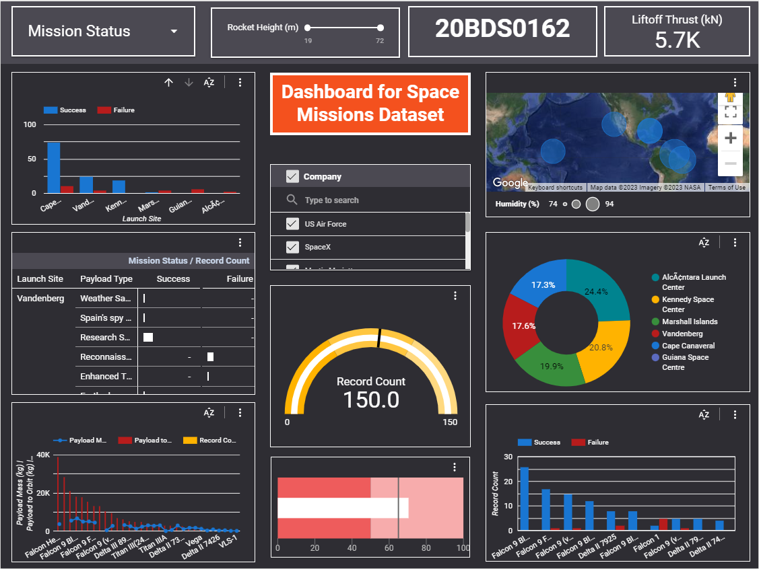

**Dashboard Link:**

<https://lookerstudio.google.com/reporting/88b53500-b4ee-4b28-a9f9-5157a49fcaee>

**Result:**

Successfully created a dashboard on the Google Looker Studio for the Space Missions dataset and used various types of plots to do the analysis of the dataset with various controls to make the dashboard interactive and user friendly.