Technical Approach: Realistic Person-Scene Integration

Date: July 22, 2024

Job Role To Be Offered : AI Engineer Intern

Prepared By: Shobhit Chaturvedi

1. **Introduction**

This document outlines the methodology for a comprehensive algorithm designed to seamlessly integrate a person, along with their natural shadow, into a new background scene. The approach prioritizes photorealism by focusing on the detailed analysis and harmonization of lighting, shadows, and color between the source (person) and target (background) images. Each step in the process is designed to address key challenges in image compositing, moving beyond simple extraction to achieve a physically plausible and visually convincing final result.

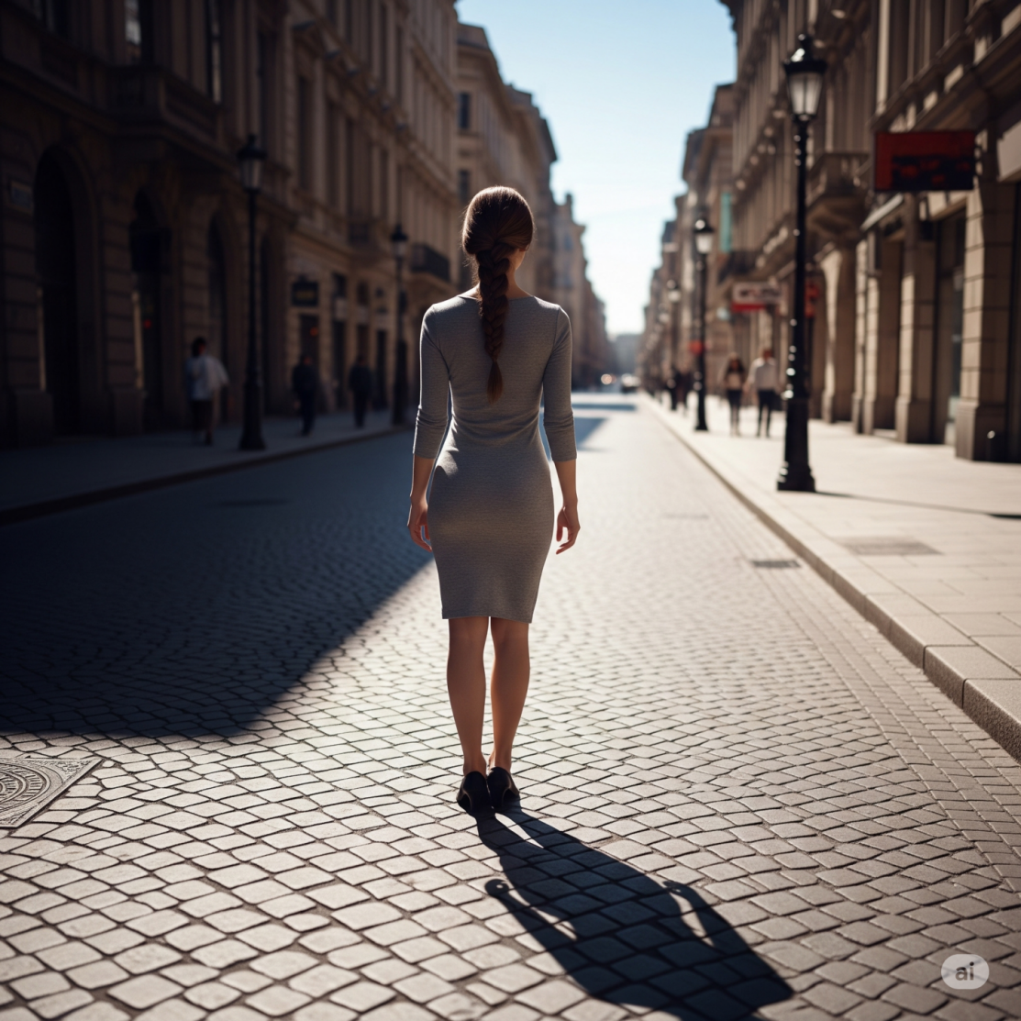

# Step 1: Person and Shadow Extraction

The initial and most critical phase is to isolate the person from their original background while carefully preserving their corresponding shadow. Traditional background removal often discards shadows, which are essential for grounding an object in its environment. Our method ensures both are retained.

# Process:

* 1. **AI-Powered Segmentation:** An AI-based tool is used to accurately generate a primary mask of the person.

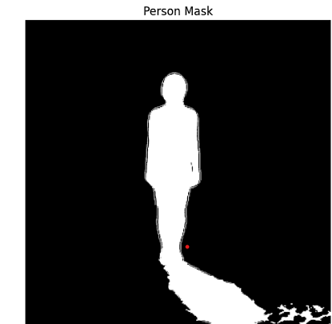

* 1. **Shadow Mask Generation:** A separate shadow mask is created by applying adaptive thresholding and morphological operations to the original image, isolating dark regions connected to the person's silhouefle.

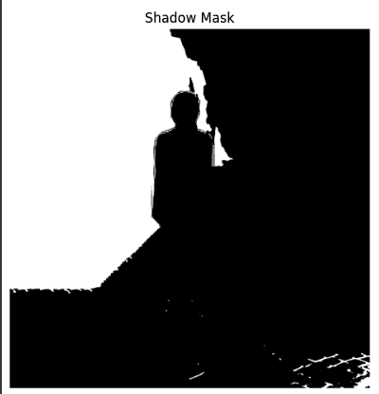

* 1. **Combined Output:** The person mask and the shadow mask are combined to create a single foreground element that includes both the subject and their natural, cast shadow.

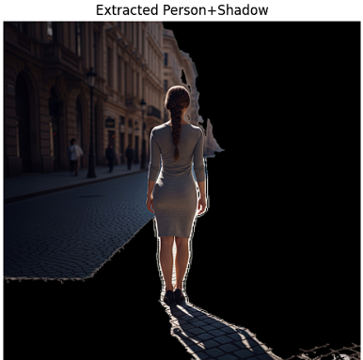

**Result:** An extracted foreground layer containing the person and their intact shadow, ready for integration.

# Step 2: Background Scene Analysis

Before integration, a thorough analysis of the target background scene's lighting and shadow properties is required. This ensures that the inserted person and their shadow will conform to the existing environment.

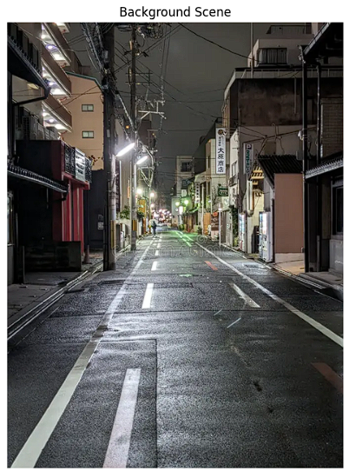

# Process:

1. **Shadow Detection:** The background scene is analyzed to detect all existing shadows. The image is converted to the LAB color space to improve the accuracy of shadow detection.
2. **Shadow Classification:** Detected shadows are classified based on their edge characteristics. Sharp edges indicate **hard shadows** (from a direct, focused light source), while gradual, blurred edges indicate **soft shadows** (from a diffused or ambient light source).

**Result:** A comprehensive understanding of the target scene's lighting environment, which will dictate how the new shadow is rendered.

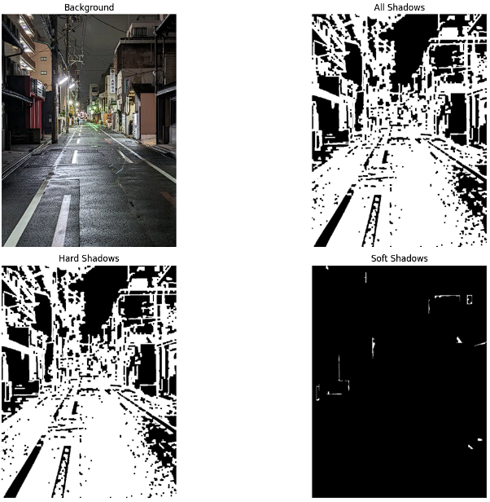

# Step 3: Light Source Triangulation

To realistically cast a shadow, the direction and intensity of the primary light source(s) must be determined for both the original person's environment and the new background scene.

# Process:

1. **Vector Analysis:** For images with clear shadows, the direction of the light source is estimated by analyzing the vector from the base of the object to the tip of its shadow.
2. **Brightness Analysis:** In the absence of clear shadows, a quadrant-based brightness analysis is used to approximate the general direction of the dominant light source.
3. **Intensity Estimation:** The intensity of the light is inferred by comparing the brightness of lit surfaces to shadowed areas.

**Result:** A defined light direction angle and intensity value for both images, allowing for an accurate transformation of the person's shadow.

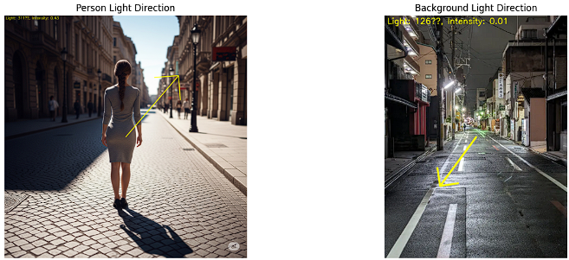

# Step 4: Color Harmonization and Blending

A direct composite would result in a noticeable and unnatural mismatch in color and tone. This step harmonizes the foreground element with the background scene to create a seamless blend.

# Process:

1. **Statistical Color Transfer:** The color profile of the extracted person is adjusted to match the statistical color properties (mean and standard deviation) of the background scene using the Reinhard color transfer algorithm in the LAB color space.
2. **Histogram Matching:** The histogram of the foreground element is matched to the background's histogram to ensure a similar tonal distribution.
3. **Luminance Adjustment:** The overall brightness of the person is scaled to match the lighting intensity of the new scene.

**Result:** The person's color and lighting are re-balanced to appear as though they were naturally part of the background scene.

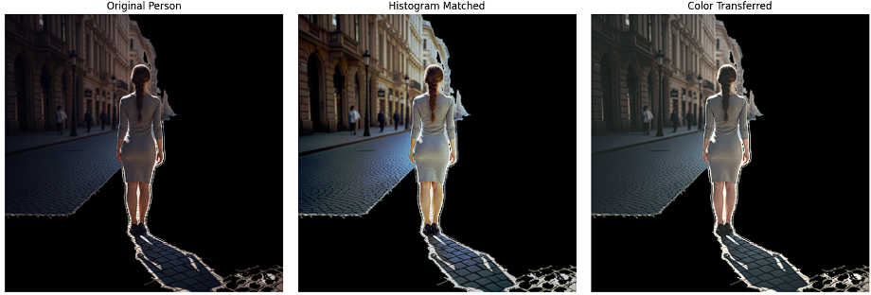

# Step 5: Final Compositing and Refinement

The final step involves placing the harmonized person and their transformed shadow into the scene, followed by fine-tuning to perfect the integration.

# Process:

1. **Shadow Transformation & Placement:** The original shadow is transformed (rotated, scaled, and skewed) to match the light direction determined in Step 3. Its opacity and blur are adjusted based on the background's shadow properties (hard vs. soft).

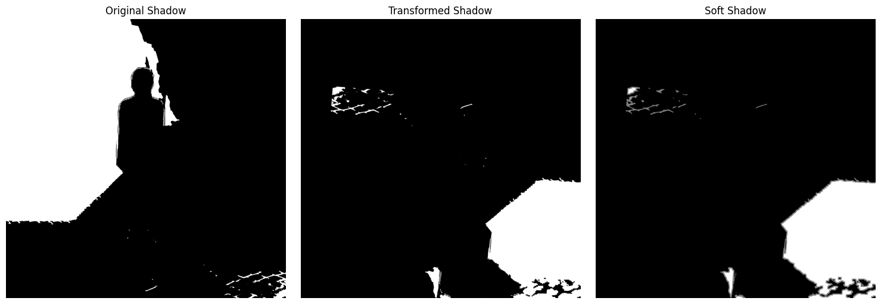

1. **Optimal Placement:** Parameters for scale and position are adjusted to find the most natural placement for the person within the scene.
2. **Edge Blending:** A feathered mask (using Gaussian blur on the mask edges) is applied to the person and shadow layers to soften the transition to the background, eliminating hard, artificial-looking edges.
3. **Final Output Generation:** The layers are composited to produce the final, photorealistic image.

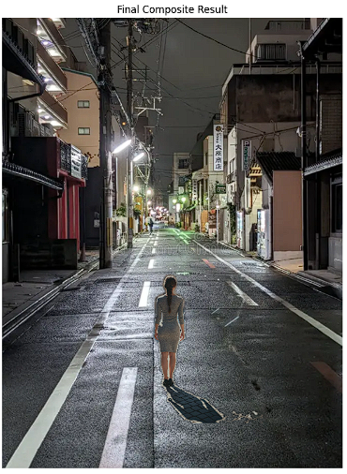

**Result:** A final, high-quality composite image where the person and their shadow are believably integrated into the new environment.