



DEV-1 PYTHON PROJECT

NAME: SHOBHIT GUPTA

BATCH: PGDM-BDA04 (H)

ROLL NO.: 045041

TOPIC: US STOCK MARKET(NASDAQ)

GITHUB LINK: <https://github.com/ShobhitGupta045041/Python_Project_045041.git>

OBJECTIVE:

The primary objective of analyzing stock market data using Python is to extract meaningful insights and patterns from historical and real-time market data, with the aim of informing investment decisions and optimizing portfolio performance. This involves tasks such as data preprocessing, statistical analysis, technical and fundamental analysis, risk assessment, and the development of predictive models. By leveraging Python's data analysis libraries and tools, analysts can identify trends, correlations, and anomalies in stock prices, trading volumes, and other relevant indicators, ultimately aiding investors in making informed choices and managing their portfolios effectively.

GENERAL DESCRIPTION OF DATA:

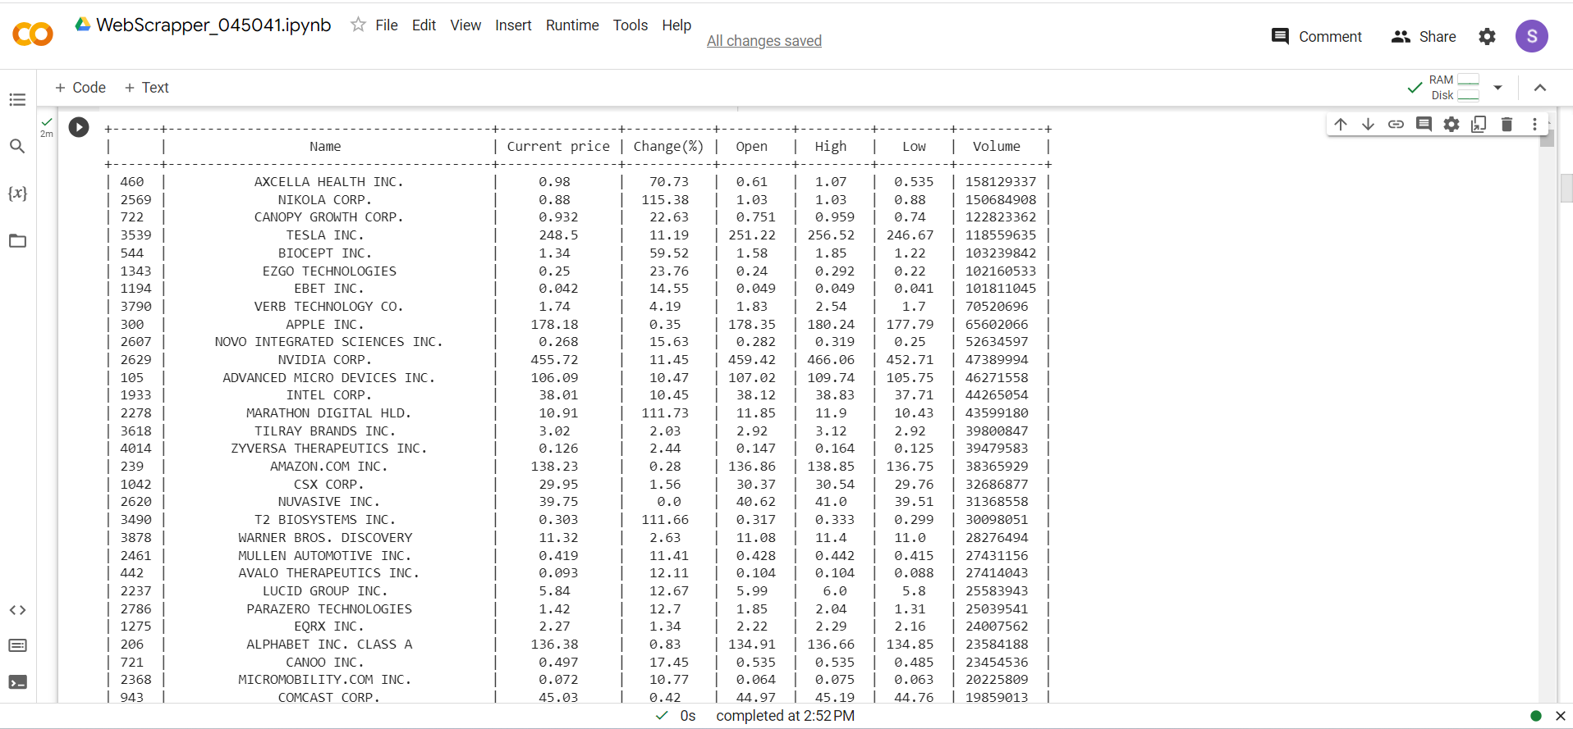

The scraped data from the US stock market NASDAQ provides a comprehensive snapshot of various stocks' performance. It includes essential information such as the names of the stocks, their current prices, percentage changes, opening prices, daily highs and lows, as well as trading volumes. This dataset enables investors and analysts to track and assess the dynamic movements of individual stocks within the NASDAQ exchange, facilitating the identification of trends, price volatility, and liquidity levels. By analyzing this data, one can gain valuable insights into market sentiment, price fluctuations, and potential investment opportunities within this prominent stock exchange.

The table extracted contains following columns:

1. Serial no.
2. Name of the stock
3. Current price
4. Change(%)
5. Open
6. High
7. Low
8. Volume

ANALYSIS OF THE DATA

**DESCRIPTIVE ANALYSIS:**

Descriptive analysis, often referred to as exploratory data analysis (EDA), involves the examination of key statistical characteristics and visualizations to gain a better understanding of your data. In the context of US stock market data containing stock names, prices, change percentages, opening prices, highs, lows, and trading volumes, here's a brief overview of the descriptive analysis you can perform:

1. **Summary Statistics**: Computed basic statistics for each numerical variable(i.e. current price, open, high, low and volume), including mean, median, standard deviation, minimum, maximum, and quartiles. This provides a snapshot of the central tendencies and spread of the data for variables like stock prices and trading volumes.

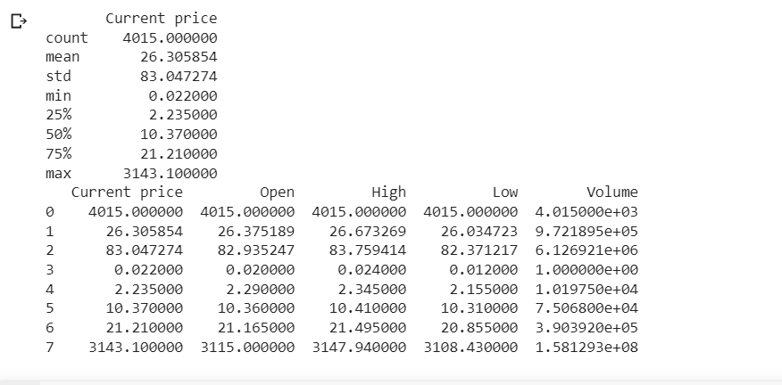

2. **Central tendencies Analysis**: calculating average or mean, median, mode, standard deviation, variance, coefficient, maximum and minimum of the given data, separately for price, open price, high price, low price and volume. 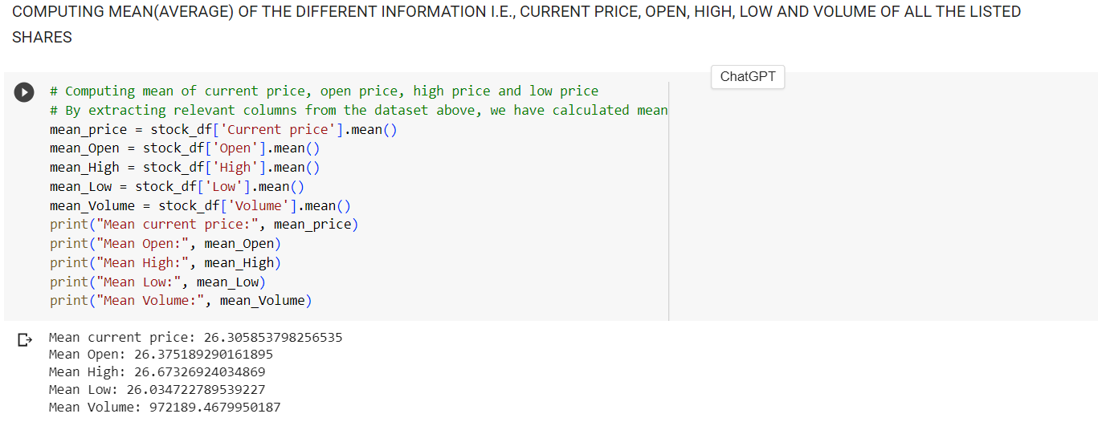

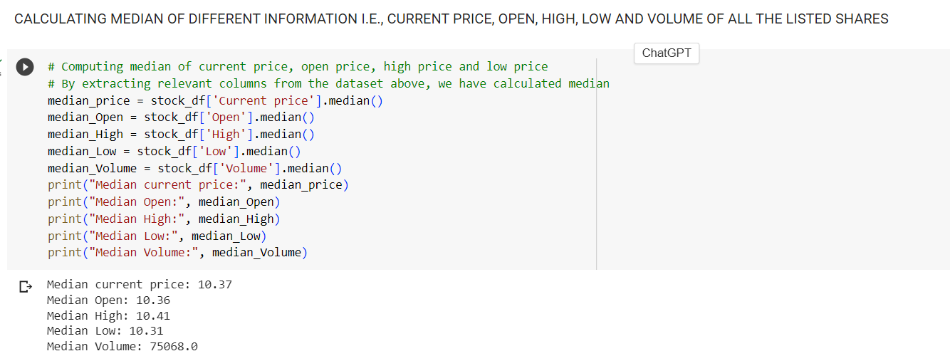

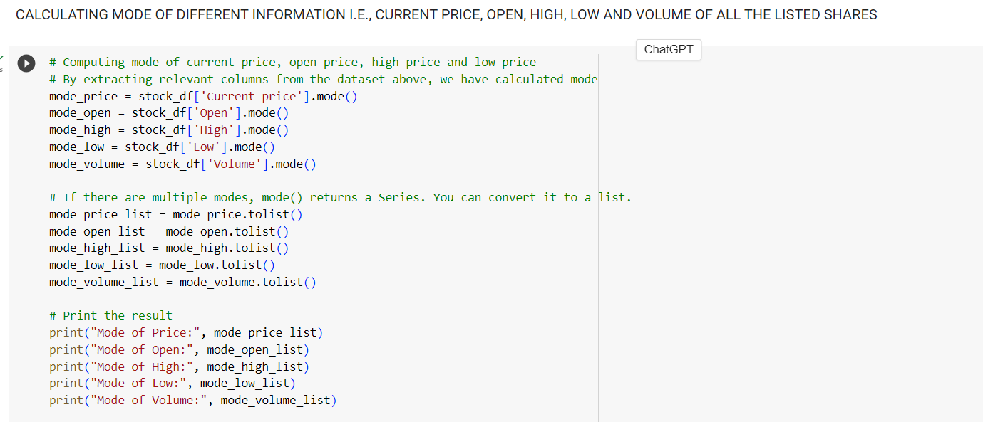

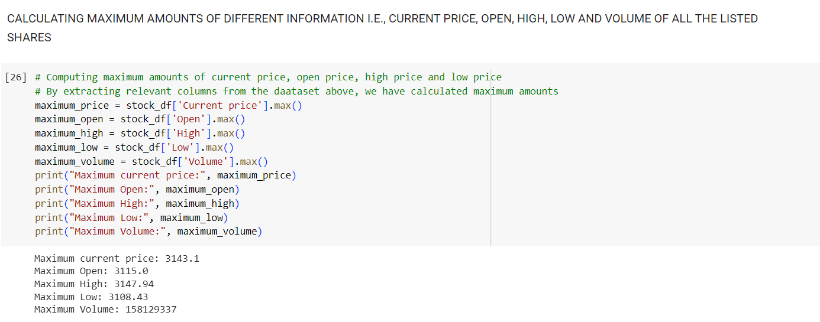

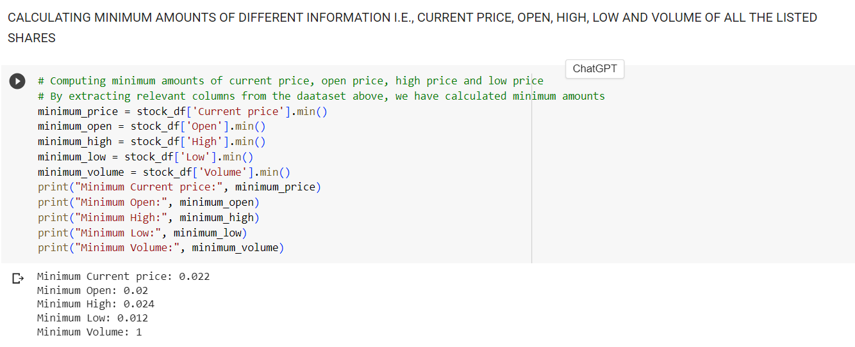

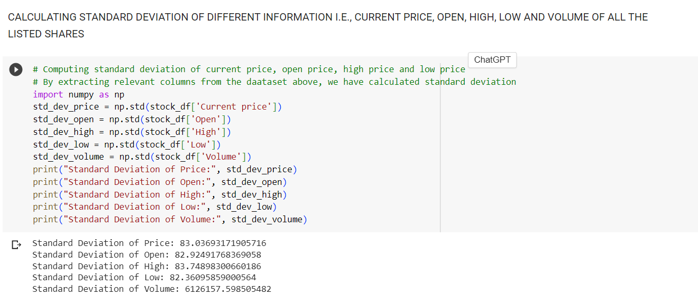

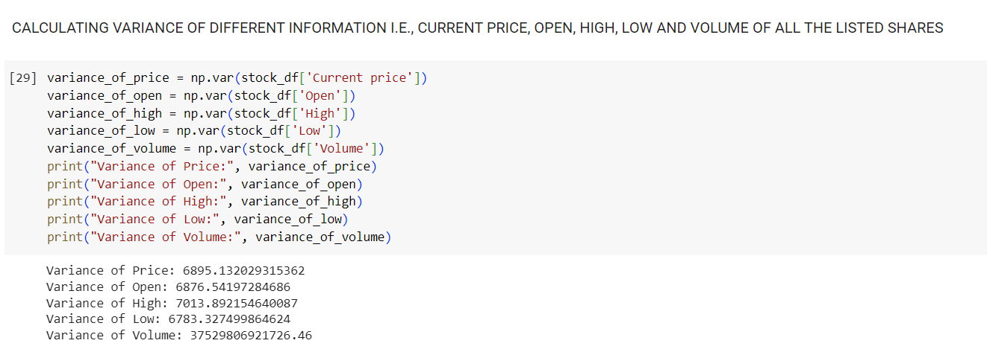

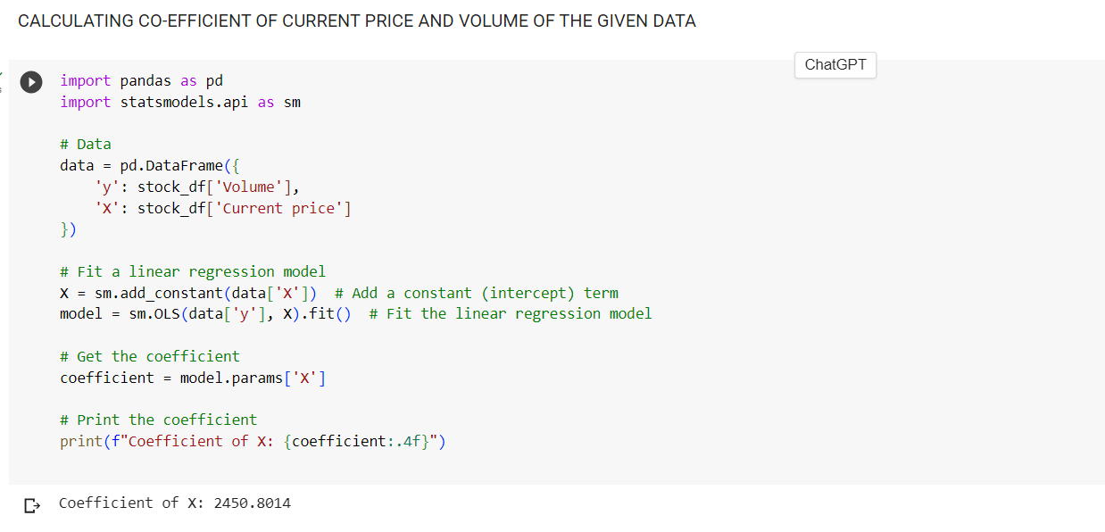

3. **Data Distribution**: Created histograms and box plots to visualize the distribution of stock prices, change percentages, and trading volumes. This helps in identifying whether these variables follow a normal distribution or exhibit skewness or outliers.

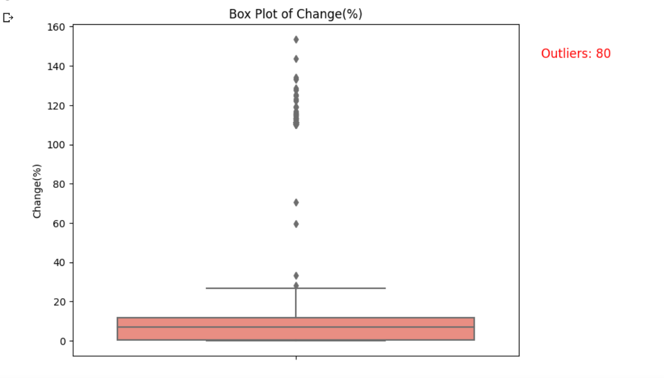

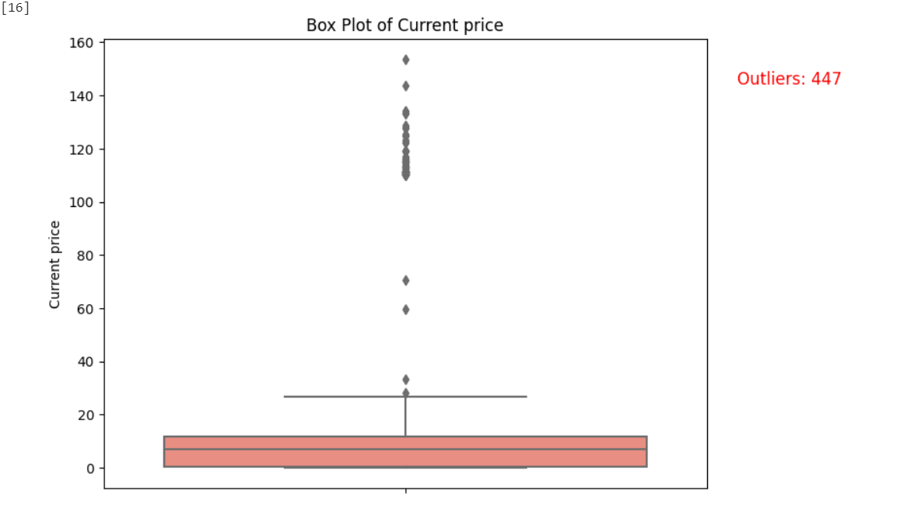

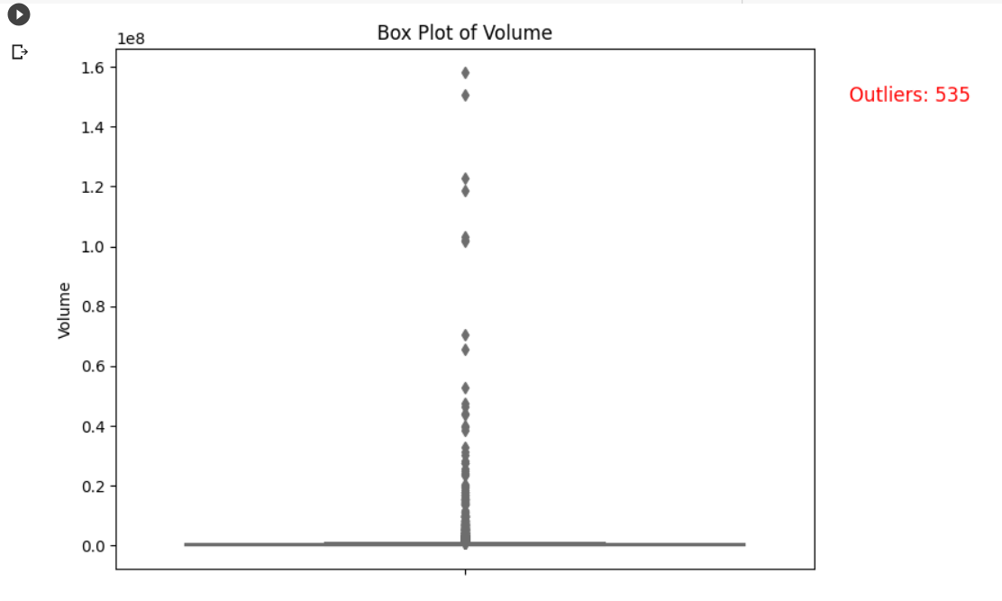

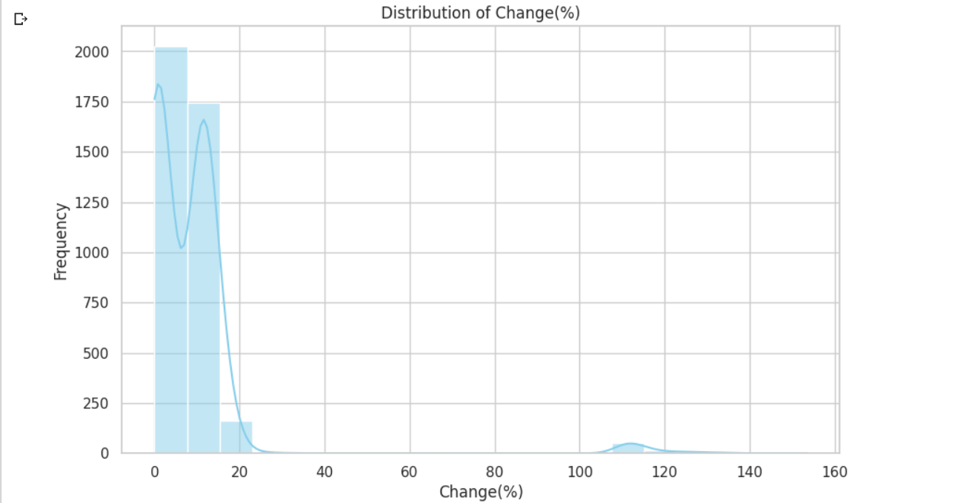

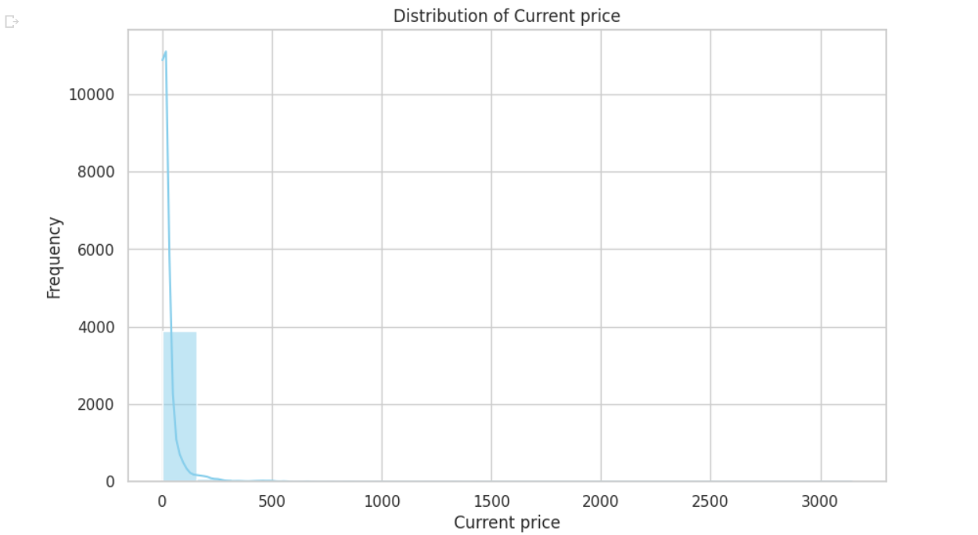

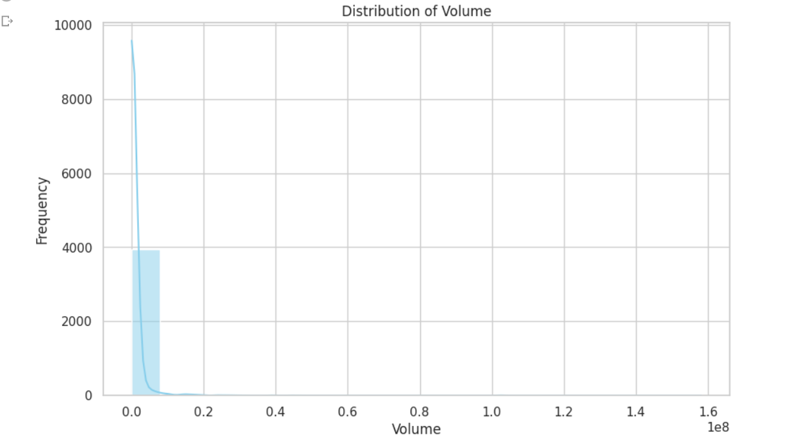

4. **Correlation Matrix**: Calculate the correlation coefficients between numerical variables (e.g., stock prices, change percentages) to understand how they relate to each other. A correlation matrix can reveal potential relationships and dependencies within the data.

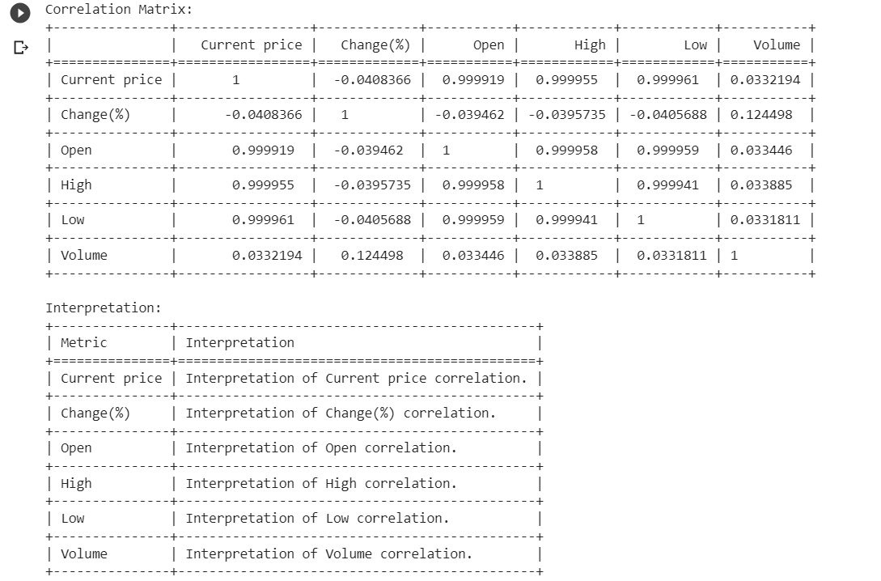

5. **Outlier Detection**: Use statistical methods or visualizations like box plots to identify potential outliers in stock prices or trading volumes, which may warrant further investigation.

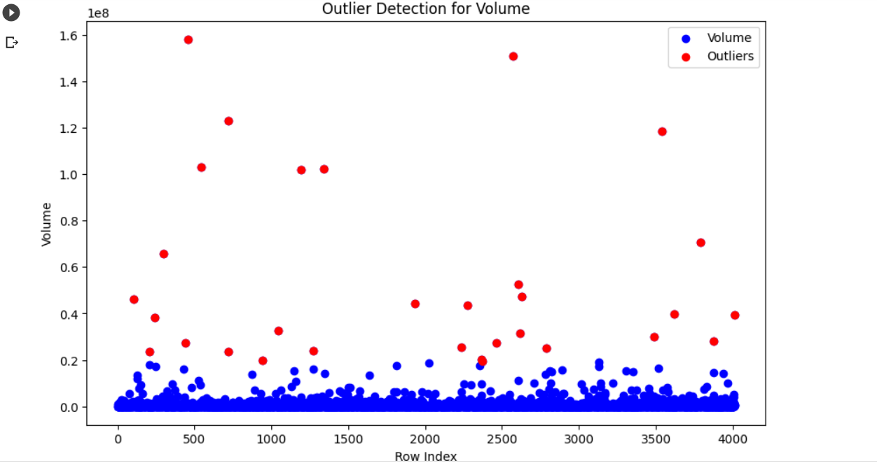

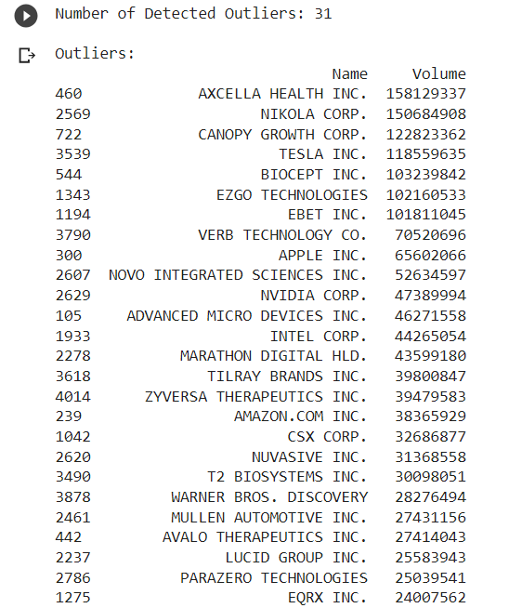

6. **Heatmaps**: Create heatmaps to visualize relationships between variables, such as correlation heatmaps to identify strong positive or negative correlations.

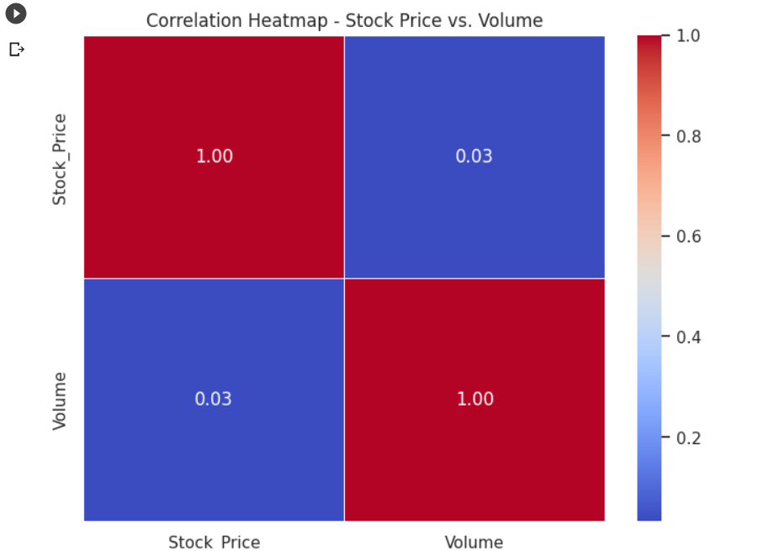

7. **Stock Analysis**: Analyzing top and bottom 5 companies on basis of current price and change(%).

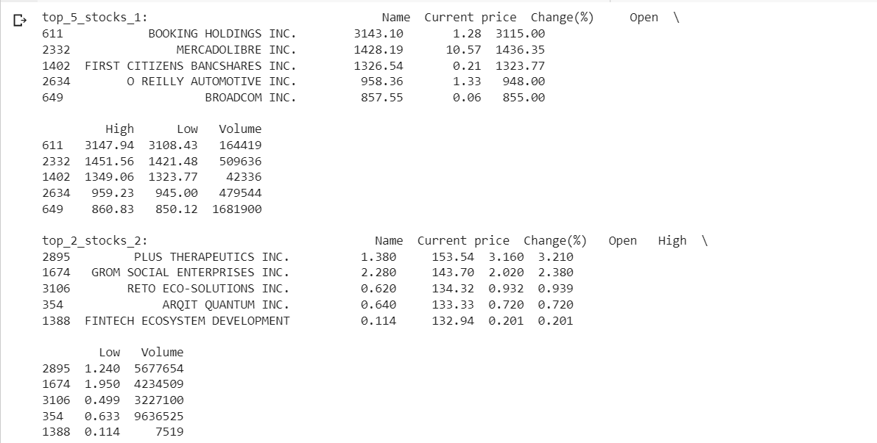

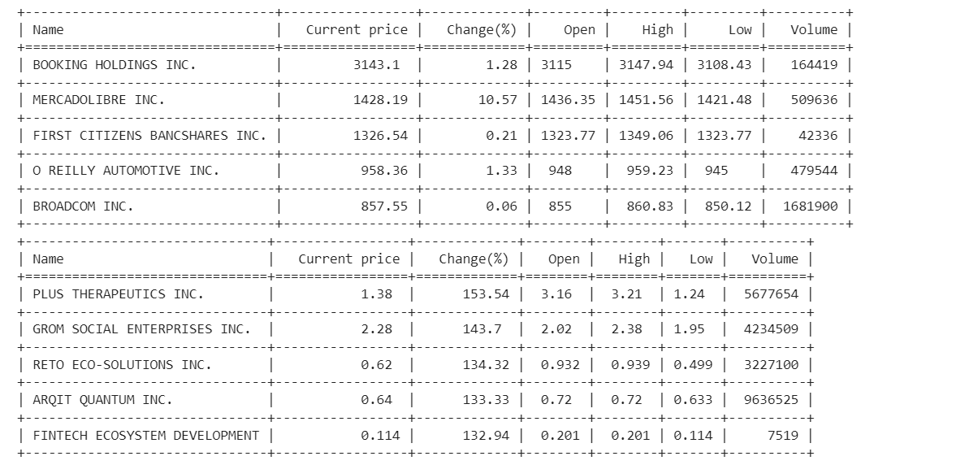

8. **Selecting the top 100 stock on basis of volume and price from all stock available**:

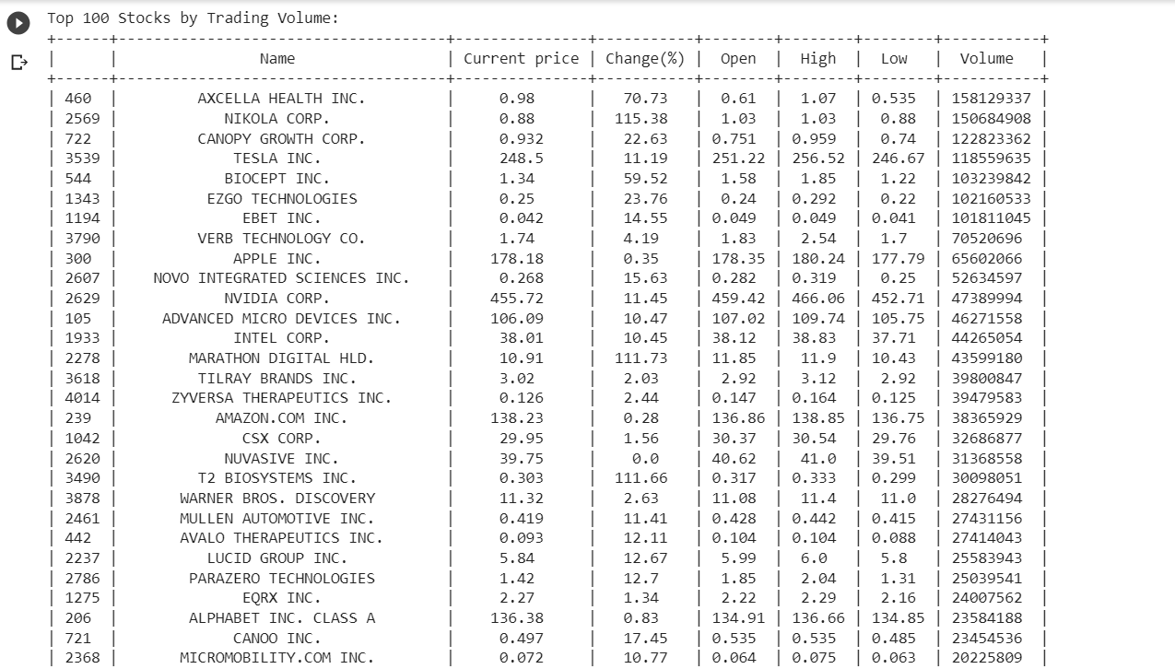

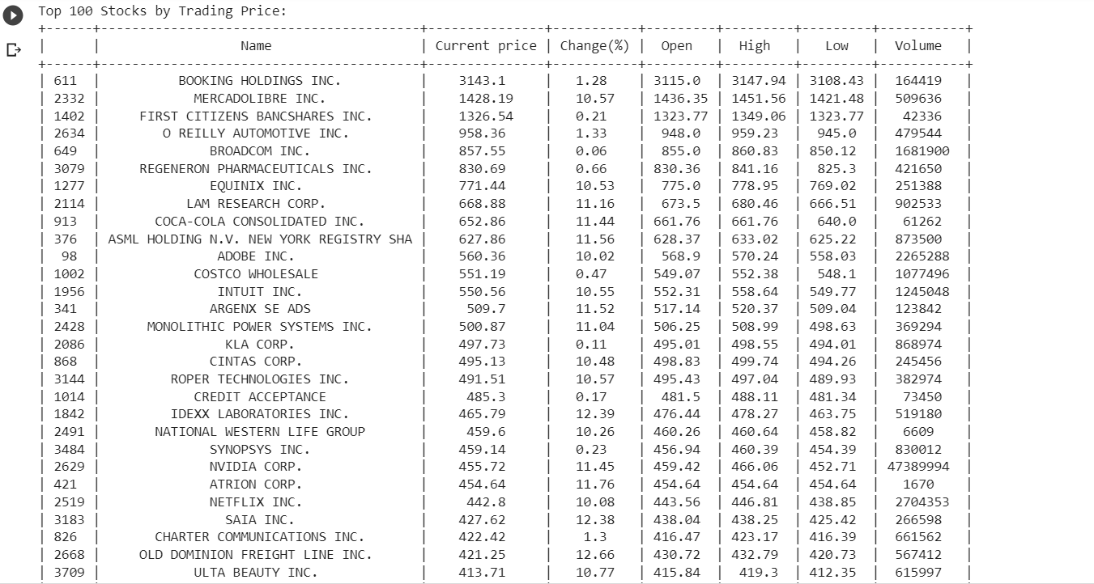

9. **Selecting the bottom 100 stocks on basis of volume and price from all stock available**:

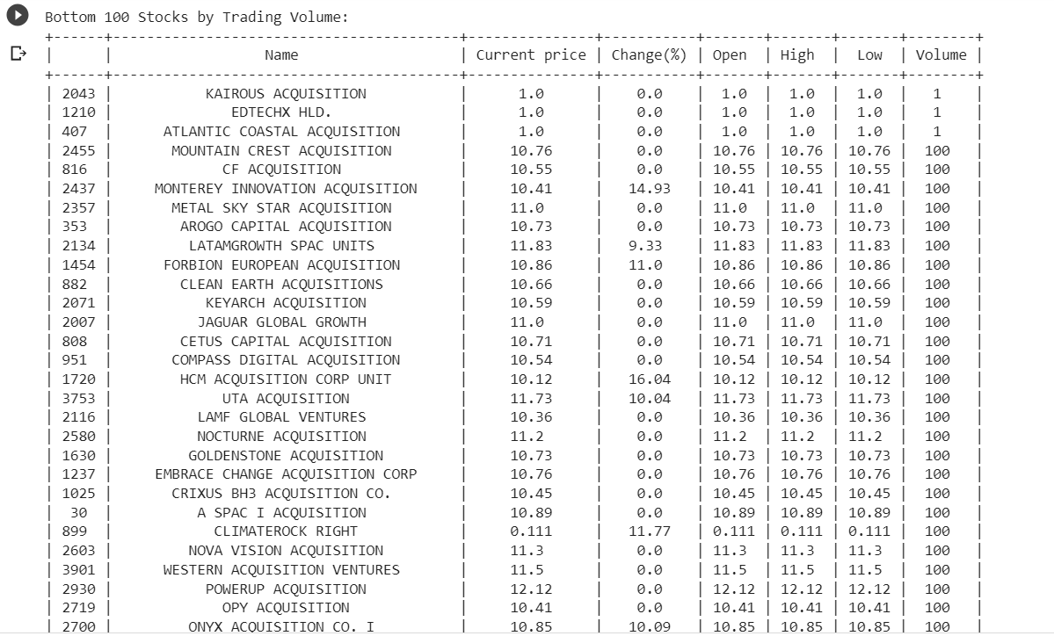

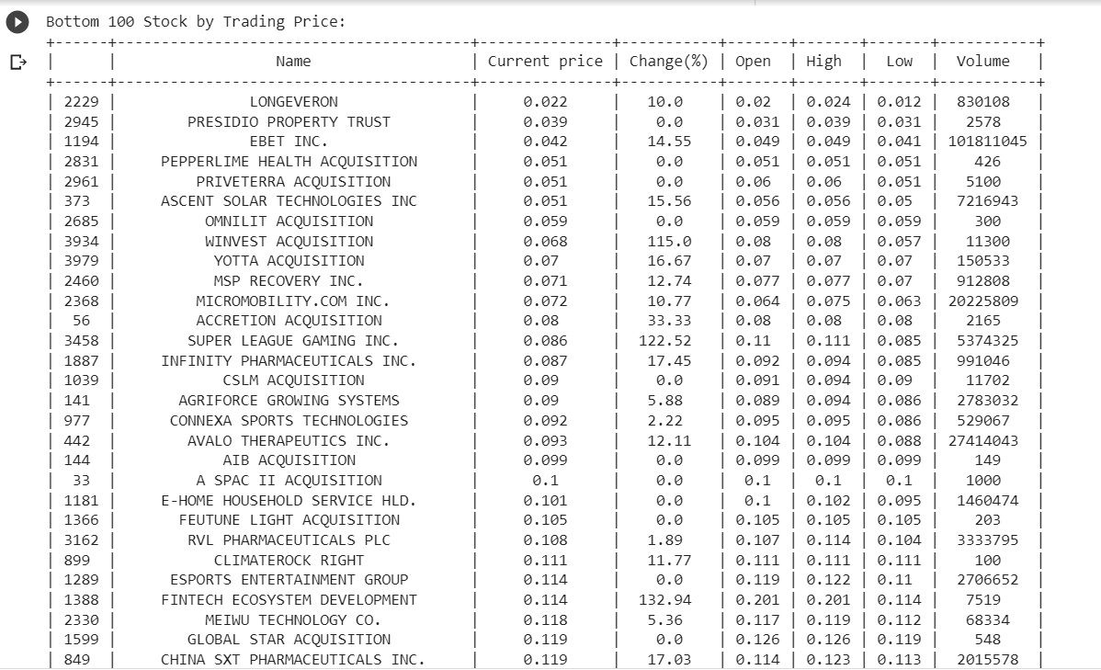

10. **Making the scatter diagram of volume vs. Price with trend line and calculating number of outliers**:

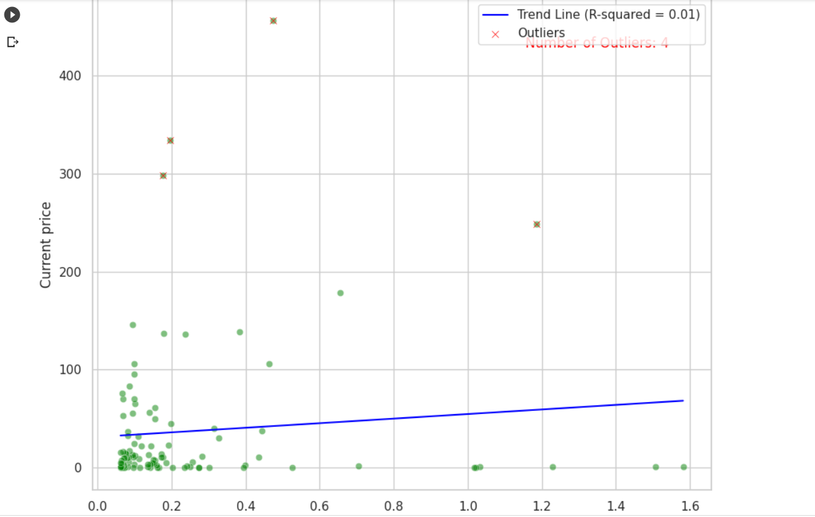

11. **Regression analysis of volume and current price**:

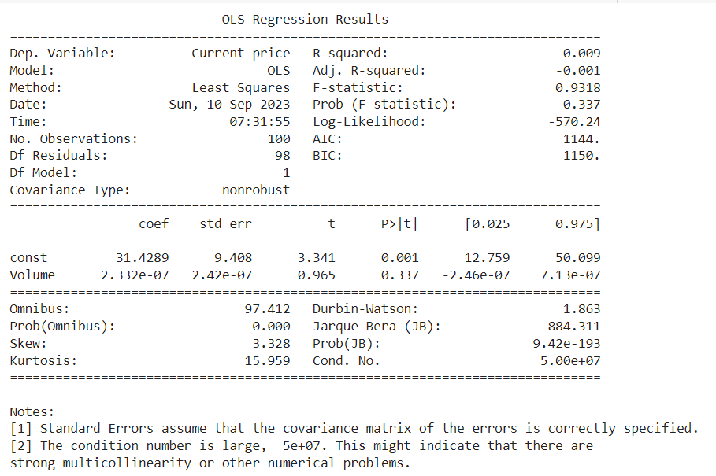

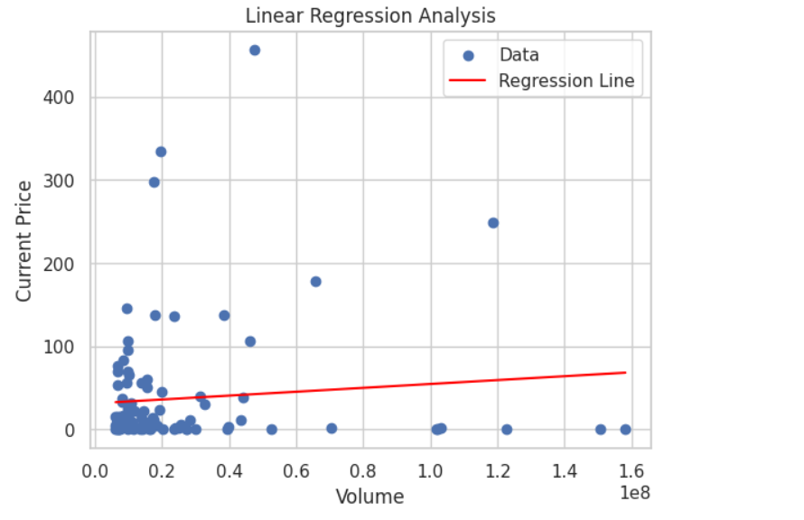

Descriptive analysis helps you gain insights into the distribution, trends, and relationships within your stock market data. It serves as an important first step before diving into more advanced analyses, such as predictive modeling or portfolio optimization, as it provides a solid foundation for understanding the characteristics of the dataset.

FINDINGS AND INFERENCES

Certainly, here are some potential findings and inferences that you can include in your report based on the various analyses you've mentioned for NASDAQ stock data:

1. **Summary Statistics**:

* Gain an overview of the data's central tendencies and variability, allowing you to understand the average stock price, typical change percentages, and trading volume levels.
* Identify whether the data is approximately normally distributed or exhibits significant skewness and kurtosis, which can impact modeling assumptions.

2. **Central Tendencies Analysis**:

* Mean prices and change percentages can provide insights into the average performance of stocks in the NASDAQ market.
* Median values can help gauge the typical stock price and change percentage, which can be especially useful when the data is skewed.
* Standard deviation and variance quantify the dispersion or volatility of stock prices and change percentages.
* Coefficient of variation (CV) can help assess the relative risk and return characteristics of stocks.
* Maximum and minimum values offer insights into the highest and lowest performing stocks within the dataset.

3. **Box Plot**:

* Visualize the distribution and spread of stock prices, change percentages, and trading volumes.
* Identify potential outliers or extreme values within the dataset.

4. **Histograms**:

* Observe the frequency distribution of stock prices, change percentages, and trading volumes, which can help in understanding their underlying patterns and deviations from normality.

5. **Correlation Matrix**:

* Determine the degree and direction of relationships between different stocks.
* Identify pairs of stocks that may move together (positively correlated) or inversely (negatively correlated).
* Use this information for diversification and risk management in portfolio construction.

6. **Outlier Detection**:

* Locate and investigate outliers in stock prices, change percentages, or trading volumes that may require further scrutiny.
* Understand if these outliers are due to data errors or genuine market events.

7. **Heat Maps**:

* Visualize the correlation matrix to quickly identify strong and weak correlations between different stocks.
* Highlight potential clusters or groups of stocks that exhibit similar price movements.

8. **Top and Bottom 5 Stock Analysis**:

* Identify the top 5 performing stocks based on metrics like price appreciation, change percentages, or trading volume.
* Understand what factors may have contributed to their strong performance.
* Analyze the bottom 5 performing stocks to identify any significant underperformers.

9. **Top 100 and Bottom 100 Stocks Analysis**:

* Investigate the top 100 stocks based on volume and price to understand which stocks are most actively traded and have the highest prices.
* Analyze the bottom 100 stocks to identify less liquid or lower-priced stocks.

10. **Scatter Diagram**:

* Use scatter plots to visually explore relationships between two variables, such as price and volume.
* Determine if there is any discernible pattern or trend.

11. **Regression Analysis**:

* Conduct regression analysis to model the relationship between stock prices and potential predictor variables (e.g., trading volume).
* Quantify the strength and significance of these relationships.
* Use regression models for forecasting stock prices or as part of a trading strategy.

These findings and inferences can provide a comprehensive understanding of the NASDAQ stock data, aiding in investment decisions, risk assessment, and portfolio management. Be sure to include appropriate visualizations and statistical tests to support your conclusions in your report.

MANAGERIAL INSIGHTS

Managerial insights derived from your analysis of NASDAQ stock data can provide valuable information for decision-making within an organization or investment firm. Here are some potential managerial insights based on the specific analyses you've mentioned:

**Summary Statistics:**

Here are some managerial insights based on the summary statistics provided for the NASDAQ stock data:

1. Count and Missing Data:

* The count of 4015 indicates that you have data for 4015 observations, which is a substantial dataset.
* There appear to be no missing values for the "Current Price," "Open," "High," "Low," or "Volume" variables, which is crucial for reliable analysis.

2. Mean and Standard Deviation:

* The mean (average) current price of 26.31 suggests that, on average, the stocks in your dataset have a price around this value.
* The relatively high standard deviation of 83.05 indicates substantial variability in stock prices, which could be due to differences in the types of stocks included in your dataset.

3. Min and Max Values:

* The minimum current price of 0.022 suggests the presence of low-priced stocks in your dataset.
* The maximum current price of 3143.10 indicates the existence of high-priced stocks as well.
* This range of prices may offer diversification opportunities for portfolio managers.

4. Quartiles (25th, 50th, 75th Percentiles):

* The 25th percentile (Q1) at 2.235 indicates that 25% of the stocks have a current price below this value, suggesting a range of lower-priced stocks.
* The median (50th percentile) at 10.37 represents the middle value in the dataset, indicating that 50% of stocks have a price below this level.
* The 75th percentile (Q3) at 21.21 suggests that 25% of the stocks have a current price above this value, indicating a range of higher-priced stocks.

5. Volume Analysis:

* The summary statistics for volume are also important. The mean volume of 972,189.5 suggests the average trading activity for the stocks in your dataset.
* The large standard deviation in volume indicates variability in trading activity among stocks.
* High maximum volume (1.58e+08) suggests at least one stock with significant trading volume, possibly a heavily traded stock.

6. Price Variability:

* The high standard deviation in prices and the wide range from the minimum to maximum values suggest that the dataset contains stocks with diverse price movements.
* Portfolio managers may need to assess risk tolerance and diversify investments across different price ranges.

7. Outliers:

* Consider investigating potential outliers in both price and volume. Extreme values can significantly impact portfolio performance and may warrant further analysis.

8. Diversification Opportunities:

* The range of stock prices and volumes in the dataset provides opportunities for diversifying a portfolio across a variety of stocks.
* Managers can consider diversification strategies to manage risk.

9. Investment Strategy:

* Managers should align their investment strategies with their risk tolerance and return objectives, considering the variability in stock prices and trading volumes.
* Stocks with different price ranges may fit different investment strategies, such as growth or value investing.

These insights can guide portfolio managers and investors in making informed decisions about portfolio composition, risk management, and investment strategies based on the summary statistics of the NASDAQ stock data.

**Central Tendencies Analysis:**

Here are some managerial insights based on the descriptive analysis data of the US stock market:

1. Mean Values:

* The mean values provide a sense of the typical levels for current price, open, high, low, and volume. Managers can use these means as reference points when evaluating individual stock performance.
* For example, the mean current price of approximately $26 suggests an average price level for the stocks in your dataset.

2. Median Values:

* The median values offer an alternative measure of central tendency and are less affected by extreme values (outliers).
* For instance, the median current price of $10.37 suggests that half of the stocks have a price below this value.

3. Mode Values:

* The mode represents the most frequently occurring values in each variable. In this case, the modes indicate common price and volume levels.
* Managers may want to pay attention to stocks with modes similar to the provided values, as they might represent stocks with high trading activity or common price points.

4. Maximum and Minimum Values:

* The maximum and minimum values highlight the range of data within the dataset.
* The presence of stocks with a minimum current price of $0.022 and a maximum of $3,143.1 demonstrates the diversity of stock prices in the market.

5. Standard Deviation and Variance:

* The standard deviation quantifies the degree of dispersion or variability around the mean for each variable.
* High standard deviations, such as for price and volume, suggest significant price fluctuations and trading volume variations among stocks.
* Managers should consider these variations when assessing risk and potential returns.

6. Variance of Volume:

* The extremely high variance in volume indicates substantial differences in trading activity among the stocks in the dataset.
* Managers should be aware of stocks with exceptionally high or low trading volumes as these can affect liquidity and execution of trades.

7. Interpretation for Investment:

* The descriptive statistics can guide investment decisions. Stocks with prices close to the mean or median may represent typical investments.
* Stocks with prices significantly above or below these values may require additional scrutiny, as they could indicate outliers or unique investment opportunities.

8. Risk Assessment:

* High standard deviations in price and volume suggest that investors may encounter more significant price swings and liquidity variations.
* Portfolio managers should assess the risk tolerance of their portfolios and adjust strategies accordingly.

9. Diversification Strategies:

* The wide range of stock prices and volumes suggests ample opportunities for portfolio diversification.
* Managers can select stocks across different price levels and trading activity to optimize portfolio risk-return profiles.

10. Outlier Consideration:

* Managers should monitor stocks with extreme values, such as the one with a minimum price of $0.022 or a maximum price of $3,143.1, to understand the reasons behind such outliers.

These insights from the descriptive analysis data provide valuable information for portfolio managers and investors to make informed investment decisions, manage risk, and tailor investment strategies to the characteristics of the US stock market.

**Box Plot and Histograms:**

* Box plots and histograms assist in visualizing the distribution and spread of key variables, helping managers identify potential outliers or unusual patterns.
* Managers can identify and investigate stocks with extreme price movements or trading volumes that may require special attention.

**Correlation Matrix:**

Here are some managerial insights based on the correlation matrix you've provided:

1. High Correlation Among Price Metrics:

* The correlation coefficients between "Current Price," "Open," "High," and "Low" are very close to 1. This indicates an extremely strong positive linear relationship among these variables.
* Managers should be aware that changes in one of these price metrics are highly likely to be mirrored in the others. This can be valuable for risk management and understanding price trends.

2. Low Correlation with Volume:

* The correlation coefficients between price metrics ("Current Price," "Open," "High," "Low") and "Volume" are quite low, approximately 0.03. This suggests a weak linear relationship between these variables.
* Managers should consider that trading volume doesn't have a strong direct impact on price movements in this dataset. Other factors may play a more significant role in influencing stock prices.

3. Change(%) Correlation:

* The "Change(%)" variable shows weak negative correlations (around -0.04) with price metrics and a weak positive correlation (0.12) with "Volume."
* The weak negative correlation with price metrics suggests that changes in percentage do not move in lockstep with the actual price levels.
* The weak positive correlation with "Volume" suggests that changes in percentage may be associated with higher trading activity, potentially indicating increased volatility.

4. Risk and Portfolio Diversification:

* Given the high correlations among price metrics, portfolio managers should be cautious about overconcentration in stocks with similar price movements. Diversification strategies may help manage risk.

5. Trading Volume Considerations:

* While trading volume has a low correlation with price metrics, its correlation with "Change(%)" suggests that it might play a role in explaining price percentage changes.
* Managers may want to explore factors beyond volume that influence stock prices and returns.

6. Market Dynamics:

* The very high correlations among price metrics ("Current Price," "Open," "High," "Low") indicate that these metrics move almost in tandem. This can be indicative of the overall market dynamics where prices tend to move together.

7. Investment Strategies:

* Managers can use this information to refine their investment strategies. For instance, if they are looking for stocks that move independently of one another, they may need to consider factors beyond these basic price metrics.

8. Risk Assessment:

* Understanding the correlation structure can help managers assess the potential risk in their portfolios. Stocks that move closely together in price may contribute to higher portfolio volatility.

In summary, the correlation matrix provides insights into the relationships among key variables in the dataset. Managers should consider these correlations when making investment decisions, constructing portfolios, and managing risk. Additionally, they should be aware that trading volume appears to have a limited direct impact on price movements in this dataset.

**Outlier Detection:**

Here are some managerial insights based on the outlier detection results:

1. Number of Detected Outliers:

* The analysis has detected 31 outliers in the dataset. Outliers are data points that significantly deviate from the typical values in the dataset.

2. Identification of Outliers:

* The table provides a list of stocks with their names and corresponding trading volumes that are considered outliers.
* These outliers may represent stocks with unusually high trading volumes compared to the majority of stocks in the dataset.

3. Outlier Impact on Portfolio:

* Managers should be aware of the potential impact of outliers on their investment portfolio.
* Stocks with extremely high trading volumes can influence portfolio returns and may require specific risk management strategies.

4. Unique Investment Opportunities:

* Some outliers might represent unique investment opportunities or stocks with exceptional market events, news, or developments.
* Managers may consider investigating these outliers further to assess whether they present potential investment value.

5. Risk Management:

* Outliers can introduce additional risk to a portfolio due to their extreme characteristics.
* Managers should evaluate the risk-return trade-off of including or excluding these outliers from their portfolios.

6. Market Dynamics:

* The presence of outliers underscores the diverse nature of the stock market, where a small number of stocks can have a significant impact on overall trading volume.
* Understanding such dynamics can help managers adapt their strategies to market conditions.

7. Monitoring and Surveillance:

* Continuous monitoring and surveillance of outliers are important to assess whether they remain outliers or if their status changes over time.
* Managers should stay informed about any developments related to these stocks.

8. Portfolio Diversification:

* Outliers may disrupt portfolio diversification efforts. Managers should consider how to manage concentration risk stemming from these stocks.

9. Outlier Reasons:

* Managers should investigate the reasons behind the outliers. For instance, are they a result of company-specific news, market events, or data errors?
* Understanding the underlying causes can guide investment decisions.

10. Tailoring Investment Strategies:

* Depending on the objectives and risk tolerance of the portfolio, managers may choose to incorporate or exclude these outliers.
* Tailoring investment strategies to accommodate or mitigate the influence of outliers is important.

In summary, outlier detection is a critical step in data analysis and portfolio management. These outliers can represent unique opportunities or risks, and managers should carefully assess their impact and make informed decisions regarding their inclusion or exclusion from their investment portfolios.

**Heat Maps:**

* Managers can use heat maps to quickly identify clusters of strongly correlated stocks or sectors that may move together. This information can inform sector-specific investment strategies.

**Top and Bottom 5 Stock Analysis:**

Here are some managerial insights based on the top 5 stocks from your dataset, which have been categorized into two groups based on current price and change percentage:

Top 5 Stocks (top_5_stocks_1 - High Current Price):

1. Booking Holdings Inc. (Current Price: $3143.10):

* Booking Holdings Inc. is the highest-priced stock in this group, making it suitable for investors with a larger capital base.
* Despite its high price, it still experienced a positive change percentage of 1.28%.

2. MercadoLibre Inc. (Current Price: $1428.19):

* MercadoLibre Inc. is another high-priced stock with a current price of $1428.19. It experienced a remarkable change percentage of 10.57%.
* Investors interested in high-growth stocks might find MercadoLibre appealing.

3. First Citizens Bancshares Inc. (Current Price: $1326.54):

* First Citizens Bancshares Inc. is a high-priced stock with a current price of $1326.54. It had a modest change percentage of 0.21%.
* This stock may appeal to investors seeking stability alongside a relatively high price.

4. O'Reilly Automotive Inc. (Current Price: $958.36):

* O'Reilly Automotive Inc. is another stock with a reasonable current price. It had a positive change percentage of 1.33%.
* Investors looking for stability with growth potential might consider this stock.

5. Broadcom Inc. (Current Price: $857.55):

* Broadcom Inc. has a moderate current price of $857.55. It experienced a minimal change percentage of 0.06%.
* Despite the lower change percentage, it has a significantly high trading volume, indicating investor interest.

Top 5 Stocks (top_5_stocks_2 - High Change Percentage):

1. Plus Therapeutics Inc. (Current Price: $1.380):

* Plus Therapeutics Inc. is a lower-priced stock with an exceptionally high change percentage of 153.54%. It experienced a significant price surge.
* Investors seeking high-growth potential might consider this stock, but it comes with higher volatility.

2. Grom Social Enterprises Inc. (Current Price: $2.280):

* Grom Social Enterprises Inc. is another lower-priced stock with an impressive change percentage of 143.70%.
* Similar to Plus Therapeutics, it offers high-growth potential but with increased risk.

3. Reto Eco-Solutions Inc. (Current Price: $0.620):

* Reto Eco-Solutions Inc. is a lower-priced stock with a substantial change percentage of 134.32%. It experienced a significant price increase.
* This stock may attract investors seeking high returns from lower-priced stocks.

4. Arqit Quantum Inc. (Current Price: $0.640):

* Arqit Quantum Inc. is another lower-priced stock with a notable change percentage of 133.33%.
* It may appeal to speculative investors interested in emerging technologies.

5. Fintech Ecosystem Development (Current Price: $0.114):

* Fintech Ecosystem Development is the lowest-priced stock in this group but had a substantial change percentage of 132.94%.
* It carries higher risk due to its low price but offers significant growth potential.

Managerial Considerations:

* Portfolio managers and investors should align their investment strategies with their risk tolerance and investment objectives.
* High-priced stocks may provide stability but require larger capital investments.
* Lower-priced stocks with high change percentages offer growth potential but come with higher volatility and risk.
* Diversification across both high and low-priced stocks can help balance risk and return profiles.
* Thorough analysis of each company's financial health and market prospects is essential before making investment decisions.

These insights can assist investors in making informed decisions when considering stocks based on their current price and change percentages.

**Top 100 and Bottom 100 Stocks Analysis:**

Here are some managerial insights based on the information provided in both tables:

Top 100 Stocks by Trading Volume:

1. High Volume Stocks: Stocks with the highest trading volumes, such as "Axcella Health Inc." and "Nikola Corp.," have attracted significant market attention. This could indicate increased investor interest or trading activity in these companies.

2. Volatility and Gains: Some stocks like "Tesla Inc." have shown significant price changes (11.19% change), which may present trading opportunities for investors looking for volatility.

3. Sector Analysis: It's essential to analyze the sectors of these high-volume stocks. For instance, there are technology companies like "Apple Inc." and "Microsoft Corp." among the top volume stocks, which suggests continued interest in tech stocks.

4. Penny Stocks: Stocks like "Ebet Inc." and "Jetblue Airways" have very low current prices. These are often considered penny stocks and can be more volatile and risky investments.

5. Diversification: A well-diversified portfolio may include stocks from various sectors and price ranges. Managers should assess the overall portfolio's risk and exposure when considering these stocks.

Top 100 Stocks by Trading Price:

1. High-Priced Stocks: Stocks with the highest trading prices, such as "Booking Holdings Inc." and "Mercadolibre Inc.," are in the high-end price range. These stocks may attract long-term investors and institutions due to their high prices.

2. Stability: Many of the high-priced stocks show relatively stable price changes. For example, "Netflix Inc." and "Adobe Inc." have lower price volatility, making them potential choices for conservative investors.

3. Sector Leaders: Companies like "Coca-Cola Consolidated Inc." and "Charter Communications Inc." represent well-established companies in their respective sectors (consumer goods and telecommunications). These stocks might be considered for a stable portfolio.

4. Mid-Range Stocks: Stocks like "Roku Inc." and "IDEXX Laboratories Inc." fall into the mid-price range. They can offer a balance between stability and growth potential for investors.

5. Diversification and Risk Management: Managers should assess their portfolio's risk profile and ensure diversification across different sectors, price ranges, and risk levels. High-priced stocks may require significant capital investment, which could limit diversification for some investors.

6. Growth vs. Value: Consider the investment strategy when choosing stocks from this list. Some may be growth-oriented, like technology companies, while others may be value-oriented, offering stability and dividends.

It's important to note that investment decisions should be based on various factors, including risk tolerance, investment goals, and market conditions. These insights provide an initial understanding of the stocks but should be part of a more comprehensive investment strategy.

**Scatter Diagram:**

* Managers can use scatter diagrams to identify potential trends or relationships between stock prices and trading volumes.
* This insight can be valuable for developing trading strategies or optimizing portfolio allocations.

**Regression Analysis:**

The provided output appears to be the summary of a simple linear regression analysis with the dependent variable "Current price" and the independent variable "Volume" for the US stock market. Let's break down the managerial analysis based on this regression output:

1. R-squared Value: The R-squared value is 0.009, which is very low. It means that only approximately 0.9% of the variation in the current stock prices can be explained by changes in trading volume. This suggests that trading volume alone is not a strong predictor of stock prices.

2. Coefficients:

* The coefficient for the constant (intercept) is 31.4289. This represents the estimated current stock price when the trading volume is zero.
* The coefficient for "Volume" is 2.332e-07. This indicates the estimated change in the current stock price for a one-unit change in trading volume.

3. P-values:

* The p-value for "Volume" is 0.337. This p-value represents the probability that the coefficient for "Volume" is statistically different from zero. A high p-value suggests that trading volume is not a statistically significant predictor of stock prices at the conventional significance level (e.g., 0.05).

4. F-statistic:

* The F-statistic is 0.9318, and its associated probability is 0.337. The F-statistic tests whether the overall regression model (using Volume to predict Current price) is statistically significant. In this case, the high p-value suggests that the model as a whole is not statistically significant.

5. Interpretation:

* The coefficient for "Volume" is very close to zero, and its p-value is high. This indicates that changes in trading volume are not providing meaningful information to predict changes in stock prices in this model.
* The low R-squared value suggests that there are other factors, not included in this model, that influence stock prices to a much greater extent than trading volume.

6. Managerial Implications:

* Based on this analysis, it is not advisable to use trading volume alone as a predictor of stock prices. Other fundamental and market factors should be considered in investment decisions.
* This model may need additional independent variables or more complex modeling techniques to improve its predictive power.
* Investors and portfolio managers should be cautious about making investment decisions solely based on trading volume trends. Diversifying investments and considering a broader range of financial indicators is essential for a well-rounded strategy.

In summary, the regression analysis suggests that trading volume alone is not a strong predictor of stock prices in the US stock market, and other factors should be considered when making investment decisions.

Overall, the managerial insights derived from these analyses can inform investment strategies, risk management practices, and portfolio allocations within an organization or investment firm, ultimately contributing to more informed decision-making and potentially better financial performance.