**OTT Publisher’s API Analyser doc**

1. Run command – “python manage.py runserver <hostip>:<port>”
2. Open browser and open portal by giving hostip & port.
3. Login Page
   * URL: <hostip>:<port>

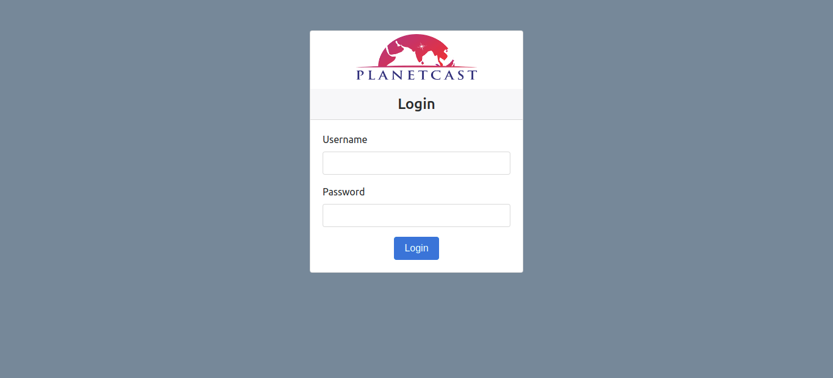

1. Admin Panel

There are two users for our portal.

* + Admin users
  + Normal users

If you log in with admin credentials then you will be redirected to our main admin panel where you can add new users, publishers and their respective apis.

Our admin panel looks like below-

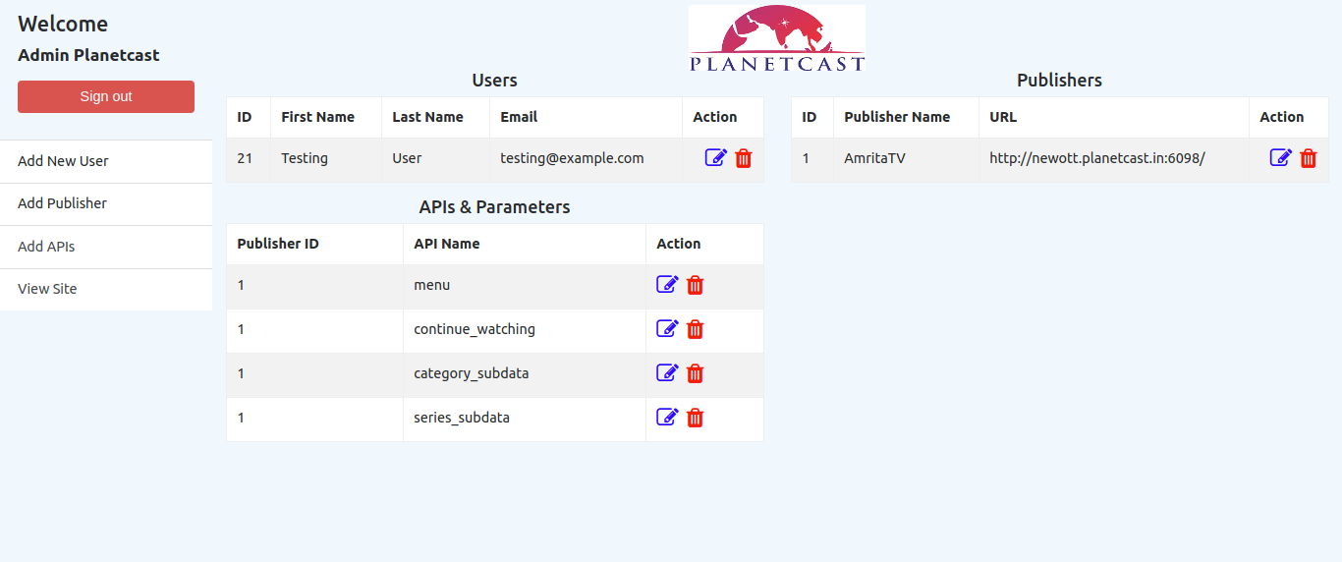

1. Add new user.

Enter required details to create new user for our portal.

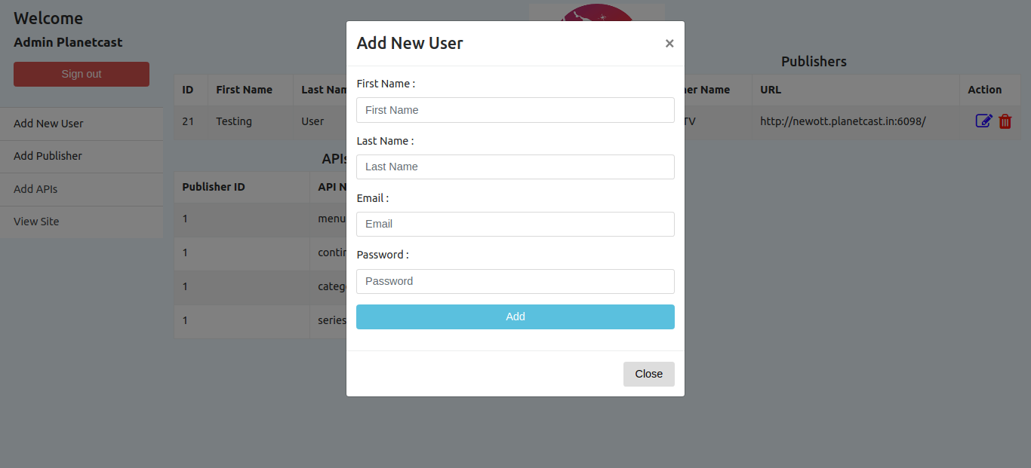

1. Add publisher

Enter publisher details such as publisher name and its url.

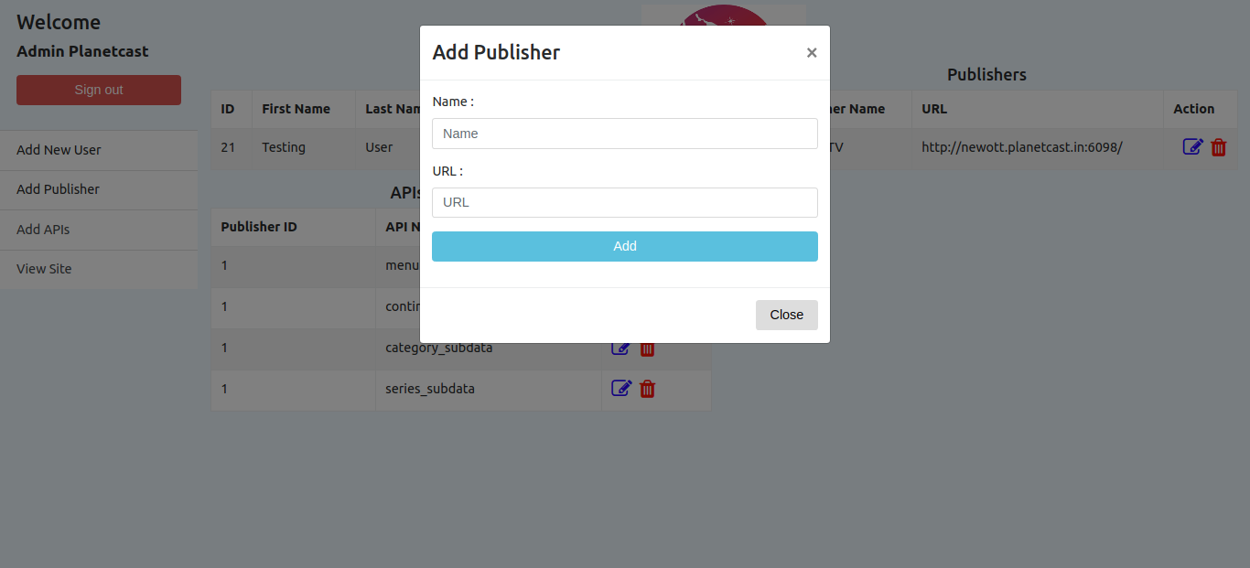

1. Add Publisher APIs

Select publisher name from dropdown menu & enter api name.

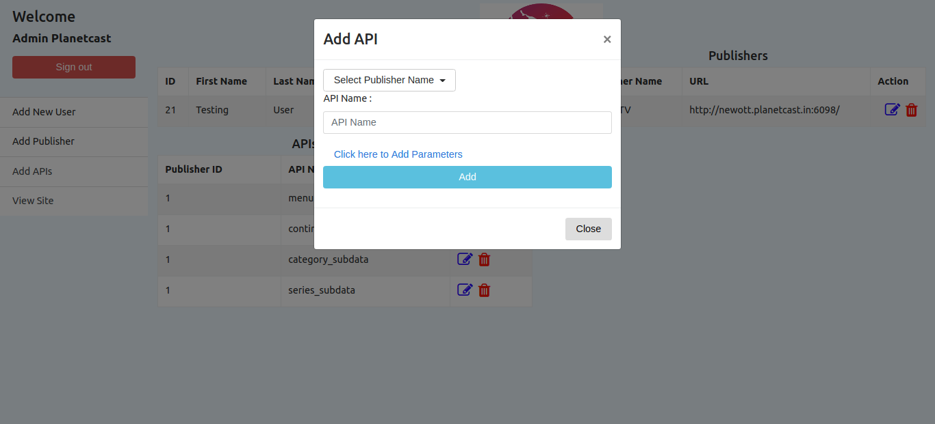

You can add or remove parameters to your api just by clicking on “click here to add parameters” button.

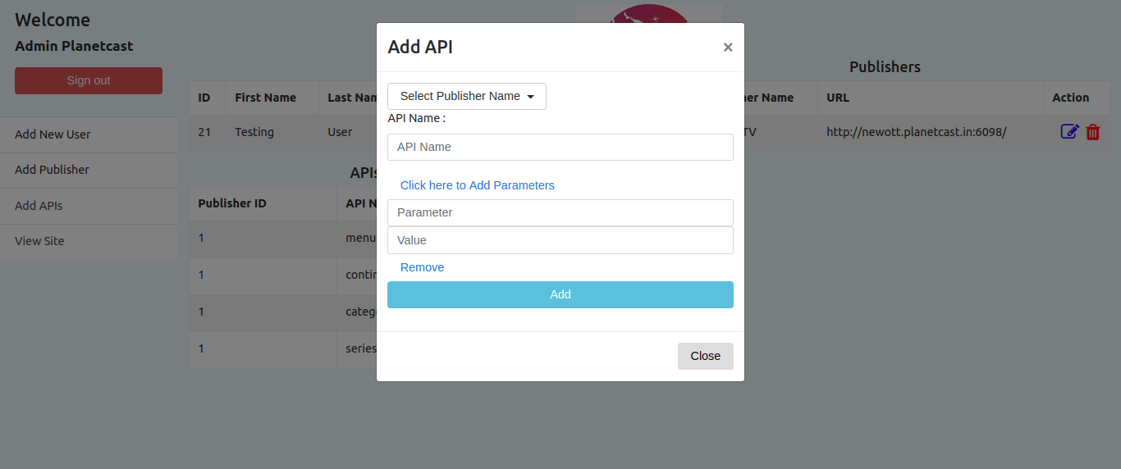

1. View site

Visit home page by clicking view site tab.

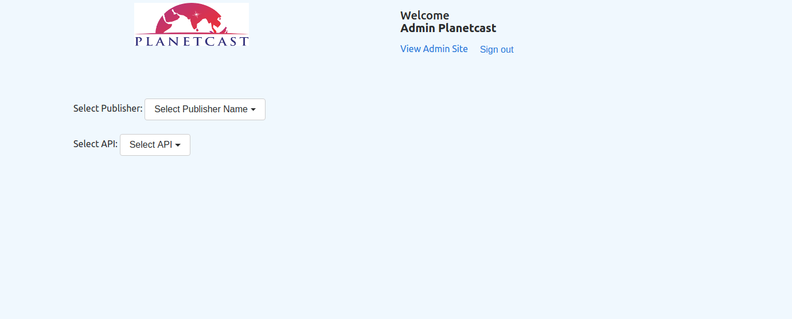

Select values from dropdown to view response. Refer to below image.

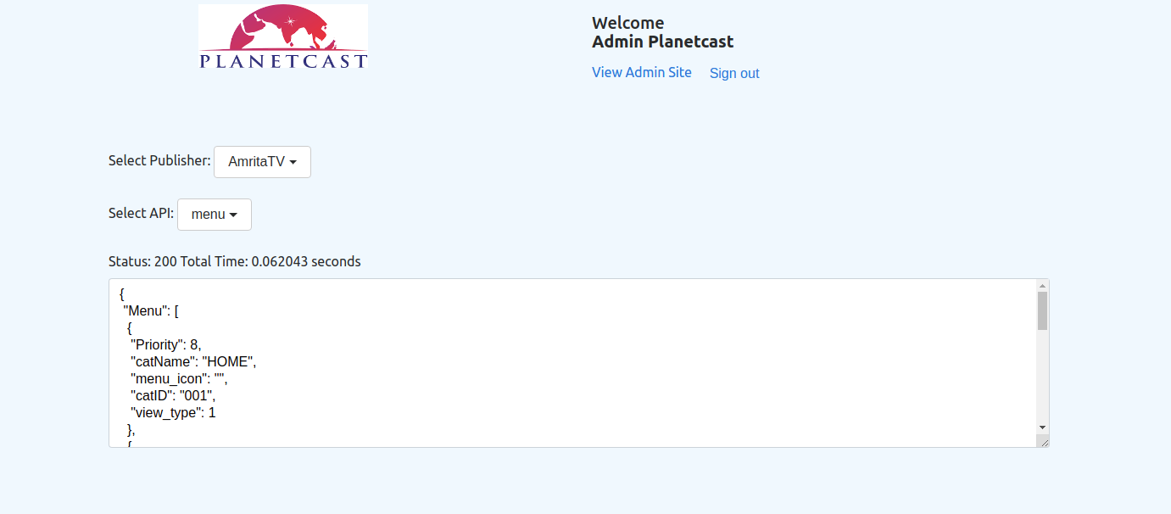

1. If you login with normal user credentials then you’re redirected to home page directly. Where you can only see the publishers, its apis and their api responses added by admin.