WORKFLOW

1. Register a new customer.

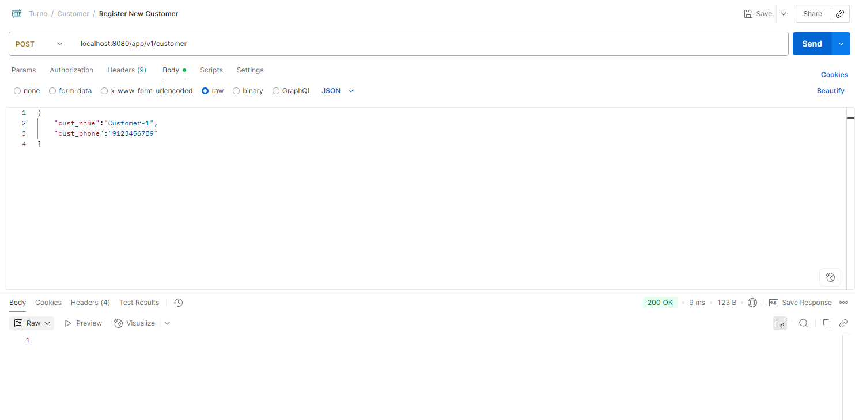

1. Get all the Registered Customers

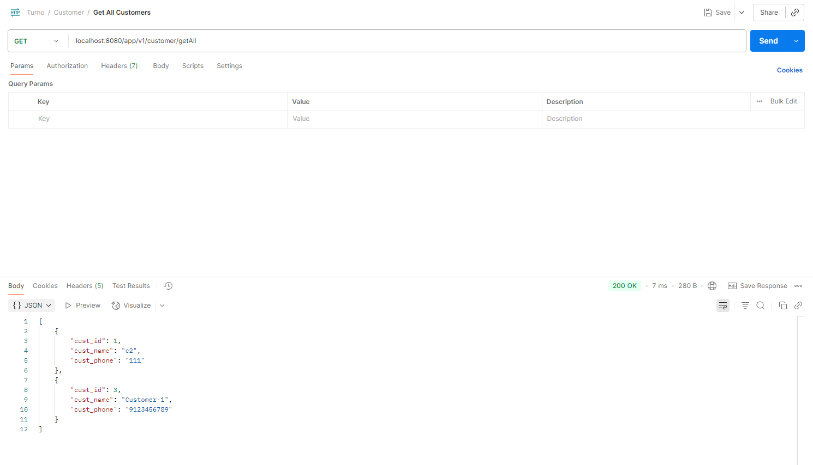

1. Apply for a Loan using the customer_id, loanAmount and loanType

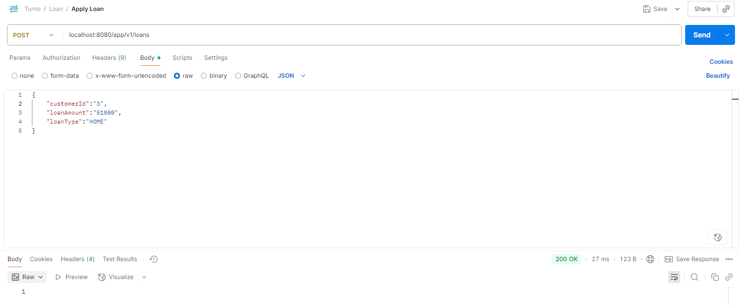

1. Use Get All Loans to view the status of all Loans

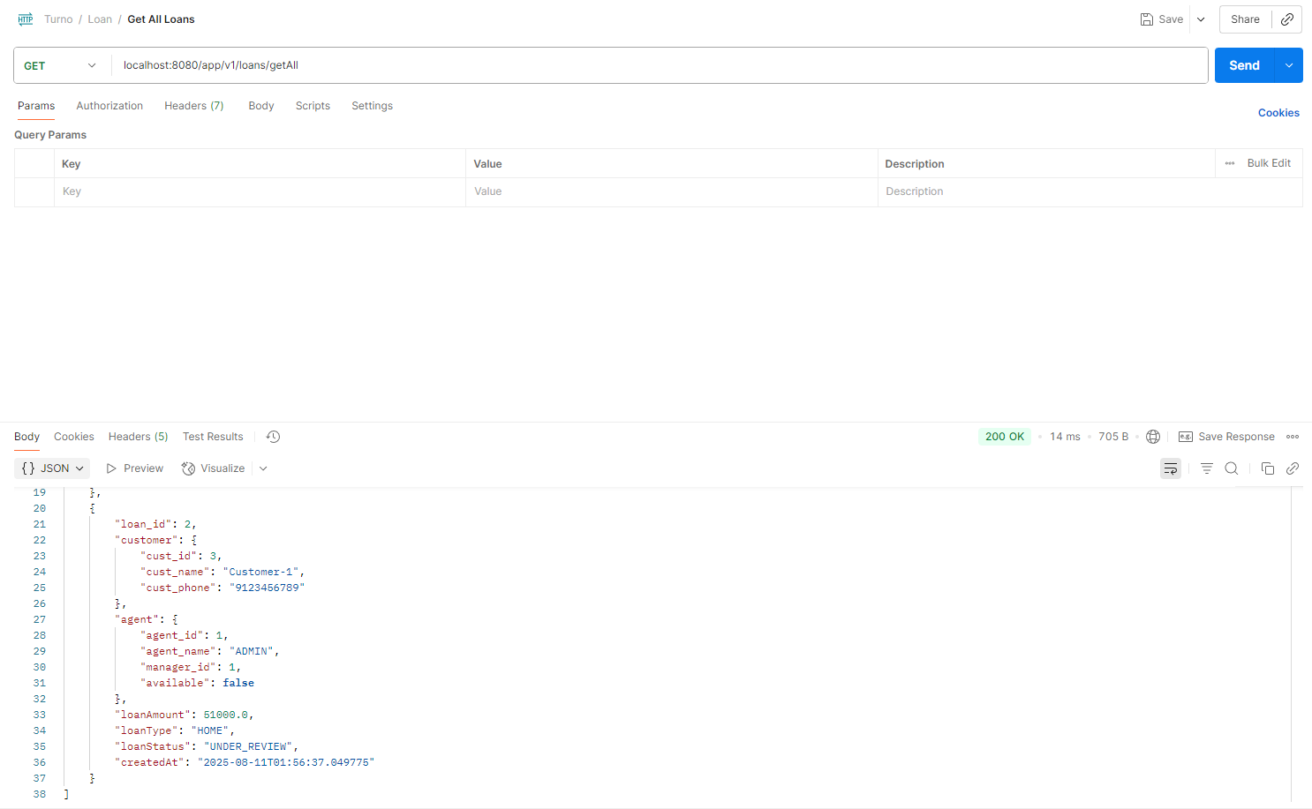

1. Push Notification is sent to the Agent

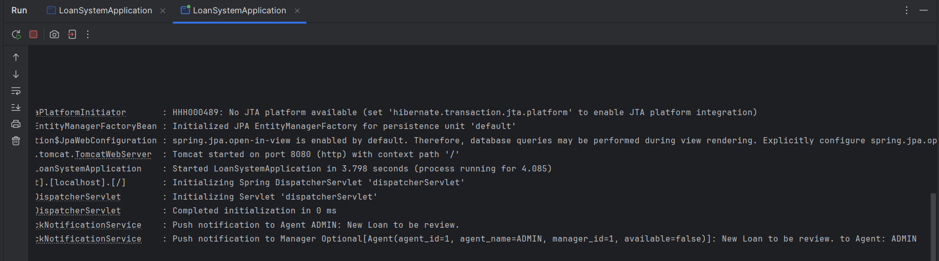

1. Agent makes a decision and send either APPROVE or REJECT accordingly.

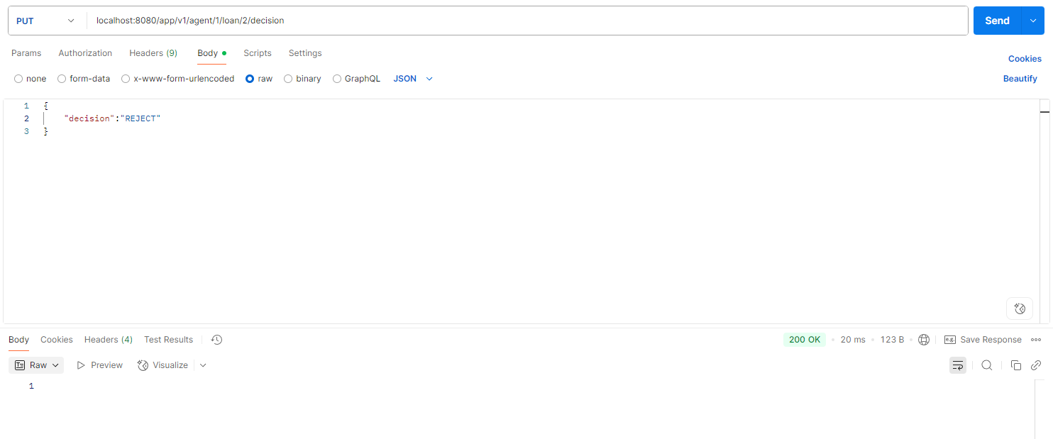

1. View the updated loan status, and note that the agent is set to available.

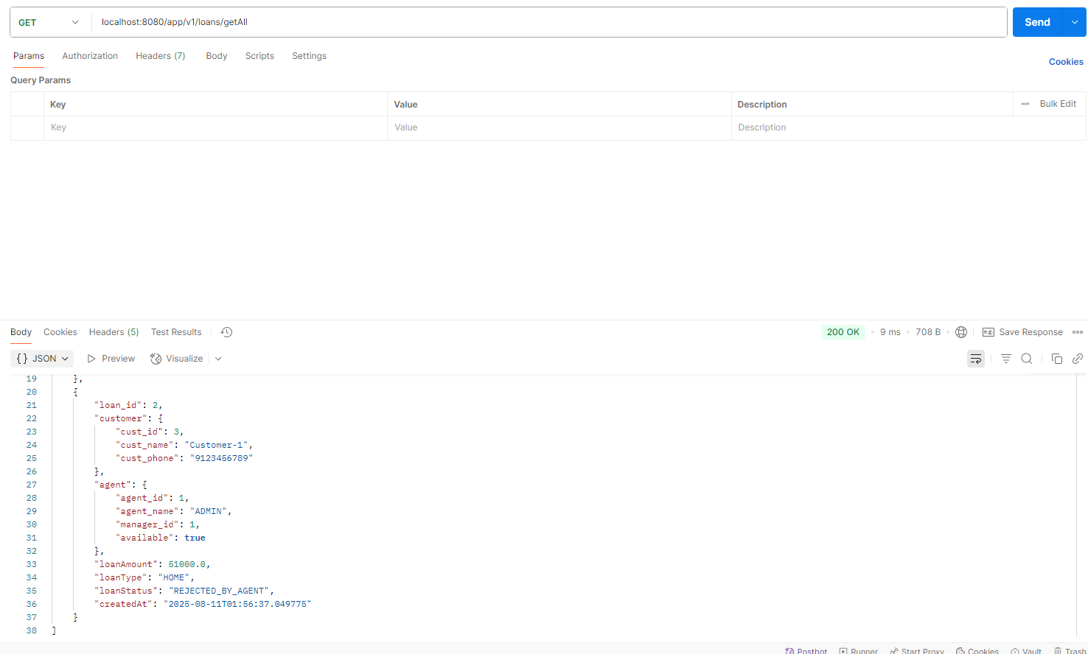

1. When the loan is Approved by the Agent

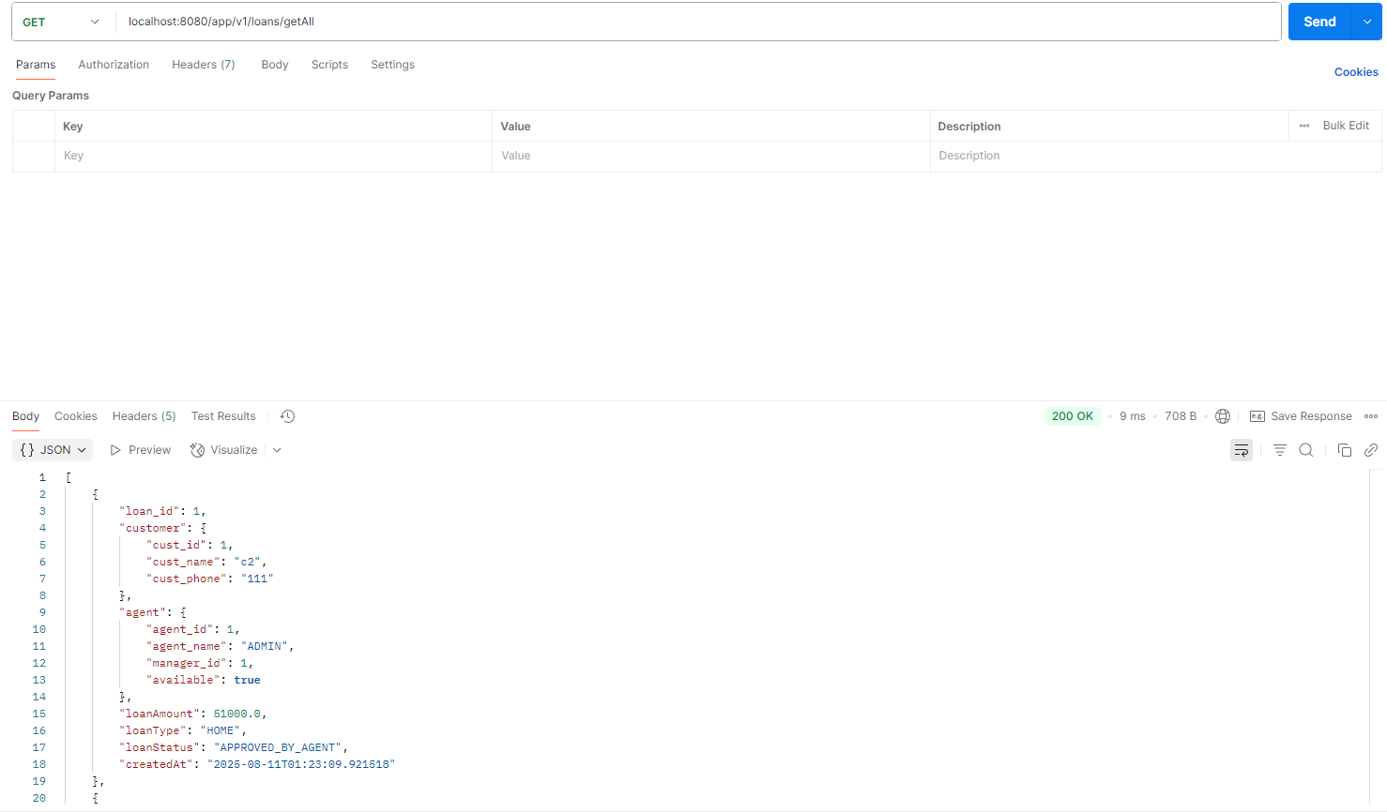

1. An SMS is sent to the customer after the loan is approved or rejected by the agent.

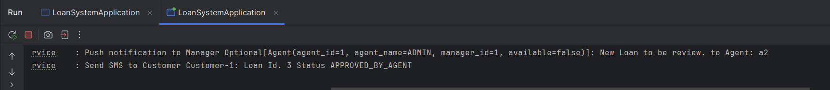

1. Loan Status Monitoring : Provides real-time counts of loans in each status.

Endpoint: GET /api/v1/loans/status-count

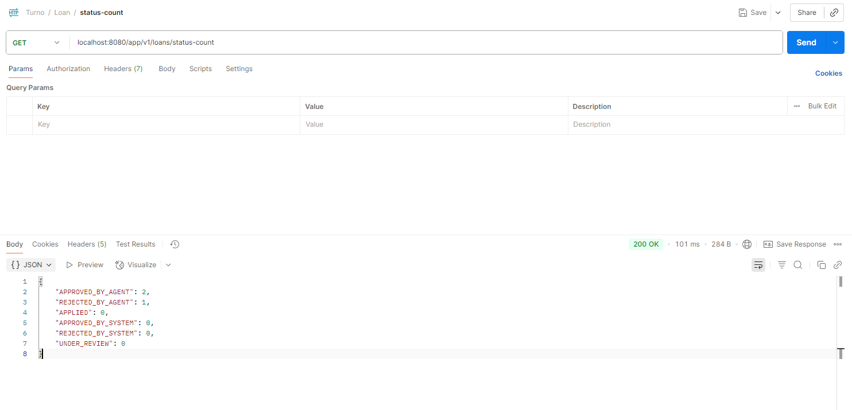

1. Top Customers API : Returns the top 3 customers with the most approved loans (APPROVED_BY_SYSTEM + APPROVED_BY_AGENT).

Endpoint: GET /api/v1/customers/top

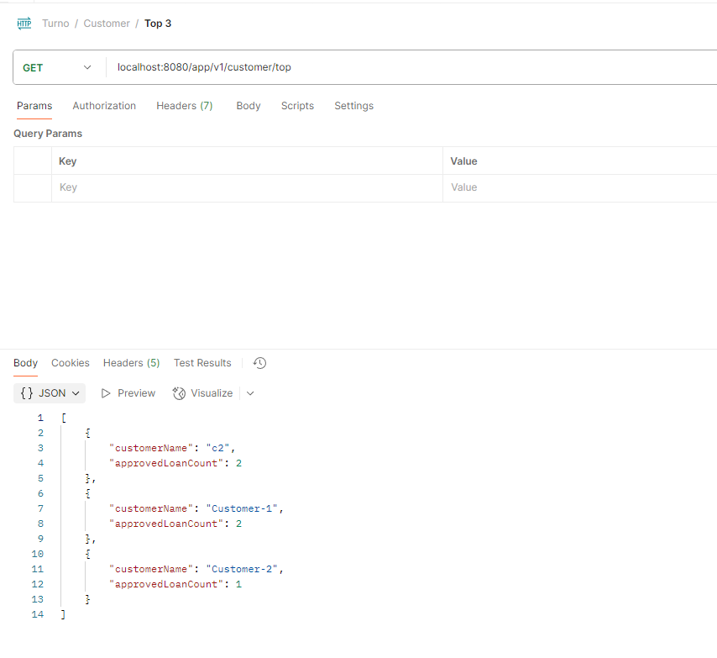

1. Fetch Loans by Status with Pagination

Endpoint: GET /api/v1/loans?status={status}&page={n}&size={m}

