Data Analyst Project

Project Title:
Week1:
Financial Risk and Performance Analysis in Consumer Lending
Week 2 & Week 3:
Unraveling the Narrative of Supply Chain Excellence and Digital Footprints
Dataset Name: DataCoSupplyChainDataset.csv & TokenizedAccessLogs.csv

Name:
- Yashman Singh
- Shobhith B N
- Uday Satone
- Saikat Mondal

Batch: almax-prox-57 – gp03-da01
PPT link : Group_3_presentation_update1.pptx
GitHUB:

Week 1
Financial Risk and Performance Analysis in Consumer Lending
Company Name: CRED
Document Link[DA_week1_doc.docx]
Screenshots:

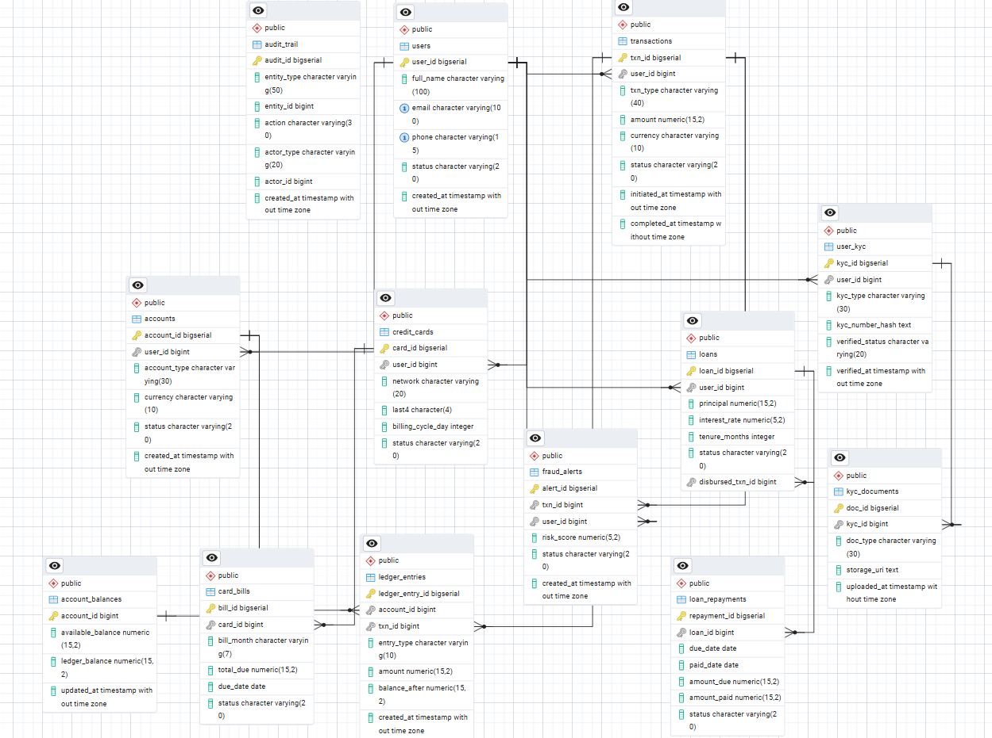

Week 2
Unraveling the Narrative of Supply Chain Excellence and Digital Footprints
SQL ETL, Excel EDA & Advanced Analytics

Document Link[DA_week2_doc.docx]
- Query file link: DA_1-15_sql_ans.sql
- Excel file link: Excel20Question_with_inshits_final.xlsx
- Excel dashboard link: DAProjectExcel_UsingSQL_dashboard (1).xlsx
- Screenshots: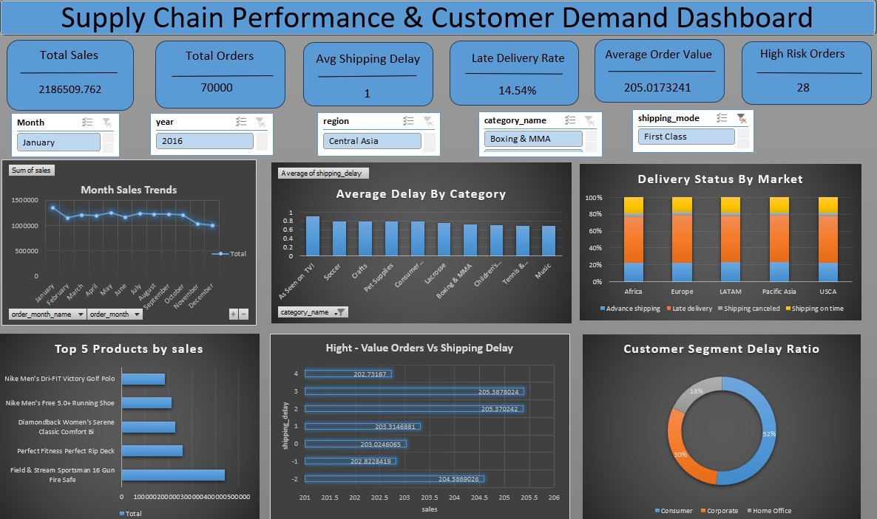

Week 3
Power BI Dashboarding, GenAI + n8n Automation

Document Link[DA_week3_doc]
- PowerBI dashboard link: DA_e-comerce_dashboard.pbix
- N8n Workflow json link: n8n workflow
- PowerBI Screenshots:

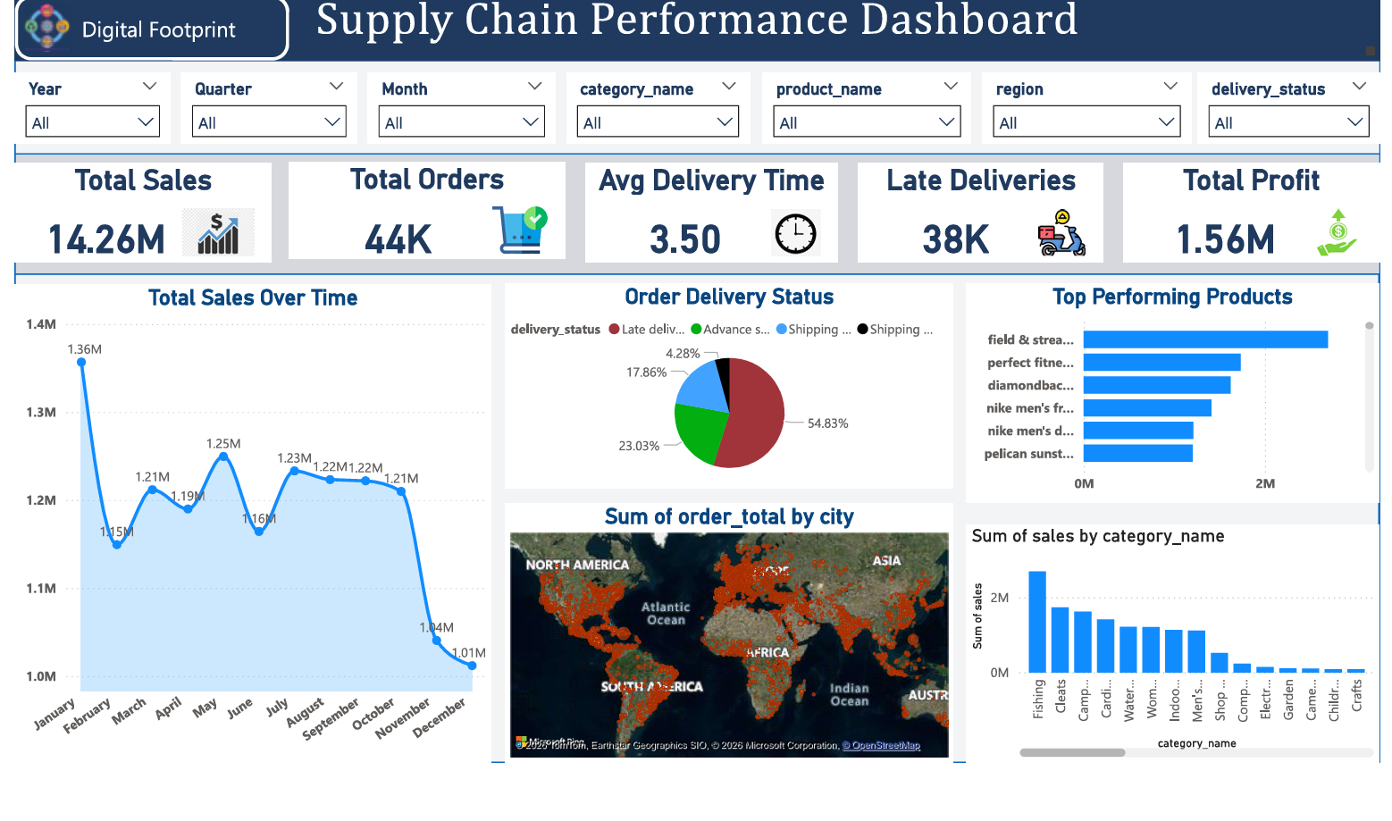
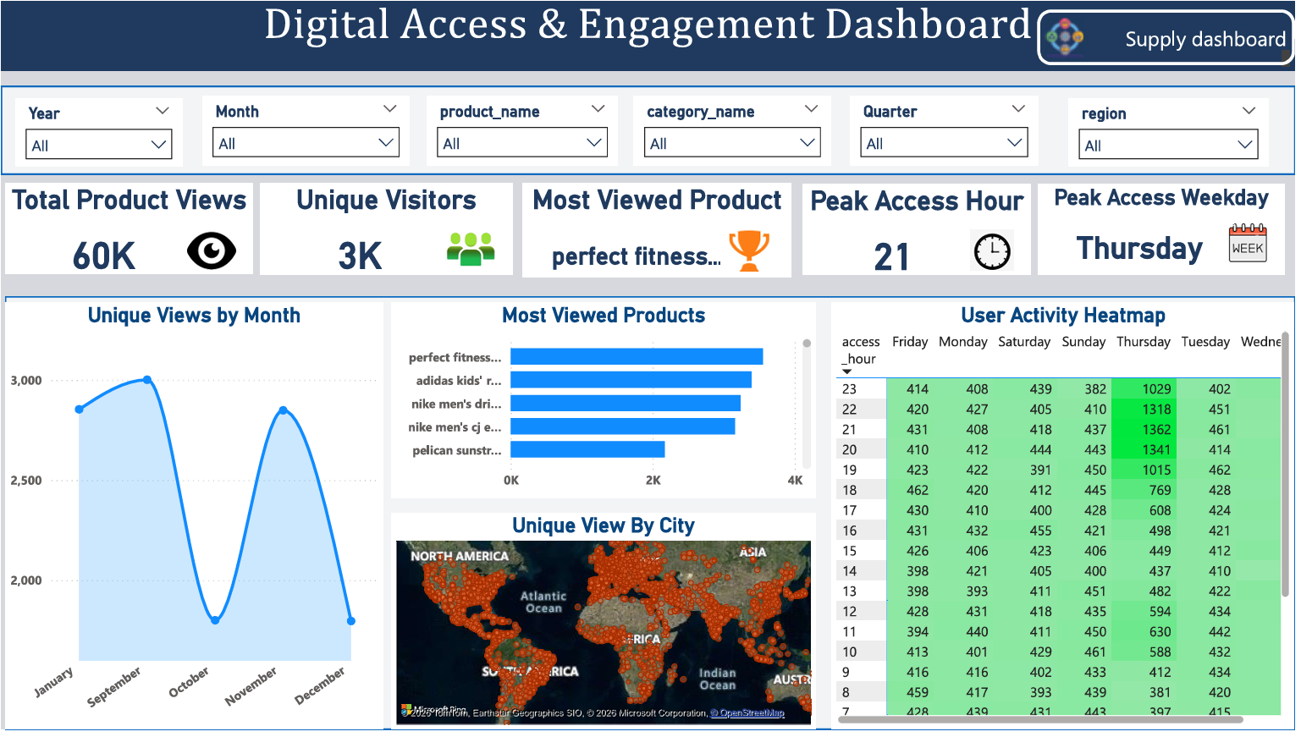

- n8n screenshots:
