2026 FIFA WORLD CUP — STATISTICAL INVESTIGATION
Descriptive Statistics, Probability & Bayes' Rule, Random Variables & Distributions, Expectation & Variance
Dataset: total goals scored per match, all 104 matches of the 2026 FIFA World Cup (group stage through final)

1. Introduction
This report applies the four analytical parts required by the project brief — descriptive statistics, probability and Bayes' Rule, random variables and distributions, and expectation and variance — to real match data from the 2026 FIFA World Cup, held in Canada, Mexico, and the United States from June 11 to July 19, 2026.
The variable analyzed throughout is X = total goals scored in a match (both teams combined), recorded for all 104 matches played across the group stage, round of 32, round of 16, quarterfinals, semifinals, third-place match, and final. Spain won the tournament, beating Argentina 1-0 after extra time in the final.

2. Part A — Descriptive Statistics

2.1 Summary Statistics
Statistic | Value
n (matches) | 104
Mean (total goals/match) | 3.14
Median | 3
Mode | 3 (22 matches)
Range | 10 (0 to 10 goals)
Sample Variance | 3.78
Sample Std. Deviation | 1.94

Interpretation: The average World Cup 2026 match produced just over 3 goals, with a typical match deviating by about 1.9 goals from this mean. The mean (3.14) sits slightly above the median (3), indicating a mild right skew — a small number of high-scoring blowouts (e.g., Germany 7-1 Curaçao, France 4-6 England in the third-place match) pull the average upward relative to the typical match.

2.2 Frequency Table and Chart
Total Goals | Frequency | Proportion
0-1 | 22 | 0.212
2-3 | 42 | 0.404
4-5 | 28 | 0.269
6-7 | 10 | 0.096
8-10 | 2 | 0.019

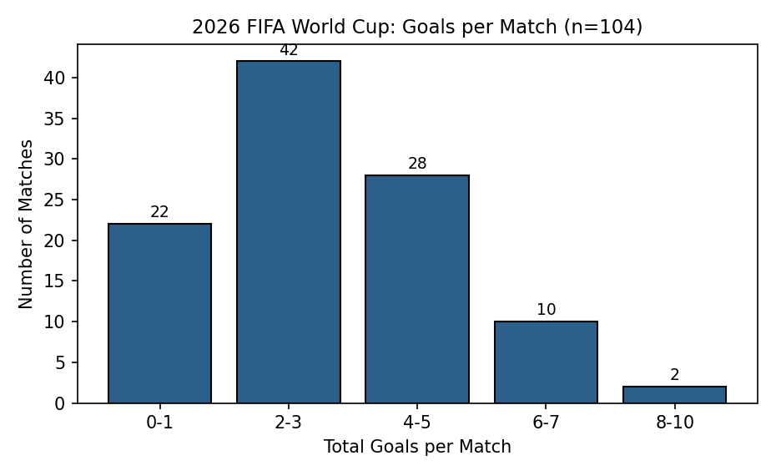

2.3 Comparing Two Groups: Group Stage vs. Knockout Stage
Group-stage matches (72 total) averaged 215 / 72 = 2.99 goals per match, while knockout-stage matches (32 total, round of 32 through the final) averaged 112 / 32 = 3.50 goals per match — a gap of about 0.51 goals, roughly 17% higher scoring in the knockout rounds. This is plausible given that several knockout matches went to extra time (adding up to 30 extra minutes for further scoring) and eliminated weaker teams progressively, leaving contests between stronger, more attacking sides. Whether this difference is statistically meaningful (versus normal match-to-match variability) would need a formal hypothesis test, which is outside the scope of this descriptive comparison.

3. Part B — Probability and Bayes' Rule

3.1 Basic Probabilities
- P(a group-stage match ends in a draw) = 20/72 ≈ 0.278
- P(a match has 4 or more total goals) = 40/104 ≈ 0.385
- P(a knockout-stage match requires extra time or penalties) = 9/32 ≈ 0.281

3.2 Conditional Probability
Let A = the event that a match has 4+ total goals, and K = the event that a match is a knockout-stage fixture (round of 32 or later).
P(A | K) = 11/32 ≈ 0.344, compared with the unconditional P(A) = 40/104 ≈ 0.385.
Interpretation: high-scoring matches (4+ goals) were actually slightly less common in the knockout stage than across the tournament overall — despite knockout matches averaging more total goals (see 2.3), they were less likely to be true blowouts. This is consistent with knockout fixtures being tighter, more cautious contests between closely matched teams, with the higher average driven partly by extra-time minutes rather than by a higher rate of blowout scorelines.

3.3 Bayes' Rule
Question: given that a match had 4+ total goals, what is the probability it was a knockout-stage match?
Let K = knockout-stage match, P(K) = 32/104 ≈ 0.308 (prior). Let A = match has 4+ total goals.
P(A | K) = 11/32 ≈ 0.344 (likelihood, knockout). P(A | K′) = 29/72 ≈ 0.403 (likelihood, group stage).
P(A) = P(A|K)P(K) + P(A|K′)P(K′) = (11/32)(32/104) + (29/72)(72/104) = 11/104 + 29/104 = 40/104 ≈ 0.385
P(K | A) = P(A|K)P(K) / P(A) = (11/104) / (40/104) = 11/40 = 0.275 (posterior)
Interpretation: before knowing anything about goals, there was a 30.8% chance a randomly chosen match was a knockout fixture (32 of 104 total matches). Learning that a match had 4+ goals actually lowers that belief slightly, to 27.5% — because the group stage, with more than double the number of matches, produced most of the tournament's outright blowouts.

4. Part C — Random Variables and Distributions

4.1 Empirical PMF of X = Goals Bin
Using the frequency table in 2.2, dividing each frequency by 104 gives the empirical PMF; the probabilities sum to 1 (22/104 + 42/104 + 28/104 + 10/104 + 2/104 = 104/104 = 1).

4.2 Fitting a Poisson Model
With sample mean λ = 3.14, the fitted Poisson model gives P(X = k) = e^(−λ) λ^k / k!. Fitted vs. observed proportions (X = total goals in a match) are compared below.
k (goals) | Fitted Poisson P(X=k) | Observed proportion
0 | 0.043 | 0.067
1 | 0.136 | 0.144
2 | 0.213 | 0.192
3 | 0.223 | 0.212
4 | 0.176 | 0.135
5 | 0.110 | 0.135
6 | 0.058 | 0.077
7 | 0.026 | 0.019
8+ | 0.015 | 0.019

Comment on fit: the Poisson model slightly under-predicts the number of very low-scoring matches (0-1 goals) and over-predicts the middle of the distribution (2-4 goals), while the observed data shows a fatter tail at higher goal counts (5+). This pattern — actual variance exceeding the mean — is confirmed numerically in Part D and is a sign the data is overdispersed relative to a pure Poisson process.

4.3 Binomial Model, Parallel to Free Throws / Penalties
A natural binomial analogue in football is a team's win count across its three fixed group-stage matches. Let Y = number of wins for a randomly selected team in its 3 group-stage games. Across all 72 group matches (144 team-match instances), 52 matches produced a winner and 20 ended in draws, giving an estimated per-match win probability p = 52/144 ≈ 0.361. Then Y ~ Binomial(n = 3, p = 0.361), giving:
Y (wins in 3 group matches) | Binomial P(Y)
0 | 0.261
1 | 0.442
2 | 0.250
3 | 0.047

This means a randomly chosen team had roughly a 5% modeled chance of winning all three group matches, and about a 26% chance of failing to win any (consistent with 16 of 48 teams being eliminated at the group stage without qualifying).

4.4 Assumptions
The Poisson model assumes goals occur independently at a constant average rate over 90+ minutes, with no two goals at exactly the same instant. This is a simplification: scoring rate is not constant across a match — teams change tactics when protecting or chasing a result, and stoppage-time goals cluster near the final whistle (several matches in this dataset, including Argentina's group games, saw late goals in minute 90+). The binomial win model assumes each team's three group matches are independent trials with a fixed win probability, which ignores real effects such as group difficulty, fatigue, and mid-tournament tactical adjustments. Both are useful first approximations rather than exact descriptions of how football matches unfold.

5. Part D — Expectation, Variance, and Prediction
From the empirical distribution, E(X) = 3.14 and Var(X) = E(X²) − [E(X)]² = 3.78 (sample variance, computed directly from the 104-match dataset in Part A).
Comparing to the fitted Poisson model, where mean = variance = λ = 3.14 by definition: the empirical variance (3.78) is noticeably larger than the mean, confirming the data is overdispersed relative to Poisson. This makes sense in football — some matches are cagey, low-event affairs while others become open, high-scoring games once one side is chasing the result, producing more spread than a constant-rate Poisson process would predict.
Example function of a random variable: if a simple fantasy-style score is defined as W = 2X (2 points awarded per total goal in the match), then by linearity of expectation, E(W) = 2 × E(X) = 2 × 3.14 = 6.29.
Example prediction: based on the fitted model and the empirical mode, a randomly selected future match between comparable teams would most likely fall in the 2–3 total goal range — the single most common outcome in this dataset (42 of 104 matches, ≈40%) — while noting this prediction assumes conditions (competition level, stakes, rule set) stay similar to the sampled matches, a stated and honest limitation given the small sample of major tournaments this rule set has been used in.

6. Data Source & Methodology
All 104 match scorelines (goals for each team, all matches from the June 11, 2026 opener through the July 19, 2026 final) were compiled from worldfootball.net's 2026 FIFA World Cup results archive, cross-checked against Wikipedia's 2026 FIFA World Cup article. Extra-time and penalty-shootout goals are included in the total-goals count for the match in which they occurred; where a match went to a penalty shootout after a draw, the reported score reflects goals scored in normal and extra time only (per standard football scoring convention).
- Group stage: 72 matches across Groups A–L (12 groups × 6 matches each).
- Knockout stage: 32 matches — round of 32 (16), round of 16 (8), quarterfinals (4), semifinals (2), third-place match (1), final (1).
- All calculations (mean, variance, frequency counts, conditional and Bayesian probabilities, Poisson and binomial fits) were computed directly from the full 104-match scoreline list and can be reproduced by hand from that list.

