**Testing Of Hypothesis**

**Statistical Decisions:**

We all make decisions about populations on the basis of sample information. Such decisions are called statistical decisions.

Example:

We may wish to decide on the basis of sample data, whether one product is better than the other.

**Statistical Hypothesis:**

A statement about the nature of a population. It is often stated in terms of a population parameter.

Hypothesis testing is a statistical method that is used to make a statistical decision using experimental data. Hypothesis testing is basically an assumption that we make about a population parameter. It evaluates two mutually exclusive statements about a population to determine which statement is best supported by the sample data.

**Defining Hypotheses**

* **Null hypothesis (H0):**In statistics, the null hypothesis is a general statement or default position that there is no relationship between two measured cases or no relationship among groups. In other words, it is a basic assumption or made based on the problem knowledge.  
  Example: A company’s mean production is 50 units/per da H0: μ = 50.
* **Alternative hypothesis (H1):**The alternative hypothesis is the hypothesis used in hypothesis testing that is contrary to the null hypothesis.   
  Example: A company’s production is not equal to 50 units/per day i.e. H1: μ≠ 50.

**Hypothesis Testing**

**Level of significance**: It refers to the degree of significance in which we accept or reject the null hypothesis. 100% accuracy is not possible for accepting a hypothesis, so we, therefore, select a level of significance that is usually 5%. This is normally denoted with α*α*and generally, it is 0.05 or 5%, which means your output should be 95% confident to give a similar kind of result in each sample.

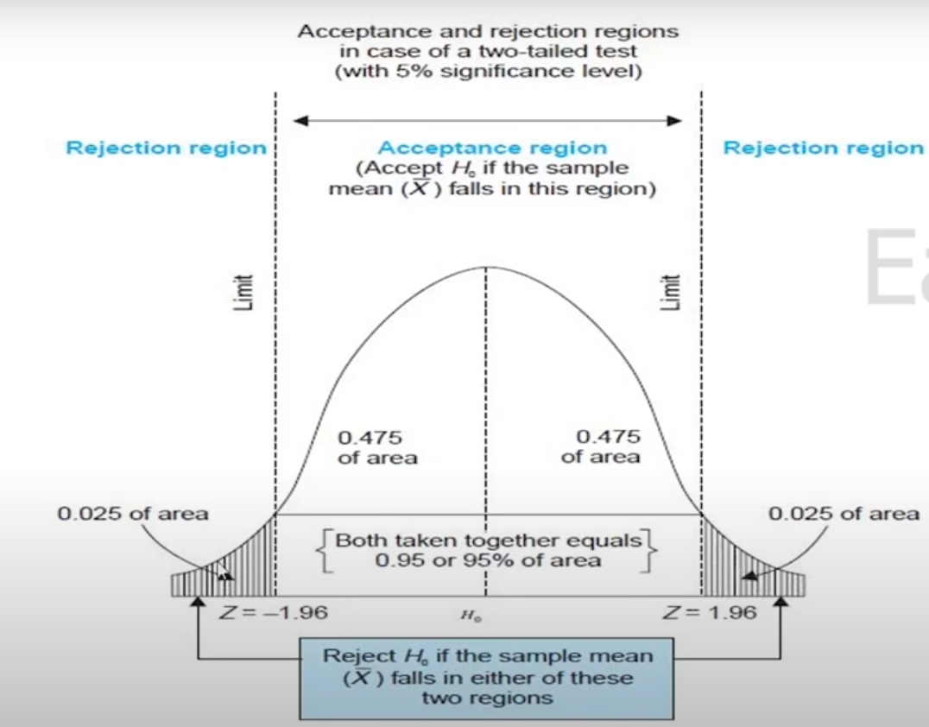

**P-value:**The [P value](https://www.geeksforgeeks.org/p-value/), or calculated probability, is the probability of finding the observed/extreme results when the null hypothesis(H0) of a study-given problem is true. If your P-value is less than the chosen significance level then you reject the null hypothesis i.e. accept that your sample claims to support the alternative hypothesis.

**Test Statistic:**The test statistic is a numerical value calculated from sample data during a hypothesis test, used to determine whether to reject the null hypothesis. It is compared to a critical value or p-value to make decisions about the statistical significance of the observed results.

**Critical value:** The critical value in statistics is a threshold or cutoff point used to determine whether to reject the null hypothesis in a hypothesis test.

**Degrees of freedom:** [Degrees of freedom](https://www.geeksforgeeks.org/degrees-of-freedom/) are associated with the variability or freedom one has in estimating a parameter. The degrees of freedom are related to the sample size and determine the shape.

**One-Tailed and Two-Tailed Test**

One tailed test focuses on one direction, either greater than or less than a specified value. We use a one-tailed test when there is a clear directional expectation based on prior knowledge or theory. The critical region is located on only one side of the distribution curve. If the sample falls into this critical region, the null hypothesis is rejected in favor of the alternative hypothesis.

**One-Tailed Test**

There are two types of one-tailed test:

* **Left-Tailed (Left-Sided) Test:** The alternative hypothesis asserts that the true parameter value is less than the null hypothesis.

Example: H0​:μ ≥ 50 and H1: μ < 50

* **Right-Tailed (Right-Sided) Test:** The alternative hypothesis asserts that the true parameter value is greater than the null hypothesis.

Example: H0 : μ ≤ 50 and H1:μ > 50

**Two-Tailed Test**

A two-tailed test considers both directions, greater than and less than a specified value.We use a two-tailed test when there is no specific directional expectation, and want to detect any significant difference.

Example: H0: μ= 50 and H1: μ ≠ 50

**Type 1 and Type 2 errors in Hypothesis Testing?**

In hypothesis testing,[Type I and Type II errors](https://www.geeksforgeeks.org/alpha-and-beta-test/)are two possible errors that researchers can make when drawing conclusions about a population based on a sample of data. These errors are associated with the decisions made regarding the null hypothesis and the alternative hypothesis.

* [**Type I error:**](https://www.geeksforgeeks.org/questions/hypothesis-testing-type-1-error-explained/) When we reject the null hypothesis, although that hypothesis was true. Type I error is denoted by alpha(α).
* [**Type II errors**](https://www.geeksforgeeks.org/type-ii-error-in-two-tailed-test-of-population-mean-with-known-variance-in-r/)**:** When we accept the null hypothesis, but it is false. Type II errors are denoted by beta(β).

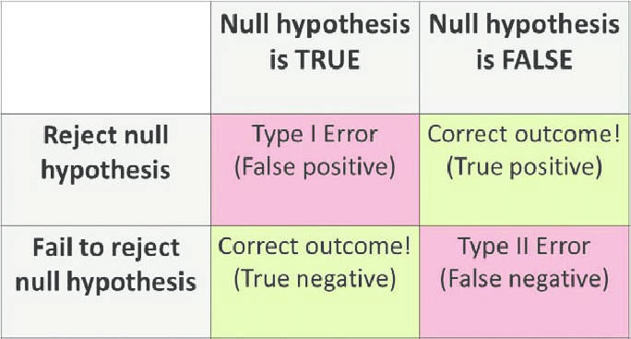

|  |  |  |  |
| --- | --- | --- | --- |
| **Level of significance** | | | |
| **Critical value** | | | |
|  | 1% | 5% | 10% |
| 1. Two tailed test | 2.58 | 1.96 | 1.645 |
| 2.Right tailed test | 2.33 | 1.645 | 1.28 |
| 3.Left tailed test | - 2.33 | - 1.645 | - 1.28 |

**Type 1 - Test of significance of single proportion.**

1. **The manufactures claimed that at least 95% of equipment’s which he supplied to a factory conformed to the specifications. An examination of sample of 200 pieces of equipment’s revealed at 18 were faulty, test his claim at 5% level of significance.**
2. **In a sample of 1000 people in Karnataka, 540 are rice eaters and the rest are wheat eaters, can we assume that both rice and wheat eaters are equally popular. In this state at 1% level of significance.**
3. **In a big city, 325 men out of 600 men were found to be smokers. Does this information support the conclusion that majority of the men in this city are smokers.**
4. **In a factory sample 400 parts are manufactured, the no. of defective parts was found to be 30, the company however claims that only 5% of that product is deflective.**
5. **A die was thrown 9000 times and a throw is observed 3220 times. Consider 3 or 4 will be accepted. Show that the die cannot be regarded as an unbiased.**
6. **A random sample of 500 apples was taken from a large container and 60 were found to be bad. Obtain 98% of confident limit for the number of bad apples in the container.**
7. **A random sample of 500 pineapples was taken from a large container and 65 were found to be bad. Find the percentage of bad pineapples in the container.**

**Type 2 - Test of significance of different proportion:**

1. **A random sample of 400 men and 600 women were asked whether they would like to have a school near this residency. 200 men and 325 women were in favor of their proposal. Test the hypothesis that proportion of men and women in favor of the proposal are same at 5% level.**
2. **In a two large population there are 30% and 25% respectively of fair haired people. In this difference likely to be hidden in a sample of 1200 and 900 respectively from the two population.**
3. **The manufacturing firm claim that its brand A product out sells the brand B product by 8%, it found that 42 out of sample of 200 persons prefer brand A and 18 out of another sample of 100 persons prefer brand B. Test whether 8% difference is valid claim.**
4. **A sample survey results show that out of 800 literate people 480 are employed whereas out of 600 illiterate people only 350 are employed. Can the difference between two proportions of employed persons be ascribed due to sampling fluctuations?**
5. **In a large city A, 20% of random sample of 900 school boys had a slight physical defect. In another large city B, 18.5% of random sample of 1600 school boys had the same defect. Is there any difference between the proportions of significance?**
6. **In a random sample of 400 students of university teaching department, it was found that 300 students failed in the examination. In another random sample of 500 students of the affiliated college, the no. of failures in the same examination was found to be 300. Find out whether the proportion of failures in the university teaching department is significantly greater than the proportion of failures in the university teaching department and affiliated colleges taken together.**

**TYPE 3 - TEST OF SIGNIFICANCE OF SINGLE MEAN:**

1. **A sample of 900 members has a mean of 3.4cm and S.D. is 2.61cm. If the sample from a large population of mean 3.25cm and S.D is 2.61cm. If the population is normal and its mean is unknown, find the 95% of fiducial limit of the true mean.**
2. **A normal population has a mean of 6.48 and a S.D of 1.5 In a sample of 400 members, mean is 6.75. Is the difference significant?**
3. **An insurance agent has claimed that the average age of policy holders who issue through him is less than the average for all agents which is 30.5 years. A random sample of 100 policy holders who had issued through him gave the following age distribution.**

|  |  |  |  |  |  |
| --- | --- | --- | --- | --- | --- |
| **Age:** | **16 - 20** | **21 – 25** | **26 – 30** | **31 – 35** | **36 – 40** |
| **No. of persons:** | **12** | **22** | **20** | **30** | **16** |

**Calculate the arithmetic mean and S.D. of this distribution and use these values to test his claim at 5% level of significance.**

**TYPE – 4 TEST OF SIGNIFICANCE OF DIFFERENCE OF MEAN**

1. **The mean of two large sample of size 2000 and 1000 of the mean are 68.0 and 67.5 respectively can the sample mean regarded as drawn from the same population standard deviation of 2.25.**

1. **Given that the information relating to two places A and B test whether there is any significant difference between two mean wages**

|  |  |  |
| --- | --- | --- |
|  | **Place A** | **Place B** |
| **Mean wages** | **47** | **49** |
| **S.D** | **28** | **40** |
| **No. of workers** | **1000** | **1500** |

1. **Two random sample of size 1600 and 2000 of farms gave a yield of 2000kg and 2050kg respectively. The variance of the farms in country may be taken as 100kg. Examine whether the two samples differ significantly in the yield.**
2. **The following data are got from an investigation.**

|  |  |  |  |
| --- | --- | --- | --- |
|  | **No. of cases** | **Mean wages** | **S.D of the wages** |
| **Sample I** | **400** | **Rs.47.4** | **Rs.3.1** |
| **Sample I** | **900** | **Rs.50.3** | **Rs.3.3** |

**Find out whether the two mean wages differ significantly.**

**Type 5: Test of Significance of SD**

1. **The S.D of the random sample of 900 members is 4.6 & that of another independent sample of 1600 members is 4.8 .Examine together the S.D is significantly different.**
2. **A random sample drawn from the 2 countries A&B .If the following data relating to the height of the male adults**

|  |  |  |
| --- | --- | --- |
|  | **A** | **B** |
| **Maximum height** | **67.42** | **67.25** |
| **No.of males** | **1000** | **1200** |
| **S.D** | **2.58** | **2.5** |

1. **If the difference of the two mean is significant**
2. **If the difference of the two S.D is significant**
3. **The standard deviation of a random sample of 1000 is found to be 2.6 and the standard deviation of another random sample of 500 is 2.7. Assuming the samples to be independent, find whether the two samples could have come from populations with the same standard deviation.**

**UNIT 5**

**Small Samples**

**Problems STUDENT’S t - TEST**

1. **A machinist is making engine parts with axle diameters of 0.700 inch. A random sample of 10 parts shows a mean diameter of 0.742 inch with a S.D of 0.040 inch. Compute the statistic you would use to test whether the work is meeting the specification. [May 2015]**
2. **The mean weekly sales of soap bars in departmental stores was 146.3 bars per store. After an advertising campaign the mean weekly sales in 22 stores for a typical week increased to 153.7 and showed a S.D. of 17.2. Was the advertising campaign successful?**

**3. The average breaking strength of steel rods is specified to be 18.5 thousand pounds. To test this a sample of 14 rods was tested. The mean and standard deviations obtained were 17.85 and 1.955 respectively. Is the result of the experiment significant?**

**4. A random sample of size 16 valves from a normal population showed a mean of 53 and a sum of squares of deviation from the mean equals to 150. Can this sample be regarded as taken from the population having 56 as mean? Obtain 95% confidence limits of the mean of the population.**

**STUDENT’S t - TEST (When S.D. of the sample is not given directly)**

1. **A random sample of 10 boys had the following I.Q.’s of 70, 120, 110, 101, 88, 83, 95, 98, 107, 100. To these data support the assumption of a population mean of I.Q of 100? Find a reasonable range in which most of the mean I.Q values of samples of 10 boys lie. [May 16]**
2. **Certain pesticide is packed into bags by a machine. A random sample of 10 bags is drawn and their contents are found to weigh (in kg) as follows: 50, 49, 52, 44, 45, 48, 46, 45, 49, 45. Test if the average packing can be taken to be 50 kg. (t0.05 for 9d.f. = 2.262) [Nov 2016, Dec 2010]**
3. **Test whether the sample having the values 63, 63, 64, 55, 69, 70, 70 and 71 has been chosen from a population with mean of 65 at 5% level of significance.**

**PROBLEMS:**

1. **Samples of two types of electric light bulbs were tested for length of life and following data were obtained**

|  |  |  |
| --- | --- | --- |
|  | **Type I** | **Type II** |
| **Sample Number** | **8** | **7** |
| **Sample Means** | **1234 hours** | **1036 hours** |
| **Sample S.D.** | **36 hours** | **40 hours** |

**Is the difference in the means sufficient to warrant that type I is superior to type II regarding the length of life. [Dec 11]**

1. **To verify whether a course in accounting improved performance, a similar test was given to 12 participants both before and after the course. The marks are**

**Before : 44 40 61 52 32 44 70 41 67 72 53 72**

**After : 53 38 69 57 46 39 73 48 73 74 60 78Was the course useful?**

1. **Below are given the gain in weights (in lbs) of pigs fed of two diets A and B.**

|  |  |  |  |  |  |  |  |  |  |  |  |  |  |  |  |
| --- | --- | --- | --- | --- | --- | --- | --- | --- | --- | --- | --- | --- | --- | --- | --- |
| **Diet A** | **25** | **32** | **30** | **34** | **24** | **14** | **32** | **24** | **30** | **31** | **35** | **25** | **-** | **-** | **-** |
| **Diet B** | **44** | **34** | **22** | **10** | **47** | **31** | **40** | **30** | **32** | **35** | **18** | **21** | **35** | **29** | **22** |

**Test if the two diets differ significantly as regards their effect on increase in weight.**

1. **The mean of two random sample sizes 9 and 7 are 196.42 and 198.82. The sum of the squares of the deviations from the mean are 26.94 and 18.73 respectively. can the sample be considered drawn from normal populations of equal means.**
2. **The height of six randomly chosen sailors are (in inches): 72, 71, 69, 68, 65, 63. Those of ten randomly chosen army men are 73, 72, 71, 70, 69, 69, 66, 65, 62, 61. Analyse the concept that the army men are shorter, on the average, than sailors.**

**F – TEST FOR VARIANCE**

1. **In one sample of 10 observations from a normal population, the sum of the squares of the deviations of the sample values from the sample mean is 102.4 and in another sample of 12 observations from another normal population, the sum of the squares of the deviations of the sample values from the sample mean is 120.5. Examine whether the two normal populations have the same variances**
2. **Two random samples gave the following results:**

|  |  |  |  |
| --- | --- | --- | --- |
| **Sample** | **Size** | **Sample Mean** | **Sum of Squares of Deviation from the Mean** |
| **1** | **10** | **15** | **90** |
| **2** | **12** | **14** | **108** |

**Test whether the samples come from the same normal population. [Nov 11]**

1. **It is known that the mean diameters of rivets produced by two firms A and B are practically the same but the standard deviations may differ. For 22 rivets produced by the firm A, the standard deviation is 2.9 mm, while for 16 rivets manufactured by firm B, the standard deviation is 3.8 mm. Compute the statistic you would use to test whether the products of firm A have the same variability as those of firm B and test it’s significance**
2. **Two independent samples of sizes 9 and 7 from a normal population had the following values of the variables.**

|  |  |  |  |  |  |  |  |  |  |
| --- | --- | --- | --- | --- | --- | --- | --- | --- | --- |
| **Sample I** | **18** | **13** | **12** | **15** | **12** | **14** | **16** | **14** | **15** |
| **Sample II** | **16** | **19** | **13** | **16** | **18** | **13** | **15** |  |  |

**Do the estimates of the population variance differ significantly at 5% level? [MAY 2017]**

1. **Test whether the two sets of data are drawn from same population**

|  |  |  |  |  |  |  |  |  |  |
| --- | --- | --- | --- | --- | --- | --- | --- | --- | --- |
| **I set** | **17** | **27** | **18** | **25** | **27** | **29** | **27** | **23** | **17** |
| **II set** | **16** | **16** | **20** | **16** | **20** | **17** | **15** | **21** | **-** |

**Chi square test for goodness of fit and independence of attributes**

1. The following table gives number of aircrafts accidents that occurred during various days. Use $Ψ^{2}$ test and find whether the accidents are uniformly distributed over the week

|  |
| --- |
| Days : Sun Mon Tues Wed Thurs Fri Sat |
| No of Accidents: 14 16 8 12 11 9 14 |

1. **The following table gives the number of aircraft accidents that occur during the various days of the week. Test whether the accidents are uniformly distributed over the week.**

|  |  |  |  |  |  |  |  |
| --- | --- | --- | --- | --- | --- | --- | --- |
| **Days** | **Mon** | **Tue** | **Wed** | **Thu** | **Fri** | **Sat** | **Total** |
| **No. of accidents** | **14** | **18** | **12** | **11** | **15** | **14** | **84** |

1. **The theory predicts the proportion of beams in the 4 groups A,B,C,D be 9 : 3 : 3 : 1. In an experiment with 1600 beams the numbers in 4 groups where 882, 313, 287, 118. Does the experimental result support the theory. [May 14]**
2. **The survey of 320 families with 5 childrens each gave the following distribution:**

|  |  |  |  |  |  |  |
| --- | --- | --- | --- | --- | --- | --- |
| **No of boys** | **5** | **4** | **3** | **2** | **1** | **0** |
| **No of girls** | **0** | **1** | **2** | **3** | **4** | **5** |
| **No of families** | **14** | **56** | **110** | **88** | **40** | **12** |

**Use $Ψ^{2}$ test whether the male and female birth are equally popular.**

1. **Examine the goodness of fit for the Poisson distribution to the following data**

|  |  |  |  |  |  |
| --- | --- | --- | --- | --- | --- |
| **x** | **0** | **1** | **2** | **3** | **4** |
| **f** | **109** | **65** | **22** | **3** | **1** |

1. **Fit a binomial distribution for the following data and also test the goodness of fit.**

|  |  |  |  |  |  |
| --- | --- | --- | --- | --- | --- |
| **X** | **0** | **1** | **2** | **3** | **4** |
| **F** | **5** | **29** | **36** | **25** | **5** |

1. **From the following information state whether the condition of the home is associated with the condition of the child .**

**Condition of Home**

|  |  |  |
| --- | --- | --- |
|  | **Clean** | **Dirty** |
| **Clean** | **69** | **51** |
| **Fairly clean** | **81** | **20** |
| **Dirty** | **35** | **44** |

**Condition**

**Of**

**Child**

1. **In an experiment of immunization of cattle from TB , The following results were**

|  |  |  |
| --- | --- | --- |
|  | **Affected** | **Non-affected** |
| **Inocalated** | **12** | **28** |
| **Non – Inocalated** | **13** | **7** |

**Examine the effect of vaccine controlling the incidents of TB**

1. **The following data are for a sample of 300 car owners. Who where classified with respect to age and the number of accidents they had during the past 2 years . Test whether there is any relationship between these 2 variables. [May 2012]**

**Number of Accidents**

|  |  |  |  |
| --- | --- | --- | --- |
|  | **1** | **1 or 2** | **More than 2** |
| **Less than 30** | **8** | **23** | **14** |
| **Between 30 and 50** | **21** | **42** | **12** |
| **More than 50** | **71** | **90** | **19** |

**Age**

1. The data given below are taking during an epidemic of cholera. Test the effectiveness of inoculation in preventing the attack of cholera

|  |  |  |  |
| --- | --- | --- | --- |
|  | **Attacked** | **Non- Attacked** | **Total** |
| **Inocalated** | **31** | **469** | **500** |
| **Non – Inocalated** | **185** | **1315** | **1500** |
| **Total** | **216** | **1784** | **2000** |

1. **In a certain sample of 2000 families 1400 families are consumers of tea. Out of 1800 Hindu families 1236 families consumes tea. Use test and state whether there is any significant difference between consumption of tea among Hindu and Non – Hindu families**
2. **On the basis of information noted below, find out whether the new treatment is comparatively superior to the conventional one. [NOV 2017]**

|  |  |  |  |
| --- | --- | --- | --- |
|  | **Favourable** | **Non -Favourable** | **Total** |
| **Conventional** | **40** | **70** | **110** |
| **New** | **60** | **30** | **90** |
| **Total** | **100** | **100** | **N = 200** |