|  |  |  |
| --- | --- | --- |
| **Ex.No** |  | **Date** |
|  |  |

**STEP 1 : Loading the Dataset into DataFrame**

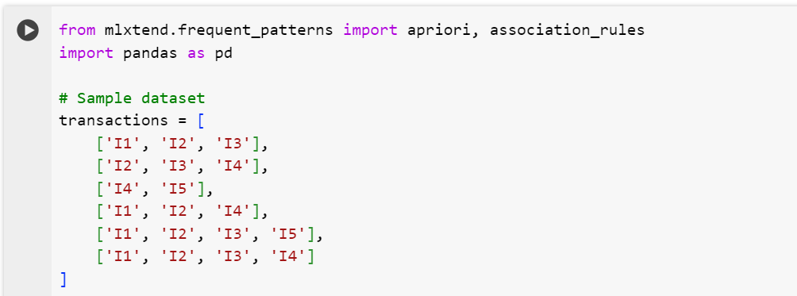

**STEP 2: Calculating Frequent Itemset**

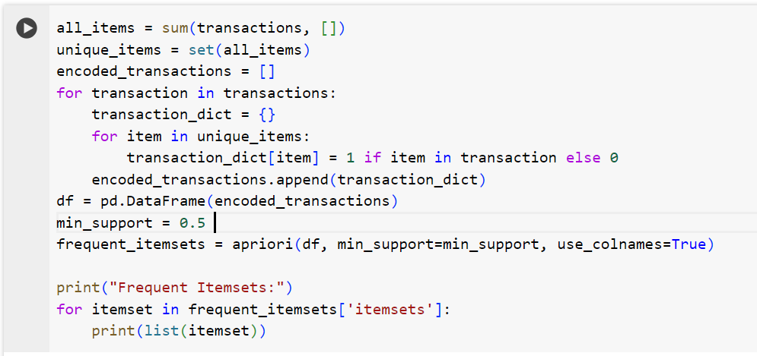

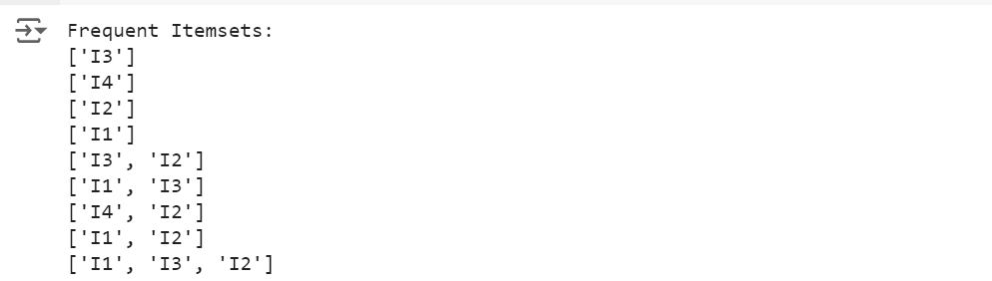

**STEP 3: Generate Association Rules  
