SKAT
The game is played with three persons and a 32-card deck. Each round, the dealer shuffles the deck, makes it cut and deals : 3-Skat(2)–4-3
A bidding is resolved in Bid-Answer-Dealer order until two players passed. The declarer may exchange two cards with the Skat (card points in the Skat goes to the declarer), then announces the game type. The declarer plays alone against the other two. If nobody bid, the next dealer deals. Dealing rotates clockwise around the table at each round.
Dealer’s left plays first in clockwise order. Players must follow suit when possible. The highest card of the suit led wins unless a trump is played, in which case the highest trump wins.
THE DECK
Contains 120 card points in total : A (11pts), 10 (10pts), K (4pts), Q (3pts), J (2pts), other cards have no point value. The declarer can aim for two goals :
- Trump game (capturing at least 61 card points in tricks)
- Null game (not taking any trick)
Cards ordering depends on the game set by the declarer :
SUITS | CARDS (highest to lowest)
Grand game | ♣J, ♠J, ♥J, ♦J
Trump game (♣, ♠, ♥ or ♦) | ♣J, ♠J, ♥J, ♦J, A, 10, K, Q, 9, 8, 7
Side suits (non-trumps cards) | A, 10, K, Q, 9, 8, 7
Null game (no trumps) | A, K, Q, J, 10, 9, 8, 7 in each suit
THE BIDDING
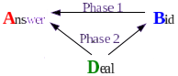
Phase 1 : player B bids, A answer (e.g. B:18 A:yes B:20 A:pass)
Phase 2 : D continues to bid, the winner of phase 1 answers
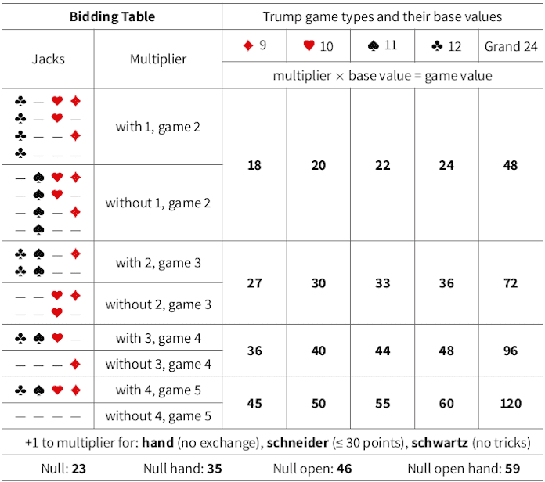
hand game : schneider and schwarz can be announced for additional +1s
THE SCORING
The declarer must achieve a game value equal or higher than the bid :
- If winning the game, the declarer receives the game value plus 50 points.
- If losing the game, the declarer loses double the game value minus an additional 50 points ; each opponents receives 40 points. If the declarer has overbid, the game value is the lowest multiple of the base value which would have been sufficient.

