Color Whist (Kleurenwiezen)

GOAL
Players try to earn the most points individually by achieving contracts, either by oneself or with a partner. Teams that can be formed vary per deal, there are no fixed partners. The declarer (player or team that won the bidding) undertakes a contract to win a certain number of tricks, or in specific cases, to avoid taking tricks. The opponents (defenders) try to collectively fail the contract.

THE DECK
A standard 52-card pack is used. Within each suit the cards rank from high to low : A-K-Q-J-10-9-8-7-6-5-4-3-2

THE DEAL
The dealer role rotates to the left, and the deal is done clockwise. The cards are gathered together and shuffled (at least once between deals), and then cut by the previous player (dealer’s right). The cards are then dealt out in batches of 4-5-4. If no contract has been played, the cards are collected and dealt again by the same dealer. The total number of deals played must be a multiple of 4.

THE CONTRACTS
Contracts are categorized into PARTNERSHIP or SOLITAIRE type :
PARTNERSHIP :
- Together (Proposal and Acceptance) : A player PROPOSES a suit for trump, for another player to ACCEPT this suit. These two players must take at least 8 tricks as a team, but this can be increased to 13 tricks if other players make a higher bid.
- Three Aces : A player with three Aces is forced to bid this contract (4 Aces should not be bid). The player holding the fourth Ace is the partner but is only revealed if the contract is settled. Together they must take at least 9 tricks. The partner can set any trump and leads first with any card.
SOLITAIRE :
Solitaire contracts with a declarer trying to win a certain number of tricks :
- Solo : Win at least 6 tricks alone with the trump suit of his choice. If required, a bid for Solo can be increased to 8 tricks or any contract below.
- Abundance : Win at least 9 tricks alone with a trump suit of his choice. If required, a bid for Abundance can be increased to 11 tricks. The declarer leads to the first trick.
- Small Slam : Win 12 tricks alone with a trump suit or with no trump (lower). The declarer leads to the first trick.
- Slam : This bid is similar to Small Slam. The difference is that the player must win all 13 tricks.
Solitaire contracts with a declarer trying to avoid tricks. Multiple players can be declarer at the same time, each play on their own against other defenders playing collectively :
- Small Misere : There is no trump suit and the declarer(s) must avoid taking any tricks. Prior to the first trick, each player on the table must discard a card face-down.
- Piccolo : The declarer(s) must win exactly 1 trick, played with no trump suit.
- Misere : This bid is similar to Small Misere. The difference is that no cards may be discarded.
- Misere on the table : This bid is similar to Misere. The difference is that the declarer(s) puts his cards on the table after the first trick is played. The other players must not speak to each other while playing.

THE BIDDING
The bidding determines the teams, the trump suit and the contract.
Contracts are ranked in ascending order. Contracts played with a trump suit can be of the same type/tricks but are still ranked by their suit (from high to low) :


First turn
Starting clockwise from the Forehand player (dealer's left), a player must bid “Three Aces” if holding strictly three Aces. Declarers can still increase their bid on the next turn.
Second turn
In the same order, each player must PASS (out of the bidding) or :
- PROPOSE a suit
- ACCEPT a suit proposal for playing a higher Together contract
- Bid any higher SOLITAIRE contract (Solo is forbidden in a suit with a possible partner)Solo is only allowed for a suit with no possible partner
Forehand player has an additional choice to WAIT.
Third turn
On their turn, the highest bid player(s) doesn’t speak, while other players must PASS or increase their previous contract :
- A Together contract can be increased into another Together of same suit (the bid is led by the accepter, the proposer must remain silent)
- A SOLITAIRE contract can be increased into any other SOLITAIRE contract of any type or suit
Forehand player who did WAIT can now ACCEPT a suit or PASS (forced PASS if no suit available).
Player whose suit proposal didn’t find a partner must PASS or :
- Bid any higher SOLITAIRE contract of any type or suit (now including Solo)
- ACCEPT a higher suit for playing a higher Together contract
- PROPOSE the same suit a last time (forced PASS if nobody accepts)
Further turns
Following the same protocol, bidding proceed for several turns until the contract is settled when all players but the declarer(s) passed.
Proposer whose Together partner PASSED must speak again to PASS or bid any higher SOLITAIRE contract of any type or suit.

Bidding details
- Accept : A lower suit cannot be accepted. A Together can only get one partner.
- Propose : A suit cannot be proposed if there’s no possible partner. A suit cannot be simultaneously proposed by different players. Solo is not allowed in a suit that is being proposed.
- Suits ranks : A Together can be bid over an equal Together of lower suit (Together8♥ over Together8♦), also applies to Solitaire contracts played with a suit (Solo6♦ over Solo6♣). A lower suit bid is still possible but requires one more trick (Solo7♣ over Solo6♦).
- Together bid : a Together bid must always start from 8 tricks when possible. There’s no more requirement if a Solitaire bid has been made beforehand, any Together can be bid directly.
- Solitaire bid : A Solitaire bid can be increased into any higher Solitaire contract, even of different suit or type (trick avoidance/trump). Solo8 cannot be bid directly over Small Misere, the player who can still propose a suit must first try to play a Together12.

THE PLAY
When the final contract is settled, the play begins clockwise. Players must follow suit whenever possible. A player with no card of the suit led may play any card. There is no obligation to trump, nor to beat the cards previously played to the trick. The trick is won by the highest card of the suit led, unless there are trumps in it, in which case the highest trump wins. The winner of a trick leads to the next.
Play starts with Forehand, except for Abundance and Slam (starting with the declarer), and “Three Aces” (starting with the partner).

POINTS TABLE
If Declarer(s) achieve the contract, each winner earn the base contract points from the table (base + 3 more points per overtrick in Solo and Together).

If Declarer(s) lose the contract, each loser lose the contract points (base + 3 more points per undertrick in Solo and Together). Defenders win points for having defeated the declarer.

In Misere contracts, where more than one player can participate, the defenders score more for defeating more players.
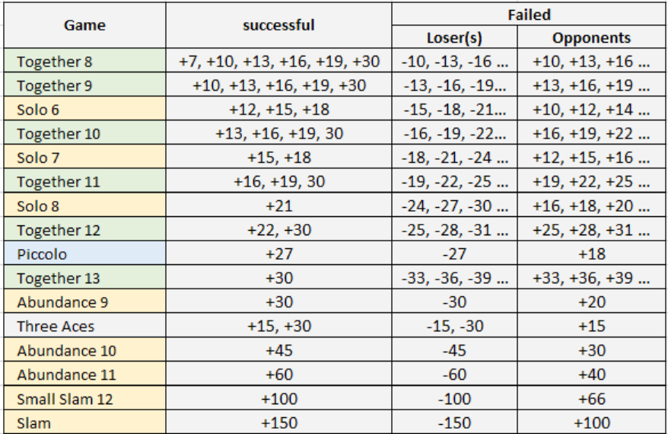

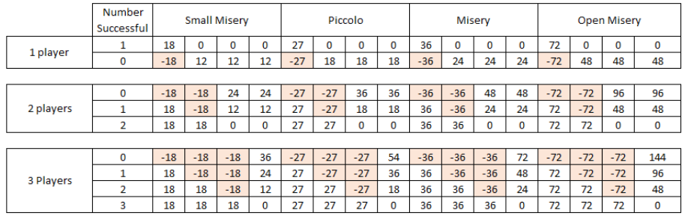

REFERENCES
Version 1.0 (01-28-2026)
Sources: Fédération IWWA Whist Couleurs Version 1 – 01-10-2025 (https://www.whistiwwa.com/fr/reglementen-tornooien)
This document has been validated by Nico Luijten from IWWA.
This document uses edited materials from Whisthub (https://www.whisthub.com/rules) and BGG (https://boardgamegeek.com/thread/2904805/whist-a-la-couleur-kleurenweizen-rules)

