SKAT
A game for three players, using a 32-card deck. Each round, the dealer shuffles the deck. has it cut, and deals batches of : 3, 2 (Skat), 4, 3
Then bidding is resolved, the bid winner becomes the declarer who plays alone against the defenders (if nobody bids, cards are dealt again). The declarer may secretly exchange two cards with the Skat (card points goes to the declarer), and announces the game type.
Dealer’s left plays first, in clockwise order players must follow suit when possible. The highest card of the suit led wins unless a trump is played, in which case the highest trump wins.
GAMES
The deck contains 120 card points in total : A (11pts), 10 (10pts), K (4pts), Q (3pts), J (2pts), other cards (0pt). The declarer can aim for a :
- Trump game (win at least 61 card points)
- Null game (win no trick, played with no trump)
Cards rank depends on the game type :
SUIT | RANK (highest to lowest)
Trump (♣, ♠, ♥ or ♦) | ♣J, ♠J, ♥J, ♦J, A, 10, K, Q, 9, 8, 7
Trump (Grand) | ♣J, ♠J, ♥J, ♦J
Side suits (non-trump) | A, 10, K, Q, 9, 8, 7
Null | A, K, Q, J, 10, 9, 8, 7
BIDDING
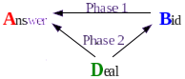
Phase 1 : B bids / A answers, until a player passes (e.g. B:18 A:yes B:20 A:pass)
Phase 2 : D bids / winner of phase 1 answers, until a player passes (e.g. D:22 B:pass)
Bidder-Answer-Dealer roles rotate clockwise each round.
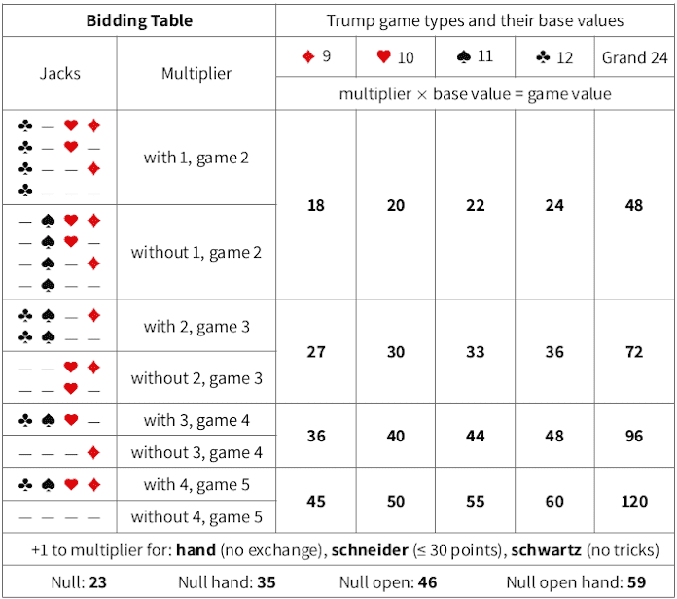
hand game : schneider/schwarz can be announced for additional multiplier +1s
SCORING
The declarer must achieve a game value higher (or equal) than the bid :
- If winning the game, the declarer receives the game value plus 50 points.
- If losing the game, the declarer loses double the game value minus an additional 50 points ; each opponent receives 40 points. If the declarer has overbid, the game value is the lowest multiple of the base value which would have been sufficient.

