Fighting the Landlord (Card Game)
Expert's Winning Strategy

"Although chess is a game of skill, its principles are quite subtle. One must concentrate to gain knowledge, and one must follow the rules to surpass others." This is a brilliant explanation of chess from *The Secret of the Orange*. These sayings also apply to card games. Fifty-four cards offer endless possibilities, testing the player's intelligence, logic, judgment, and reaction time. Currently, the most popular card game among the Chinese public is undoubtedly "Landlord."

China is a vast country, and different regions have different variations of poker. "Landlord," however, transcends regional limitations and is loved by the vast majority of people. I feel it's necessary to discuss the unique charm of "Landlord." The landlord's card game is like a battlefield in the Three Kingdoms period, where the two weaker players unite to fight against the stronger third.

Strategic planning involves not only a contest of strength, but also a battle of wits and reason.

You can strategize and command, unify the world, or lead the charge single-handedly to rescue your lord. You can also patiently wait for the right opportunity, bide your time, or take a desperate gamble to turn the tide… High-level players excel at summarizing experience through long-term practice, forming their own routines and tactics. When they have a winning hand, they can play smoothly and effortlessly; when they have a bad hand, they remain calm and collected, patiently waiting for the opportune moment to strike unexpectedly, catching opponents off guard. If you want to improve your card skills but can't find the right approach, try carefully analyzing the games of skilled players, observing their strategies and tactics. You might discover things you've never noticed before. In fact, that's exactly what I did while learning to play cards.

Here, I would like to especially thank the enthusiastic readers of my first book, *The Landlord's Killing Hand*, who raised some questions and valuable opinions. Therefore, while explaining high-stakes games in this book, I particularly emphasize...Practical techniques, such as card counting and deduction, are included to help players better understand their application in actual gameplay through real-game analysis.

There are always people more skilled than you, and there's always something beyond your understanding; the skill level of a landlord has no limits. Even if you are a beginner in the game of Landlord, do not think that the content of this book is too profound and intimidating; even if you are a seasoned veteran, do not think that your tactics are perfect. While they can be used to attack, understanding other players' strategies can continuously improve your own skills. In short, this book is suitable for both beginners and experienced readers; readers of different levels will find different interpretations.

Sitting alone in the east room, as the sun sets,
a ray of soft light,
a cup of tea, a gentle breeze—opening the book, studying landlord techniques—is this not one of life's greatest pleasures? Many thanks to the online friends "天道酬勤", "天堂鸟", "正南偏北", "心静思远", "风轻", and "专医" for their valuable suggestions and careful revisions to the content of this book. Due to the author's limited knowledge, omissions are inevitable. All mahjong enthusiasts are welcome to offer criticism and corrections!

Liao Jiale
October 2016

Just like any sport requires solid fundamentals, a good card player also needs to be strong. A good card player needs to play a large number of games and constantly analyze and summarize their experiences. They need to remember as many cards as possible and make fewer mistakes, thus gaining an advantage in the game. In this chapter, the author summarizes some basic skills for playing the landlord game. Through interpretation and practice, readers can become more adept at playing cards, memorizing, and deducing situations, ultimately calculating all the cards and becoming a true master.

Card Counting

(I) Card Counting Skills

Card counting is crucial in the Landlord game.

If a person cannot roughly remember all the cards played on the table, their Landlord skills will not be very good. It should be said that card counting ability and Landlord skills are positively correlated; the more cards remembered, the better the Landlord skills. Although the two are not entirely equal, it can be said that over 80% of a landlord's skill comes from card counting. First, you must remember the cards to know how to play and pass them. Whether your hand is a big hand, whether you can form a bomb, whether you can win, etc., all these judgments rely on card counting. Only by clearly remembering the cards can you make the correct choices. Some people believe that if you have a bad memory, it's difficult to remember anything, so it's understandable that you can't remember the cards in a game like Landlord. However, I believe that remembering cards and having a good memory are not necessarily related, and they are not entirely equivalent. In Landlord, it's not that a person with a good memory can remember more cards, but rather that they need to focus on the cards. If you don't pay attention to each card during the game, even the best memory won't be able to remember many cards. Conversely, even if your memory is usually poor, if you carefully pay attention to every card your opponent plays, I believe everyone can remember many cards. Therefore, don't lose confidence in remembering cards just because you have a poor memory. Here, I recommend a card-counting practice method—the four-step card-counting process.

① During the game, you first need to organize your cards in order from largest to smallest, such as
D X 2 A K Q J 1 0 9 8 7 6 5 4 3 (D is the Big Joker, X is the Small Joker, the same applies below). This greatly reduces the difficulty of card counting, and it also makes it easier to spot missing suits. ② Divide the cards into 15 card points. DD 2 A K Q J 1 0 9 8 7 6 5 4 3. Except for DD, which has one card each, each of the remaining points has four cards, such as 3 3 3 3. This reduces remembering 54 cards to remembering 15 card points.

③ After receiving the cards, first pay attention to your missing suit. This needs to be memorized until...After it appears, it is then eliminated.

④ For example, if your hand is D 2 A K K Q J J 1 0 9 9 8 7 6 6 5 5, first remember your hand, then remember the missing suits 4 and 3. There are currently four of each of these two suits, and two to three of the rest. If the landlord plays a single 4, you need to mentally discard one 4, comparing it to your own hand, and silently think of three 4s on the outside. If the landlord plays a single 5, you discard one 5, and silently think of one more 5 on the outside, and so on.

Also, remember the cards you play! Don't mistake your played cards for missing suits. If your hand is 55, after playing 55, when another 5 appears on the other side, you can only silently think, "There's still one 5 left on the other side." Remember: every card played on the other side needs to be calculated, eliminated, and silently thought of in your mind. This way, in the final stage, the remaining cards on the other side will naturally appear in your mind. Perhaps, at first you'll find it very difficult, but this kind of training is extremely effective. Of course, improving your card-memorizing ability this way requires time. Expecting instant results is unrealistic. With practice using the methods above, you'll be able to memorize all 54 cards without missing a single one in a short period of time. (II) Card Counting Intensive Practice

1. Card Counting Ability Levels

We can simply divide card counting ability into five levels.

Level A: Able to remember all the cards that have been played and know the distribution of the remaining cards among the other two players. This is the ultimate goal of intensive practice.

Level B: Able to remember most of the cards played in the game. For single cards, you need to remember D X 2 A K Q J 1 0 9 8 7. That is, when 7 is the highest single card, the player needs to know that 7 is a single card. For pairs, you need to remember all of them. For example, when 3 3 is high, the player needs to know that there is no pair higher than 3 3. It goes without saying that you need to know whether all other hand types are single cards. Level C: For single cards, remember D X 2 A K Q J 1 0 9; for pairs, remember at least 7; for three-of-a-kind, remember all; for sequences, remember all.

Level D: For single cards, remember D X 2 A K Q J; for pairs, remember at least 9; for three-of-a-kind, remember all.
Level E: For single cards, only remember DX 2 A; for pairs, only remember K K or higher; for three-of-a-kind, remember 10 or higher.

2. Use card-memorizing ability to judge a player's skill level.

If a player passes the Level A assessment, congratulations! You are a very difficult player to deal with, and have entered the "Super High-Level" category.

If a player can pass the B-level assessment, it's a very good option and should qualify them for the Advanced category, but they'll only be considered a "Regular Advanced Player."

If a player can pass the C-level assessment, they'll only be considered a "Regular Player," somewhere between the Intermediate and Advanced levels.

If a player passes the D-level assessment, they can only be considered a "landlord enthusiast," meaning their understanding of the game is roughly at a low to mid-level.

If a player only passes the E-level assessment, they are a beginner, their understanding of the game is far from sufficient, and their skill level needs continuous improvement. 3. Practice Methods
For players with different levels of card-counting ability, card-counting ability can be improved through the following tiered training methods.

(1) Beginner Practice Example
This is the top player's hand. The card-playing process is as follows:

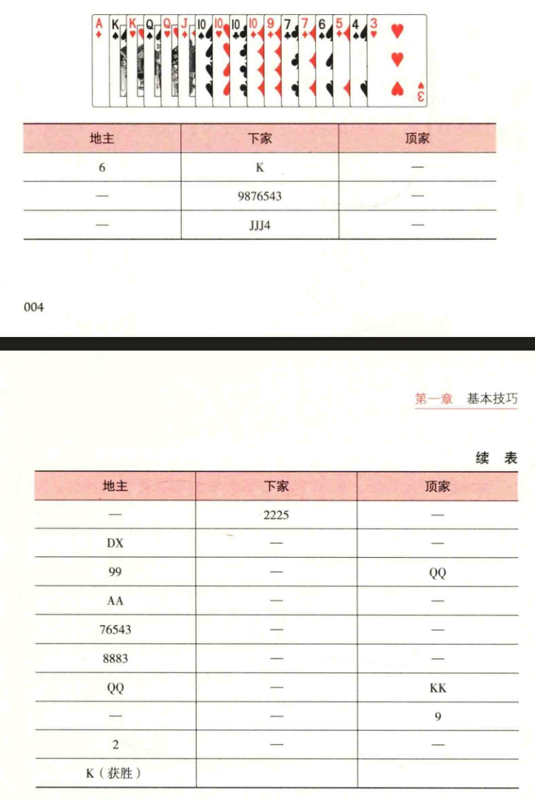

Practice memorizing cards of Q and above.

Practice for 2 hours each day for 2-6 consecutive days.

Advance to the enhanced card-memorizing mode (Note: the interval between each step should be no less than 20 seconds).

Step 1: First, take 5 seconds to find the missing suit cards D, X, 2, 8 (please remember this).

Step 2: The landlord plays a 6, and the next player passes with a K. After the next player plays a K, the player above intentionally delays their turn to eliminate potential opponents (ideally 20 seconds, gradually increasing the speed as they become more familiar with this card-counting method). Silently recite the remaining cards as D X 2 2 2 2 A A A K Q Q (beginners only need to calculate Q and above). Recite silently before playing.

The third step: The player above passes, the landlord passes, and the next player plays 9 8 7 6 5 4 3. No cards above Q have appeared. Continue silently reciting the remaining cards: D X 2 2 2 2 A A A K Q Q. Play a card after reciting.

Step 4: Top player PASS, Landlord PASS, Next player plays JJ 4. No cards above Q have appeared yet.

Continue silently reciting the remaining cards: D X 2 2 2 2 A A A K Q Q. Play a card after reciting.

Step 5: The top player passes, the landlord passes, and the next player plays 2 2 2 5. At this point, cards of Q or higher have appeared and need to be eliminated. Silently recite the remaining cards: D X 2 A A A K Q Q. After reciting, proceed…

Play cards.

Step Six: The top player plays Pass, the landlord plays DX, the next player plays Pass. Cards of Q and above have appeared again. They need to be eliminated. Silently recite the remaining cards: 2 AA AK Q Q. Play cards after reciting.

Step Seven: The top player plays Pass, the landlord plays 9 9, the next player plays Pass. Cards of Q and above have not appeared.

Continue to silently recite the remaining cards: 2 AA AK Q Q. Silently recite the sequence before playing a card.

Step 9: The top player plays QQ, the landlord plays AA, and the next player plays PASS. Cards of Q or higher have appeared again. They need to be eliminated. Silently recite the remaining cards: 2 AK QQ. Silently recite the sequence before playing a card.

Step 9: The top player plays PASS, the landlord plays 7 6 5 4 3, and the next player plays PASS. Cards of Q or higher have not appeared.

Continue to silently recite the remaining cards: 2 AK QQ. Silently recite the sequence before playing a card.

Step 10: The top player plays Pass, the landlord plays 8 8 8 3, the next player plays Pass. No cards higher than Q have appeared.

Continue silently reciting the remaining cards: 2 A K Q Q. Silently recite the sequence before playing a card.

Step 11: The top player plays Pass, the landlord plays Q Q, the next player plays Pass. Cards higher than Q have appeared again and need to be eliminated. Silently recite the remaining cards: 2 A K. Silently recite the sequence before playing a card.

Step 12: The top player plays KK, the landlord plays ASS, and the next player plays ASS. Although cards of Q or higher appear,

since it's your own KK, it's not excluded. Continue silently reciting the sequence; the remaining cards are 2AK. Silently recite the sequence before playing a card.

Step 13: The top player plays 9, the landlord plays 2, declares a single card, and the next player plays ASS. When cards of Q and above appear, they need to be eliminated. Silently recite the remaining cards as A and K. Play a card after reciting.

In the fourteenth step, the top player passes, the landlord's K is discarded, and the landlord wins. Finally, verify that the card counting is correct.

With continuous practice, you will eventually be able to easily remember cards of Q and above, and then you can move on to the next step, "Intermediate Practice Example Cards".

(2) Intermediate Practice Example Cards
This is the top player's hand. The playing process is as follows:

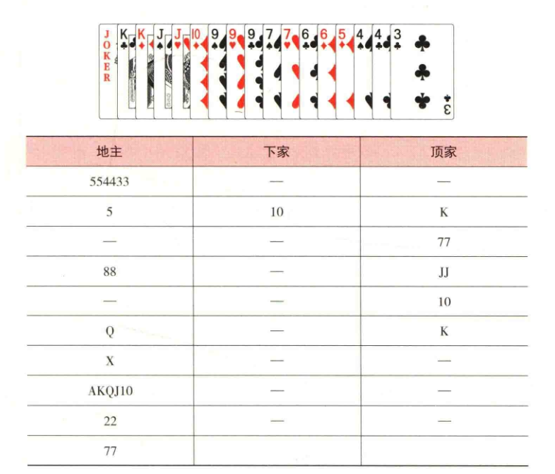

Practice memorizing cards of 8 or higher.

Practice for 2 hours each day for 10-20 days.

Advance to the enhanced card-memorizing mode (Note: the interval between each step should be no less than 20 seconds).

Step 1: First, take 5 seconds to find the missing suit cards: X2 AQ8 (Please remember this).

Step 2: The landlord plays 554433, and the next player passes. The player at the top intentionally delays their turn to eliminate cards (ideally 20 seconds, gradually increasing the speed as they become more familiar with this card-counting method). Since cards 8 and above haven't appeared, no elimination is needed. The player at the top silently recites the remaining cards: X 2 2 2 2 A A A A K K Q 0 Q Q J J 1 0 1 0 1 0 9 8 8 8 8. They then play their card. Step 3: The top player passes, the landlord plays a 5, and the next player plays a 10. Cards of 8 or higher must be eliminated. Silently recite the remaining cards: X 2 2 2 2 A A A A K K Q Q Q Q J 1 0 1 0 9 8 8 8 8. Then play a card.

Step 4: The player to the left plays K, the landlord passes, and the next player passes. K is a card played by the player to the left, so no action is taken.

Continue silently reciting the remaining cards: X 2 2 2 2 A A A A K K Q 0 0 Q J 1 0 1 0 9 8 8 8 8. After silently reciting, play a card.

Step 5: The player to the left plays 7 7, the landlord plays 8 8, and the next player passes. Cards of 8 or higher must be played.

Silently recite the remaining cards: X 2 2 2 2 A A A A K K Q Q 0 Q J J 1 0 1 0 9 8 8. After reciting, discard and play another card.

Step Six: The top player plays J, the landlord passes, the next player passes. Silently recite the remaining cards: X 2 2 2 2 A A A A K K Q 0 Q Q J J 1 0 1 0 9 8 8. After reciting, play another card.

Step Seven: The top player plays 1 0, the landlord plays Q, the next player passes. If a card of 8 or higher appears, it needs to be eliminated. Silently recite the remaining cards: X 2 2 2 2 A A A A K K Q Q Q J 1 0 1 0 9 8 8. Play a card after reciting.

Step 8: The top player plays K, the landlord plays X, and the next player passes. If a card of 8 or higher appears, it needs to be eliminated. Silently recite the remaining cards: 2 2 2 2 A A A A K K Q Q Q J 1 0 1 0 9 8 8. Silently recite the sequence before playing a card.

Step 9: The top player passes, the landlord plays AK QJ 1 0, the next player passes. Cards of 8 or higher must be eliminated. Silently recite the remaining cards: 2 2 2 2 AA AK Q Q J 1 0 9 8 8. Silently recite the sequence before playing a card.

Step 10: The top player passes, the landlord plays 2 2, reporting a pair, the next player passes. Cards of 8 or higher must be eliminated. Silently recite the remaining cards: 2 2 A A A K Q Q J 1 0 9 8 8. Play a card after reciting it.

In the tenth step, the top player passes, the landlord plays 7 7, and the landlord wins. Finally, verify that the card counting is correct.

With continuous practice, you will eventually be able to easily remember cards of 8 and above, and then you can move on to the next step, "Advanced Practice Example Cards".

(3) Advanced Practice Example Cards
This is the top player's hand. The playing process is as follows:

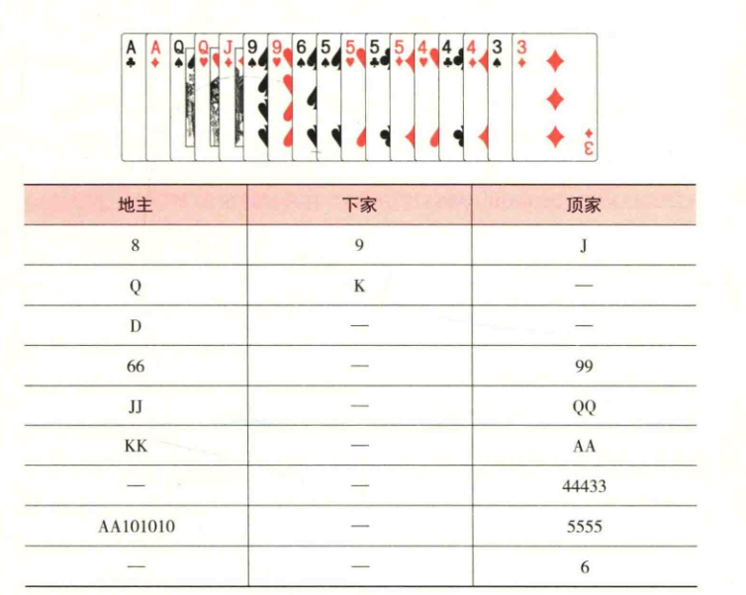

Practice memorizing all the cards.

Practice for 2 hours each day, 20-30 days is sufficient.

Advance to the enhanced card-memorizing mode (Note: the interval between each step should be no less than 20 seconds).

Step 1: First, take 5 seconds to find the missing suit cards: D X 2 K 1 0 8 7 (please remember this).

Step 2: The landlord plays 8, then the elephant plays 9. After the next player plays a 9, the player before them deliberately delays their turn to eliminate potential opponents (ideally 20 seconds, gradually increasing the speed as they become more familiar with this card-counting method). At this point, the player before them silently counts down the missing suit card, 8, which has now appeared, and refreshes the missing suit to DX 2 K 1 0 7. Then silently recite the remaining cards: D X 2 2 2 2 A A K K K K Q Q J J 1 0 1 0 1 0 1 0 9 8 8 8 7 7 7 7 6 6 6 4 3 3. After reciting, play a card.

The third step: the top player plays J, the landlord plays Q, and the next player plays K. Silently count the remaining cards: D X 2

2 2 2 A A K K K Q J J 1 0 1 0 1 0 1 0 9 8 8 8 7 7 7 7 6 6 6 4 3 3. Keep this count under 20 seconds. Play a card after counting.

Fourth step: Top player PASS, Landlord plays D, Next player PASS. Silently count the remaining cards:

X 2 2 2 2 A A K K K Q J J 1 0 1 0 1 0 1 0 9 8 8 8 7 7 7 7 6 6 6 4 3 3, time control is above 20 seconds. Although only one D was played, this time control pattern needs to be developed during intensive practice. Silently recite the next card before playing.

Step 5: Top player PASS, Landlord plays 6 6, Next player PASS. Silently recite the remaining cards:

X 2 2 2 2 A A K K K Q J I 1 0 1 0 1 0 1 0 9 8 8 8 7 7 7 7 6 4 3 3, keeping the time above 20 seconds. After reciting,

play a card.

Sixth step: The top player plays 9 9, the landlord plays J, and the next player plays PASS. Silently count the remaining cards:

X 2 2 2 2 A A K K K Q J 1 0 1 0 1 0 1 0 9 8 8 8 7 7 7 7 6 4 3 3, keeping the count at least 20 seconds. Play your cards after counting.

In the seventh step, the landlord plays QQ, the next player plays KK, and the player after them plays PASS. Silently count the remaining cards in the deck:
X 2 2 2 2 A A K Q J 1 0 1 0 1 0 1 0 9 8 8 8 7 7 7 7 6 4 3 3. Keep this count under 20 seconds. Play your cards after counting.

In the eighth step, the top player plays AA, the landlord plays PASS, and the next player plays PASS. Silently count the remaining cards:

X 2 2 2 2 A A K Q J 1 0 1 0 1 0 1 0 9 8 8 8 7 7 7 7 6 4 3 3, keeping the count at least 20 seconds. Play a card after counting.

In the ninth step, the top player plays 4 4 4 3 3, the landlord plays AA 1 0 1 0 1 0, and the next player passes. Silently count the remaining cards: X 2 2 2 2 K Q J 1 0 9 8 8 8 7 7 7 7 6 4 3 3. Keep this count under 20 seconds. Play a card after counting.

Step 10: The top player plays 5 5 5 5, indicating a single card left. The landlord passes, and the next player passes. The remaining cards on the outside are X 2 2 2 2 K Q J 1 0 9 8 8 8 7 7 7 7 6 4 3 3 (these remaining cards are the sum of the landlord's and the next player's remaining cards). If you compare the landlord's and the next player's cards and find no mistakes, then you have memorized all the cards. After you are proficient in memorizing all the cards, practice deduce the hand types of the two players.

II. Practice.

Deducing Card Patterns

Once you feel that remembering the cards is easy enough, the next step is to deduce the card patterns based on your card counting skills.

1. Basic Deduction

When you don't have a 4, and the next player plays a single 4, simply memorizing the cards only means remembering that there are still 444s on the outside. Deduction requires, based on card memorization, judging the distribution of card types on the outside.

For example, if you don't have a 4, and the next player plays a single 4, you can initially deduce that the previous player had a 444, and so on.

2. Intermediate Deduction

If you have a hand of D 2 • • • • • 8 7 6 6 6 4 3, and haven't seen a 5 yet, and if the player to your left has played 3 3, 4, 7 7, and the player to your right has played a single 4, then you need to make a preliminary deduction: You don't have a 5 5 5 5 bomb, and the player to your right has a straight containing 7 6 5 4 3. Note: This is only a preliminary deduction; you need to decide whether to change your preliminary judgment based on the subsequent plays. 3. Advanced Deduction

The top player plays 1010, the landlord chooses to pass, the top player plays a single card 8, the landlord continues to pass, the top player

plays an A, the landlord plays a 2, the top player plays an X, the landlord plays a D, the next player and the top player pass, the landlord plays AKQJ1O, reporting a double.

If the top player has a bomb, can you deduce whether the landlord still has one? If you can clearly answer "can bomb" or "should bomb", then what about 2? At this point, is it possible to "bomb" the landlord? This basically means you already possess high-level deduction ability.

Why do I say you can bomb?

If your answer is yes, when the landlord plays 1010 before the top player, the landlord chooses PASS. If the landlord has 22, to prevent being bombed, they should play 22 to suppress it, then play A, K, Q, J, 1, O, and finally finish with D + a single card to prevent a bomb. Therefore, the landlord should only have one 2, and has already played it. In that case, you can be considered to have advanced deduction ability.

Why say you can't bomb? If your answer is that when the top player played 1010, the landlord deliberately didn't play 22, waiting for the top player to play a single card. The landlord then deliberately split the 2, playing 2 to let X bet on it, and then the landlord used D to bet on X. Finally, the landlord reported 2+single, misleading the farmers into thinking that the landlord couldn't possibly have 22, and ultimately tricking the farmers into revealing their bomb. Therefore, the landlord may very well still have 2.

Therefore, I firmly believe you already possess superior deductive reasoning abilities!

III. Offensive Strategy

A good start is half the battle. In the game of Landlord, mastering offensive skills is extremely important. As the Landlord, you must be able to handle everything on your own and be fully aware of every card you play, especially your first card. Because everyone, as the landlord, has a general idea of ​​how to play their cards after receiving them. If this idea is disrupted, the player often loses their composure and may even make mistakes later. As the first player, the attacker has many unknown cards to play and must adhere to their own strategy. In the later stages of a game, when unexpected events occur and fewer cards remain, it's easier to calculate and plan.

However, at the beginning, everything is unknown,

and once an unexpected event occurs, it's difficult to make correct judgments. If the first player is even slightly careless,

the farmer could seize the opportunity to disrupt the hand or even steal the win.

In actual gameplay, it often happens that the landlord has a large hand of cards and bombs, but because they didn't play their first card well, the opponent steals the lead. Moreover, in this situation, the peasants' cards are often quite extreme, and the landlord often gets countered or loses their bomb. Therefore, we should strive to determine the best offensive direction by analyzing our existing hand.
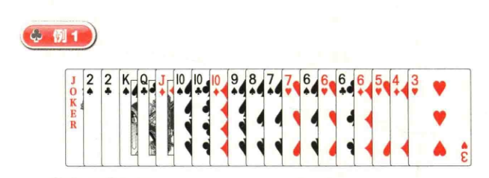

First Attack: 3 or 1010.

Playing Strategy: Discard any extra cards first.

Advantages of Playing 3: The landlord plays 3 to play K, testing the distribution of Aces, then waits for 77 or 1010 before playing 22. If the Aces form a bomb, the landlord's straight might become a big hand; if the Aces don't form a bomb, the straight will be taken away.
The landlord can use 6666 to bomb, then play a single card and use a D to take it back, then declare a single card.

The advantage of playing 1010: Since the landlord is missing a suit and only has an Ace, the probability of forming a bomb is relatively low. If the landlord plays 1010 and then plays 22 to take it back, and there is no Ace to bomb, the landlord's win is more direct.
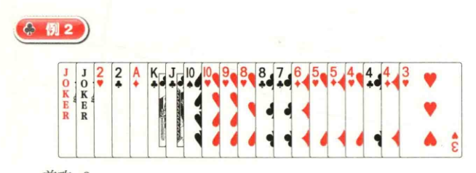

Attack: 8.

Playing strategy: Discard excess cards first. If the landlord can pass with a single card A K, and then play consecutive cards J 1 0 9 8 7 6 and 4 4 4 3, then you can discard the two Kings to finish with 5 5 + 2 2 + a single card. If the peasants directly play a 2, the landlord should ideally distribute the Kings (more single cards, no control over the hand), to prevent the peasants from playing pairs or other card types.
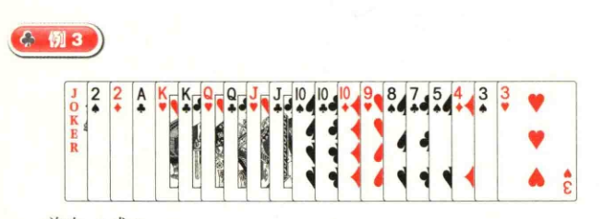

First attack: 5 or 4.

Playing strategy: Discard any extra cards first. If the other player plays a card lower than 10, the landlord can pass with a 10. If the other player plays a card higher than 10, the landlord can play an Ace or a King.

Advantages of playing Ace: The landlord plays Ace to distribute the peasants' 22, leaving D 2 2 K K Q Q J 1 0 1 0 1 0 9 8 7 5 (or 4) 3 3. K K or Q Q may play a role in advancing (using the hand to play a small card after playing a small card).
Advantages of playing K: The landlord plays K to distribute the peasants' 2 2, leaving D 2 2 A K Q Q J 1 0 1 0 1 0 9 8 7 5 (or 4) 3 3. After passing 1 0, adapt to the situation based on the other side's play.
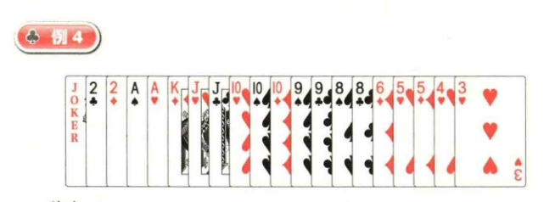

First attack: 4.

Playing strategy: Discard excess cards first. 101010 could be considered with a 3, so play 4 first, then K. If the outside keeps playing single cards, you can split 99 or J first.
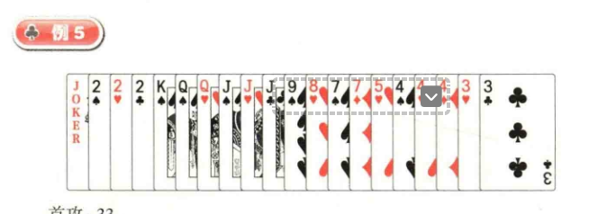

First attack: 3 3.

D 2 2 2 J J 9 8 5 4 4 4 Control the board.

Playing strategy: First discard the weakest card. Hopefully 7 7 and 0 0 can successfully pass through, then wait for the K to pass, and the rest…
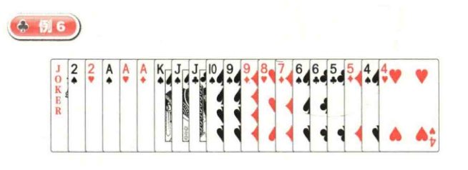

First Attack: 6 6 5 5 4 4.

Playing Strategy: Anti-Spring Awareness Play. If no one from the peasant faction responds to 6 6 5 5 4 4, the landlord can consider playing J or a straight of J1 0 9 8 7.

Advantages of Playing J: After playing J, wait for K to pass, then immediately play X. The remaining cards are 2 2 and AA 9, controlling singles, pairs, and three-of-a-kind. J1 0 9 8 7 can be used to finish the hand.

Disadvantages of playing J10987: If there's a bomb (four of a kind) outside, J10987 might become useless.

Advantages of playing J10987:

① It allows you to cash out your missing suit, the Queen. If the farmers make a bomb with the Queen, they lose J10987.

② If you cash out the Queen, you won't lose winning opportunities later on because you need to consider making a bomb with the Queen.

③ Even if Q doesn't become a bomb, J 1 0 9 8 7 might still be a big card, preventing the peasants from passing Q or K. You can directly play K, ending the hand in the pattern 2 2 + AA 9 + ].

Disadvantages of playing J 1 0 9 8 7:

① It might force the peasants to play small single cards. For example, if the next player's hand is D 2 0 J 1 0 9 9 8 5 5 … • … and they play a 9, the landlord's single card is K J 9, which must be passed by either J or K. The next player successfully passes by with a 2.

② Loses the opportunity to play a straight. If the next player's hand is D A K K K Q Q 1 0 9 8 7 7 6 6 5 4 3, and if the landlord plays a straight first and then a single card, the next player can play an A and then immediately play a D, ending with a straight first and then K K K Q Q.
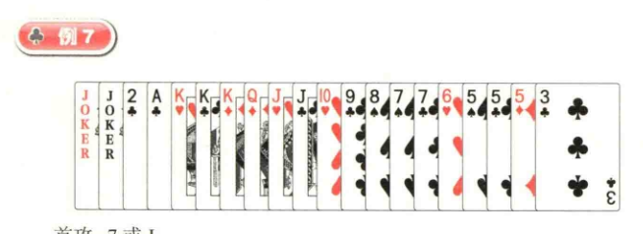

First card: 7 or J.

Playing strategy: Play the extra cards first. Because 555 can be played with one card, don't play the smallest single card, 3. KKK

You can decide whether to keep KKK or pass KK and play AK in a straight based on the subsequent card plays.
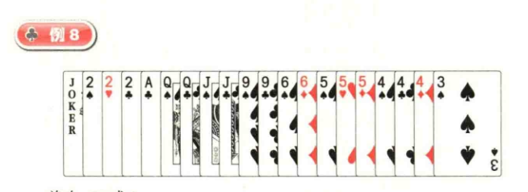

First Attack: 99 or 3.

Playing Strategy: Discard any extra cards first.

Advantages of playing 99: Prevents the peasant from passing with a small pair.

Advantages of playing 3: Prevents the peasant from passing with both a pair and a single card (if you play a pair, the next player might pass with a pair, then play a large pair, causing the player to discard a small single card; actually, this allows the next player to pass with several pairs and also discard a small single card).
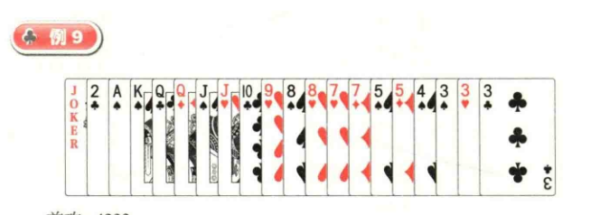

Attack: 4 3 3 3.

Playing strategy: Discard excess cards first.

Advantages of playing 4 3 3 3: Strategic. If the next player has a three-of-a-kind with a pair (e.g., AA), don't play AA first to allow the previous player to play a smaller three-of-a-kind. If the previous player doesn't have a three-of-a-kind and takes the lead, the landlord's 4 3 3 3 will easily win.
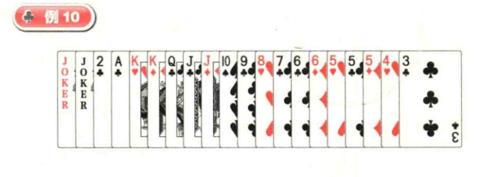

First Attack: J or 6.

Playing Strategy: Discard any extra cards first.

Advantages of playing J: Prevents the next player from passing single cards below J first. For example, if the next player's hand is 2 A K Q J 1 0 1 0 8... and the top player's hand is 2 2 A A K Q... If the landlord plays 6 first, the next player passes 8, the top player plays K, the landlord plays 2 then J, the next player plays 2, and finally, only 10 remains. The landlord can only use DX to bomb and play 5 5, allowing the top player to play. If the landlord plays J first, the next player might not immediately play 2, but instead let the top player play K. The landlord plays 2 and then 6, the next player plays 8, and if the top player plays 2 and then a pair, the landlord has a chance to pass 5-5.
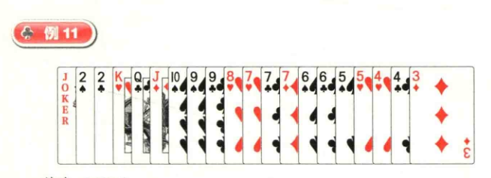

First Attack: 6 6 5 5 4 4.

Playing the card: Effectively prevents a counter-attack. If the opponent cannot follow 6 6 5 5 4 4, play K Q J 1 0 9 8 to see if an Ace appears. If the opponent still cannot follow, play 7 7 7 3, leaving D 2 2 9.

First Attack: 7 6 5 4 3.

The intended play is K Q J 1 0 9 to take back the lead, leaving D 2 2 9 8 7 7 6 5 4. If the opponent plays A K Q J 1 0 to take the lead, then the bomb effect doesn't need to be considered in this round.
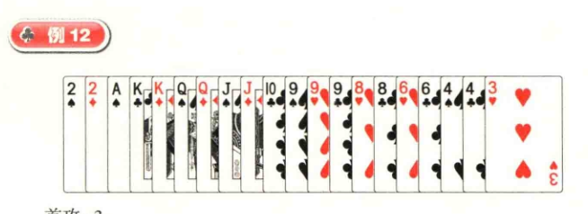

Attack: 3.

Playing strategy: The landlord has no single cards, so discard cards that cannot be controlled first.

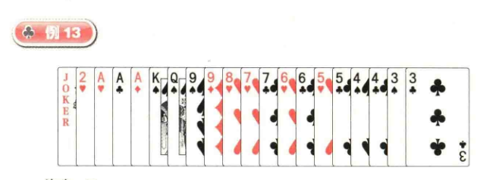

Attack: 9 9.

Playing cards: Concealed card type; the final choice can be 7 6 5 4 3 or 7 7 6 6 5 5 4 4 3 3.
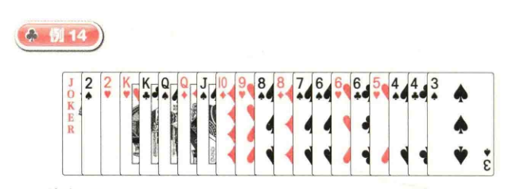

Attacking: 6 6.

Playing strategy: Play 6 6 followed by K K, then check the Ace's situation.
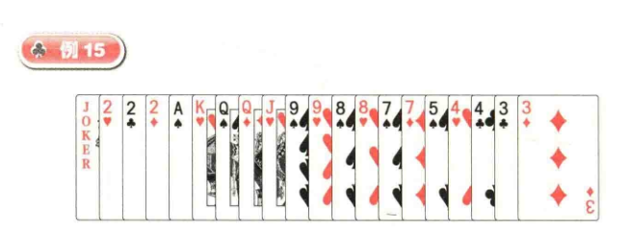

Attack: 3-3.

Playing strategy: First discard cards that are weak against the opponent.

