**User Manual**

**For**

**Sys Admin Tool**

|  |  |
| --- | --- |
| **Document Created By** | Sharmin Akter |
| **Document Verified By** | Shamim Ahmed |
| **Document Version** | 1.0 |
| **Release Date** |  |

Contents

Log on 3

User 3

View User 3

Search User 4

Add User 5

Delete User 6

Modify User 7

PAM Management 8

Unlock User 8

Server Password Reset 10

PAM Server Add & Modify. 11

Add New PAM Server 11

Delete PAM Server 11

Modify PAM Server 12

User Role 13

Delete & Modify User Role. 13

Add or Remove User Role. 14

Logout 15

# Log on

A User ID and password is required to log onto web interface.

* Step-01: Enter User ID & Password for access the System.

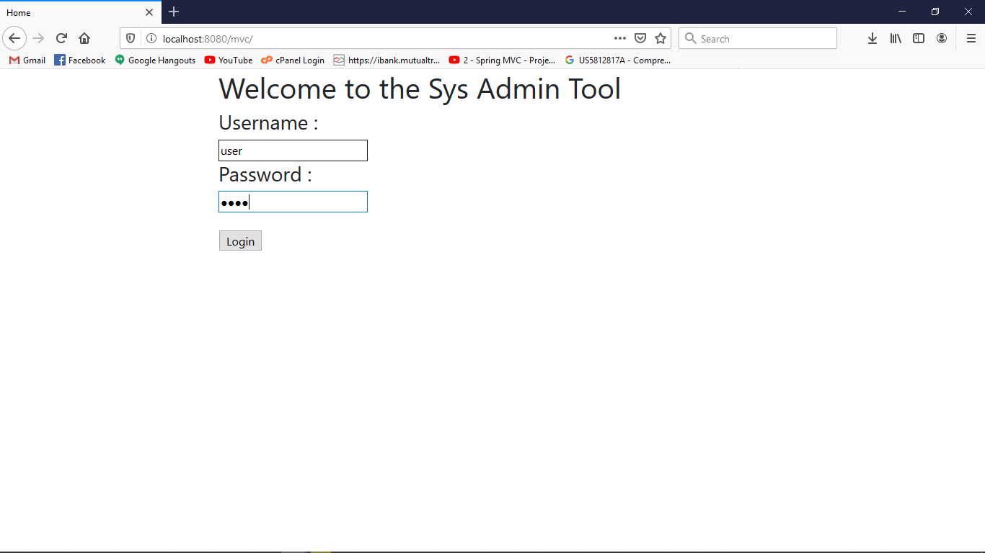

# User

## View User

* 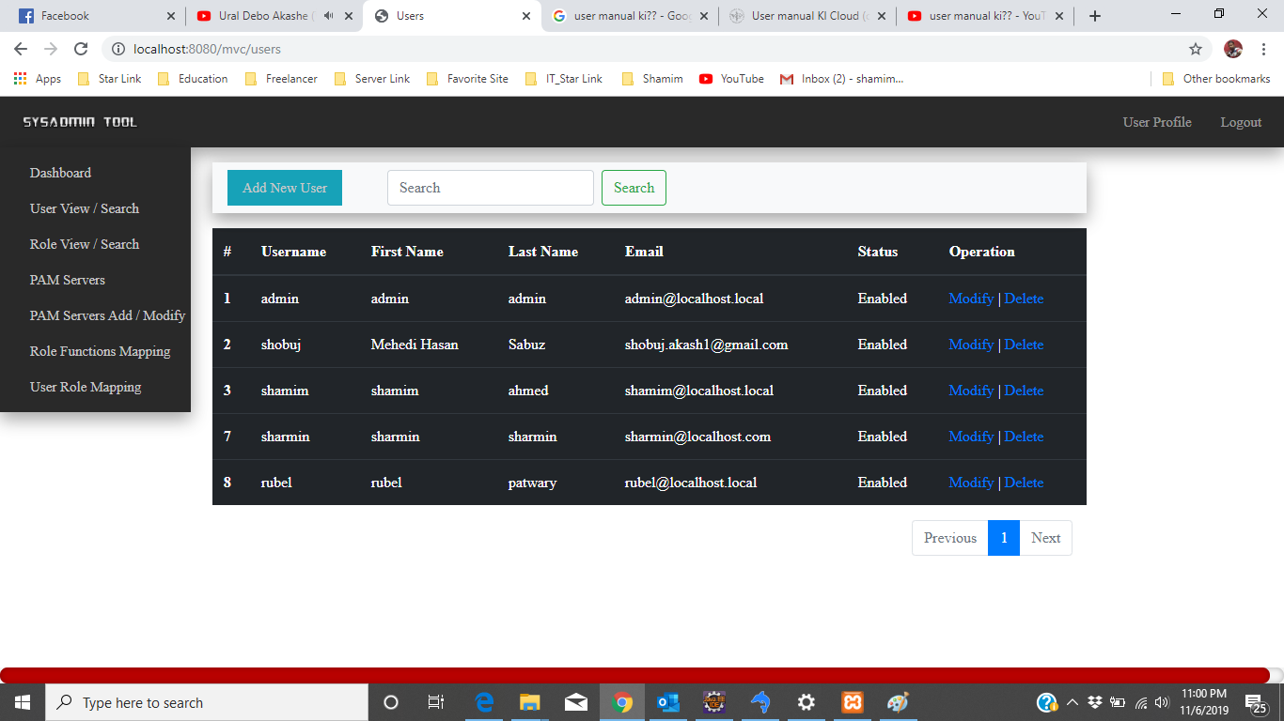Step-01: Click “User View / Search” at the Left in the Dashboard.

Fig-01: View User (Step-01)

## Search User

* 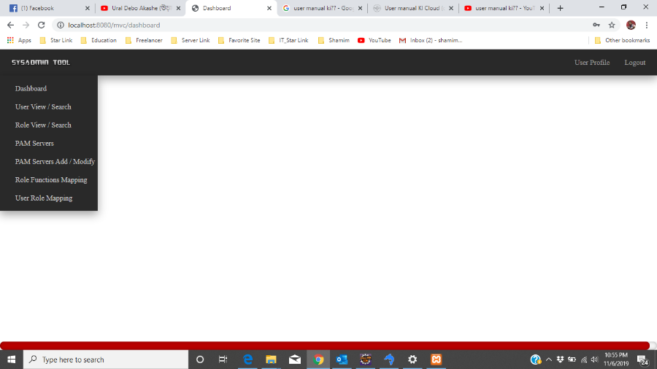Step-01: Click User View / Search at the Left in the Dashboard.

Fig-02: Search User (Step-01)

* 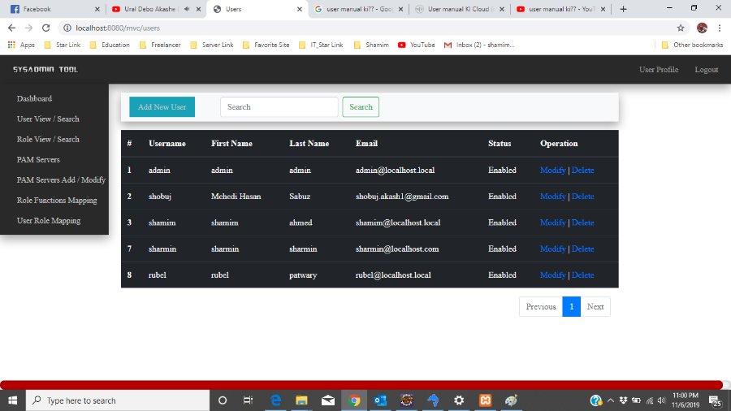Step-02: Enter User ID in Search Box at the top of the view page & Click Search Button.

## Add User

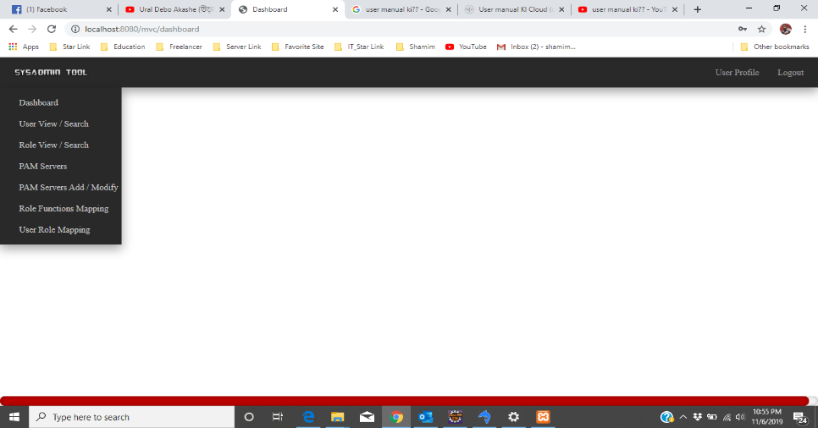Step: 1 Click User View / Search at the Left in the Dashboard.

Fig-01: Add User (Step-01)

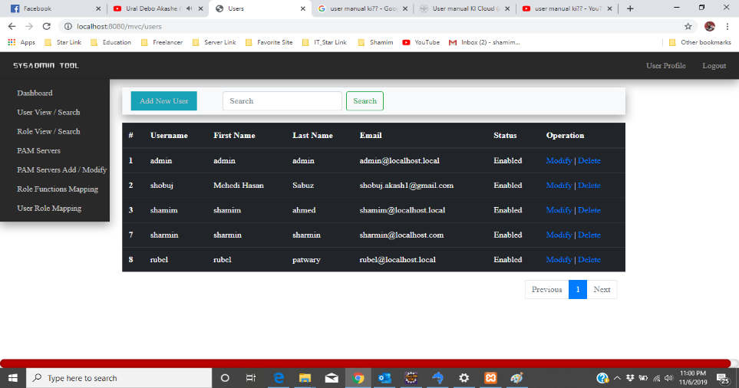Step: 2 Click Add New User at the top of the view page.

Fig-02: Add User (Step-02)

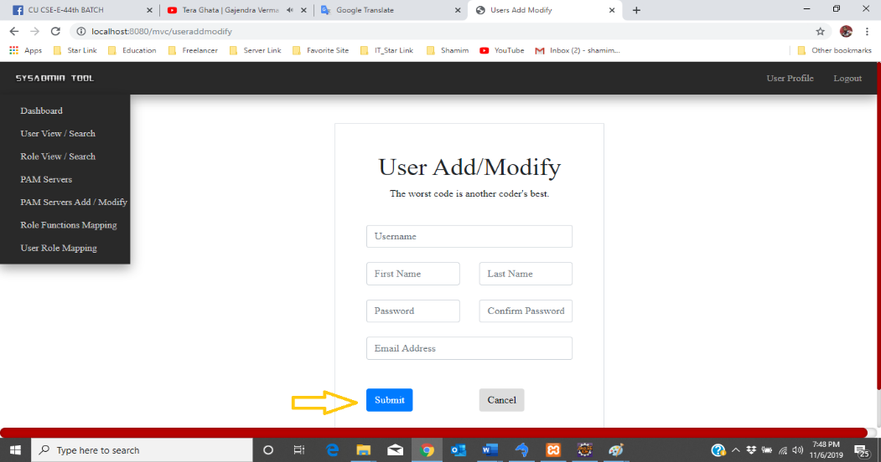Step:3 Fill Up All Required Information in User Add/ Modify Form & Click Submit Button.

Fig-03: Add User Step-03

## Delete User

Step 1: Click User View / Search at the Left in the Dashboard.



Step 2: Click Delete Function Under the Operation Column.



## Modify User

Step 1: Click User View / Search at the Left in the Dashboard.

Step 2: Click Modify Function Under the Operation Column



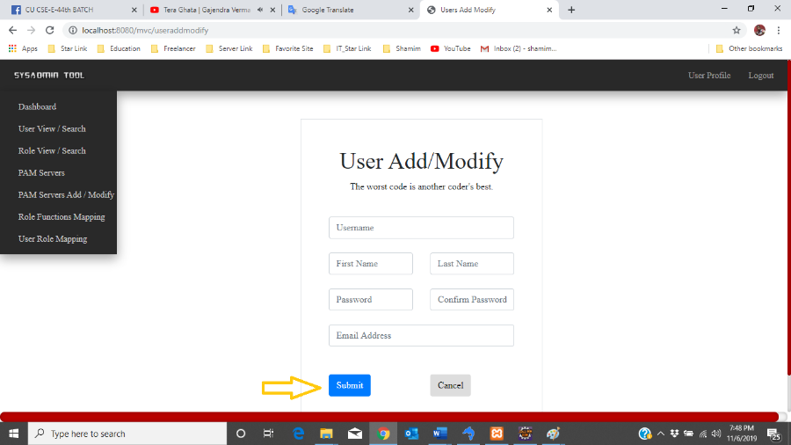Modify User Step 3: Enter your current Information & Click Submit Button.

# PAM Management

## Unlock User

Step 1: Click PAM Server at the Left in the Dashboard.

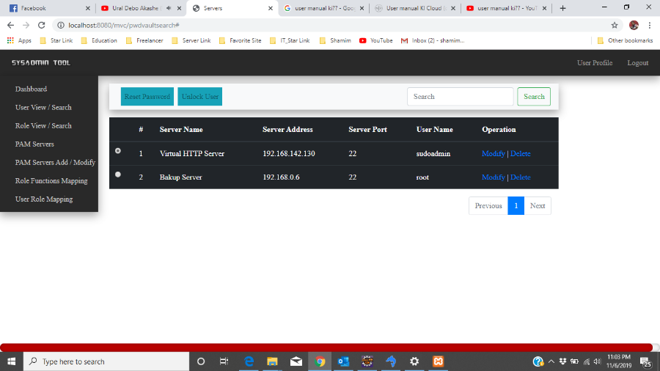Step 2: Check Radio Button in the left in table & Click Unlock Button in top of the page.

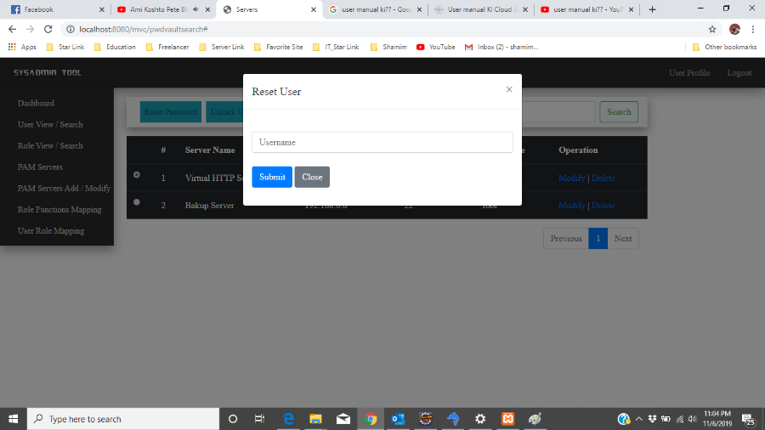Step 3: Enter User Name & Click Submit Button.

## Server Password Reset

 Steps 1: Click PAM Servers

Step 2: Click Reset Password Button in top of the page.

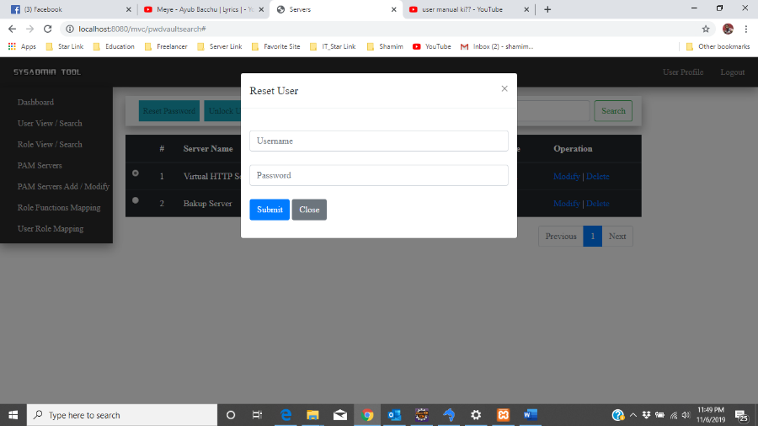Step-3: Enter Server Information & Click Submit Button.

# PAM Server Add & Modify.

## Add New PAM Server

Steps 1: Click PAM Server Add / Modify at the Left in the Dashboard.



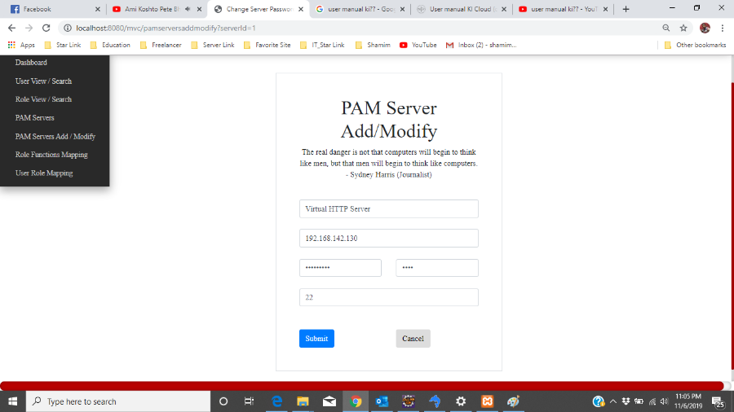Steps 2:

## Delete PAM Server

Step-01: Click on the “PAM Servers” from the left menu bar.

Step-02: Click on the delete button which you want to delete on the right side.

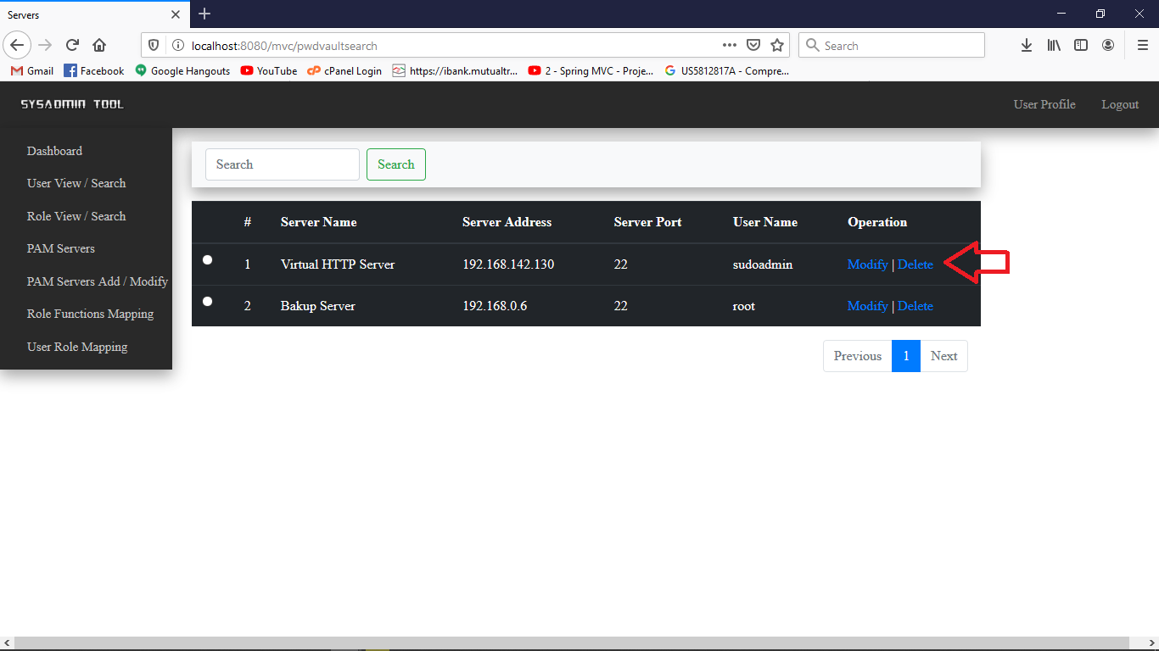

## Modify PAM Server

Step-01: Click on the “PAM Servers” from the left menu bar.

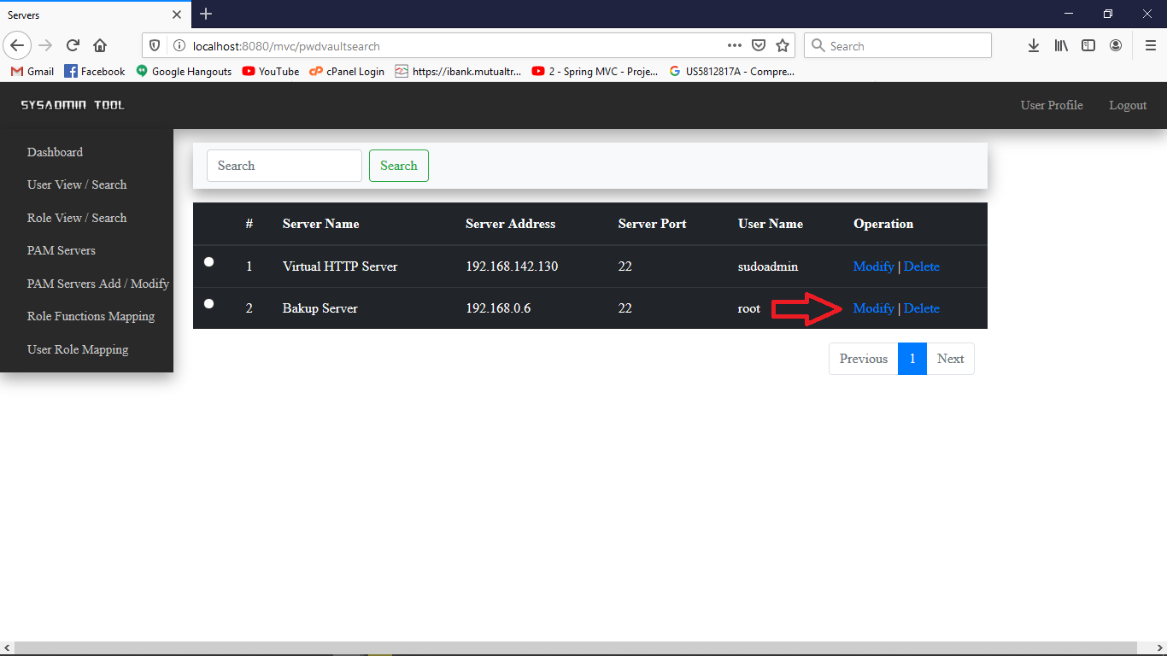 Step-02: Click on the Modify Button on the right side which you want to modify

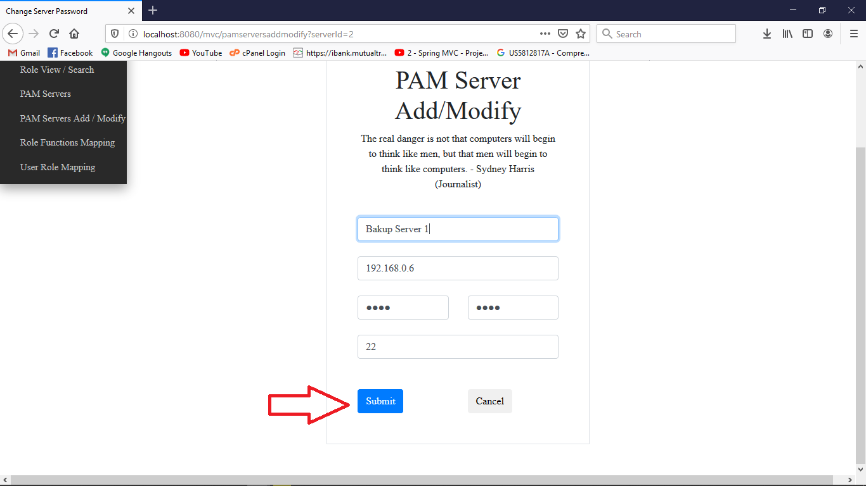Step-03: A new page with the selected server information will appear. Enter necessary information and click on Submit button

# User Role

## Delete & Modify User Role.

Steps 1: Click Roll view / Search at the Left in the Dashboard.

Steps 2: Click Modify or Delete as you like operation Under the Operation Column. & Follow the above 8 & 9 no Instruction.

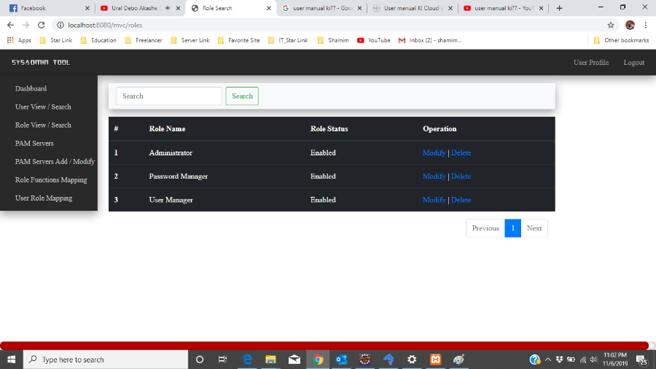

## Add or Remove User Role.

Step-01: Click User Role Mapping at the Left in the Dashboard.

Steps 1: Select User in the dropdown list in the top of the page.

Steps 2: Select role list in the box click &

Steps 3: Click Add or Remove Button in the middle of two box.

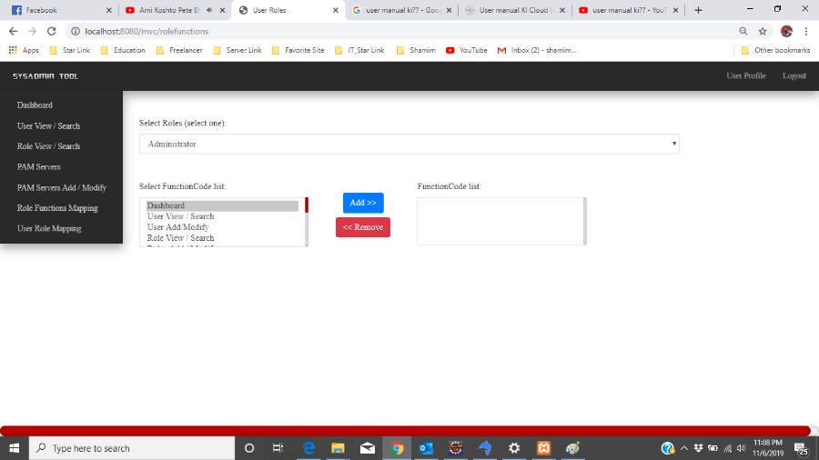

# Logout

Step-01: Click on logout button in right in the main page.