University of Asia Pacific
Computer Science and Engineering

Project Name: Registration System
A third year project for software development course submitted in the fulfillment of requirements.

Submitted by:
Syed Zafrul Bahar (13101062)
Tabia Afrose (15201018)
Shamim Rayhan (15201054)

Submission Date: February 28, 2018
Problem Statement & Solution Plan
Problem statement
Problems that are facing by the users while using the current registration system are as follows.
1. The current system of the university doesn’t allow users to see the prerequisites of some courses. Even some students don’t have any idea about prerequisites.
2. The registration system is not very user friendly. When new students come into our university they and even many current students are also having trouble with the user interface of our current registration system.
3. The current registration system is not very secure in some ways. Students can change their name and many other details. They misuse this facility sometimes.

Solution Plan
Changes that are planned in our registration system are as follows.
1. Our registration system will allow the students to see the prerequisite courses and won’t allow them to register for a course without completing the prerequisite courses or the course.
2. Our registration system will be very user friendly. We tried our best to make a user interface so that students find the interface very friendly.
3. The current registration system is not very secure in some ways. Students can change their name and many other details. They misuse this facility sometimes.

Table of Content

- Introduction
1.1 Motivation
1.2 Purpose

- Database Description
2.1 Description of Each Table
2.2 Relational Data Structures
2.3 ER-Diagram
2.4 Data Dictionary

- Implementation Notes

- Conclusion

1. Introduction

A course registration system for our university students. In this system students can see the prerequisites of courses and according to that they can do their course registration.

1.1 Motivation

The existing registration system that is being used by our university is not well enough as students don’t see anything about prerequisites while they register for their new semester’s courses. So we made a plan to make such a system that helps the students to do their registration while registering for courses.

1.2 Purpose

We planned about this course at the time of our software development course. According to our teacher’s advice our purpose is making a registration system where students can’t take a course without completing their prerequisite courses. Our system will have facilities such as given below.

- Prerequisite Checking
- All Course details such as credit hours and semesters
- Notice board
- Student detail
- Give students no opportunity to change their major details
- Make a good interface for students and administration

2. Database Description

The Database for University Registration System consists of seven tables. They are:

- Student
- Course
- Semester List
- Completed Course
- Prerequisite Course
- Semester Registration
- Semester Result

2.1 Description of Each Table

Student:
The education history and statistics of a student can be found in this table. Including statistics the registration form items also appears here.

Course:
Everything about all the courses of a university can be found in this table. The course name, course code and credit hours can be found in this table.

Semester List:
Every semester’s name can be found in this table. Info about if a semester is running or not is also available in this table.

Completed Course:
From this table we can find the list of completed courses of any student.

Prerequisite Course:
From this table we can find the list of prerequisite courses of any course.

Semester Registration:
From this table we can find the registration history of the students of our university.

Semester Result:
From this table we can find the result of any student and any semester we want.

2.2 Relational Data Structures

Student ( studentID, name, email, batch, pass, sscBatch, sscResult, hscBatch, hasResult )
Course ( courseID, shortName, name, semester, credit)
Semester List ( semesterID , name , isRunning )
Completed Course ( completedCourseID , studentID , courseID, result )
Prerequisite Course ( prerequisiteCourseID , courseID , prerequisite )
Semester Registration ( semesterRegistrationID, semesterID , studentID , courseID )
Semester Result ( semesterResultID, semesterID, studentID, courseID, result )

2.3 Entity Relationship Diagram

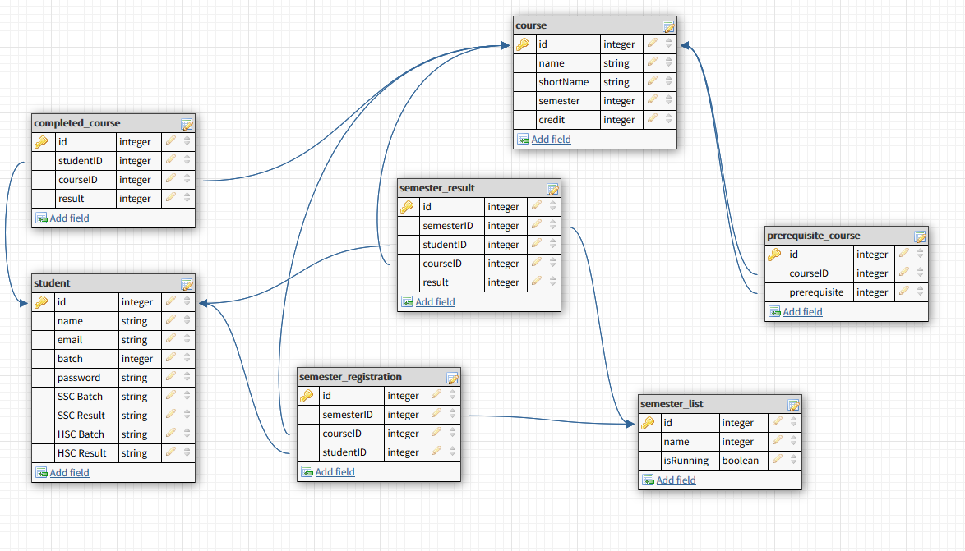

2.3 Data Dictionary

Name used in the system | Description
studentID | The registration id of a student.
sscBatch | The year when a student passed his SSC examination.
sscResult | The result of the SSC exam of a student.
hscBatch | The year when a student passed his HSC examination.
hasResult | The result of the HSC exam of a student.
courseID | The unique number given to a course so we can uniquely identify a course.
shortName | The short name which is also said course code in some places or universities.
semesterID | The unique number given to a semester so we can uniquely identify a semester.
isRunning | If a semester is running or not.
completedCourseID | The entry of a data which is saying that a student has passed a course.
prerequisiteCourseID | The entry of a data which is saying that a course is a prerequisite of another course.
semesterRegistrationID | The entry of a data which is saying that a student has just registered for a course.
semesterResultID | The entry of a data which is saying that a student has got a mark on a particular semester.

3. Implementation Note

For this project we have used some tools and languages.

The tools were:

- Browser (Firefox)
- Visual Studio Code (vscode)
- XAMPP Control Panel

The language list:

- HTML
- CSS
- Javascipt (jQuery)
- PHP

4. Conclusion

We have made a nice interface but we still don’t have huge data that usually any university has. We can make our system perform better with many testing if we get data of a university if some university feels interested in working with us.

