Future Path Caseworker Scenario
Using the Future Path AI Assistant to Support a Youth Transition Plan
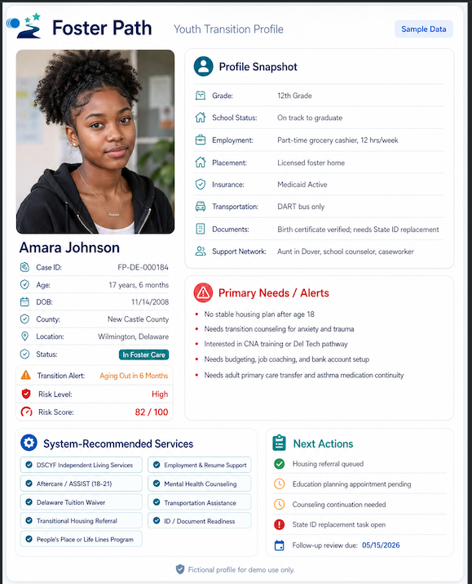
Sample Future Path youth transition profile used for this scenario.

Scenario Overview
Youth Profile: Amara Johnson is a 17-year-old young adult in New Castle County, Delaware. She is 6 months away from aging out of care and has been flagged as high risk with a risk score of 82/100. This scenario shows how a caseworker could use Future Path and the Future Path AI Assistant from intake review through transition planning and follow-up.
Profile Area | Current Status
Caseworker Assigned | Denise Carter, Youth Transition Caseworker
Assigned Youth | Amara Johnson
Age / Transition Timeline | 17 years, 6 months; aging out in 6 months
Education | 12th grade; on track to graduate
Employment | Part-time grocery cashier, 12 hours/week
Current Placement | Licensed foster home
Risk Level | High - 82/100

Primary Needs and Alerts
- No stable housing plan after age 18.
- Needs transition counseling for anxiety and trauma.
- Interested in CNA training or a Delaware Tech pathway.
- Needs budgeting, job coaching, and bank account setup.
- Needs adult primary care transfer and asthma medication continuity.
- Needs state ID replacement.

Start-to-End Caseworker Workflow
Step 1: Review the Youth Profile
Denise opens Amara’s Future Path profile, verifies demographic and transition information, and checks the current risk level, risk score, documents, services, and next actions.
Step 2: Confirm Priority Needs
Denise reviews the Primary Needs / Alerts section and identifies housing, documents, healthcare, counseling, and education planning as top priorities.
Step 3: Start the Future Path AI Assistant
Denise launches the AI Assistant to complete a structured intake session with Amara. The assistant asks targeted questions and records the responses.
Step 4: Review AI Summary
The assistant summarizes Amara’s top needs, risk areas, and recommended resource categories.
Step 5: Build the Action Plan
Denise uses professional judgment to approve recommendations and create a 30/60/90-day transition plan.
Step 6: Track Follow-Up
Denise updates task statuses in Future Path so progress can be tracked and risk can be reassessed over time.

Future Path AI Assistant Intake Session
The assistant asks 7-10 questions to identify needs and recommend resources. The questions are structured so answers can be saved to the database and used by the risk score and recommendation system.
Question Area | Sample Answer | AI Assistant Action
Housing | No confirmed housing after age 18; may stay with aunt but not official. | Flags housing as urgent and recommends housing assistance and transitional planning.
Employment | Works part-time at a grocery store, about 12 hours/week. | Marks partial stability; recommends job coaching and career pathway support.
Education | Interested in CNA training or Delaware Tech. | Recommends Delaware Tuition Waiver, CNA pathway, and education planning appointment.
Transportation | Uses DART bus, but reliability is a challenge. | Flags transportation as a moderate barrier and recommends transportation assistance.
Documents | Birth certificate verified; needs replacement state ID. | Creates urgent ID/document readiness task.
Health | Needs asthma medication continuity and adult primary care transfer. | Recommends Medicaid continuity, adult primary care, and medication planning.
Counseling | Anxiety about aging out and transition uncertainty. | Flags counseling as a high-priority support need.
Support Network | Aunt, school counselor, and caseworker. | Marks support network as present but needing a formal transition meeting.
Financial Readiness | Needs help with budgeting, bank account, and job coaching. | Recommends financial literacy and bank account setup support.
Primary Need | Housing is the biggest concern. | Sets housing stability as the top priority.

AI Assistant Summary Output
Summary Item | Result
Overall Risk Level | High
Top Need | Housing stability
Secondary Needs | Counseling, education planning, documents, healthcare continuity, financial readiness
Priority Focus | Confirm housing plan before age 18 and connect Amara to independent living supports

Recommended Resource Assignments
Need | Recommended Resource | Priority
Housing | DSCYF Independent Living Services | High
Housing | Aftercare / ASSIST 18-21 | High
Education | Delaware Tuition Waiver | High
Employment | Employment & Resume Support | Medium
Counseling | Mental Health Counseling | High
Transportation | Transportation Assistance | Medium
Documents | ID / Document Readiness | High
Life Skills | People’s Place or Life Lines Program | Medium

30/60/90-Day Transition Action Plan
Timeline | Main Focus | Caseworker Actions | Expected Outcome
First 30 Days | Urgent stability | Confirm possible housing with aunt; contact independent living services; start Aftercare / ASSIST referral; begin state ID replacement; schedule counseling continuation; confirm Medicaid and asthma medication coverage. | Housing planning meeting is scheduled, ID replacement is started, and health/counseling continuity is confirmed.
Days 31-60 | Education and employment pathway | Schedule Delaware Tech or CNA information session; review tuition waiver eligibility; create resume; connect to job coaching; open bank account; build monthly budget; review transportation needs. | Amara has a career pathway started, financial readiness support in place, and transportation barriers identified.
Days 61-90 | Final transition readiness | Confirm housing arrangement in writing; confirm adult primary care provider; confirm counseling continuation; confirm education/training plan; confirm ID completion; review safety and support contacts. | Amara has a documented transition plan before aging out, with resources assigned and follow-up dates scheduled.

Follow-Up Tracking
Task | Status
Housing referral queued | In progress
Education planning appointment | Pending
Counseling continuation | Needed
State ID replacement | Open
Follow-up review | 05/15/26

How the AI Assistant Supports the Caseworker
- Asks structured intake questions so important needs are not missed.
- Saves answers to the database for review and reporting.
- Identifies urgent needs such as housing, safety, documents, and healthcare continuity.
- Assigns risk points and updates risk categories.
- Recommends resources based on answers and youth profile data.
- Creates case summaries, supervisor notes, and follow-up checklists.
- Supports caseworker decision-making without replacing professional judgment.

Demo Talking Point
Important: The Future Path AI Assistant is a decision-support tool. It does not replace the caseworker. It helps organize intake answers, identify risk areas, recommend resources, and support follow-up planning while the caseworker remains responsible for final decisions and human judgment.

End-of-Scenario Outcome
- Denise completes Amara’s AI Assistant intake.
- The case shows a high-risk score with housing as the top priority.
- Recommended resources are assigned and reviewed.
- A 30/60/90-day transition plan is created.
- Follow-up tasks are tracked in the Future Path dashboard.
- Amara has a clearer path toward stability before aging out.

