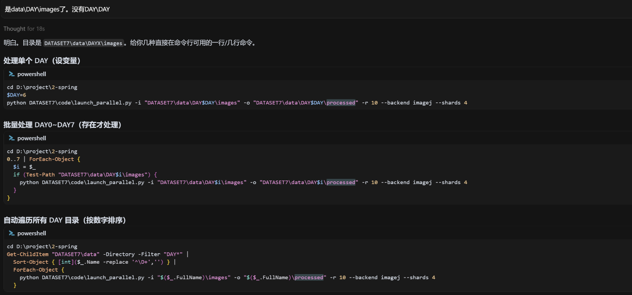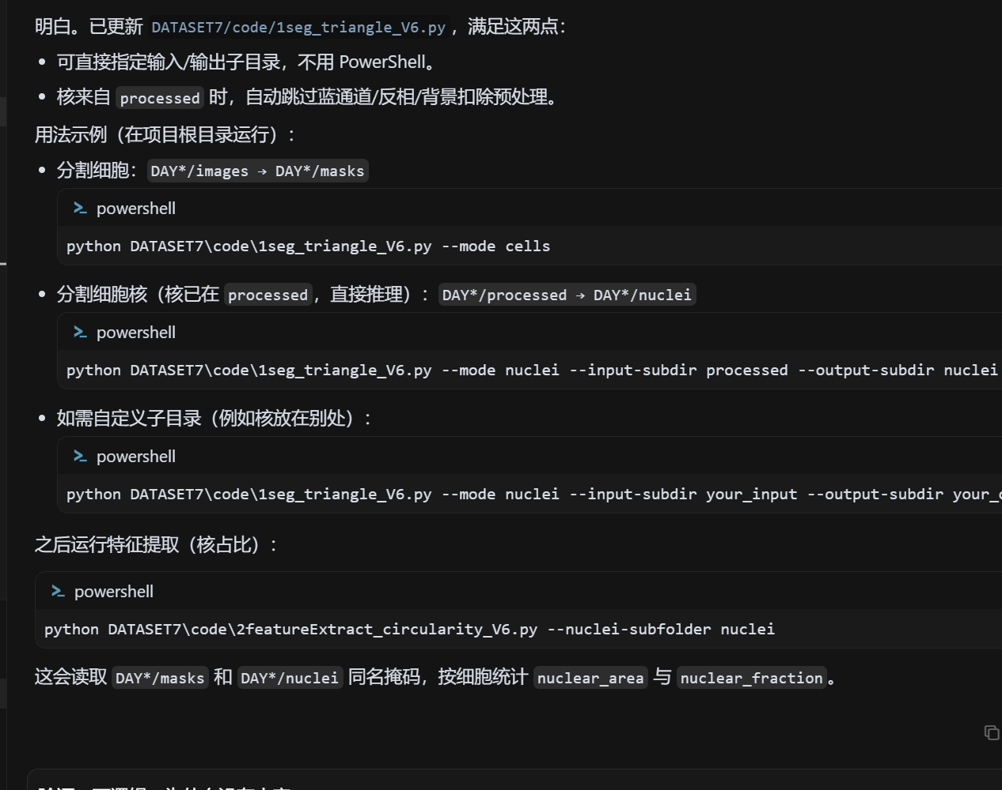

cd D:\project\2-spring

$DAY=6

python DATASET7\code\launch_parallel.py -i "DATASET7\data\DAY$DAY\images" -o "DATASET7\data\DAY$DAY\processed" -r 10 --backend imagej --shards 4

cd D:\project\2-spring

Get-ChildItem "DATASET7\data" -Directory -Filter "DAY*" |

Sort-Object { [int]($_.Name -replace '^\D+','') } |

ForEach-Object {

python DATASET7\code\launch_parallel.py -i "$($_.FullName)\images" -o "$($_.FullName)\processed" -r 10 --backend imagej --shards 4

}

