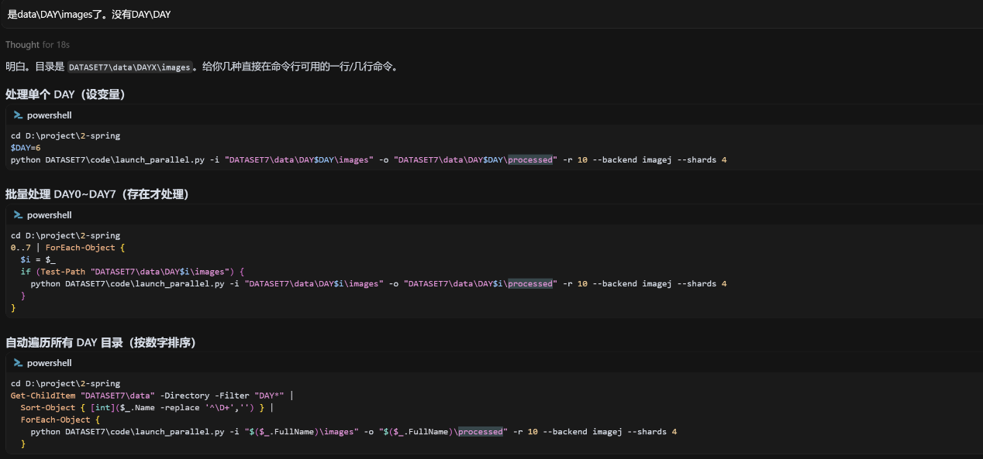
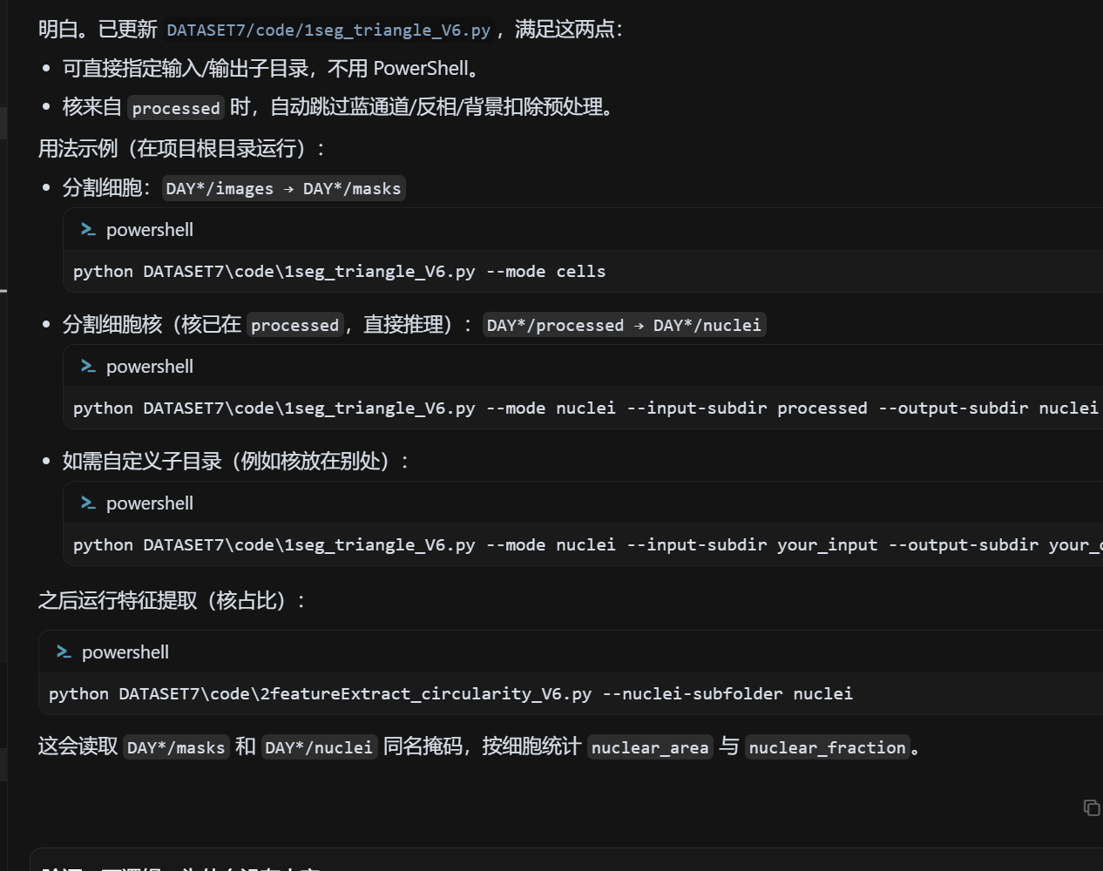
cd D:\project\2-spring
$DAY=6
python DATASET7\code\launch_parallel.py -i "DATASET7\data\DAY$DAY\images" -o "DATASET7\data\DAY$DAY\processed" -r 10 --backend imagej --shards 4

cd D:\project\2-spring
Get-ChildItem "DATASET7\data" -Directory -Filter "DAY*" |
Sort-Object { [int]($_.Name -replace '^\D+','') } |
ForEach-Object {
python DATASET7\code\launch_parallel.py -i "$($_.FullName)\images" -o "$($_.FullName)\processed" -r 10 --backend imagej --shards 4
}
