This report is for performance comparison between SQL and MangoDB methods.

1. Collect performance data from your SQL and MongoDB implementations on the following tasks:

\* Load user database from a CSV file.

\* Load status database from a CSV file.

\* Add a user / status update.

\* Update a user / status update.

\* Search for a user / status update.

\* Delete a user / status update.

For this task from the beginning, I was planning to use build-in function “Timeit” to see what time is required for all operations above for both methods. But then found that I need a graphical representation due to a lot of operations go on…And to show performance differences graphicly for each operation I decided to switch to cProfile method (so “Timeit” method is incomplete and could be updated to work properly but leave it for now due to better method - cProfile). Raw data from cProfile-ing will be attached to the package. To see the raw data use snakeviz xxx.dat – thru the command line.

Final comparison you can see at the table below. All details see next pages.

Same .csv files were used. Same user/status were added, modified and so on, for precise comparison.



Performance: It is obvious that MONGO is much faster in total time to execute all operations above. But as we can see the bigger time obstacle in SQL database is to load “Statuses” into database. Seems create a relation db thru “peewee” with primary and foreign keys is time consuming. But most of the operations (like Search user) in SQL is much faster.

Other technical aspects such as ease of implementation if appropriate.

From my perspective to use MANGO is faster if you familiar how to operate with it. But SQL is more transparent and easier to understand. But in general, those two DB implementations looks similar.

* nvestigate MONGODB:

Search User: 483s

Add User: 355s

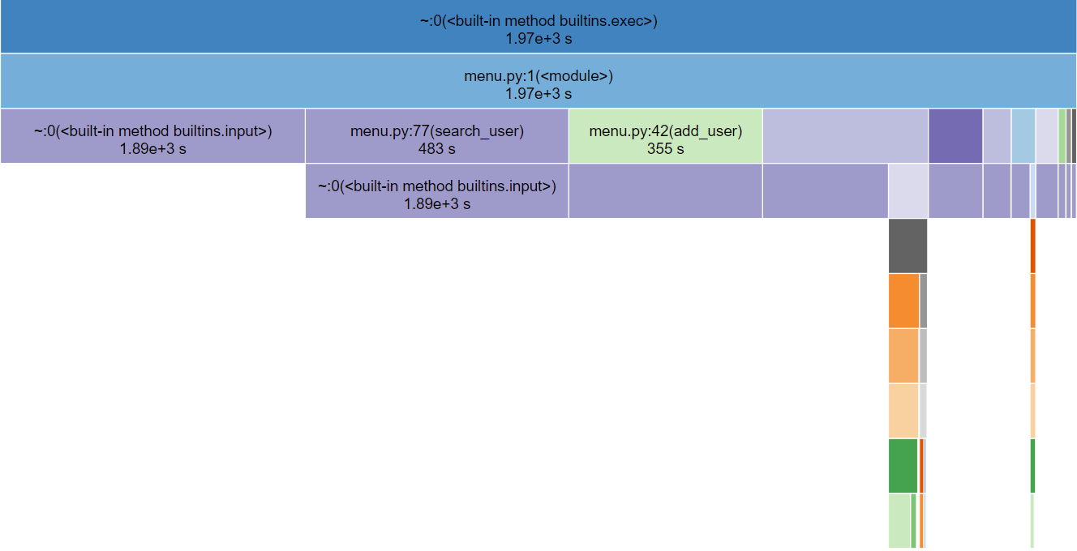

Load Status: 304s 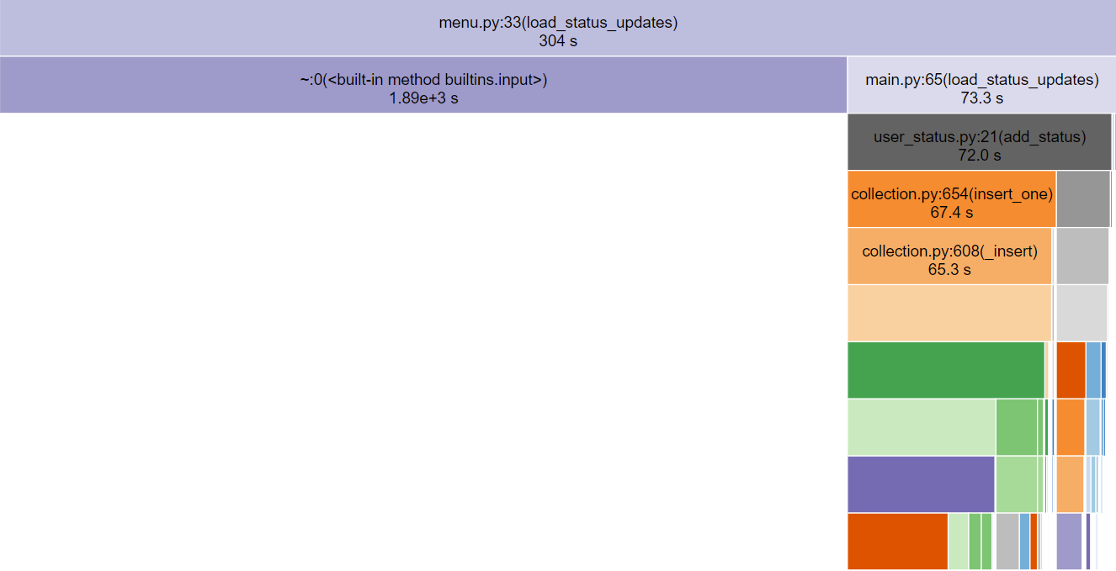

Update User: 100s

Update Status: 51.5s

Load User: 45.2s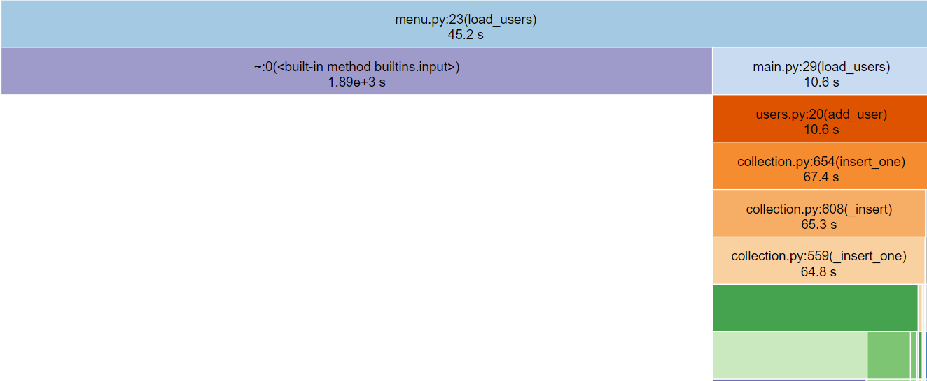

Add Status: 40.8s

Delete User: 14.6s

Search Status: 9.83s

Delete Status: 9.54s

* Investigate SQL DB:

Load Status updates: 2350s

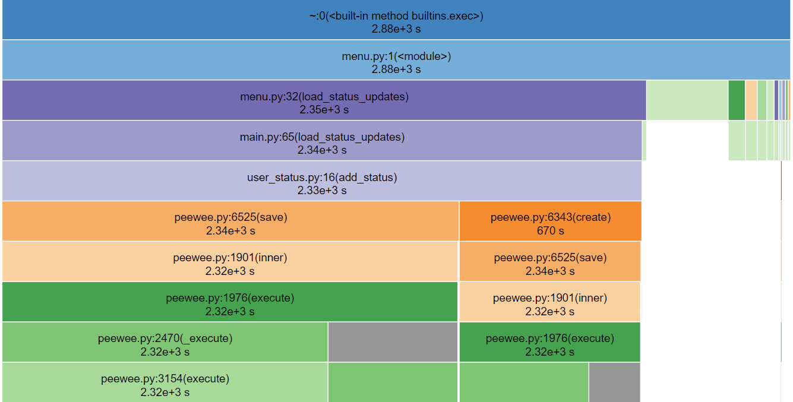

Update User: 62.5s

Add User: 43.2s 

Add Status: 35.1s 

Update Status: 26.6s 

Delete Status: 16.1s



Load Users: 12.5s 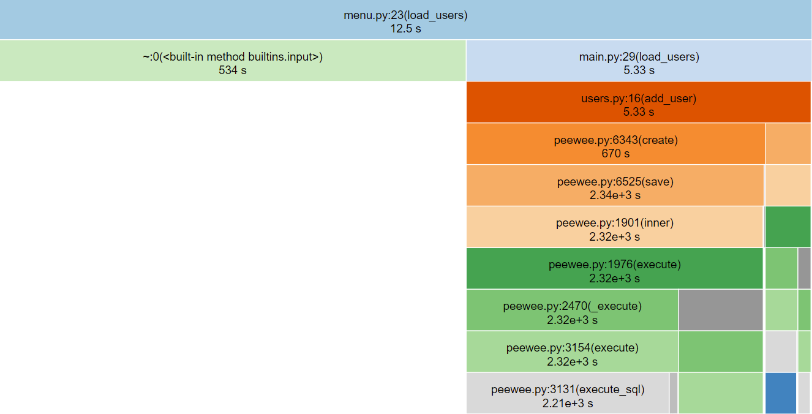

Search Status: 12.2s 

Search User: 10.3s



Delete User:8.58

