Tips:

Run function from Terminal: python -c "import Proba; Proba.load_users()"

Pip instalPylint and Flake8 – checking stile of the script

<https://docs.python.org/3/library/tempfile.html>

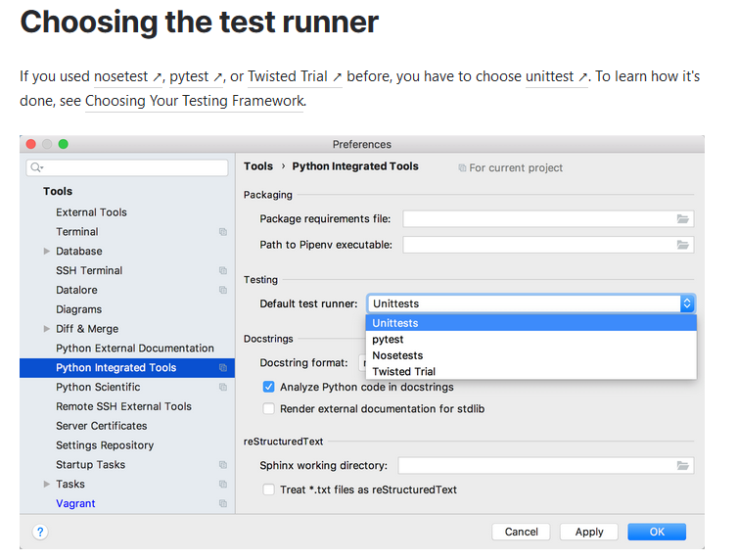

Pip install coverage or pylint or flake8

**Mock:** Replace data to perform test correctly

**for homework**

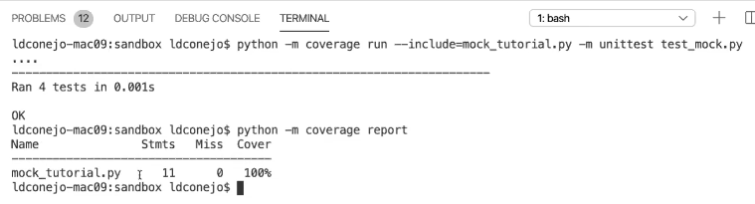

coverage run –m pytest users.py user_status.py

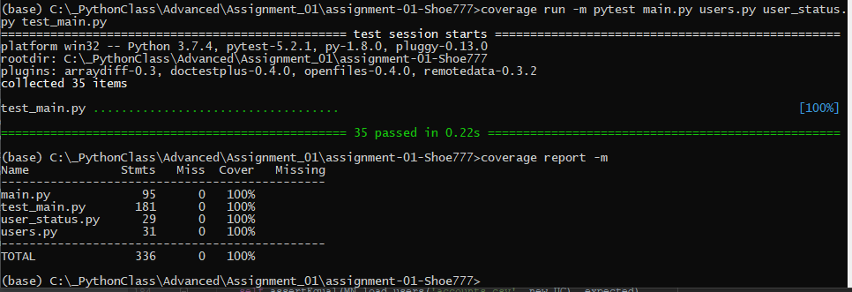  **Prompt Anaconda**

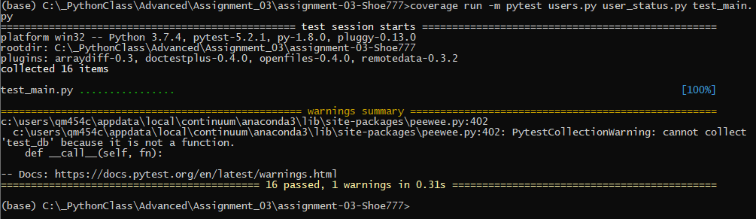

**Patch:** additional functionality to Mock. Can even replace Mock

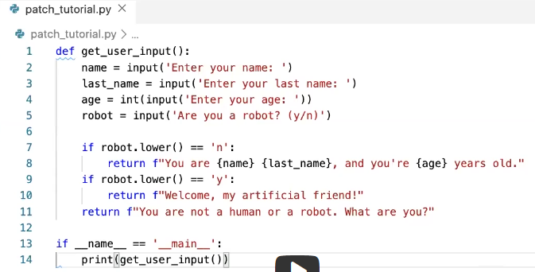

For test purpose:

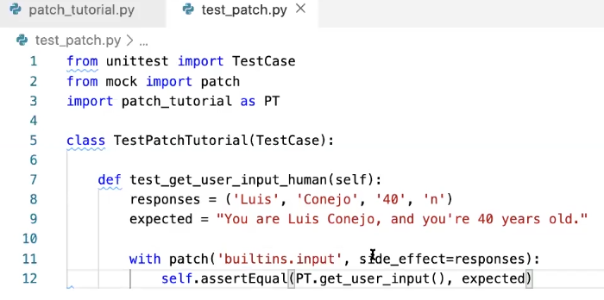

Next example: first file

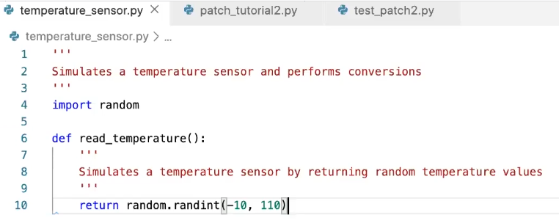

Second file

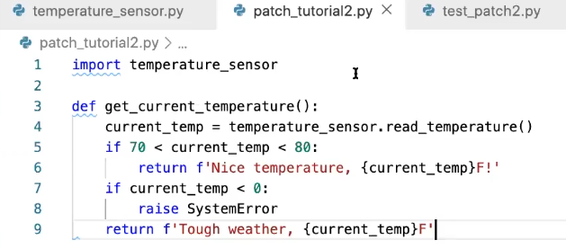

Combine in one test file:

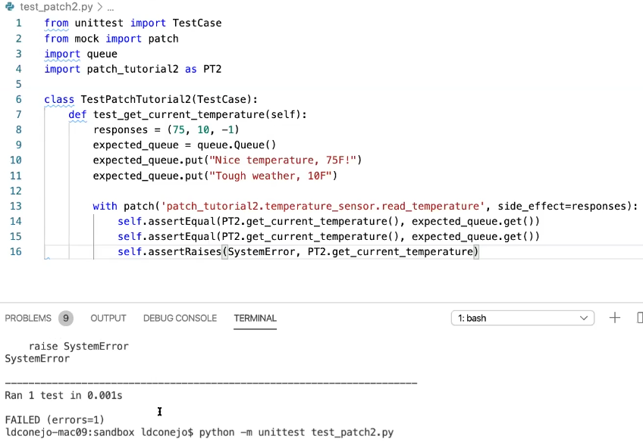

Don’t add parentheses (), script will crushed

Different way how to Raise Error

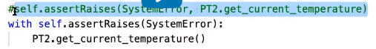

Important Notes:

“PT2” - > module overwriting doesn’t work with Patch function!!! Need to use module’s name, see below.

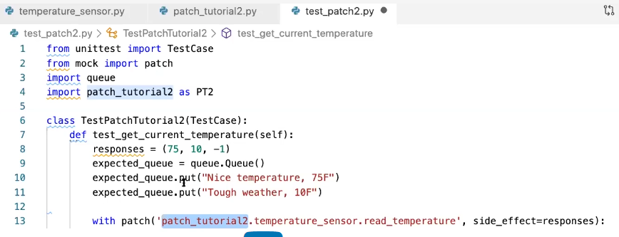

How to use PATCH in decorator:

At HW we are interesting at patch_tutorial2.py

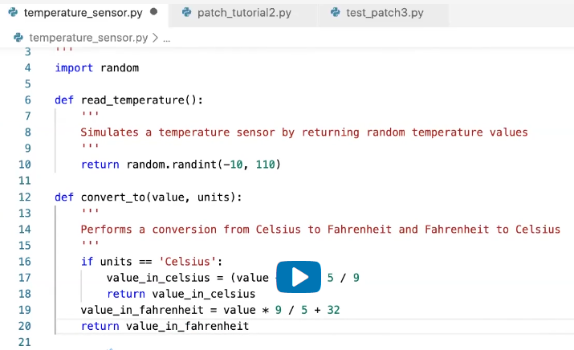

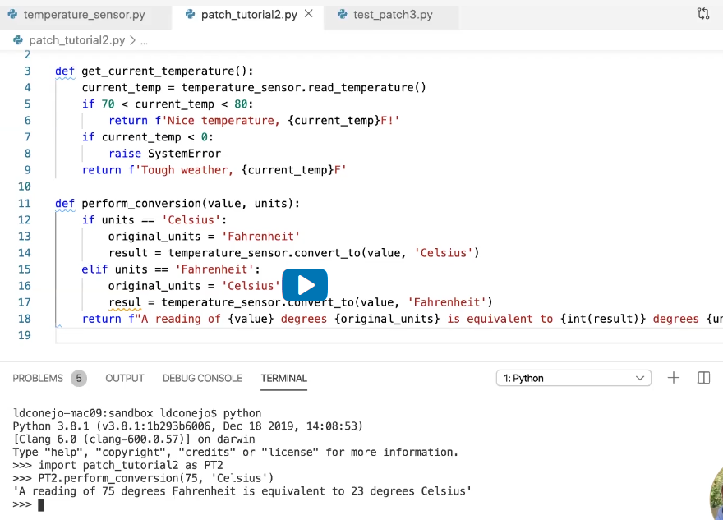

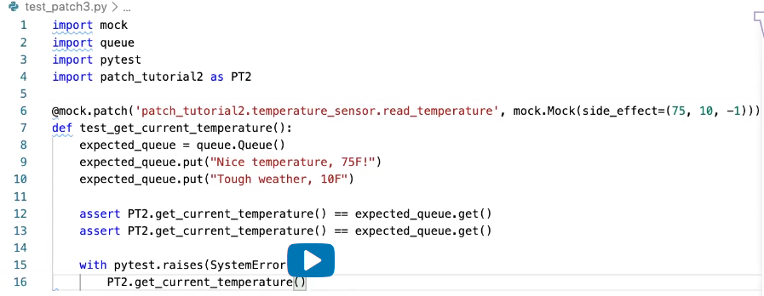

Decorator:

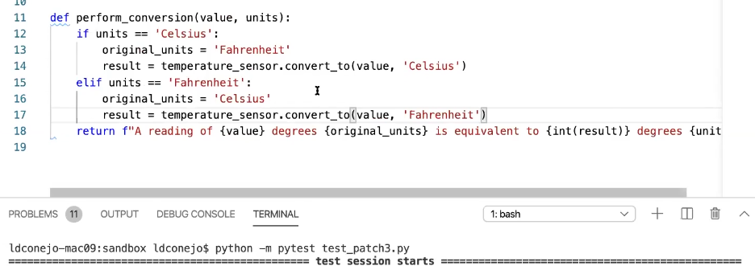

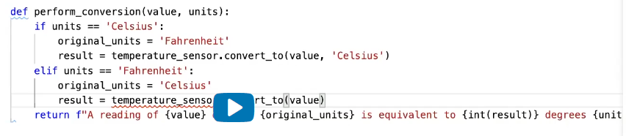

MIstake

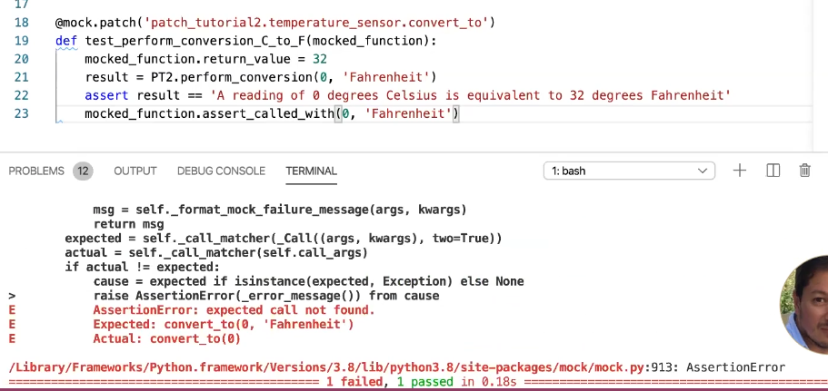

Need to use

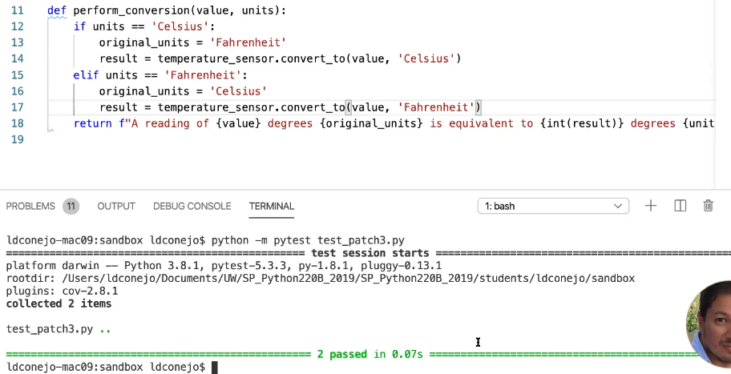

Pylint:

Linting your code is very important. lint, or a linter, is a static code analysis tool used to flag programming errors, bugs, stylistic errors, and suspicious constructs

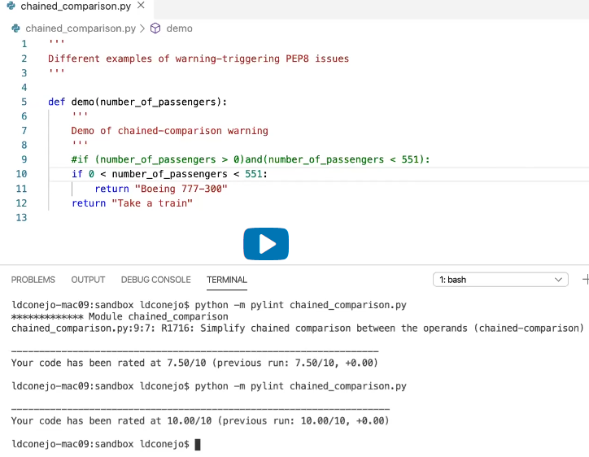

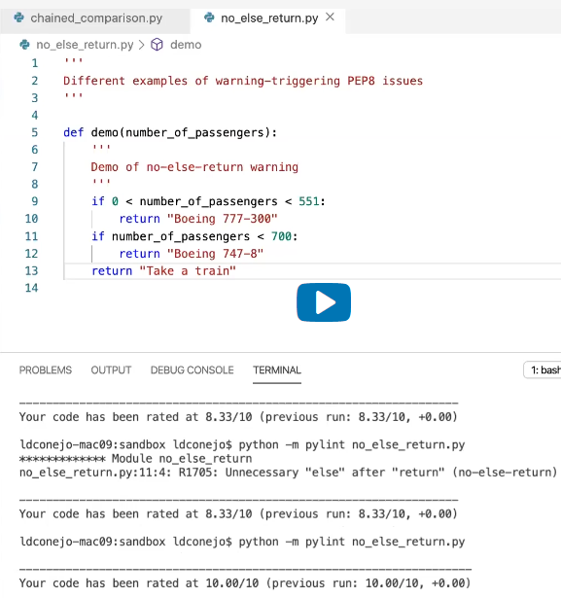

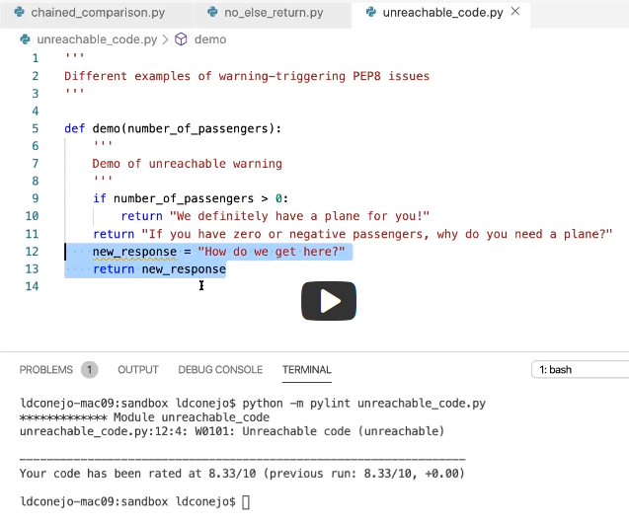

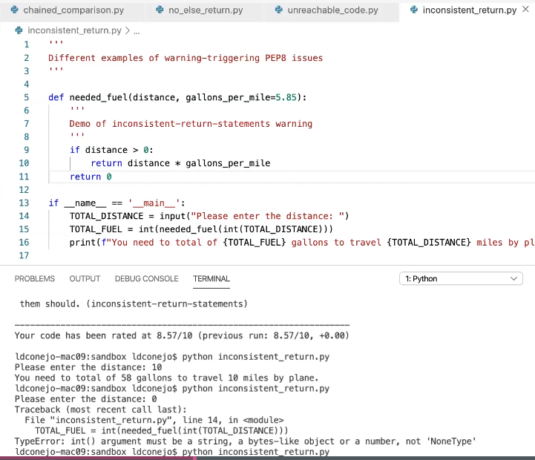

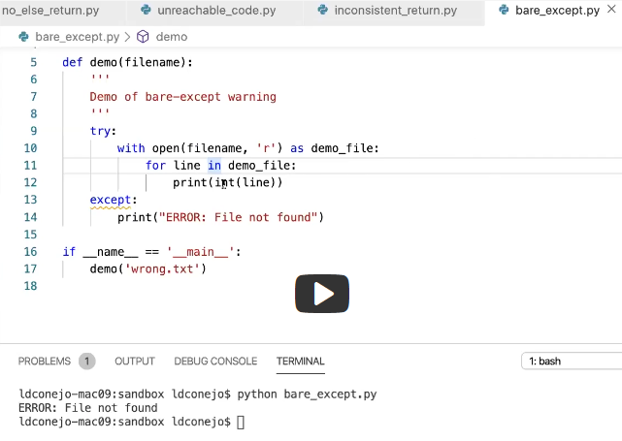 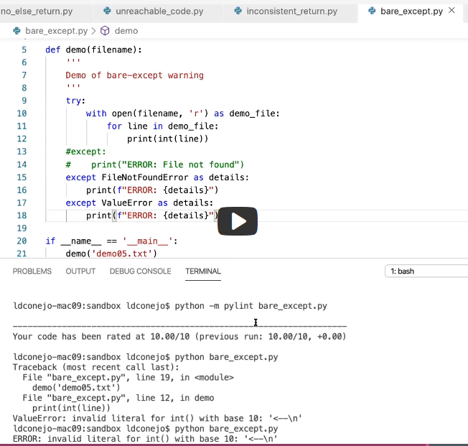

Assignment:

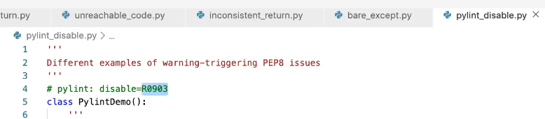

Third warning will disappear:

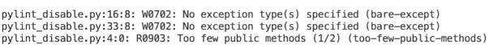

Next warning:

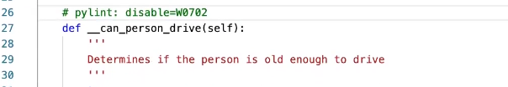

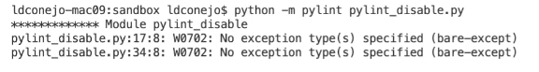

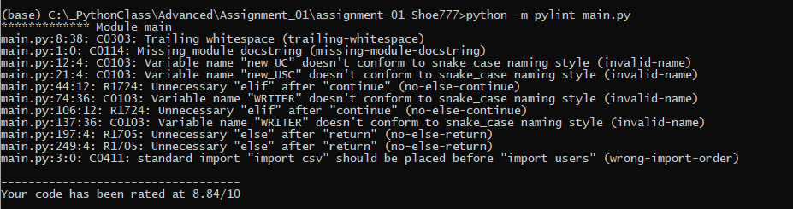

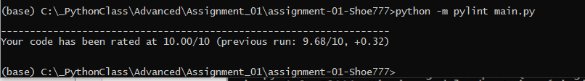

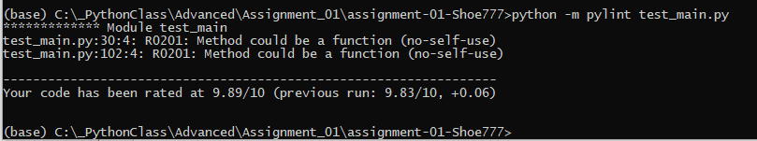

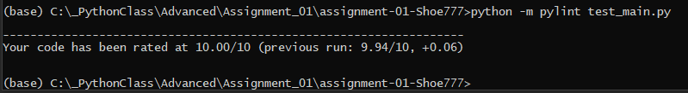

To run thru the Pycharm

