Quotient – отношение

PyPy - documentation

<https://doc.pypy.org/en/latest/>

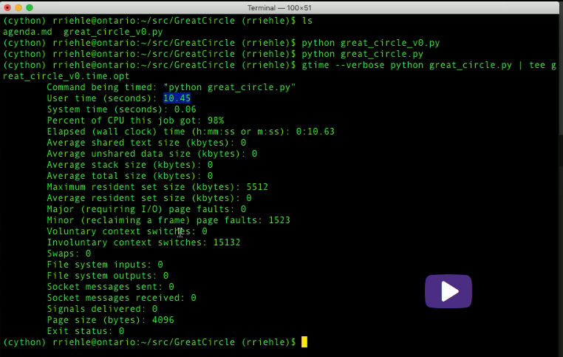



**Simplest** and **quickest** way to find where all the time is going.

1. pip install snakeviz

2. python -m cProfile -o temp.dat <PROGRAM>.py

3. snakeviz temp.dat

Draws a pie chart in a browser. Biggest piece is the problem function. Very simple.

The python wiki is a great page for profiling resources: <http://wiki.python.org/moin/PythonSpeed/PerformanceTips#Profiling_Code>

as is the python docs: <http://docs.python.org/library/profile.html>

as shown by Chris Lawlor cProfile is a great tool and can easily be used to print to the screen:

python -m cProfile -s time mine.py <args>

or to file:

python -m cProfile -o output.file mine.py <args>

PS> If you are using Ubuntu, make sure to install python-profile

apt-get install python-profiler

If you output to file you can get nice visualizations using the following tools

PyCallGraph : a tool to create call graph images   
install:

pip install pycallgraph

run:

pycallgraph mine.py args

view:

gimp pycallgraph.png

You can use whatever you like to view the png file, I used gimp  
Unfortunately I often get

dot: graph is too large for cairo-renderer bitmaps. Scaling by 0.257079 to fit

which makes my images unusably small. So I generally create svg files:

pycallgraph -f svg -o pycallgraph.svg mine.py <args>

PS> make sure to install graphviz (which provides the dot program):

pip install graphviz

Alternative Graphing using gprof2dot via @maxy / @quodlibetor :

pip install gprof2dot

python -m cProfile -o profile.pstats mine.py

gprof2dot -f pstats profile.pstats | dot -Tsvg -o mine.svg