Follow Along Guide
May 26th, 2019
Project: YouTube Data Mining
Team Members:
Anthony Schroeder

Table of Contents
1 Packages
2 Coding And Debugging
3 PostgreSQL
4
5

Before We start:
Please read instructions before blindly following, although you can general get away with this its important to know what each step does before preforming sudo commands that might ruin your current installation. Commands can unintentional consequences, and even having a general idea what each step does is important. “Knowledge is power”.
I performed this on a clean installation of Ubuntu V19.04 to document as much set up possible,
Quick guide to ubuntu and how the system is built:
many times its easier to install stuff on ubuntu because the terminal allows for easy installation and management of packages.

Updating and upgrading:
Its always good practice to update and upgrade your machine when installing new packages, this allows for all software to be up to date, and prevents “coherency” issues

sudo snap install atom --classic

Atom:
My suggested text editor is atom as it allows for extensive addons and has a built in github repository manager.
Download atom:

sudo apt update; sudo apt install atom

One thing to note is that CTRL+SHIFT+P can help get around,

Suggested python linter:(Link)
pylama-pylint
pip install pylama pylama-pylint

Download Python:

sudo apt-get install python3.7

Download pip:()
Pip is python’s package manager and allows us to install cool libraries, allowing for further functionality.

sudo apt-get install -y python3-pip

Similarly you should preform :

sudo apt install python-pip

Download PostgreSQL:(Link)
sudo apt-get install postgresql

Download psycopg2
We will need to install the development version of psycopg2, to allow us to work in a developer setting
sudo apt-get install python-psycopg2

sudo apt-get install libpq-dev

pip3 install psycopg2

Sklearn

pip3 install sklearn

quandl

pip3 install quandl

pandas

pip3 install pandas

BeautifulSoup4
pip install BeautifulSoup4

Pytube:
This package will be using Pytube to download you tube videos for data mining and analysis
pip3 install pytube

colorama
pip3 install colorama

Download Django:
pip3 install django

Create New Django Environment:
python3 -m django startproject Dnet

Moviepy
pip3 install moviepy
Moviepy
sudo apt install ffmpeg

sudo apt-get install frei0r-plugins

you will also need to set up ffmpeg as an environment variable.
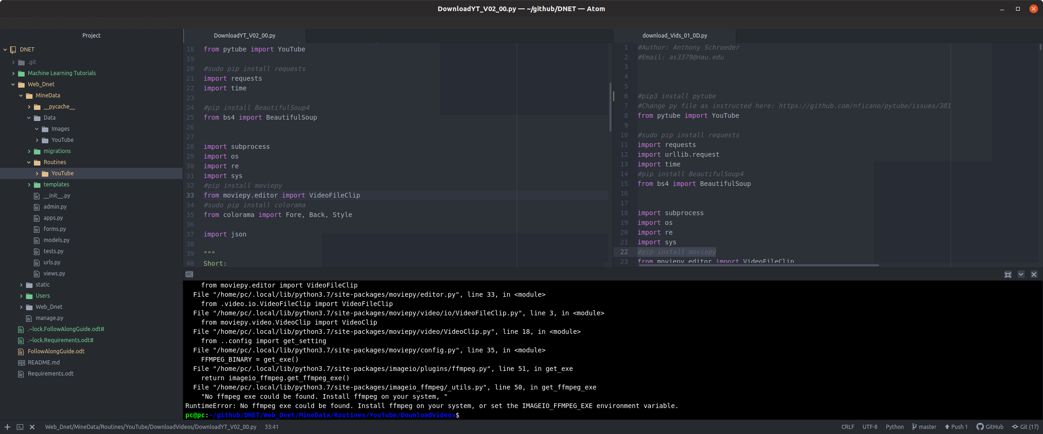

Run Django Server Locally
in the newly created Django folder, running this command will run the web Framework
python3 manage.py runserver

Create New Application:

python3 -m django startapp MineData
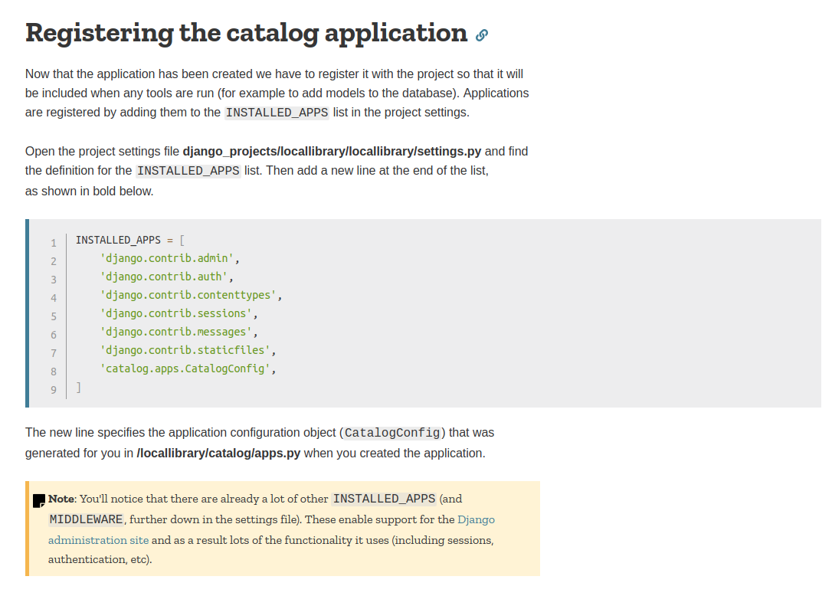
So YouTubeDataMining when added to the installed_apps becomes:

python3 manage.py migrate

python3 manage.py makemigrations

Install PostgreSQL:

Sudo apt-get install postgresql postgresql-contrib

To get root access of postgres’s database, and create/edit/remove users and database’s, use this command in the terminal.
sudo -u postgres psql

create database dnet;
drop database dnet;

Grants root privledges
grant all privileges on database <dbname> to <username>;

Set Password

CREATE USER <USER> WITH ENCRYPTED PASSWORD '<Password>';

Set role in data base

GRANT ALL PRIVILEGES ON DATABASE <yourdbname> TO <youruser>;

python3 manage.py makemigrations
python3 manage.py migrate

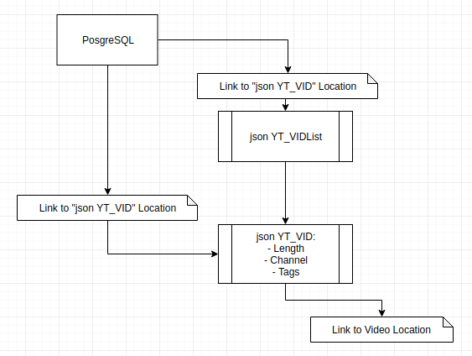

Additional Packages to consider:

