**Topic: Chittagong**

**Topology:**

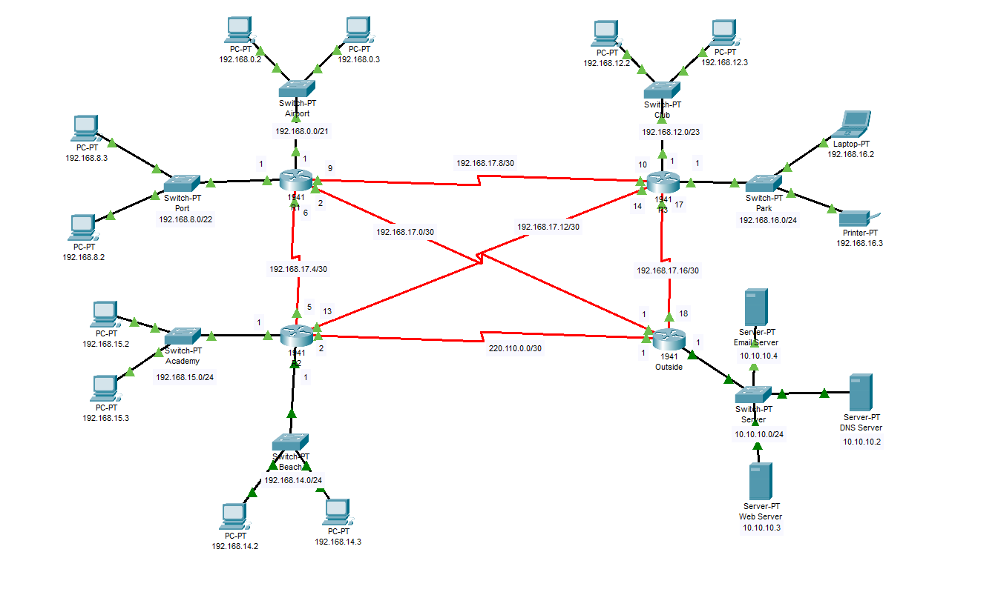

**Shortest Path**

|  |  |  |  |
| --- | --- | --- | --- |
| **Source** | **Destination** | **Cost** | **Path** |
| **Patenga Sea Beach** | **Bangladesh Naval Academy** | **1.4** | **Beach>Academy** |
| **Patenga Sea Beach** | **Shah Amanat International Airport** | **4.2** | **Beach>Airport** |
| **Patenga Sea Beach** | **Chittagong Boat Club** | **6.4** | **Beach>Club** |
| **Patenga Sea Beach** | **Chittagong Port** | **11** | **Beach>Port** |
| **Patenga Sea Beach** | **Butterfly Park** | **3.3** | **Beach>Park** |
| **Bangladesh Naval Academy** | **Shah Amanat International Airport** | **3.3** | **Academy>Park>Airport** |
| **Bangladesh Naval Academy** | **Chittagong Boat Club** | **5.3** | **Academy>Club** |
| **Bangladesh Naval Academy** | **Chittagong Port** | **12** | **Academy>Port** |
| **Bangladesh Naval Academy** | **Butterfly Park** | **2.2** | **Academy>Park** |
| **Shah Amanat International Airport** | **Chittagong Boat Club** | **3.4** | **Airport>Club** |
| **Shah Amanat International Airport** | **Chittagong Port** | **14** | **Airport>Port** |
| **Shah Amanat International Airport** | **Butterfly Park** | **1.1** | **Airport>Park** |
| **Chittagong Boat Club** | **Chittagong Port** | **11** | **Club>Port** |
| **Chittagong Boat Club** | **Butterfly Park** | **3.4** | **Club>Park** |
| **Chittagong Port** | **Butterfly Park** | **12** | **Port>Park** |

**Network Address Table (VLSM)**

|  |  |  |  |  |  |  |
| --- | --- | --- | --- | --- | --- | --- |
| **Network Name** | **Host** | **IP** | **Given IP** | **Host Bit** | **Net Bit** | **Network Address** |
| **Airport** | **1024** | **1026** | **2048** | **11** | **21** | **192.168.0.0/21** |
| **Port** | **526** | **528** | **1024** | **10** | **22** | **192.168.8.0/22** |
| **Club** | **312** | **314** | **512** | **9** | **23** | **192.168.12.0/23** |
| **Beach** | **234** | **236** | **256** | **8** | **24** | **192.168.14.0/24** |
| **Academy** | **156** | **158** | **256** | **8** | **24** | **192.168.15.0/24** |
| **Park** | **128** | **130** | **256** | **8** | **24** | **192.168.16.0/24** |
| **R1>Outside** | **2** | **4** | **4** | **2** | **30** | **192.168.17.0/30** |
| **R1>R2** | **2** | **4** | **4** | **2** | **30** | **192.168.17.4/30** |
| **R1>R3** | **2** | **4** | **4** | **2** | **30** | **192.168.17.8/30** |
| **R2>R3** | **2** | **4** | **4** | **2** | **30** | **192.168.17.12/30** |
| **R3>Outside** | **2** | **4** | **4** | **2** | **30** | **192.168.17.16/30** |
| **R2>Outside** | **2** | **4** | **4** | **2** | **30** | **220.110.0.0/30** |
| **Server** | **-** | **-** | **-** | **8** | **24** | **10.10.10.0/24** |

**IP Address Table**

|  |  |  |  |  |
| --- | --- | --- | --- | --- |
| **Device** | **Interface** | **IPv4 Address** | **Subnet Mask** | **Default Gateway** |
| **R1** | **G0/0** | **192.168.8.1** | **255.255.252.0** | **N/A** |
| **G0/1** | **192.168.0.1** | **255.255.248.0** | **N/A** |
| **S0/0/0** | **192.168.17.2** | **255.255.255.252** | **N/A** |
| **S0/1/0** | **192.168.17.6** | **255.255.255.252** | **N/A** |
| **S0/1/1** | **192.168.17.9** | **255.255.255.252** | **N/A** |
| **R2** | **G0/0** | **192.168.15.1** | **255.255.255.0** | **N/A** |
| **G0/1** | **192.168.14.1** | **255.255.255.0** | **N/A** |
| **S0/0/0** | **220.110.0.2** | **255.255.255.252** | **N/A** |
| **S0/1/0** | **192.168.17.5** | **255.255.255.252** | **N/A** |
| **S0/1/1** | **192.168.17.13** | **255.255.255.252** | **N/A** |
| **R3** | **G0/0** | **192.168.12.1** | **255.255.254.0** | **N/A** |
| **G0/1** | **192.168.16.1** | **255.255.255.0** | **N/A** |
| **S0/0/0** | **192.168.17.17** | **255.255.255.252** | **N/A** |
| **S0/1/0** | **192.168.17.10** | **255.255.255.252** | **N/A** |
| **S0/1/1** | **192.168.17.14** | **255.255.255.252** | **N/A** |
| **Global** | **G0/0** | **10.10.10.1** | **255.255.255.0** | **N/A** |
| **S0/0/0** | **220.110.0.1** | **255.255.255.252** | **N/A** |
| **S0/1/0** | **192.168.17.1** | **255.255.255.252** | **N/A** |
| **S0/1/1** | **192.168.17.18** | **255.255.255.252** | **N/A** |
| **PC1** | **NIC** | **192.168.14.3** | **255.255.255.0** | **192.168.14.1** |
| **PC2** | **NIC** | **192.168.14.2** | **255.255.255.0** | **192.168.14.1** |
| **PC3** | **NIC** | **192.168.15.3** | **255.255.255.0** | **192.168.15.1** |
| **PC4** | **NIC** | **192.168.15.2** | **255.255.255.0** | **192.168.15.1** |
| **PC5** | **NIC** | **192.168.8.2** | **255.255.252.0** | **192.168.8.1** |
| **PC6** | **NIC** | **192.168.8.3** | **255.255.252.0** | **192.168.8.1** |
| **PC7** | **NIC** | **192.168.0.2** | **255.255.248.0** | **192.168.0.1** |
| **PC8** | **NIC** | **192.168.0.3** | **255.255.248.0** | **192.168.0.1** |
| **PC9** | **NIC** | **192.168.12.2** | **255.255.254.0** | **192.168.12.1** |
| **PC10** | **NIC** | **192.168.12.3** | **255.255.254.0** | **192.168.12.1** |
| **Laptop** | **NIC** | **192.168.16.2** | **255.255.255.0** | **192.168.16.1** |
| **Printer** | **NIC** | **192.168.16.3** | **255.255.255.0** | **192.168.16.1** |
| **Email Server** | **NIC** | **10.10.10.4** | **255.255.255.0** | **10.10.10.1** |
| **DNS Server** | **NIC** | **10.10.10.2** | **255.255.255.0** | **10.10.10.1** |
| **Web Server** | **NIC** | **10.10.10.3** | **255.255.255.0** | **10.10.10.1** |

**Router Configuration**

**R1:**

Router>en

Router#conf t

Router(config)#hostname R1

R1(config)#

R1(config)#int g0/0

R1(config-if)#ip address 192.168.8.1 255.255.252.0

R1(config-if)#no shut

R1(config-if)#exit

R1(config)#

R1(config)#ip dhcp pool Port

R1(dhcp-config)#network 192.168.8.0 255.255.252.0

R1(dhcp-config)#default-router 192.168.8.1

R1(dhcp-config)#dns-server 10.10.10.2

R1(dhcp-config)#exit

R1(config)#ip dhcp excluded-address 192.168.8.1

R1(config)#exit

R1#conf t

R1(config)#int g0/1

R1(config-if)#ip address 192.168.0.1 255.255.248.0

R1(config-if)#no shut

R1(config-if)#exit

R1(config)#

R1(config)#ip dhcp pool Airport

R1(dhcp-config)#network 192.168.0.0 255.255.248.0

R1(dhcp-config)#default-router 192.168.0.1

R1(dhcp-config)#dns-server 10.10.10.2

R1(dhcp-config)#exit

R1(config)#ip dhcp excluded-address 192.168.0.1

R1(config)#

R1(config)#int s0/1/0

R1(config-if)#ip address 192.168.17.6 255.255.255.252

R1(config-if)#no shut

R1(config-if)#int s0/1/1

R1(config-if)#ip address 192.168.17.9 255.255.255.252

R1(config-if)#no shut

R1(config-if)#int s0/0/0

R1(config-if)#ip address 192.168.17.2 255.255.255.252

R1(config-if)#no shut

R1(config-if)#exit

R1(config)#

R1(config)#ip route 192.168.15.0 255.255.255.0 s0/1/0

R1(config)#ip route 192.168.14.0 255.255.255.0 s0/1/0

R1(config)#ip route 192.168.16.0 255.255.255.0 s0/1/1

R1(config)#ip route 192.168.12.0 255.255.254.0 s0/1/1

R1(config)#ip route 192.168.17.16 255.255.255.252 s0/1/1

R1(config)#ip route 10.10.10.0 255.255.255.0 s0/0/0

R1(config)#ip route 10.10.10.0 255.255.255.0 s0/1/1 100

R1(config)#exit

R1#

R1#copy r st

Destination filename [startup-config]?

Building configuration...

[OK]

R1#

**R2:**

Router>en

Router#conf t

Router(config)#hostname R2

R2(config)#

R2(config)#int g0/0

R2(config-if)#ip address 192.168.15.1 255.255.255.0

R2(config-if)#no shut

R2(config-if)#int g0/1

R2(config-if)#ip address 192.168.14.1 255.255.255.0

R2(config-if)#no shut

R2(config-if)#int s0/0/0

R2(config-if)#ip address 220.110.0.2 255.255.255.252

R2(config-if)#no shut

R2(config-if)#int s0/1/0

R2(config-if)#ip address 192.168.17.5 255.255.255.252

R2(config-if)#no shut

R2(config-if)#int s0/1/1

R2(config-if)#ip address 192.168.17.13 255.255.255.252

R2(config-if)#no shut

R2(config-if)#exit

R2(config)#

R2(config)#exit

R2#

R2#copy r st

Destination filename [startup-config]?

Building configuration...

[OK]

R2#

R2(config)#ip route 192.168.8.0 255.255.252.0 s0/1/0

R2(config)#ip route 192.168.0.0 255.255.248.0 s0/1/0

R2(config)#ip route 192.168.17.8 255.255.255.252 s0/1/0

R2(config)#ip route 192.168.17.0 255.255.255.252 s0/1/0

R2(config)#ip route 192.168.12.0 255.255.252.0 s0/1/1

R2(config)#ip route 192.168.16.0 255.255.255.0 s0/1/1

R2(config)#ip route 192.168.17.16 255.255.255.252 s0/1/1

R2(config)#ip route 10.10.10.0 255.255.255.0 s0/0/0

R2(config)#ip route 10.10.10.0 255.255.255.0 s0/1/1 100

R2(config)#exit

R2#

R2#copy r st

Destination filename [startup-config]?

Building configuration...

[OK]

R2#

**R3:**

Router>en

Router#conf t

Router(config)#hostname R3

R3(config)#int g0/0

R3(config-if)#ip address 192.168.12.1 255.255.254.0

R3(config-if)#no shut

R3(config-if)#exit

R3(config)#ip dhcp pool Club

R3(dhcp-config)#network 192.168.12.0 255.255.254.0

R3(dhcp-config)#default-router 192.168.12.1

R3(dhcp-config)#dns-server 10.10.10.2

R3(dhcp-config)#exit

R3(config)#ip dhcp exclude 192.168.12.1

R3(config)#

R3(config)#int g0/1

R3(config-if)#ip address 192.168.16.1 255.255.255.0

R3(config-if)#no shut

R3(config-if)#int s0/1/0

R3(config-if)#ip address 192.168.17.10 255.255.255.252

R3(config-if)#no shut

R3(config-if)#int s0/1/1

R3(config-if)#ip address 192.168.17.14 255.255.255.252

R3(config-if)#no shut

R3(config-if)#int s0/0/0

R3(config-if)#ip address 192.168.17.17 255.255.255.252

R3(config-if)#no shut

R3(config-if)#exit

R3(config)#

R3(config)#ip route 192.168.0.0 255.255.248.0 s0/1/0

R3(config)#ip route 192.168.8.0 255.255.252.0 s0/1/0

R3(config)#ip route 192.168.17.4 255.255.255.252 s0/1/0

R3(config)#ip route 192.168.17.0 255.255.255.252 s0/1/0

R3(config)#ip route 192.168.15.0 255.255.255.0 s0/1/1

R3(config)#ip route 192.168.14.0 255.255.255.0 s0/1/1

R3(config)#ip route 10.10.10.0 255.255.255.0 s0/0/0

R3(config)#ip route 10.10.10.0 255.255.255.0 s0/1/0 100

R3(config)#exit

R3#

R3#copy r st

Destination filename [startup-config]?

Building configuration...

[OK]

R3#

**Outside:**

Router>en

Router#conf t

Router(config)#hostname Outside

Outside(config)#int g0/0

Outside(config-if)#ip address 10.10.10.1 255.255.255.0

Outside(config-if)#no shut

Outside(config-if)#int s0/0/0

Outside(config-if)#ip address 220.110.0.1 255.255.255.252

Outside(config-if)#no shut

Outside(config-if)#int s0/1/0

input detected at '^' marker.

Outside(config-if)#ip address 192.168.17.1 255.255.255.252

Outside(config-if)#no shut

Outside(config-if)#int s0/1/1

Outside(config-if)#ip address 192.168.17.18 255.255.255.252

Outside(config-if)#no shut

Outside(config-if)#

Outside(config-if)#end

Outside#

Outside#copy r st

Destination filename [startup-config]?

Building configuration...

[OK]

Outside#

Outside#conf t

Outside(config)#

Outside(config)#ip route 192.168.16.0 255.255.255.0 s0/1/1

Outside(config)#ip route 192.168.12.0 255.255.254.0 s0/1/1

Outside(config)#ip route 192.168.8.0 255.255.252.0 s0/1/0

Outside(config)#ip route 192.168.0.0 255.255.248.0 s0/1/0

Outside(config)#ip route 192.168.15.0 255.255.255.0 s0/0/0

Outside(config)#ip route 192.168.14.0 255.255.255.0 s0/0/0

Outside(config)#ip route 0.0.0.0 0.0.0.0 s0/0/0

Outside(config)#exit

Outside#

Outside#copy r st

Destination filename [startup-config]?

Building configuration...

[OK]

Outside#

**Website:**

**To access website, enter “www.bracu.ac.bd”**

**Email:**

The procedure of sending, receiving and setting up server is given below frame by frame-

