 Project for CSE471

**Title of the Project: Rent-a-gadget**

**Group Number: 19**

**Group Members: 01**

|  |  |
| --- | --- |
| **Student ID** | **Student Name** |
| Shoeb Islam Shaon | 18101138 |
|  |  |
|  |  |
|  |  |
|  |  |

1

Assignment for CSE471

Introduction

Rent-a- gadget will provide such a platform where people can rent their various kinds of gadgets to the people who can barely afford it. It will make the best use of the gadget as well as it will be in constant use. It will also be a place for tech enthusiasts who will share their valuable reviews  about gadgets. As a whole, it will be a platform where tech enthusiasts can share their thoughts and  also borrow and rent their desired products.

Motivation

The majority of people in our country are from middle-class families. As a result, individuals are frequently unable to purchase high-priced items that they desire. For example a nice DSLR camera may cost up to 2 lakh taka, and only a few individuals can afford it. In addition, if the person is not a professional photographer, the camera is only used once or twice a year. As a result, a person traveling on a tour could be able to utilize a camera of such caliber to capture their memories. In this way, the user may get the most out of his device while still earning money for doing nothing. On the other hand, that person who couldn’t afford that can get the camera with a minimum amount of money and use it as long as he needs it.

System request

**Project Sponsor:** CEO: Hussain Elius (Pathao)

**Business Need**: This project has been initiated to help the majority of general people who can’t  afford expensive electronics gadgets, which are not used in our day-to-day life. Rather we need  to use them in any occasions.

**Business Requirement:**

1. Search for electric gadgets based on peoples’ choices.

2. Search for best options in minimum expenses.

3. Compare between specific gadgets and can also decide on customers’ reviews. 4. Able to know about specifications of gadgets and can also can get suggestions from expert users.

5. User can find which gadget is vacant and by when it will be available, and thus it can be occupied in quicker times.

6. Liability between the borrower and the owner of the gadget.

**Business Value:**

1. Higher customer satisfaction due to less hassle.

2. People can save their time and money as they don’t have to wait for anyone’s gadget and also they don’t have to buy a newer one.

3. Extra earnings for the owner as they can lend their gadgets in their off time, when they are not using those.

4. Maximum benefits of the both side as the owner will earn extra and the borrower can complete his deeds in few expenses.

**Special issues or constraints**:

1. Though, there will be liability among customers, but there will be always some risks regarding gadget. The owner may put wrong info about his products so that those people who are eager to take that, they can be fascinated. And from the borrowers’ point of view, they can take or exchange some parts from the gadget that may hamper the gadget specifications.

2. Miscommunication may happen, as some may be in dire need of that gadget and the owner may be unable to hand out the products in due time. The opposite can also happen.  3. The owner may change his product but not updating us or in the website/app about the change, so misleading information can also occur in some cases.

# Requirement analysis

1. **Functional Requirements**
2. The system will allow customer to borrow and rent a gadget.
3. The system will allow the user to select minimum/maximum days of renting their gadgets.
4. A user can upload multiple gadgets renting post at once.
5. Owner or Borrower anyone can rate each other after the product is returned.
6. A user can mark his location for quick access which would be linked to Google Map
7. Borrower can pay through online banks or cryptocurrency regarding his accessibility
8. User can choose their favorite genre of gadgets and turn on notifications for that.
9. A user can pay ad money to get attention of their gadget
10. The system will provide a pull up notifications to all the users regarding their favorite gears.
11. If multiple users want to borrow a particular gadget, then turn on the automated bidder option
12. If a user post with wrong info, already created automated AI to penalize them extra money for next rent or block their ID for good.
13. **Software & Bug Fixes**
14. Create a downloadable online voucher for both owner and borrower
15. Categorize gadgets regarding their features
16. Send instant feedback of internet connection during payment or uploading a post so that no user feel any hassle
17. Send instant feedback to the developer team if the app freezes or crashes on any device
18. Create a record of a user’s personal info, posts and borrowed gadgets
19. Send live ratings of a user just behind their names regarding their average rating of all stuffs
20. Automatically send the owner’s and borrower’s contact to the authority when a gadget is selected to be rented

**2. Nonfunctional requirements**

**A. Operational requirements:**

A.1 The system should be able to work in any web browser.

A.2 The system will operate in Windows environment.

**B. Performance requirements**

B.1 Response time should be less than 10 seconds.

B.2 The database will be updated after any member puts any device on the database.

B.3 The system should be available for 24 hours’ use.

**C. Security requirements**

C.1 Only admin have the authority to permit the gadget after checking its conditions.

C.2 The system will guaranty customer’s information on source and destination confidential.

**D. Cultural and political requirements**

D.1 During strikes and political gatherings and rally our delivery about devices (from whom we will collect the device and will go to them who will be lending) may be not on time.

D.2 only the devices that have proper documents will be granted for the website/app.

# Use case diagram

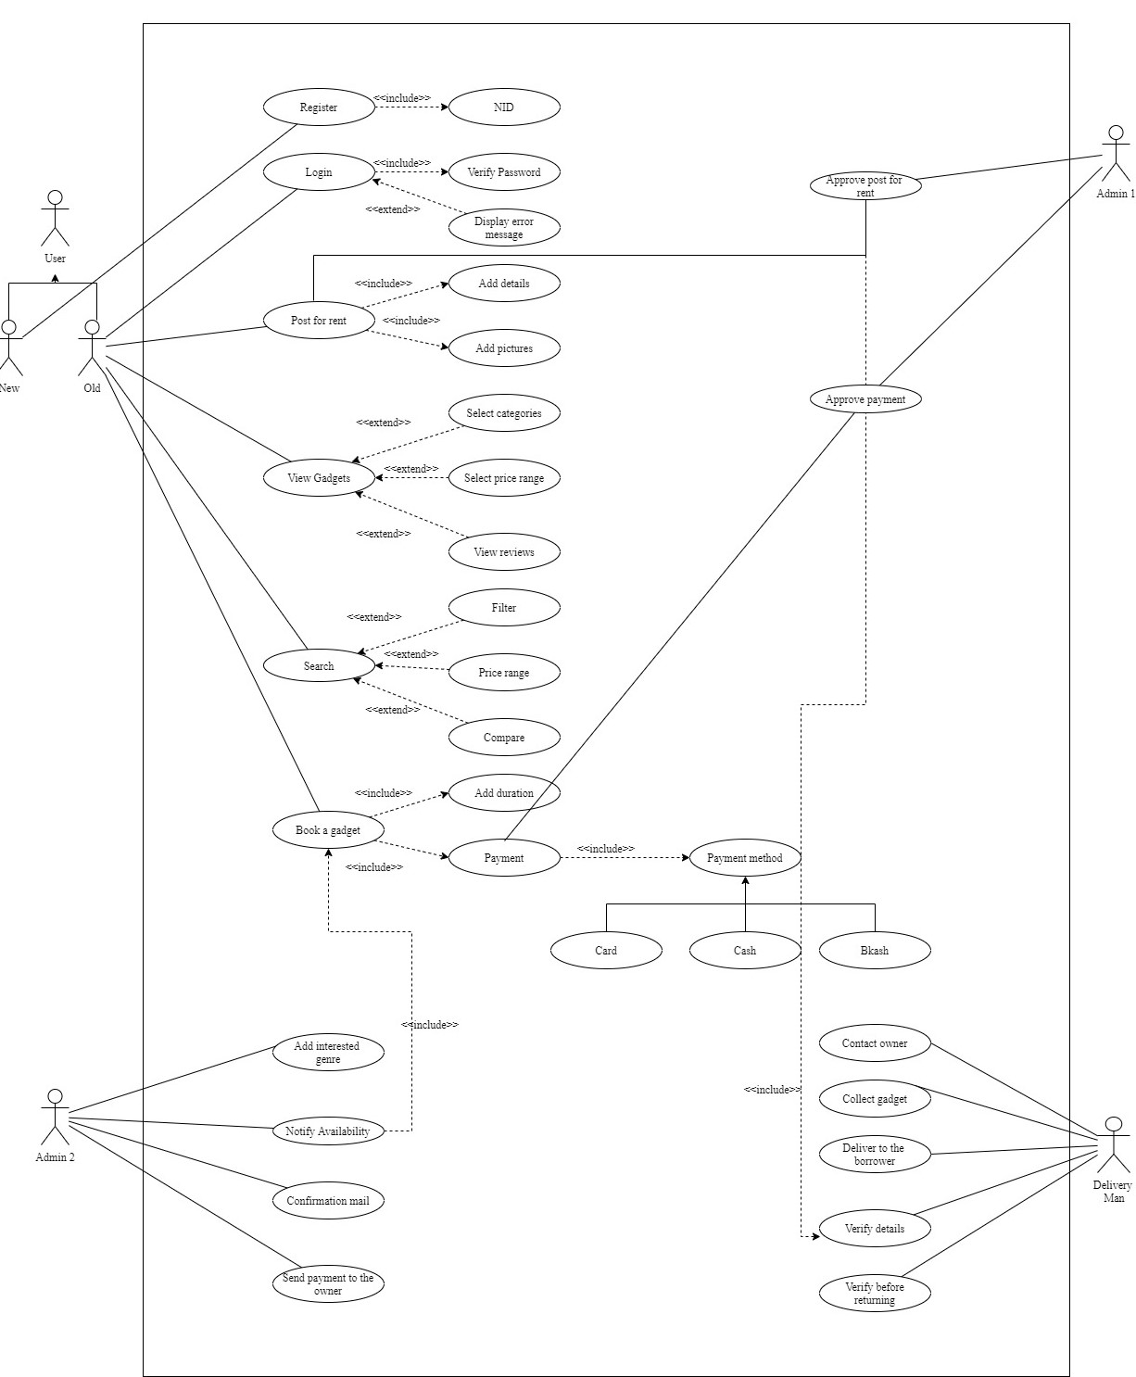

# Activity diagram

**Diagram-1**

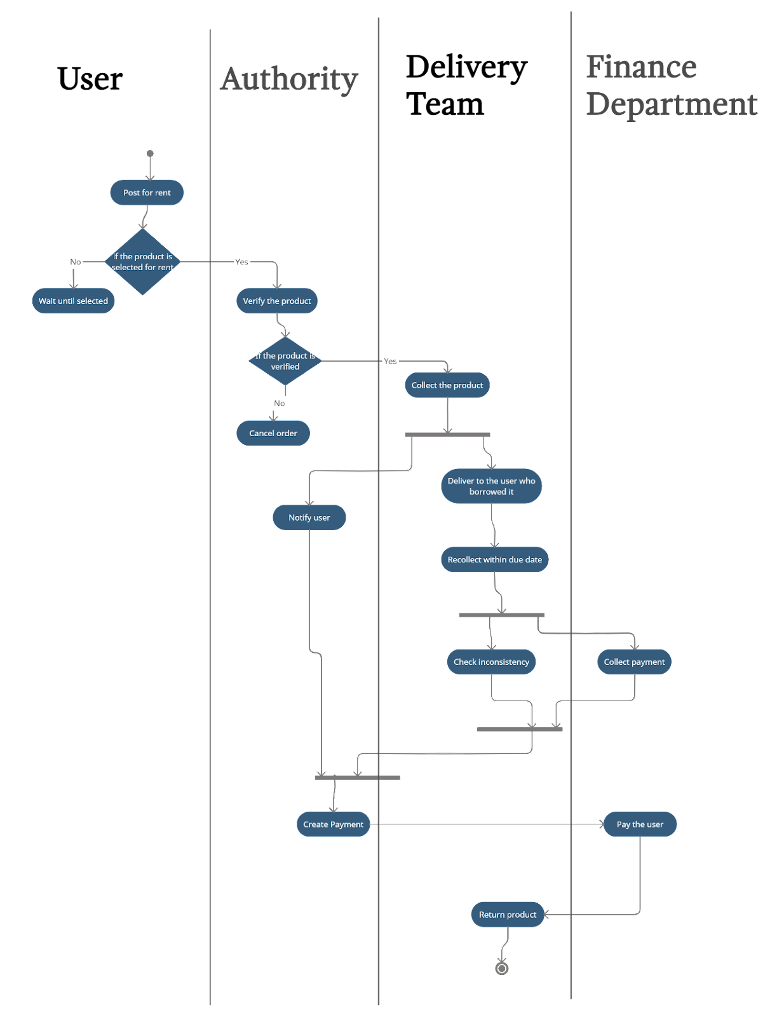An Activity Diagram for the user who would post to rent their gadgets on Rent-a-Gadget. All the procedures are given below in the activity diagram

**Diagram-2**

An activity diagram for those users who would choose Rent-a-Gadget to borrow others’ gadgets. All the procedure to borrow a gadget from Rent-a-Gadget is given below in the activity diagram

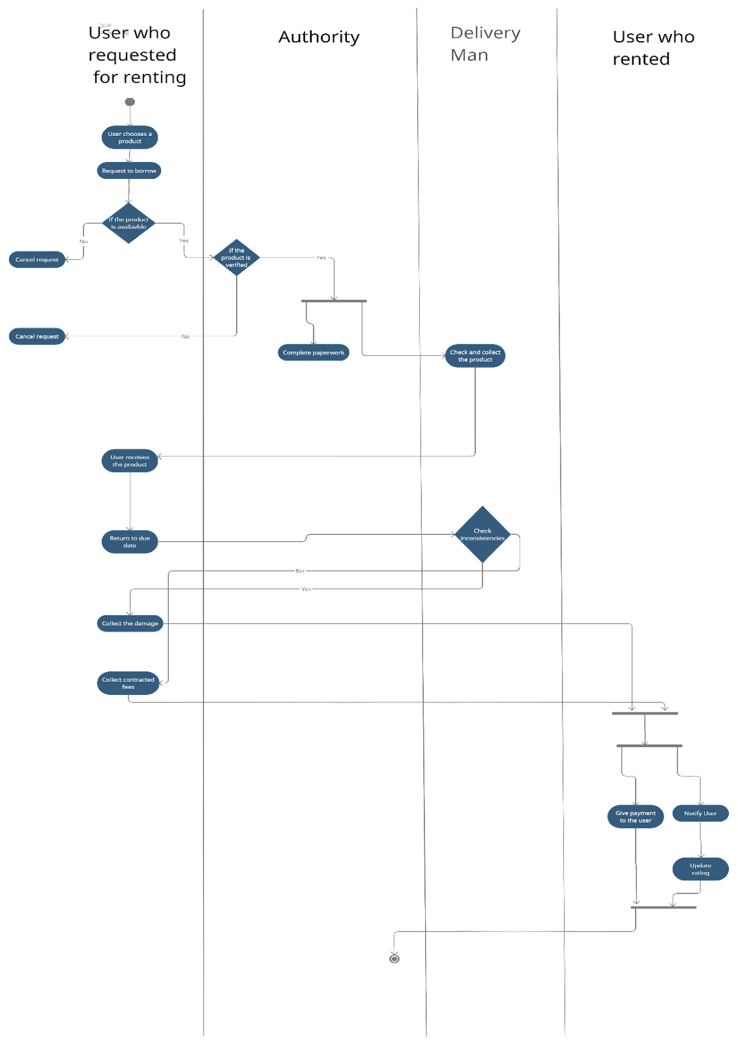

# C:\Users\Shoeb\Desktop\CSE471 project\Sequence Diagram.pngSequence diagram

# 

# State machine diagram

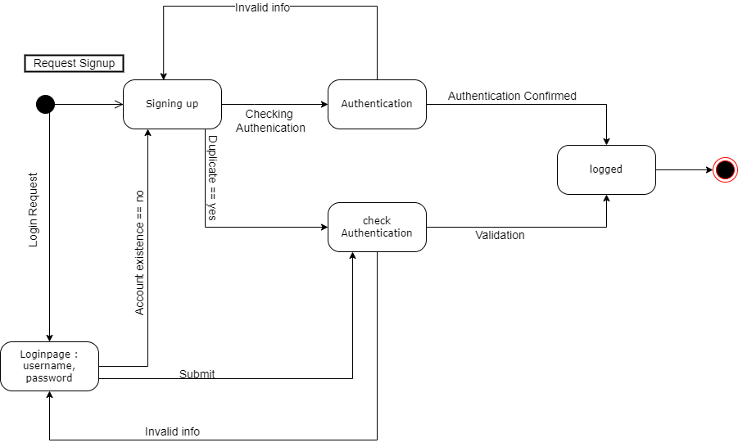

# Windows navigation diagram

