# Design diagram

* **Use Case Diagram of Rent-a-Gadget:**

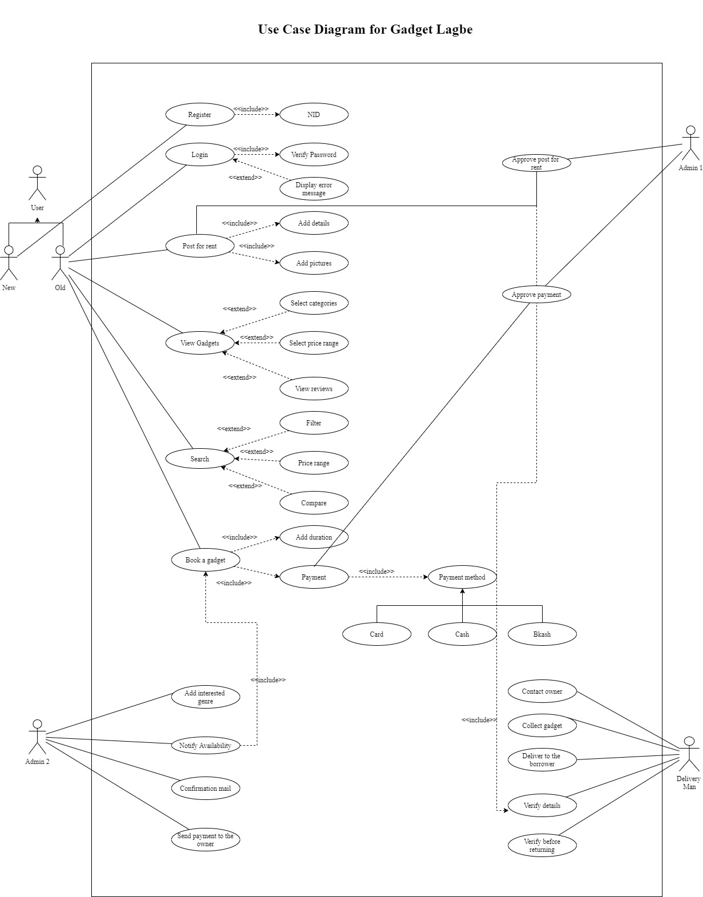

* **Class Diagram for Rent-a-Gadget:**

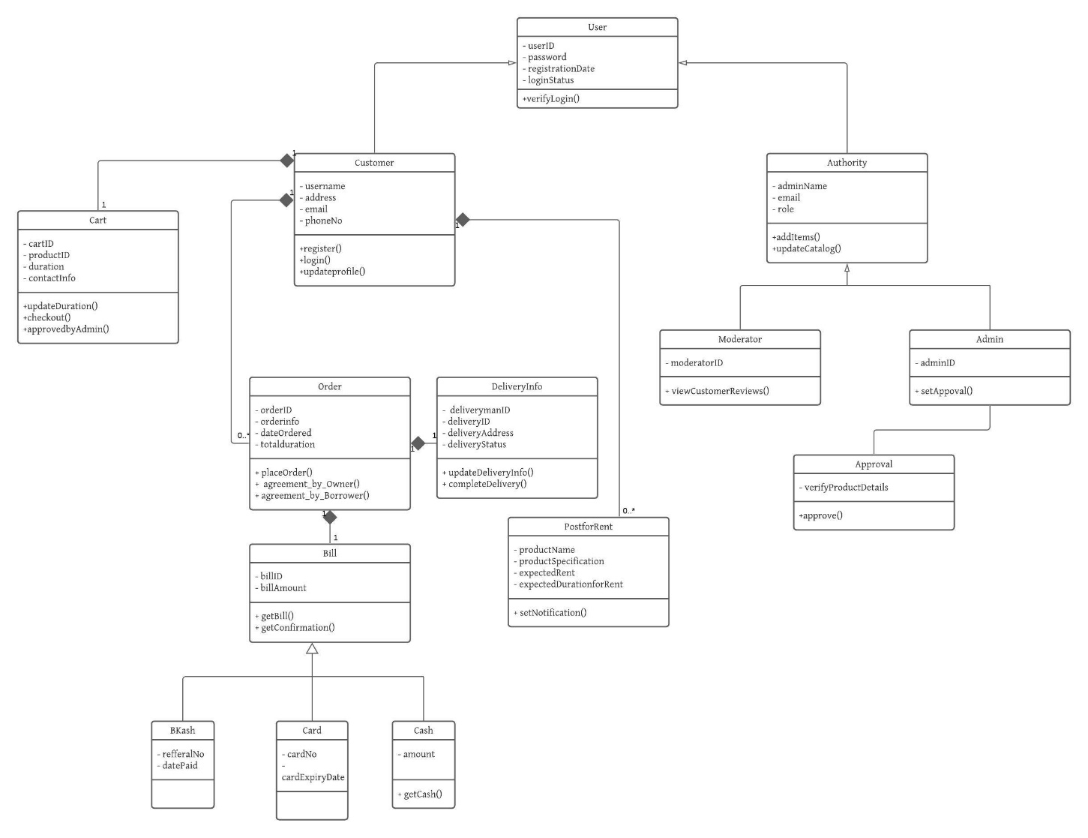

* **Sequence Diagram for Rent-a-Gadget:  
    
    
  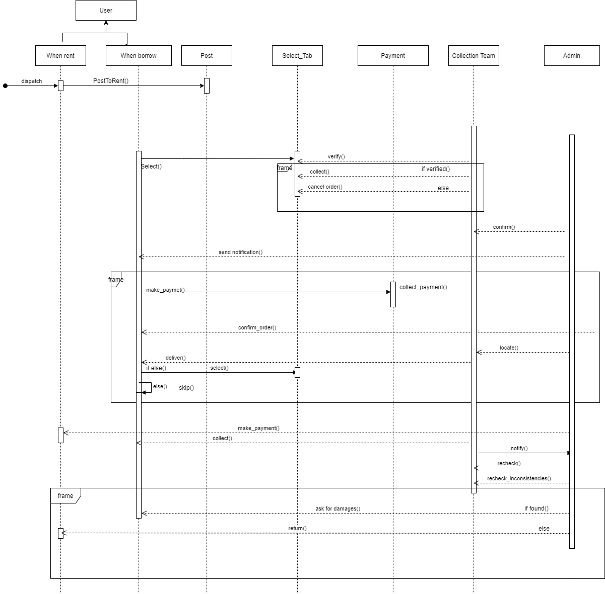**
* **Activity Diagram for Rent-a-Gadget:**

**Diagram-1**

An Activity Diagram for the user who would post to rent their gadgets on Rent-a-Gadget. All the procedures are given below in the activity diagram 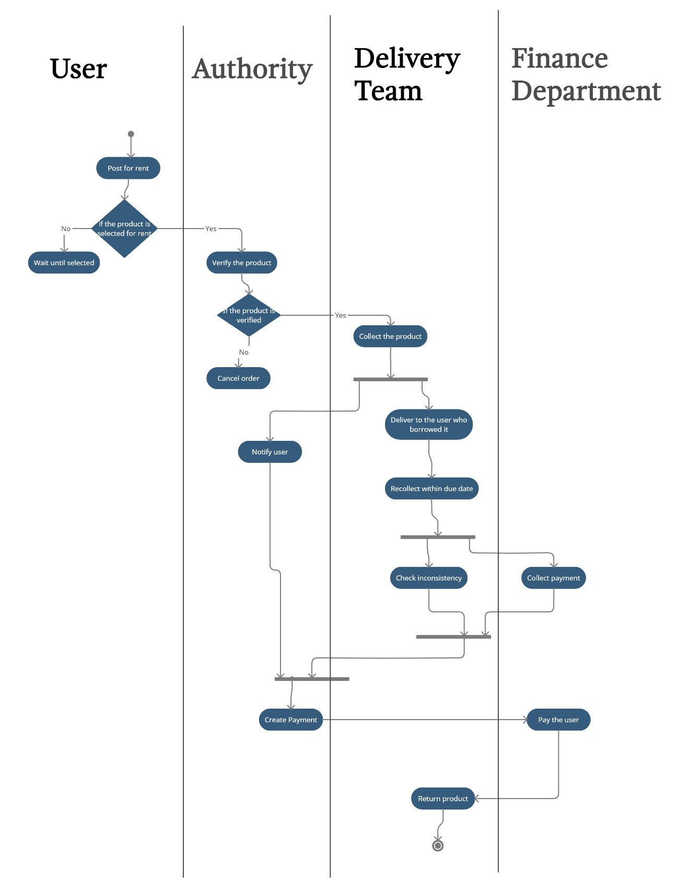

**Diagram-2**

An activity diagram for those users who would choose Rent-a-Gadget to borrow others’ gadgets. All the procedure to borrow a gadget from Rent-a-Gadget is given below in the activity diagram