Git and GitHub:

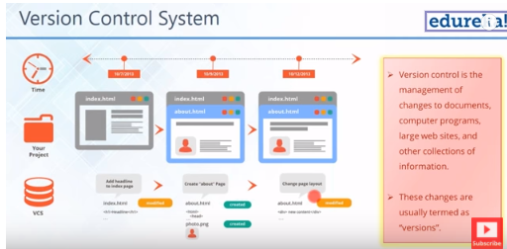

Why version control:

Collaboration:

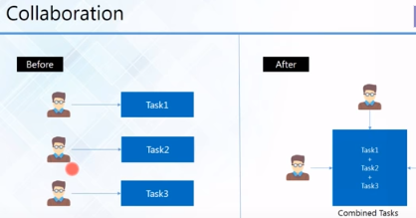

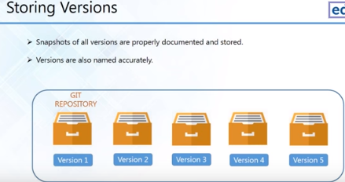

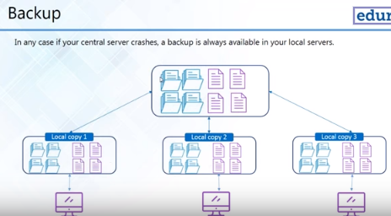

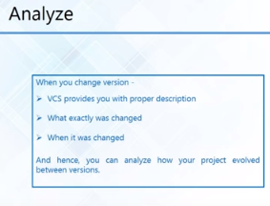

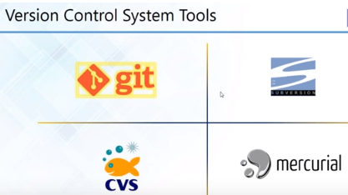

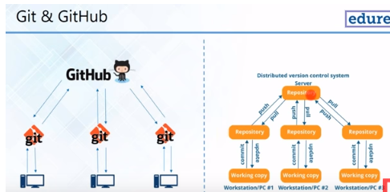

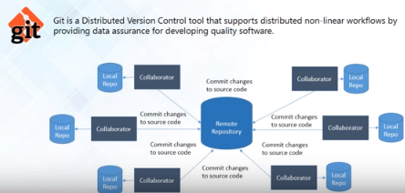

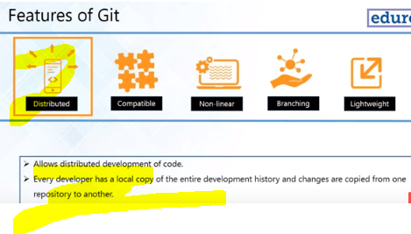

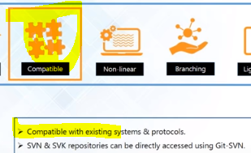



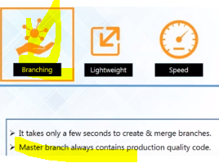

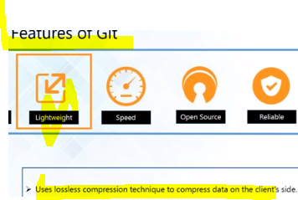

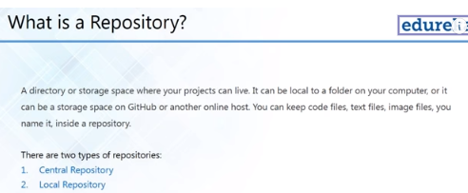

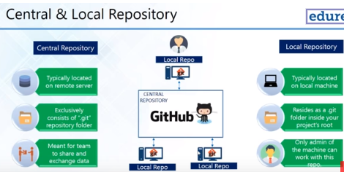

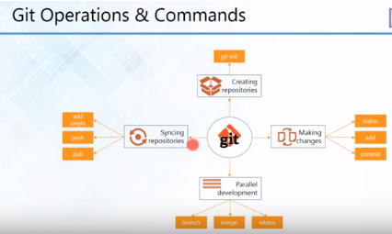

Git operations and commands:

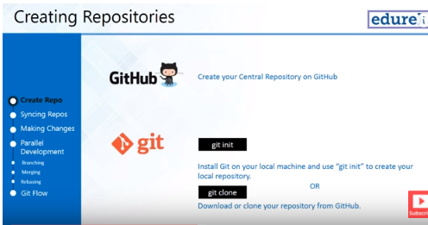

1. Install git bash.
2. To create git local repository, create a folder, right click, open git bash and type : >git init
3. To link the local to remote: git remote add origin “<path>”
4. Get the path:
5. 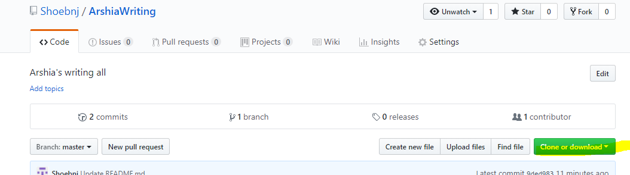
6. Get from remote everything: >git pull origin master
7. To commit: >git push
8. >git status: Tells you which files
9. >git add <file name> which is created. It added to index and became p
10. >Git commit -m “comment”

1. To get Repository from remote to Local: Git clone < your repo link from githab.com>

2. Go to repo directory with cd and to see status: git status.

3. add a file to repo directory in Local machine and git status

4. Add this file to local repo: git add <file name> -m "Comment"

5. again git status

6. To see details of Commit: git log

7. git push to push the file to remote Git hub: git push

1. 