# **Importance of Regular Exercise**

## Introduction:

We all know that exercise is extremely important in our daily lives, but we may not know why or what exercise can do. It’s important to remember that we have evolved from nomadic ancestors who spent all their time moving around in search of food and shelter, travelling large distances on a daily basis. Our bodies are designed and have evolved to be regularly active. Over time, people may come across problems if they sit down all day at a desk or in front of the TV and minimize the amount of exercise they do. *Exercise* is a bodily movement performed in order to develop or maintain *physical fitness* and *good health* overall. *Exercise* leads to the physical exertion of sufficient intensity, duration and frequency to *achieve or maintain fitness* and *health*. (Clinic & 2021., 2023)

## Need of Exercise:

The human body is like a complex and delicate machine which comprises several small parts. A slight malfunction of one part leads to the breakdown of the machine. In a similar way, if such a situation arises in the human body, it also leads to malfunctioning of the body. *Exercise* is one of the *healthy lifestyles* which contributes to optimum *health and quality of life*. People who exercise regularly can reduce their risk of death. By doing exercise, active people increase their life expectancy by two years compared to inactive people. *Regular exercise* and *good physical fitness* enhance the quality of life in many ways. *Physical fitness* and *exercise* can help us to *look good, feel good, and enjoy life*. Moreover, *exercise* provides an enjoyable way to spend leisure time. (Clinic & 2021., 2023)

*Exercise* helps a person develop emotional balance and maintain *a strong self-image*. As people get older, *exercise* becomes more important. This is because, after the age of 30, the heart’s blood pumping capacity declines at a rate of about 8 per cent each decade. *Exercise* is also vital for a child’s overall development. *Exercising* helps to maintain *a healthy weight* by *stoking our metabolism, utilizing and burning the extra calories*.

## Types of Exercise

There are three broad intensities of *exercise*:

* **Light exercise** – Going for a walk is an example of light exercise. In this, the exerciser is able to talk while exercising.
* **Moderate exercise** – Here, the exerciser feels slightly out of breath during the session. Examples could be walking briskly, cycling moderately or walking up a hill.
* **Vigorous exercise** – While performing this exercise, the exerciser is panting during the activity. The exerciser feels his/her body being pushed much nearer its limit compared to the other two intensities. This could include running, cycling fast, and heavy-weight training.

## Importance of Exercise

*Regular exercise increases our fitness level and physical stamina.* It plays a crucial role in the prevention of *cardiovascular diseases*. It can help with *blood lipid abnormalities, diabetes and obesity.* Moreover, it can help to reduce blood pressure. *Regular exercise* substantially reduces the risk of dying of *coronary heart disease and* *eases the risk of stroke and colon cancer*. People of all age groups benefit from exercising. (Clinic & 2021., 2023)

|  |  |
| --- | --- |
| Exercise Type | Benefits |
| Running | Improves cardiovascular health |
| Yoga | Increases flexibility and reduces stress |
| Strength Training | Builds muscle and bone density |

*Exercise* can be effective in improving the *mental well-being of human beings.* It *relieves human stress* *and anxiety.* When we come back from work or school, we feel exhausted after a whole day of work. If we can go out to have a walk or jog for at least 30 minutes, it makes us feel happy and relaxed. A number of studies have found that a lifestyle that includes *exercise* helps alleviate depression. Those who can maintain *regular exercise* will also reduce their chances of seeing a doctor. Without physical activity, the body’s muscles lose their strength, endurance and ability to function properly. Regular exercise keeps all parts of the body in continuous activity. *It improves overall health and fitness, as well as decreases the risk of many chronic diseases.* Therefore, physical exercise is very important in our life.

Pic-1: Outdoor running for cardio fitness

## Conclusion

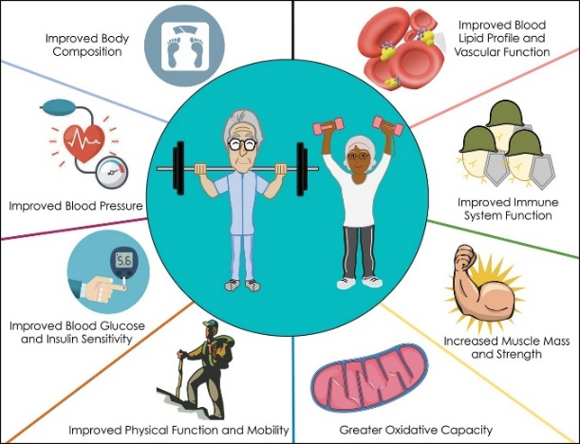*Exercise* can play a significant role in keeping the individual, society, community and nation wealthy. If the citizens of a country are healthy, the country is sure to touch heights in every facet of life. The country’s healthy generation can achieve the highest marks in various fields and thereby enable their country to win laurels and glory at the international level. The first step is always the hardest. However, if we can overcome it, and *exercise for 21 days continuously*, *it will be a new beginning for a healthy life.*

Pic-2: Benefit of weight lifting

# **References**

Clinic, A. P., & 2021. (2023, August 23). *benefits of regular physical activity*. Retrieved from https://www.mayoclinic.org/.