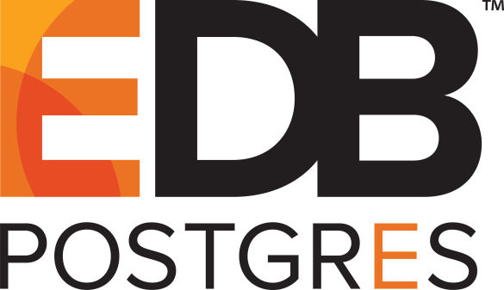

**EDB Postgres™ Language Pack Guide**

Version 10

November 1, 2017

EDB Postgres™ Language Pack Guide, Version 10  
by EnterpriseDB® Corporation  
Copyright © 2017 EnterpriseDB Corporation. All rights reserved.

EnterpriseDB Corporation, 34 Crosby Drive Suite 100, Bedford, MA 01730, USA  
**T** +1 781 357 3390 **F**  +1 978 589 5701 **E** info@enterprisedb.com **www**.enterprisedb.com

Table of Contents

1 Introduction 4

1.1 Supported Platforms 4

1.2 Typographical Conventions Used in this Guide 5

2 Installing Language Pack 6

2.1 Invoking the Graphical Installer 6

2.2 Installing Language Pack with StackBuilder Plus 10

2.3 Configuring Language Pack on an Advanced Server Host 11

2.4 Configuring Language Pack on a PostgreSQL Host 13

3 Using the Procedural Languages 15

3.1 PL/Perl 16

3.2 PL/Python 17

3.3 PL/Tcl 18

# Introduction

Language pack installers contain supported languages that may be used with EDB Postgres Advanced Server and EnterpriseDB PostgreSQL database installers. The language pack installer allows you to install Perl, TCL/TK, and Python without installing supporting software from third party vendors. The Language Pack installer includes:

* TCL with TK version 8.6
* Perl version 5.24
* Python version 3.4

The Perl package contains the cpan package manager, and Python contains pip and easy_install package managers. There is no package manager for TCL/TK.

In previous Postgres releases, plpython was statically linked with ActiveState's python library. The Language Pack Installer dynamically links with our shared object for python. In ActiveState Linux installers for Python, there is no dynamic library. As a result of these changes, plpython will no longer work with ActiveState installers.

This document uses the term *Postgres* to mean either EDB Postgres Advanced Server or EDB PostgreSQL. For more information about using EDB Postgres products, please visit the EnterpriseDB website at:

<http://www.enterprisedb.com/documentation>

StackBuilder Plus is distributed with Advanced Server; Stack Builder (distributed with PostgreSQL) provides comparable functionality. This document uses the term *StackBuilder Plus* to mean either StackBuilder Plus or Stack Builder.

## Supported Platforms

Language Pack v10 is tested on:

* EDB Postgres Advanced Server version 10
* PostgreSQL version 10

If you are using version 9.6 or prior, you can use StackBuilder Plus to download a version-specific Language Pack installer.

## Typographical Conventions Used in this Guide

Certain typographical conventions are used in this manual to clarify the meaning and usage of various commands, statements, programs, examples, etc. This section provides a summary of these conventions.

In the following descriptions, a term refers to any word or group of words that are language keywords, user-supplied values, literals, etc. A term’s exact meaning depends upon the context in which it is used.

* Italic font introduces a new term, typically in the sentence that defines it for the first time.
* Fixed-width (mono-spaced) font is used for terms that must be given literally such as SQL commands, specific table and column names used in the examples, programming language keywords, etc. For example, SELECT * FROM emp;
* Italic fixed-width font is used for terms for which the user must substitute values in actual usage. For example, DELETE FROM table_name;
* A vertical pipe | denotes a choice between the terms on either side of the pipe. A vertical pipe is used to separate two or more alternative terms within square brackets (optional choices) or braces (one mandatory choice).
* Square brackets [ ] denote that one or none of the enclosed terms may be substituted. For example, [ a | b ] means choose one of “a” or “b” or neither of the two.
* Braces {} denote that exactly one of the enclosed alternatives must be specified. For example, { a | b } means exactly one of “a” or “b” must be specified.
* Ellipses ... denote that the preceding term may be repeated. For example, [ a | b ] ... means that you may have the sequence, “b a a b a”.

# Installing Language Pack

The graphical installer is available from the EnterpriseDB website or via StackBuilder Plus.

## Invoking the Graphical Installer

On Windows, assume Administrator privileges, and double-click the installer icon; if prompted, provide the password associated with the Administrator account.

On a Linux host, assume superuser privileges, disable SELinux (if applicable), navigate into the directory in which the installer resides, and invoke the installer with the command:

./edb-languagepack-*version*.run

Where *version* identifies version and platform-specific installer information.

The installer Welcome window opens (see Figure 2.1).

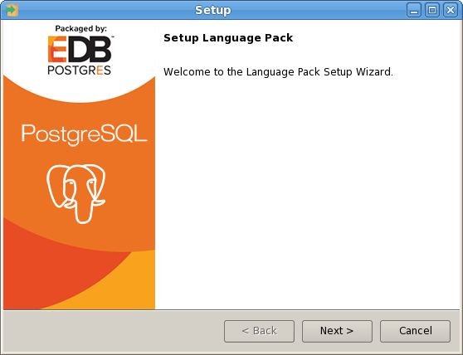

*Figure 2.1 – The Language Pack Welcome window.*

Click Next to continue.

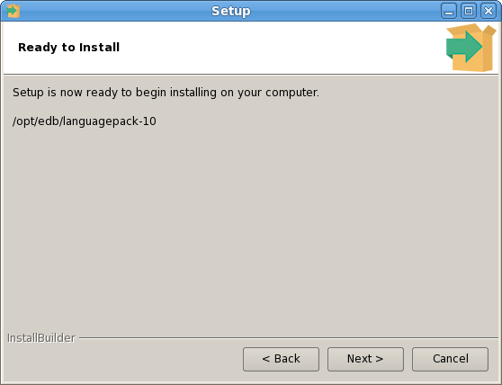

*Figure 2.2 – The Language Pack Welcome window.*

The Ready to Install window (see Figure 2.2) displays the Language Pack installation directory:

On Linux 32 or 64: /opt/edb/languagepack-10/

On Windows 32: C:\edb\languagepack-10\i386

On Windows 64: C:\edb\languagepack-10\x64

On OSX: /Library/edb/languagepack-10

You cannot modify the installation directory. Click Next to continue.

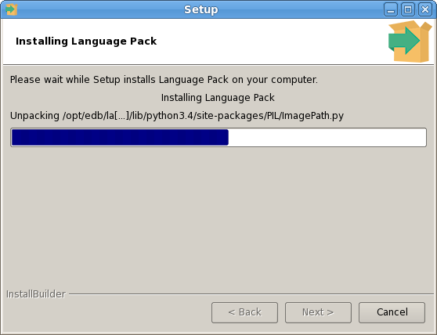

*Figure 2.3 – The Language Pack Welcome window.*

A progress bar marks installation progress (see Figure 2.3); click Next to continue.

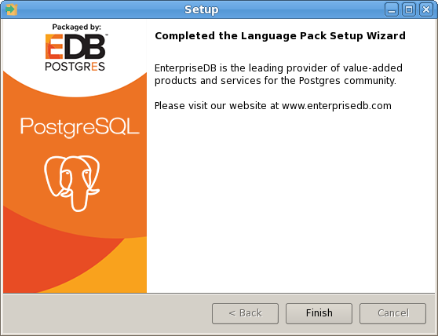

*Figure 2.4 – The Language Pack Welcome window.*

The installer will inform you that the Language Pack installation has completed (see Figure 2.4); click Finish to exit the installer.

## Installing Language Pack with StackBuilder Plus

You can use StackBuilder Plus to download and invoke the Language Pack graphical installer. To open StackBuilder Plus, select the StackBuilder Plus menu item from the version-specific EDB Postgres sub-menu.

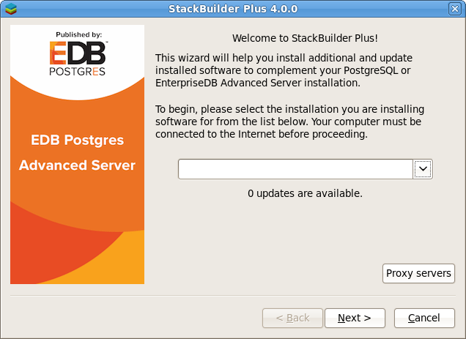

*Figure 2.5 – The StackBuilder Plus Welcome window.*

Select your server from the drop-down menu on the StackBuilder Plus Welcome window (see Figure 2.5) and click Next to continue.

Expand the Add-ons, tools and utilities node of the Categories tree control, and check the box to the left of EDB Language Pack; click Next to continue.

When prompted, provide your EnterpriseDB account credentials; if you have not registered for an account, use the provided link to register. StackBuilder Plus will confirm your package selection before downloading the installer. When the download completes, StackBuilder Plus will offer to invoke the installer for you, or to skip the installation until a more convenient time.

For details about using the graphical installer, see Section 2.1.

## **Configuring Language Pack on an Advanced Server Host**

***Configuring Language Pack on Linux***

On Linux, the installer places the languages in:

/opt/edb/languagepack-10/

If you install Language Pack before Advanced Server, the Advanced Server installer will detect the Language Pack installation, and set the paths in the plLanguages.config file for you.

If you are invoking the Advanced Server installer using the --extract-only option, or if you install Language Pack after installing Advanced Server, you must manually configure the installation. The Language Pack configuration file is named:

/opt/edb/as10/etc/sysconfig/plLanguages.config

If you are installing Language Pack on a system that already hosts an Advanced Server installation, use your editor of choice to modify the plLanguages.config, changing the entries to include the locations of each language:

EDB_PERL_VERSION=5.24  
EDB_PYTHON_VERSION=3.4  
EDB_TCL_VERSION=8.6

EDB_PERL_PATH=/opt/edb/languagepack-10/Perl-5.24 EDB_PYTHON_PATH=/opt/edb/languagepack-10/Python-3.4 EDB_TCL_PATH=/opt/edb/languagepack-10/Tcl-8.6

After modifying the plLanguages.config file, restart the server for the changes to take effect.

***Configuring Language Pack on Windows***

On Windows, the Language Pack installer places the languages in:

C:\edb\languagepack-10\x64

After installing Language Pack, you must set the following variables:

set PYTHONHOME=C:\edb\languagepack-10\x64\Python-3.4

Use the following commands to add Python, Perl and Tcl to your search path:

set PATH= C:\edb\LanguagePack-10\x64\Python-3.4\bin:  
C:\edb\LanguagePack-10\x64\Perl-5.24\bin:  
C:\edb\LanguagePack-10\x64\Tcl-8.6\bin:%PATH%

After setting the system-specific steps required to configure Language Pack on Windows, restart the Advanced Server database server.

## **Configuring Language Pack on a PostgreSQL Host**

After installing Language Pack on a PostgreSQL host, you must

**Configuring Language Pack on Linux:**

To simplify setting the value of PATH or LD_LIBRARY_PATH, you can create environment variables that identify the installation location:

PERLHOME=/opt/edb/languagepack-10/Perl-5.24  
PYTHONHOME=/opt/edb/languagepack-10/Python-3.4  
TCLHOME=/opt/edb/languagepack-10/Tcl-8.6

Then, instruct the Python interpreter where to find Python:

export PYTHONHOME

You can use the same environment variables when setting the value of PATH:

export PATH=$PYTHONHOME/bin:$PERLHOME/bin:$TCLHOME/bin:$PATH  
export PATH=/opt/edb/languagepack-10/Python-3.4/bin:

Lastly, use the variables to tell Linux where to find the shared libraries:

export LD_LIBRARY_PATH=  
$PYTHONHOME/lib:  
$PERLHOME/lib/CORE:  
$TCLHOME/lib:  
$LD_LIBRARY_PATH

Configuring Language Pack on Windows

***On 32-bit Windows:***

If you are using 32-bit Windows, you must tell the Python interpreter where to find Python:

set PYTHONHOME=C:\edb\languagepack-10\i386\Python-3.4

Then, set the path to the Language Pack installation:

SET PATH=C:\edb\languagepack-10\i386\Python-3.4;  
C:\edb\languagepack-10\i386\Perl-5.24\bin;  
C:\edb\languagepack-10\i386\Tcl-8.6\bin;%PATH%

***On 64-bit Windows:***

After installing Language Pack, you must tell the Python interpreter where to find Python:

set PYTHONHOME=C:\edb\languagepack-10\x64\Python-3.3

Then, use the following commands to add Language Pack to your search path:

set PATH= C:\edb\LanguagePack-10\x64\Python-3.3\bin: C:\edb\LanguagePack-10\x64\Perl-5.20\bin: C:\edb\LanguagePack-10\x64\Tcl-8.5\bin:%PATH%

After setting the system-specific steps required to configure Language Pack on Windows, restart the database server.

Configuring Language Pack on OSX

To simplify setting the value of PATH or LD_LIBRARY_PATH, you can create environment variables that identify the installation location:

PERLHOME=/Library/edb/languagepack-10/Perl-5.24 PYTHONHOME=/Library/edb/languagepack-10/Python-3.4 TCLHOME=/Library/edb/languagepack-10/Tcl-8.6

Then, instruct the Python interpreter where to find Python:

export PYTHONHOME

You can use the same environment variables when setting the value of PATH:

export PATH=$PYTHONHOME/bin:  
$PERLHOME/bin:  
$TCLHOME/bin:$PATH

Lastly, use the variables to tell Linux where to find the shared libraries:

export DYLD_LIBRARY_PATH=$PYTHONHOME/lib:  
$PERLHOME/lib/CORE:$TCLHOME/lib:  
$DYLD_LIBRARY_PATH

# Using the Procedural Languages

The Postgres procedural languages (PL/Perl, PL/Python, and PL/Java) are installed with by the Language Pack installer. You can also use an RPM package to add procedural language functionality to your Advanced Server installation. For more information about using an RPM package, please see the EDB Advanced Server Installation Guide, available at:

<https://www.enterprisedb.com/resources/product-documentation>

## PL/Perl

The PL/Perl procedural language allows you to use Perl functions in Postgres applications.

You must install PL/Perl in each database (or in a template database) before creating a PL/Perl function. Use the CREATE LANGUAGE command at the EDB-PSQL command line to install PL/Perl. Open the EDB-PSQL client, establish a connection to the database in which you wish to install PL/Perl, and enter the command:

CREATE LANGUAGE plperl;

The server confirms that the language is loaded with the response:

CREATE LANGUAGE;

You can now use a Postgres client application to access the features of the PL/Perl language. The following PL/Perl example creates a function named perl_max that returns the larger of two integer values:

CREATE OR REPLACE FUNCTION perl_max (integer, integer) RETURNS integer AS   
$$  
 if ($_[0] > $_[1])   
 { return $_[0]; }  
 return $_[1];  
$$ LANGUAGE plperl;

Pass two values when calling the function:

SELECT perl_max(1, 2);

The server returns:

perl_max  
---------  
 2  
(1 row)

For more information about using the Perl procedural language, consult the official Postgres documentation available at:

[https://www.postgresql.org/docs/10/static/plperl.html](https://www.postgresql.org/docs/9.6/static/plperl.html)

## PL/Python

The PL/Python procedural language allows you to create and execute functions written in Python within Postgres applications. The version of PL/Python used by Advanced Server and PostgreSQL is untrusted (plpython3u); it offers no restrictions on users to prevent potential security risks.

Install PL/Python in each database (or in a template database) before creating a PL/Python function. You can use the CREATE LANGUAGE command at the EDB-PSQL command line to install PL/Python. Use EDB-PSQL to connect to the database in which you wish to install PL/Python, and enter the command:

CREATE LANGUAGE plpython3u;

The server confirms that the language is loaded with the response:

CREATE LANGUAGE

After installing PL/Python in your database, you can use the features of the PL/Python language.

Please note: The indentation shown in the following example must be included as you enter the sample function in EDB-PSQL. The following PL/Python example creates a function named pymax that returns the larger of two integer values:

CREATE OR REPLACE FUNCTION pymax (a integer, b integer) RETURNS integer AS   
 $$  
 if a > b:  
 return a  
 return b  
 $$ LANGUAGE plpython3u;

When calling the pymax function, pass two values as shown below:

SELECT pymax(12, 3);

The server returns:

pymax  
 -------  
 12  
 (1 row)

For more information about using the Python procedural language, consult the official PostgreSQL documentation available at:

[https://www.postgresql.org/docs/10/static/plpython.html](https://www.postgresql.org/docs/9.6/static/plpython.html)

## PL/Tcl

The PL/Tcl procedural language allows you to use Tcl/Tk functions in applications.

You must install PL/Tcl in each database (or in a template database) before creating a PL/Tcl function. Use the CREATE LANGUAGE command at the EDB-PSQL command line to install PL/Tcl. Use the psql client to connect to the database in which you wish to install PL/Tcl, and enter the command:

CREATE LANGUAGE pltcl;

After creating the pltcl language, you can use the features of the PL/Tcl language from within your Postgres server.

The following PL/Tcl example creates a function named tcl_max that returns the larger of two integer values:

CREATE OR REPLACE FUNCTION tcl_max(integer, integer) RETURNS integer AS $$  
 if {[argisnull 1]} {  
 if {[argisnull 2]} { return_null }  
 return $2  
 }  
 if {[argisnull 2]} { return $1 }  
 if {$1 > $2} {return $1}  
 return $2  
 $$ LANGUAGE pltcl;

Pass two values when calling the function:

SELECT tcl_max(1, 2);

The server returns:

tcl_max  
--------  
 2  
(1 row)

For more information about using the Tcl procedural language, consult the official Postgres documentation available at:

[https://www.postgresql.org/docs/10/static/pltcl.html](https://www.postgresql.org/docs/9.6/static/pltcl.html)