## **Water Flow Sensor - 1/8"**

Model: YF-S401

## https://www.dfrobot.com/wiki/images/thumb/3/3f/Name_SEN0216.jpg/300px-Name_SEN0216.jpg**Contents**

* 1 Introduction
* 2 Specification
* 3 Board Overview
* 4 Tutorial
  + 4.1 Requirements
  + 4.2 Connection Diagram
  + 4.3 Sample Code

## **Introduction**

The Water Flow sensor measures the rate of a liquid flowing through it. The YF-S401 water flow sensor consists of a plastic valve body, flow rotor and hall effect sensor. It is usually used at the inlet end to detect the amount of flow. When liquid flows through the sensor, a magnetic rotor will rotate and the rate of rotation will vary with the rate of flow. The hall effect sensor will then output a pulse width signal. Connect it to a microcontroller and you can monitor multiple devices such as your coffee maker, sprinkler or anything else, and control the water flow rate to suit your needs!

* A 6 mm hose is recommended
* Avoid unit contact with corrosive chemicals
* The unit must be installed vertically, tilted no more than 5 degrees
* Liquid temperature should be less than 120 C to avoid damage to unit

## **Specification**

* Inner Diameter: 4 mm
* Outside diameter: 7 mm
* Proof Water Pressure: <0.8 MPa
* Water Flow Range: 0.3-6 L/min
* Voltage Range: 5~12 V
* Operating Current: 15 mA (DC 5V)
* Insulation Resistance: >100 MΩ
* Accuracy: ±5% (0.3-3L/min)
* The Output Pulse High Level: >4.5 VDC (DC input voltage 5 V)
* The Output Pulse Low Level: <0.5 VDC (DC input voltage 5 V)
* Output Pulse Duty Ratio: 50% ± 10%
* Water-flow Formula: 1L = 5880 square waves
* Working Humidity Range: 35% ~ 90% RH (no frost)
* Dimension: 58*35*26 mm/2.28*1.37*1.02 inches
* Weight: 30g

## **Board Overview**

[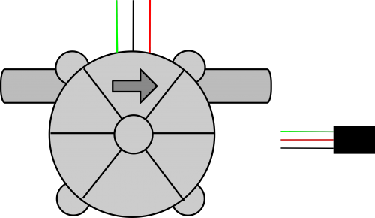](https://www.dfrobot.com/wiki/index.php/File:SEN0216_With_Cable.png)

|  |  |  |  |
| --- | --- | --- | --- |
| **Number** | **Color** | **Name** | **Description** |
| 1 | Green | Signal | Pulse Signal |
| 2 | Red | VCC | 5~12V |
| 3 | Black | GND | GND |

**Pulse Signal**

[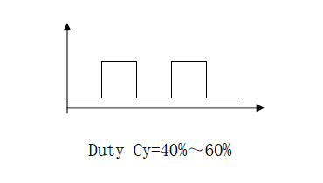](https://www.dfrobot.com/wiki/index.php/File:SEN0216_SW.png)

## **Tutorial**

In this Tutorial, we'll measure liquid flow using this sensor.

### **Requirements**

* **Hardware**
  + Arduino UNO R3
  + Water flow sensor
  + Jumper Wires
* **Software**
  + Arduino IDE

### **Connection Diagram**

[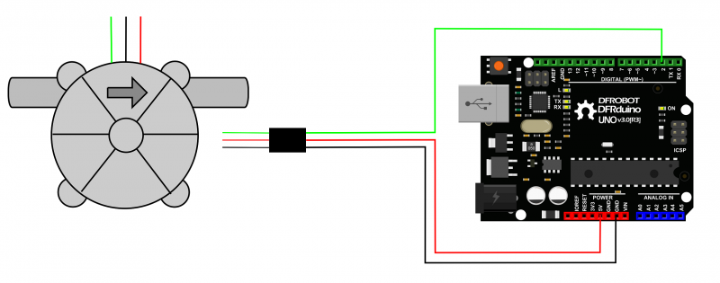](https://www.dfrobot.com/wiki/index.php/File:SEN0216_CONNET.png)

### **Sample code**

*/\*\*\*\*\*\*\*\*\*\*\*\*\*\*\*\*\*\*\*\*\*\*\*\*\*\*\*\*\*\*\*\*\*\*\*\*\*\*\*\*\*\*\*\*\*\*\*\*\*\*\**

2  *This example reads Water flow sensor Sensor.*

3

4  *Created 2016-3-13*

5  *By berinie Chen <bernie.chen@dfrobot.com>*

6

7  *GNU Lesser General Public License.*

8  *See <http://www.gnu.org/licenses/> for details.*

9  *All above must be included in any redistribution*

10  *\*\*\*\*\*\*\*\*\*\*\*\*\*\*\*\*\*\*\*\*\*\*\*\*\*\*\*\*\*\*\*\*\*\*\*\*\*\*\*\*\*\*\*\*\*\*\*\*\*\*\*\*/*

11

12 */***********Notice and Trouble shooting\*\*\*\*\*\*\*\*\*\*\*\*\*\*\**

13  *1.Connection and Diagram can be found here http://www.dfrobot.com/wiki/index.php?title=Water_Flow_Sensor_-_1/8%22_SKU:_SEN0216*

14  *2.This code is tested on Arduino Uno.*

15  *\*\*\*\*\*\*\*\*\*\*\*\*\*\*\*\*\*\*\*\*\*\*\*\*\*\*\*\*\*\*\*\*\*\*\*\*\*\*\*\*\*\*\*\*\*\*\*\*\*\*\*\*/*

16 **volatile** double waterFlow;

17 void setup() {

18 Serial.begin(9600); *//baudrate*

19 waterFlow = 0;

20 attachInterrupt(0, pulse, RISING); *//DIGITAL Pin 2: Interrupt 0*

21 }

22 void loop() {

23 Serial.print("waterFlow:");

24 Serial.print(waterFlow);

25 Serial.println(" L");

26 delay(500);

27 }

28

29 void pulse() *//measure the quantity of square wave*

30 {

31 waterFlow += 1.0 / 5880.0;

32 }