**Public Transportation Optimization**

**Problem definition:**

The objective of this project is to enhance the efficiency, reliability, and user experience of public transportation through the implementation of Internet of Things (IoT) technologies. By leveraging real-time data and smart devices, the aim is to optimize various aspects of public transport systems, including route planning, vehicle tracking, passenger experience, and overall operational efficiency.

**Detailed Explanation:**

* **Real-time Vehicle Tracking:** Implement GPS and IoT sensors on public transport vehicles to provide real-time location tracking. This allows for accurate arrival and departure predictions.
* **Dynamic Route Planning:** Utilize data analytics to optimize public transport routes based on real-time traffic conditions, historical data, and user demand. This can improve the efficiency of the system and reduce travel time.
* **Passenger Information Systems:** Develop a system to provide passengers with real-time information about bus/train locations, expected arrival times, and any delays. This can be accessible through mobile apps, digital displays at stops, or other communication channels.
* **Condition Monitoring and Maintenance:** Equip vehicles with IoT sensors to monitor their condition in real time. This can help predict and prevent breakdowns, optimize maintenance schedules, and extend the lifespan of the vehicles.
* **Occupancy Monitoring:** Use sensors to monitor the occupancy of vehicles in real time. This information can be used to optimize routes, allocate resources efficiently, and enhance the overall passenger experience.
* **Integration with Other Modes of Transport:** Develop interfaces to integrate public transport systems with other modes of transportation, such as ride-sharing services or bike-sharing programs, to provide users with a seamless and interconnected travel experience.

**Design thinking:**

**Project objectives:**

* To reduce delays, improves route efficiency, and provides real-time information, collectively reducing the overall travel time for passengers.

**IoT sensor design:**

* Generate ideas for a system that incorporates IR sensors, level sensors, speed sensors, temperature and humidity sensors, GPS module, Wi-Fi module, and an LCD interface.
* Create a physical prototype, connecting IR sensors for obstacle detection, level sensors for fluid monitoring, speed sensor, temperature, and humidity sensors for environmental conditions, GPS module for location tracking, and Wi-Fi module for data transmission.

**Real time transit Information platform:**

* The web-based real-time transit information platform aims to provide a comprehensive, user-friendly, and secure experience for passengers. Continuous improvement through iterative testing and user feedback ensures that the platform remains responsive to changing needs and technological advancements.

**Integration approach:**

* ThinkSpeak is a popular Internet of Things (IoT) platform that allows users to easily build and control IoT projects through a user-friendly mobile app. It provides a simple way to connect various hardware devices, sensors, and microcontrollers to the internet and control them remotely.

**Work Flow:**

* When system is powered up, it goes through initializing phase during which it sets the baud rate for connected devices communicating a Universal Asynchronous Received Transmitted (UART) serial connected devices such as Wi-Fi module, GPS, and serial monitor as well initializes the LCD and DHT sensor.
* After that microcontroller scans all the sensors and reads both analogue and digital sensors.
* The microcontroller then performs analogue to digital conversion for all analogue read sensors. It then processes the data read and computes passenger count, calculate bus speed, compute GPS coordinates, passenger count, temperature, and humidity.
* All computed parameters are displayed on the LCD locally.
* The same values are also sent to serial monitor for testing and debugging purpose.
* These parameters are sent to the ThingSpeak cloud over the internet using ESP8266 module.
* The data sent to cloud is fetched from the cloud and displayed in a web browser for user visualization. In the next step data is fetch from the cloud using channel ID and API key which is then analyzed using the MATLAB.

**Plan of action:**

The project focuses on the design and implementation of a comprehensive system for optimizing public transport, integrating hardware and software components. The system design diagram includes sensors, communication modules, and the ThingSpeak cloud.

1. **Hardware Implementation:**

In this project we use 2 IR sensors which are connected to digital pins on the Arduino Uno. The IR sensors count passengers entering and exiting the transport, providing essential data for optimizing Public Transport operations. Solu's SL067 level sensor is a sensor which is used to measure the fuel level in the tank, aiding in fuel management and optimizing refueling schedules. The analog output of the sensor is connected to the analog input of the Arduino. The output pin of LM393 module is connected to the digital pin of the Arduino, which is used to determine the speed of the transport, providing crucial information for route optimization and scheduling. The DHT11 is connected to the digital pin on the Arduino, it is used to monitor internal transport environment, contributing to passenger comfort and safety. The NEO 6M GPS module is connected to the software serial ports on the Arduino Uno. Although, the recommended operating voltage is 3.3V but it is tolerant to 5V making it easier to connect to Arduino without using logic level converter. The module has four pins: GND, Vcc for powering chip, TxD (Transmitter) and RxD (Receiver) pins are used for serial communication. The Arduino pins 2 and 3 are configured as software serial receiver and transmitter respectively using software serial library. For local display of the data in the bus, we used a 20x4 Character I2C LCD, which is connected to microcontroller using only four wires instead of many thus simplifying the wiring. The four pins used are VCC, GND, SDA, and SCL. SDA and SCL are the serial data and the clock pins, respectively. There is a POT on the I2C Module. We can control the contrast of the LCD display by rotating this POT.

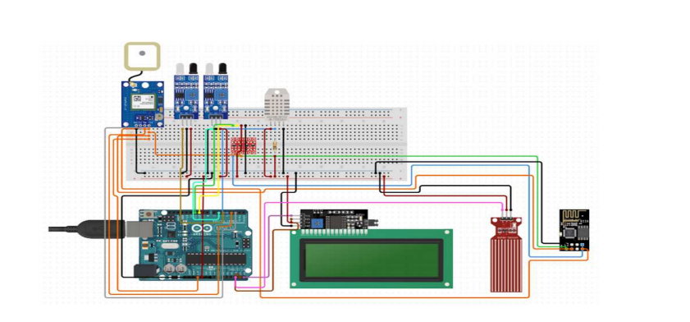

1. **Data transmission from Arduino to Wi-Fi module:**

The system is connected to the internet using ESP8266 module, a low-cost Wi-Fi module that has an in-built microcontroller and a 1MB flash. The TCP/IP protocol stack allows the module to communicate with Wi-Fi signals. The module is connected to microcontroller using soft serial UART having a specified baud rate. Microcontroller communicates with the Wi-Fi module using a set of AT commands. On the Arduino side, the Serial library can be used to communicate over the hardware serial pins (usually pins 0 and 1). On the ESP8266 side, Arduino libraries or the ESP8266 core for Arduino can be used to receive data from the Arduino. The maximum working voltage of the module is 3.3 V and it has total of six pins: 3.3 V Power Pin, Ground Pin, Active Low Reset Pin, Active High Enable Pin, Serial Transmit Pin of UART, and Serial Receive Pin of UART.

1. **From Wi-Fi module to Real time Transit Information Platform:**

To link data from Wi-Fi module to a real time transit information platform, we select ThinkSpeak platform. Then we configure ESP8266 Wi-Fi module to connect to the chosen platform and provide the necessary credentials to establish secure connection. Next Program the ESP8266 to collect relevant data from sensors (e.g., passenger count, GPS location) and transmit it to the IoT platform at regular intervals using protocols like HTTP or MQTT.

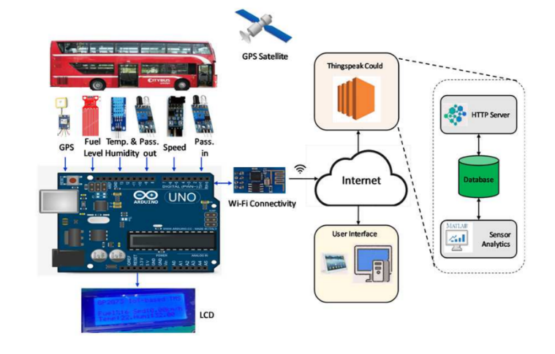

**Innovation:**

1. **Dynamic Traffic Signal Coordination:**

* Adaptive Traffic Control:

1. Implement IoT sensors at traffic intersections to collect real-time data on traffic flow.

* Congestion Alerts:

1. Implement a system that uses IoT data to provide real-time congestion alerts to public transport operators and commuters.
2. Optimize routes dynamically to avoid congested areas.
3. **Smart Ticketing and Boarding:**

* Passenger Movement Tracking:

1. Utilize IoT sensors to track passenger movement within public transport systems.
2. Optimize boarding and alighting processes based on real-time data.
3. **Predictive Maintenance for Vehicles:**

* IoT Sensors for Real-time Monitoring:

1. Equip public transport vehicles with IoT sensors to monitor various components in real time.
2. Detect potential issues before they lead to breakdowns.

* Fleet Health Dashboard:

1. Implement a centralized dashboard for transport authorities to monitor the health of the entire vehicle fleet.
2. Enable efficient resource allocation for maintenance and repairs.
3. **Dynamic Predictive Model:**

* Integrated Traffic Monitoring:

1. Develop a dynamic machine learning model that continuously learns from historical data, traffic patterns, and real-time conditions to predict accurate arrival times for buses and trains.
2. Integrate IoT-enabled traffic monitoring systems along public transport routes to gather real-time data on traffic congestion, road closures, and other factors influencing travel times.

**Team Members:**

Aishwarya I (2021504005)

Hayagreevan S (2021504009)

Janani M (2021504010)

Naresh Kumar S (2021504025)

Shohail Shahabudeen (2021504040)