

FINAL ASSESMENT

COURSE NAME : AGILE DEVELOPMENT PROCESS AND DEVOPS LAB

COURSE CODE : ISWE406L

SLOT : L3 + L4

FACULTY : Ramaligam

NAME : sham shohan (23MIS0633)

Question:

Problem Statement:

Ensure room bookings are managed without double-booking and maintain accurate availability status.

Tasks:

Develop room booking and cancellation logic.

Write JUnit tests for booking success and failure scenarios.

Implement CI/CD pipeline with automated testing:

Set up version control using GitHub

Configure CI pipeline (Jenkins / GitHub Actions)

Automate build using Apache Maven

Integrate unit testing

Configure CD pipeline for deployment

Deploy services on Docker and Kubernetes:

Containerize application using Docker

Push image to Docker Hub

Create Kubernetes deployment and service YAML files

- FILE STRUCTURE

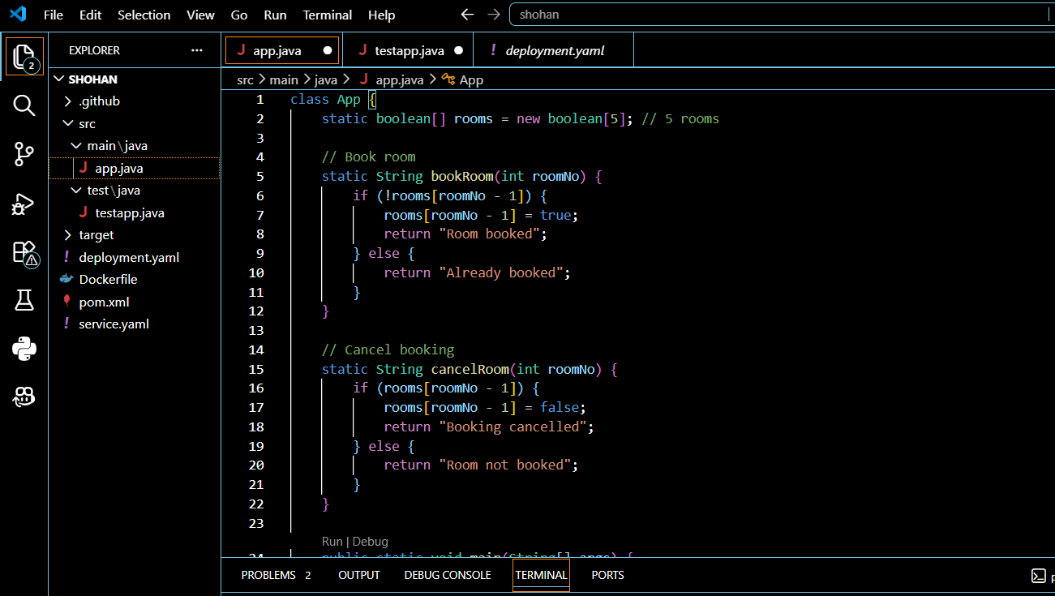

- MAVAN BUILD USING MVN CLEAN PACKAGE MVN CLEAN TEST

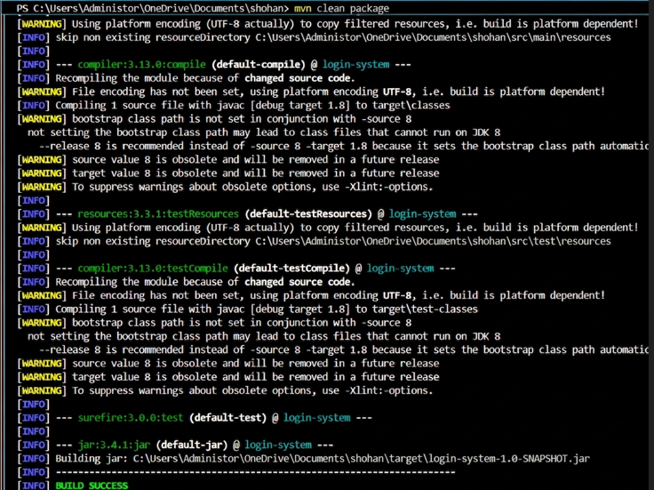
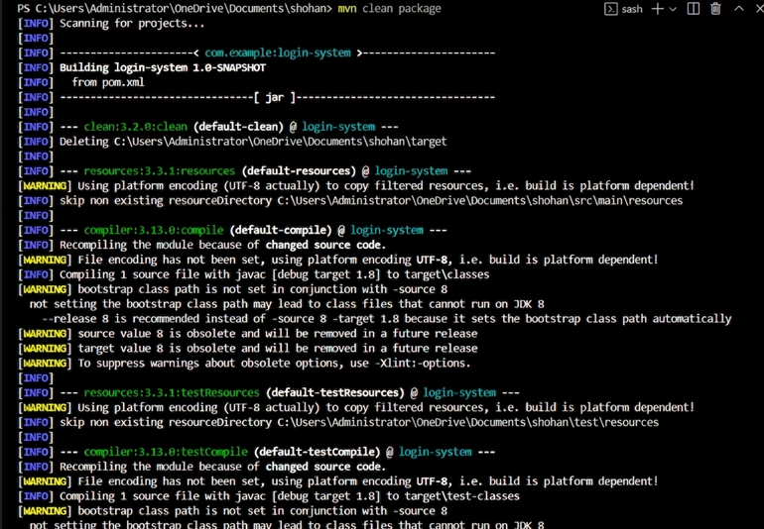

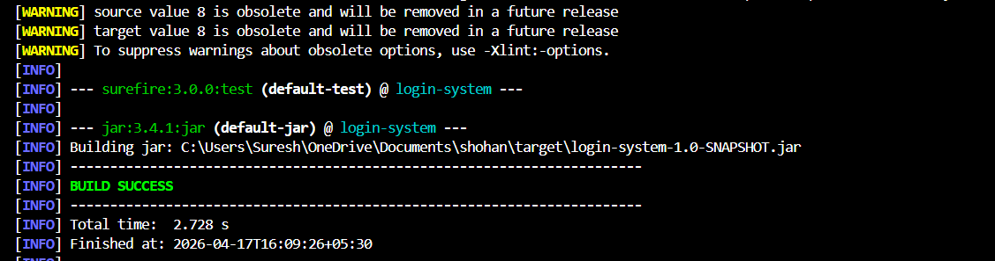

z

- VERIFY TARGET CLASS IS FORMED IN FILE STRUCTURE

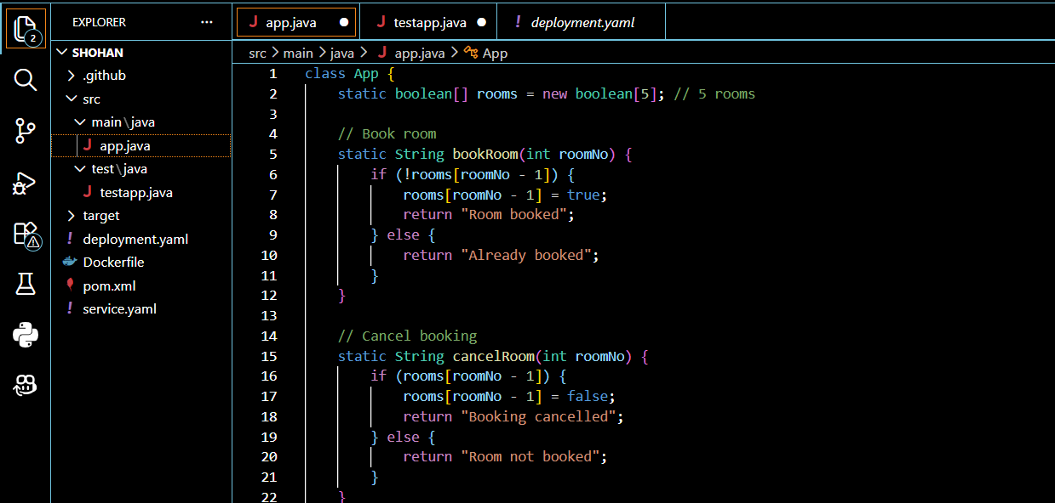

- CREATE THE REPOSITORY IN GIT

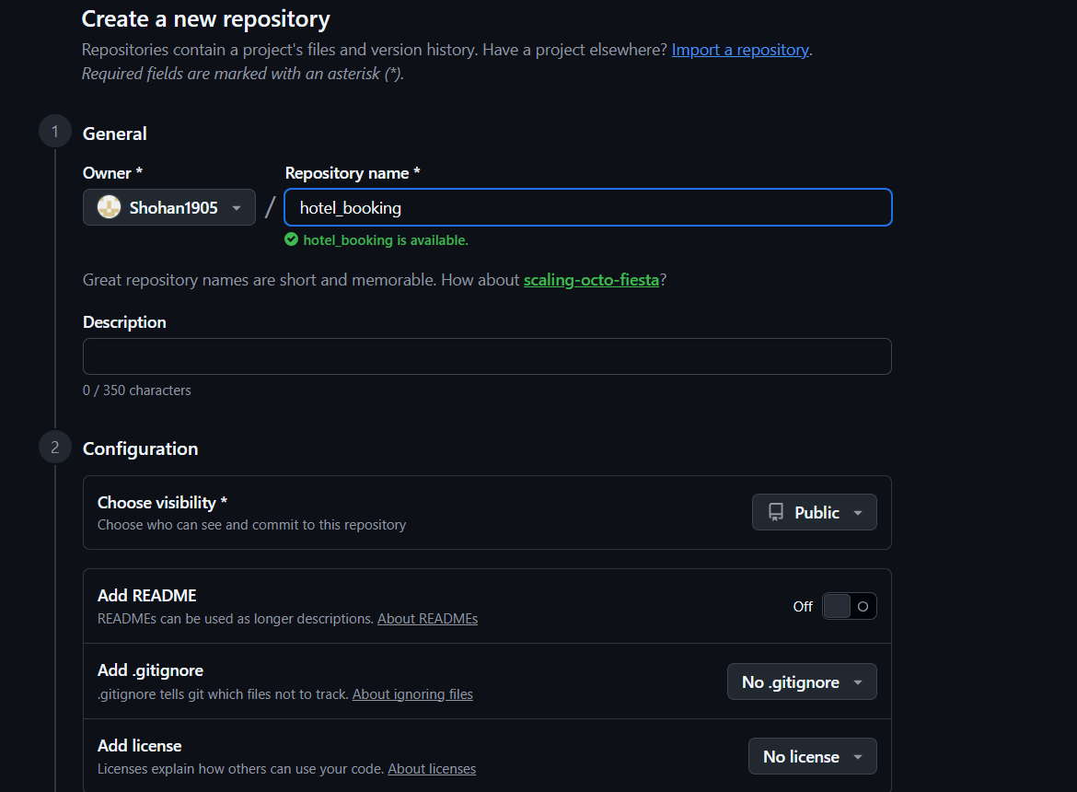

- PUSH TO GIT

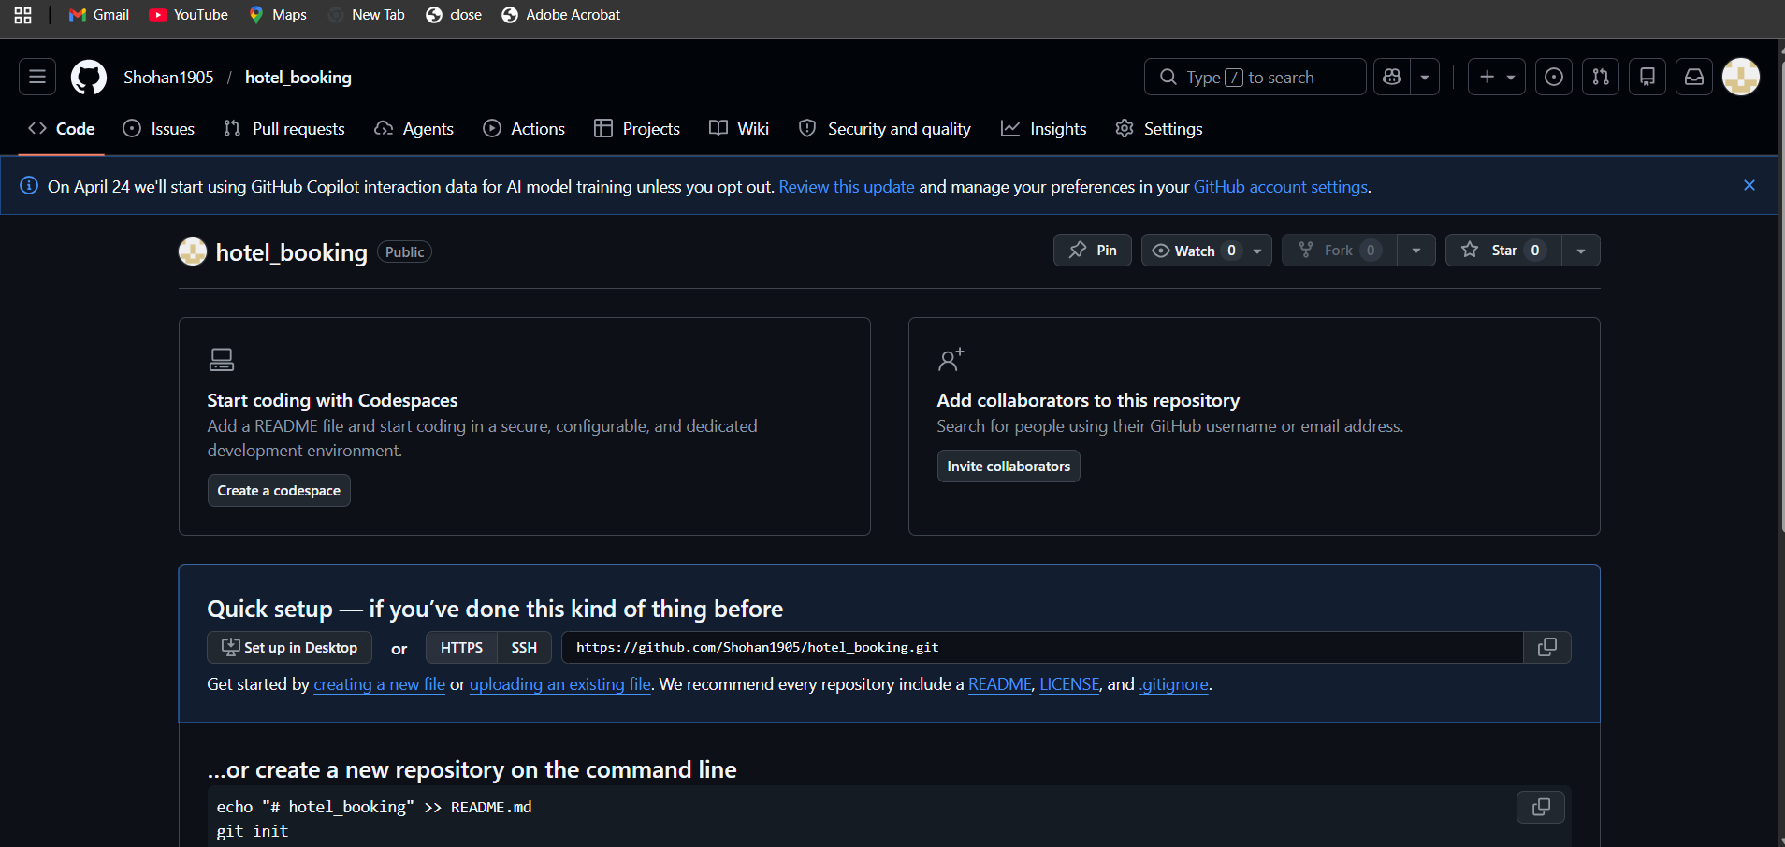

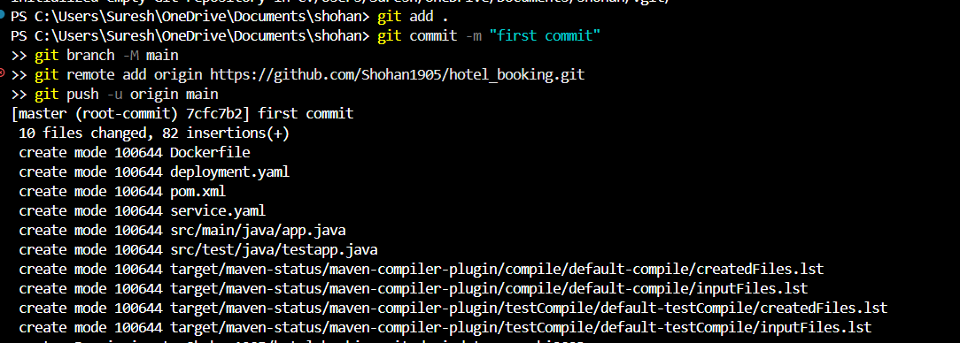

- CREATE NEW ITEM IN JENKINS

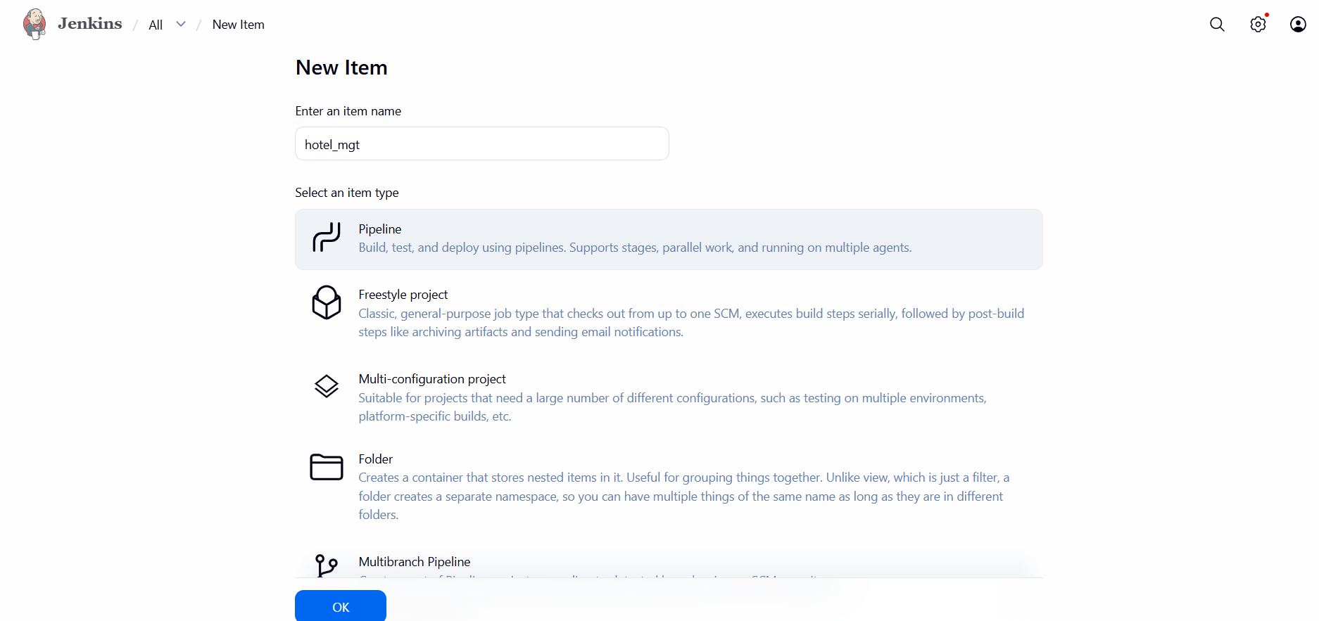
- CHECK THE RUNNING OF DOCKER ENGINE AND KUBERNETS IMAGES ARE CREATED
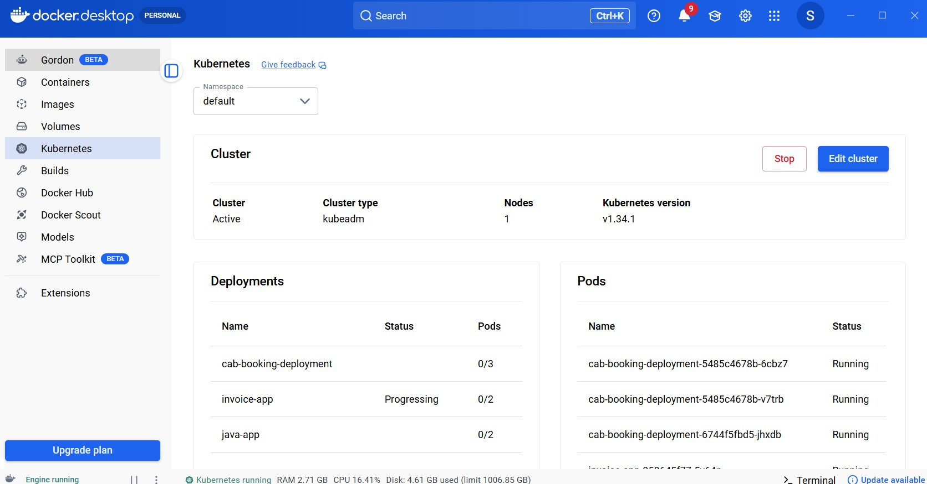

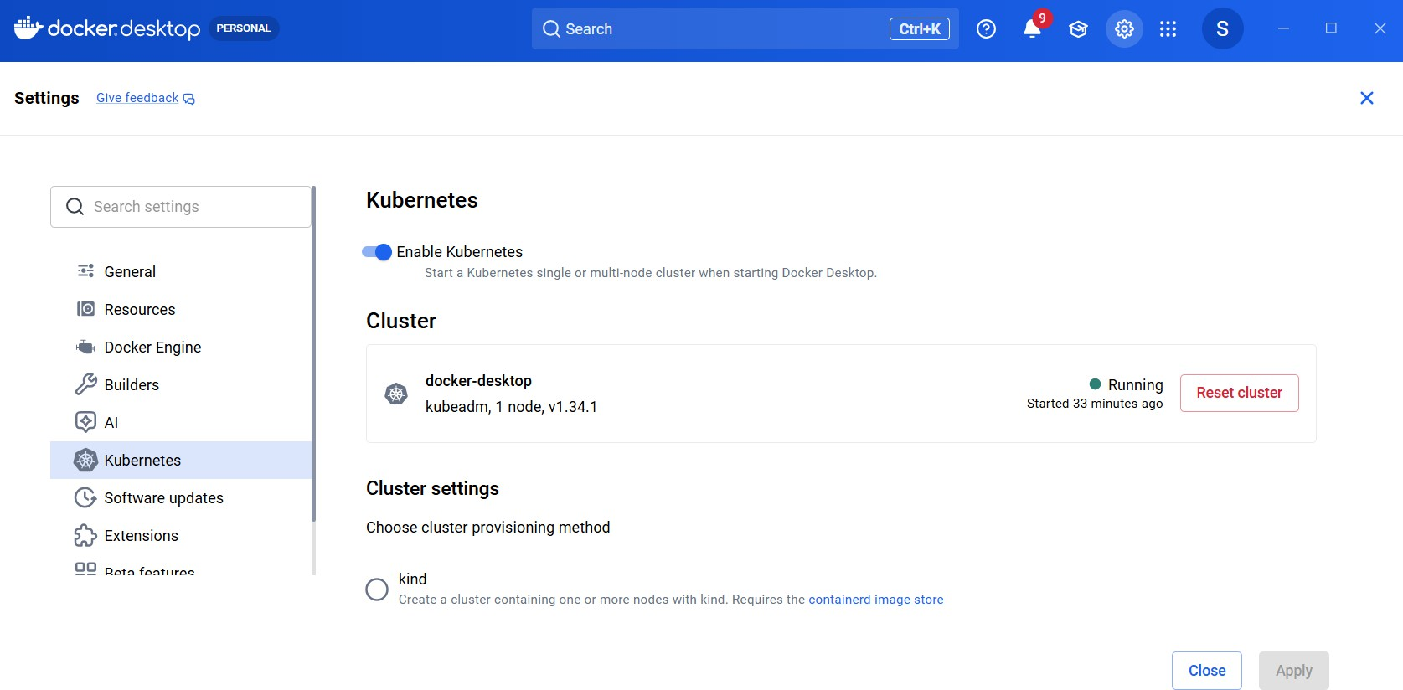

- UPLOAD THE PIPELINE CODE AND SAVE

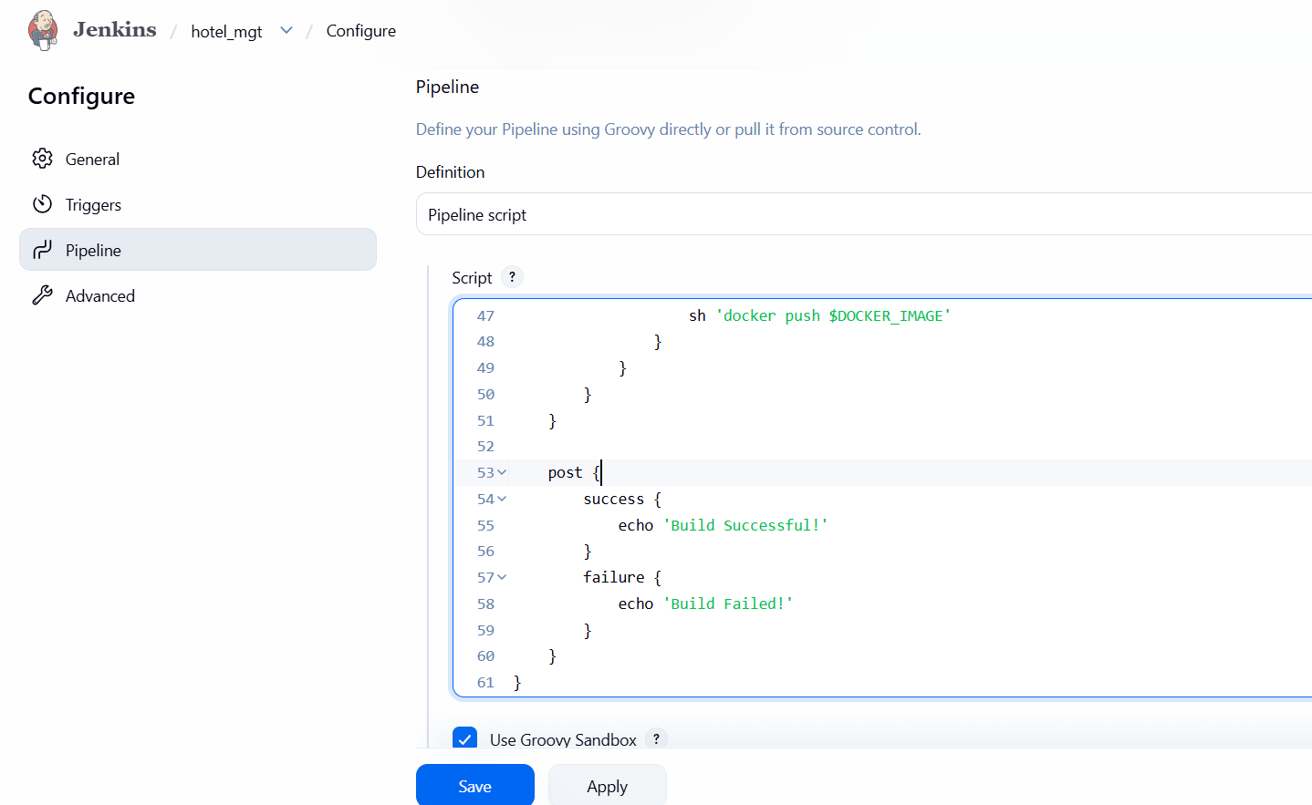

- CONSOLE OUTPUT

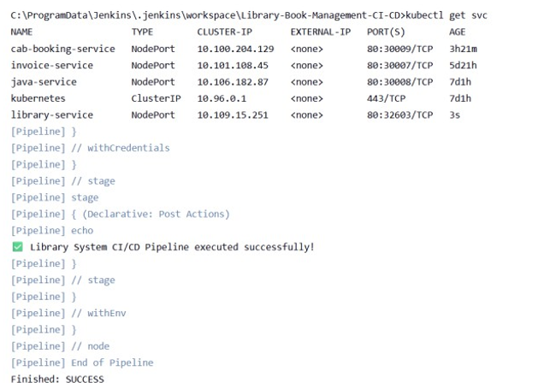

- PIPELINE STAGES

