Final exam - data formatting for question
Md Shohel Mojumder
March 05, 2021
###Answer to the questions no 2a and 2b
#install.packages("Hmisc")
library(Hmisc)
kiggs <- spss.get("KiGGS03_06.sav",use.value.labels = FALSE)
head(kiggs[, c('HbA1c','bmiB','sex', 'age2','fq44', 'fq44a')])
## HbA1c bmiB sex age2 fq44 fq44a
## 1 4.2 21.92927 1 7 2 1
## 2 5.4 16.54683 1 6 3 4
## 3 4.4 22.56497 2 5 3 3
## 4 3.6 20.71477 2 8 4 3
## 5 NA 15.81679 1 3 3 4
## 6 NA 16.61797 2 1 NA NA
kiggs$sex<- factor(kiggs$sex,labels = c("boys", "girls"))
kiggs$age2<- factor(kiggs$age2,labels = c("0-1y", "2-3y", "4-5y", "6-7y", "8-9y", "10-11y", "12-13y", "14-15y", "16-17y"))
kiggs$fq44<- factor(kiggs$fq44,labels = c("never", "1/month", "2-3/month", "1-2/week", "3-4/week", "5-6/week", "1/day", "2-3/day", "4-5/day", ">5/day"))
kiggs$fq44a <- factor(kiggs$fq44a,labels = c("never", "1/4 cup (or less)", "1/2 cup", "1 cup", "2 cups", "3 cups (or more)"))
###Answre to the questions 2c
# Saving the data.
save(kiggs, file = "data_formatting.RData")
###Answer of the question 3a
head(kiggs[, c('HbA1c','bmiB','sex', 'age2','fq44', 'fq44a')])
## HbA1c bmiB sex age2 fq44 fq44a
## 1 4.2 21.92927 boys 12-13y 1/month 1/4 cup (or less)
## 2 5.4 16.54683 boys 10-11y 2-3/month 2 cups
## 3 4.4 22.56497 girls 8-9y 2-3/month 1 cup
## 4 3.6 20.71477 girls 14-15y 1-2/week 1 cup
## 5 NA 15.81679 boys 4-5y 2-3/month 2 cups
## 6 NA 16.61797 girls 0-1y <NA> <NA>
str(kiggs$sex)
## Factor w/ 2 levels "boys","girls": 1 1 2 2 1 2 1 2 2 1 ...
sex is a nominal variable.
str(kiggs$age2)
## Factor w/ 9 levels "0-1y","2-3y",..: 7 6 5 8 3 1 1 3 3 7 ...
str(kiggs$fq44)
## Factor w/ 10 levels "never","1/month",..: 2 3 3 4 3 NA NA 2 3 NA ...
str(kiggs$fq44a)
## Factor w/ 6 levels "never","1/4 cup (or less)",..: 2 5 4 4 5 NA NA 3 3 NA ...
age2, fq44, fq44a are Ordinal variables.
str(kiggs$HbA1c)
## 'labelled' num [1:17640] 4.2 5.4 4.4 3.6 NA NA NA 5 NA 4.5 ...
## - attr(*, "value.labels")= Named num(0)
## ..- attr(*, "names")= chr(0)
## - attr(*, "label")= Named chr "Glykohämoglobin 1c [%] "
## ..- attr(*, "names")= chr "HbA1c"
str(kiggs$bmiB)
## 'labelled' num [1:17640] 21.9 16.5 22.6 20.7 15.8 ...
## - attr(*, "label")= Named chr "Body-Mass-Index (kg/qm), berechnet aus gewiB und groeB"
## ..- attr(*, "names")= chr "bmiB"
HbA1c, bmiB are metric Variables.
In short,sex is a nominal variable. age2, fq44, fq44a are Ordinal variables. HbA1c, bmiB are metric Variables.
#which descriptive statistic is best suited?
sex is a nominal variable.it would be better suited by the frequencies.
age2, fq44, fq44a are Ordinal Variables.Ordinal variables are those which could be ranked and calculated median, range, and quantiles. However, they are not appropriate for the mean and standard deviation. Moreover,If any ordinal variable does not have many categories, they are good for the frequencies descriptive statistics. Therefore,age2, fq44, fq44a are best suited for the frequencies descriptive statistics.
Since HbA1c, bmiB are metric variables, they are suited with mean/standard deviation descriptive statistics.
#calculation of descriptive statistics and display them in a table
# install.packages("qwraps2")
library(qwraps2)
options(qwraps2_markup = "markdown")
our_summary <-
list("HbA1c(Blood Sugar Levels)" =
list("Mean (SD)" = ~ qwraps2::mean_sd(.data$HbA1c, denote_sd = "paren", na_rm = TRUE, show_n = "never")),
"bmiB(Body Mass Index)" =
list("Mean (SD)" = ~ qwraps2::mean_sd(.data$bmiB, denote_sd = "paren", na_rm = TRUE, show_n = "never")),
"SEX" =
list("boys" = ~ qwraps2::n_perc0(.data$age2 == "0-1y", show_symbol = TRUE, na_rm = TRUE),
"girls" = ~ qwraps2::n_perc0(.data$age2 == "2-3y", show_symbol = TRUE, na_rm = TRUE)),
"Age Group" =
list("0-1y" = ~ qwraps2::n_perc0(.data$age2 == "0-1y", show_symbol = TRUE, na_rm = TRUE),
"2-3y" = ~ qwraps2::n_perc0(.data$age2 == "2-3y", show_symbol = TRUE, na_rm = TRUE),
"4-5y" = ~ qwraps2::n_perc0(.data$age2 == "4-5y", show_symbol = TRUE, na_rm = TRUE),
"6-7y" = ~ qwraps2::n_perc0(.data$age2 == "6-7y", show_symbol = TRUE, na_rm = TRUE),
"8-9y" = ~ qwraps2::n_perc0(.data$age2 == "8-9y", show_symbol = TRUE, na_rm = TRUE),
"10-11y" = ~ qwraps2::n_perc0(.data$age2 == "10-11y", show_symbol = TRUE, na_rm = TRUE),
"12-13y" = ~ qwraps2::n_perc0(.data$age2 == "12-13y", show_symbol = TRUE, na_rm = TRUE),
"14-15y" = ~ qwraps2::n_perc0(.data$age2 == "14-15y", show_symbol = TRUE, na_rm = TRUE),
"16-17y" = ~ qwraps2::n_perc0(.data$age2 == "16-17y", show_symbol = TRUE, na_rm = TRUE)),
"fq44(Sanke Frequency)" =
list("never" = ~ qwraps2::n_perc0(.data$fq44 == "never", show_symbol = TRUE, na_rm = TRUE),
"1/month" = ~ qwraps2::n_perc0(.data$fq44 == "1/month", show_symbol = TRUE, na_rm = TRUE),
"2-3/month" = ~ qwraps2::n_perc0(.data$fq44 == "2-3/month", show_symbol = TRUE, na_rm = TRUE),
"1-2/week" = ~ qwraps2::n_perc0(.data$fq44 == "1-2/week", show_symbol = TRUE, na_rm = TRUE),
"3-4/week" = ~ qwraps2::n_perc0(.data$fq44 == "3-4/week", show_symbol = TRUE, na_rm = TRUE),
"5-6/week" = ~ qwraps2::n_perc0(.data$fq44 == "5-6/week", show_symbol = TRUE, na_rm = TRUE),
"1/day" = ~ qwraps2::n_perc0(.data$fq44 == "1/day", show_symbol = TRUE, na_rm = TRUE),
"2-3/day" = ~ qwraps2::n_perc0(.data$fq44 == "2-3/day", show_symbol = TRUE, na_rm = TRUE),
"4-5/day" = ~ qwraps2::n_perc0(.data$fq44 == "4-5/day", show_symbol = TRUE, na_rm = TRUE),
">5/day" = ~ qwraps2::n_perc0(.data$fq44 == ">5/day", show_symbol = TRUE, na_rm = TRUE)),
"fq44a(Sanke Amount)" =
list("never" = ~ qwraps2::n_perc0(.data$fq44a == "never", show_symbol = TRUE, na_rm = TRUE),
"1/4 cup (or less)" = ~ qwraps2::n_perc0(.data$fq44 == "1/4 cup (or less)", show_symbol = TRUE, na_rm = TRUE),
"1/2 cup" = ~ qwraps2::n_perc0(.data$fq44a == "1/2 cup", show_symbol = TRUE, na_rm = TRUE),
"1 cup" = ~ qwraps2::n_perc0(.data$fq44a == "1 cup", show_symbol = TRUE, na_rm = TRUE),
"2 cups" = ~ qwraps2::n_perc0(.data$fq44a == "2 cups", show_symbol = TRUE, na_rm = TRUE),
"3 cups (or more)" = ~ qwraps2::n_perc0(.data$fq44a == "3 cups (or more)", show_symbol = TRUE, na_rm = TRUE))
)
our_table <- summary_table(kiggs, our_summary)
our_table
 | x (N = 17,640)
HbA1c(Blood Sugar Levels)
Mean (SD) | 4.86 (0.43)
bmiB(Body Mass Index)
Mean (SD) | 18.26 (3.72)
SEX
boys | 1,860 (11%)
girls | 1,879 (11%)
Age Group
0-1y | 1,860 (11%)
2-3y | 1,879 (11%)
4-5y | 1,935 (11%)
6-7y | 2,032 (12%)
8-9y | 2,104 (12%)
10-11y | 2,076 (12%)
12-13y | 2,018 (11%)
14-15y | 1,972 (11%)
16-17y | 1,764 (10%)
fq44(Sanke Frequency)
never | 1,683 (11%)
1/month | 3,408 (22%)
2-3/month | 5,199 (33%)
1-2/week | 3,737 (24%)
3-4/week | 1,080 (7%)
5-6/week | 261 (2%)
1/day | 311 (2%)
2-3/day | 73 (0%)
4-5/day | 9 (0%)
>5/day | 6 (0%)
fq44a(Sanke Amount)
never | 1,683 (11%)
1/4 cup (or less) | 0 (0%)
1/2 cup | 4,090 (26%)
1 cup | 5,110 (32%)
2 cups | 1,305 (8%)
3 cups (or more) | 266 (2%)
#Missing values in the each variable are given below:
sum(is.na(kiggs$HbA1c))
## [1] 3543
sum(is.na(kiggs$bmiB))
## [1] 147
sum(is.na(kiggs$fq44))
## [1] 1873
sum(is.na(kiggs$fq44a))
## [1] 1916
Variable HbA1c has 3543 missing values. variable bmiB has 147 missing values. Variable fq44 has 1873 missing values. variable fq44a has 1916 missing values.
sum(is.na(kiggs$age2))
## [1] 0
sum(is.na(kiggs$sex))
## [1] 0
The variables age2 and sex do not have any missing values.
#no of observations complete data
library(dplyr)
observations <- select(kiggs, HbA1c, bmiB, sex, age2, fq44, fq44a)
nrow(observations[complete.cases(observations), ])
## [1] 13276
The 13276 observations have complete data for all 6 variables.
###Answer to the questions no 3b
Since sex is a nominal variable, Barplot is more suitable for displaying their distribution.
a histogram is more suitable for displaying the HbA1c and bmiB variables distribution as they are metric variables.
age2, fq44, fq44a are Ordinal variables.Therefore, Barplot is more suitable to display their distributions.
# plot the variables using ggplot()
library(ggplot2)
ggplot(data = kiggs, mapping = aes(x = bmiB)) + geom_histogram()
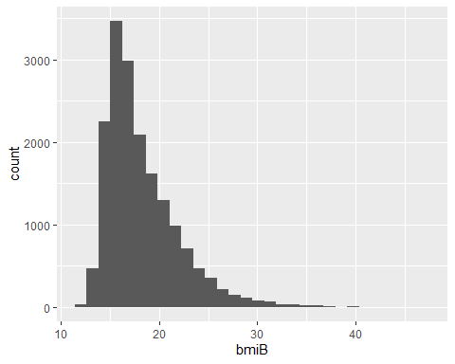
ggplot(data = kiggs, mapping = aes(x = HbA1c)) + geom_histogram()
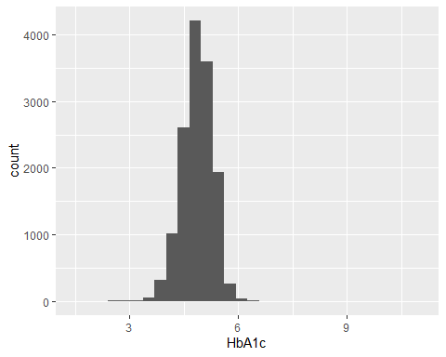
ggplot(data = kiggs, mapping = aes(x = sex)) + geom_bar()
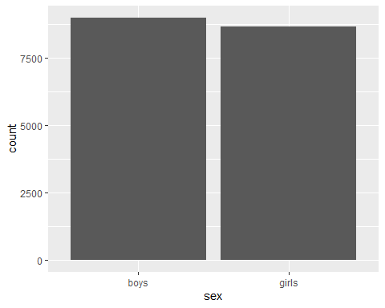
ggplot(data = kiggs, mapping = aes(x = age2)) + geom_bar()
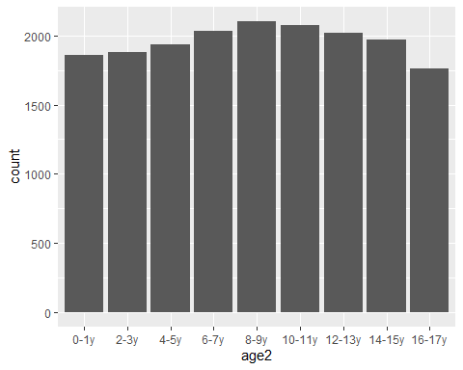
ggplot(data = kiggs, mapping = aes(x = fq44)) + geom_bar()
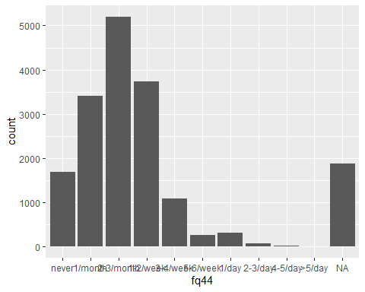
ggplot(data = kiggs, mapping = aes(x = fq44a)) + geom_bar()
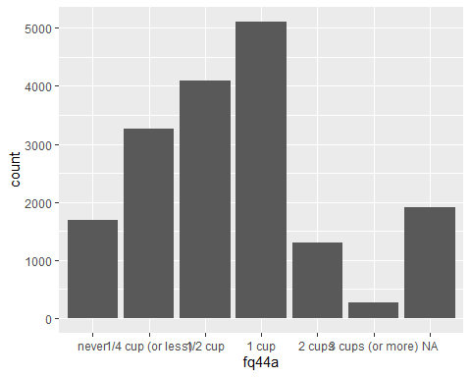
###Answer to the questions no 4a
#compute linear regression model
fit <-lm(HbA1c ~ as.numeric(fq44) + as.numeric(fq44a) + as.numeric(age2) + bmiB+ sex, data = kiggs)
summary(fit)$coefficients
## Estimate Std. Error t value Pr(>|t|)
## (Intercept) 4.8307071433 0.021509849 224.5811792 0.000000e+00
## as.numeric(fq44) -0.0040147778 0.003192125 -1.2577133 2.085176e-01
## as.numeric(fq44a) 0.0088902653 0.003667020 2.4243845 1.534763e-02
## as.numeric(age2) 0.0094561376 0.002080042 4.5461286 5.512481e-06
## bmiB -0.0009586075 0.001208144 -0.7934549 4.275270e-01
## sexgirls -0.0449256946 0.007440047 -6.0383620 1.598445e-09
#how I take predictors into the regression model and Why is it that way?
fq44,fq44a,age2,sex are factors.Moreover,HbA1c and bmiB are metric variables.
I have converted the fg44, fq44a, and age2 into the rank variable(ordinal variables) using as.numeric as it is easy to describe which means there is one coefficient for one variable for its categories. This allows us to compare two adjacent categories and we estimated one parameter and we assume that it is always going up to the next categories by the same amount. On the other hand, if we take variables as they are which means if we take the variable as factor variables it might give us much information. However, the Model may become very complicated and there may be a problem arise because of collinearity.
bmi is a metric variable. I use it in my model without doing any conversion.
HbA1c is an outcome variable and it should be metric in the models.
if we have binary variables then if we incorporate either them using as.numeric() or dummy variables, the coefficient will always reflect an increase between the two categories as there are two values. Therefore, in the case of a binary variable, this does not matter whether you take it as a factor or using as.numeric(). Sex is a binary variable and I have taken sex as a factor variable.
#create variables
HbA1c<-kiggs$HbA1c
age <-kiggs$age2
fq44<-kiggs$fq44
fq44a<-kiggs$fq44a
sex<-kiggs$sex
bmi<-kiggs$bmiB
###Answer to the questions no 4b
#create variables and create the same model again to explain properly
blood_sugar<-kiggs$HbA1c
snack_frequent<-kiggs$fq44
snack_amount<-kiggs$fq44a
#compute linear regression model
fit1 <-lm(blood_sugar ~ bmi + as.numeric(snack_frequent) + as.numeric(snack_amount) + sex + as.numeric(age))
summary(fit1)$coefficients
## Estimate Std. Error t value Pr(>|t|)
## (Intercept) 4.8307071433 0.021509849 224.5811792 0.000000e+00
## bmi -0.0009586075 0.001208144 -0.7934549 4.275270e-01
## as.numeric(snack_frequent) -0.0040147778 0.003192125 -1.2577133 2.085176e-01
## as.numeric(snack_amount) 0.0088902653 0.003667020 2.4243845 1.534763e-02
## sexgirls -0.0449256946 0.007440047 -6.0383620 1.598445e-09
## as.numeric(age) 0.0094561376 0.002080042 4.5461286 5.512481e-06
#Interpretion
The coefficient value of fq44(snack_frequent) is -0.004. So there is a negative association here, which means if they consume snacks frequently, their blood sugar levels would get lower. However, increasing in the one unit(for example, going from never to 1/month ), Blood sugar level decrease by 0.004 as the value of the regression coefficient is 0.004. Here the value of the coefficient is very small, which means the differences of two adjacent groups in the variable are very small and, therefore, there are no big differences between the groups.
The coefficient fq44a(snack_amount) is 0.009,which is a positive.Therefore, there is a positive association here. This means if they consume more amount of snacks, their blood sugar levels would get higher. However, an increase of the one unit that is going from 1/month to 2-3/month and 2-3/month to 1-2/week, etc. Blood sugar level would increase by 0.009 as the value of the regression coefficient is 0.009. Here the value of the coefficient is almost zero which means the differences between two adjacent groups are almost zero and, therefore, there are no big differences between the group.
The coefficient of bmi is close to zero and negative. So there is a negative association, which means if BMI gets higher, blood sugar levels would get lower.
#conclusion based on the p-values
The p-value of bmi is 0.42 which is greater than 0.05. Therefore, we accept the null hypothesis. There is no association between the outcome variable blood_sugar(HbA1c) and dependent variable bmi.
The p-value of fq44 is 0.21 and this is greater than 0.05.,we accept the null hypothesis. There is no association between the outcome variable blood_sugar(HbA1c) and dependent variable snack_frequent(fq44).
The p-value of fq44a is 0.01 which is less than 0.05. Therefore, we reject the null hypothesis. There is an association between the outcome variable blood_sugar(HbA1c) and dependent variable snack_amount (fq44a).
The p-value of sex is close to zero. As it is less than 0.05.,we reject the null hypothesis. There is an association between the outcome variable blood_sugar(HbA1c) and the dependent variable sex.
The p-value of age is also very small and it is close to zero. As it is less than 0.05, we reject the null hypothesis. There is an association between the outcome variable blood_sugar(HbA1c) and dependent variable age(age2).
# get confidence intervals for regression coefficient:
library(jtools)
jtools::summ(fit, exp = F, confint = T, model.fit = F, digits = 3)
## MODEL INFO:
## Observations: 13276 (4364 missing obs. deleted)
## Dependent Variable: HbA1c
## Type: OLS linear regression
##
## Standard errors: OLS
## --------------------------------------------------------------------
## Est. 2.5% 97.5% t val. p
## ----------------------- -------- -------- -------- --------- -------
## (Intercept) 4.831 4.789 4.873 224.581 0.000
## as.numeric(fq44) -0.004 -0.010 0.002 -1.258 0.209
## as.numeric(fq44a) 0.009 0.002 0.016 2.424 0.015
## as.numeric(age2) 0.009 0.005 0.014 4.546 0.000
## bmiB -0.001 -0.003 0.001 -0.793 0.428
## sexgirls -0.045 -0.060 -0.030 -6.038 0.000
## --------------------------------------------------------------------
#95% confidence intervals for the variables
The 95% confidence intervals for the regression coefficients(-0.001) of bmi is between -0.003 and 0.001.
The 95% confidence intervals for the regression coefficients(-0.004) of fq44(as.numeric(fq44)) is between -0.010 and 0.002.
The 95% confidence intervals for the regression coefficients(0.009) of fq44(as.numeric(fq44a)) is between 0.002 and 0.016.
The 95% confidence intervals for the regression coefficients(-0.045) of sex(sexgirls) is between -0.060 and -0.030.
The 95% confidence intervals for the regression coefficients(0.009) of age2(as.numeric(age)) is between 0.005 and 0.014.
###Answer to the questions no 4c
##Look at assumptions:
- is HbA1c a continuous variable?
str(HbA1c)
## 'labelled' num [1:17640] 4.2 5.4 4.4 3.6 NA NA NA 5 NA 4.5 ...
## - attr(*, "value.labels")= Named num(0)
## ..- attr(*, "names")= chr(0)
## - attr(*, "label")= Named chr "Glykohämoglobin 1c [%] "
## ..- attr(*, "names")= chr "HbA1c"
HbA1c is a metric variables. so, HbA1c is a continuous variable.
- relationship between the X variables and Y linear?
Look at scatterplots:
plot(as.numeric(fq44), HbA1c)
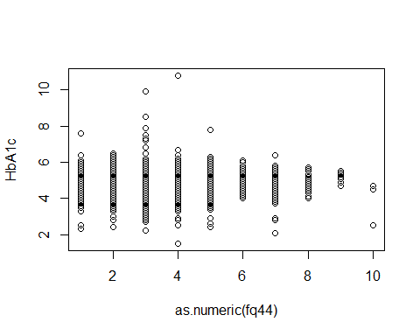
plot(as.numeric(fq44a), HbA1c)
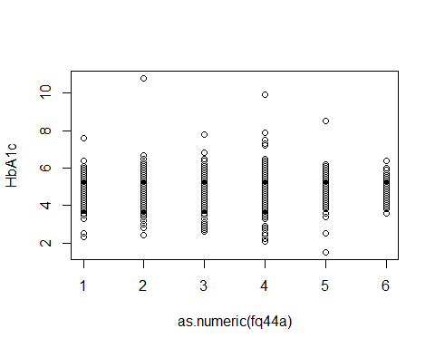
plot(as.numeric(bmi), HbA1c)
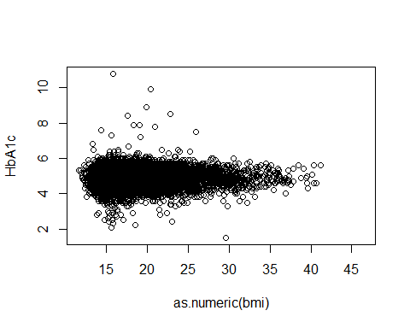
plot(as.numeric(age), HbA1c)
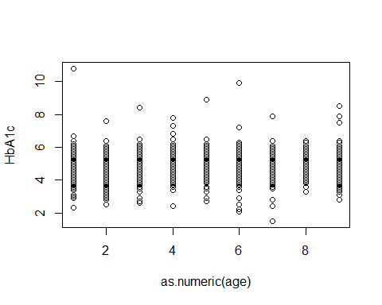
plot(as.numeric(sex), HbA1c)
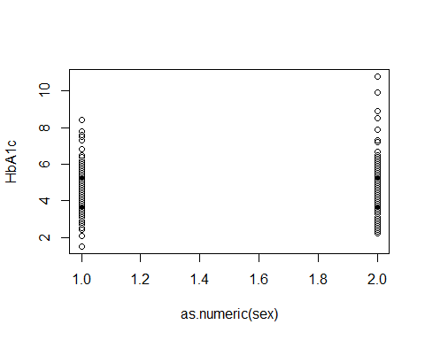 From the above scatter plots, we can see that the relationships are linear. For each variable, we can fit a regression line for the linear relationships. We can get better visualization by adding the jitter into the plots.
# Looking at the scatter plots by adding the jitter:
plot(jitter(as.numeric(snack_amount)), HbA1c)
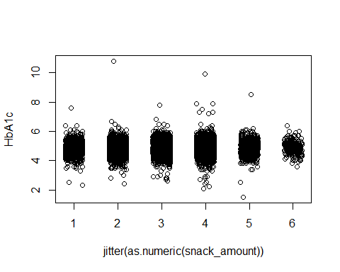
plot(jitter(as.numeric(snack_frequent)), HbA1c)
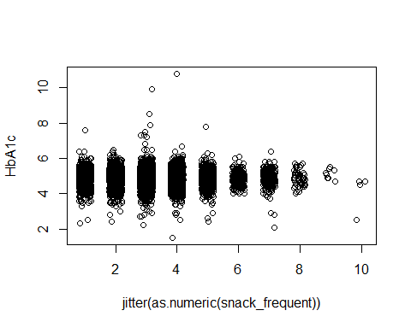
plot(as.numeric(bmi), HbA1c)
plot(as.numeric(age), HbA1c)
plot(as.numeric(sex), HbA1c)
After adding the jitter into the plots, we get better visualizations. We can see the linear relationship. We can further investigate it by using the box plots below:
Look at boxplots with added regression line:
plot(snack_amount, HbA1c)
abline(lm(HbA1c ~ as.numeric(snack_amount)), col = "blue")
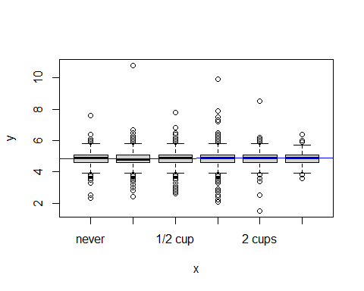
plot(snack_frequent, HbA1c)
abline(lm(HbA1c ~ as.numeric(snack_frequent)), col = "blue")
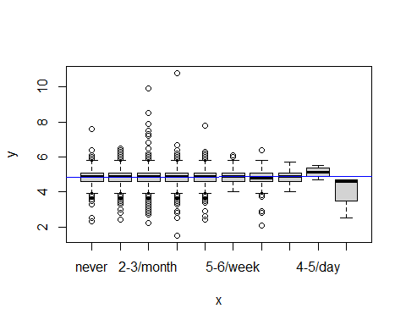
plot(bmi, HbA1c)
abline(lm(HbA1c ~ as.numeric(bmi)), col = "blue")
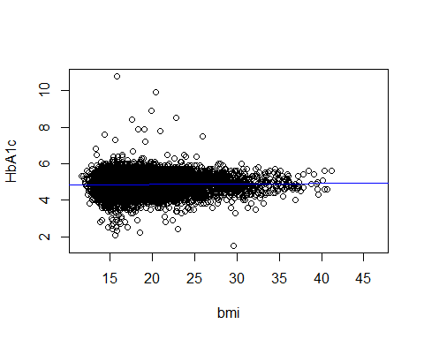
plot(age, HbA1c)
abline(lm(HbA1c ~ as.numeric(age)), col = "blue")
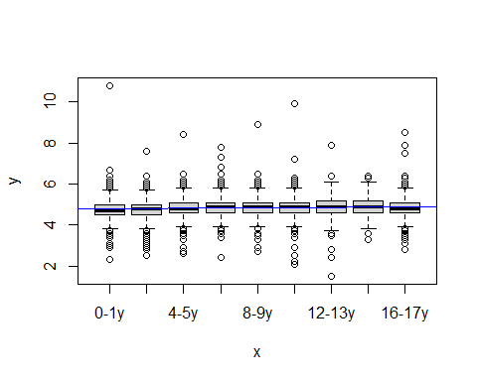
plot(sex, HbA1c)
abline(lm(HbA1c ~ as.numeric(sex)), col = "blue")
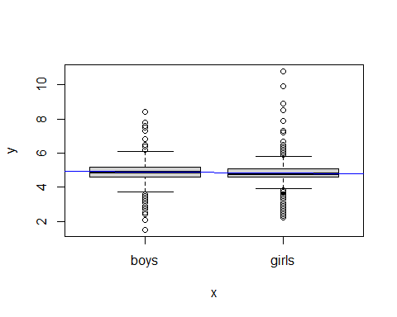
We can get a lot of information by adding the regression line (with the respective predictor) in the boxplots. We can see a better regression line from these plots.
Other way to look at it: look at residual plot.
plot(fit, 1)
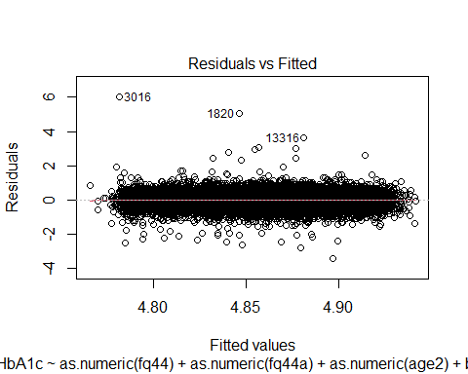
From above plot, we can see the linear relationship in the model. There is an optimal regression line for the model. We see that the relationship is linear. Therefore, we used as.numeric with the variables in the regression models.
- All relevant variables (covariates, confounders) are in the model
I think this cannot be tested, this would be our assumption. However, here, I believe that the assumption is not correct.I think that there are many other variables that can potentially have an effect.
- Normally-distributed residuals
# Distribution of outcome:
hist(HbA1c)
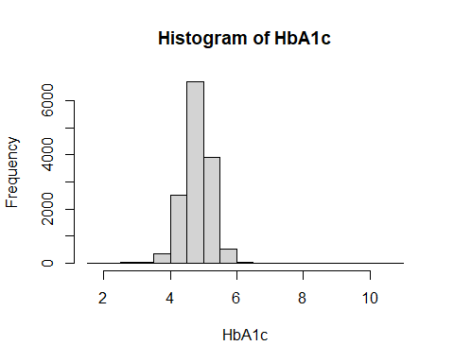
qqnorm(scale(HbA1c)); abline(0,1)
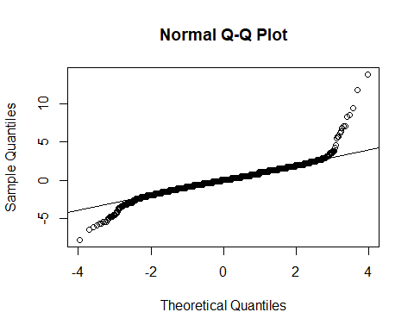
if we plot the outcome variables(HbA1c) in the histogram, we can see the plot seems to have normal distributions. Moreover, if we plot the outcome variable in the Normal Q-Q plot, we get most of the values on the line. So we can consider it as a normal distribution.
# Distribution of residuals, see:
hist(residuals(fit))
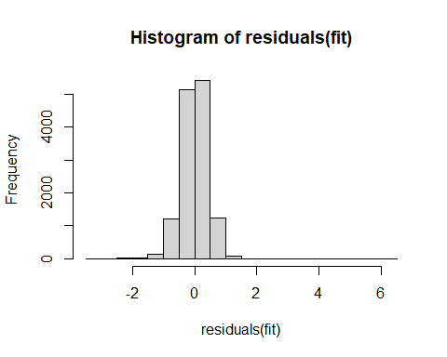
If we plot the residuals in the histogram ,we can see that the residuals are very close to normal distribution.SO,we can say this model has normally distributed residuals.
- Homoscedastic residuals
# Look at first plot in:
plot(fit,1)
This is Homoscedastic as the errors which the model is making are basically constant across the independent variables of sex,age2,fq44,fq44a, and bmi.
###Answer to the questions no 4d
# Anova Model:
summary(aov(HbA1c ~ fq44 + fq44a))
## Df Sum Sq Mean Sq F value Pr(>F)
## fq44 9 3.9 0.4297 2.365 0.011484 *
## fq44a 4 4.2 1.0504 5.781 0.000121 ***
## Residuals 13316 2419.5 0.1817
## ---
## Signif. codes: 0 '***' 0.001 '**' 0.01 '*' 0.05 '.' 0.1 ' ' 1
## 4310 observations deleted due to missingness
Interpretation:
There is an association between fq44a and HbA1c since the p-value of the fq44a term is very small and This value is less than 0.05. Furthermore, there is also an association between fq44 and HbA1c as the p-value of this association is less than 0.05.
#difference from this analysis to the regression analysis above
In linear regression,Here,we estimate the relationship between dependent variables fq44a,fq44,age2,bmiB,sex and independent variables HbA1c.Here,there is no association between predictors fq44 and outcome variable HbA1c as the P-value of fq44 is 2.085176e-01 i.e. 0.2 which is greater than 0.05.Furthermore, there is an association between the predictors fq44a and HbA1c since the p-value of fq44a is 1.534763e-02 that is 0.015 and this value is less than 0.05.
Blood sugar levels differ between fq44 groups(since p-value <0.011484), also Blood sugar levels differ differ between fq44a groups (p-value = 4.44e-05).Both of these p-value less than 0.05.
In the linear regression, I transform factor variables into ordinal variables by using as.numeric() functions whereas In ANOVA, We need to use factor variables as predictors.
In the linear regression, I have taken metric variables as dependent variables whereas, in ANOVA, we are not allowed to take any metric variables as dependent variables.
In the linear regression, I can arrange predictors in any order and it does not make any differences in the outcome variable blood sugar levels, however, In the ANOVA model If we change the order of predictors, different results might be produced.
###answer to the queston no 5a
#create a binary variable from HbA1c
threshold<-mean(kiggs$HbA1c, na.rm = TRUE)
table(threshold)
## threshold
## 4.86126126126126
## 1
blood_sugarL<- kiggs$HbA1c >= threshold
table(blood_sugarL)
## blood_sugarL
## FALSE TRUE
## 6734 7363
###answer to the queston no: 5b
# compute the logistic regression model:
fitL <- glm(blood_sugarL ~ bmi+sex++ as.numeric(age)+as.numeric(snack_frequent) + as.numeric(snack_amount) , family = binomial(link = "logit"))
summary(fitL)
##
## Call:
## glm(formula = blood_sugarL ~ bmi + sex + +as.numeric(age) + as.numeric(snack_frequent) +
## as.numeric(snack_amount), family = binomial(link = "logit"))
##
## Deviance Residuals:
## Min 1Q Median 3Q Max
## -1.350 -1.205 1.044 1.142 1.291
##
## Coefficients:
## Estimate Std. Error z value Pr(>|z|)
## (Intercept) 0.044703 0.101383 0.441 0.659
## bmi -0.008367 0.005696 -1.469 0.142
## sexgirls -0.206758 0.035078 -5.894 3.76e-09 ***
## as.numeric(age) 0.045033 0.009815 4.588 4.47e-06 ***
## as.numeric(snack_frequent) -0.005951 0.015056 -0.395 0.693
## as.numeric(snack_amount) 0.019362 0.017298 1.119 0.263
## ---
## Signif. codes: 0 '***' 0.001 '**' 0.01 '*' 0.05 '.' 0.1 ' ' 1
##
## (Dispersion parameter for binomial family taken to be 1)
##
## Null deviance: 18382 on 13275 degrees of freedom
## Residual deviance: 18315 on 13270 degrees of freedom
## (4364 observations deleted due to missingness)
## AIC: 18327
##
## Number of Fisher Scoring iterations: 3
###answer to the queston no: 5c
The p-value of bmi (bmi) is 0.142.Moreover, the p-value of fq44 (snack_frequent) is 0.693 and the p-value of fq44a (snack_amount) is 0.263.Since the p-value of bmi(bmiL) is 0.142 which is greater than 0.05 and ,therefore,there is no association between bmi(bmi) and HbA1c(blood_sugar).Moreover,fq44 (snack_frequent) also has the p-value which is the greater than 0.05 and the fq44a(snack_amount) also has the p-value which is greater than 0.05.Therefore,both of them has no association with the outcome variable HbA1c(blood_sugar).On the other hand, The p-value of sex and age2 are lower than the 0.05,which means both sexL(sex) and ageL(age2) has the association with the outcome variable HbA1c(blood_sugarL).The p-value of sex and age(age2) are close to zero.
###answer to the queston no 5d
library(jtools)
jtools::summ(fitL, exp = T, confint = T, model.fit = F, digits = 3)
## MODEL INFO:
## Observations: 13276 (4364 missing obs. deleted)
## Dependent Variable: blood_sugarL
## Type: Generalized linear model
## Family: binomial
## Link function: logit
##
## Standard errors: MLE
## -----------------------------------------------------------------------------
## exp(Est.) 2.5% 97.5% z val. p
## -------------------------------- ----------- ------- ------- -------- -------
## (Intercept) 1.046 0.857 1.276 0.441 0.659
## bmi 0.992 0.981 1.003 -1.469 0.142
## sexgirls 0.813 0.759 0.871 -5.894 0.000
## as.numeric(age) 1.046 1.026 1.066 4.588 0.000
## as.numeric(snack_frequent) 0.994 0.965 1.024 -0.395 0.693
## as.numeric(snack_amount) 1.020 0.986 1.055 1.119 0.263
## -----------------------------------------------------------------------------
Interpretation:
Their odds ratios of bmiB (bmi),sex(sex),age(age2),fq44(snack_frequent) and fq44a (snack_amount) are 0.992,0.813,1.046,0.994 and 1.020 respectively.
If we want to interpret the above odds we can say for every 2-year that children are older (=increase in age2(ageL) by one unit), their odds of blood sugar levels are increased by 4.6% (i.e. their odds are 1.046 the odds of being 2 years younger). Similarly, the odds of girls’ blood sugar levels are 18.7% (=1-0.813) smaller compared to the odds of boys. Moreover, The more frequently children consume snacks, The odds of their blood sugar levels decrease. For example, for every one-unit increase in fq44(snack_frequentL), their odds of blood sugar levels are reduced by 0.6% (=1-0.994).On the other hand, for every one-unit increase in fq44a(snack_amountL), the odds of their blood sugar levels are increased by 2%.which means if they consume more amount of snacks, the odds of their blood sugar levels rise. For the bmi,the odds of blood sugar level decrease by 0.8%(1-0.992).
###answer to the queston no 5e
I would report results from the linear regression. Linear regression is good for a model in which the outcome variable has continuous value and Logistic regression is good for a model in which the outcome is a binary variable. Here, HbA1c is a metric variable which means it is a continuous variable. Therefore, I would select a linear regression model for this regression. Moreover, the Linear regression model is a more robust model than any other models.

