FOOD CONNECT-To Supply Leftover Food to Poor



# Salesforce developer account creation

**Creating Developer Account**

Creating a developer org in salesforce.

1. Go to <https://developer.salesforce.com/signup> On the sign up form, enter the following details :

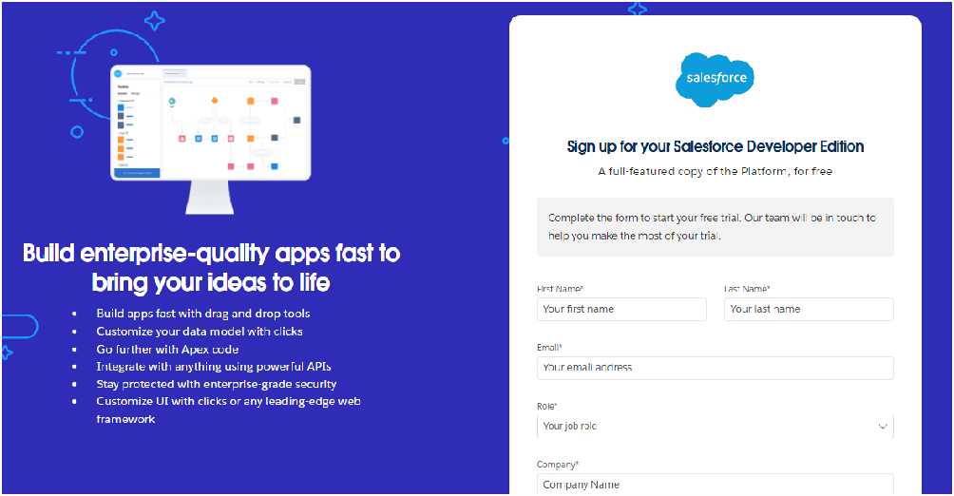

* 1. First name & Last name
  2. Email
  3. Role : Developer
  4. Company : College or Company Name
  5. County : India
  6. Postal Code : pin code
  7. Username : should be a combination of your name and company This need not be an actual email id, you can give anything in the format : [username@organization.com](mailto:username@organization.com)

Click on sign me up after ﬁlling these.

# Account Activation

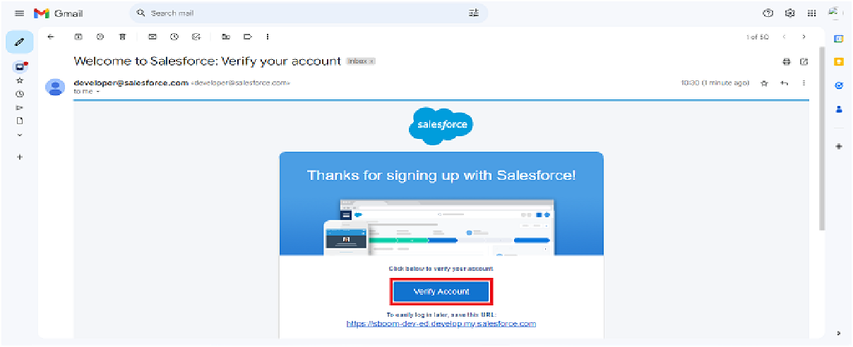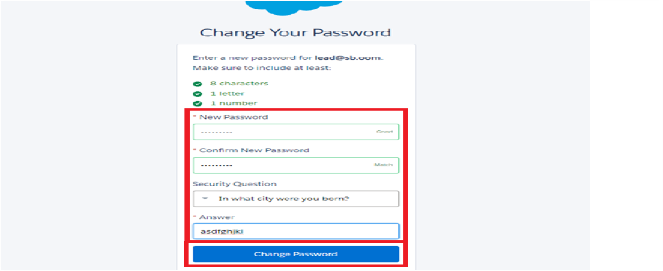1. Go to the inbox of the email that you used while signing up. Click on the verify account to activate your account. The email may take 5-10mins.

Click on Verify Account

Give a password and answer a security question and click on change password.

1. Give a password and answer a security question and click on change password.
2. 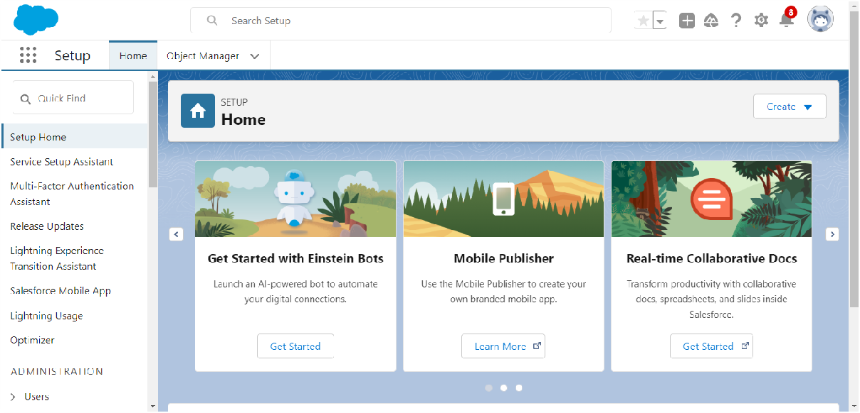Then you will redirect to your salesforce setup page.

# Object Creation:

## What is an Object? How a Custom Object is Created Object:

* An object in Salesforce is a database table that allows you to store information speciﬁc to your organization. Objects can be standard (provided by Salesforce) or custom (created by users)

# Create Venue Object

To create an object:

* 1. From the setup page >> Click on Object Manager >> Click on Create

>>Click on Custom Object.

1. Enter the label name >> Venue
2. Plural label name >> Venues
3. Enter Record Name Label and Format
   * Record Name >> Venue Name
   * Data Type >> Text
4. Click on Allow reports and Track Field History,Allow Activities.
5. Allow search >> Save.

In the same way Create Drop-Off Point Object,Task Object,Volunteer Object,Execution Detail Object.

# Tabs Creation:

1. **What is a Tab? How a Custom Tab is Created Tab:**

* A tab in Salesforce is a user interface component that allows users to create, view, and edit records for an object. Tabs are associated with standard and custom objects and can be customized to enhance the user experience.

# Creating a Custom Tab:

To create a Tab:(Venue)

* 1. 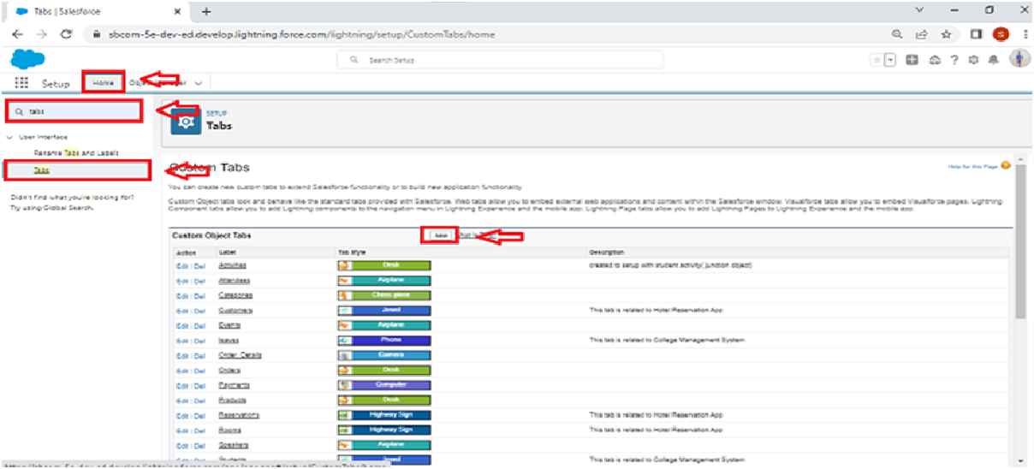Go to setup page >> type Tabs in Quick Find bar >> click on tabs >> New (under custom object tab)

1. Select Object(Venue) >> Select the tab style >> Next (Add to proﬁles page) keep it as default >> Next (Add to Custom App) uncheck the include tab .
2. Make sure that the Append tab to users' existing personal customizations is checked.
3. Click save

***Creating Remaining Tabs***

1. Now create the Tabs for the remaining Objects, they are “Drop-Off Point, Task, Volunteer, Execution Details”.
2. Follow the same steps as mentioned in above activity.

# Creating a Lightning App:

**To create a lightning app page:**

1. Go to setup page >> search “app manager” in quick ﬁnd >> select “app manager” >> click on New lightning App.

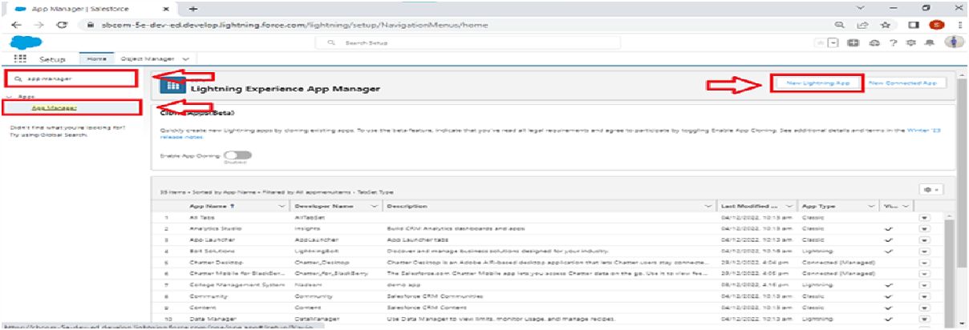

1. Fill the app name in app details and branding as follow App Name : FoodConnect

Developer Name : This will auto populated

Image : optional (if you want to give any image you can otherwise not mandatory) Primary color hex value : keep this default.

1. Then click Next >> (App option page)Set Navigation Style as Standard Navigation >> Next.

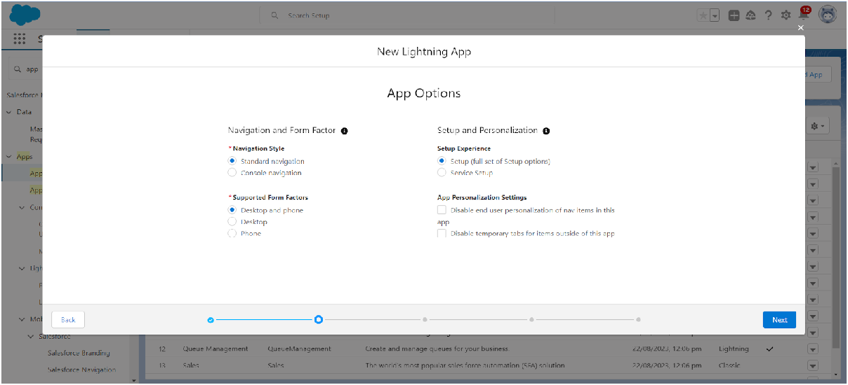

1. (Utility Items) keep it as default >> Next.
2. To Add Navigation Items:

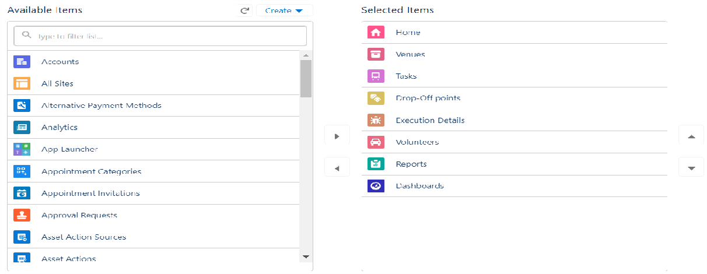

Search for the item in the (Home, Venue, Drop-Off Point, Task, Volunteer, Execution Details, Reports) from the search bar and move it using the arrow button >> Next >> Next.

1. To Add User Proﬁles:

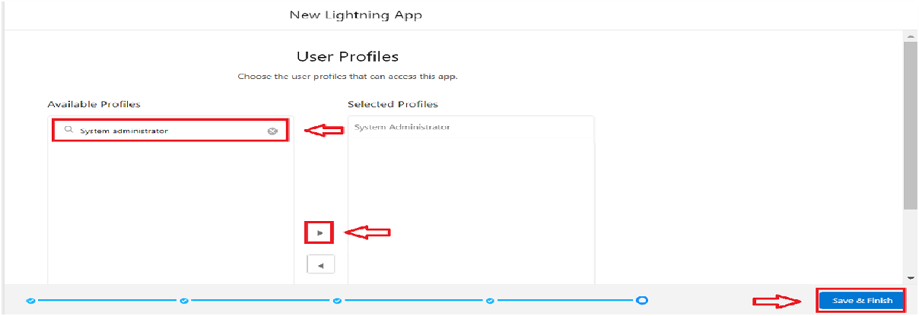

Search proﬁles (System administrator) in the search bar >> click on the arrow button >> save & ﬁnish.

## What are Fields?

**Fields:**

* Fields are data columns within an object, similar to columns in a database table.

They hold speciﬁc pieces of information related to the records of the object.

***Creation of Relationship ﬁelds in objects***

## Creation of Lookup Relationship Field on Volunteer Object :

* 1. Go to setup >> click on Object Manager >> type object name(Volunteer) in the search bar >> click on the object.

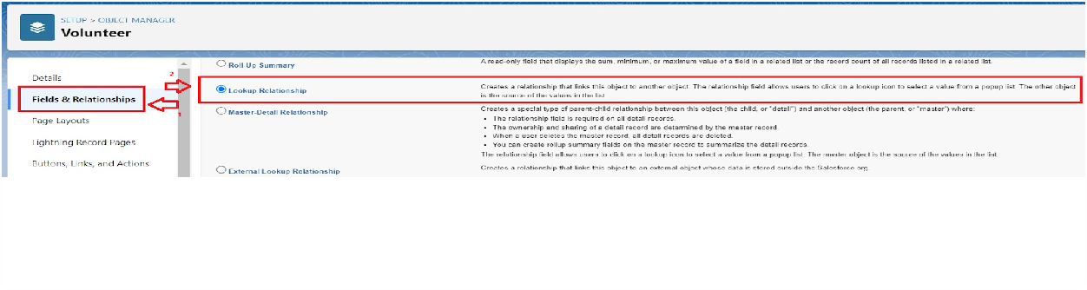

* 1. Now click on “Fields & Relationships” >> New
  2. Select Master Detail relationship
  3. 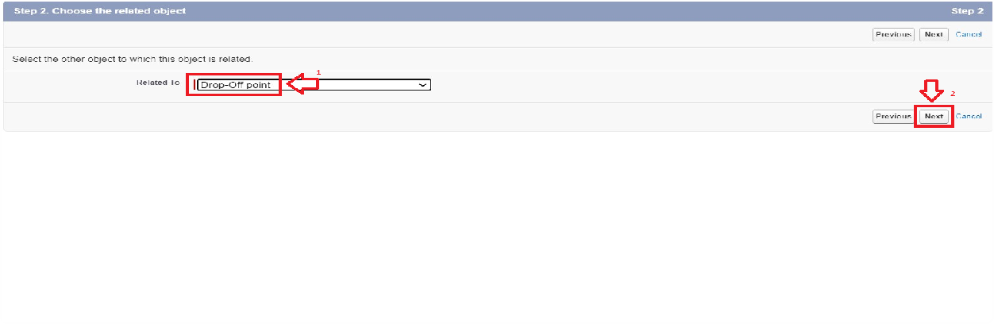Select the related object “Drop-Off point” and click next.
  4. Field Name : Drop_Off_point
  5. Field label : Auto generated
  6. Next >> Next >> Save.

## Creation of Master Detail Relationship Field on Execution Details Object :

* 1. Go to setup >> click on Object Manager >> type object name(Execution Details) in the search bar >> click on the object.
  2. Now click on “Fields & Relationships” >> New
  3. Select Master Detail relationship
  4. Select the related object “Volunteer” and click next.
  5. Field Name : Volunteer
  6. Field label : Auto generated
  7. Next >> Next >> Save.

Creation of Master Detail Relationship Field on Execution Details Object :

* 1. Go to setup >> click on Object Manager >> type object name(Execution Details) in the search bar >> click on the object.
  2. Now click on “Fields & Relationships” >> New
  3. Select Master Detail relationship
  4. Select the related object “Task” and click next.
  5. Field Name : Task
  6. Field label : Auto generated
  7. Next >> Next >> Save.

Creation of Lookup Relationship Field on Drop-Off Point Object :

* 1. Go to setup >> click on Object Manager >> type object name(Task) in the search bar >> click on the object.
  2. Now click on “Fields & Relationships” >> New
  3. Select Lookup relationship
  4. Select the related object “Drop-Off Point” and click next.
  5. Field Name : Venue 27.Field label : Venue c 28.Next >> Next >> Save.

Creation of Lookup Relationship Field on Task Object :

1. Go to setup>> click on Object Manager >> type object name(Task) in the search bar >> click on the object.
2. Now click on “Fields & Relationships” >> New
3. Select Lookup relationship

Select the related object “Venue” and click next.

1. Field Name : Sponsored By 33.Field label : Auto generated 34.Next >> Next >> Save.

Creation of Lookup Relationship Field on Task Object :

1. Go to setup>> click on Object Manager >> type object name(Task) in the search bar >> click on the object.
2. Now click on “Fields & Relationships” >> New
3. Select Lookup relationship
4. Select the related object “Drop-Off point” and click next.
5. Field Name : Drop-Off point 41.Field label : Auto generated 42.Next >> Next >> Save.

## Creation of ﬁelds for the Venue object

1. Go to setup>> click on Object Manager >> type object name(Venue) in search bar >> click on the object.
2. Now click on “Fields & Relationships” >> New
3. Select Data type as a “Email” and Click on Next
4. Fill the Above as following:
   * Field Label : Contact Email
   * Field Name : Contact Email
   * Click on required check box
   * Click on Next >> Next >> Save and new.

## To create another ﬁelds in an object:

1. Go to setup >> click on Object Manager >> type object name(Venue) in search bar >> click on the object.
2. Now click on “Fields & Relationships” >> New
3. Select Data type as a “Phone” and Click on Next
4. Fill the Above as following:
   * Field Label : Contact Phone
   * Field Name : Contact Phone
   * Click on required check box
   * Click on Next >> Next >> Save and new.

## To create another ﬁelds in an object:

1. Go to setup >> click on Object Manager >> type object name(Venue) in search bar >>click on the object.
2. Now click on “Fields & Relationships” >> New
3. Select Data type as a “Geolocation” and Click on Next
4. Fill the Above as following:
   * Field Label : Location
   * Decimal Places : 4
   * Field Name : Location
   * Description : Enter the Geolocation of your Venue
   * Click on Next >> Next >> Save and new.

To create another ﬁelds in an object:

1. Go to setup >> click on Object Manager >> type object name(Venue) in search bar >> click on the object.
2. Now click on “Fields & Relationships” >> New
3. Select Data type as a “Long Text Area” and Click on Next
4. Fill the Above as following:
   * Field Label : Venue Location
   * Field Name : Venue_Location
   * Click on Next >> Next >> Save and new.

## Creation of ﬁelds for the Drop-Oﬀ point object

Go to setup >> click on Object Manager >> type object name(Drop-Off point) in search bar >> click on the object.

1. Now click on “Fields & Relationships” >> New
2. Select Data type as a “Geolocation” and Click on Next
3. Fill the Above as following:
   * Field Label : Location 2
   * Field Name : gets auto generated
   * Description : Enter the Geolocation of the Drop off Point
   * Geolocation Options : select Decimal
   * Decimal Places : 4
   * Click on Next >> Next >> Save and new.

To create another ﬁelds in an object:

1. Go to setup >> click on Object Manager >> type object name(Drop-Off point) in search bar >> click on the object.
2. Now click on “Fields & Relationships” >> New
3. Select Data type as a “Formula” and Click on Next
4. Fill the Above as following:
   * Field Label : distance calculation
   * Field Name : distance_calculation
   * Formula Return Type : Number
   * Formula Options : DISTANCE( Location_2 c , Venue r.Location c , 'km')
   * Click on Next >> Next >> Save and new.

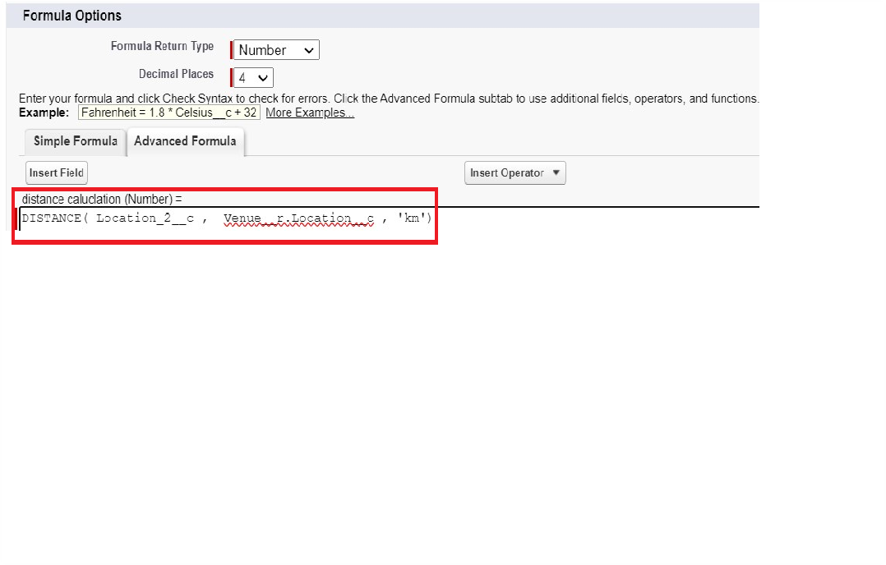

To create another ﬁelds in an object:

1. Go to setup >> click on Object Manager >> type object name(Drop-Off point) in search bar >> click on the object.
2. Now click on “Fields & Relationships” >> New
3. Select Data type as a “Picklist” and Click on Next
4. Fill the Above as following:
   * Field Label : State
   * Field Name : State
   * Enter values, with each value separated by a new line : Andhra Pradesh

Arunachal Pradesh Assam

Bihar

Chhattisgarh Goa

Gujarat Haryana

Himachal Pradesh

Jharkhand Karnataka Kerala Maharashtra Madhya Pradesh Manipur Meghalaya Mizoram Nagaland Odisha

Punjab Rajasthan Sikkim Tamil Nadu Tripura Telangana

Uttar Pradesh Uttarakhand West Bengal

Andaman & Nicobar (UT) Chandigarh (UT)

Dadra & Nagar Haveli and Daman & Diu (UT)

Delhi [National Capital Territory (NCT)]

Jammu & Kashmir (UT) Ladakh (UT) Lakshadweep (UT) Puducherry (UT)

* + Click on required check box
  + Click on Next >> Next >> Save and new.

To create another ﬁelds in an object:

1. Go to setup >> click on Object Manager >> type object name(Task) in search bar >> click on the object.
2. Now click on “Fields & Relationships” >> New
3. Select Data type as a “Number” and Click on Next
4. Fill the Above as following:
   * Field Label : Distance
   * Field Name : Distance
   * Length : 14
   * Decimal Places : 4
   * Click on required check box
   * Click on Next >> Next >> Save and new.

## Creation of ﬁelds for the Task object

Go to setup>> click on Object Manager >> type object name(Task) in search bar

>> click on the object.

1. Now click on “Fields & Relationships” >> New
2. Select Data type as a “Auto Number” and Click on Next
3. Fill the Above as following:
   * Field Label : Task ID
   * Display Format : TASK-{0}
   * Starting Number : 1
   * Field Name : gets auto generated
   * Click on required check box
   * Click on Next >> Next >> Save and new.

To create another ﬁelds in an object:

1. Go to setup >> click on Object Manager >> type object name(Task) in search bar >> click on the object.
2. Now click on “Fields & Relationships” >> New
3. Select Data type as a “Date” and Click on Next
4. Fill the Above as following:
   * Field Label : Date
   * Field Name : Date
   * Click on required check box
   * Click on Next >> Next >> Save and new.

To create another ﬁelds in an object:

1. Go to setup >> click on Object Manager >> type object name(Task) in search bar >> click on the object.
2. Now click on “Fields & Relationships” >> New
3. Select Data type as a “Picklist (Multi-Select)” and Click on Next
4. Fill the Above as following:
   * Field Label : Food Category
   * Field Name : Food Category
   * Enter values, with each value separated by a new line : Veg

Non-Veg Salad Snack

* + Click on required check box
  + Click on Next >> Next >> Save and new.

To create another ﬁelds in an object:

1. Go to setup >> click on Object Manager >> type object name(Task) in search bar >> click on the object.
2. Now click on “Fields & Relationships” >> New
3. Select Data type as a “Number” and Click on Next
4. Fill the Above as following:
   * Field Label : Number of People Served
   * Field Name : Number_of_People_Served
   * Click on required check box
   * Click on Next >> Next >> Save and new.

To create another ﬁelds in an object:

1. Go to setup >> click on Object Manager >> type object name(Task) in search bar >> click on the object.
2. Now click on “Fields & Relationships” >> New 15.Select Data type as a “Text” and Click on Next 16.Fill the Above as following:
   * Field Label : Name of the Person
   * Field Name : Name_of_the_Person
   * Click on Next >> Next >> Save and new.

To create another ﬁelds in an object:

1. Go to setup>> click on Object Manager >> type object name(Task) in search bar >> click on the object.
2. Now click on “Fields & Relationships” >> New
3. Select Data type as a “Phone” and Click on Next
4. Fill the Above as following:
   * Field Label : Phone
   * Field Name : Phone
   * Click on Next >> Next>> Save and new.

To create another ﬁelds in an object:

1. Go to setup >> click on Object Manager >> type object name(Task) in search bar >> click on the object.
2. Now click on “Fields & Relationships” >> New
3. Select Data type as a “Pick List” and Click on Next
4. Fill the Above as following:
   * Field Label : Rating
   * Field Name : Rating
   * Enter values, with each value separated by a new line : 1

2

3

4

5

* + Click on Next >> Next >> Save and new.

To create another ﬁelds in an object:

1. Go to setup >> click on Object Manager >> type object name(Task) in search bar >> click on the object.
2. Now click on “Fields & Relationships” >> New
3. Select Data type as a “Long Text Area” and Click on Next
4. Fill the Above as following:
   * Field Label : Feedback
   * Field Name : Feedback
   * Click on Next >> Next >> Save and new.

## Creation of ﬁelds for the Volunteer object

1. Go to setup >> click on Object Manager >> type object name(Volunteer) in search bar >> click on the object.
2. Now click on “Fields & Relationships” >> New
3. Select Data type as a “Auto Number” and Click on Next
4. Fill the Above as following:
   * Field Label : Volunteer ID
   * Field Name : gets auto generated
   * Click on required check box
   * Click on Next >> Next >> Save and new.
   * Click on Next >> Next >> Save and new.

To create another ﬁelds in an object:

1. Go to setup >> click on Object Manager >> type object name(Volunteer) in search bar >> click on the object.
2. Now click on “Fields & Relationships” >> New
3. Select Data type as a “Picklist” and Click on Next
4. Fill the Above as following:
   * Field Label : Gender
   * Field Name : Gender
   * Enter values, with each value separated by a new line : Female

Male

* + Click on Next >> Next >> Save and new.

To create another ﬁelds in an object:

1. Go to setup >> click on Object Manager >> type object name(Volunteer) in search bar >> click on the object.
2. Now click on “Fields & Relationships” >> New
3. Select Data type as a “Date” and Click on Next
4. Fill the Above as following:
   * Field Label : Available On
   * Field Name : Available On
   * Click on required check box
   * Click on Next >> Next >> Save and new.

To create another ﬁelds in an object:

1. Go to setup >> click on Object Manager >> type object name(Volunteer) in search bar >> click on the object.
2. Now click on “Fields & Relationships” >> New
3. Select Data type as a “Number” and Click on Next
4. Fill the Above as following:
   * Field Label : Age
   * Field Name : Age
   * Click on required check box
   * Click on Next >> Next>> Save and new.

To create another ﬁelds in an object:

1. Go to setup >> click on Object Manager >> type object name(Volunteer) in search bar >> click on the object.
2. Now click on “Fields & Relationships” >> New
3. Select Data type as a “Email” and Click on Next
4. Fill the Above as following:
   * Field Label : Email
   * Field Name : Email
   * Click on required check box
   * Click on Next>> Next >> Save and new.

To create another ﬁelds in an object:

1. Go to setup >> click on Object Manager >> type object name(Volunteer) in search bar >> click on the object.
2. Now click on “Fields & Relationships” >> New
3. Select Data type as a “Number” and Click on Next
4. Fill the Above as following:
   * Field Label : Contact Number
   * Field Name : Contact_Number
   * Click on required check box
   * Click on Next >> Next >> Save and new.

To create another ﬁelds in an object:

1. Go to setup >> click on Object Manager >> type object name(Volunteer) in search bar >> click on the object.
2. Now click on “Fields & Relationships” >> New
3. Select Data type as a “Text Area (Long)” and Click on Next
4. Fill the Above as following:
   * Field Label : Address
   * Field Name : Address
   * Click on Next >> Next >> Save and new.

To create another ﬁelds in an object:

1. Go to setup >> click on Object Manager >> type object name(Volunteer)

in search bar >> click on the object.

1. Now click on “Fields & Relationships” >> New 27.Select Data type as a “Date” and Click on Next 28.Fill the Above as following:
   * Field Label : Date of Birth
   * Field Name : Date_of_Birth
   * Click on Next >> Next >> Save and new.

## Creation of ﬁelds for the Execution Details object

1. Go to setup >> click on Object Manager >> type object name(Volunteer) in search bar >> click on the object.
2. Now click on “Fields & Relationships” >> New
3. Select Data type as a “Auto Number” and Click on Next
4. Fill the Above as following:
   * Field Label : Execution ID
   * Field Name : gets auto generated
   * Click on required check box
   * Click on Next >> Next >> Save and new.

# What are Flows? Create Flow to Create a Record in Venue Object Flows:

* Flows in Salesforce are automation tools that can collect data and perform actions in Salesforce. Flows can be used to automate complex business

processes by using a point-and-click interface.

## Create Flow to create a record in Venue object

1. Go to setup >> type Flow in quick ﬁnd box >> Click on the Flow and Select the New Flow.
2. Select the Screen ﬂow. Click on create.

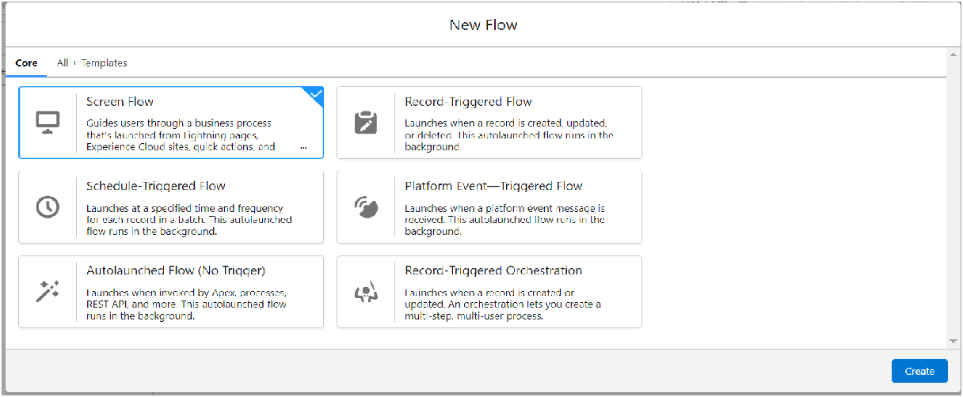

1. Click on the ‘+’ icon in between start and end, and click on screen element.
2. Under the Screen Properties: Label : Venue Details

API Name : Venue_Details

1. Now lets add components in this ﬂow. Click on Text Component and name it as:

Label : Venue Name API Name : Venue_Name

1. Click on Email Component and name it as: Label : Email

API Name : Contact_Email

1. Click on Phone Component and name it as: Label : Phone

API Name : Contact_Phone

1. Click on Text Component and name it as: Label : Venue Location

API Name : Venue_Location

1. Click on Number Component and name it as: Label : Latitude

API Name : Latitude

1. Click on Number Component and name it as: Label : longitude

API Name : longitude

1. 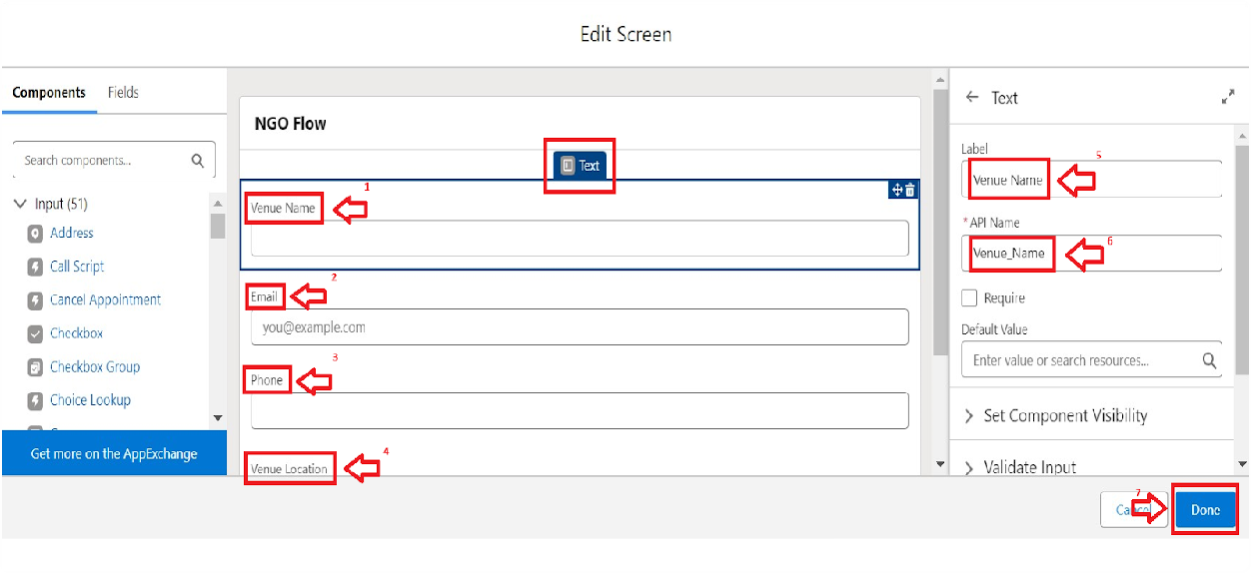Next click on Done. This would like below
2. Click on the ‘+’ icon in between Venue details and end, and click on create record element.
3. Now label it as

Label : Create Venue Record API Name : Create_Venue_Record

How Many Records to Create : One

How to Set the Record Fields : Use separate resources, and literal values

Object : Venue

Set Field Values for the Venue : Click on ‘Add Field’ 5 times Field : Value = Contact_Email c : {!Contact_Email.value} Field : Value = Contact_Phone c : {!Contact_Phone.value} Field : Value = Name : {!Venue_Name}

Field : Value = Venue_Location c : {!location} Field : Value = Location Latitude s : {!latitude}

Field : Value = Location Longitude s : {!longitude}

1. 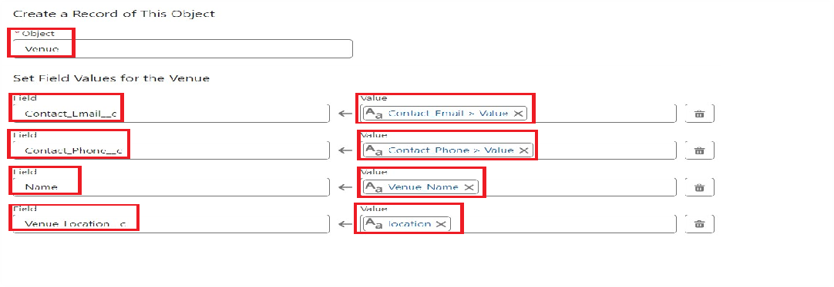This would look like:
2. Click on Save as:

Flow Label : Venue Form Flow API Name : Venue_Form

# What is a Trigger? Create a Trigger, Trigger Code Trigger:

* A trigger is an Apex script that executes before or after speciﬁed database events, such as insert, update, or delete.

## Create a Trigger

* 1. Log into the trailhead account, navigate to the gear icon in the top right corner.
  2. Click on developer console and you will be navigated to a new console window.
  3. Click on the File menu in the toolbar, and click on new >> Trigger.
  4. Enter the trigger name and the object to be triggered.

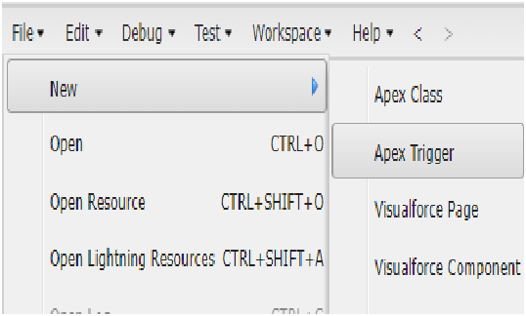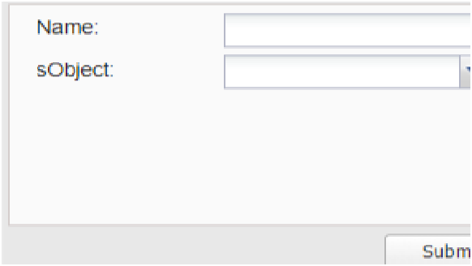

* 1. Enter Name : DropOffTrigger sObject: Drop-Off Point
  2. Click on Submit.

## Trigger Code

(This Trigger is to assign Distance ﬁeld to the Distance Calculation ﬁeld. So that we can assign the distance in the sharing rules.)

## Code:

trigger DropOffTrigger on Drop_Off_point c (before insert) { for(Drop_Off_point c Drop : Trigger.new){

Drop.Distance c = Drop.distance_calculation c;

}

}

# What are Proﬁles and Creation of Users Proﬁles:

* Proﬁles in Salesforce deﬁne a user's permissions to perform different functions within Salesforce. Proﬁles control access to objects, ﬁelds, and various

functionalities.

## Proﬁles

1. Go to setup page >> type Proﬁles in Quick Find bar >> click on Proﬁles

>> click on ‘S’

1. Click on Clone beside Standard Platform User.
2. Under Clone Proﬁle:

Proﬁle Name : NGOs Proﬁle Then click on Save.

## Creation of User1

1. Go to setup page >> type users in Quick Find bar >> click on users>> New user.
2. In General Information give details as: (Note : create users as per your wish NGO’s)

First Name : Iksha Foundation

Last Name : Iksha_Foundation Alias : iiksh

Email : Give Your Email

Username : [m ahafoundation@ mk.com](mailto:ikshafoundation@sb.com) (give the username different)

Nickname : Auto Populated

User License : Salesforce Platform Proﬁle : NGOs Proﬁle

Active : Check

1. Click on Save

## Creation of User2, User3

1. Create another Two Users by following steps in Activity - 1 with similar User License and Proﬁle.
2. 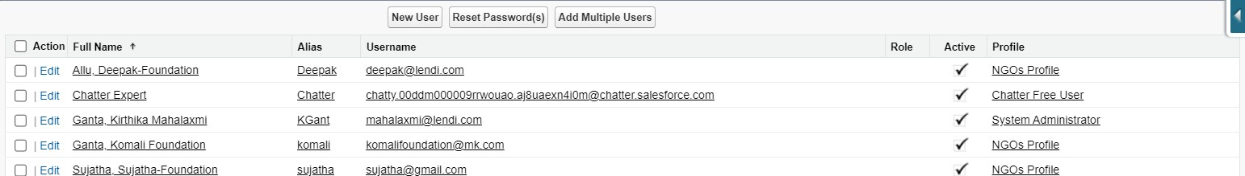Give Different First Name, Last Name based on Different NGO’s.

# What are Public Groups and Creation of Public Groups Public Groups:

* Public Groups are collections of users that can be used to simplify the sharing of records, access permissions, and reporting within Salesforce

## Creation of Public Group 1

* + 1. Go to setup page >> type Public Groups in Quick Find bar >> click on Public Groups >> click on New.
    2. Under Group Information: Label : Iksha

Group Name : Iksha

Grant Access Using Hierarchies : Check

* + 1. In Search, Select Users.
    2. In Selected Members Add Iksha Foundation and System Administrator

## Creation of Public Group 2

1. By Following Steps in Activity 1, Create other two Public Groups for other two users.
2. After Saving this would look like this.

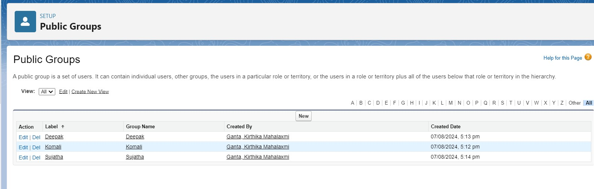

# What are Report Types and Creation of Report Type Report Types:

* **Report** Types in Salesforce deﬁne the objects and ﬁelds that are available for use

in reports. Custom report types can be created to combine data from different objects.

## Creation of Report Types

* + 1. Go to setup page >> type Report Types in Quick Find bar >> click on Report Types >> click on Continue >> Click on New Custom Report Type.
    2. In Deﬁne the Custom Report Type: Primary Object : Select Venues

Report Type Label : Venue with DropOff with Volunteer Report Type Name : Venue_with_DropOff_with_Volunteer

Description : Venue with DropOff with Volunteer Store in Category : Select Other Reports Deployment Status : Deployed

* + 1. Click on Next
    2. Near Click to relate another Object Select Drop-Off Points.
    3. And also select "A" records may or may not have related "B" records.
    4. Now again Near Click to relate another Object Select Volunteers.
    5. Now click on Save.

# Report Creation

## Creation of Report on Venue with DropOﬀ with Volunteer

* + 1. Go to the app(FoodConnect) >> click on the reports tab
    2. Click on New Folder.

Folder Label : Custom Reports

Folder Unique Name : CustomReports

* + 1. Open Custom Reports and click on New Report
    2. Select Report Type : Venue with DropOff with Volunteer
    3. Then click on Start Report.
    4. In GROUP ROWS : Add Volunteer Name
    5. In Columns : Add Venue Name, Drop-Off point Name, Distance.
    6. Now click on Save & Run.
    7. Give Label as :
    8. Report Name : venue and Drop Off point
    9. Report Unique Name : Auto Populated
    10. Click on Select Folder and select Custom Report, then click on Save.

## Creation of Report on Volunteers with Execution Details and Tasks

1. Go to the app(FoodConnect) >> click on the reports tab
2. Click on Custom Reports Folder and click on New Report
3. Select Report Type : Volunteers with Execution Details and Tasks.
4. Then click on Start Report.
5. In GROUP ROWS : Volunteer ID
6. In Columns : Add Volunteer : Volunteer Name, Task : Task Name, Execution Detail : Execution Detail Name, Volunteer: Owner Name, Task: Date, Task : Rating.
7. Now click on Save & Run.
8. Give Label as :

Report Name : Volunteer Task

Report Unique Name : Auto Populated

1. Click on Select Folder and select Custom Report, then click on Save.

# What are Dashboards?

**Dashboards:**

* Dashboards in Salesforce are visual representations of reports, allowing users to monitor key metrics and performance indicators at a glance.

## Adding venue and Drop Oﬀ point Report to the

**Dashboard**

* + 1. Go to the app(FoodConnect) >> click on the Dashboards tab.
    2. Click on New Folder.

Folder Label : Custom Dashboards Folder Unique Name : Auto Populated

* + 1. Open Custom Dashboards and click on New Dashboards
    2. Name : Organization Details
    3. Click on Widget and select Chart or Table
    4. In Select Report : Select venue and Drop Off point Report.
    5. Then click on select
    6. In Add Component:

Display As : Select Lightning Table Component Theme : Select Dark (Optional)

1. Now click on save.

## Adding Volunteer Task Report to the Dashboard

1. Click on Widget and select Chart or Table
2. In Select Report : Select Volunteer Task Report.
3. Then click on select
4. In Add Component:

Display As : Select Line Chart

Component Theme : Select Dark (Optional)

1. Now click on save.

## Adding a Picture to the Dashboard (Optional)

(Note : To upload an image into the Dashboard, we have to ﬁrst download an image from google or other sources into your system)

1. Click on Widget and select Image. Then click on Browse Files.
2. Then Select the Picture you want to upload in this Dashboard.
3. Then click on Save As :

Name : Task Execution Details

Click on Select Folder and select Custom Dashboards

1. 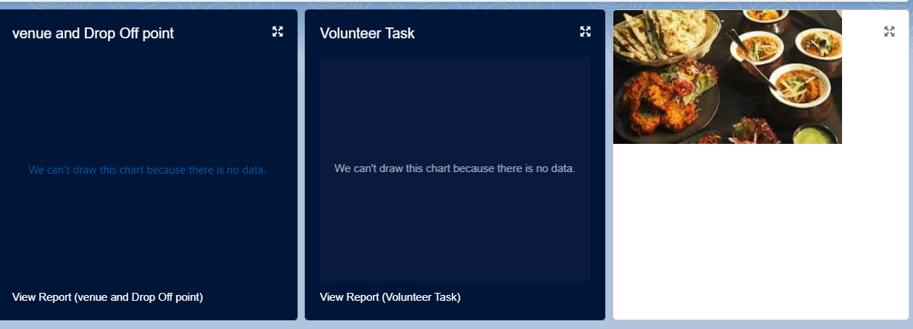Click on Select Folder and then Save.

# What are Sharing Rules? Creation of Sharing Rules Sharing Rules:

* Sharing Rules in Salesforce are used to extend the sharing access granted to users. They allow you to make automatic exceptions to your organization-wide sharing settings for deﬁned sets of users.

## Creation of sharing rules

* + 1. Go to setup >> type Sharing Settings in quick ﬁnd box >> Click on the Sharing Settings.
    2. Scroll down and ﬁnd Drop-Off point Sharing Rules.
    3. Click on new near Drop-Off point Sharing Rules and Name it as: Label : Rule 1

Rule Name : Rule_1

* + 1. Select your rule type : Select Based on criteria.
    2. Select which records to be shared:

Field : Operator : Value = Distance : less than : 15

* + 1. Select the users to share with : Near Share With Public Groups : Iksha
    2. Click on Save.
    3. Click on new near Drop-Off point Sharing Rules and Name it as: Label : Rule 2

Rule Name : Rule_2

* + 1. Select your rule type : Select Based on criteria.
    2. Select which records to be shared:

Field : Operator : Value = Distance : greater than : 15 Field : Operator : Value = Distance : less or equal : 30 11.Select the users to share with : Near Share With

Public Groups : NSS

1. Click on Save.
2. Click on new near Drop-Off point Sharing Rules and Name it as: Label : Rule 3

Rule Name : Rule_3

1. Select your rule type : Select Based on criteria.
2. Select which records to be shared:

Field : Operator : Value = Distance : greater than : 30 Field : Operator : Value = Distance : less or equal : 50

1. Select the users to share with : Near Share With Public Groups : Street Cause
2. Click on Save.

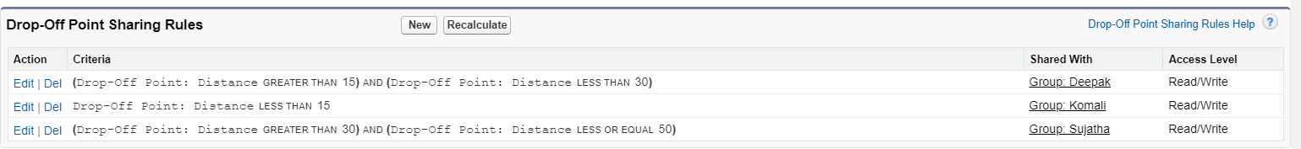

# Home Page and Creation of Home Page Home Page:

* The Home Page in Salesforce is a customizable page that provides users with an overview of their tasks, calendar events, and other important information.

## Creation of Home Page

* 1. Go to setup >> type Lightning App Builder in quick ﬁnd box >> Click on the Lightning App Builder and Select the New.
  2. Select Home Page and give Label as HOME Page.
  3. Select Standard Home Page.
  4. Near Components search for Flow and Drag and Drop in Right Side Section..
  5. On the right hand side:

Flow : Venue Flow

* 1. Near Components search for Dashboard, then Drag and Drop it in ﬁrst Section.
  2. Click on Save and Activation, then click on App Default, then Add Assignments.
  3. Add FoodConnect App and then Save.
  4. FoodConnect Home Page would Look Like this.

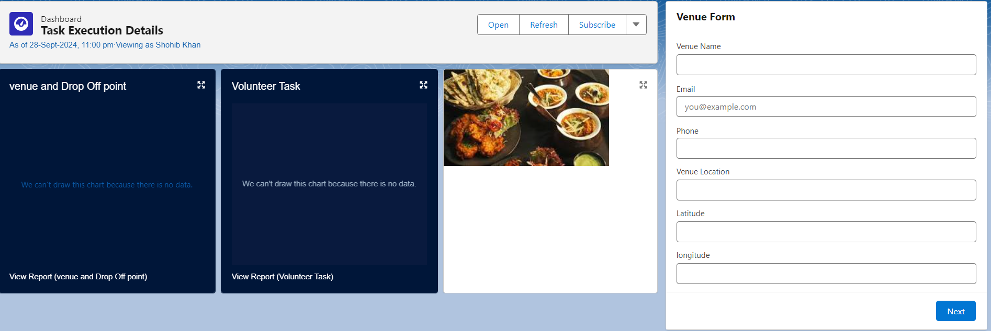

# Conclusion:

By utilizing the Salesforce platform, the project successfully created a streamlined and transparent system for managing surplus food donations. With eﬃcient coordination of volunteers and timely delivery to beneﬁciaries, the project effectively tackled food insecurity and maximized the use of available resources.