United International University
School of Business and Economics
Online Review Sentiment Analysis: Flipkart and Twitter
Assignment on NLP and Sentiment Analysis
Name: Rabea Akter Shoily Student ID: 905253001
GitHub repository: [link to be added]

1. Introduction
Customers write thousands of short opinions about products every day, on shopping sites and on social media. This project teaches a computer to read such a review and label it as positive, neutral or negative, and then uses those labels to see how opinion changes over time, between Flipkart and Twitter, and between products. The data is a synthetic set of 1,000 reviews of 15 products (600 from Flipkart, 400 from Twitter, January to December 2025). The workflow is: check the data, clean the text and turn it into numbers (TF-IDF), split the data, train and compare three classification models, study their mistakes, and finally plot the sentiment trends. The main lesson is about honest testing: how the data is split changes the results far more than the choice of model.

2. Workflow, models and results

2.1 Data and preprocessing
The dataset has no missing values. Positive reviews are 40% of the data, negative 34% and neutral 26% (Figure 1, left). Two checks shaped the rest of the work. First, the 1,000 reviews contain only 42 distinct sentence templates (14 per class); only the product name changes, and each template always carries the same label. Second, the star rating is unrelated to the sentiment label (correlation −0.005; Figure 1, right), so only the review text was used.
Cleaning steps: lower-casing, removing links, @mentions and # signs, removing punctuation, tokenising with NLTK, removing stopwords, then TF-IDF (up to 3,000 terms). Two choices differ from the class demo and were tested with cross-validation: negation words (no, not) were kept, because removing them turns “not happy” into “happy” (average F1 rose from 0.724 to 0.761), and single words were used instead of word pairs (0.761 against 0.735), because with so few templates word pairs are too specific.
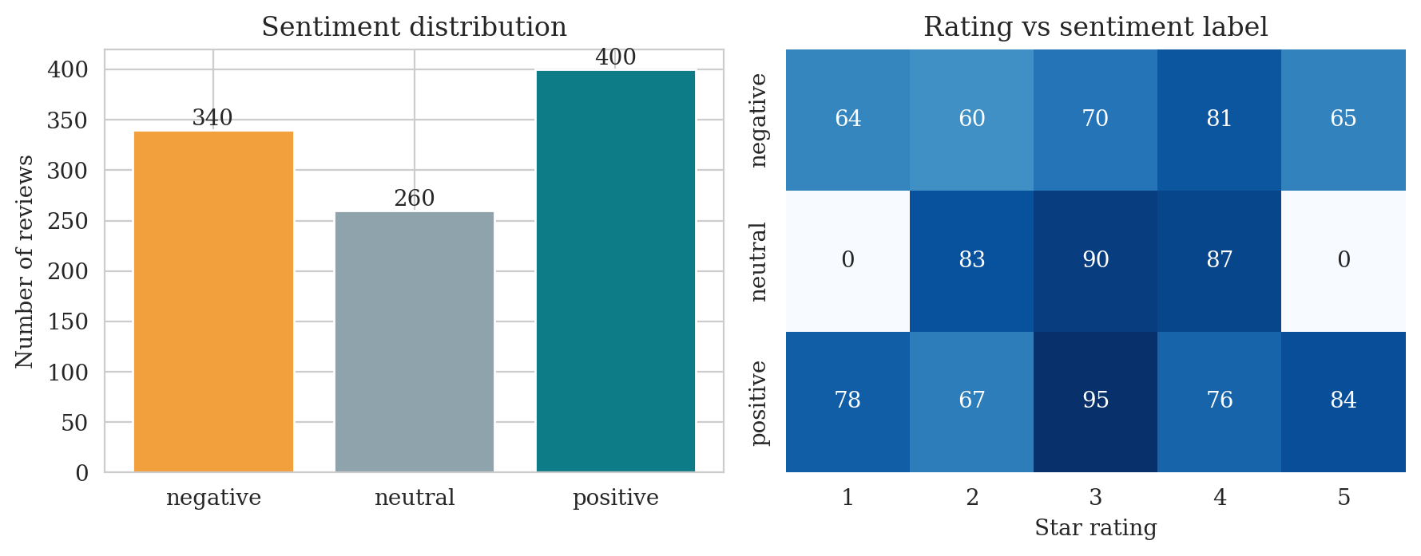
Figure 1. Sentiment distribution (left) and star rating against sentiment label (right)

2.2 Models and comparison
Three models were trained on TF-IDF features: Logistic Regression, Multinomial Naive Bayes and a Linear SVM, plus a “majority class” baseline and a tuned version of each model (regularisation chosen by grid search). Each was tested in two ways on reviews whose sentence templates it had never seen: one hold-out set (196 reviews, 8 templates) and repeated grouped cross-validation (3 × 5 folds). The best model was picked by cross-validated F1, not by the single hold-out score, which is noisy.
Table 1. Model comparison on unseen sentence templates (weighted scores)
Model | Accuracy | Precision | Recall | F1 (hold-out) | CV F1 (mean ± sd)
Linear SVM ✔ best | 0.806 | 0.872 | 0.806 | 0.807 | 0.804 ± 0.090
Linear SVM (tuned) | 0.801 | 0.870 | 0.801 | 0.802 | 0.800 ± 0.104
Logistic Regression (tuned) | 0.699 | 0.741 | 0.699 | 0.706 | 0.770 ± 0.088
Logistic Regression | 0.755 | 0.851 | 0.755 | 0.749 | 0.748 ± 0.058
Multinomial Naive Bayes | 0.745 | 0.826 | 0.745 | 0.731 | 0.730 ± 0.059
Naive Bayes (tuned) | 0.684 | 0.712 | 0.684 | 0.678 | 0.723 ± 0.102
Majority baseline | 0.378 | 0.143 | 0.378 | 0.207 | 0.229 ± 0.013
The Linear SVM won (F1 0.807 on the hold-out, 0.804 in cross-validation), ahead of Logistic Regression (0.749) and Naive Bayes (0.731); all clearly beat the baseline (0.21). The SVM also ranked first in all four cleaning and n-gram settings, so the ordering is consistent. Still, the gap to Logistic Regression is smaller than the fold-to-fold spread (about 0.09), so it is a likely advantage rather than a certainty. A plausible reason is that TF-IDF features are sparse and nearly linearly separable, which suits the SVM. Tuning did not help consistently: the tuned SVM and Naive Bayes were no better than their defaults, and tuned Logistic Regression improved in cross-validation but got worse on the hold-out. The default Linear SVM was therefore kept. Its full pipeline (cleaning, TF-IDF and model) was saved as one file; after reloading, it labelled all 7 new test sentences sensibly, including new wording such as “Not good at all, it stopped working after two days” (negative).

2.3 Error analysis
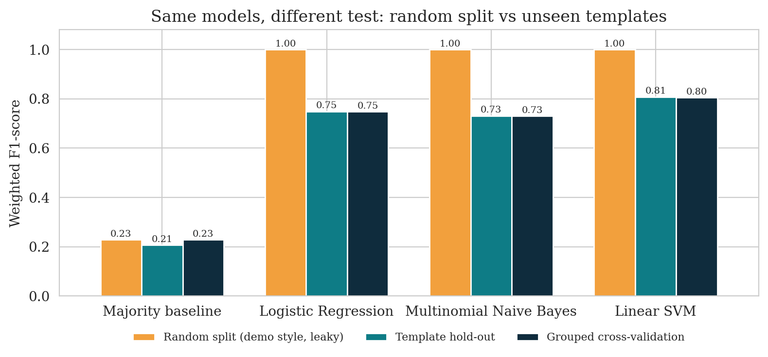  Figure 2. Same models, random split vs unseen templates | 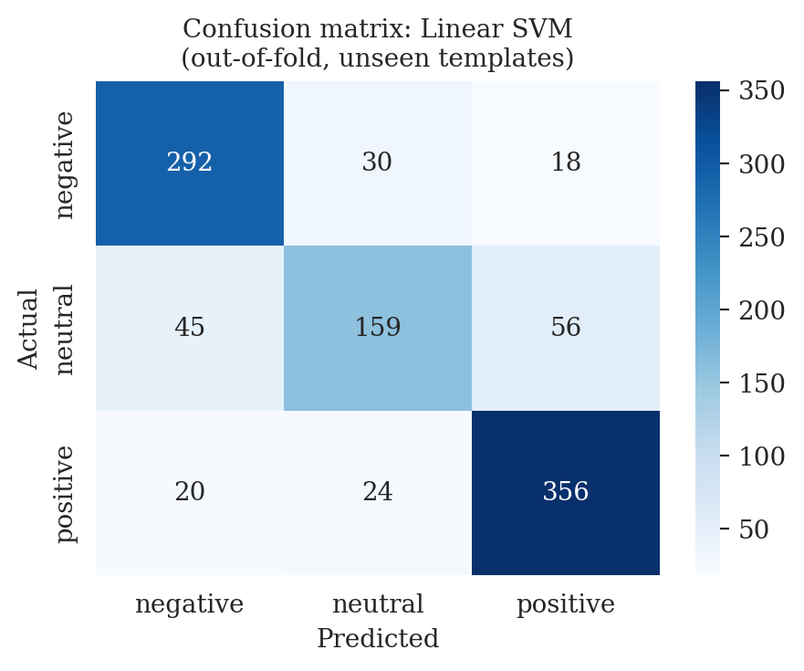  Figure 3. Confusion matrix, Linear SVM
Positive and negative reviews are recognised well (recall 0.89 and 0.86), but neutral is the weakest class (recall 0.61): 45 neutral reviews were labelled negative and 56 positive (Figure 3). This is understandable because neutral sentences mix mild praise (“works fine”), mild complaints (“packaging could be improved”) and sentences with no opinion words at all (“Comparing a few options before I decide”). The errors also come in blocks: for 8 of the 42 templates the model was wrong for every review, because the wording was unlike anything in the other templates. In other words, the model learned a small dictionary of useful words more than a general sense of sentiment. The words it relies on are sensible, e.g. “not”, “broken” and “unacceptable” for negative, and “amazing”, “exceeded” and “best” for positive.

3. Why a random split is misleading
With the class demo’s random 80/20 split, every model scored a perfect F1 of 1.00 (orange bars in Figure 2). The reason is that each template appears about 24 times in the data: 76% of the test reviews had an exact copy in the training data, and every one of them shared a template with it. Such a test only checks memory, and it cannot tell a good model from a poor one. Holding out whole templates (a grouped split) tests the model on wording it has never seen, which is what real new reviews look like, and the scores fall to 0.73–0.81, with clear differences between models. It is the same idea as splitting by time for forecasting: the test data must resemble the future, not the training data.

4. Sentiment trends
Opinion is steady across 2025 (Figure 4): positive reviews make up 30–47% of reviews every month, and the month-to-month changes are within chance (p = 0.60); the neutral count peaks in March (36 reviews). Flipkart and Twitter look almost the same (Figure 5, left): 40% positive on both, negative 33% against 35%, neutral 27% against 25% (p = 0.80). Tweets are worded differently (mentions, hashtags, questions) but are not more or less positive. By product (Figure 5, right), Air Fryer, Running Shoes and Power Bank are the most negative (net −13 points) and LED Desk Lamp and Sunglasses the most positive (+29 and +26), but with about 66 reviews per product this is not statistically significant (p = 0.40). Because the data and dates are synthetic, these patterns should not be read as real market findings.
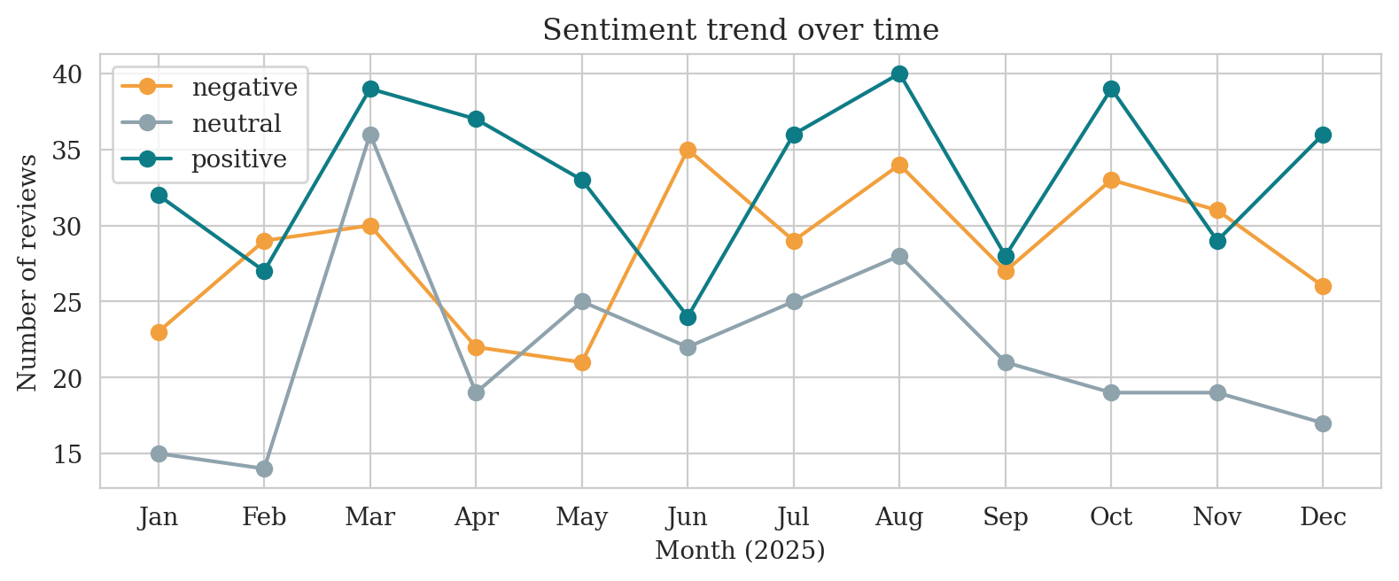
Figure 4. Sentiment trend over time
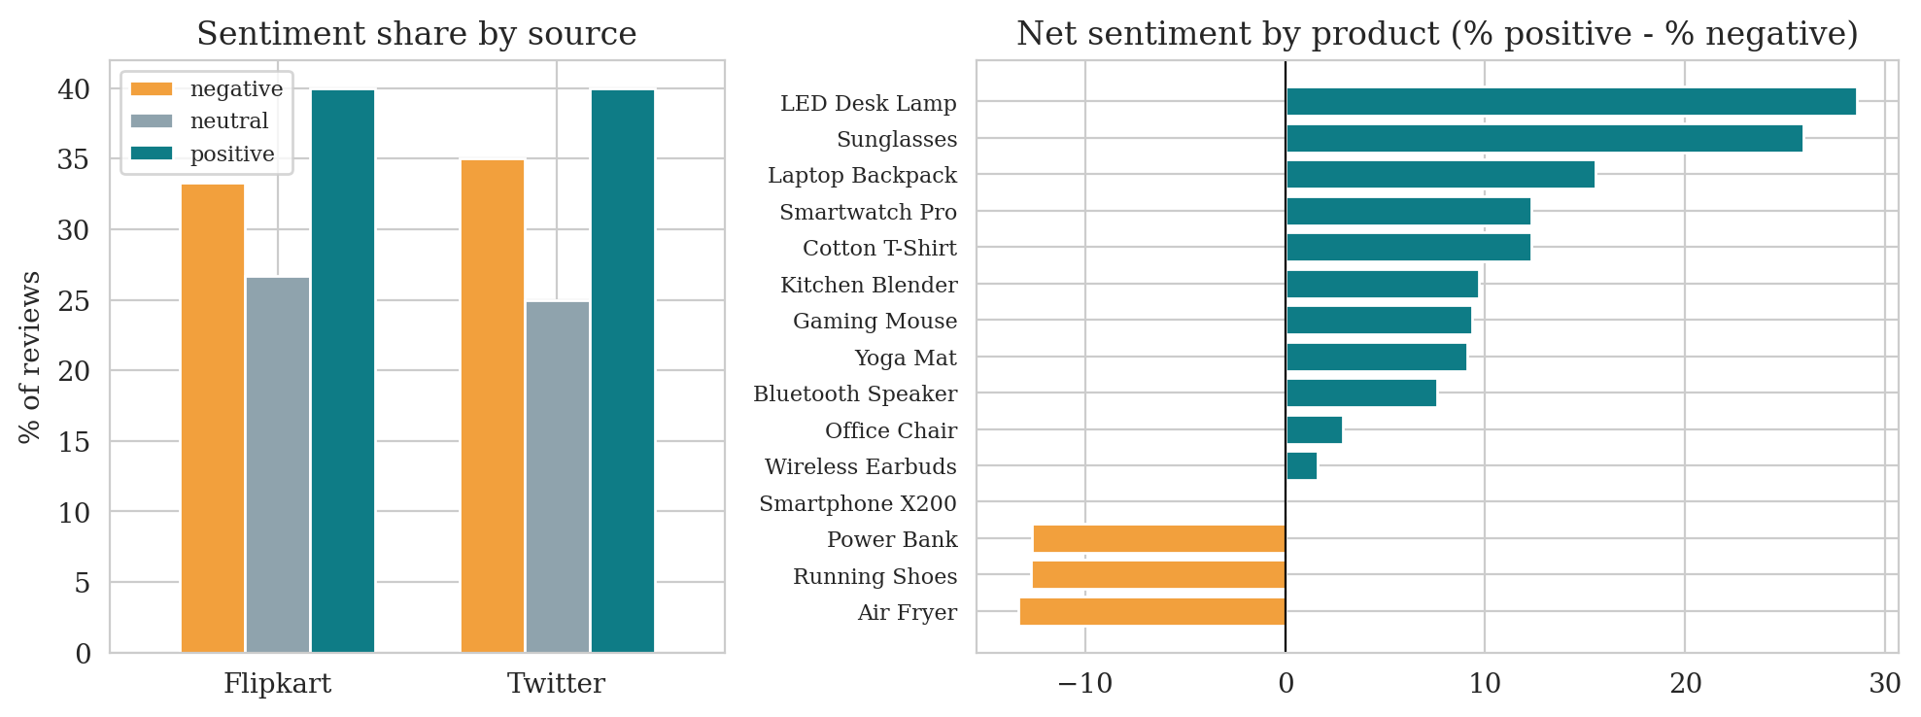
Figure 5. Sentiment by source and by product

5. Limitations and improvements
- Synthetic, template-based data. Only 42 sentence patterns exist, so scores will not carry over to real reviews. Improvement: repeat the study on real Flipkart and Twitter reviews.
- Small, noisy hold-out. The strict test set has just 8 templates, so single scores are unstable (fold spread about 0.09). Improvement: report cross-validation as the main result, as done here, and add more data.
- Unreliable rating and missing real-world language. Ratings did not match the labels, and there is no sarcasm, emoji, spelling mistakes or mixed languages. Improvement: check how the labels were produced and add such text.
- Bag-of-words models. TF-IDF ignores word order and meaning. Improvement: fine-tune a pre-trained transformer (e.g. BERT), which copes much better with new wording and with neutral text.

6. Conclusion
A Linear SVM on TF-IDF features gave the best result (F1 about 0.80 on unseen wording), and keeping negation words was the most useful preprocessing choice. The perfect scores of a random split were an illusion caused by repeated sentence templates, so the split matters more than the model. Sentiment did not differ meaningfully by month, source or product in this synthetic data, and neutral reviews remain the hardest to classify.

