# Task

**Shokhjakhon Abdunabiev**

D2FDHS

[d2fdhs@inf.elte.hu](mailto:d2fdhs@inf.elte.hu) Group 1

**2. assignment/1. Task**

08 November 2021

**Connect Four**

Connect Four is a two-player game. The discs of the first player are marked with X, and the discs of the second player are marked with O. The players take turns dropping their disc from the top into a *n*-column, *m*-row vertically suspended grid. The pieces fall straight down, occupying the lowest available space within the column. The objective of the game is to be the first to form a horizontal, vertical, or diagonal line of four of one's own discs. If the grid becomes full, the result is draw.

Implement this game, and let the grid size be selectable (8x5, 10x6, 12x7). The game should recognize if it is ended, and it has to show the name of the winner in a message box (if the game is not ended with draw), and automatically begin a new game.

# Plan

There are 4 classes in the program: Field class, Board class, BoardGUI class and ConnectFourGUI class.

Field class describes the area which should be filled with either ‘X’ or ‘O’ and at the start of the game it is empty.

Board class describes whole playing board consisting of many Fields. It can be the size of 8x5, 10x6 or 12x7. Board has isOver() method which checks if the all the Fields in the board are filled with ‘X’s and ‘O’s.

BoardGUI class implements Board class in buttons and make the game interactive. It has curPlayer field indicating the player whose turn to move is now and his sign. elapsedTime() method calculates the time within which the game has ended. refresh() method changes Field disc to a ‘X’ or ‘O’ based on the player. We also implement ActionListener for every button in the board. Whenever we click on button it applies actionPerformed() method which sets the text of the button to the current player’s sign and then checks for the winner. If there is no winner the game keeps going and changes curPlayer to a different player’s sign. reset() method clears every Field’s disc and buttons and resets time to 0. isWinner() method checks if there are four same characters (‘X’, ‘O’) connected in the board. They can be connected diagonally, vertically and horizontally.

**UML**

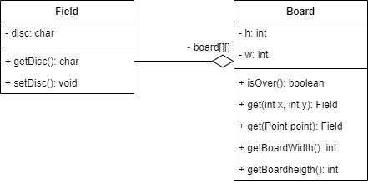

# Testing

1. Checking of the initialization
2. Checking of the getters and setters
3. Checking of the methods
4. Comparing objects, their fields.