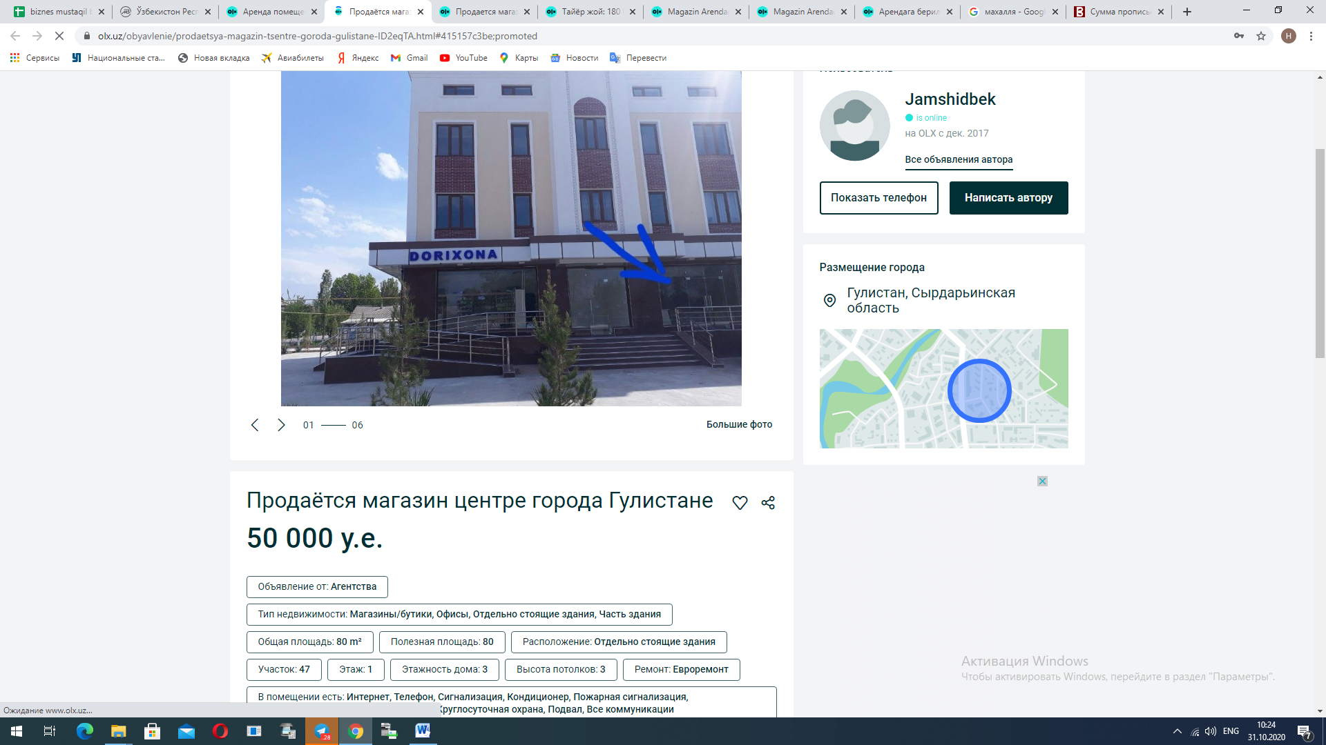

<https://www.olx.uz/obyavlenie/prodaetsya-magazin-tsentre-goroda-gulistane-ID2eqTA.html#415157c3be;promoted>

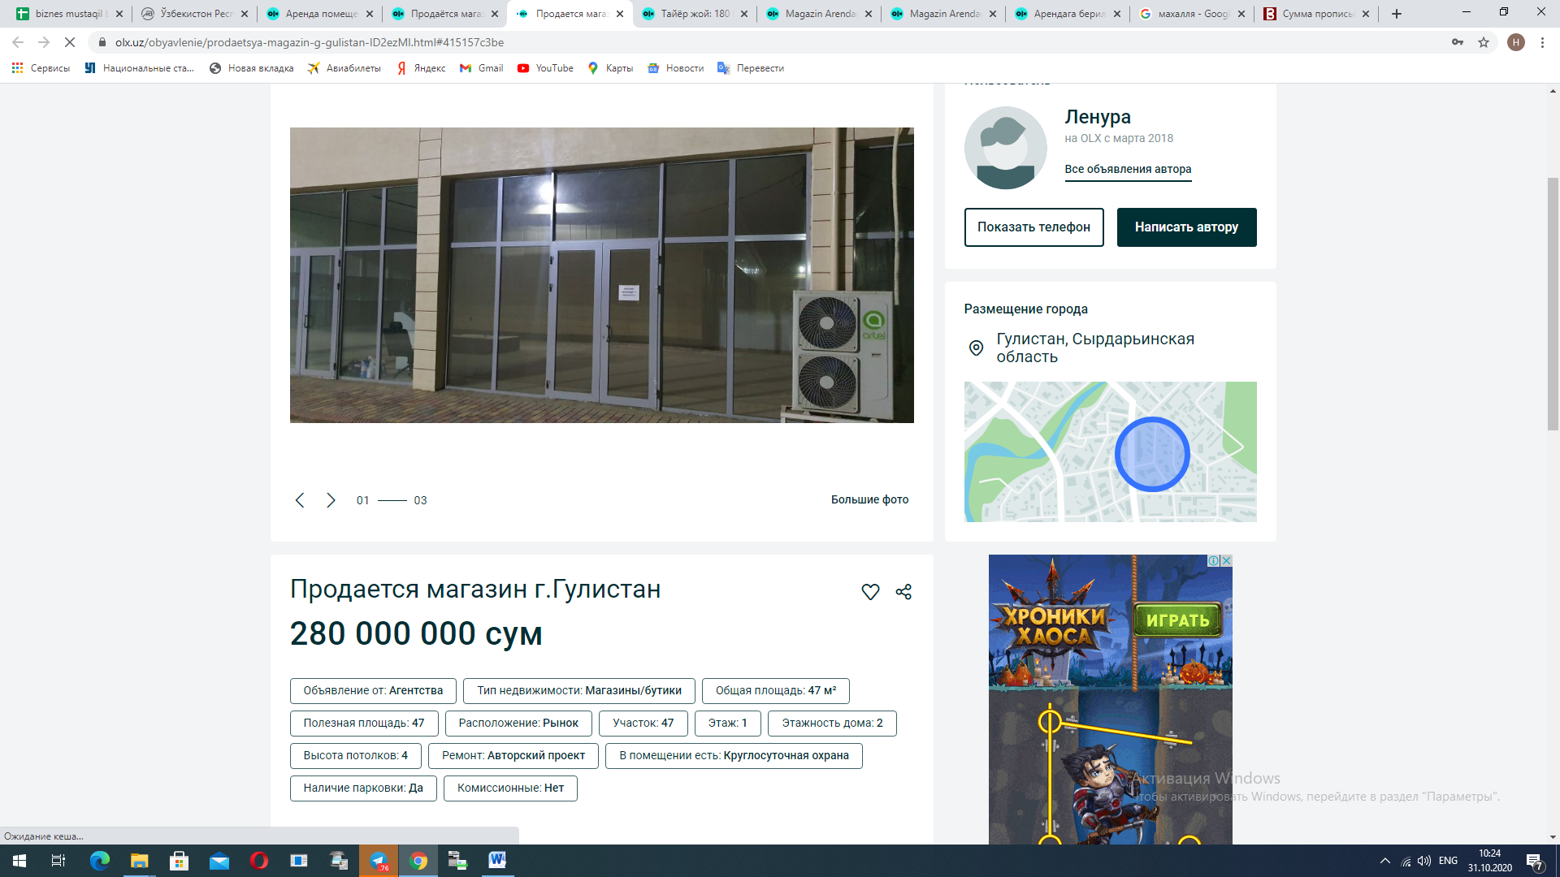

<https://www.olx.uz/obyavlenie/prodaetsya-magazin-g-gulistan-ID2ezMI.html#415157c3be>

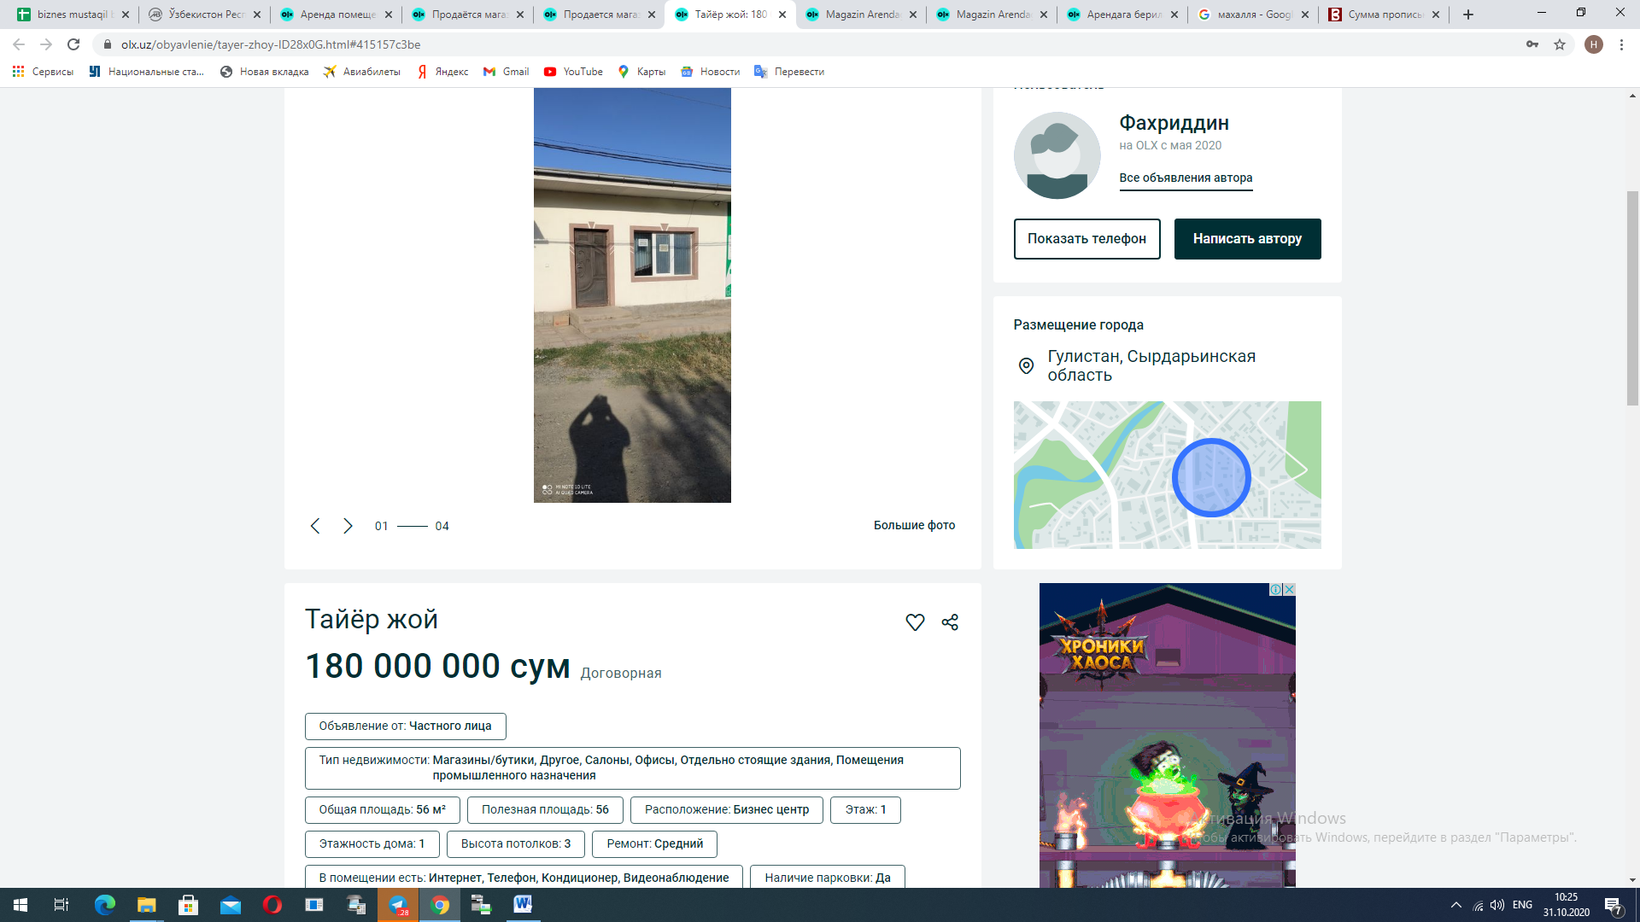

<https://www.olx.uz/obyavlenie/tayer-zhoy-ID28x0G.html#415157c3be>

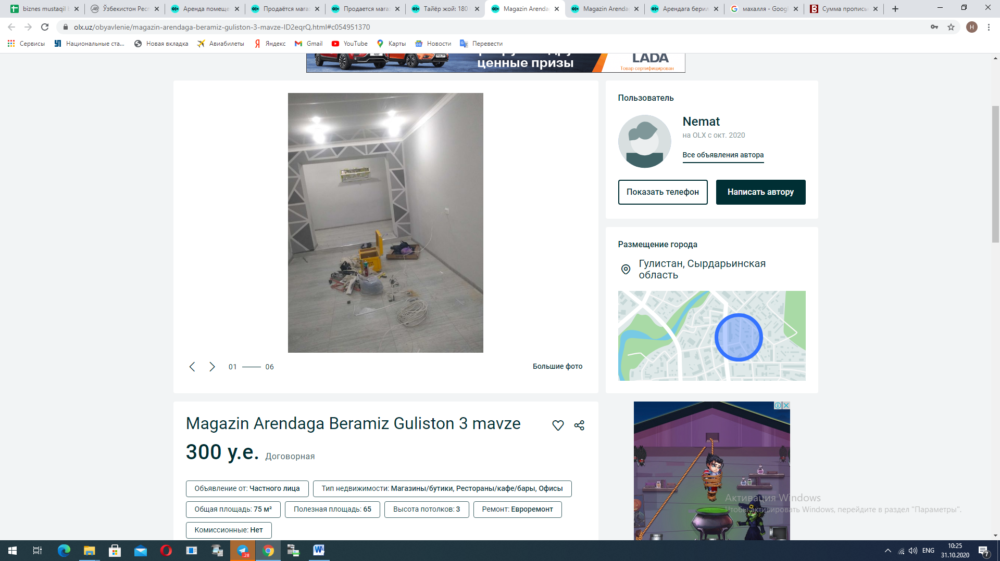

<https://www.olx.uz/obyavlenie/magazin-arendaga-beramiz-guliston-3-mavze-ID2eqrQ.html#c054951370>

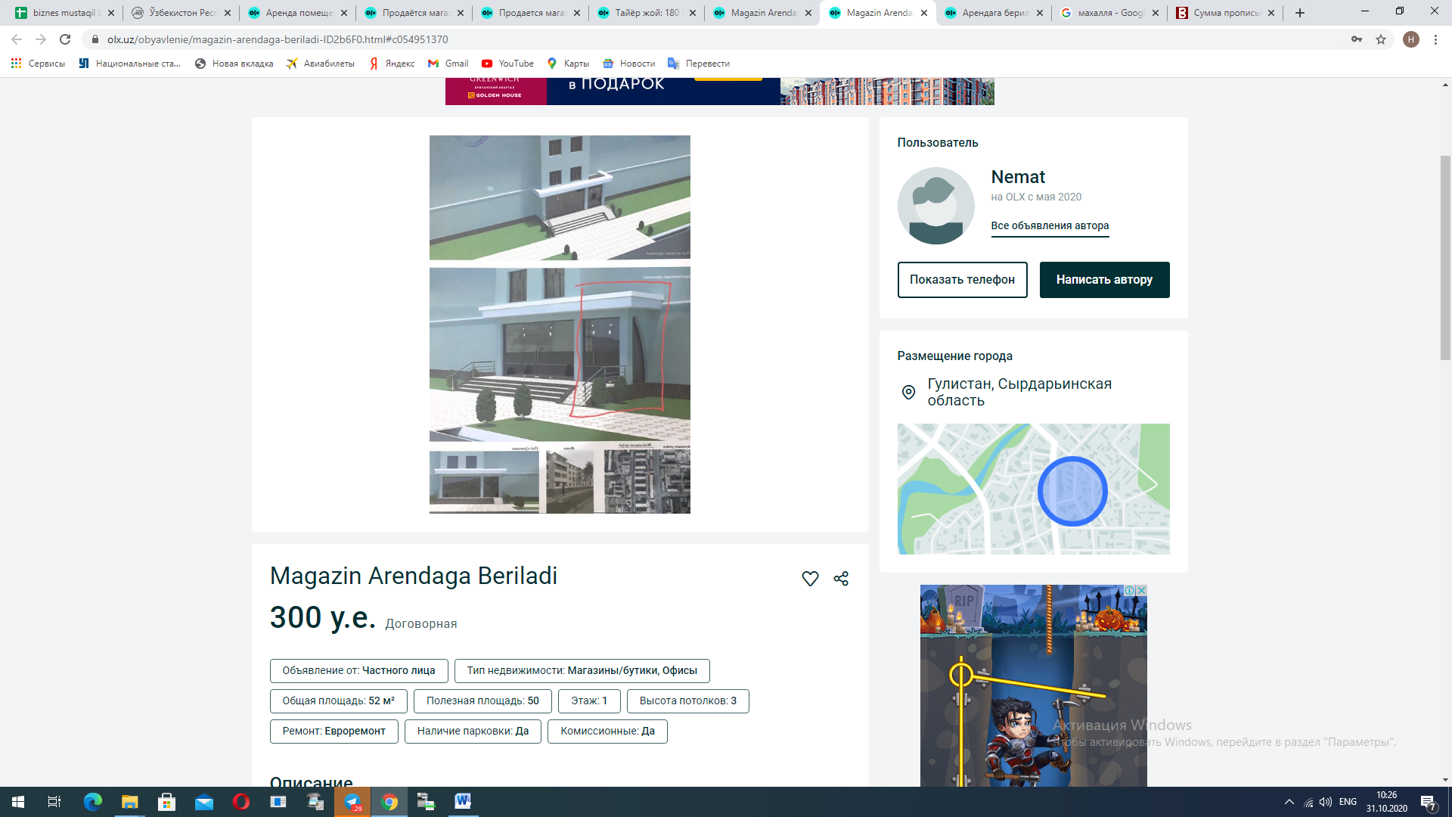

<https://www.olx.uz/obyavlenie/magazin-arendaga-beriladi-ID2b6F0.html#c054951370>

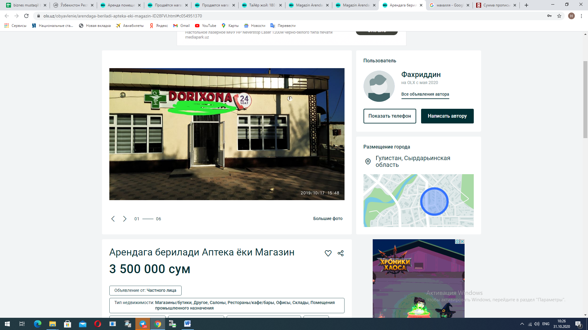

<https://www.olx.uz/obyavlenie/arendaga-beriladi-apteka-eki-magazin-ID28FVl.html#c054951370>