Here is link for Figma: <https://www.figma.com/file/QURj0jonMqxpe6amoiK0MJ/Untitled?node-id=1%3A2>

Below screenshot from Figma

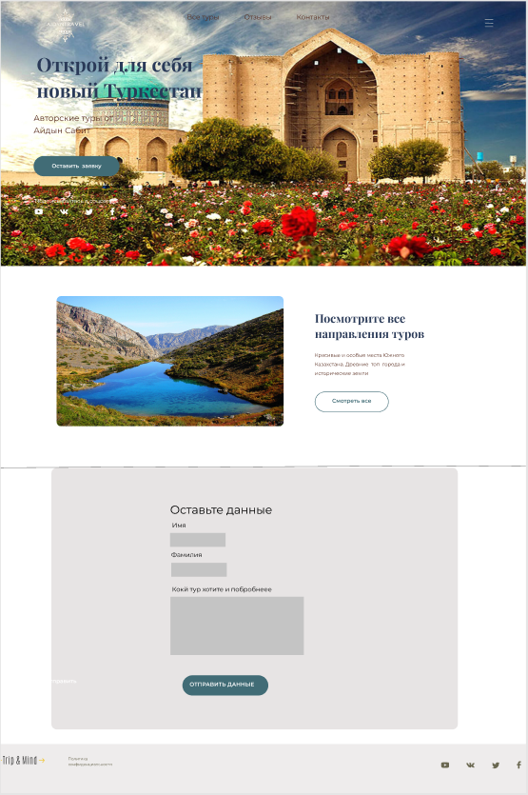

Pic. 1 Main page

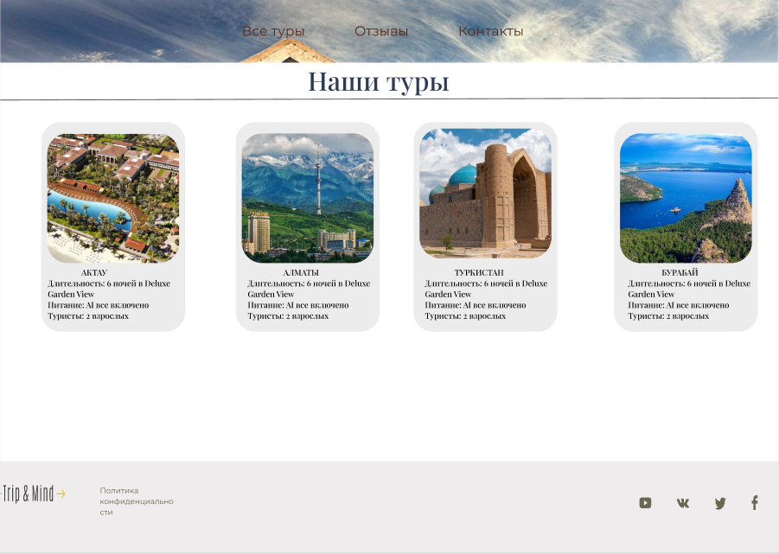

Pic.2 Page Tours

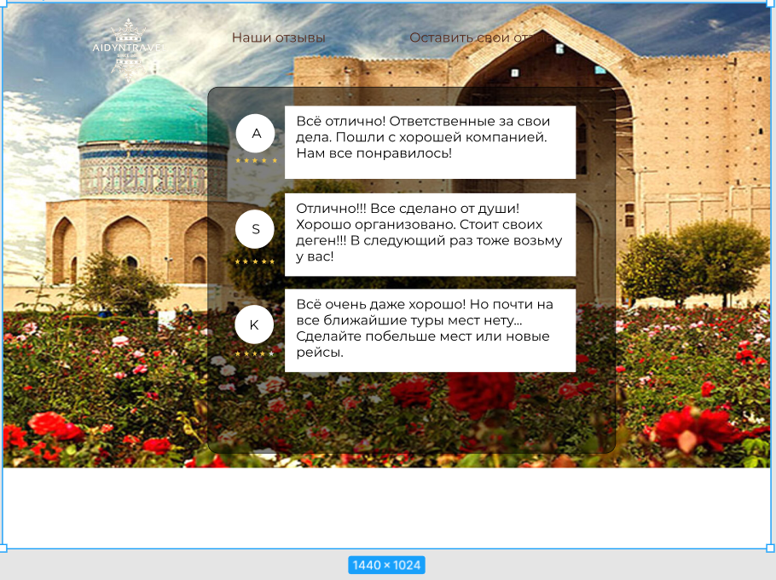

Pic.3 Comments