ARC1 Evaluation
Baseline NCA= 14 solved tasks

332efdb3
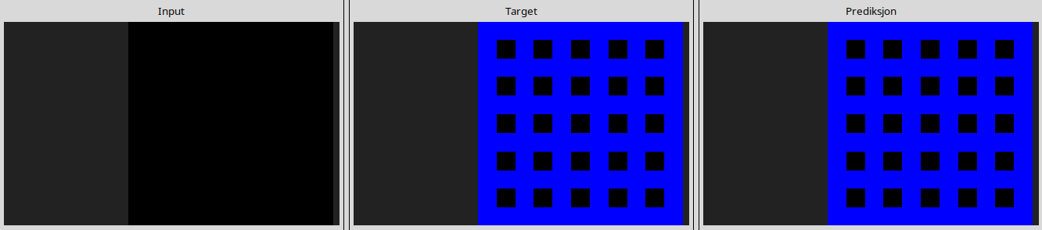
l
516b51b7
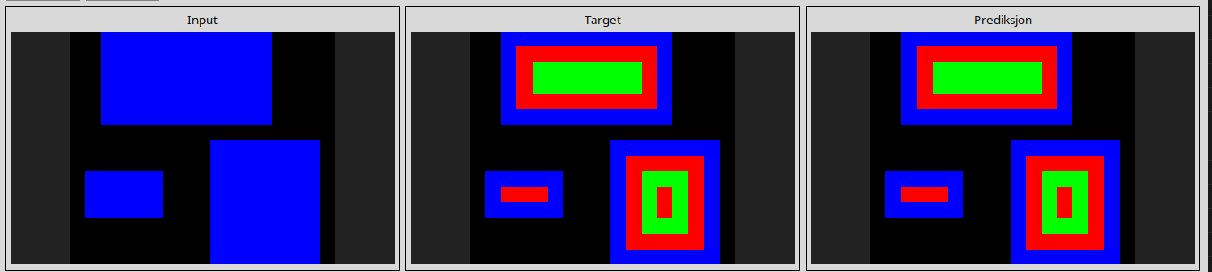
l
5207a7b5
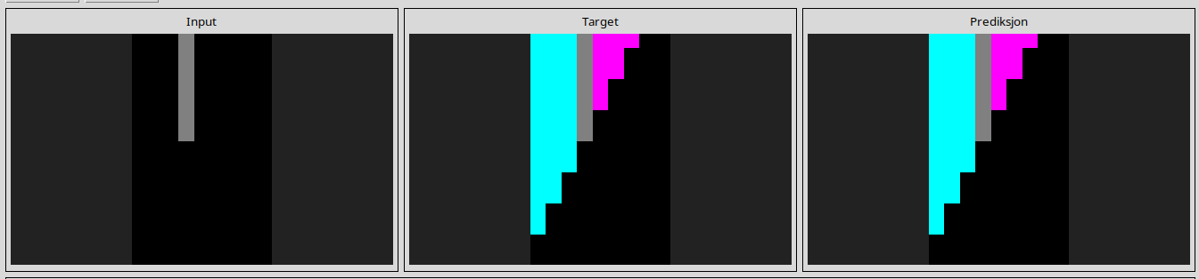
l
55059096
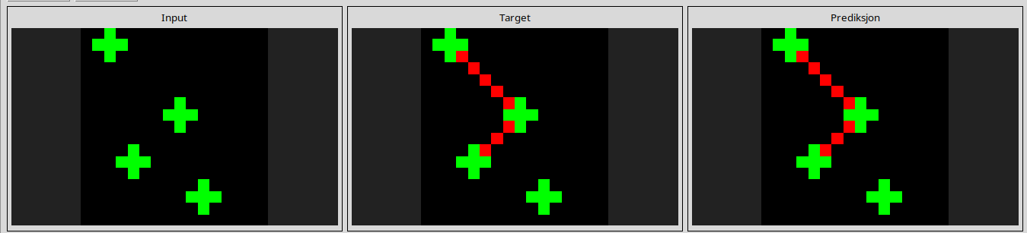
l
639f5a19
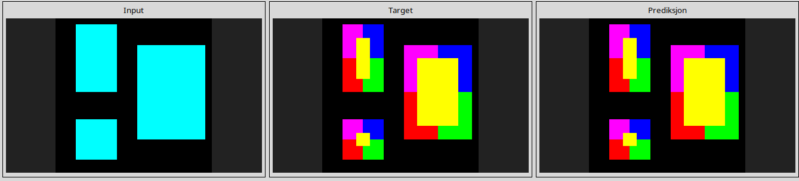
l
69889d6e
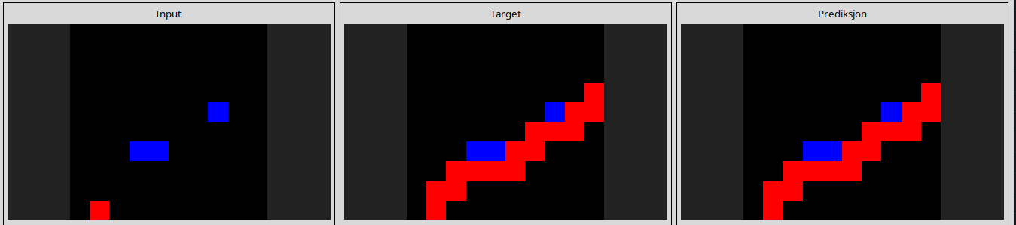
l
73c3b0d8
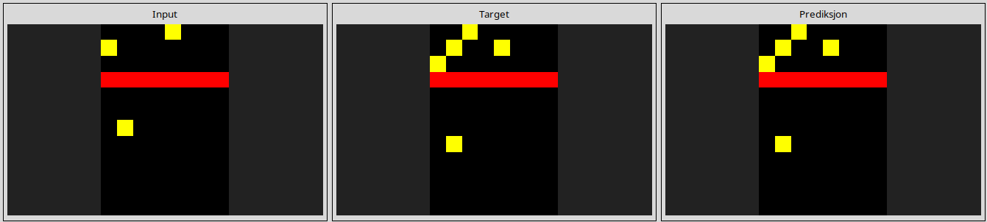
l
84f2aca1
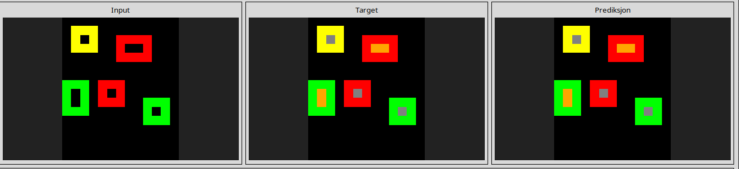
l
8a371977
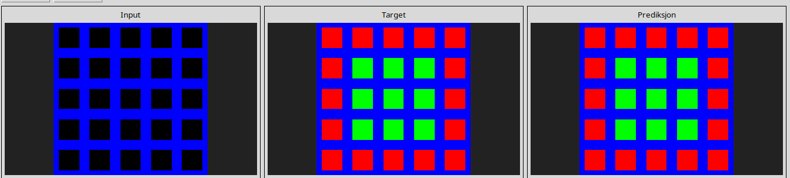
l
ae58858e
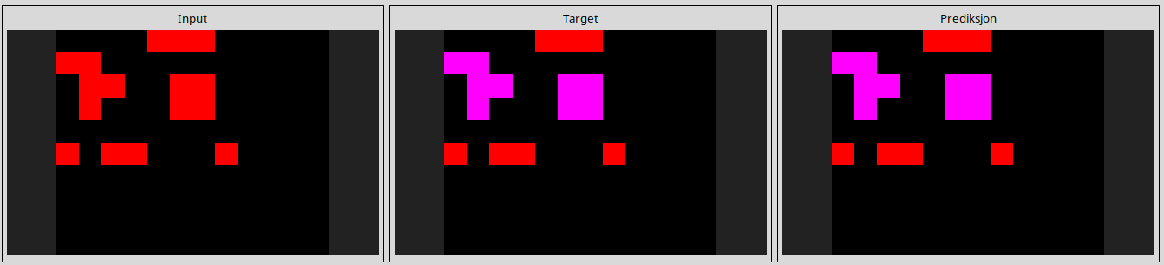
l
c1990cce
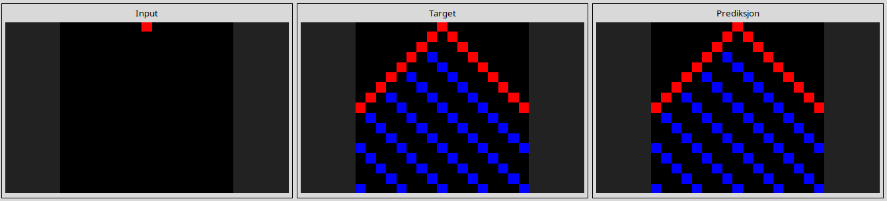
l
da2b0fe3
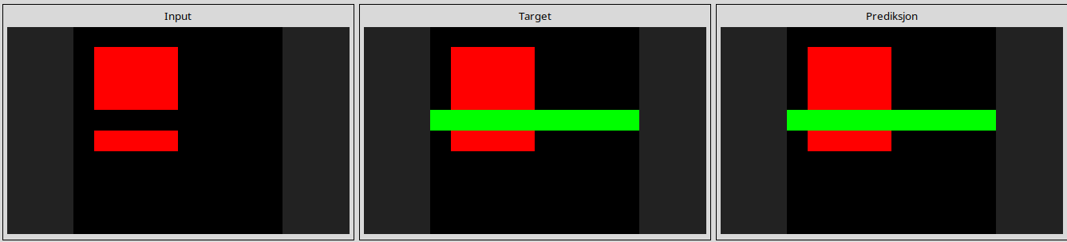
l
e872b94a
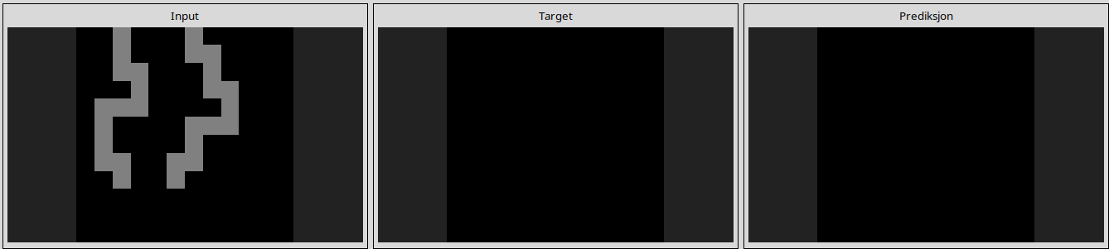
l
f0df5ff0
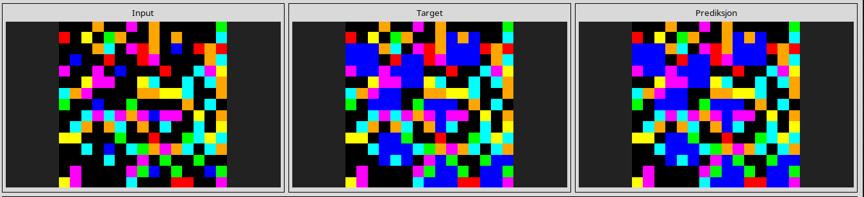
------------------------------------------------------------------------------------------------------------------------------------------------------------------------------------------------------------------------------------------------

ARC1 Eval
Fixed Filter NCA=15 solved task

21f83797
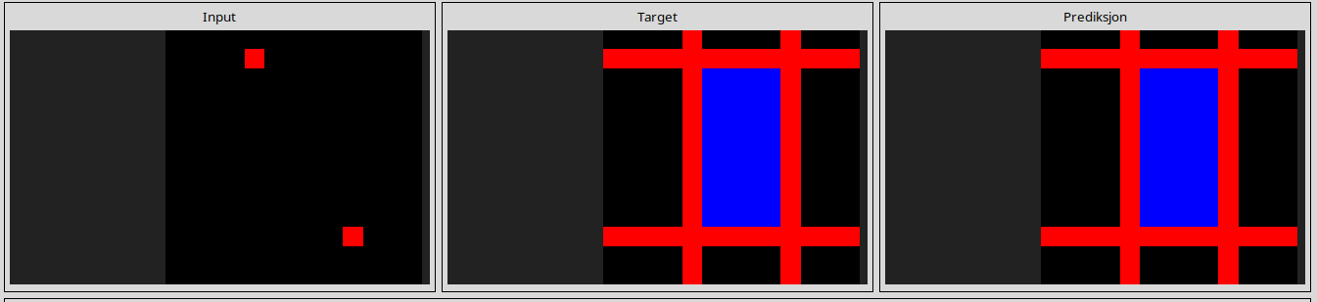
l
332efdb3
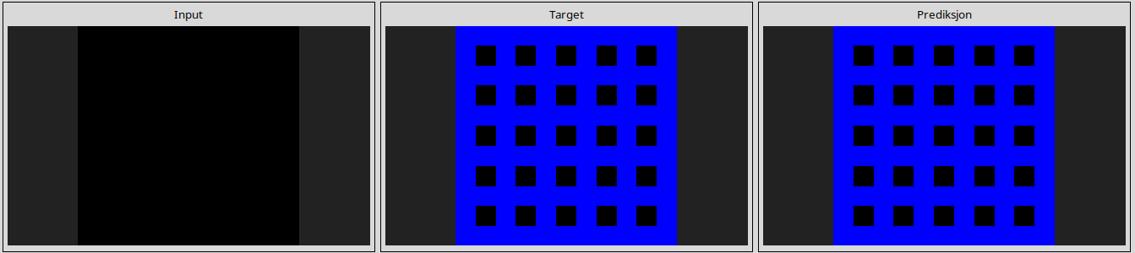
516b51b7
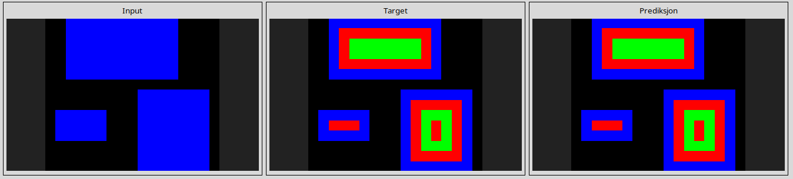
5207a7b5
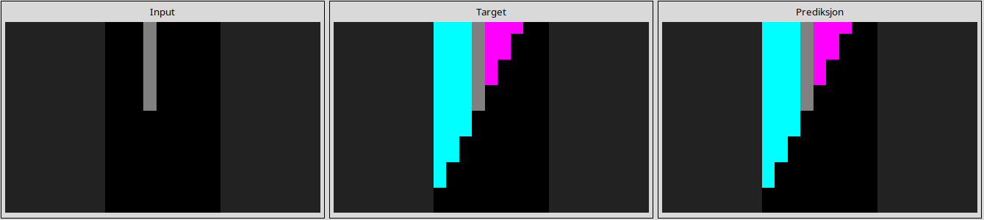
69889d6e
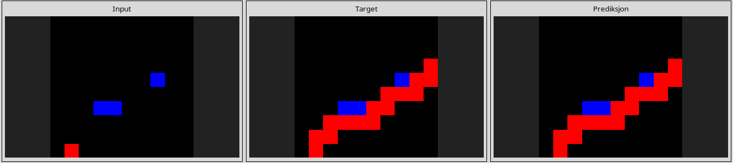
72a961c9
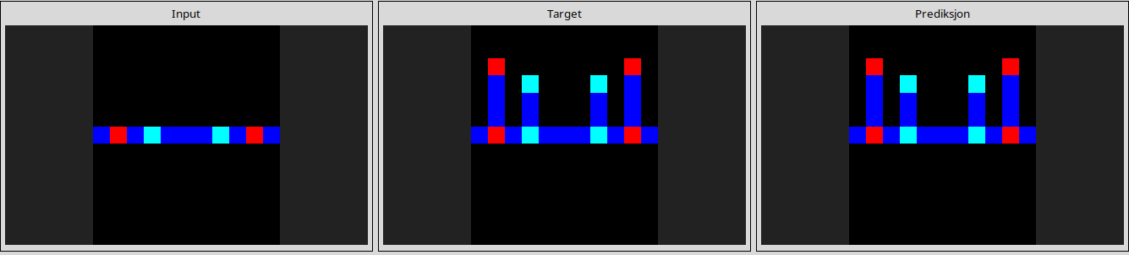
84f2aca1
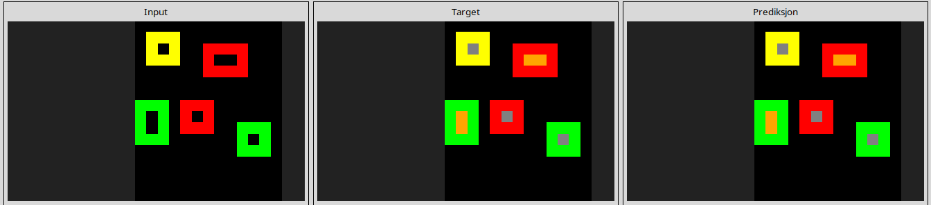
8a371977
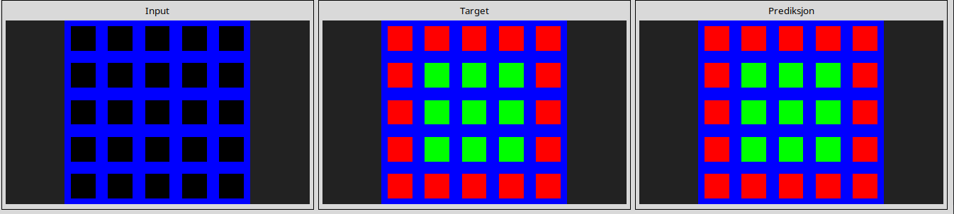
9caba7c3
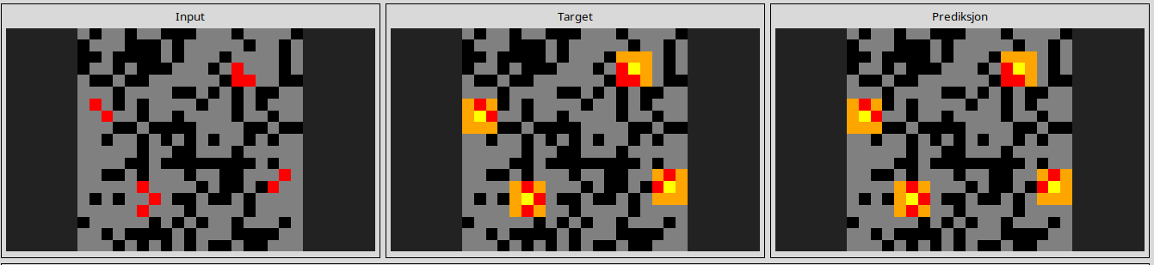
ae58858e
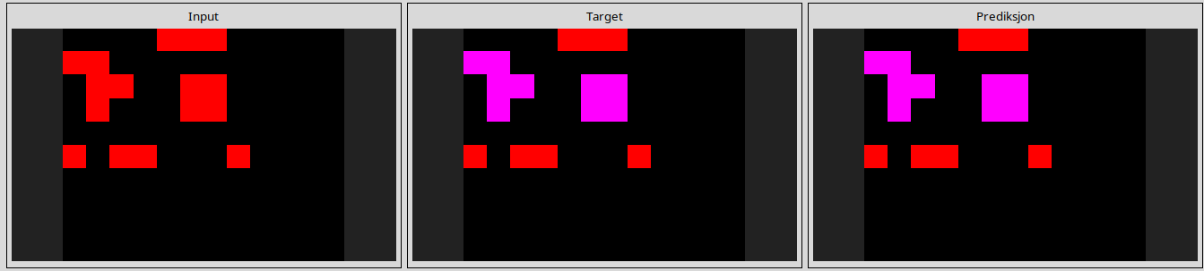
b1fc8b8e
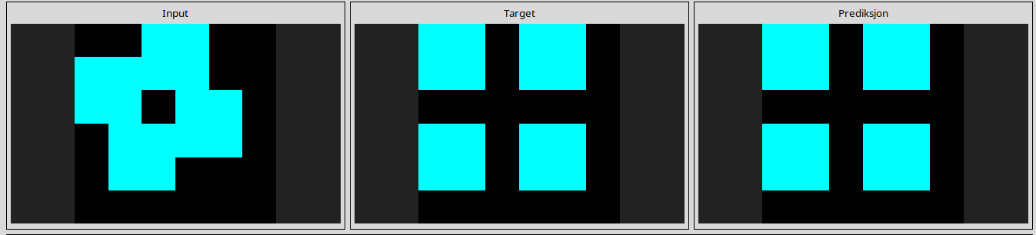
c1990cce
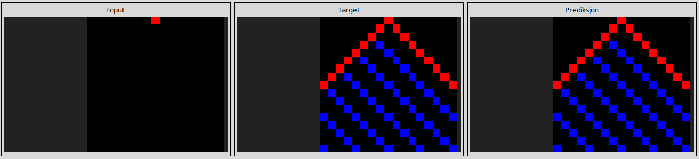
e872b94a
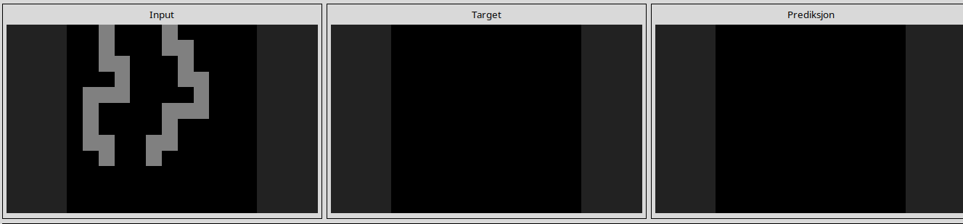
e9c9d9a1
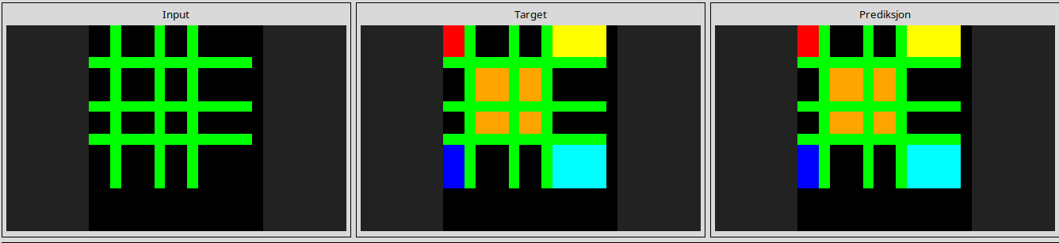
f0df5ff0
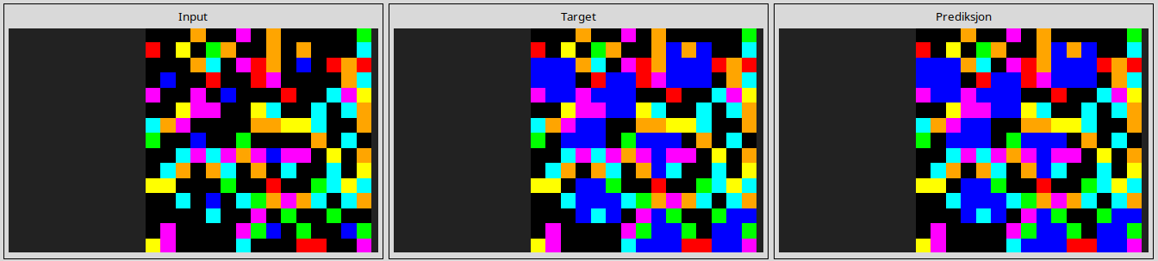
------------------------------------------------------------------------------------------------------------------------------------------------------------------------------------------------------------------------------------------------
ARC1 eval
Learnable Filter NCA=22 solved tasks
21f83797
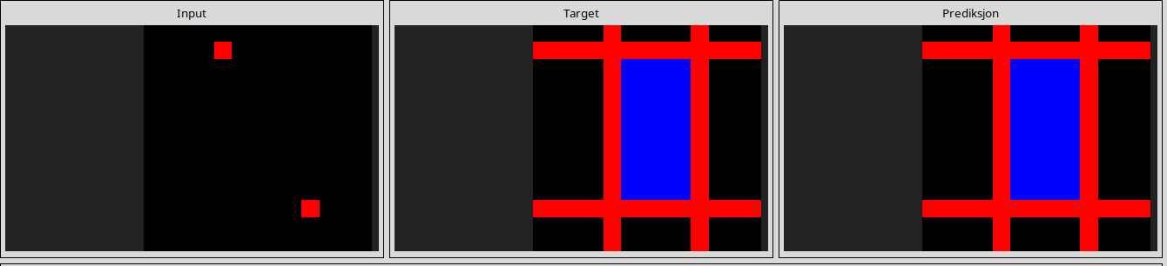
332efdb3
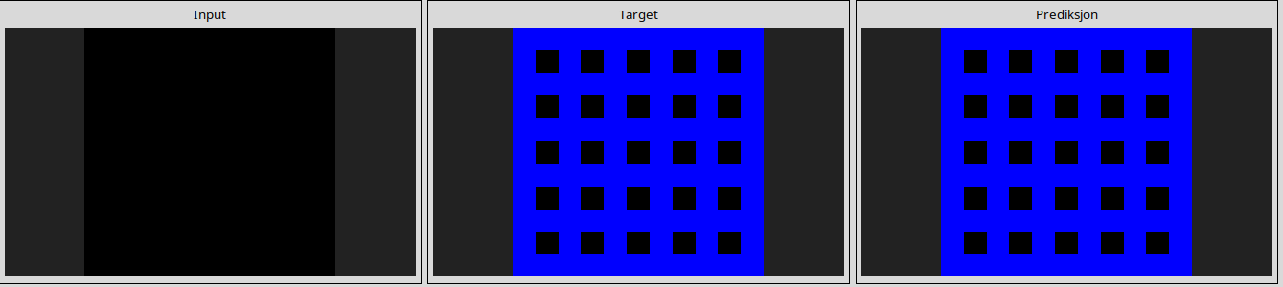
45737921
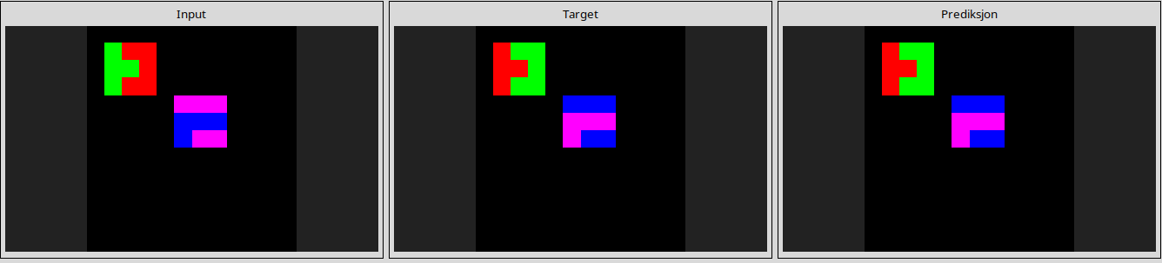
516b51b7
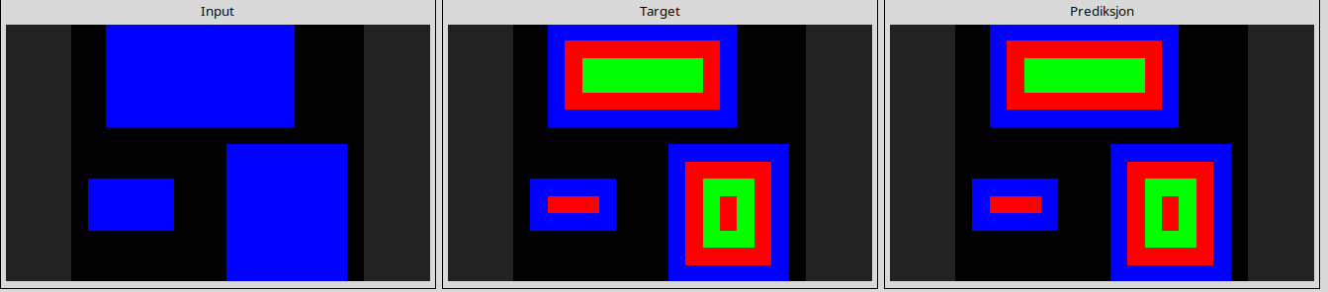
5207a7b5
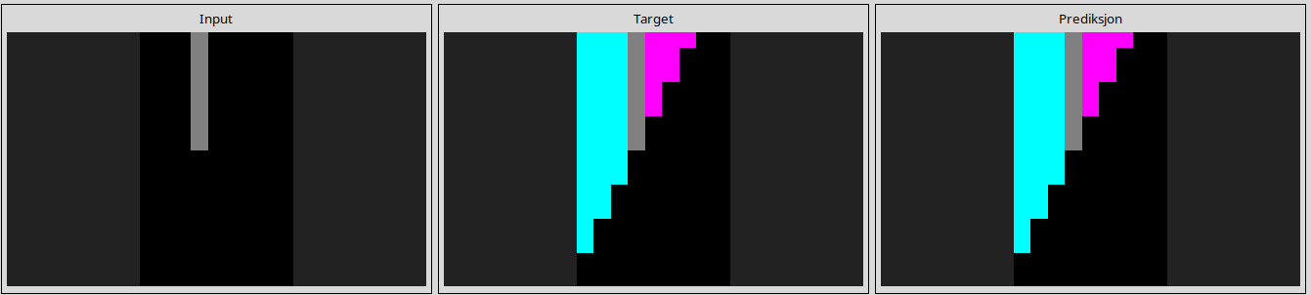
639f5a19
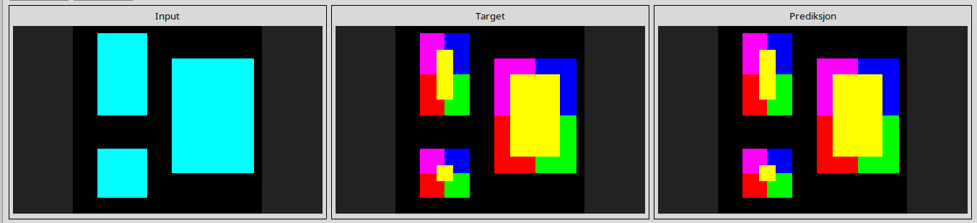
69889d6e
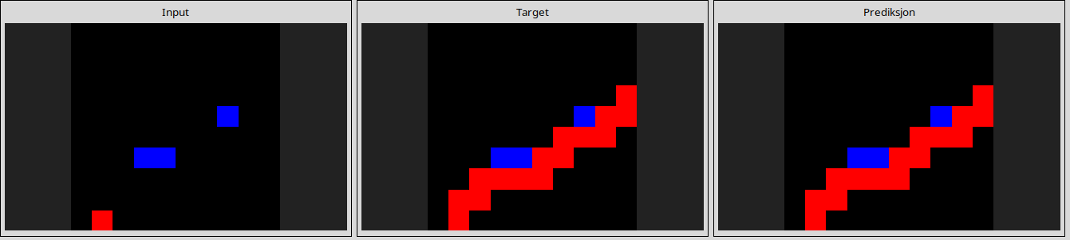
6ea4a07e
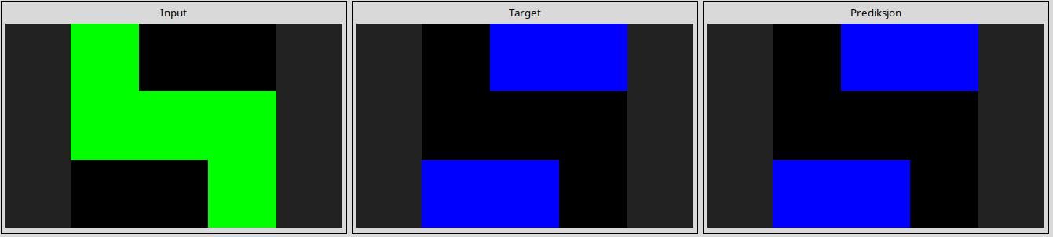
72a961c9
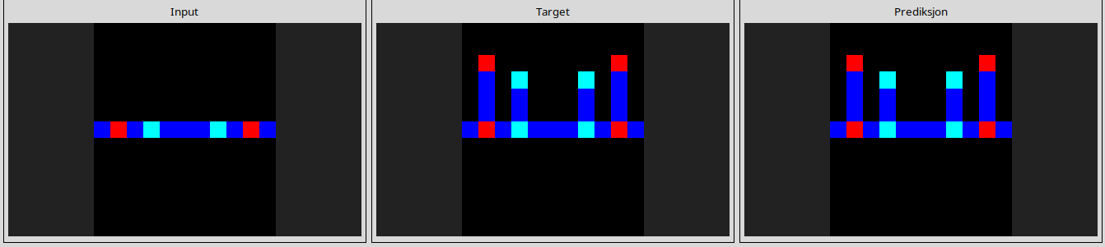
73c3b0d8
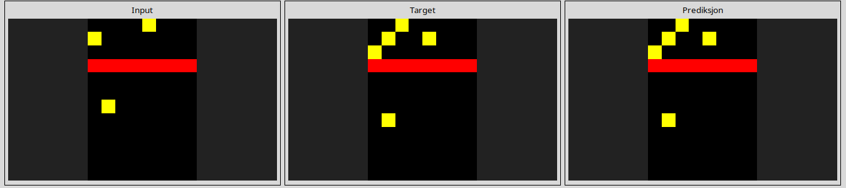
7c8af763
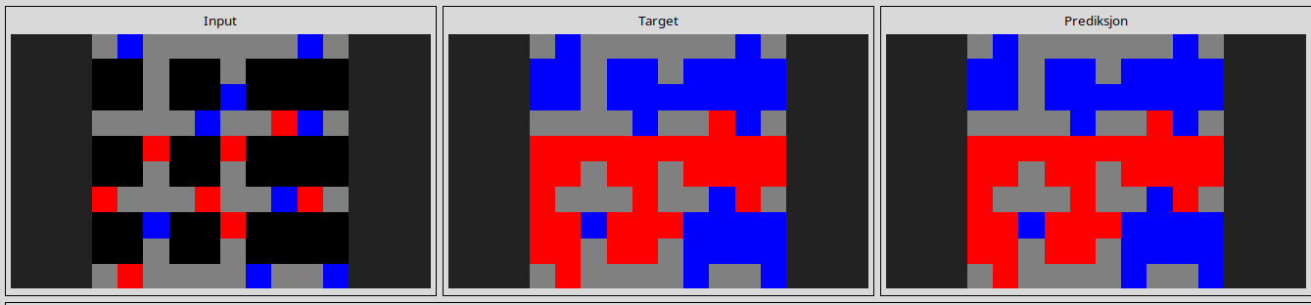
84f2aca1
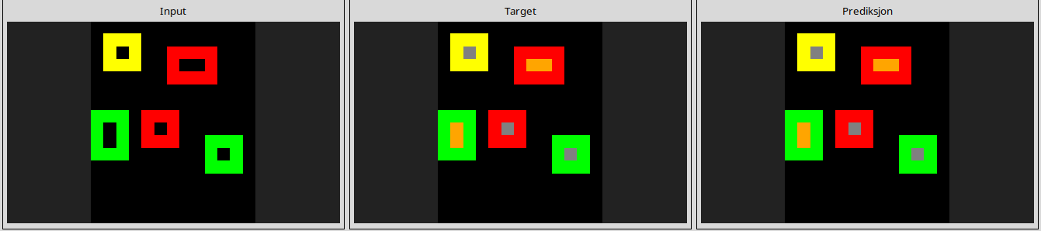
8a371977
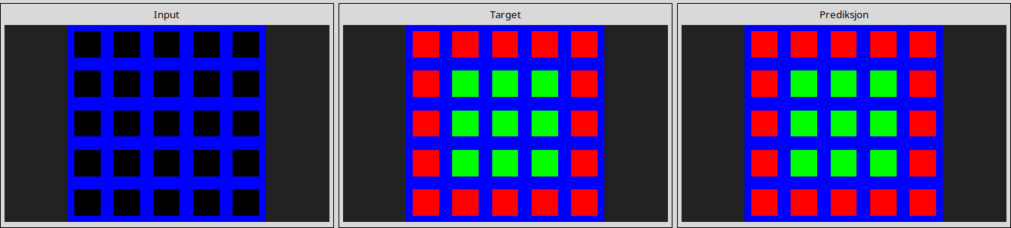
9772c176
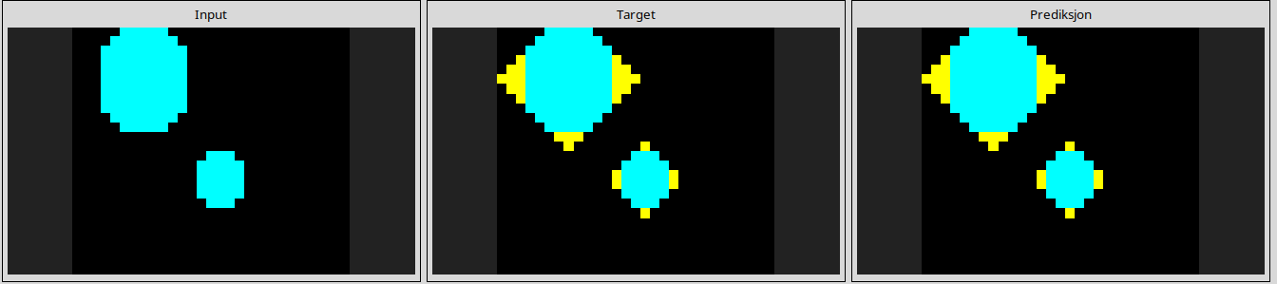
ac3e2b04
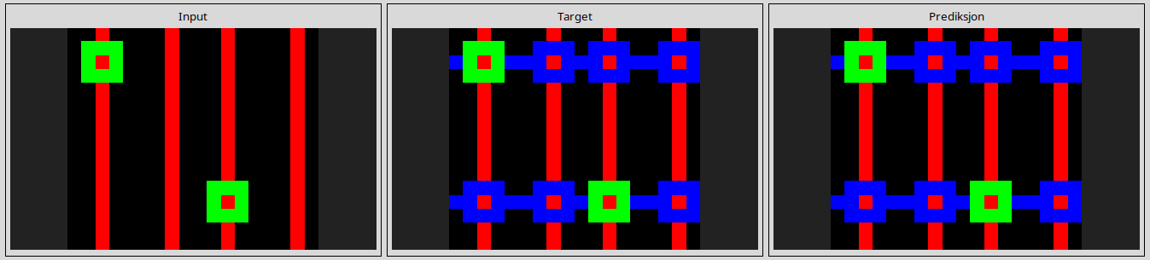
ae58858e
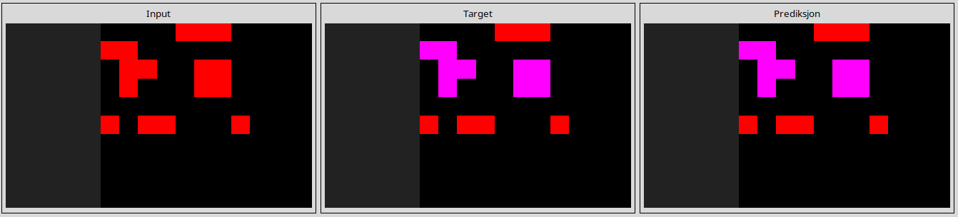
c1990cce
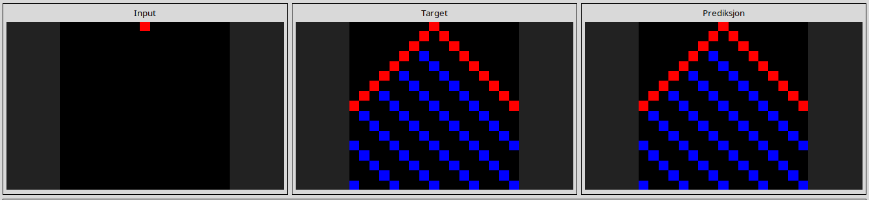
e0fb7511
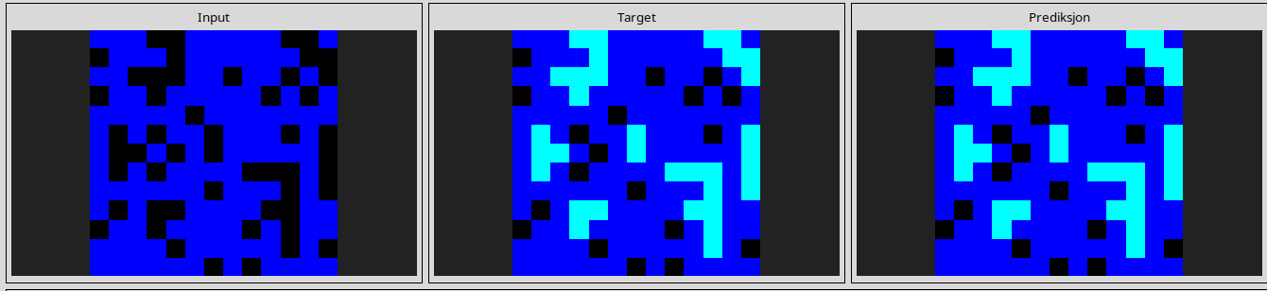
e872b94a
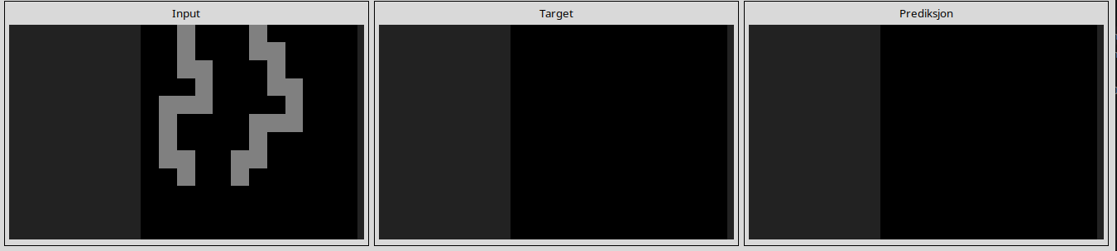
e9c9d9a1
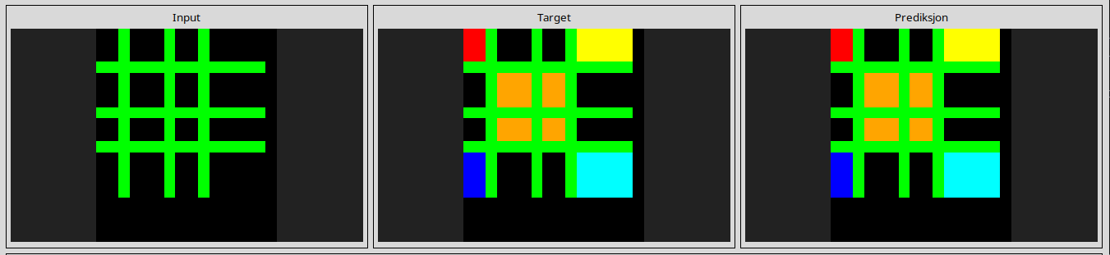
f0df5ff0
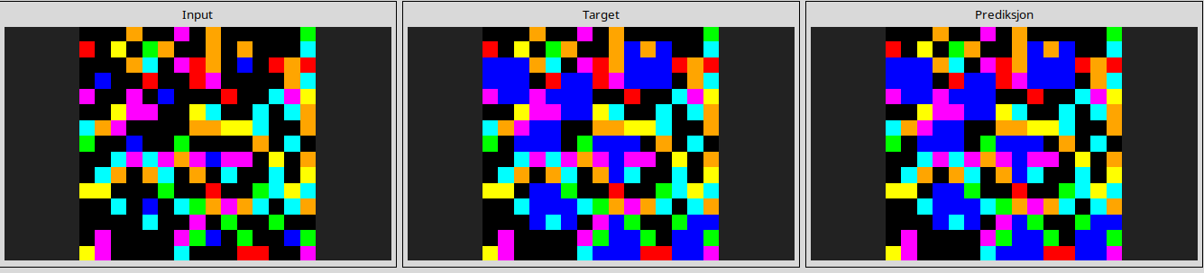
f45f5ca7
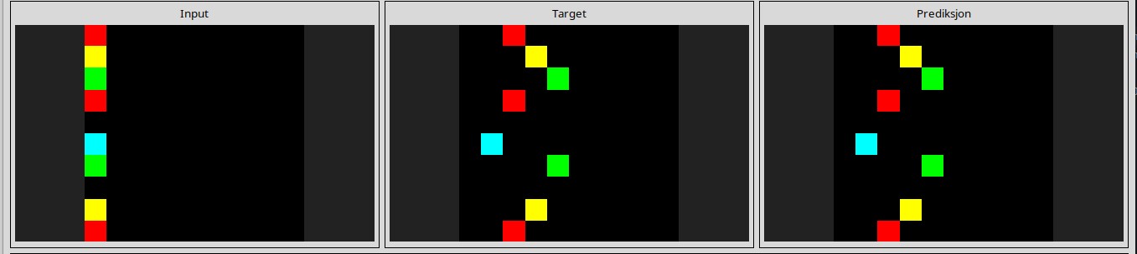
------------------------------------------------------------------------------------------------------------------------------------------------------------------------------------------------------------------------------------------------
ARC1 Evaluation
Color Permutation NCA=22 solved task

00576224
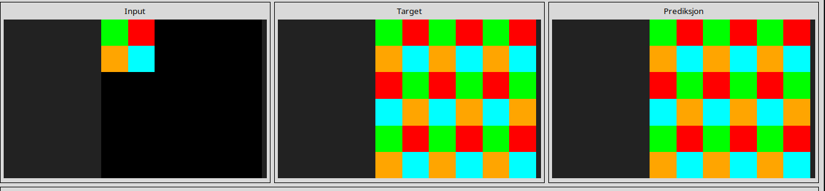

32e9702f
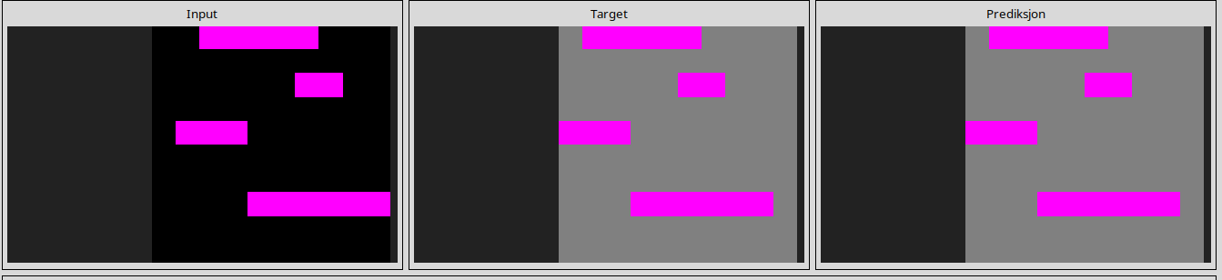
45737921
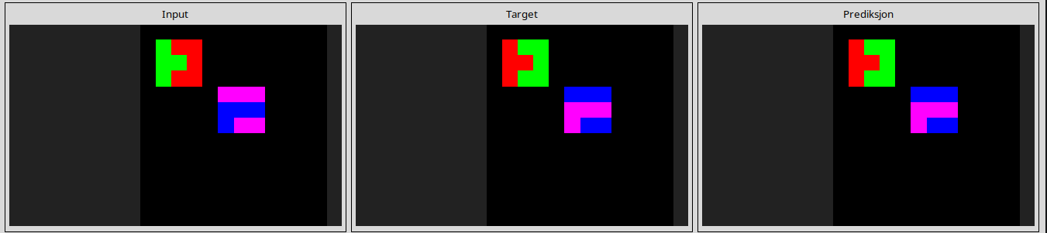
50a16a69
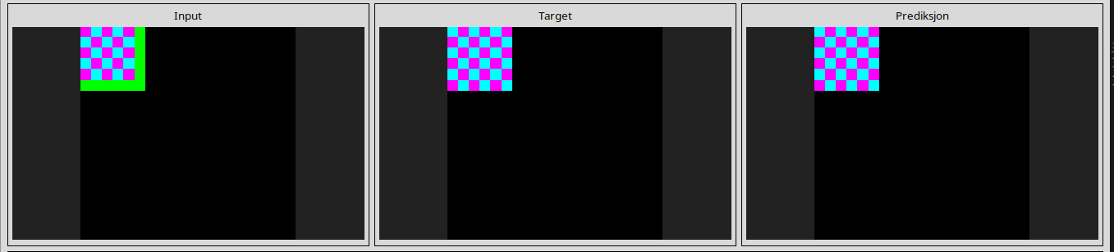
516b51b7
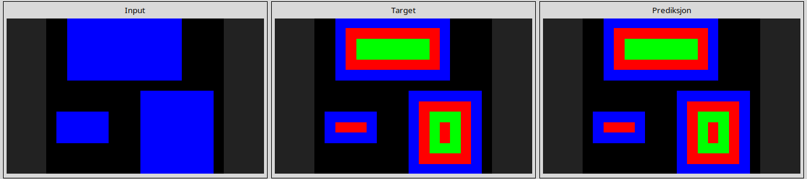
5207a7b5
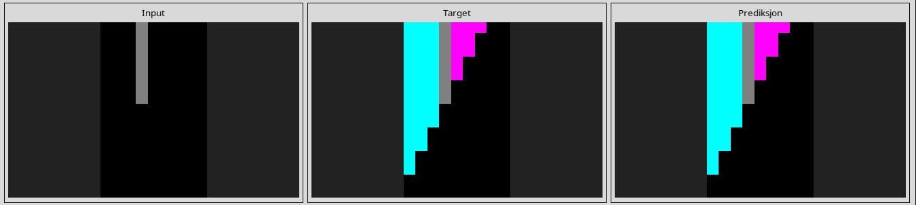
66e6c45b
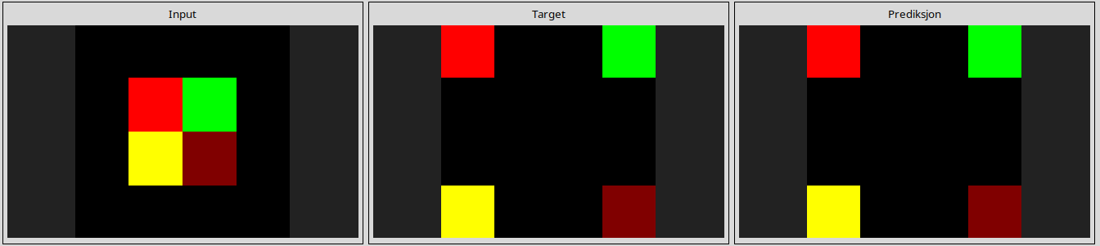
69889d6e
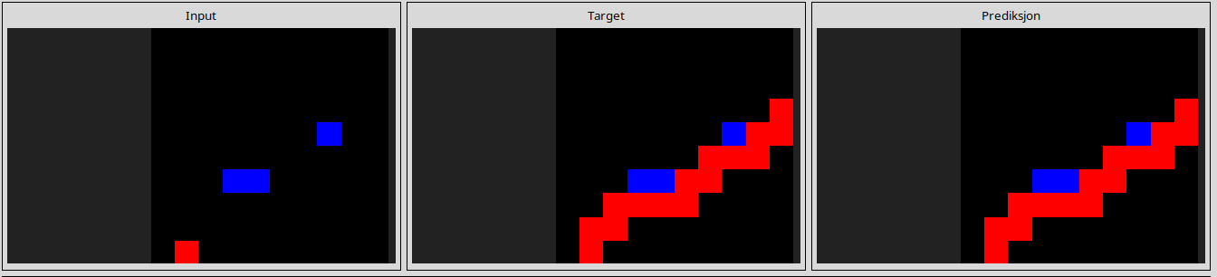
73c3b0d8
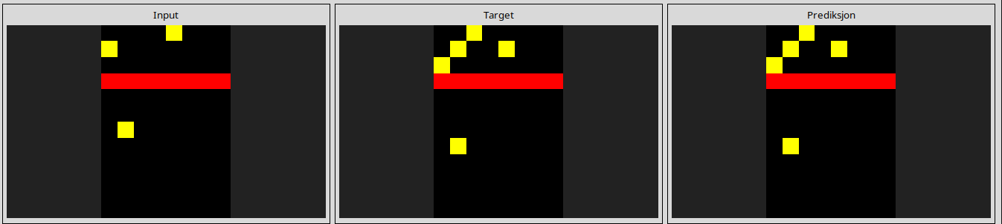
917bccba
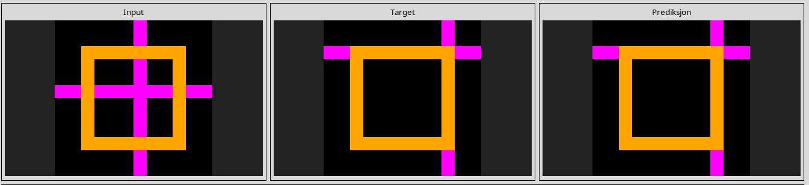
9772c176
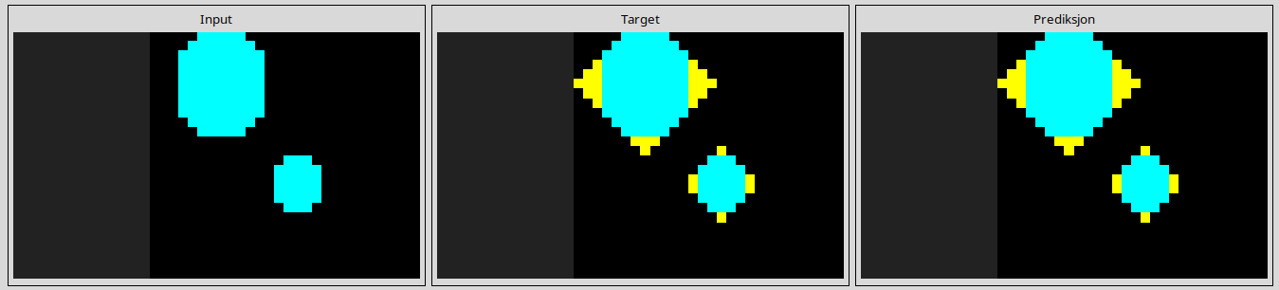
ae58858e
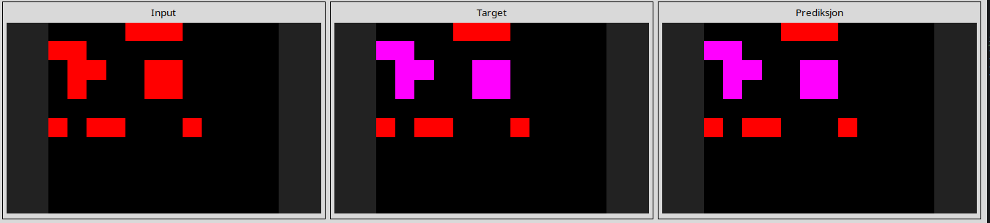
b1fc8b8e
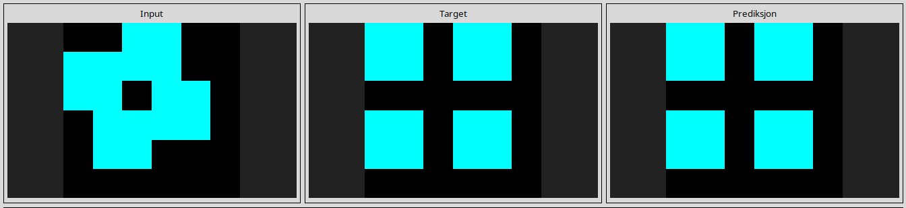

ba9d41b8
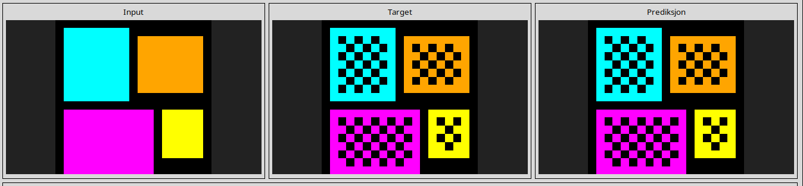
c1990cce
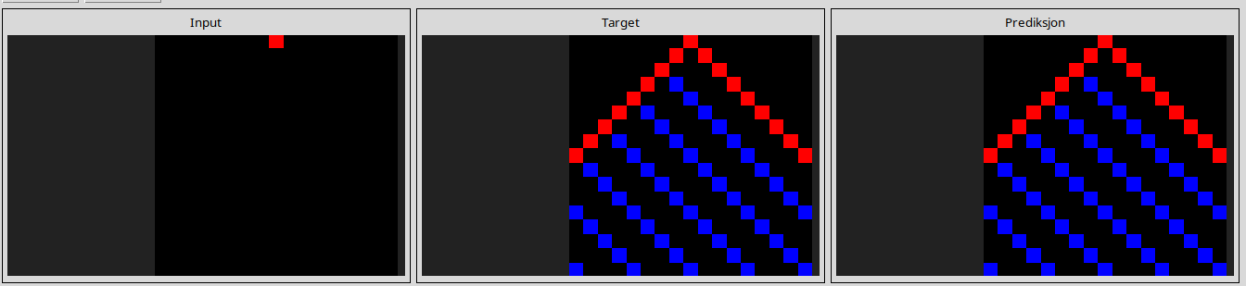
ca8de6ea
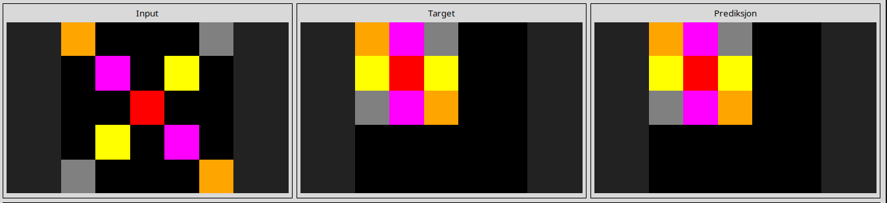
cf133acc
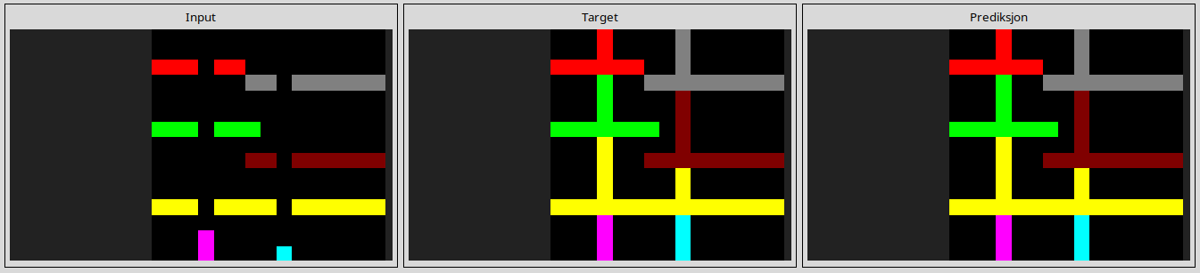
e0fb7511
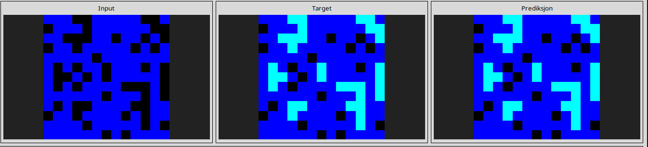
e633a9e5
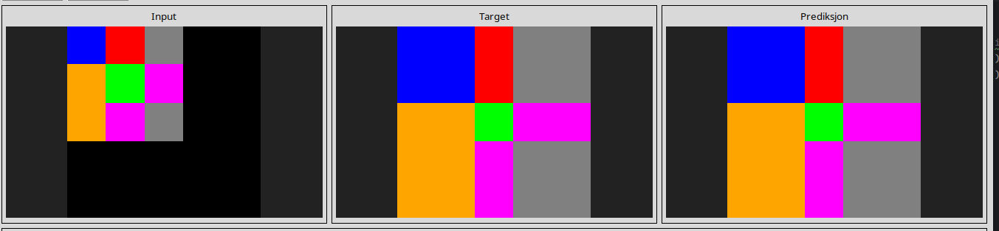
e872b94a
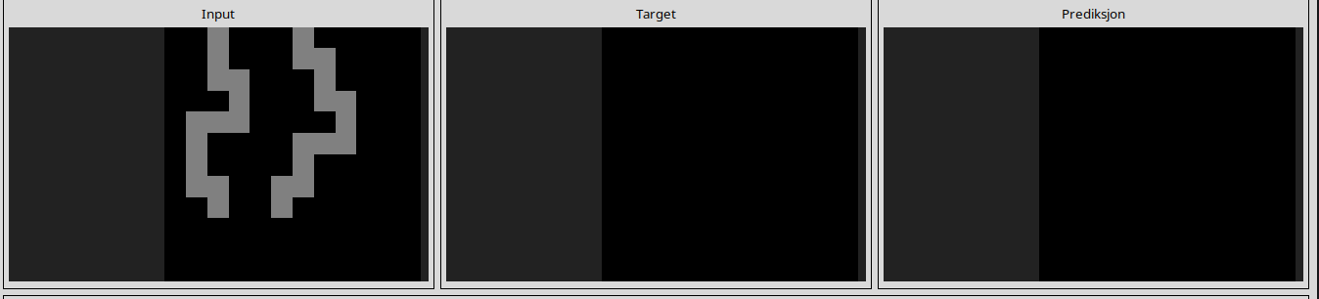
e9ac8c9e
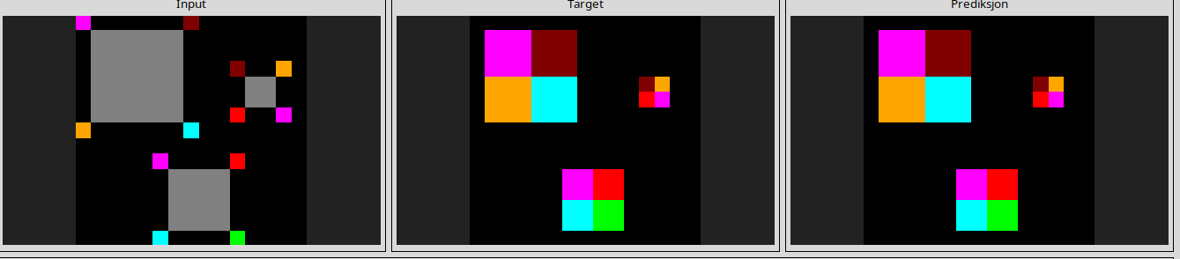
e9c9d9a1
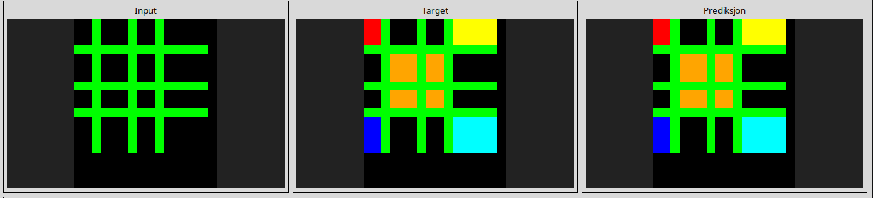
-----------------------------------------------------------------------------------------------------------------------------------------------------------------------------------------------------------------------------------------------
ARC1 Evaluation
Rotating Filter NCA=30 solved task

009d5c81
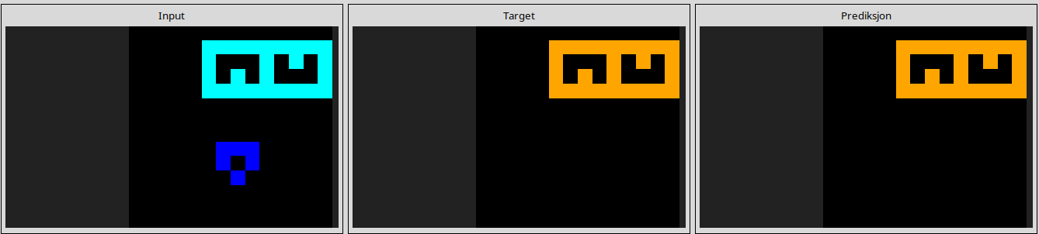
137f0df0
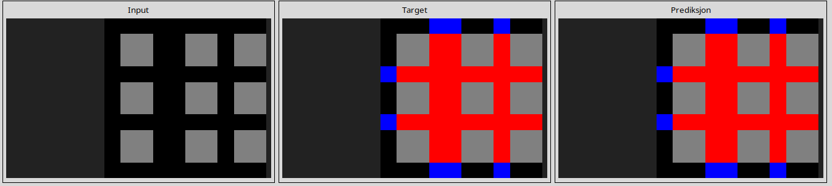
17cae0c1
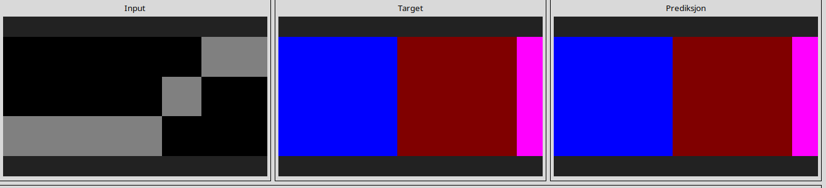
1c0d0a4b
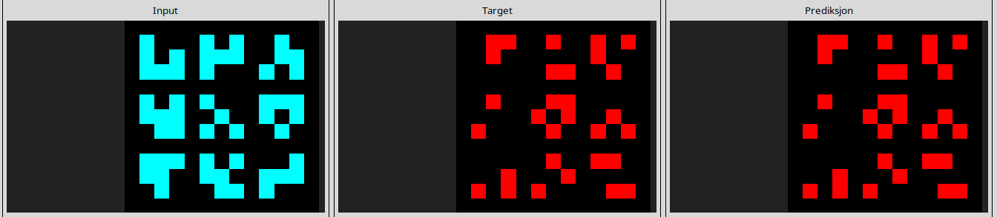
21f83797
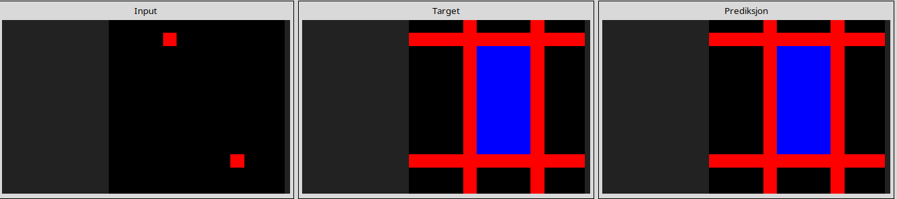
332efdb3
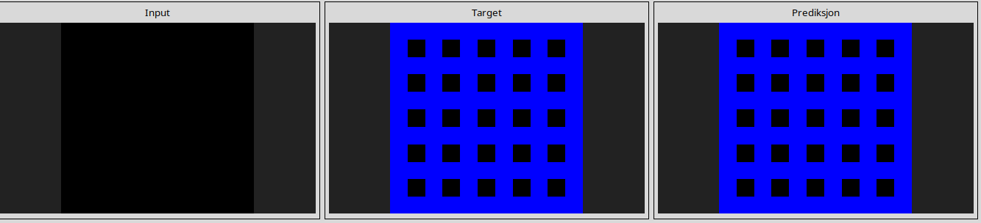
45737921
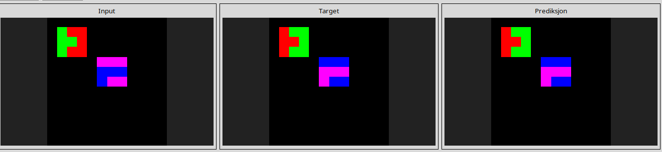
516b51b7
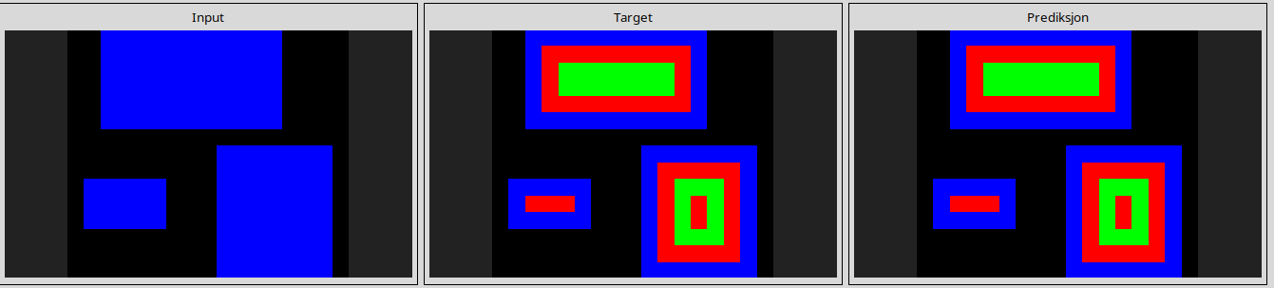
5207a7b5
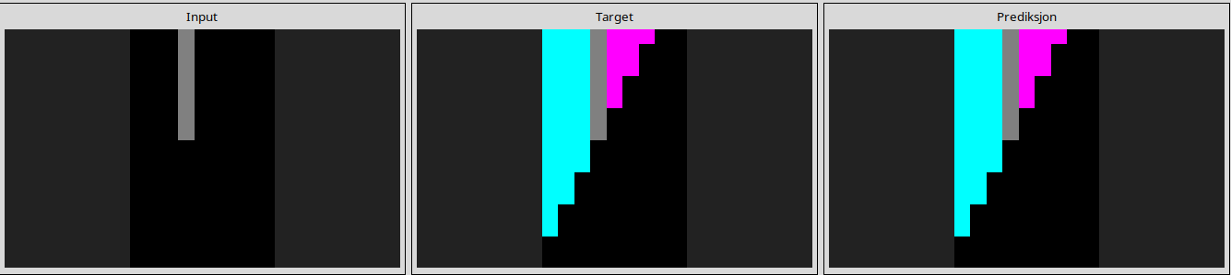
55059096
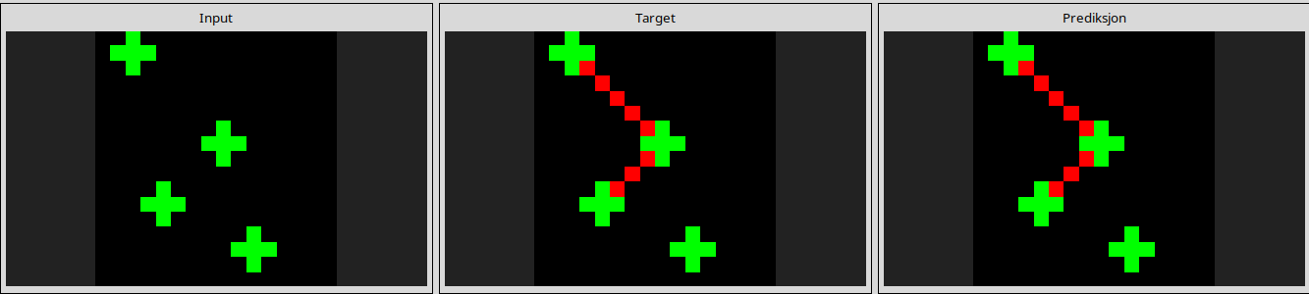
69889d6e
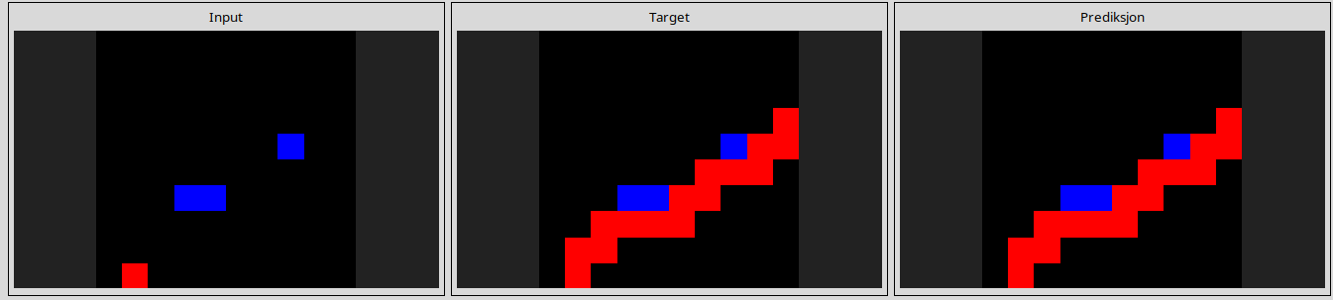
6ea4a07e
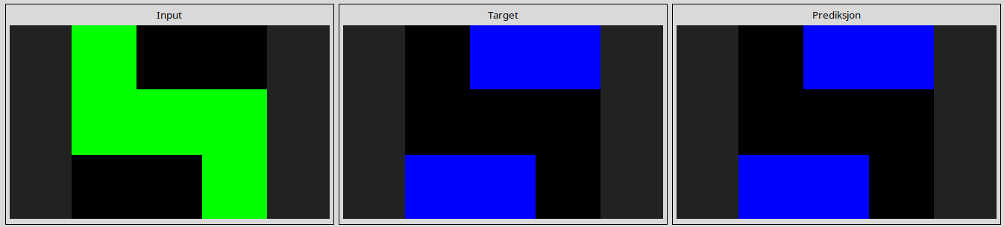
72a961c9
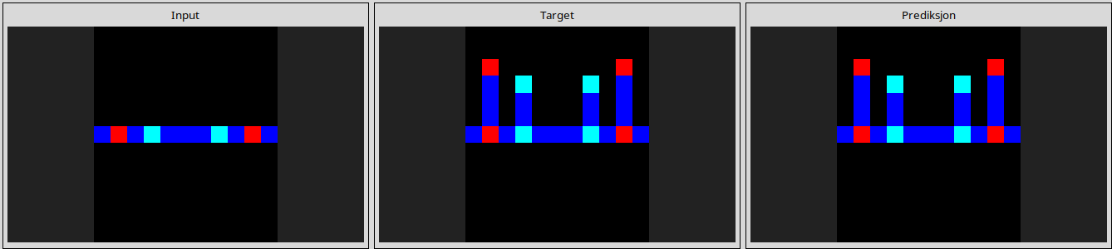
759f3fd3
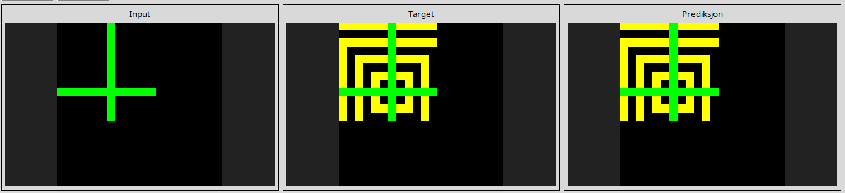
7c8af763
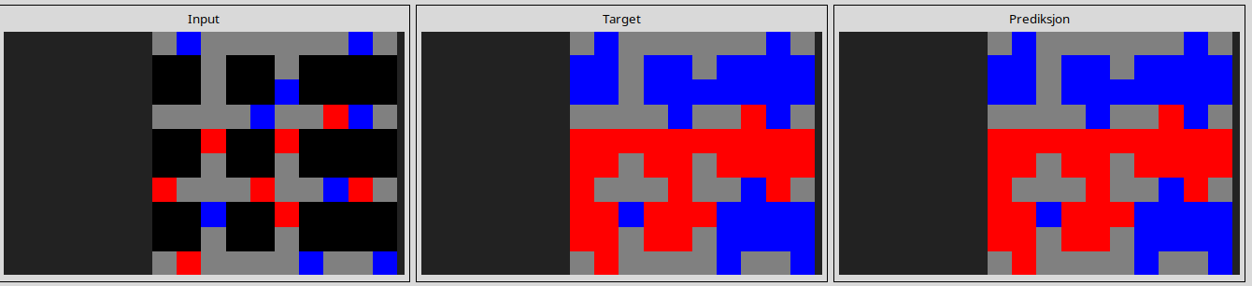
84db8fc4
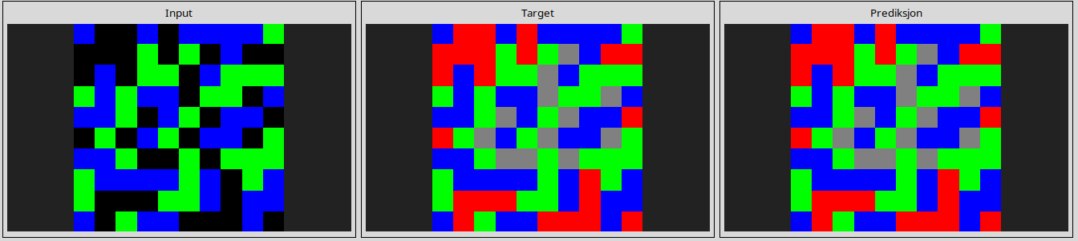
8a371977
9772c176
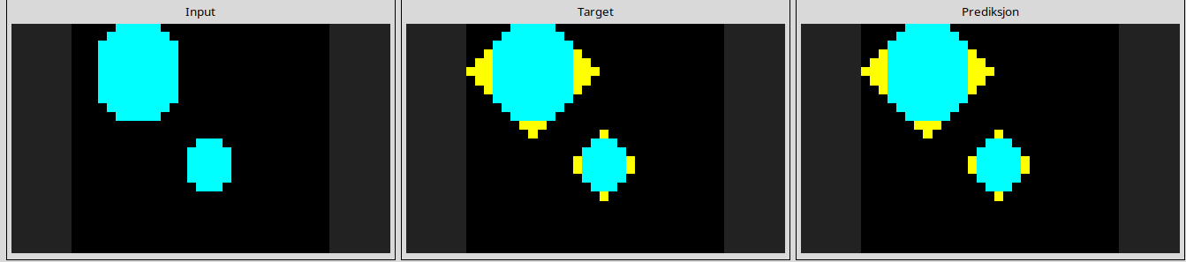
9caba7c3
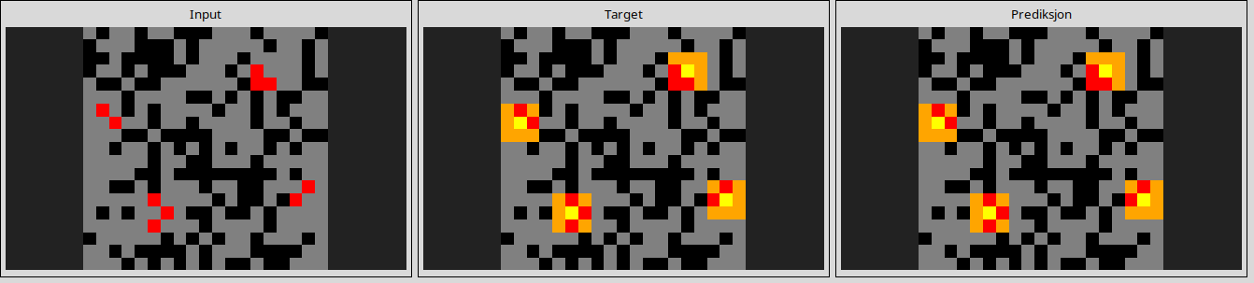
a04b2602
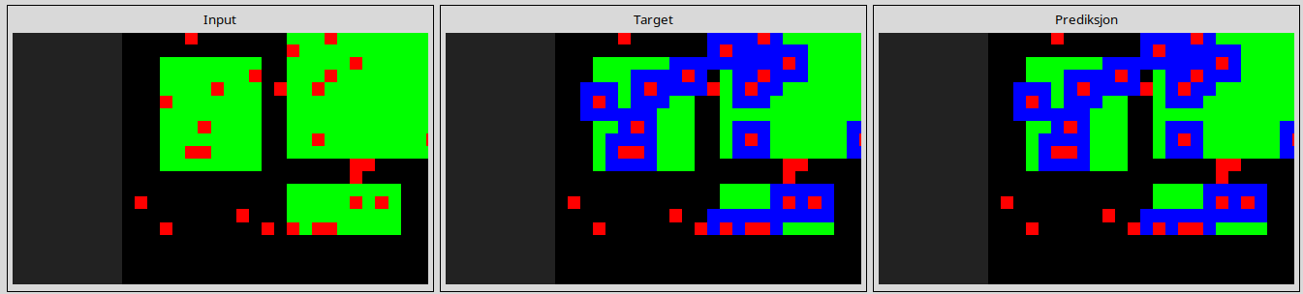
ac3e2b04
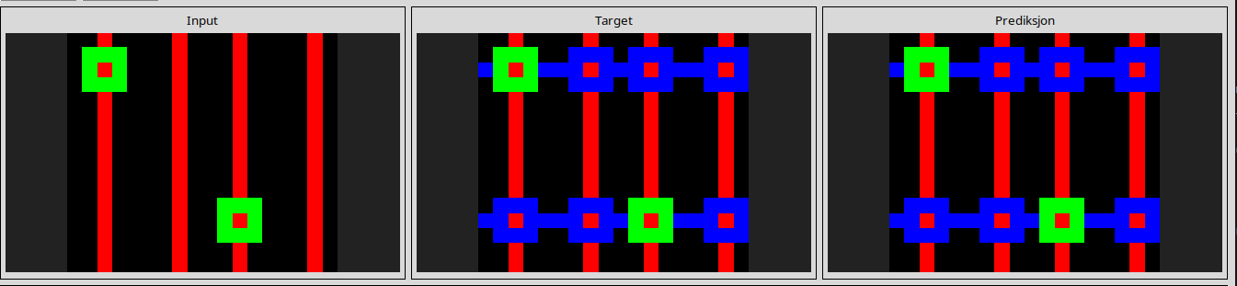
ae58858e
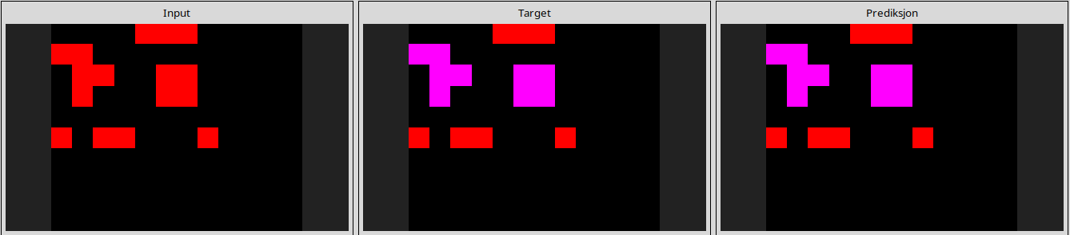
c074846d
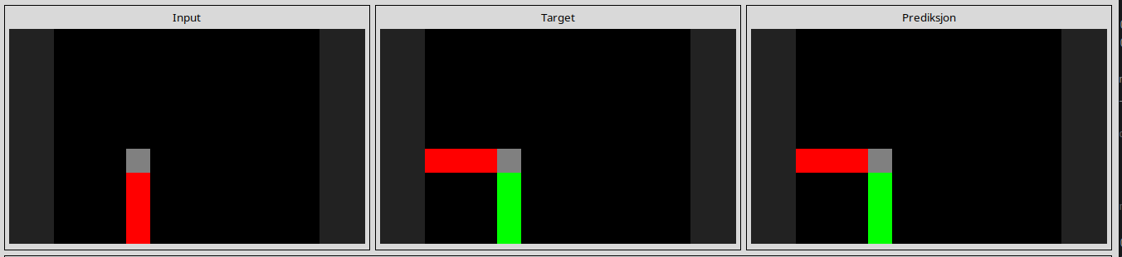
c1990cce
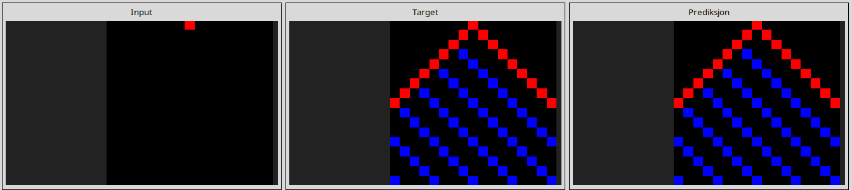
c97c0139
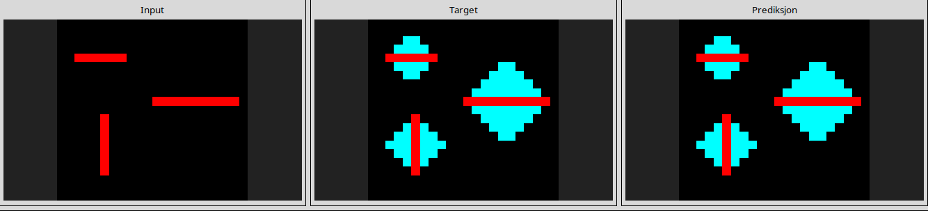
da515329
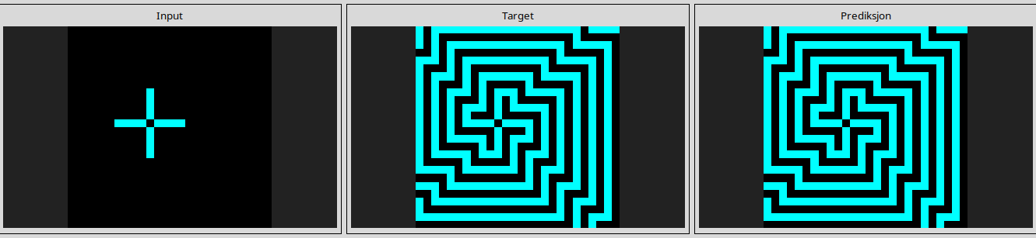
e0fb7511
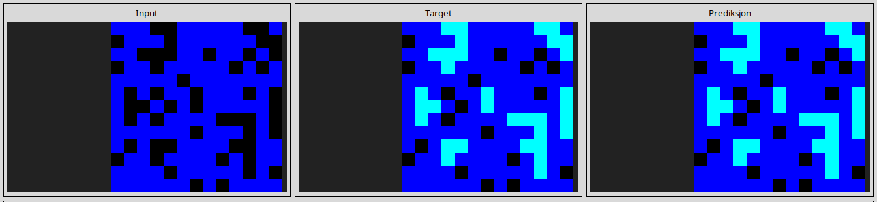
e872b94a
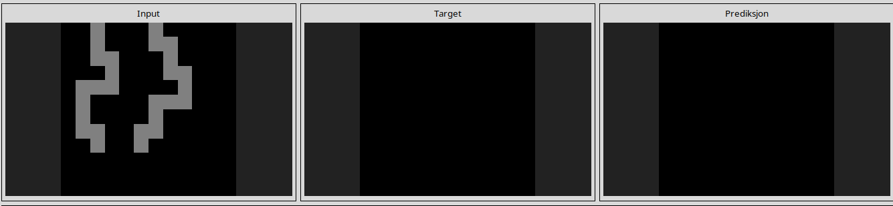
f0df5ff0
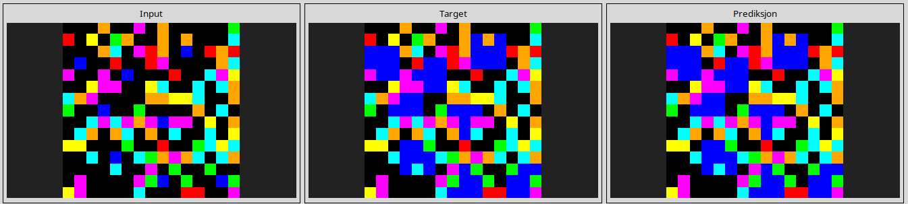

fe9372f3
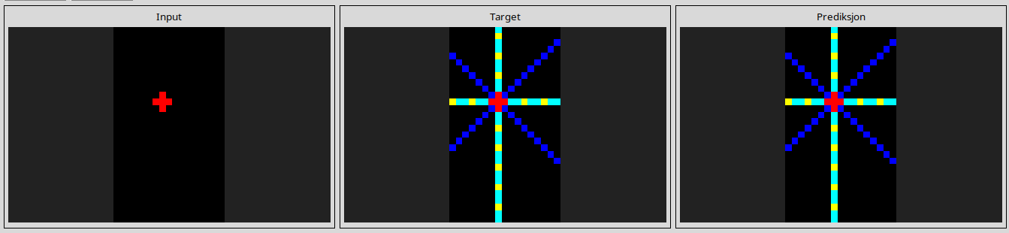
-----------------------------------------------------------------------------------------------------------------------------------------------------------------------------------------------------------------------------------------------
ARC1 Evaluation
Combine NCA=24 solved task

14754a24
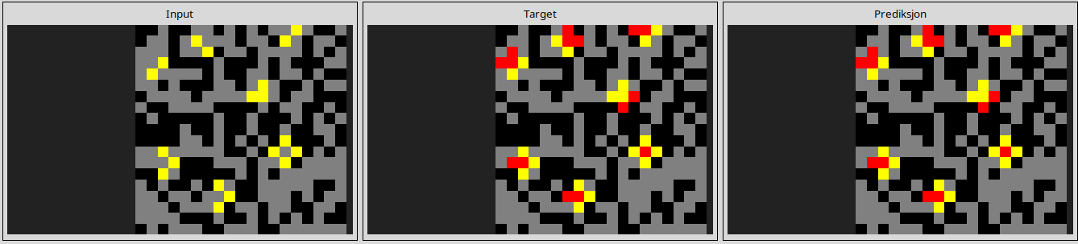
1a2e2828
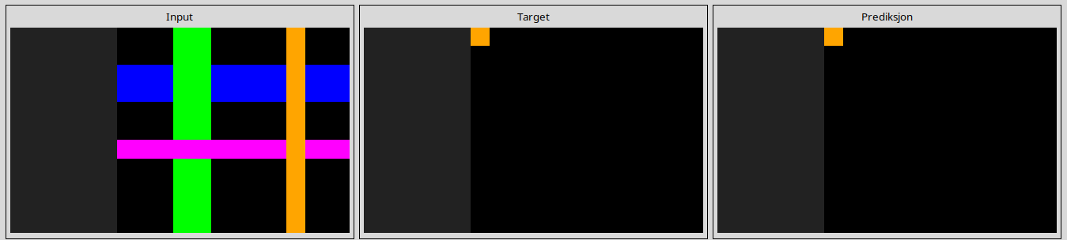
1c0d0a4b
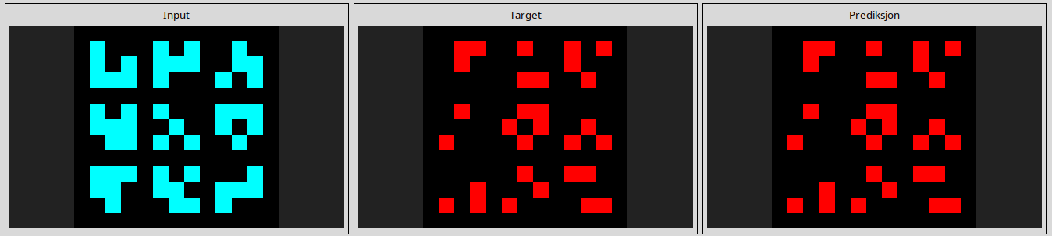
1d398264
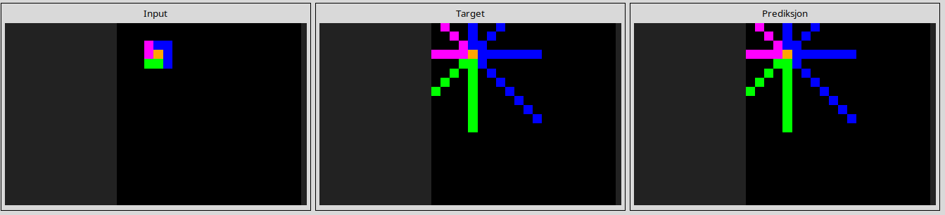
32e9702f
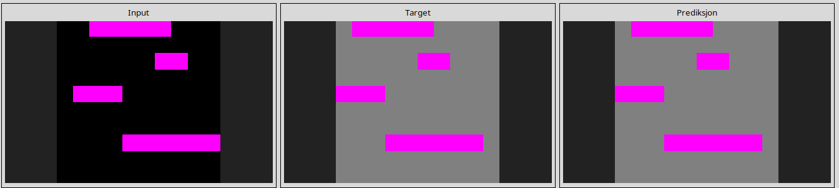
45737921
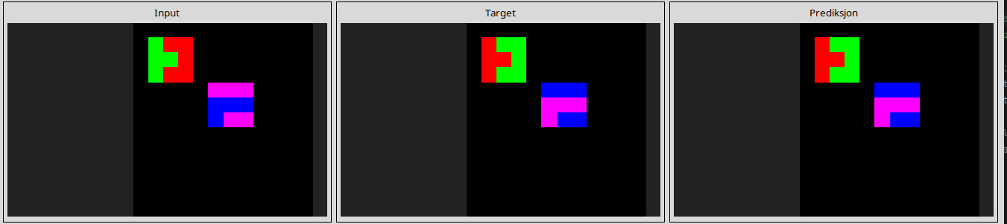
50a16a69
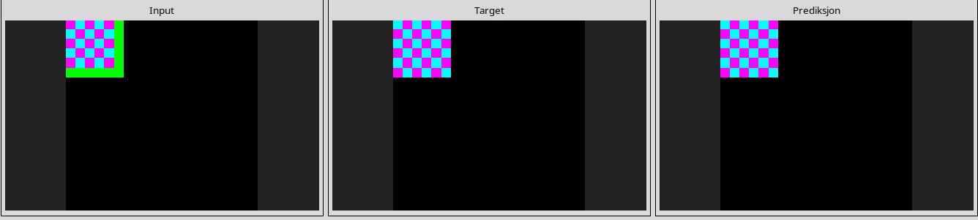
516b51b7
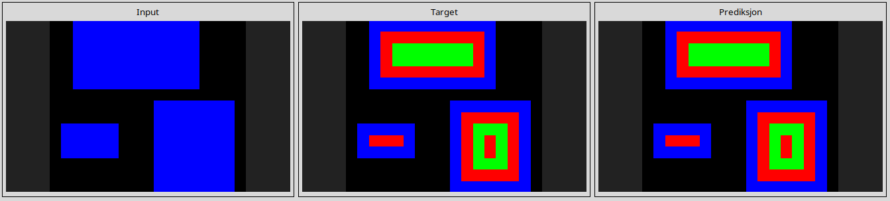
66e6c45b
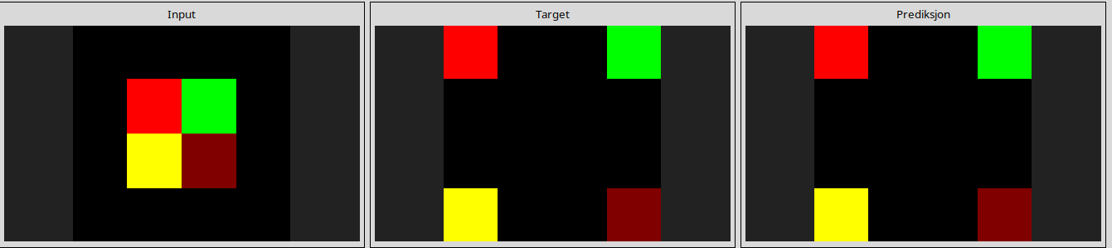
69889d6e
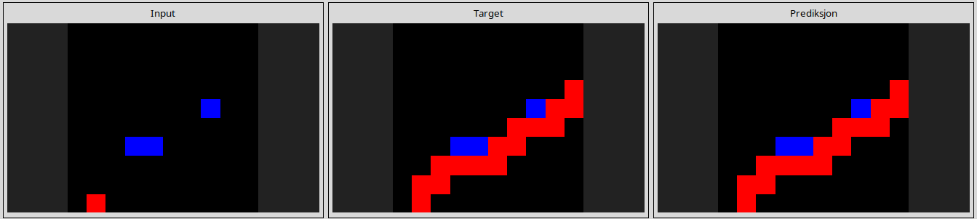
7e02026e
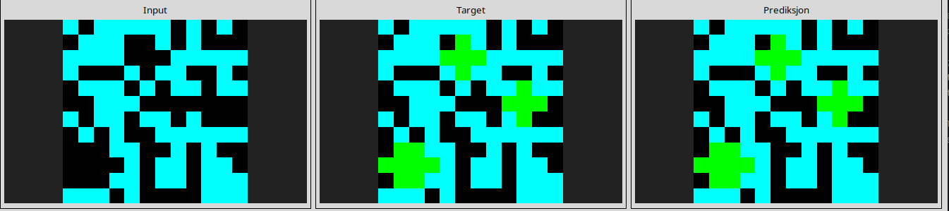
84db8fc4
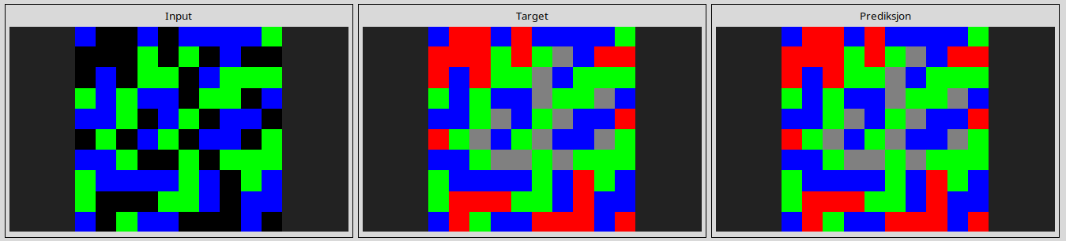
9772c176
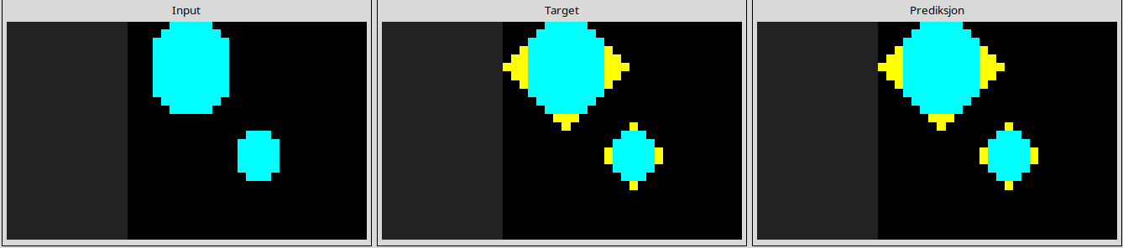
9caba7c3
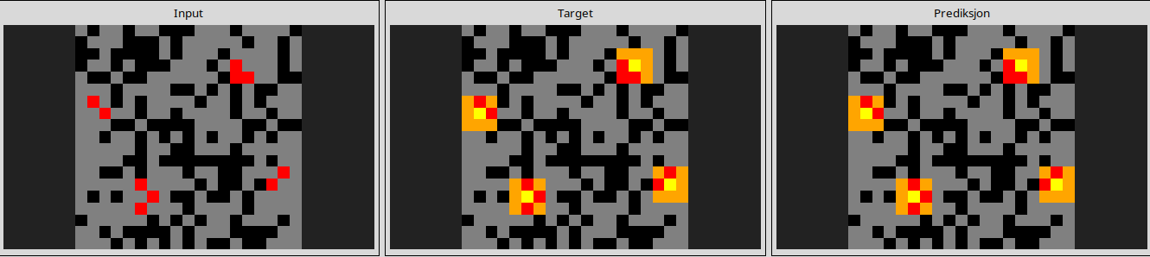
a934301b
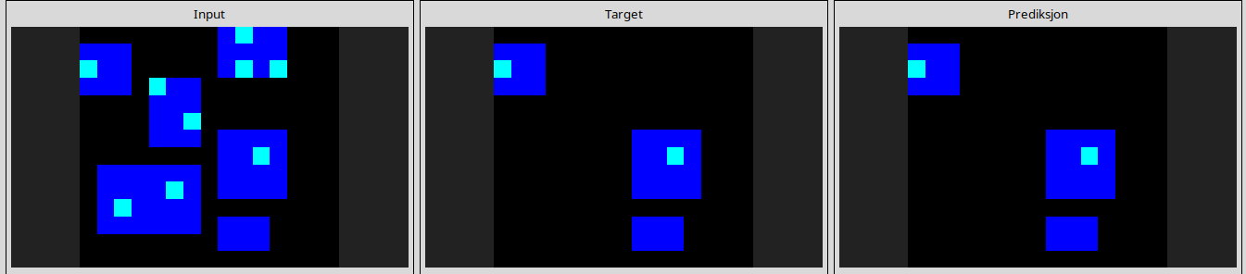
ae58858e
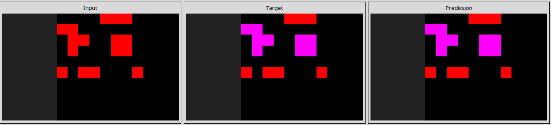
ba9d41b8
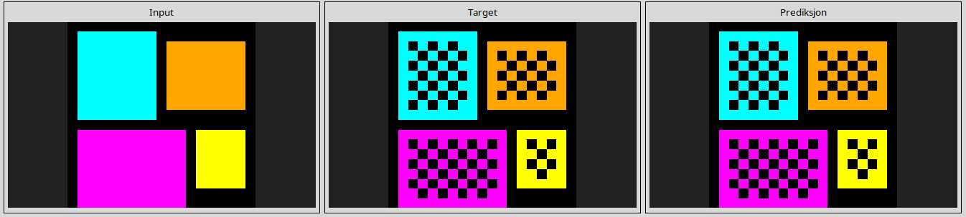
be03b35f
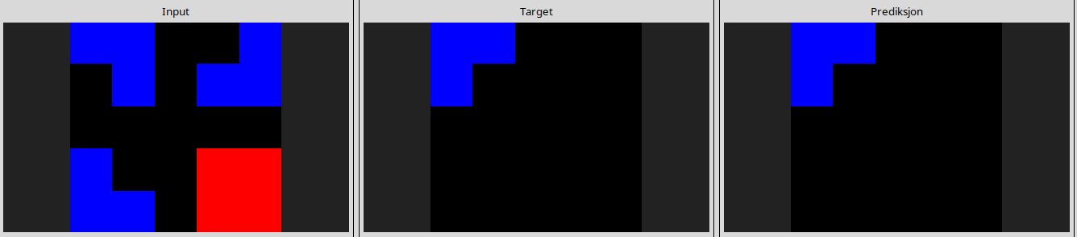
c97c0139
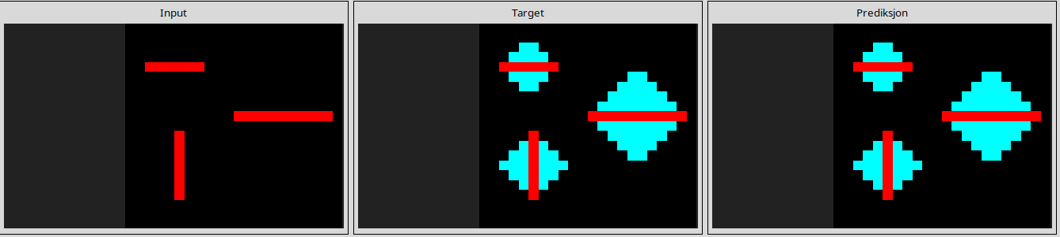
cf133acc
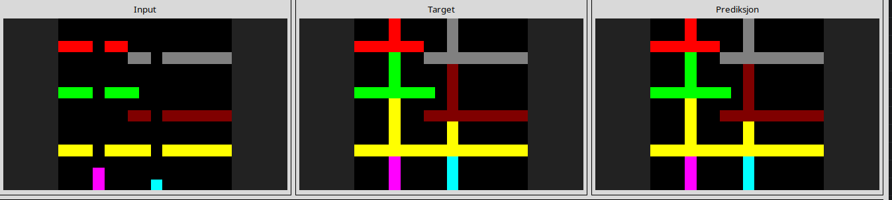
e0fb7511
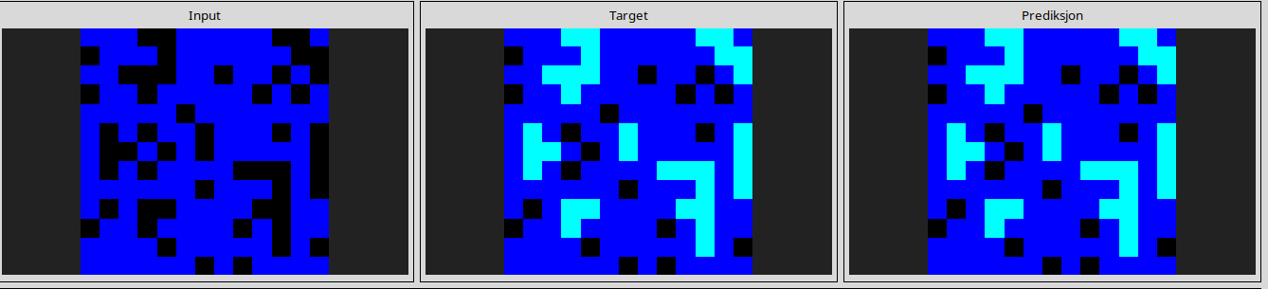
e633a9e5
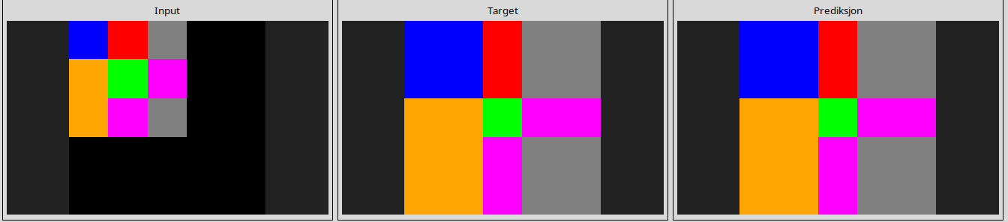
e872b94a
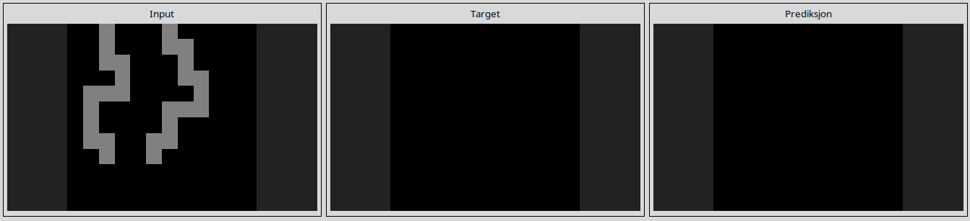
e9ac8c9e
