Color Permutation NCA
7666fa5d
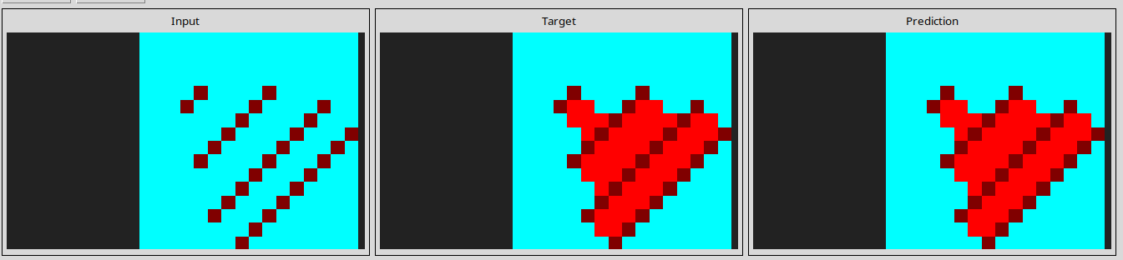
l

Learnable Filter NCA
8f3a5a89
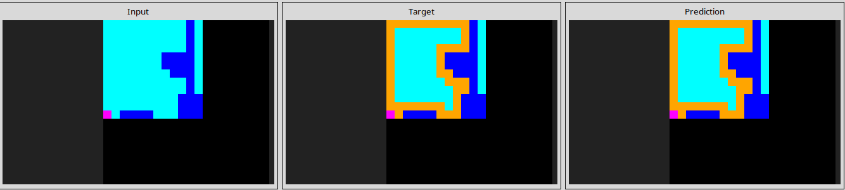
l

71e489b6
Rotating Filter NCA

