ARC_2 Train
Baseline NCA= 1 solved task

5ad8a7c0

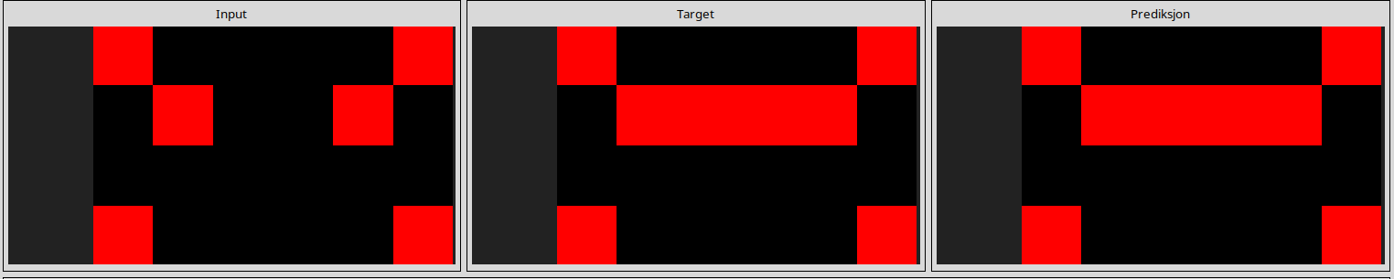
------------------------------------------------------------------------------------------------------------------------------------------------------------------------------------------------------------------------------------------------

Fixed Filter NCA= 1 solved task

af726779
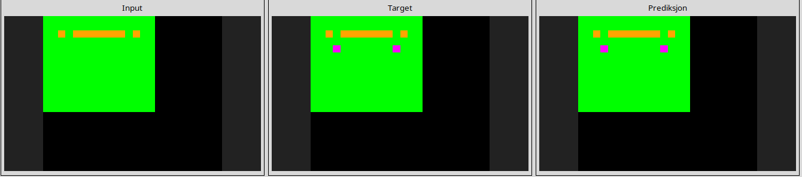
------------------------------------------------------------------------------------------------------------------------------------------------------------------------------------------------------------------------------------------------
Learnable Filter NCA= 1 solved task

af726779
------------------------------------------------------------------------------------------------------------------------------------------------------------------------------------------------------------------------------------------------

Color Permutation NCA= 3 solved tasks
2faf500b
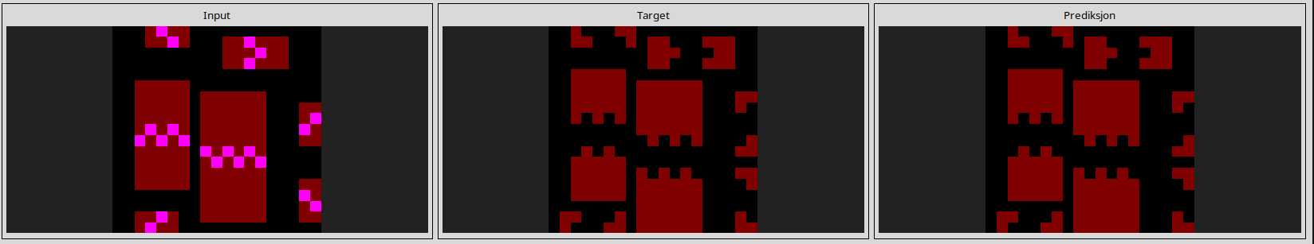
833966f4
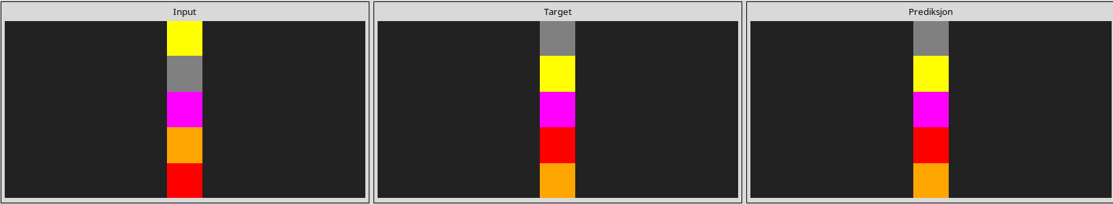
fbf15a0b
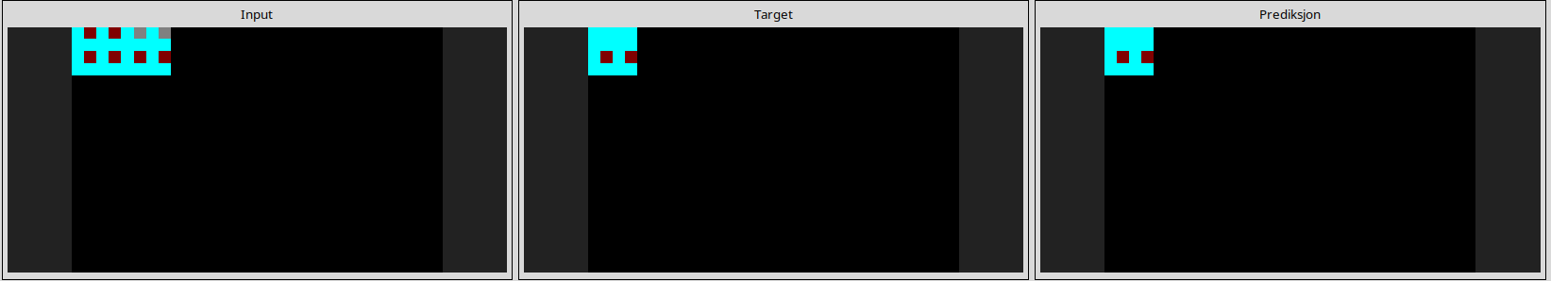
------------------------------------------------------------------------------------------------------------------------------------------------------------------------------------------------------------------------------------------------
Rotating Filter NCA= 6 solved tasks

182e5d0f
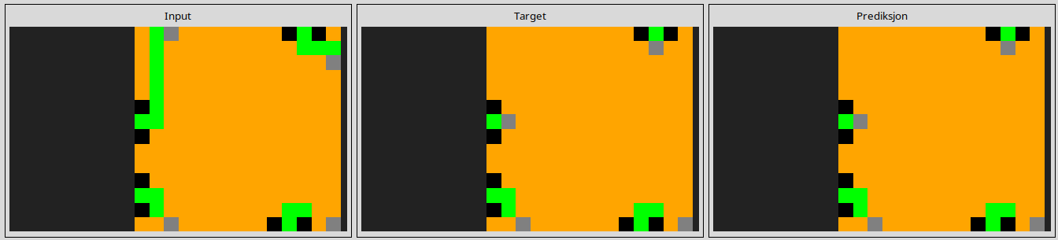
6ffe8f07
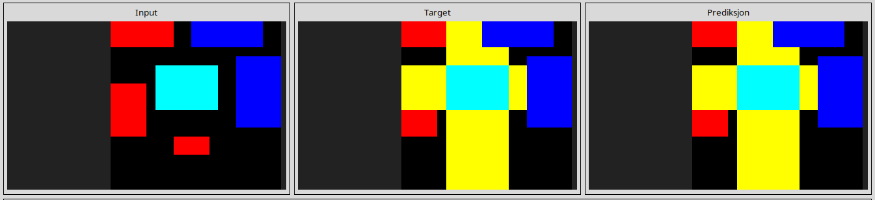
ad38a9d0
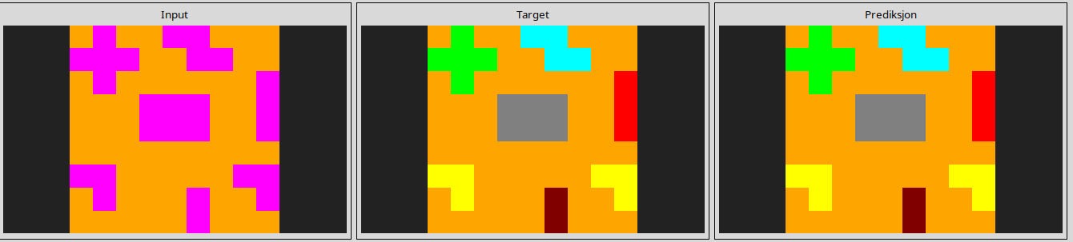
af726779
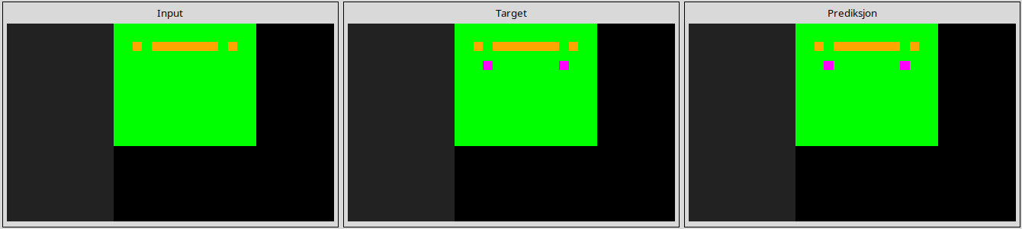
cc9053aa
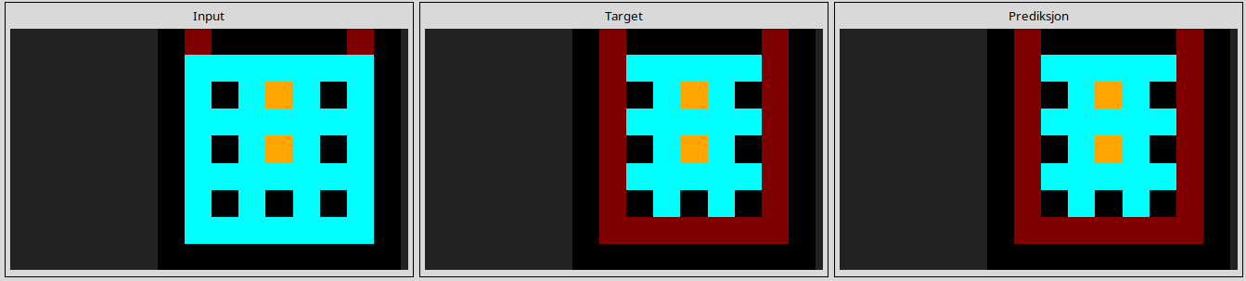
d753a70b
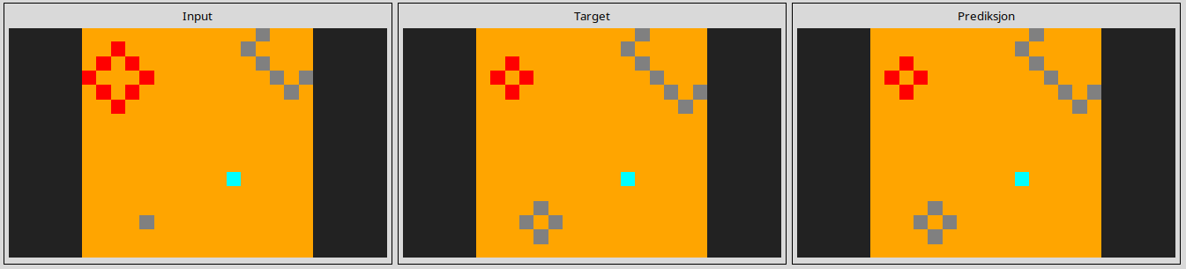
------------------------------------------------------------------------------------------------------------------------------------------------------------------------------------------------------------------------------------------------

= 5 solved tasks
2faf500b
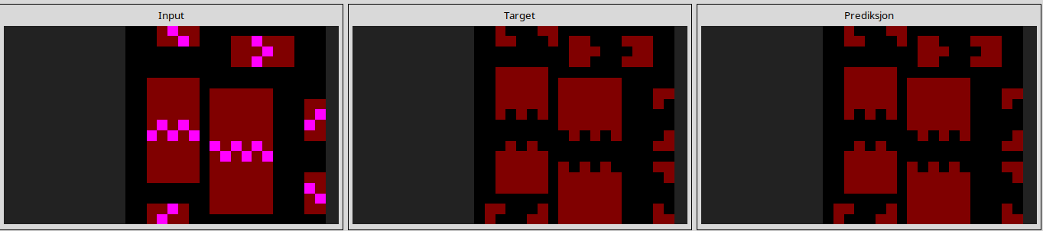
37ce87bb
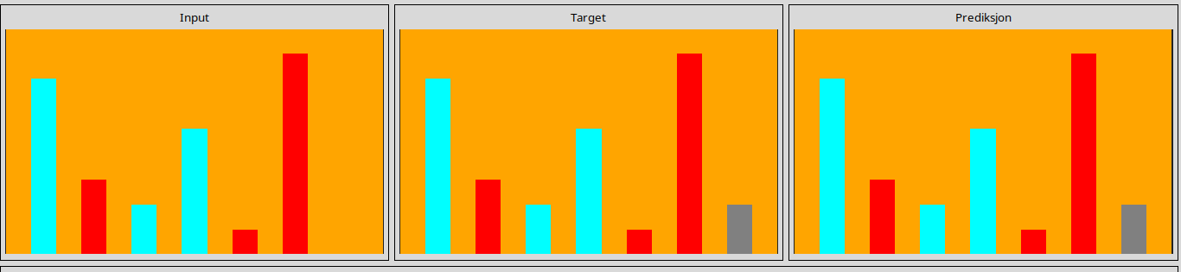
833966f4
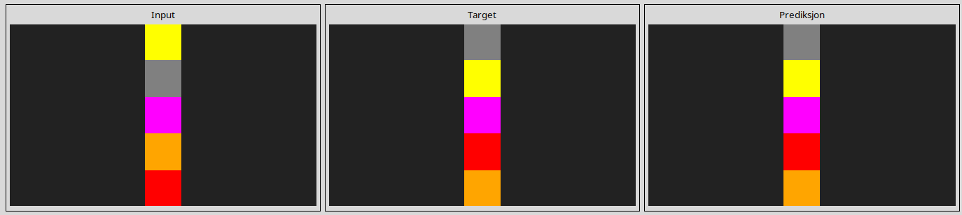
9f5f939b
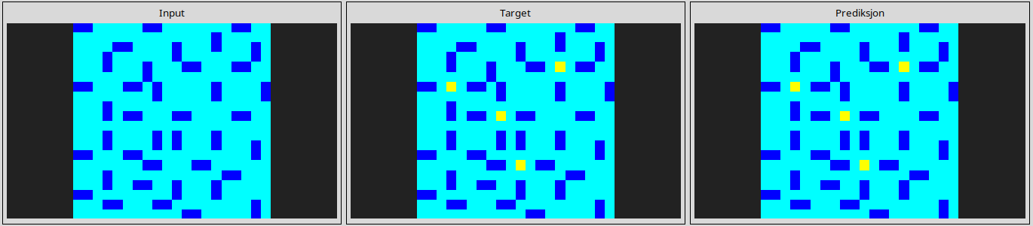
cc9053aa
