ARC1 Train
Baseline NCA= 32 solved tasks

0ca9ddb6
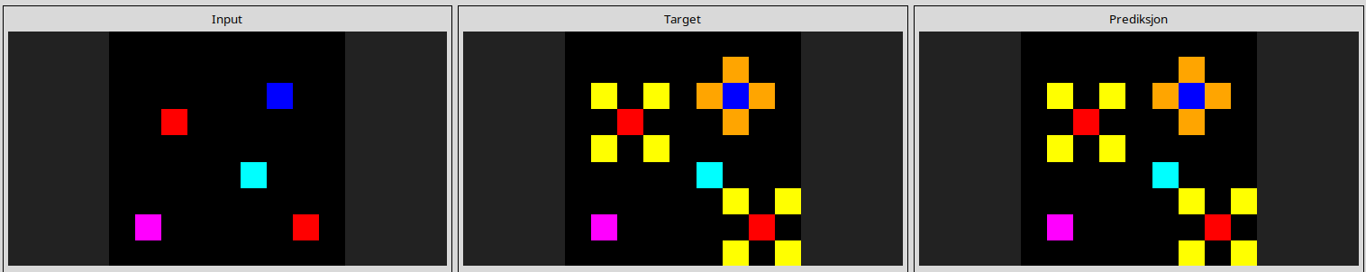
28e73c20
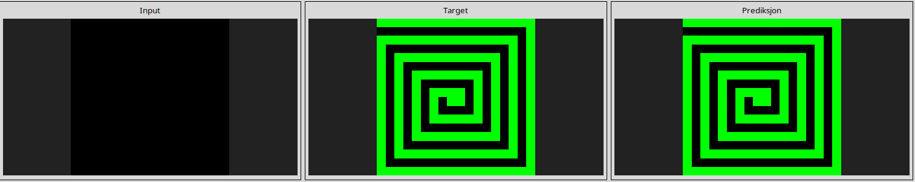
2dee498d
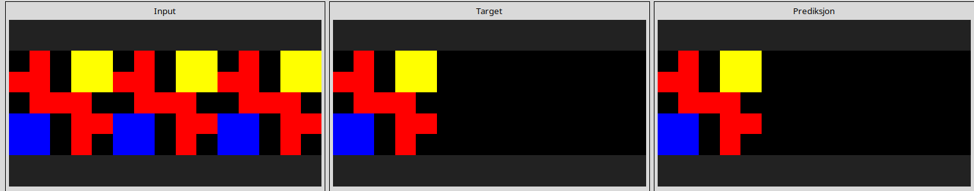
32597951
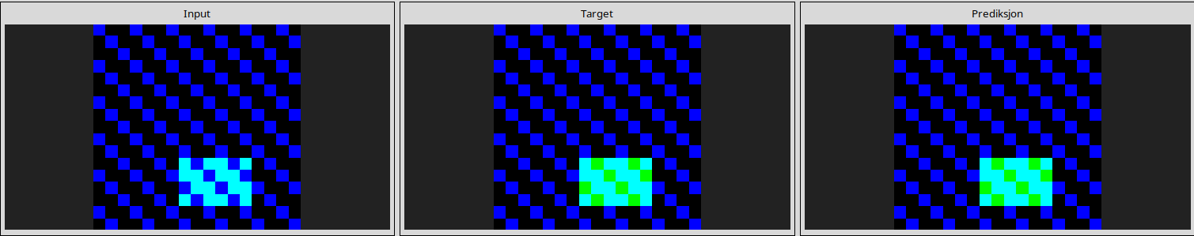
4258a5f9
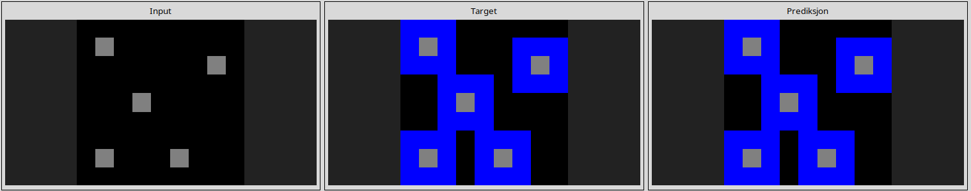
44f52bb0
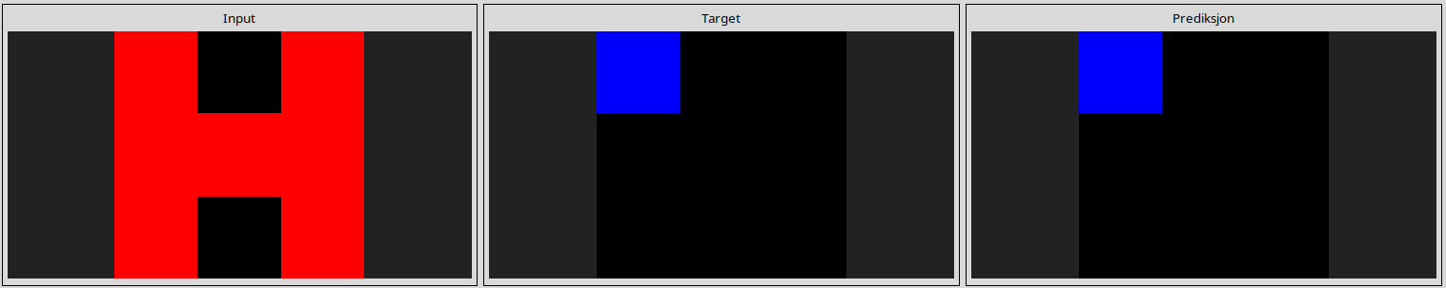
50cb2852
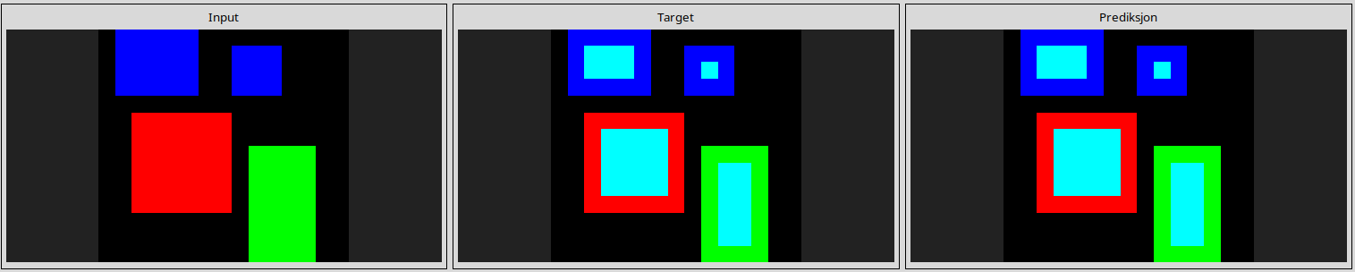
5168d44c
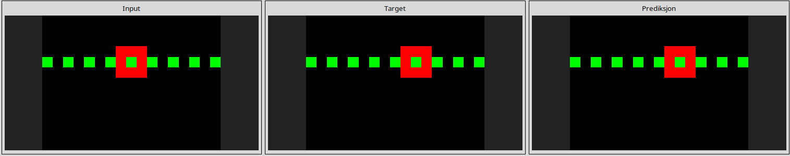
54d9e175
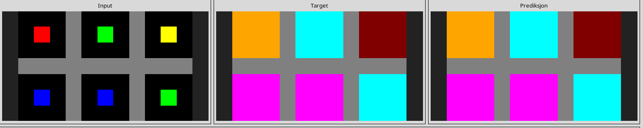
5c0a986e
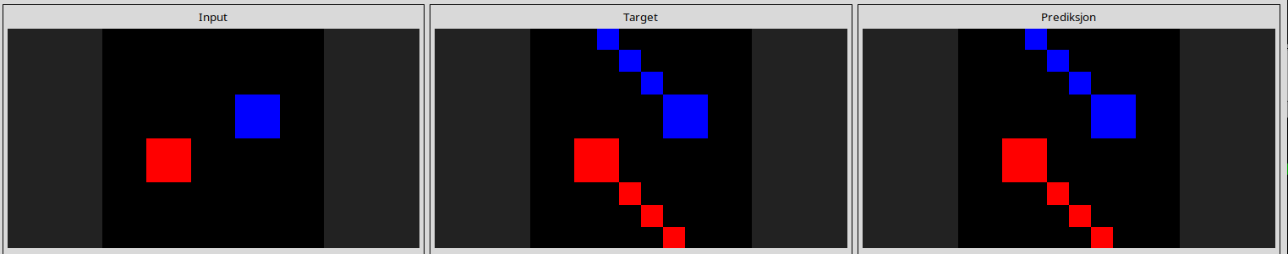
662c240a
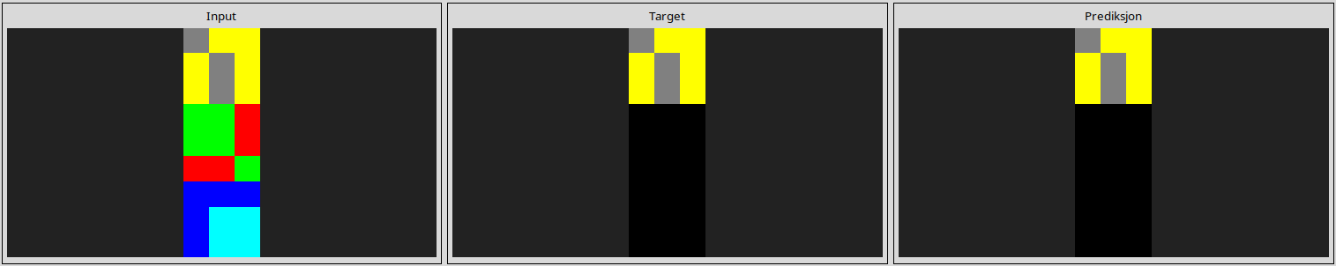
67385a82
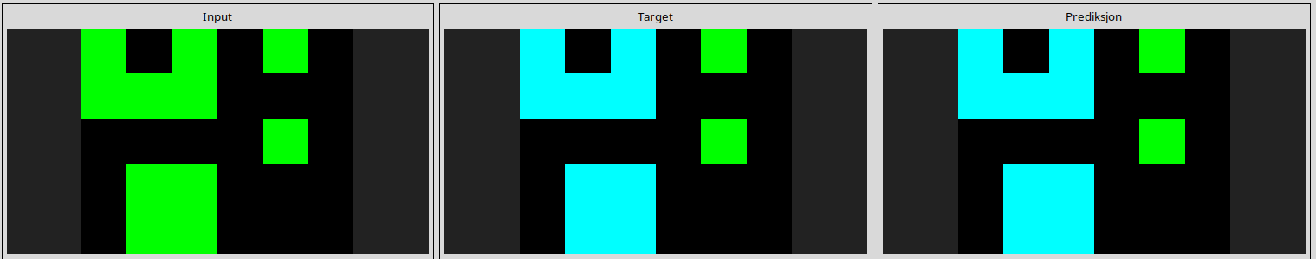
6c434453
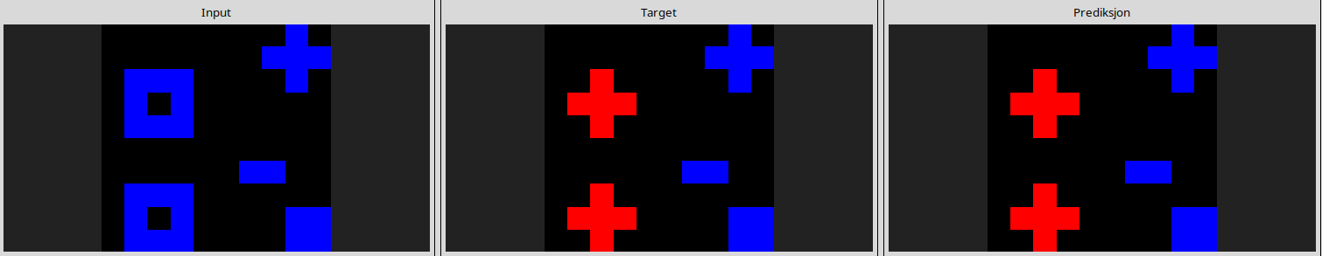
6f8cd79b
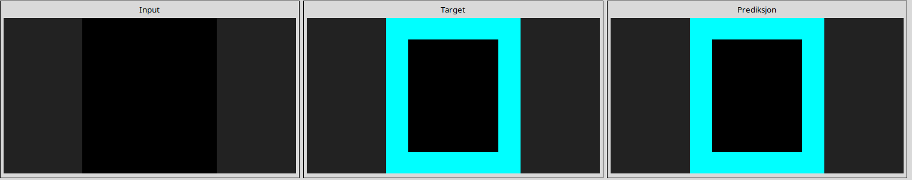
7b7f7511
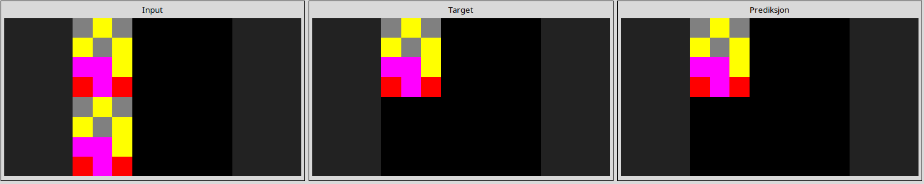
913fb3ed
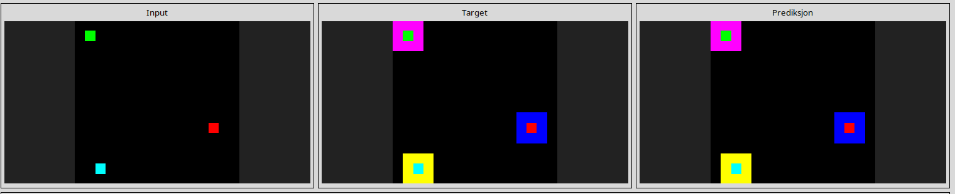
95990924
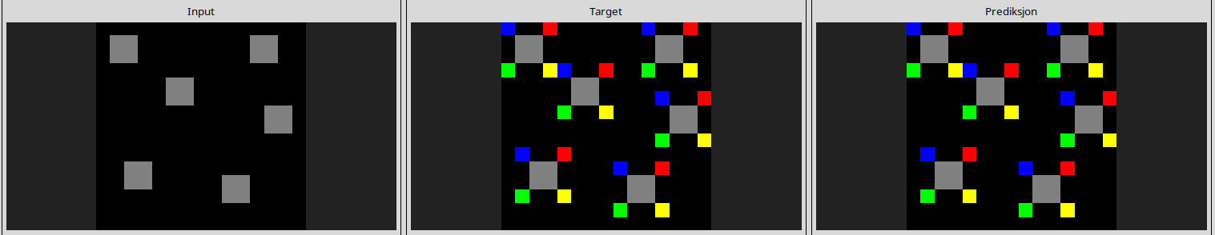
a65b410d
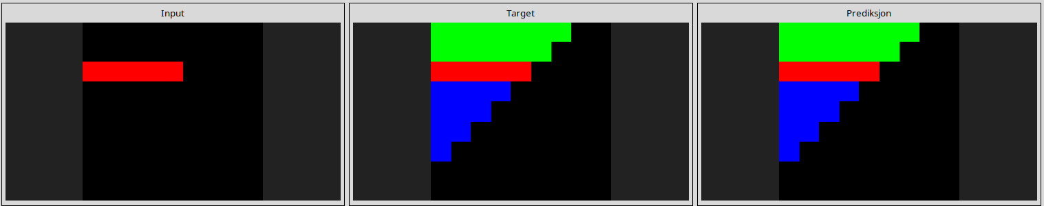
a9f96cdd
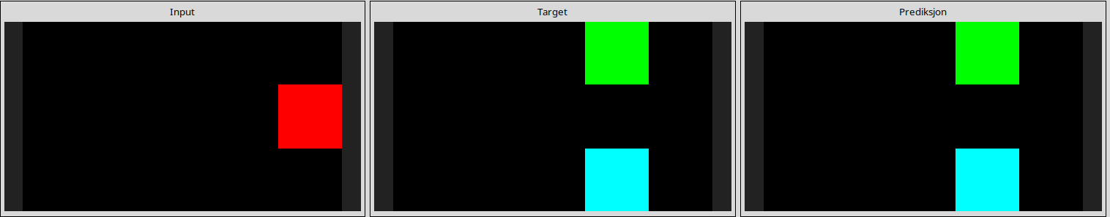
b1948b0a
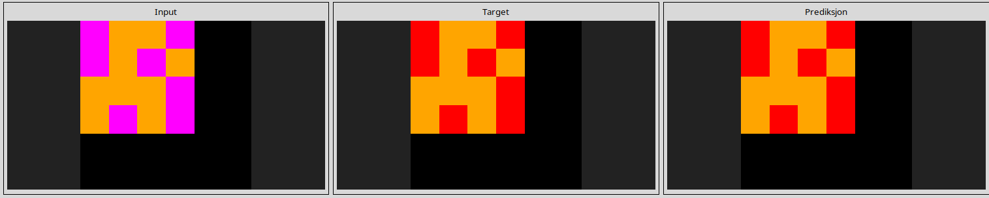
b60334d2
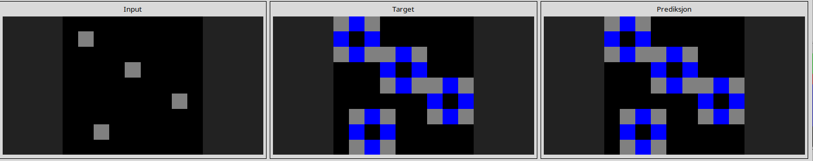
b6afb2da
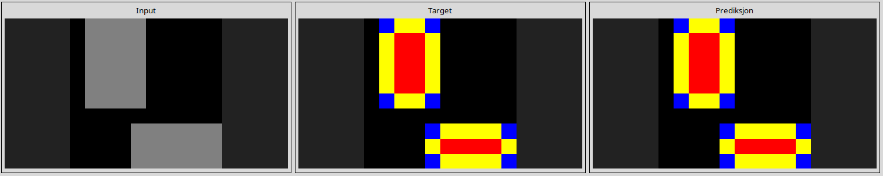
ba26e723
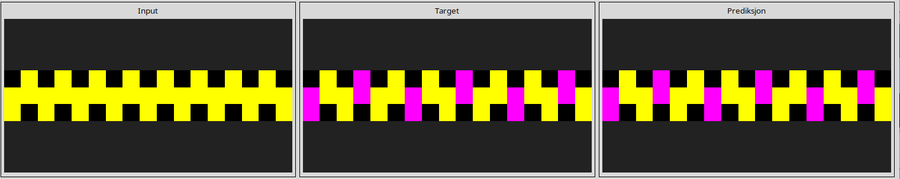
bb43febb
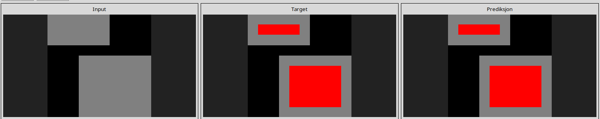
c0f76784
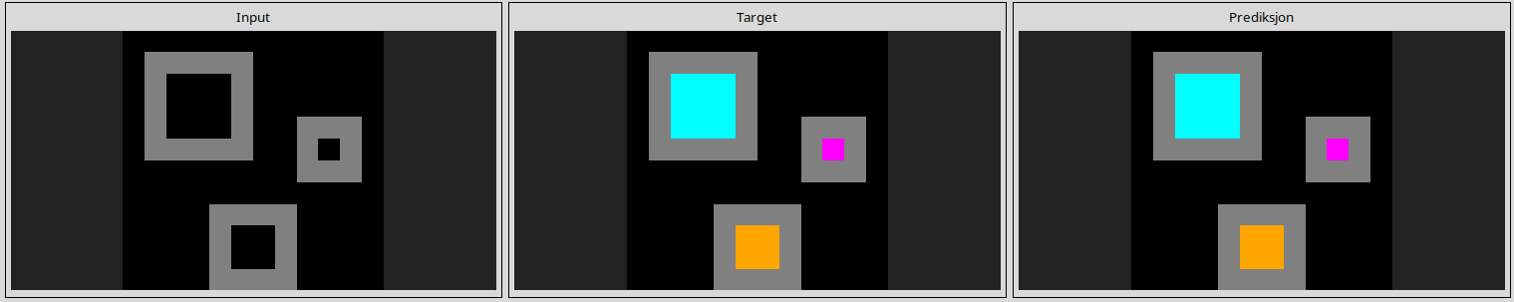
c8f0f002
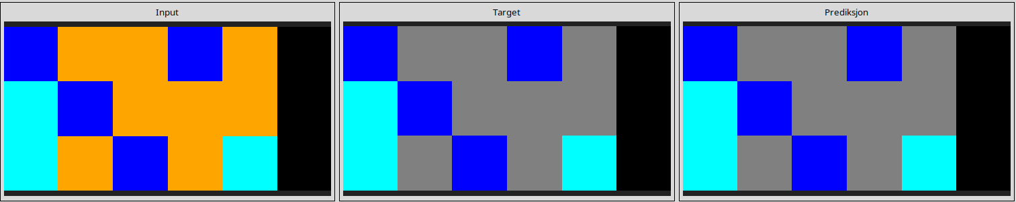
ce22a75a
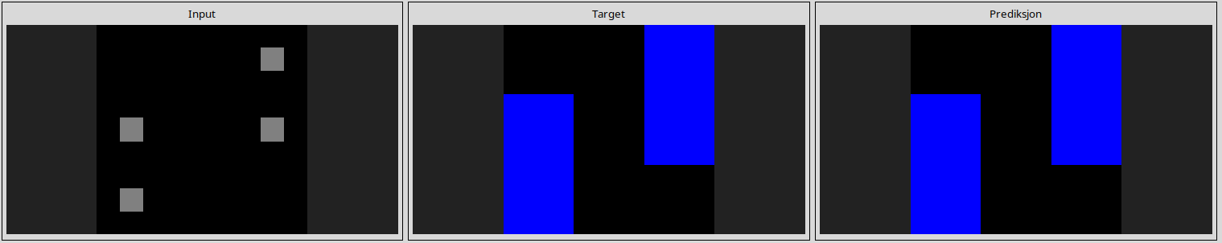
d06dbe63
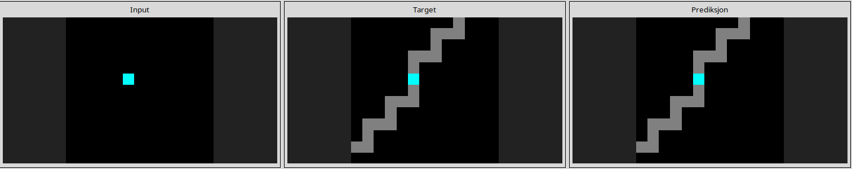
d10ecb37
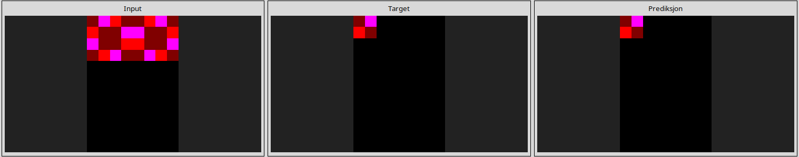
d364b489
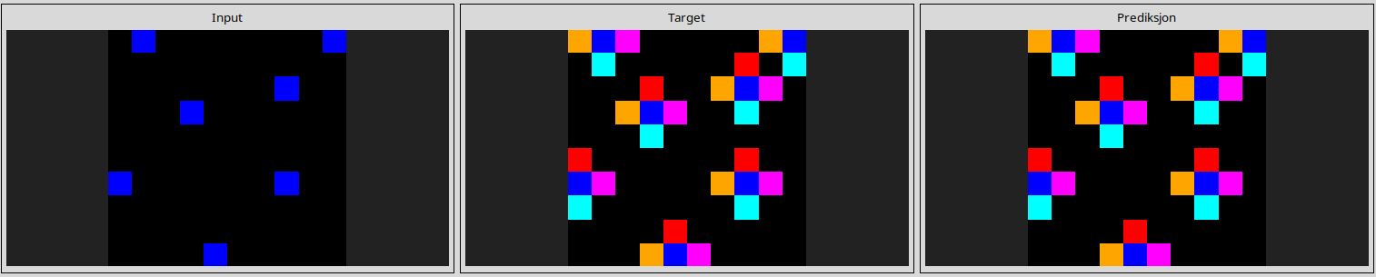
dc433765
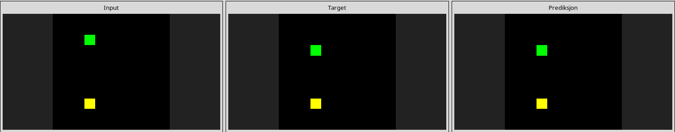
de1cd16c
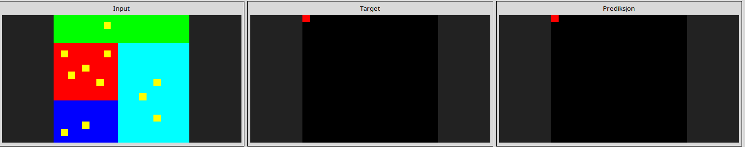
------------------------------------------------------------------------------------------------------------------------
------------------------------------------------------------------------------------------------------------------------
Almost solved task

3aa6fb7a
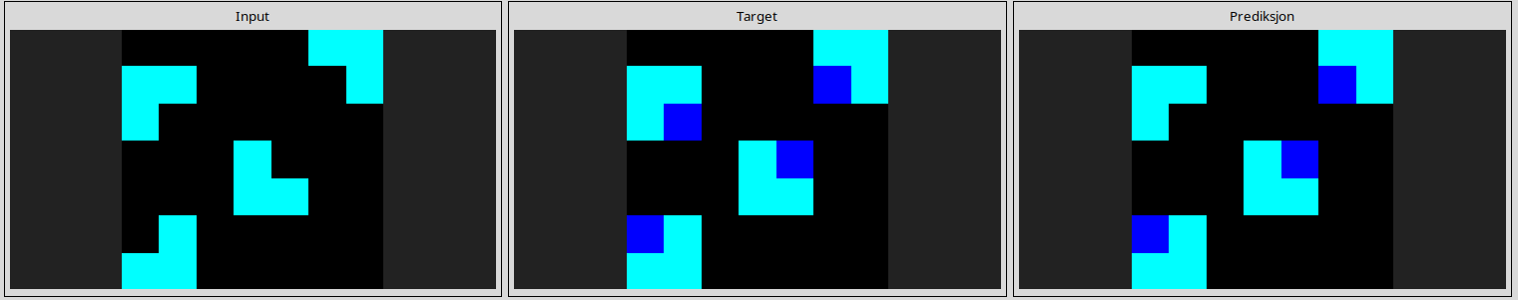
3bdb4ada
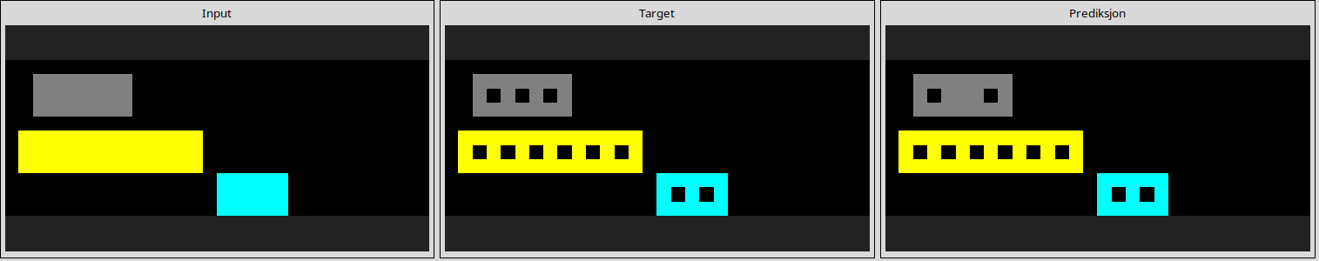
3bd67248
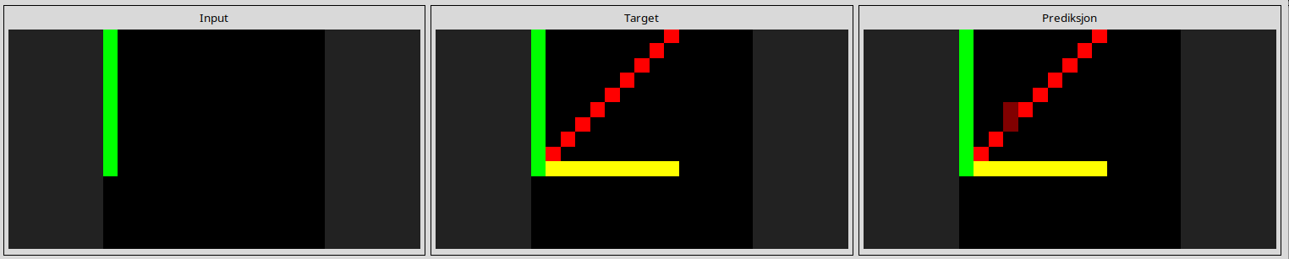
3f7978a0
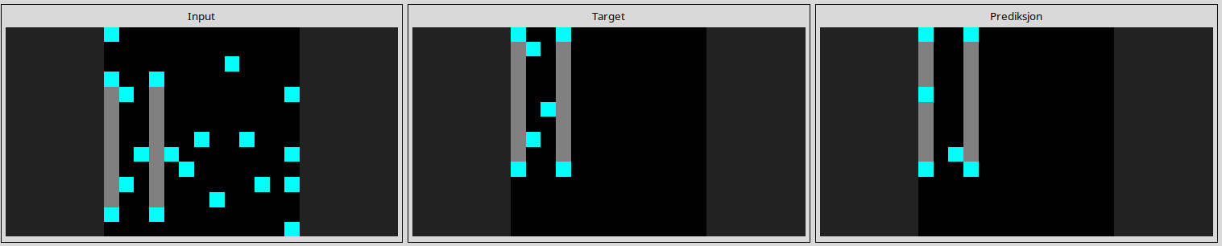
l
8d510a79
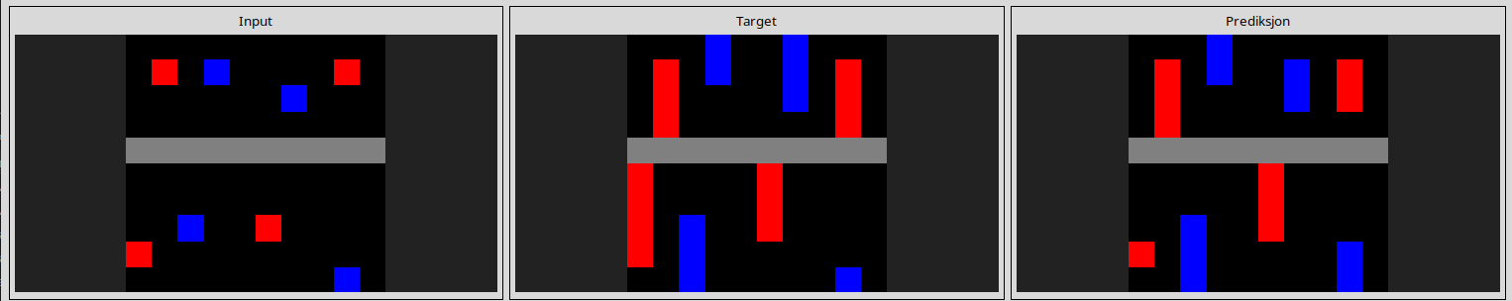
25d8a9c8
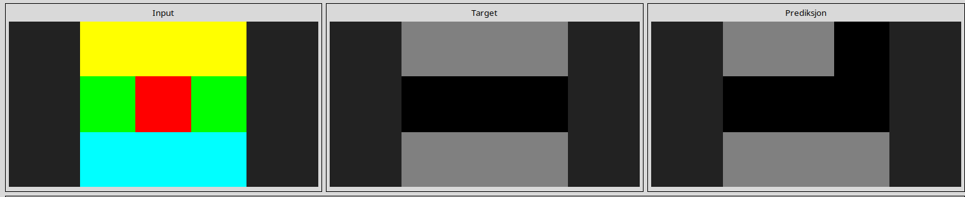
25ff71a9
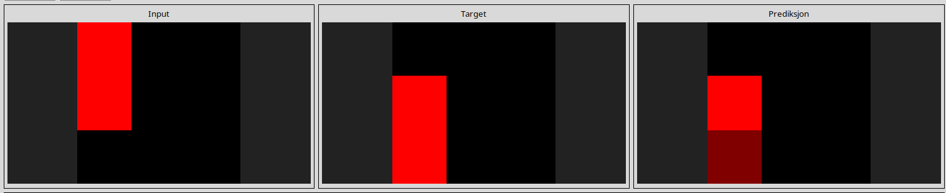
41e4d17e
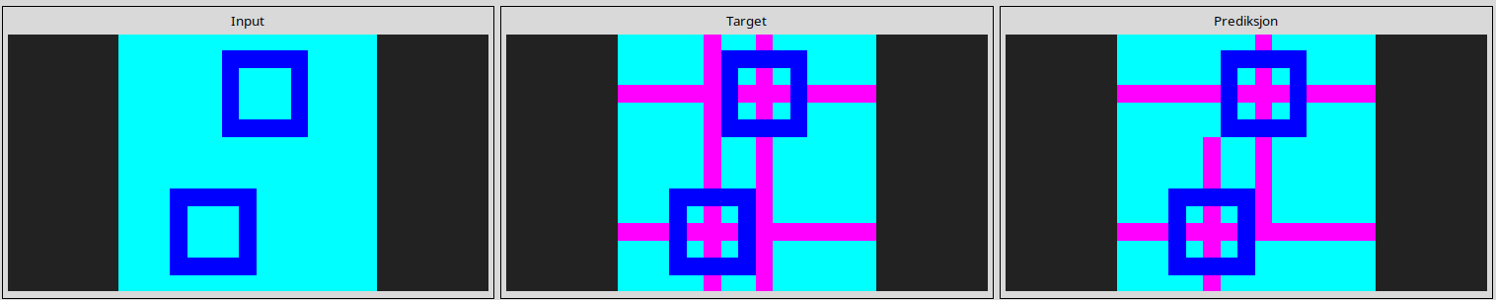
445eab21
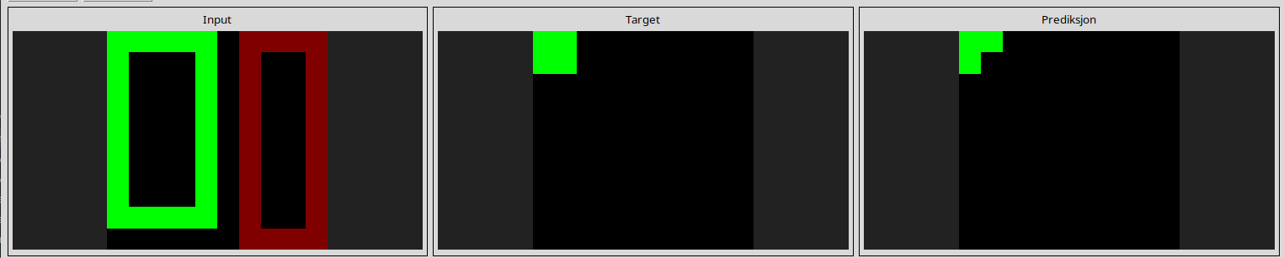
253bf280
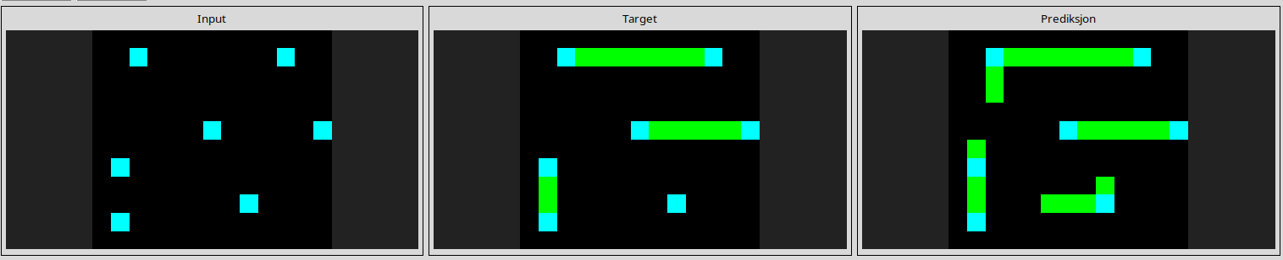
543a7ed5
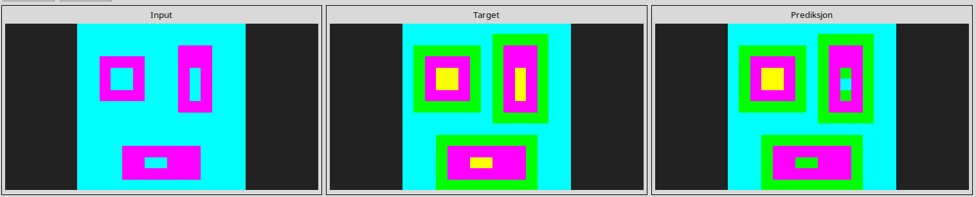
673ef223
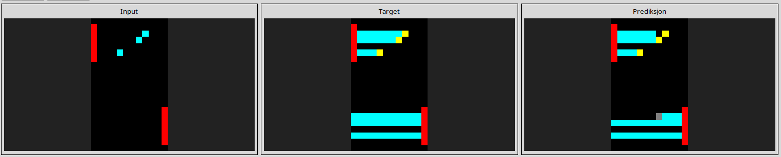

868de0fa
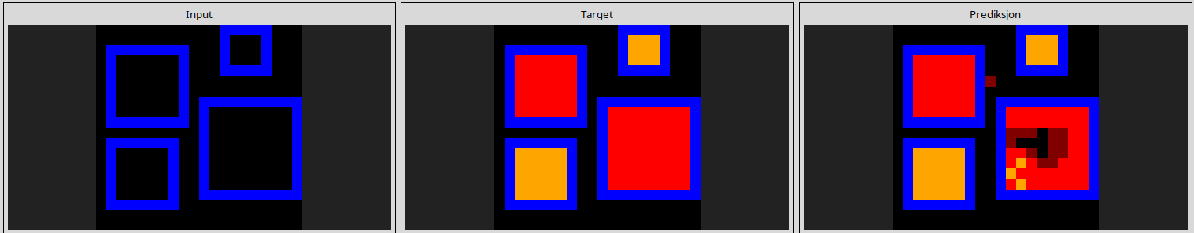

3618c87e
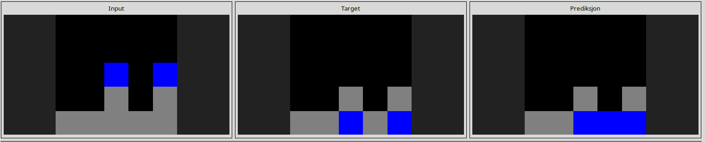
4612dd53
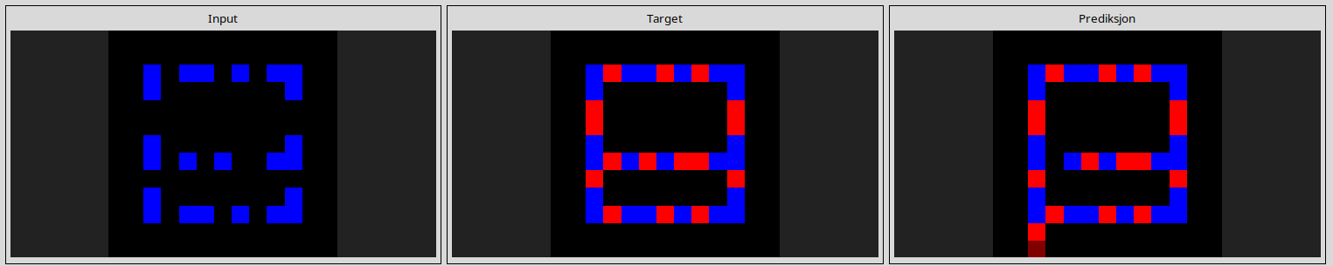
7447852a

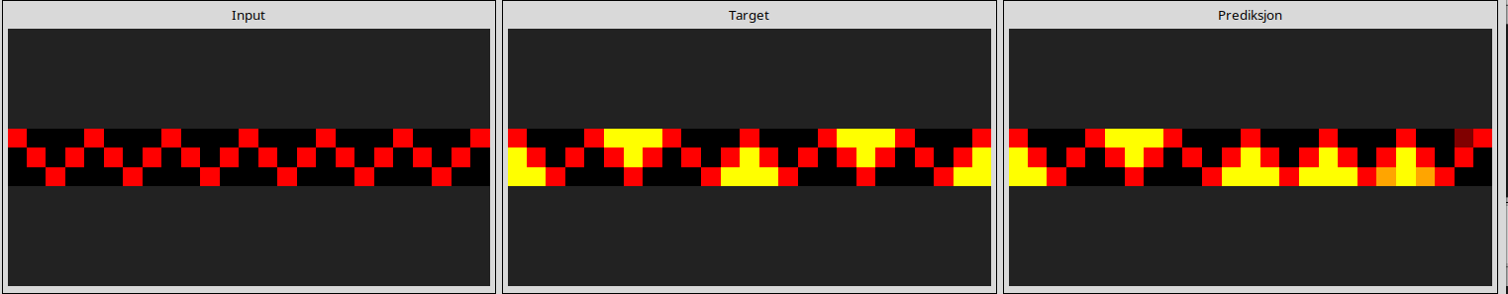
a8d7556c
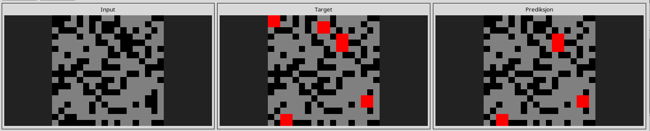
a85d4709
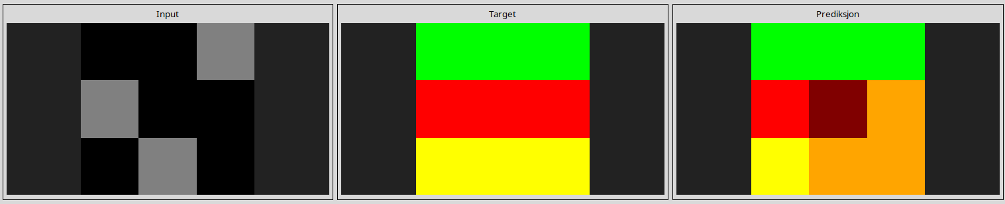
a699fb00
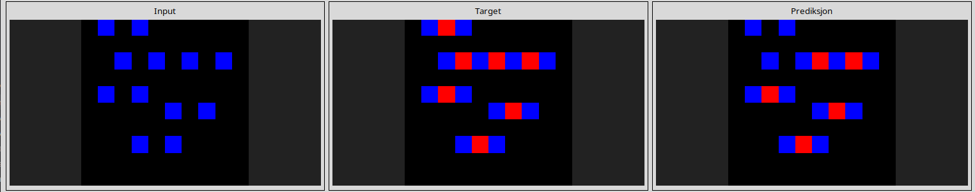
a5313dff
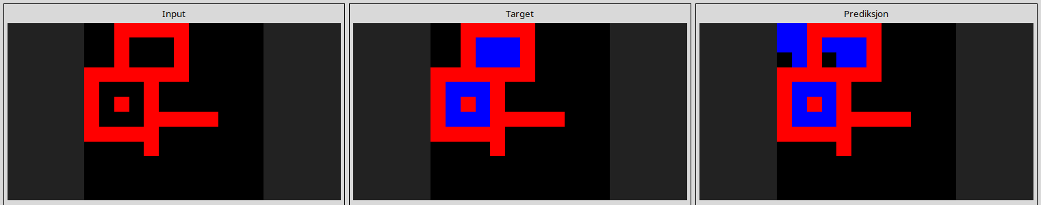
l
a79310a0
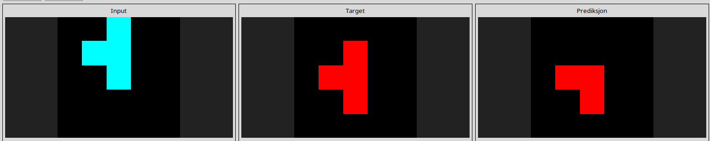
fcc82909
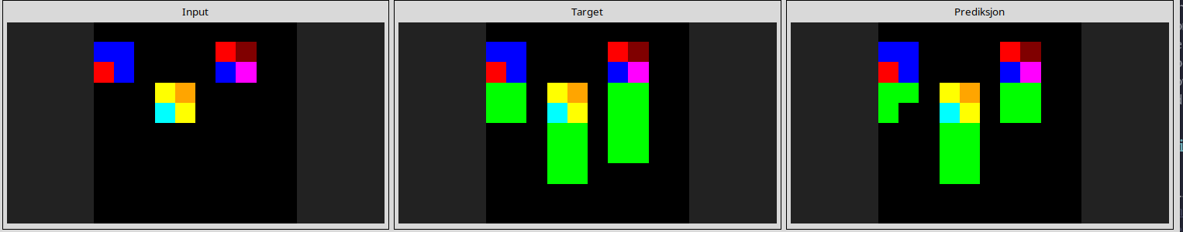
l
f2829549
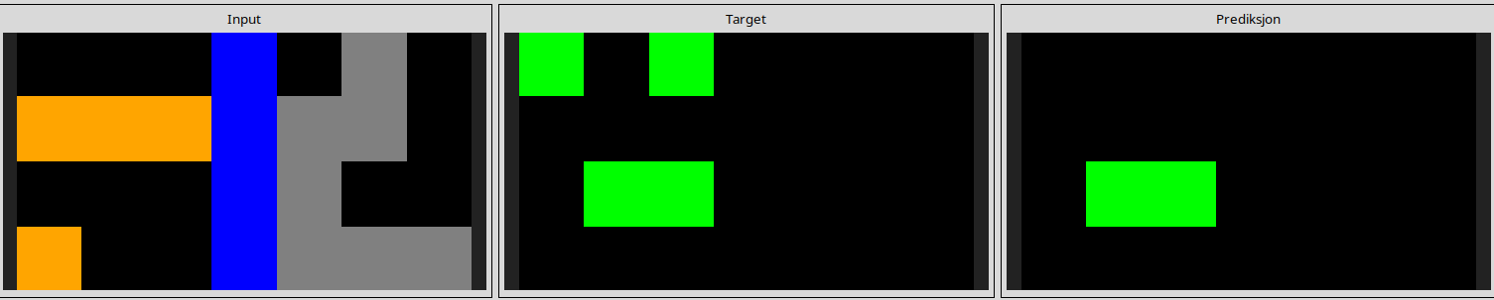
l
e73095fd
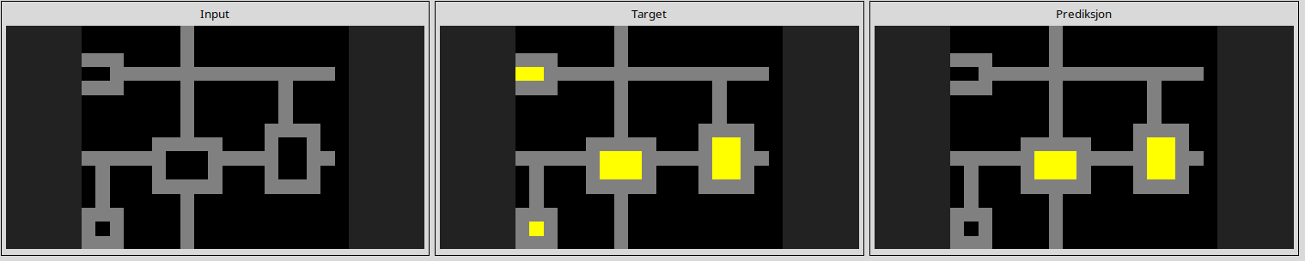
d4469b4b
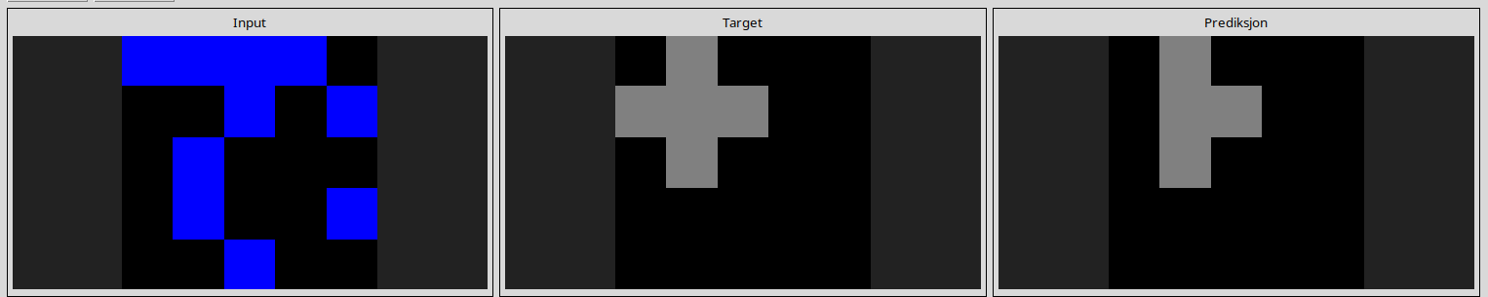
d90796e8
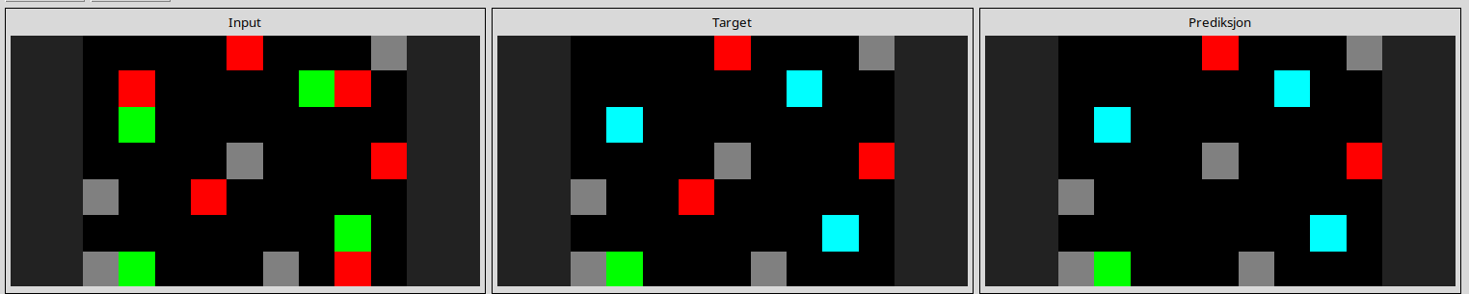
d406998b
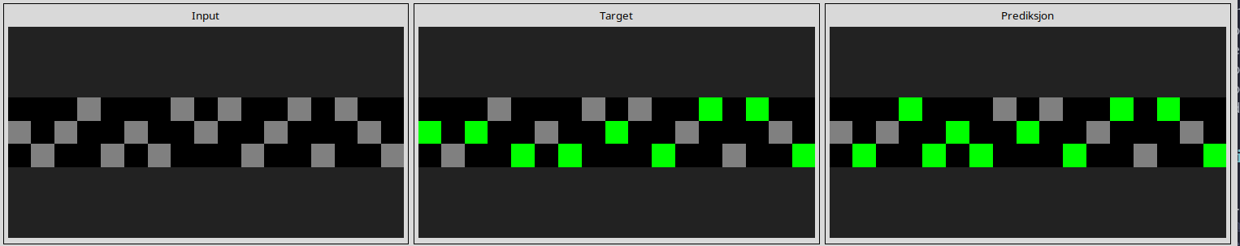

dae9d2b5
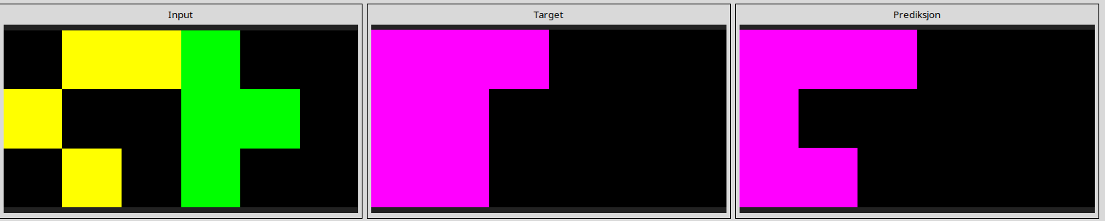
l
db3e9e38
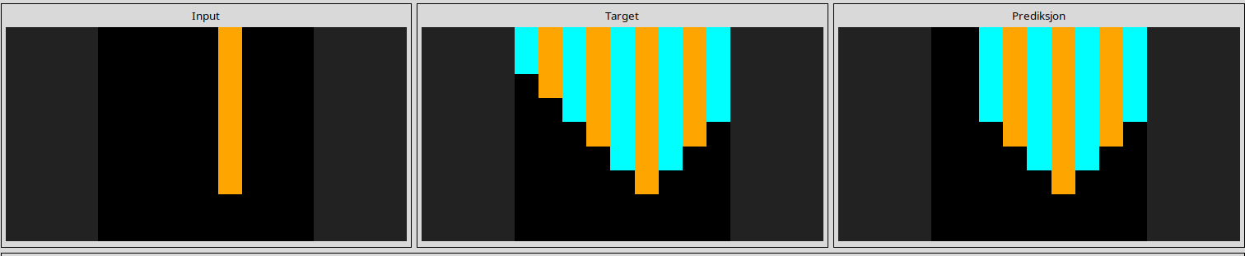
bbc9ae5d
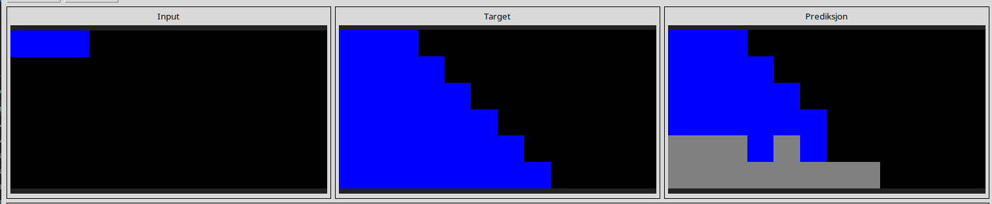
------------------------------------------------------------------------------------------------------------------------
Reasoning pitfall
623ea044

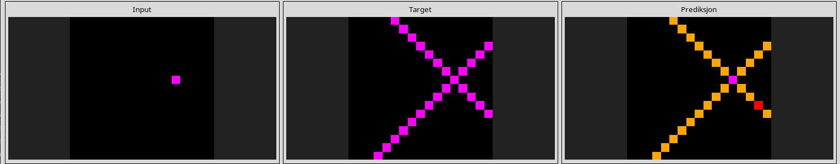
l
694f12f3
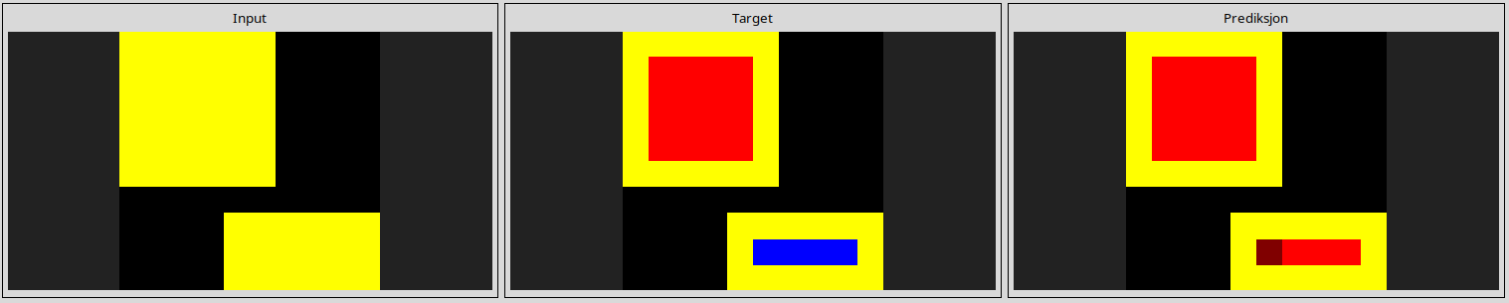
941d9a10
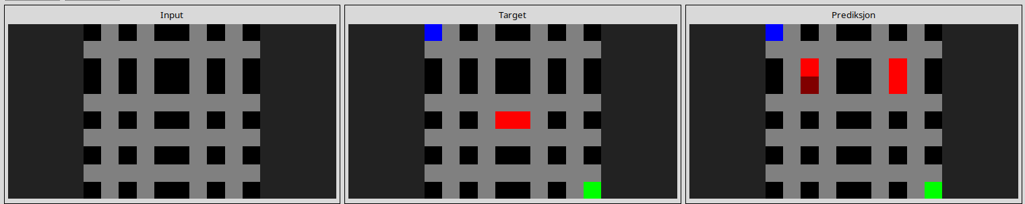
0962bcdd

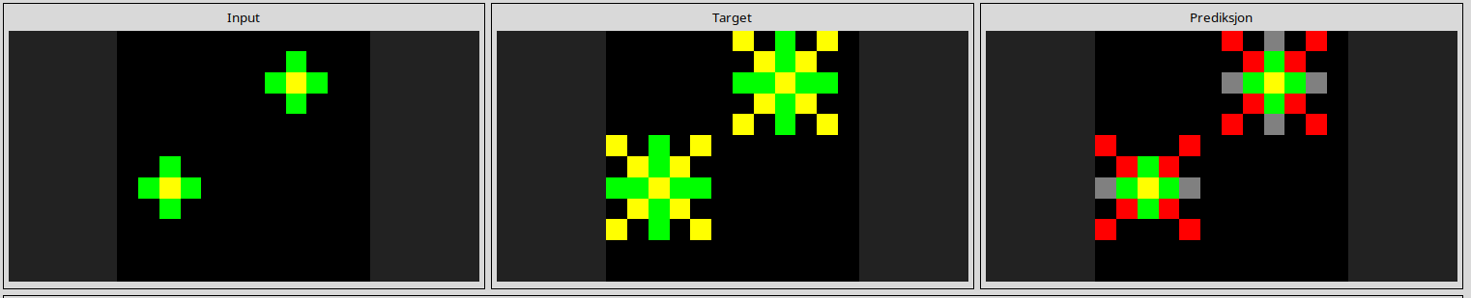
l
4347f46a
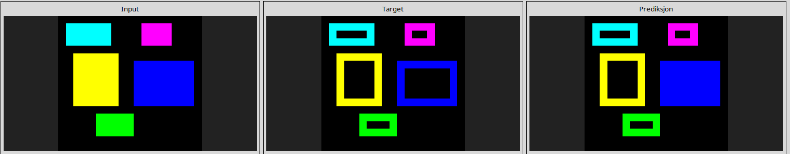
444801d8

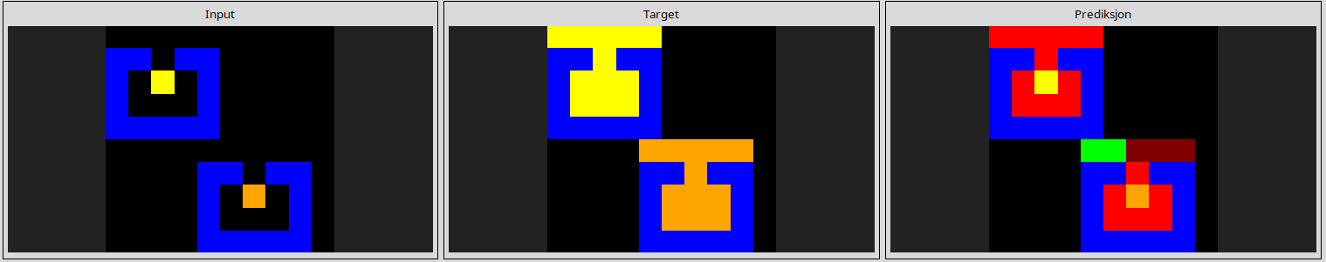
l
8403a5d5
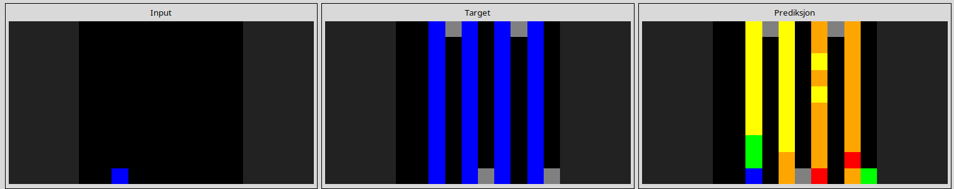
363442ee
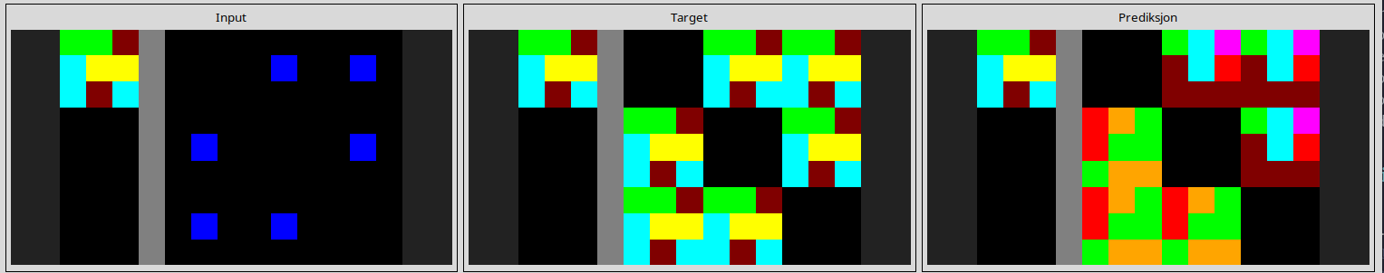
890034e9
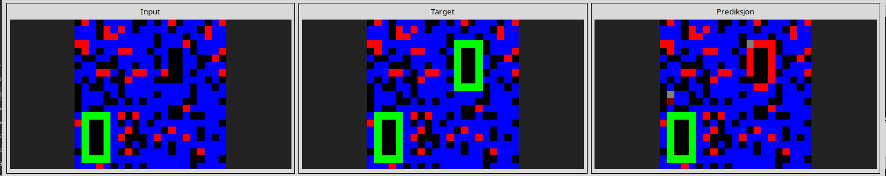
l
d631b094
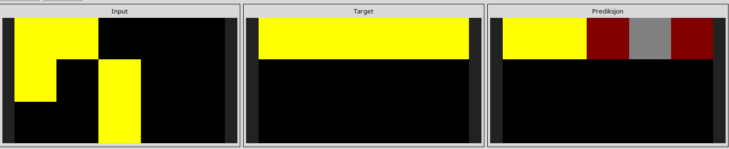
l
db93a21d
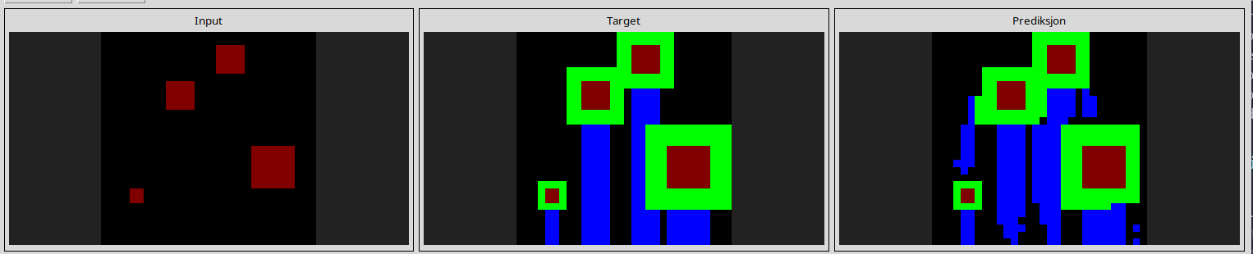
d4f3cd78

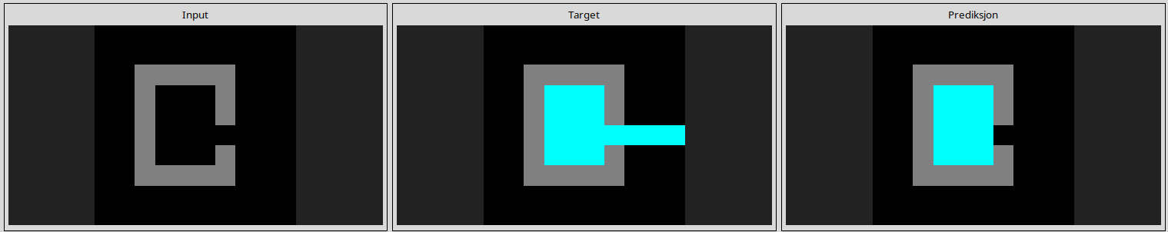
bc1d5164
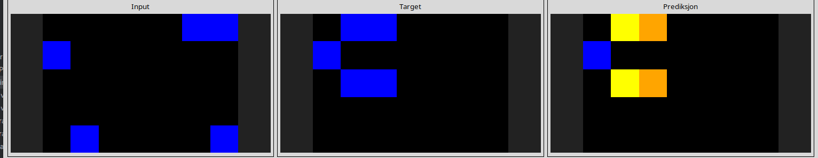
l
810b9b61
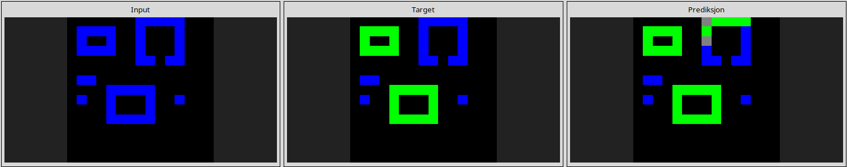
l
1190e5a7
