ARC1 Train
Fixed Filter NCA=44 solved task

0d3d703e
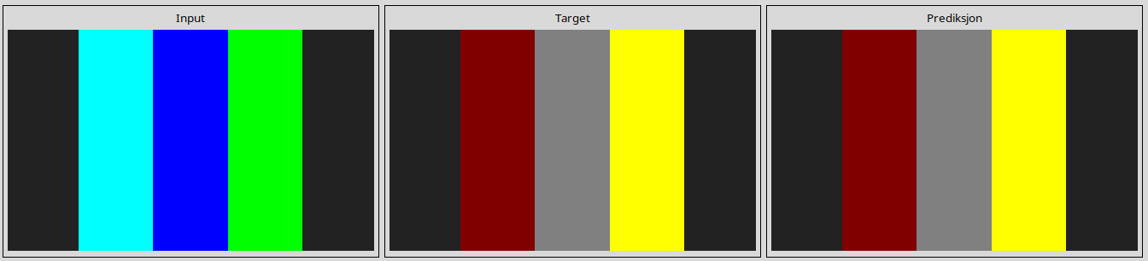
25d8a9c8
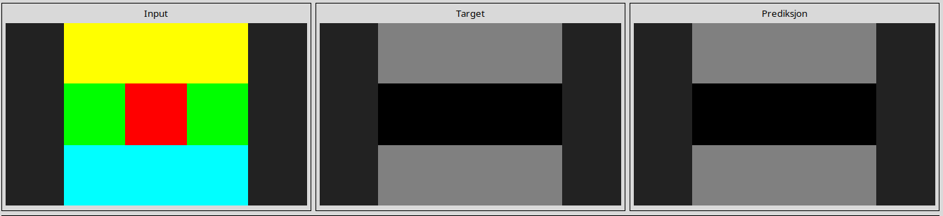
28e73c20
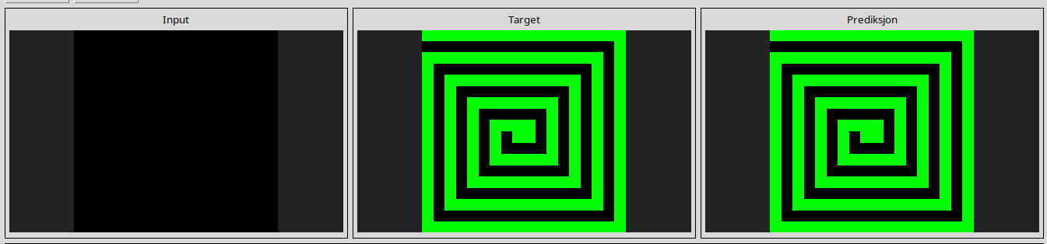
2dee498d
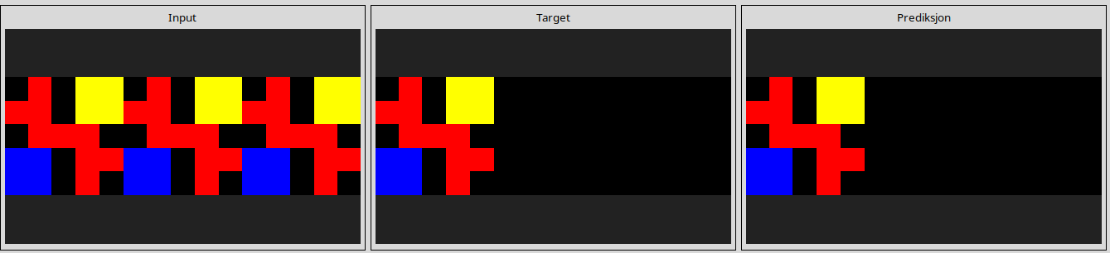
32597951
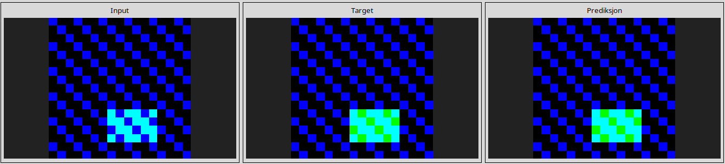
3618c87e
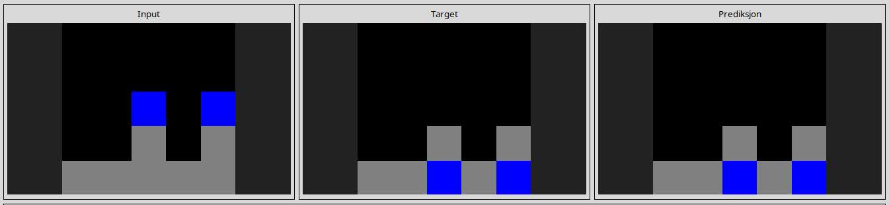
3bd67248
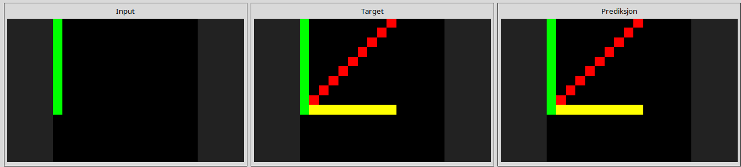
4258a5f9
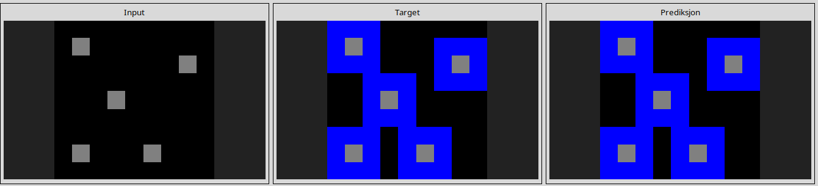
42a50994
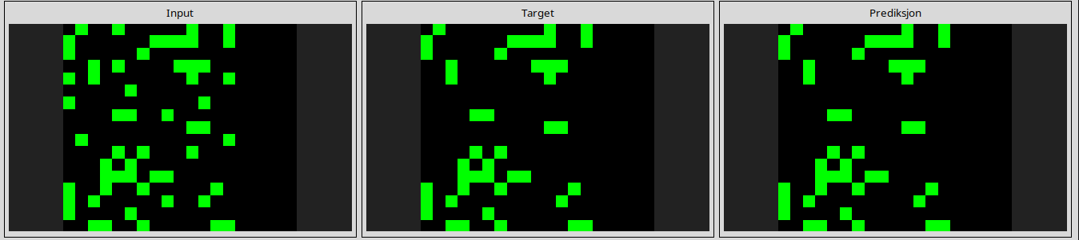
44f52bb0
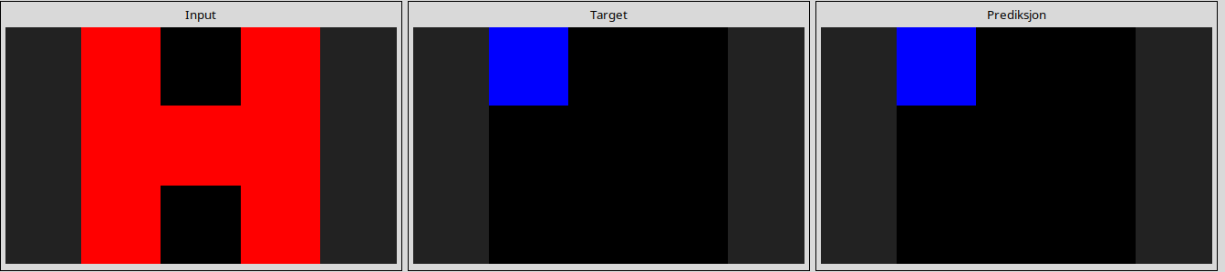
50cb2852
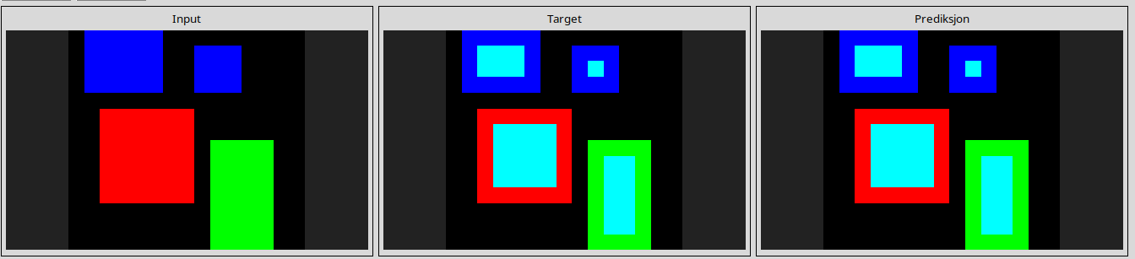
5168d44c
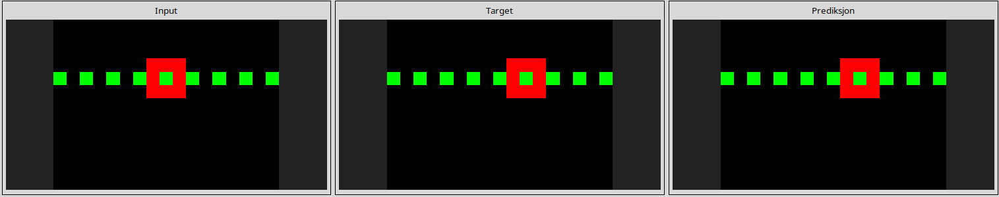
543a7ed5
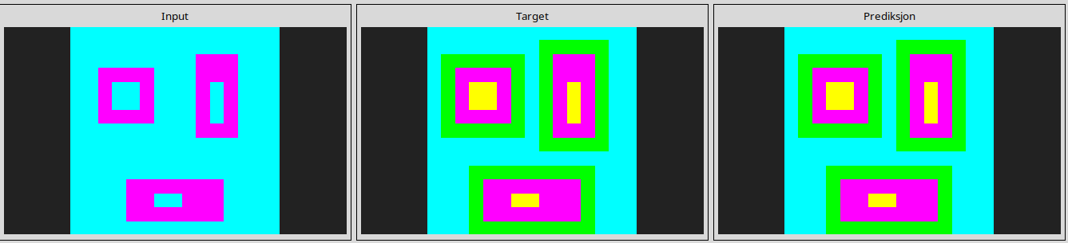
5c0a986e
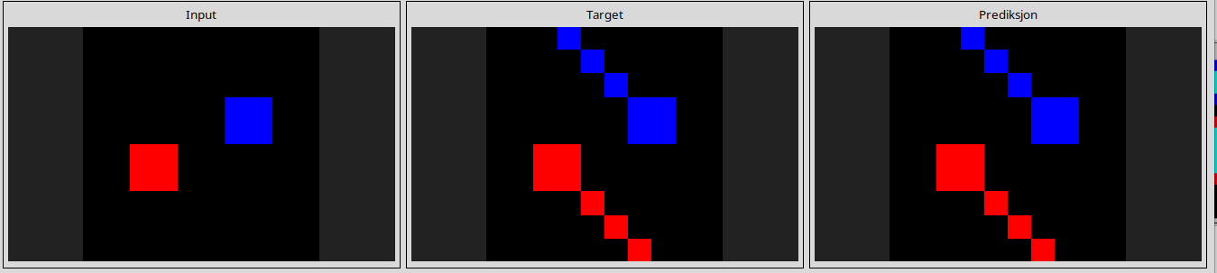
662c240a
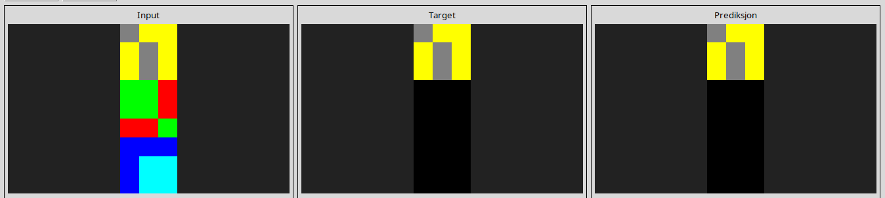
67385a82
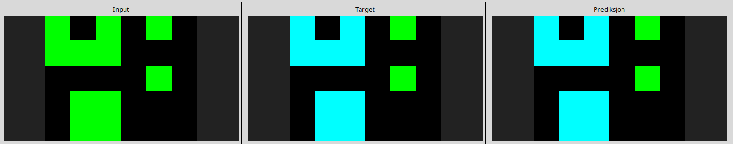
694f12f3
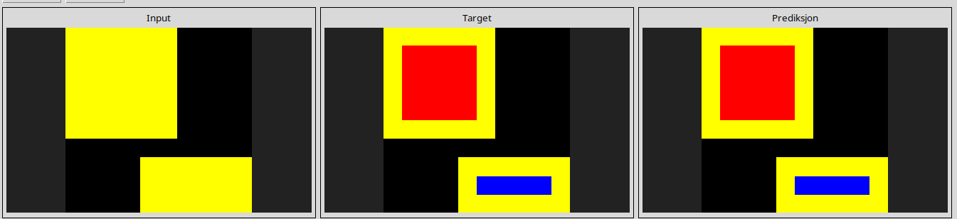
6c434453
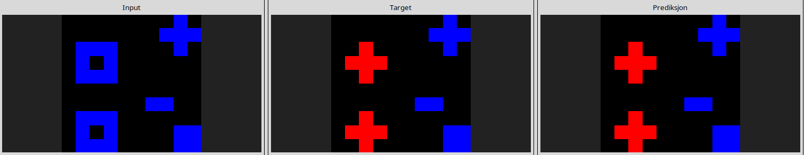
6f8cd79b
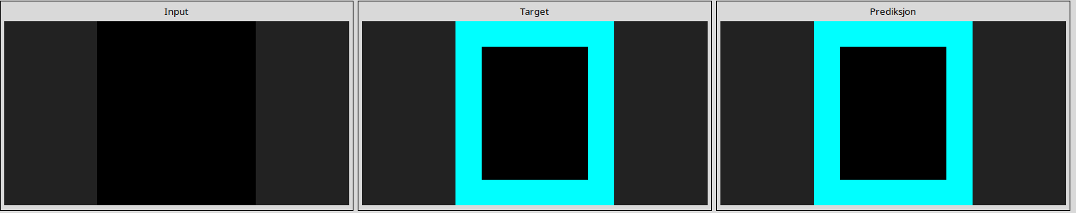
7b7f7511
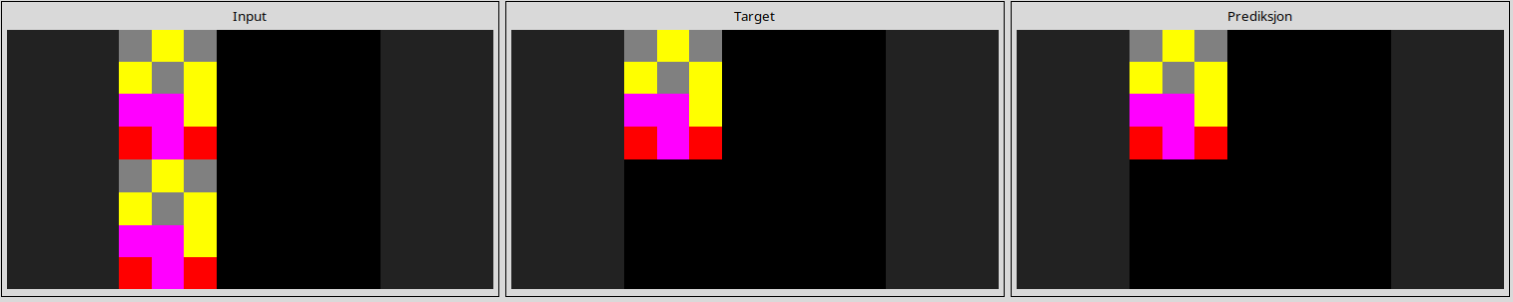
868de0fa
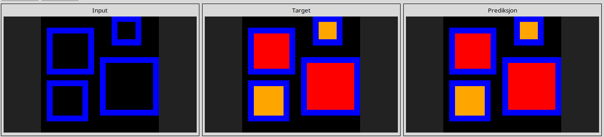
90f3ed37
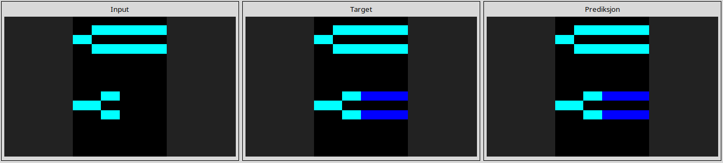
913fb3ed
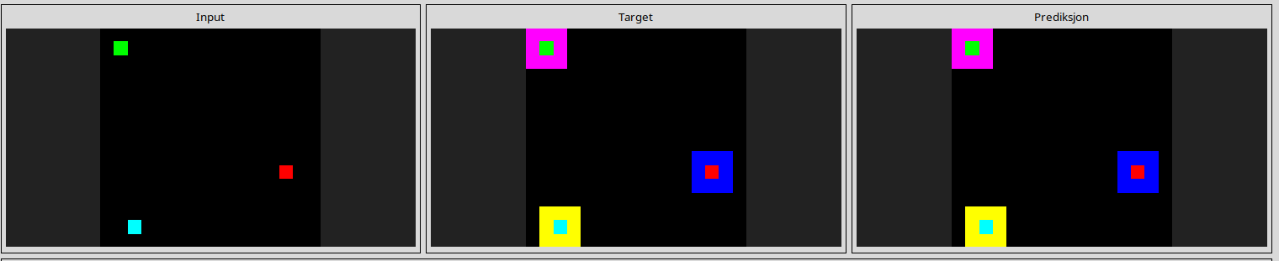
95990924
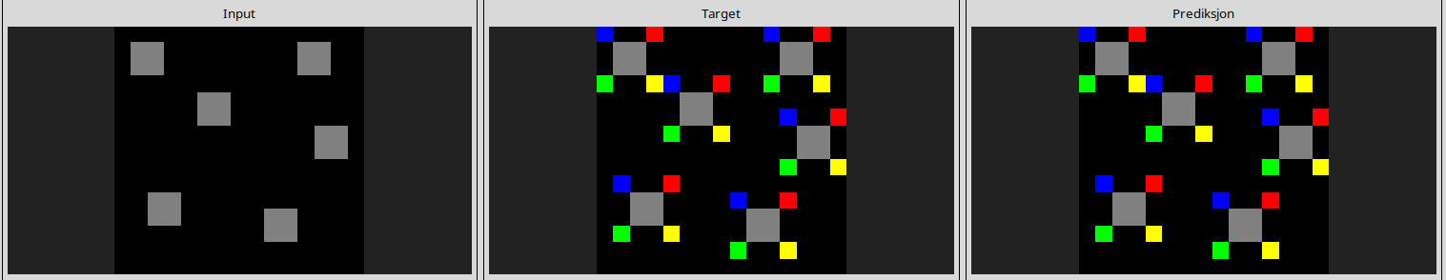
a65b410d
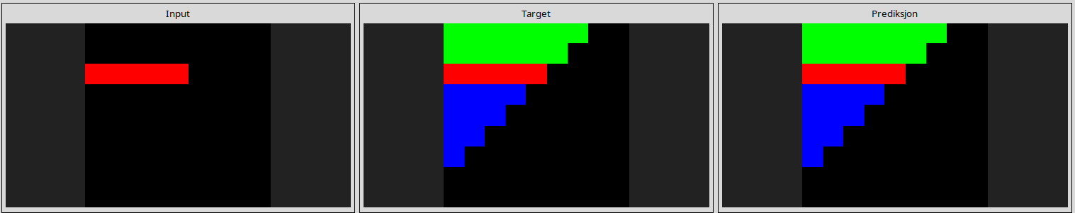
a699fb00
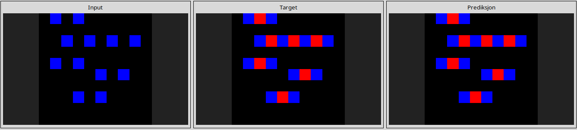
a79310a0
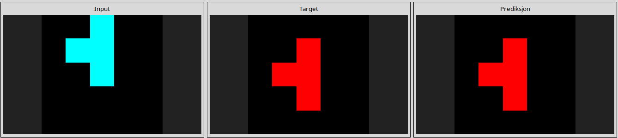
a9f96cdd
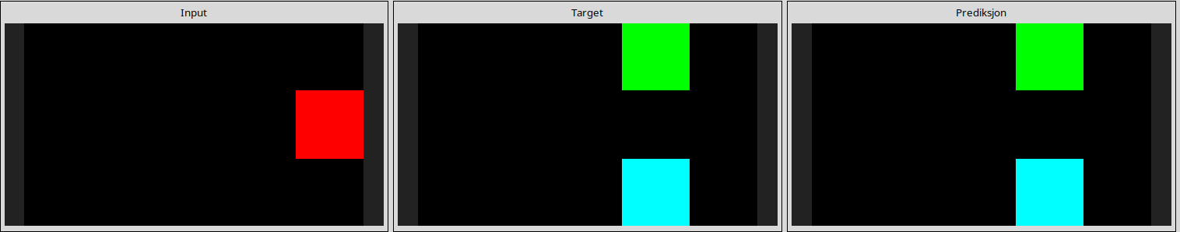
aedd82e4
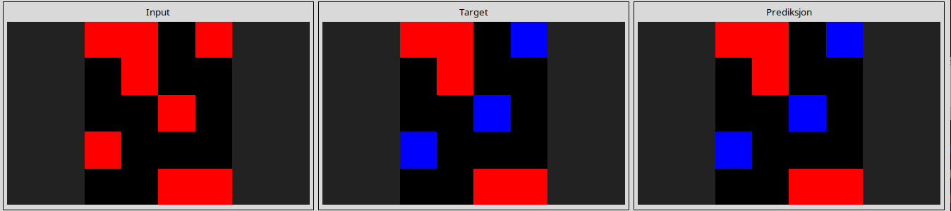
b1948b0a
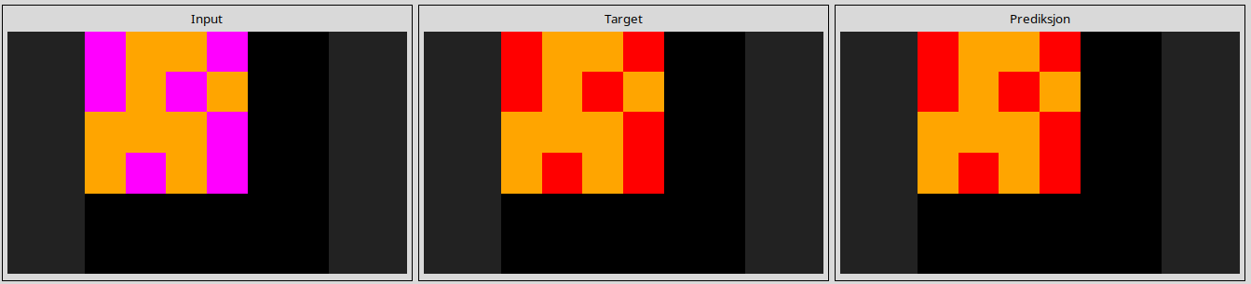
b60334d2
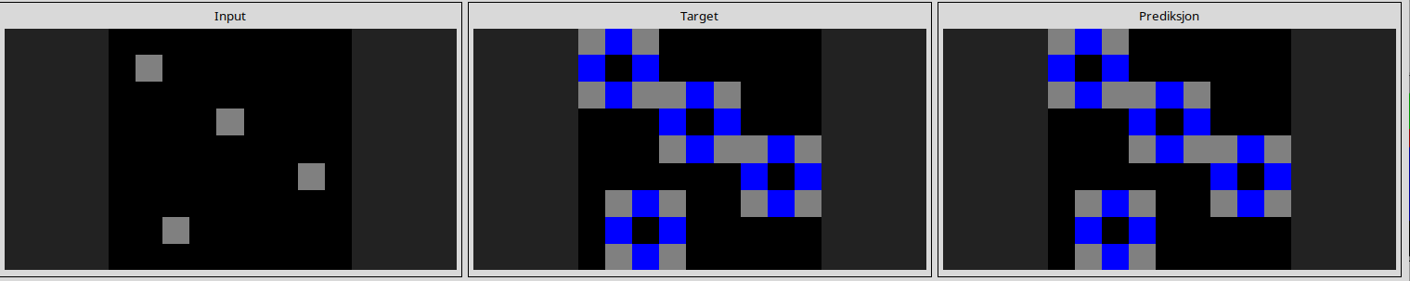
b6afb2da
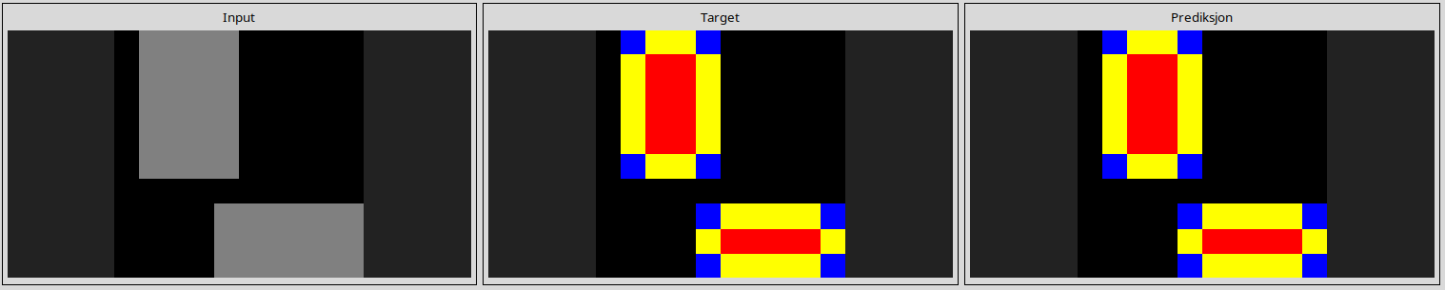
ba26e723
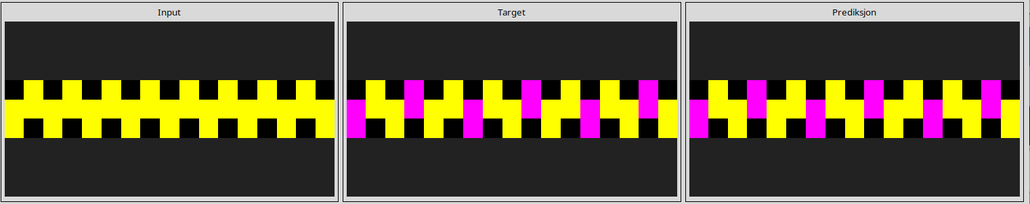
bb43febb
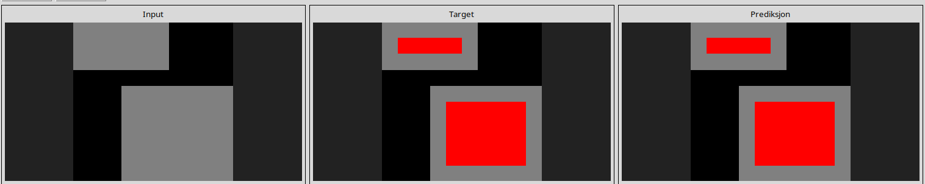
c0f76784
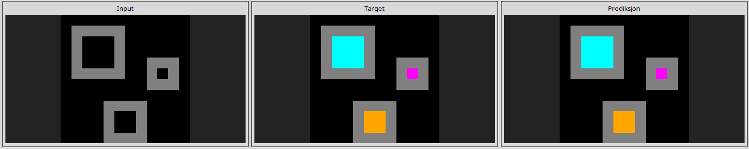
c8f0f002
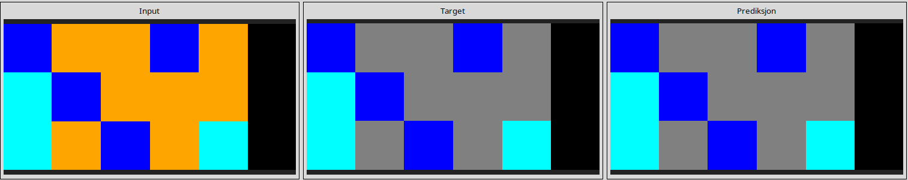
ce22a75a
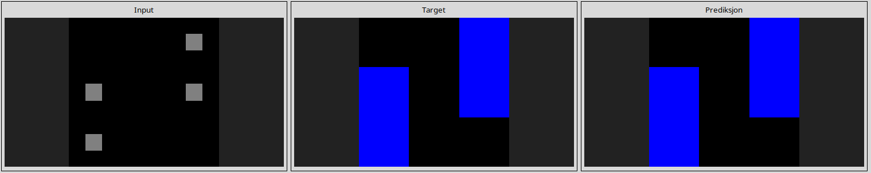
d06dbe63
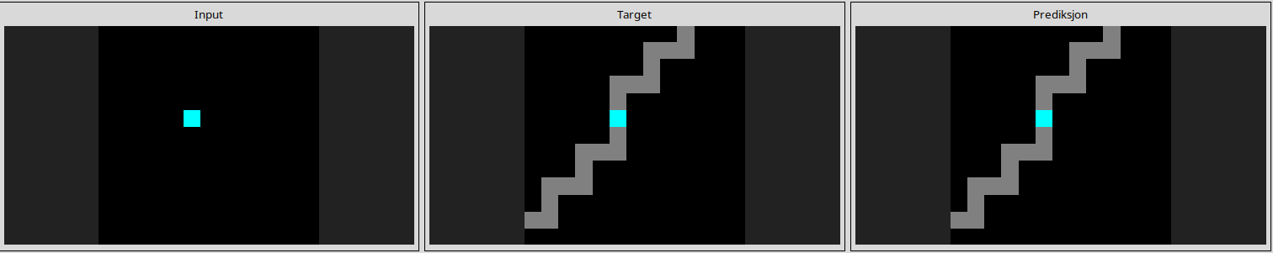
d10ecb37
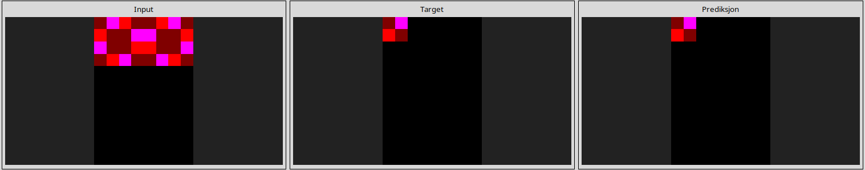
d364b489
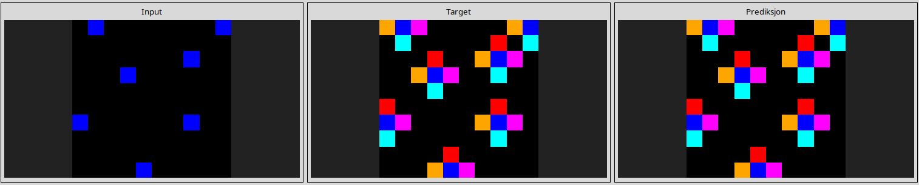
d4469b4b
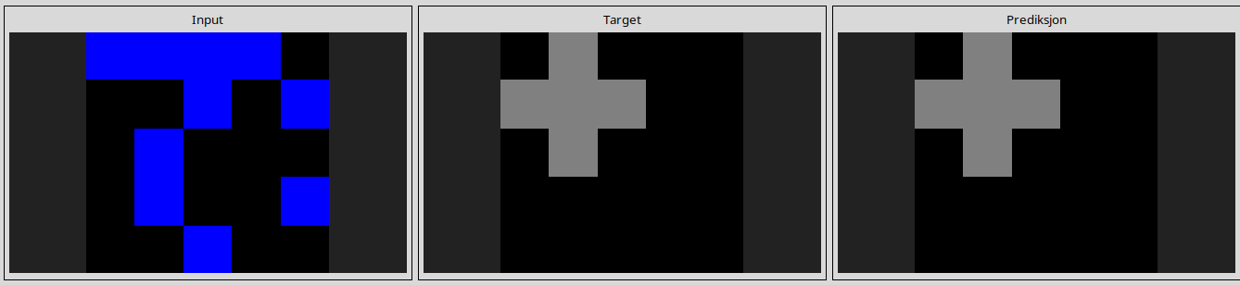
d9f24cd1
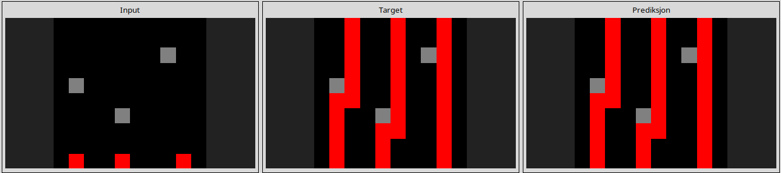
dc433765
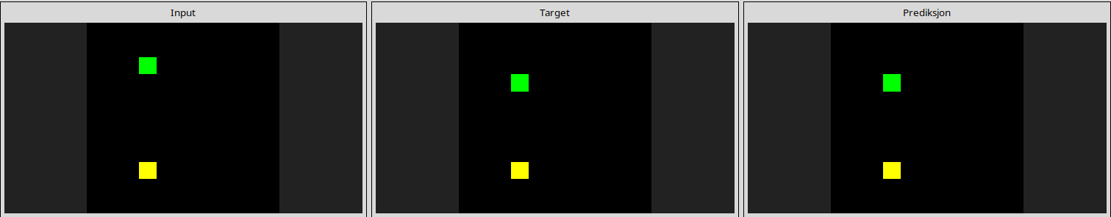
de1cd16c
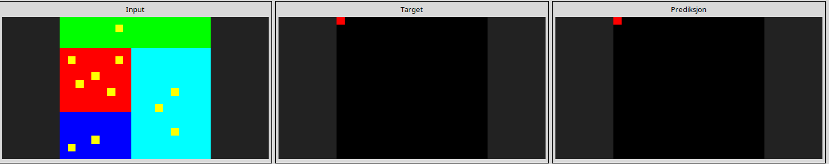
-----------------------------------------------------------------------------------------------------------------------------------------------------------------------------------------------------------------------------------------------
Almost solved task
0ca9ddb6
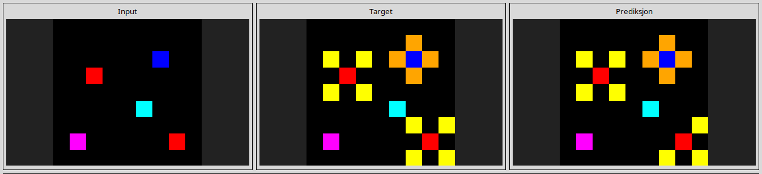
1b2d62fb
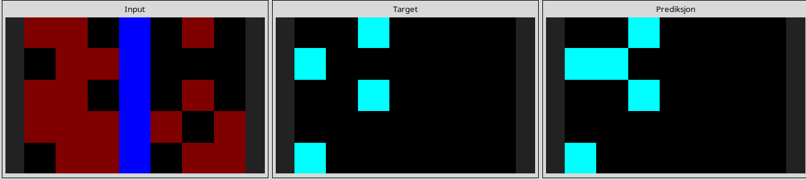
3aa6fb7a
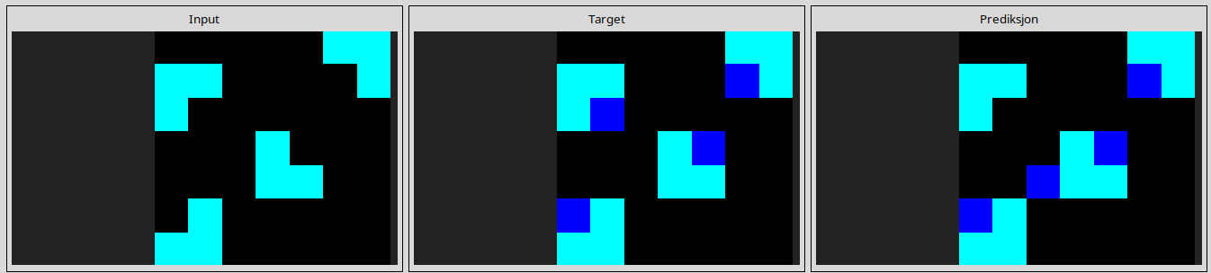
3bdb4ada
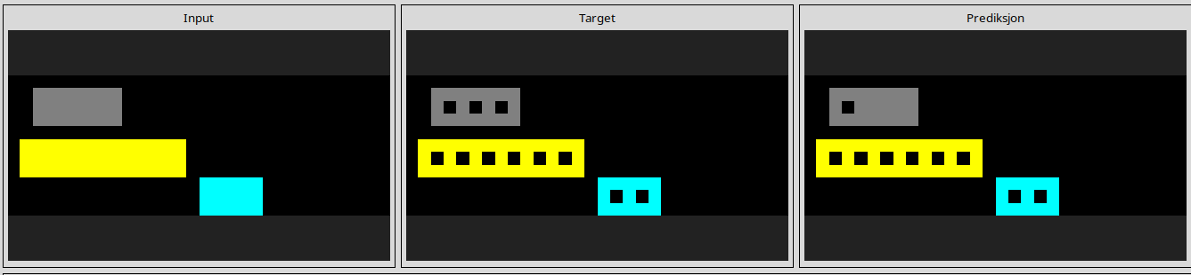
l
41e4d17e
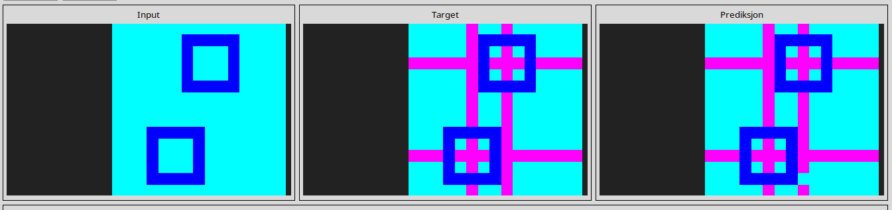
l
4612dd53
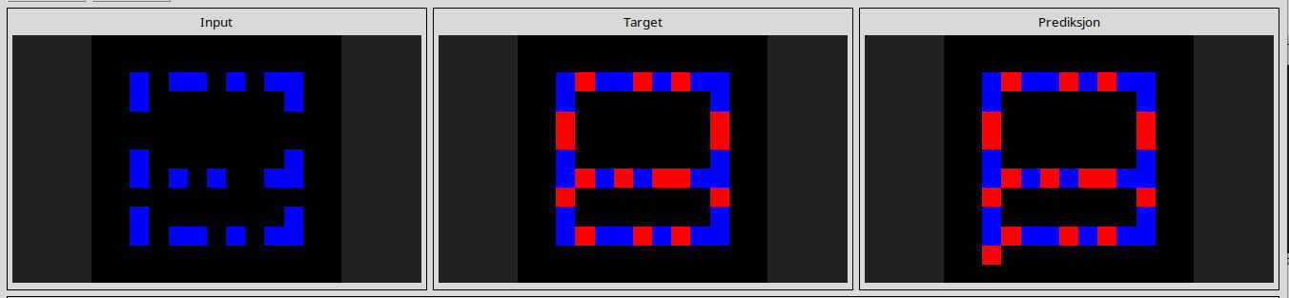
l
7b6016b9
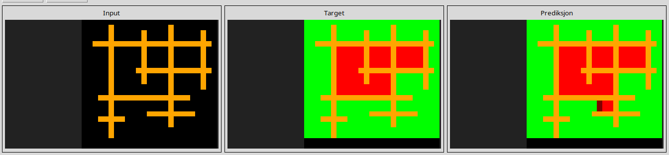
l
54d82841
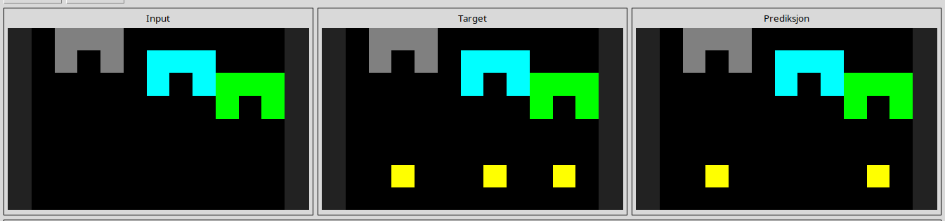
l
54d9e175
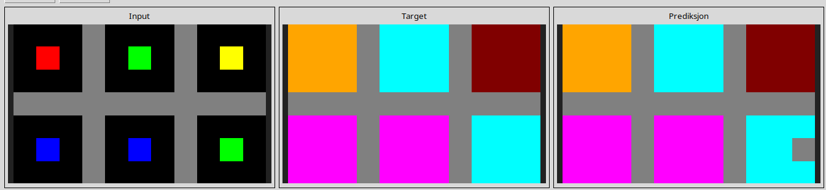
l
25ff71a9
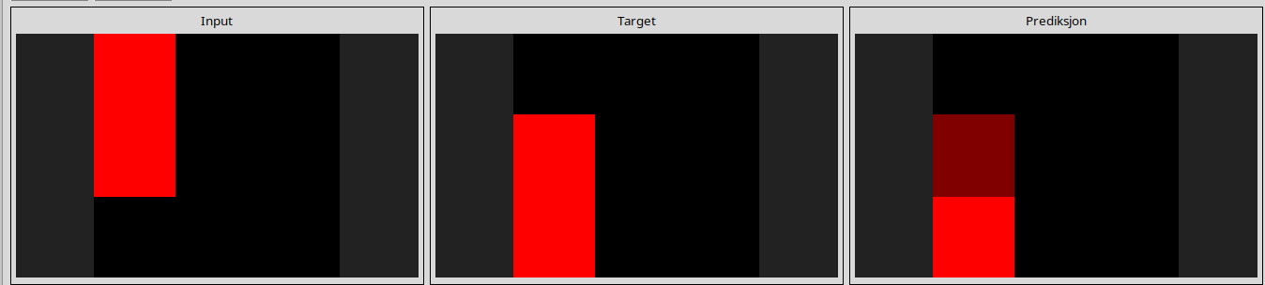
l
a5313dff
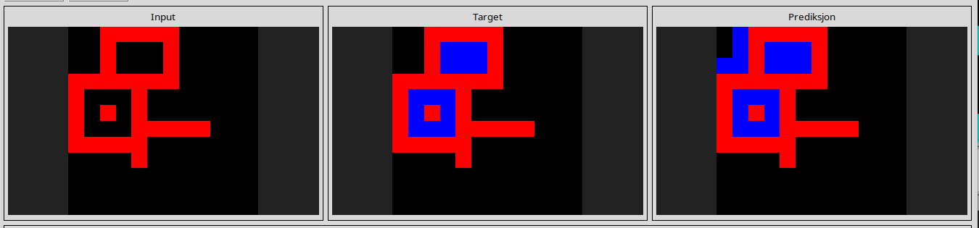
l
d406998b
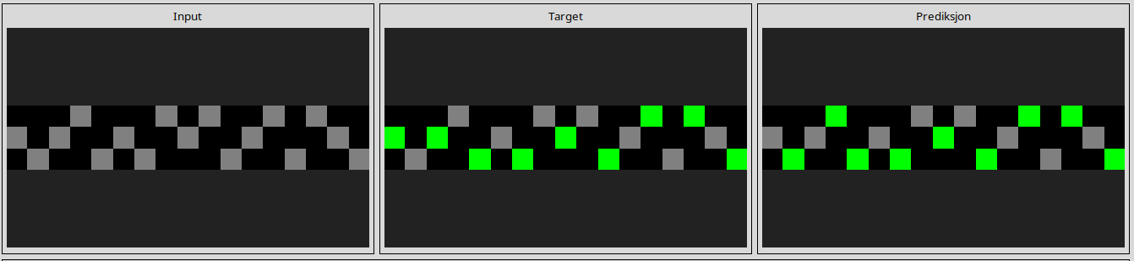
l
6cf79266
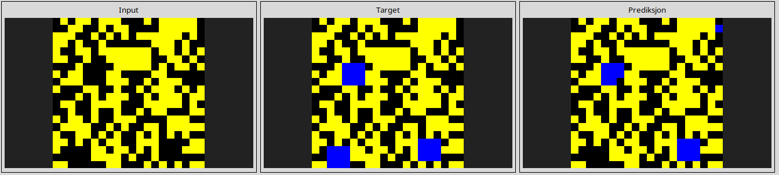
l
445eab21
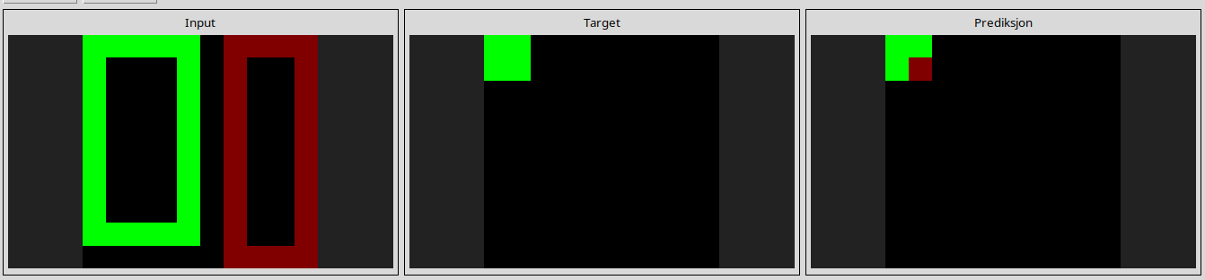
l
d5d6de2d
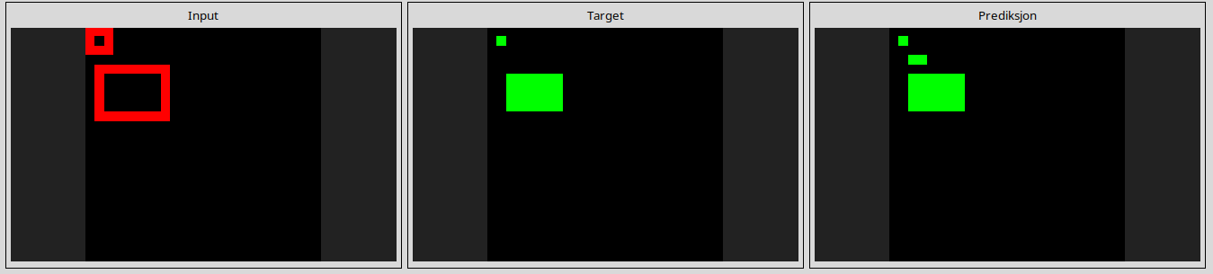
l
d90796e8
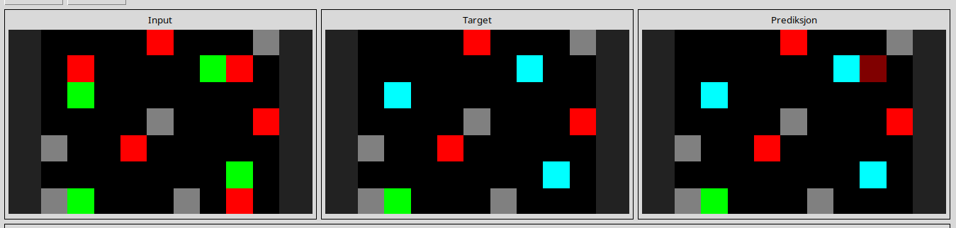
l
db3e9e38
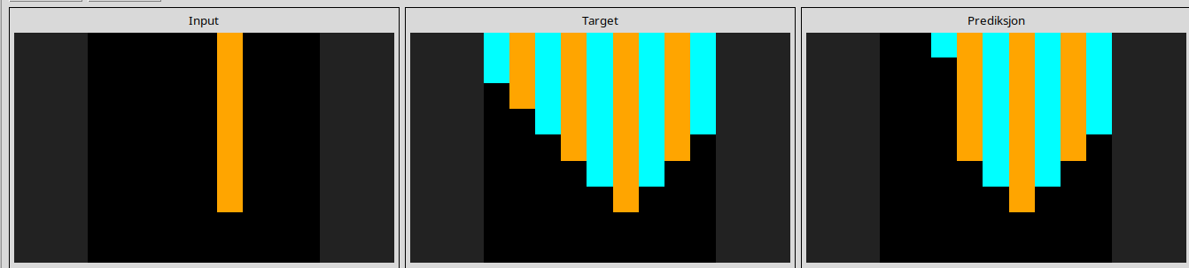
l
ef135b50
