ARC1 Train
Learnable Filter NCA=50 solved task
0d3d703e
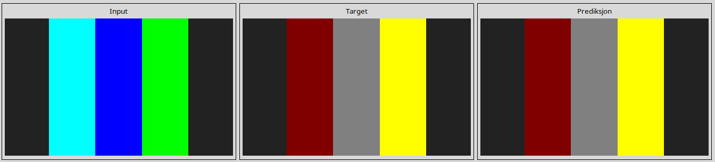
25d8a9c8
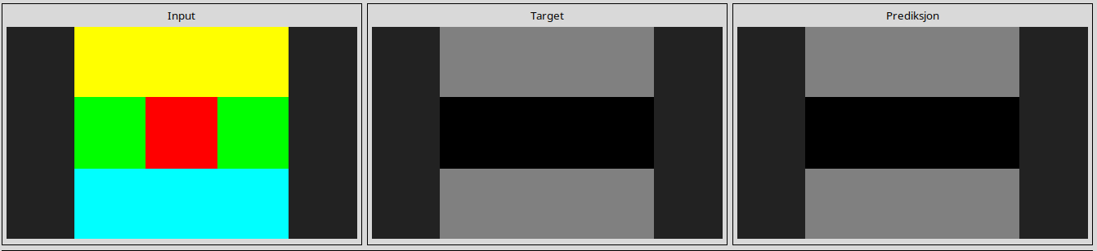
25ff71a9
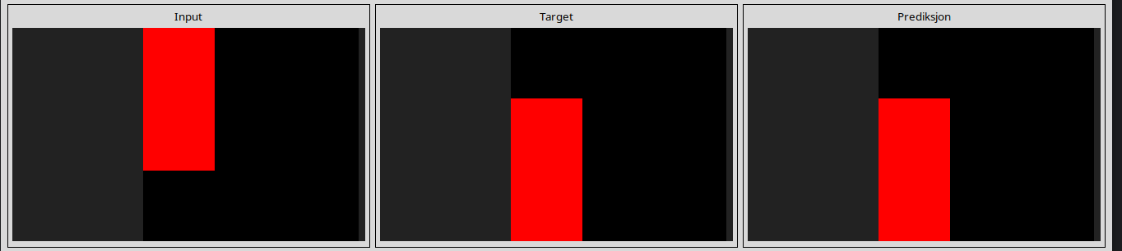
27a28665
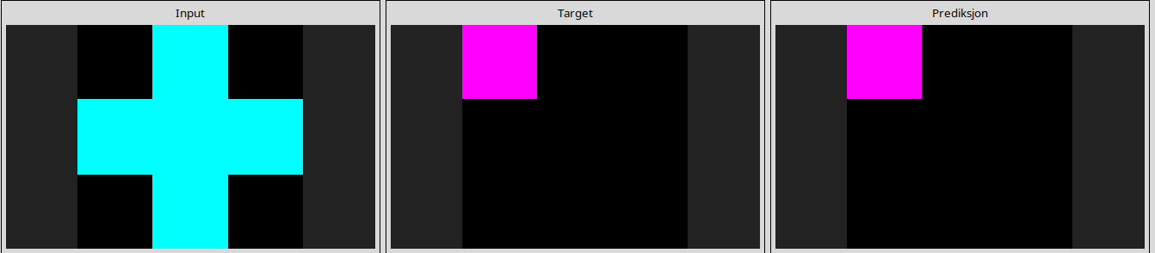
28e73c20
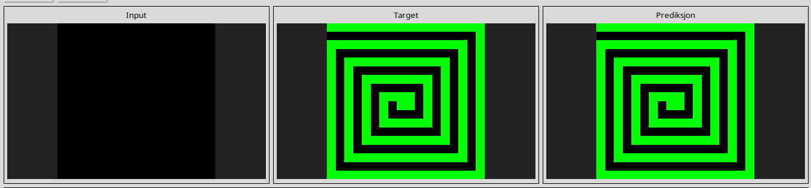

2dee498d
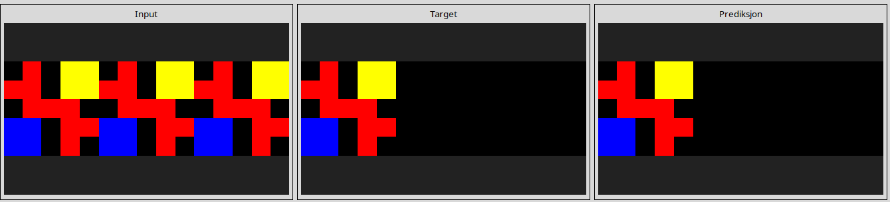
32597951
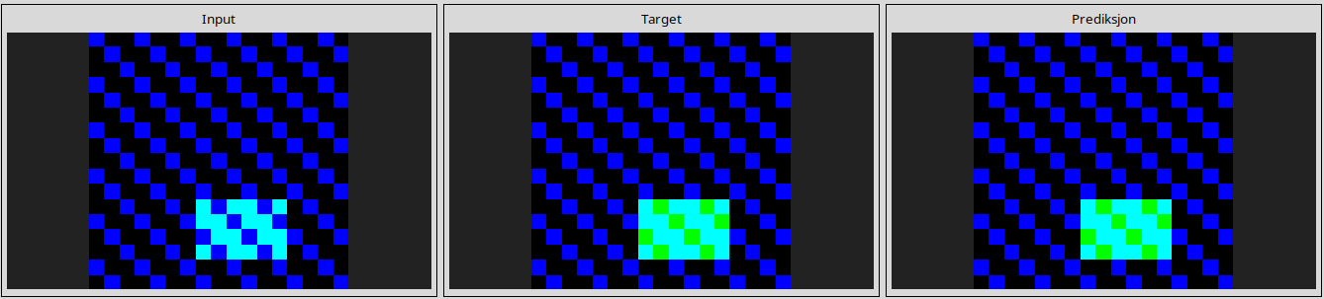
3618c87e
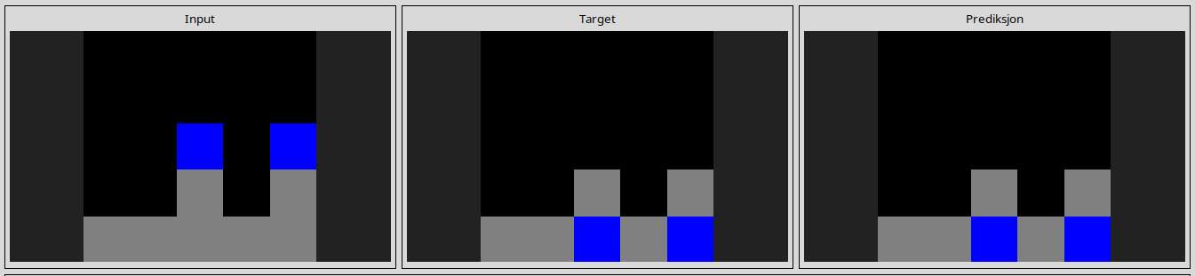
3aa6fb7a
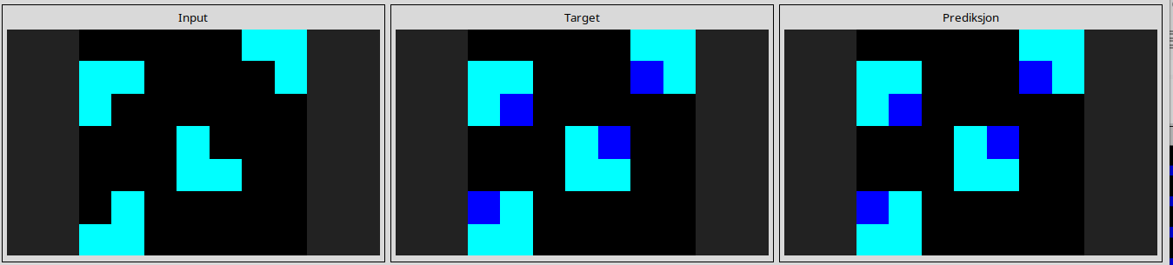
3bdb4ada
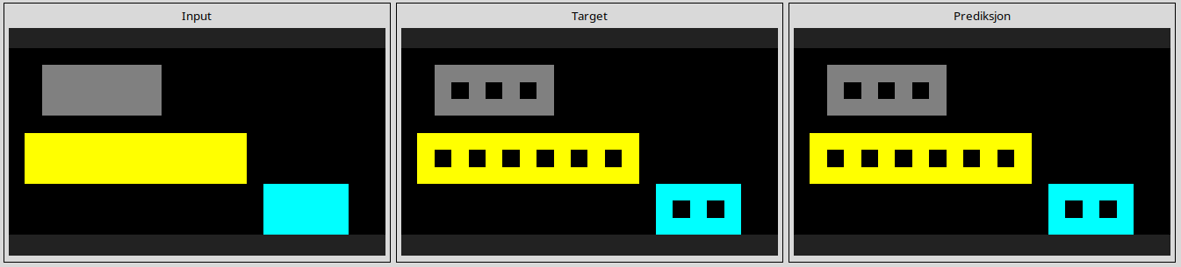

4258a5f9
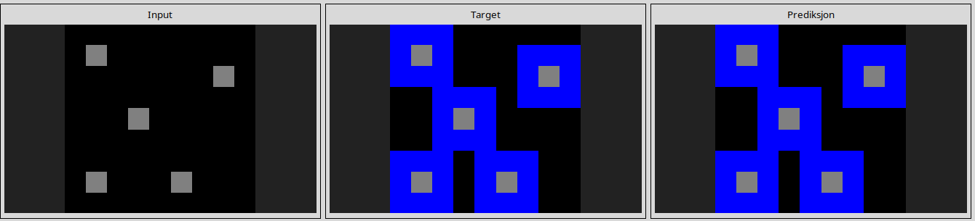
4347f46a
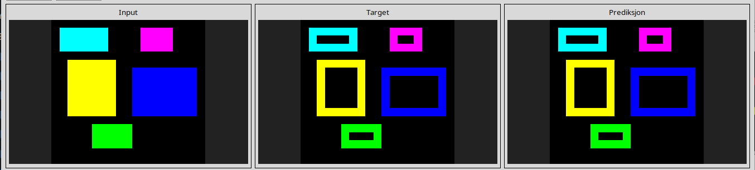
44f52bb0
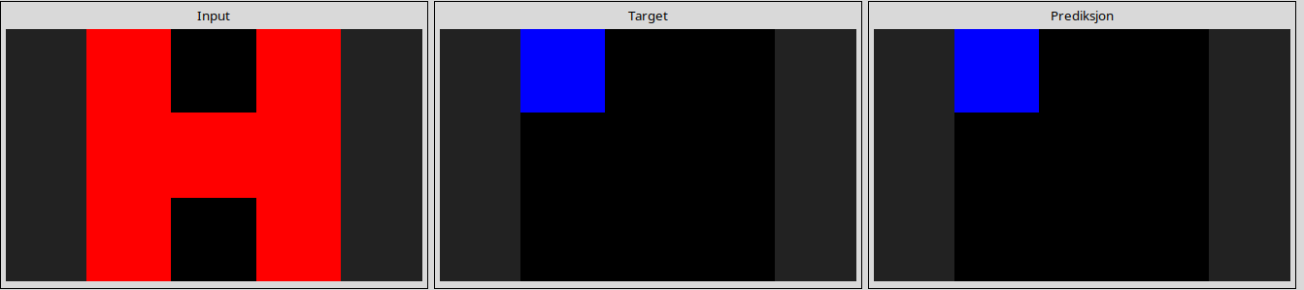
50cb2852
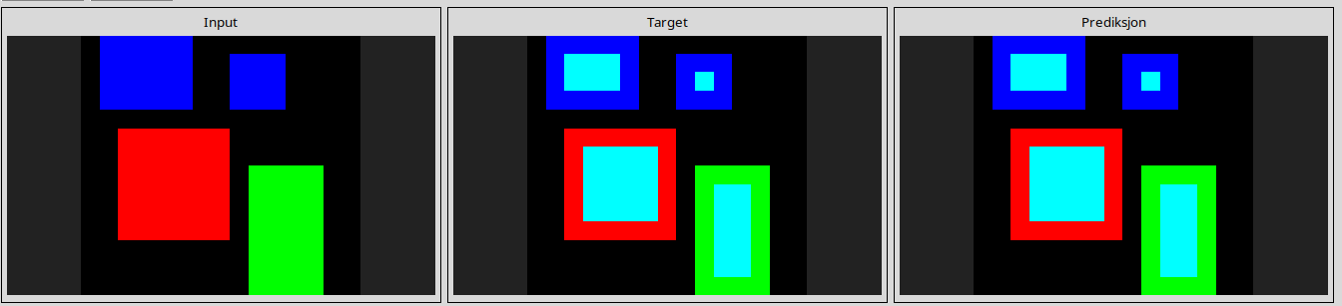
5168d44c
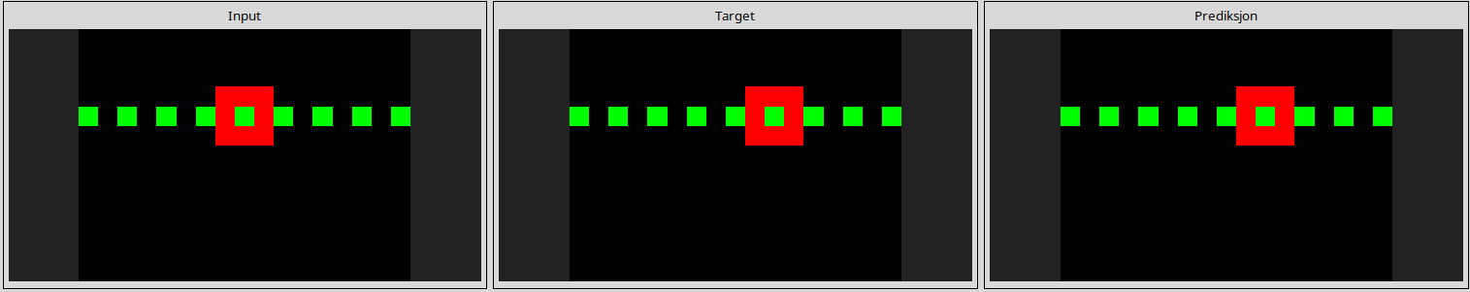
543a7ed5
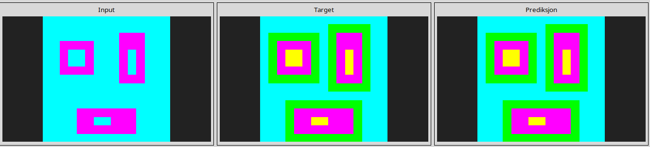
54d9e175
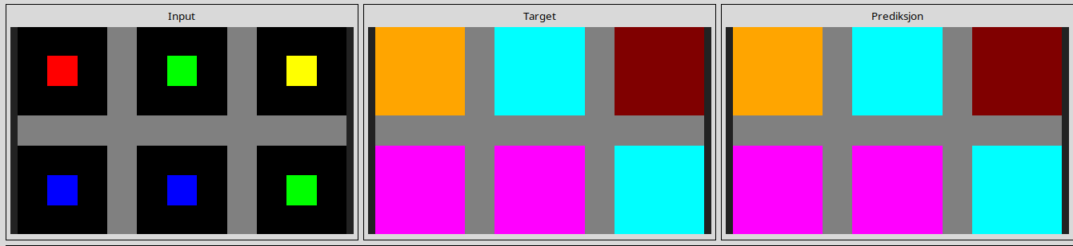
5c0a986e
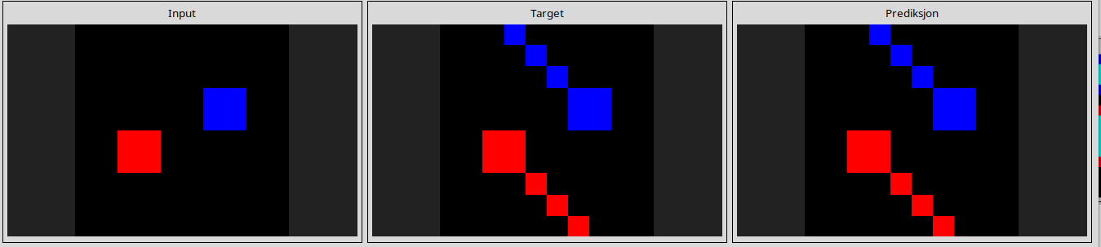
662c240a
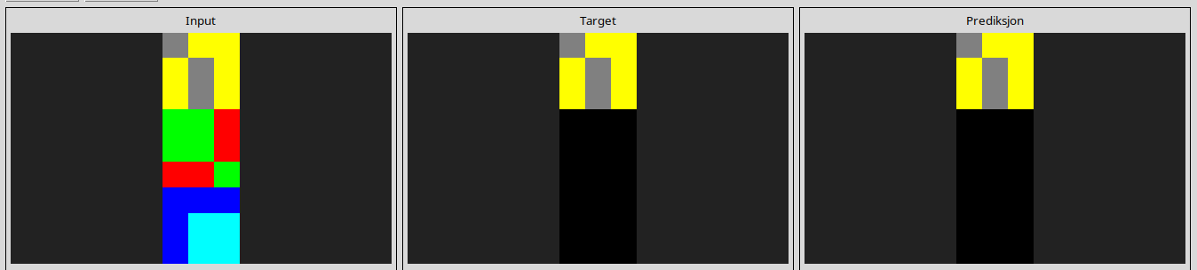
67385a82
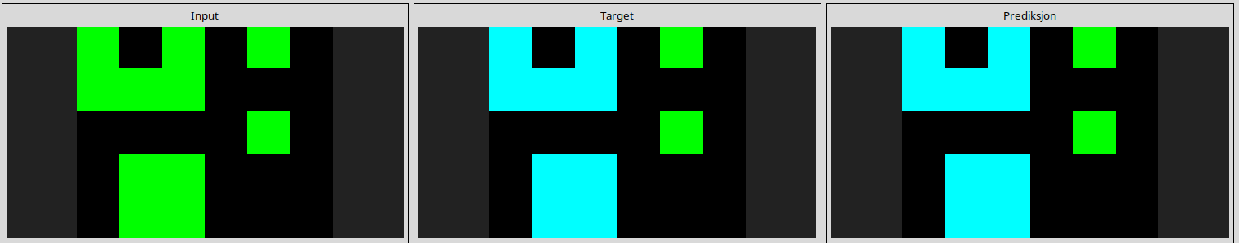
694f12f3
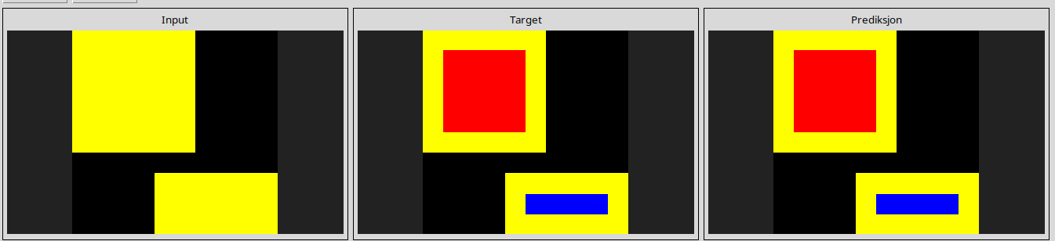
6c434453
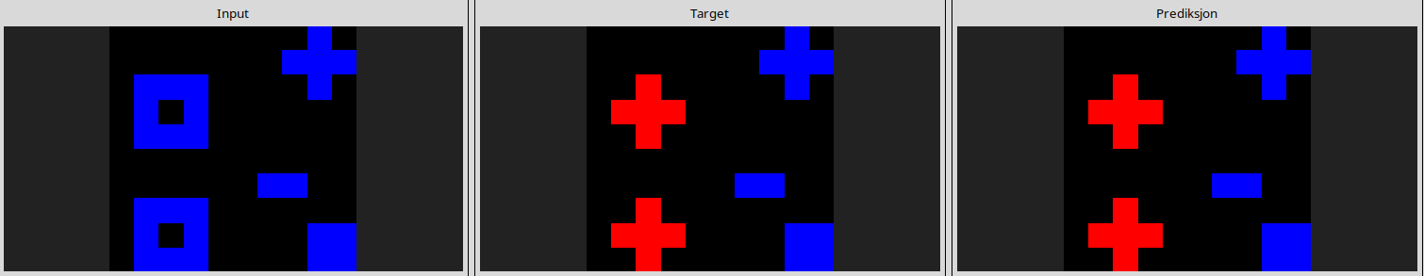
6f8cd79b
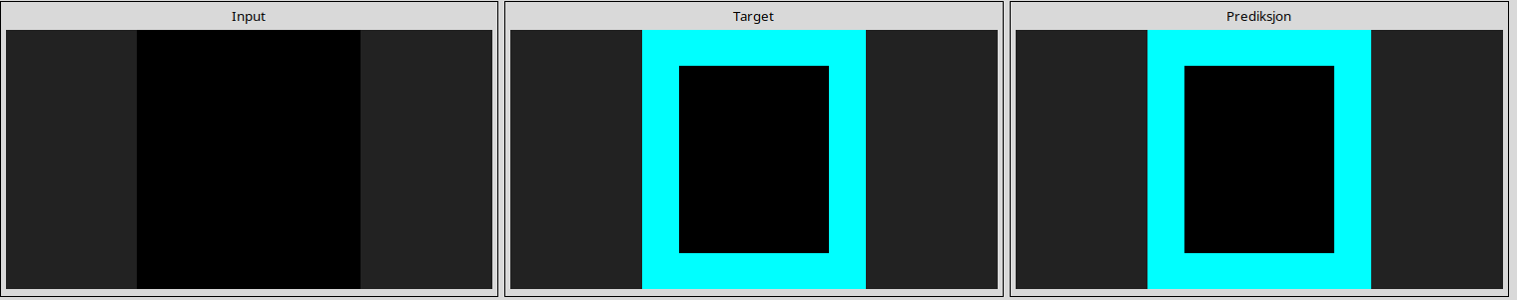
7b7f7511
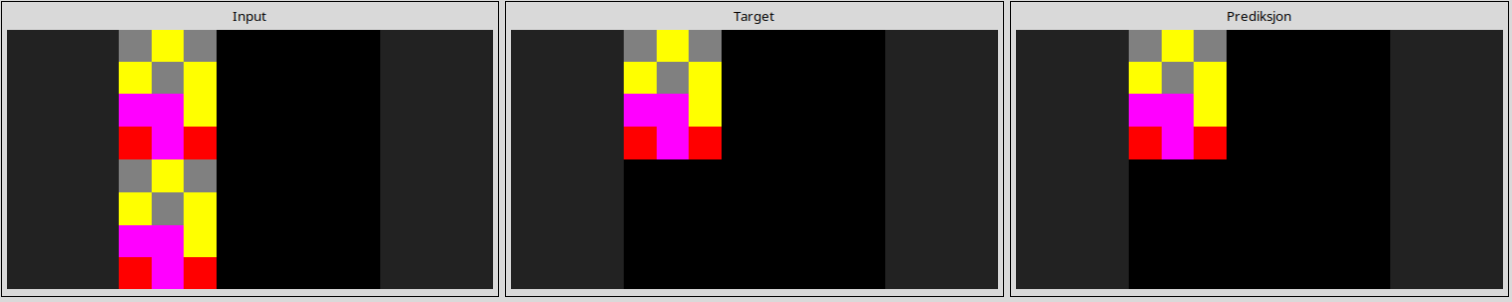
90f3ed37
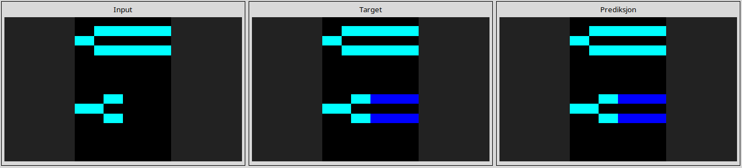
913fb3ed
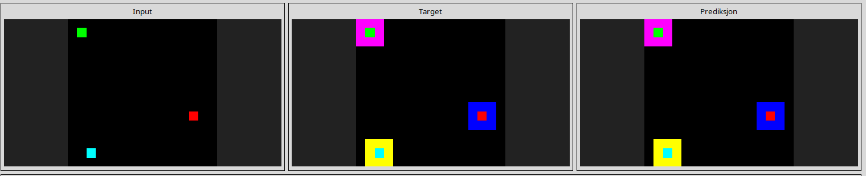
95990924
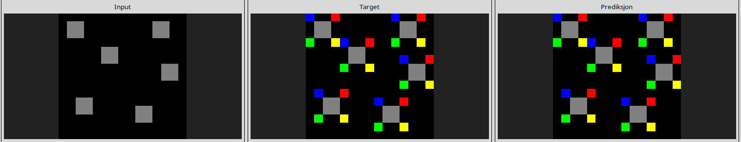
a2fd1cf0
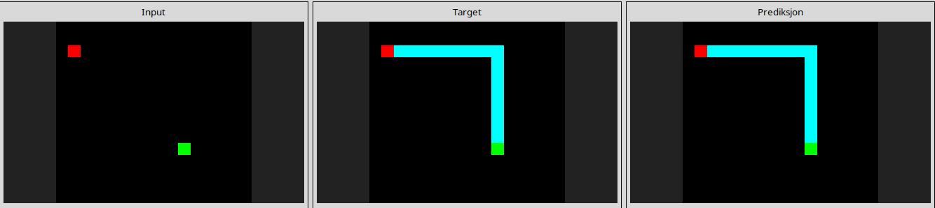
a5313dff
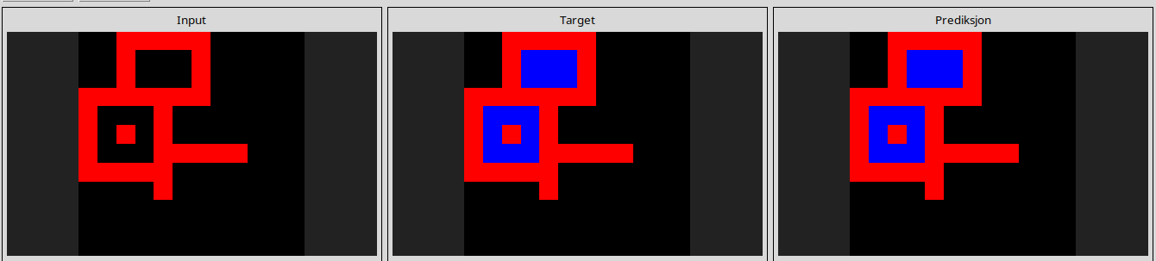
a65b410d
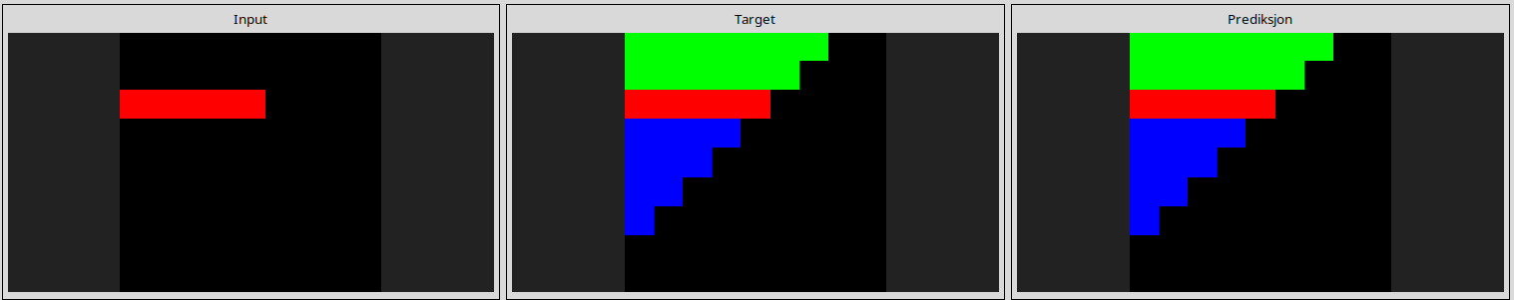
a79310a0
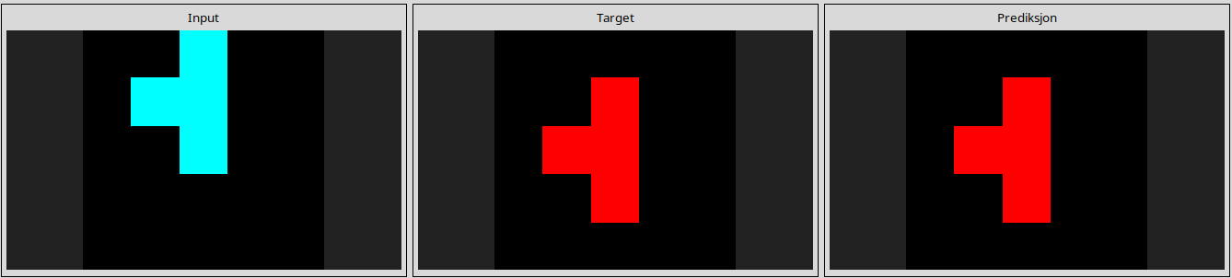
a85d4709
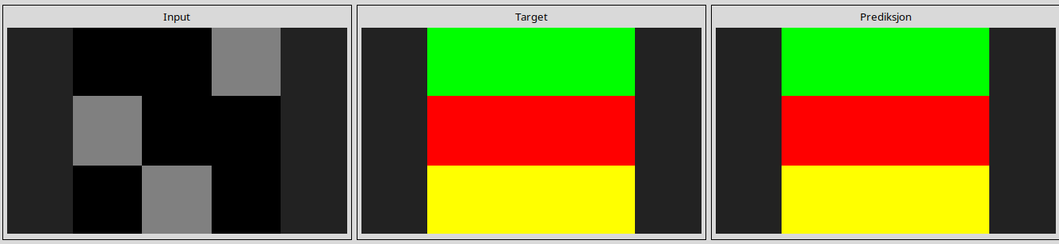
a9f96cdd
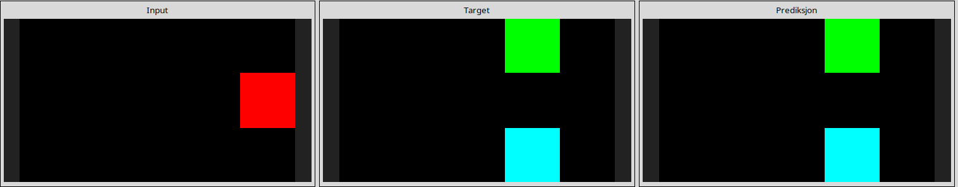
aedd82e4
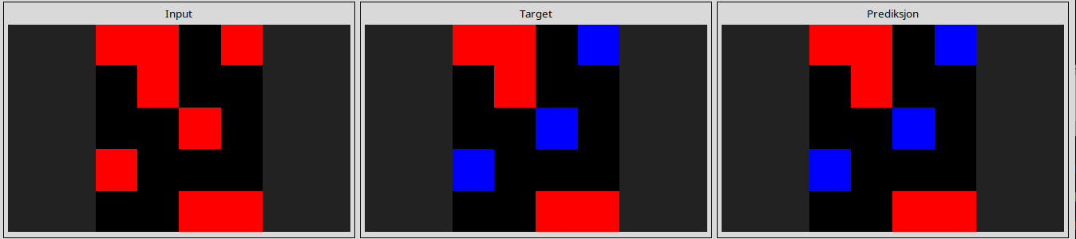
b1948b0a
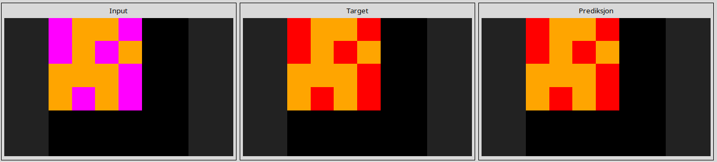
b60334d2
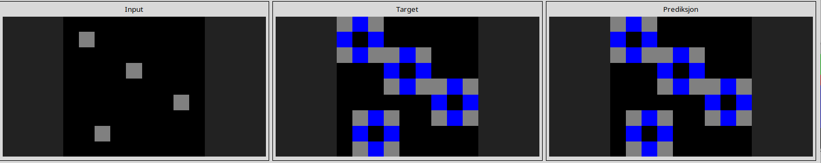
b6afb2da
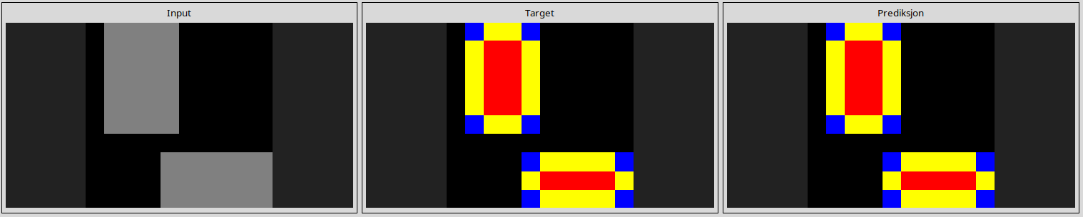
ba26e723
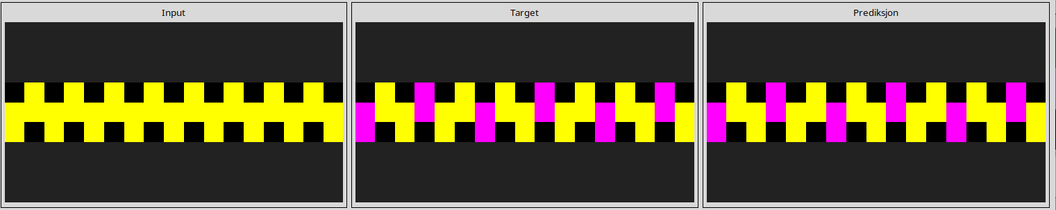
bb43febb
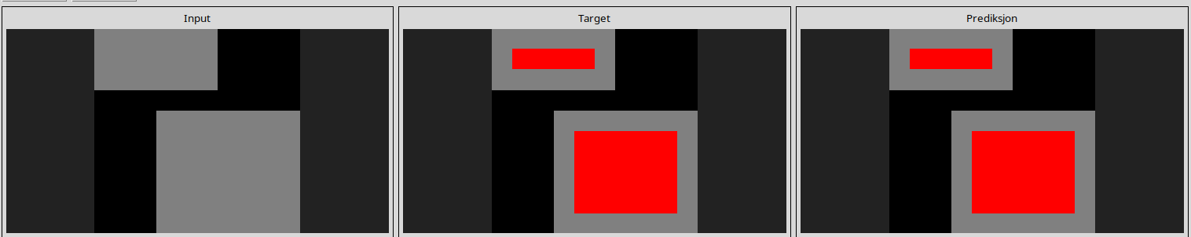
c0f76784
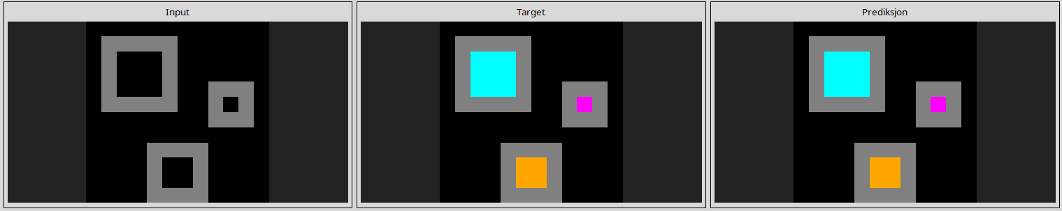
c8f0f002
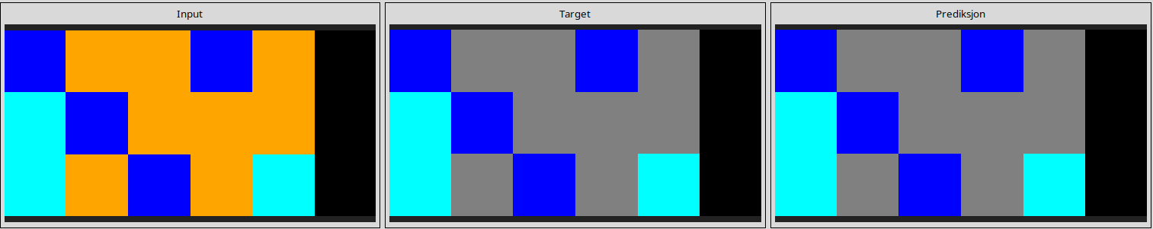
ce22a75a
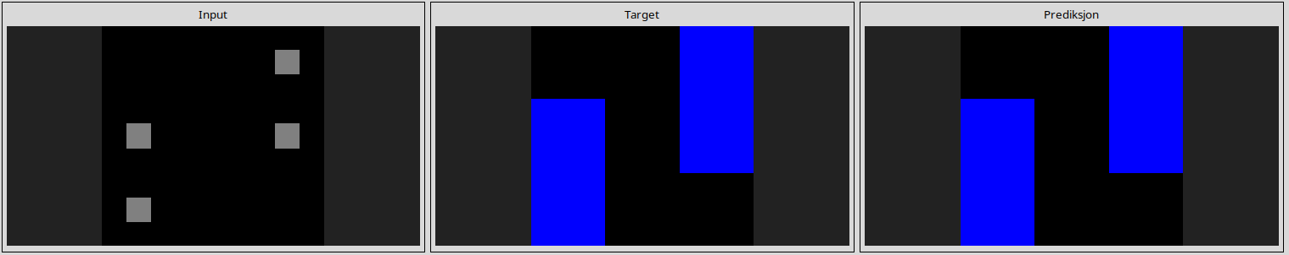
ce9e57f2
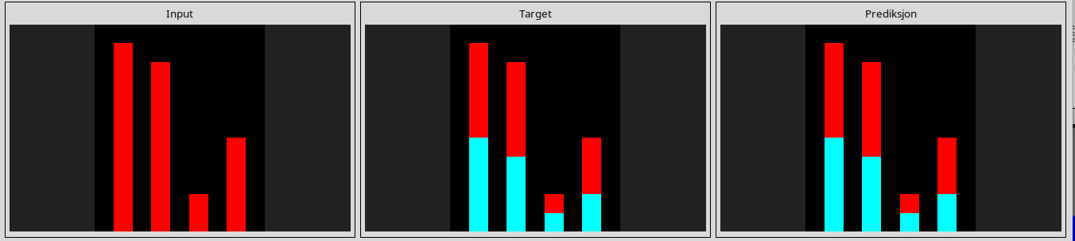
d06dbe63
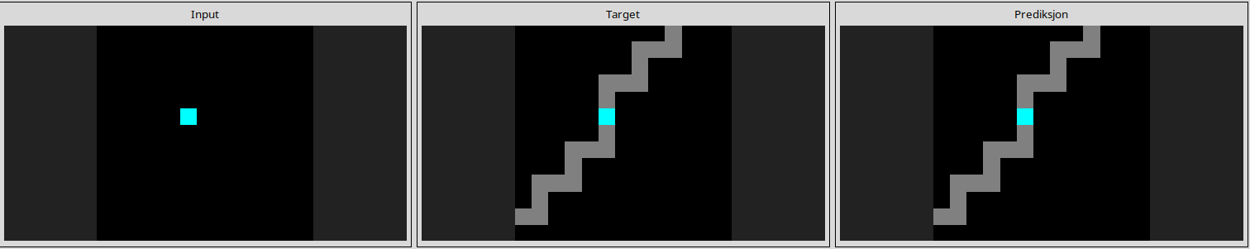
d10ecb37
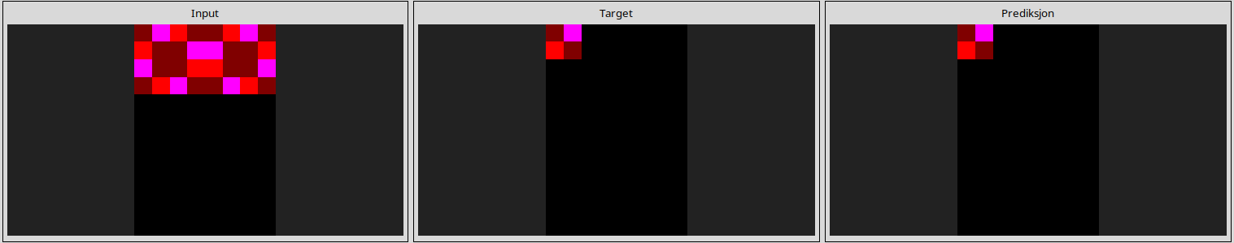
d364b489
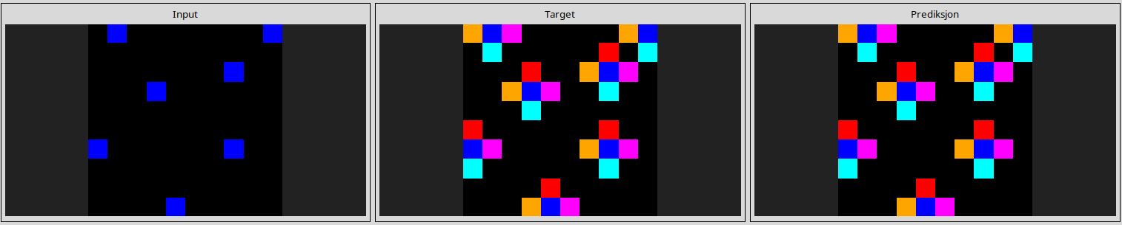
d406998b
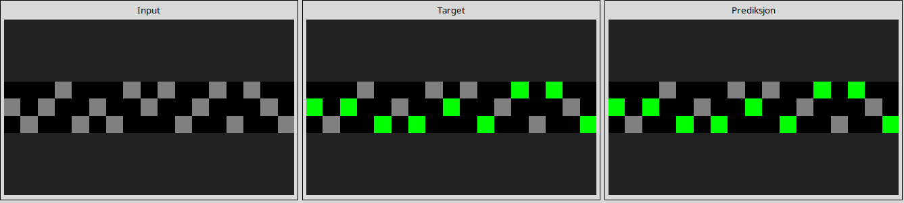
d4469b4b
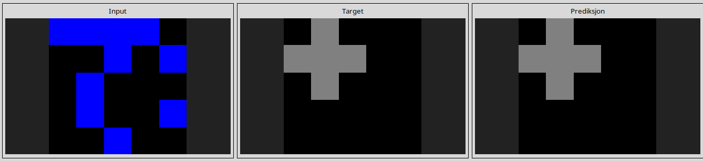
dc433765
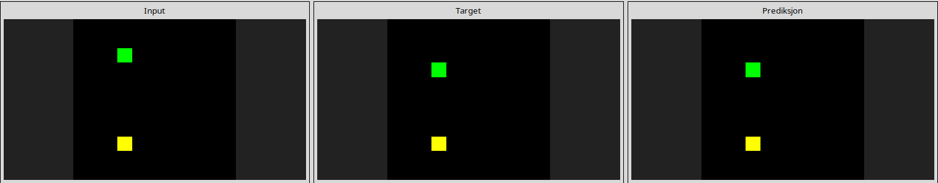
de1cd16c
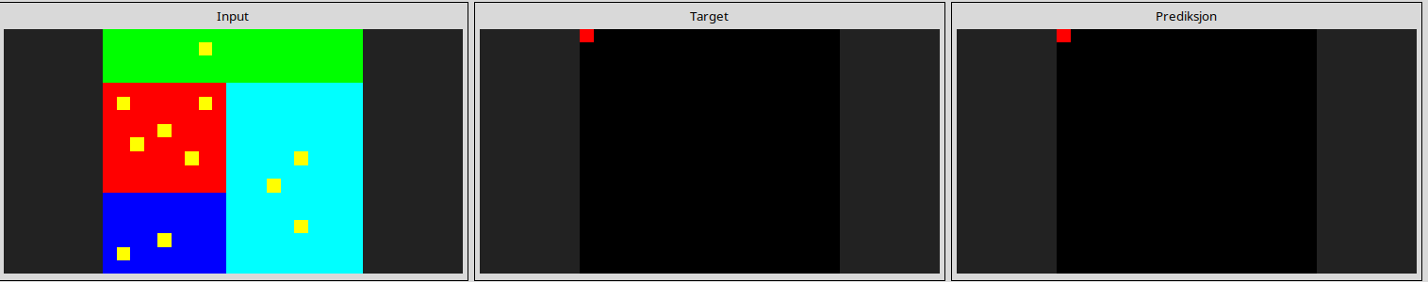
----------------------------------------------------------------------------------------------------------------------
---------------------------------------------------------------------------------------------------------------------

Almost solved tasks

0ca9ddb6
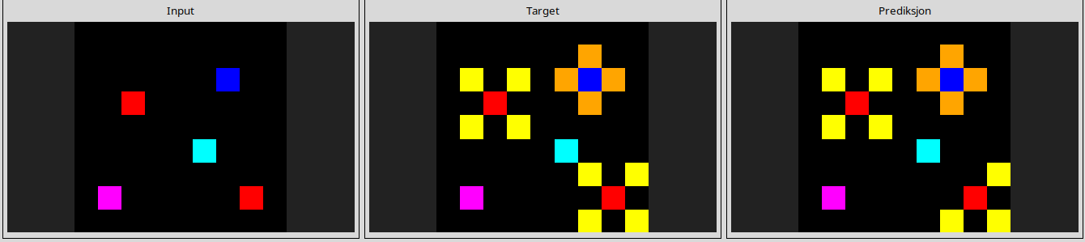
1a07d186
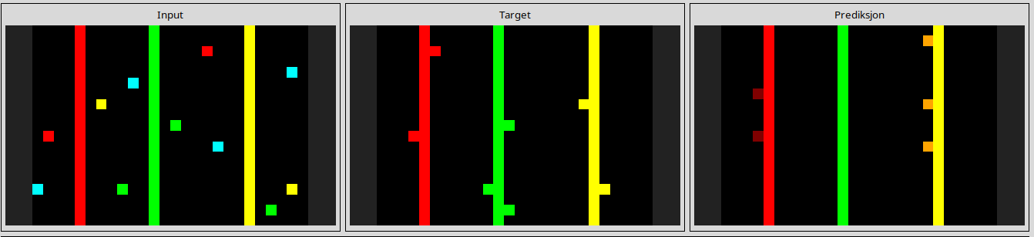
1b2d62fb
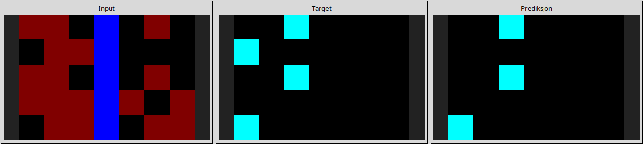
l
3bd67248
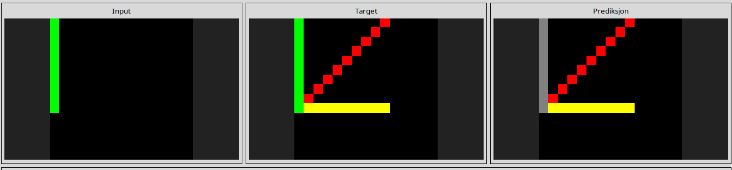
6cf79266
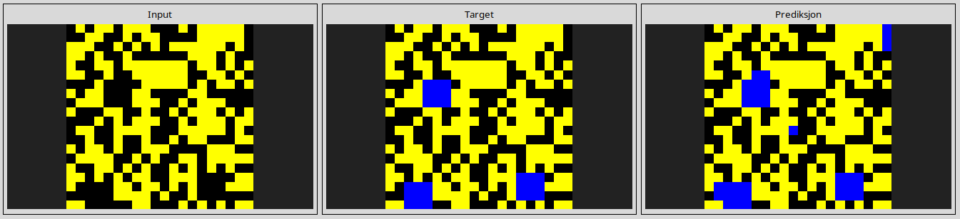
7b6016b9
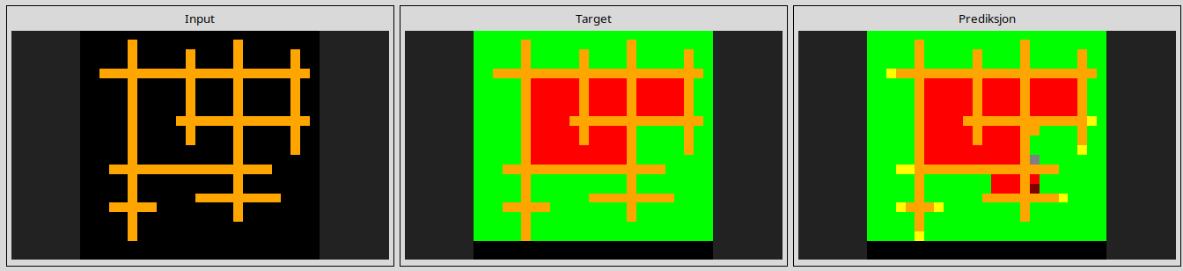
8d510a79
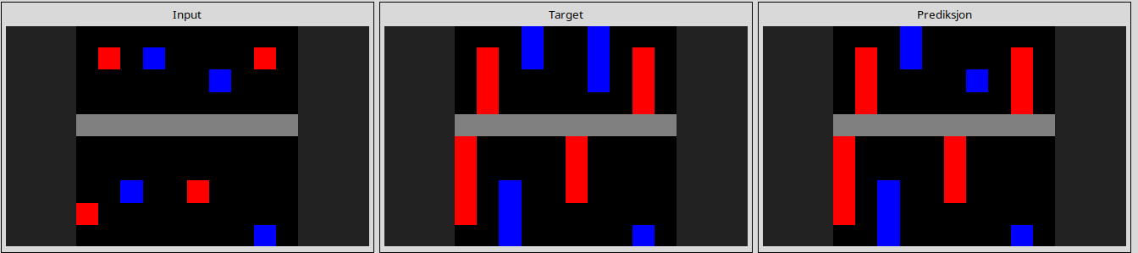
017c7c7b
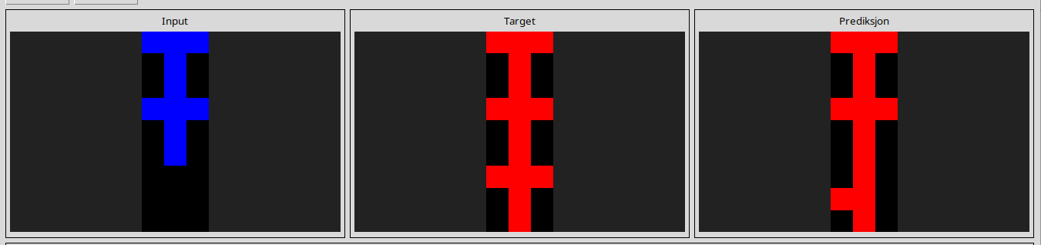
l
41e4d17e
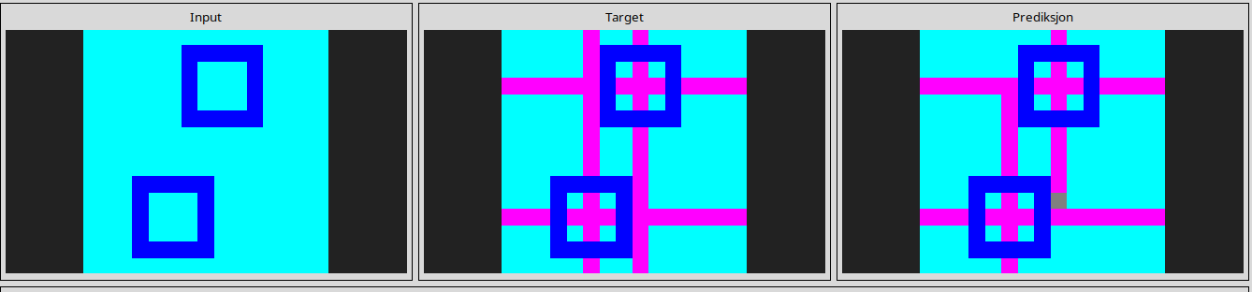
l
99fa7670
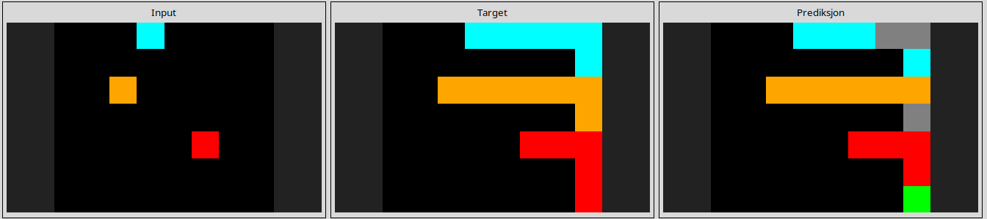
l
253bf280
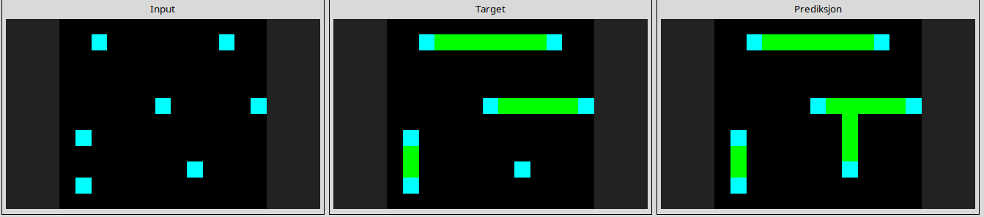
l
272f95fa
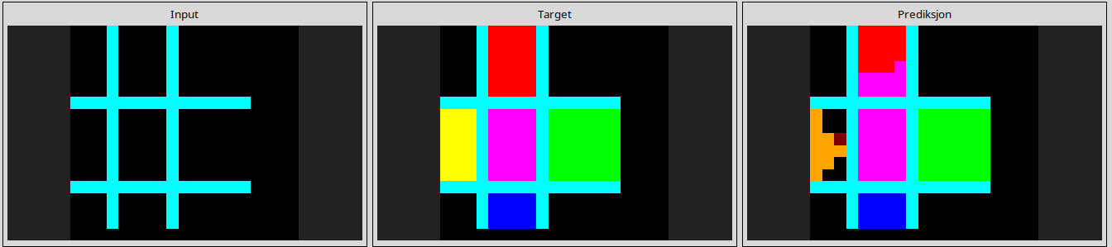
445eab21
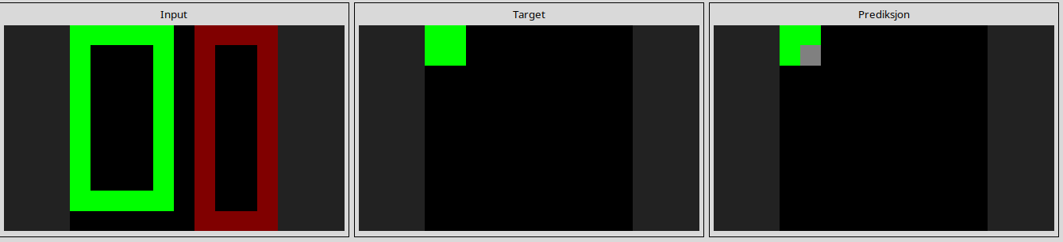
l
868de0fa
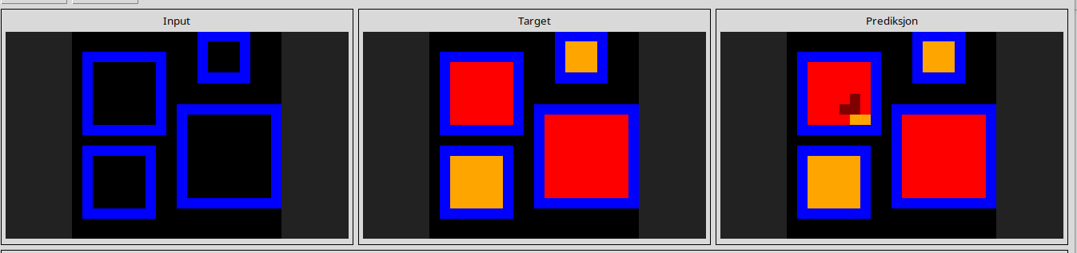
l
2281f1f4
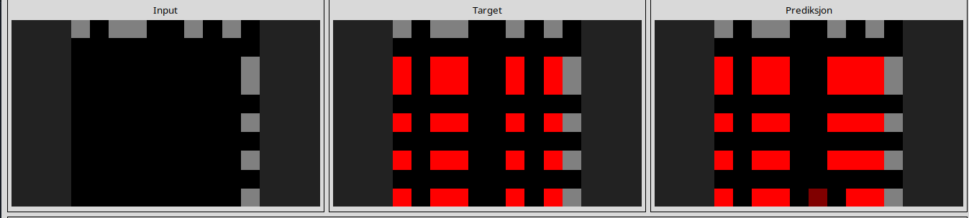
l
4612dd53
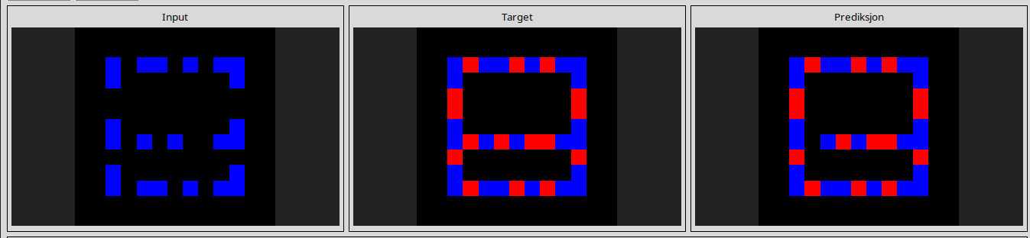
l
5521c0d9
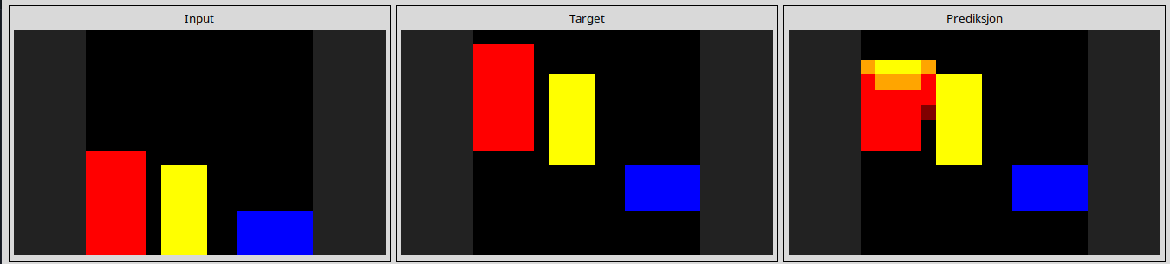
l
7447852a
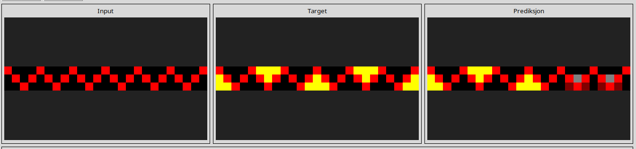
l
a3df8b1e
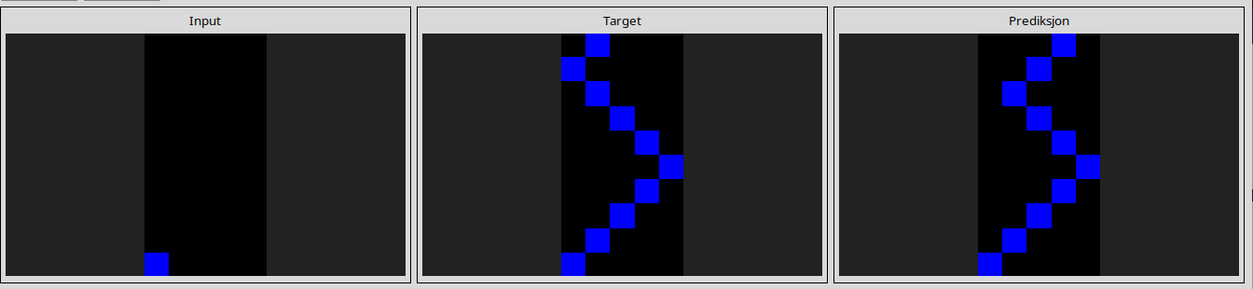
l
a8d7556c
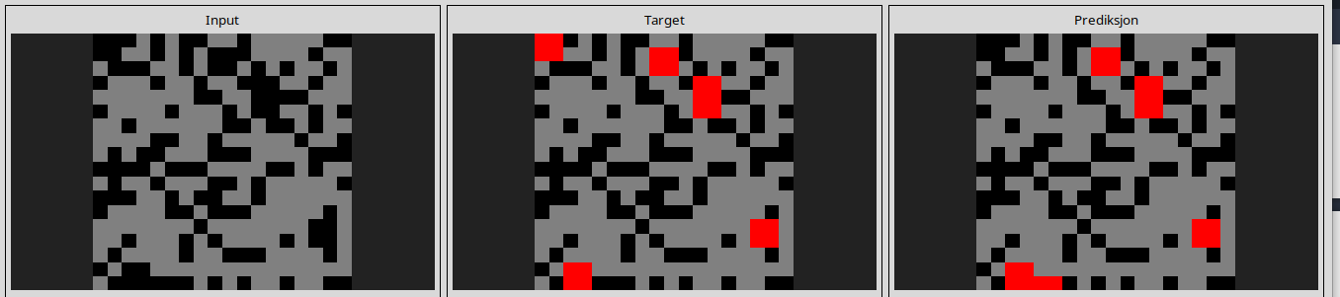
l
a68b268e
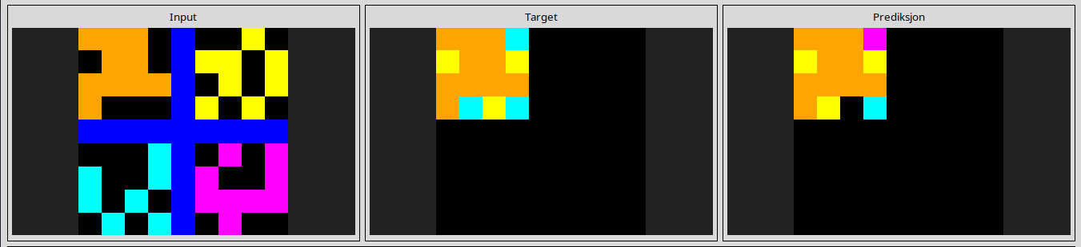
a699fb00
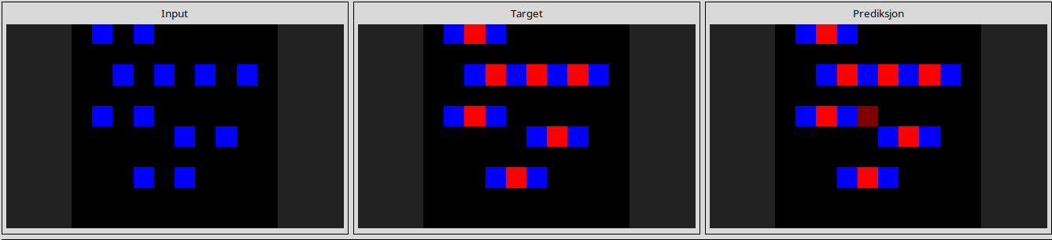
l
bbc9ae5d
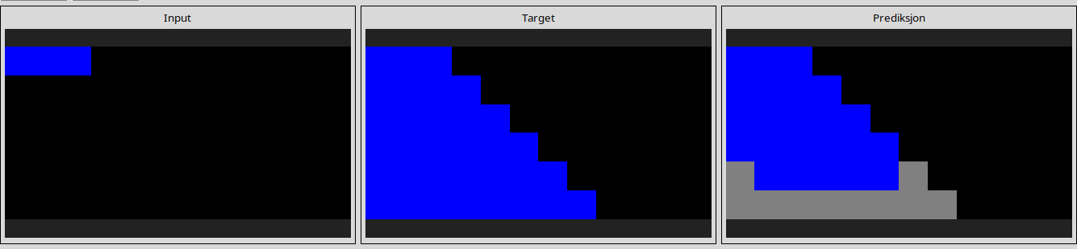
l
d5d6de2d
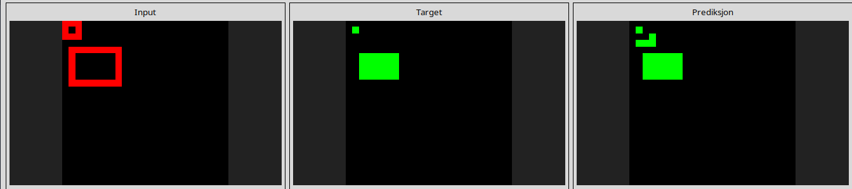
l
d9f24cd1
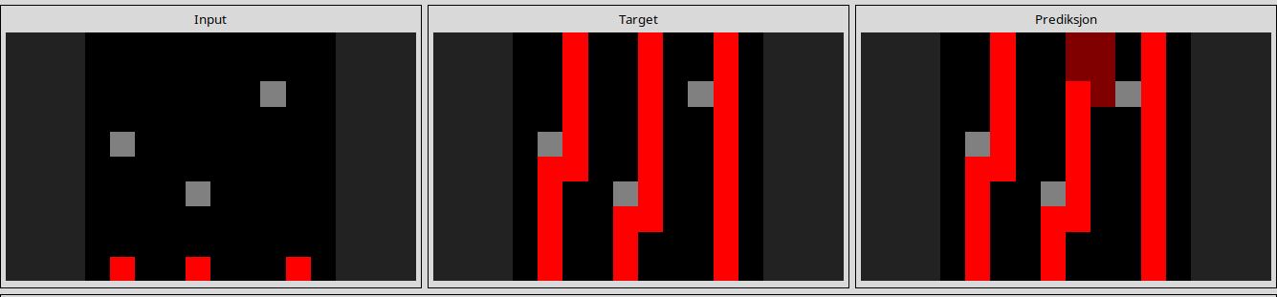
l
d90796e8
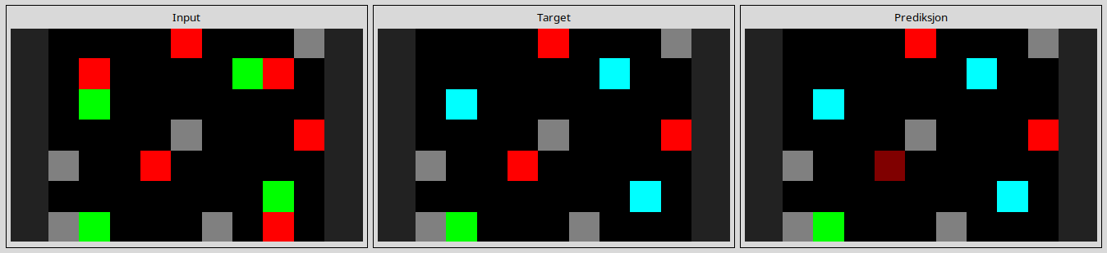
l
db3e9e38
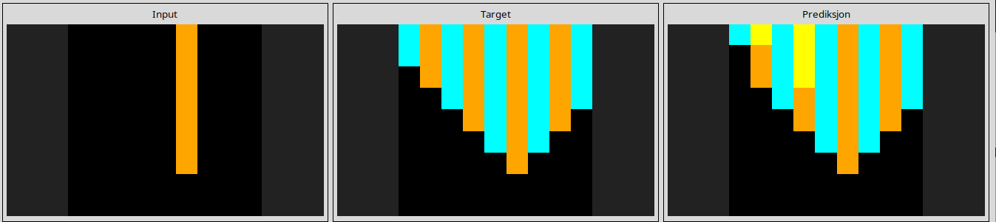
l
ded97339
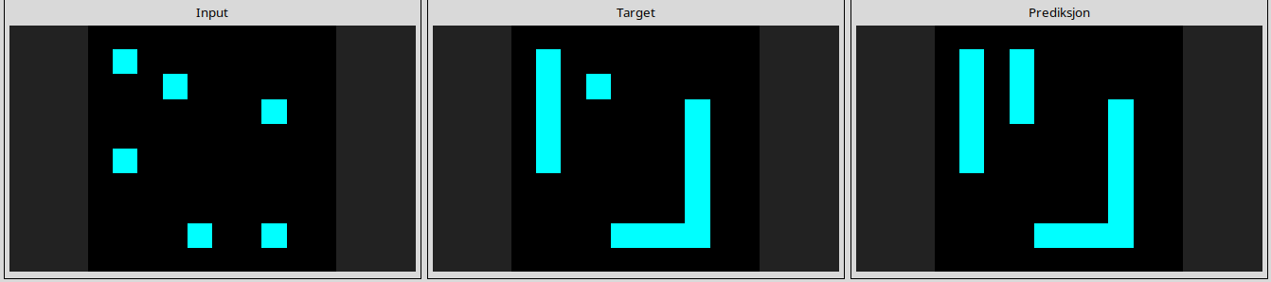
l
e179c5f4

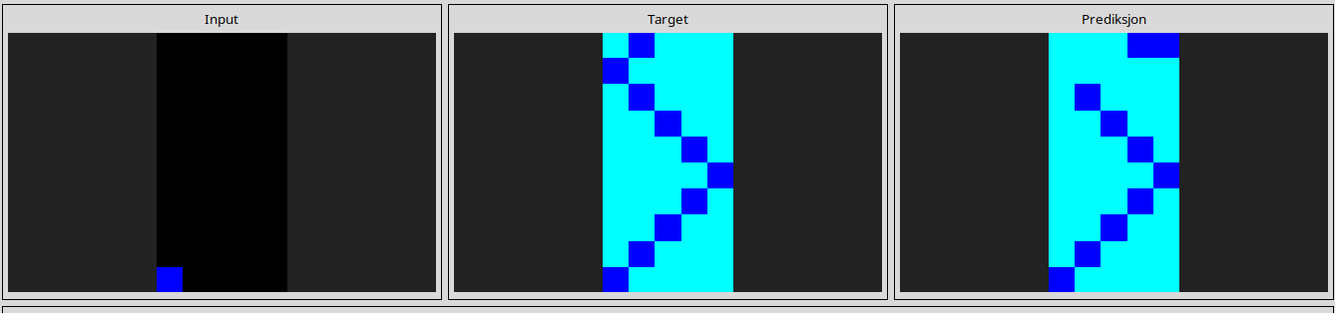
l
e8593010
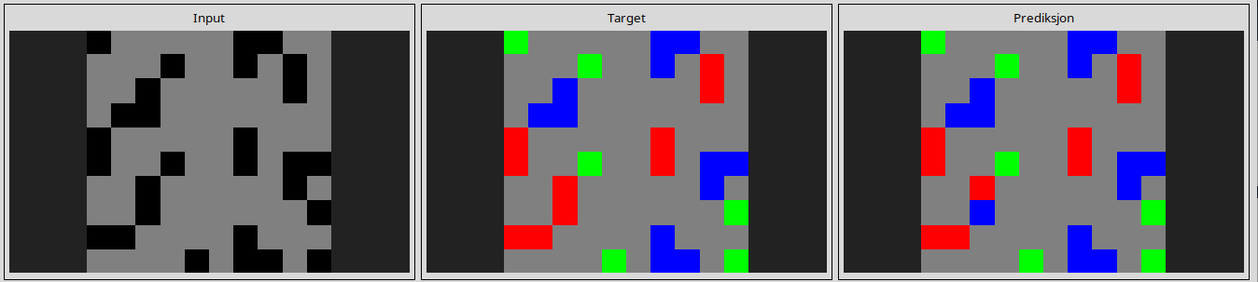
l
ef135b50
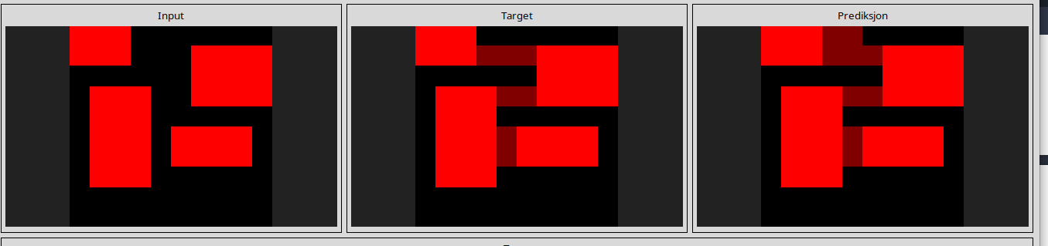
----------------------------------------------------------------------------------------------------------------------
Reasoning pitfall

1bfc4729
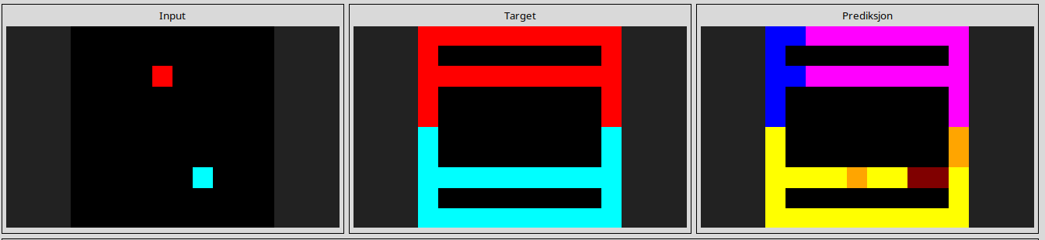
3ac3eb23
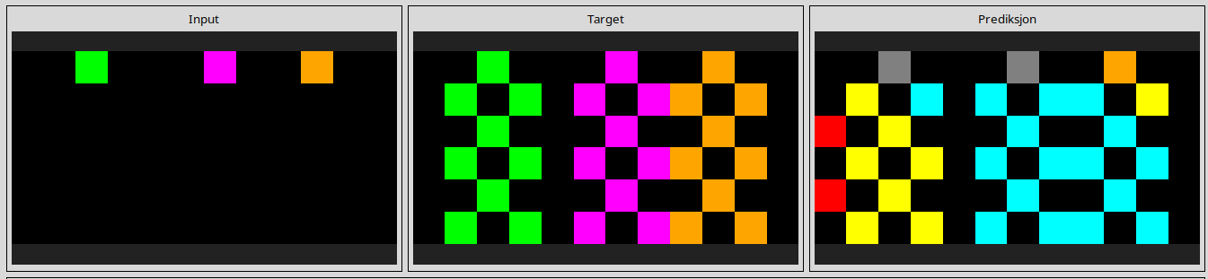
l
3befdf3e
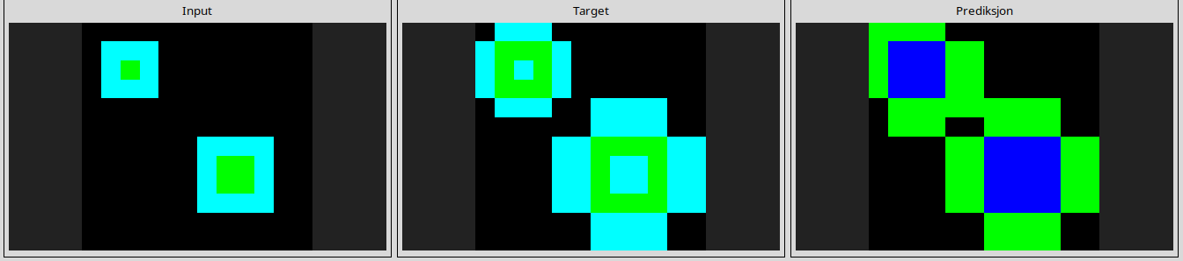
3f7978a0
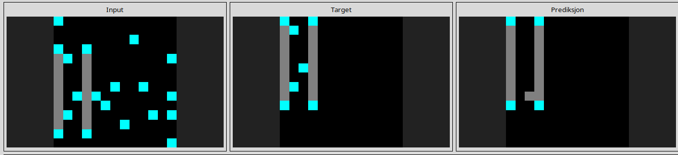
025d127b
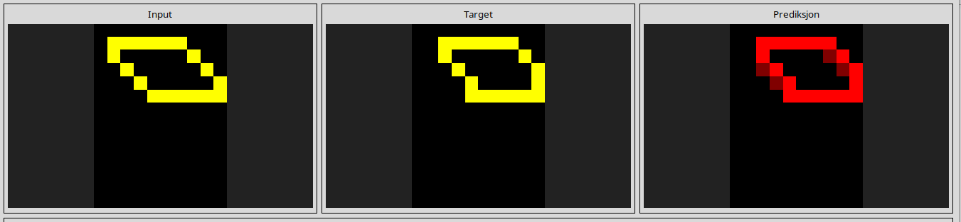
29c11459
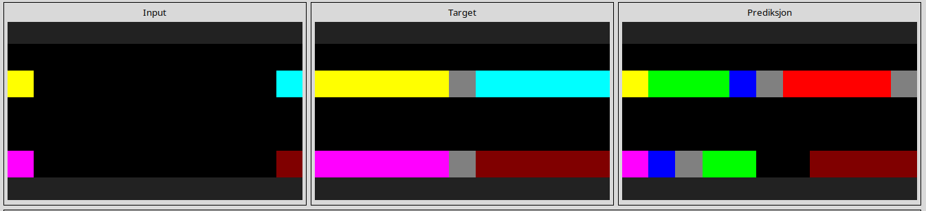
l
36fdfd69
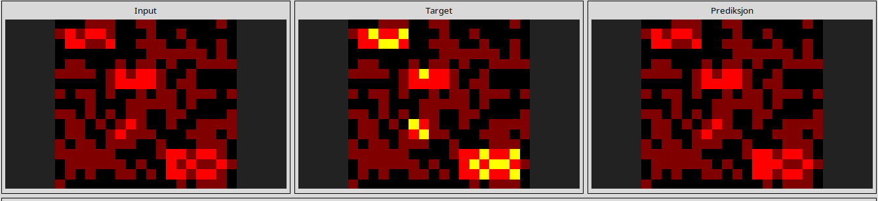
l
42a50994
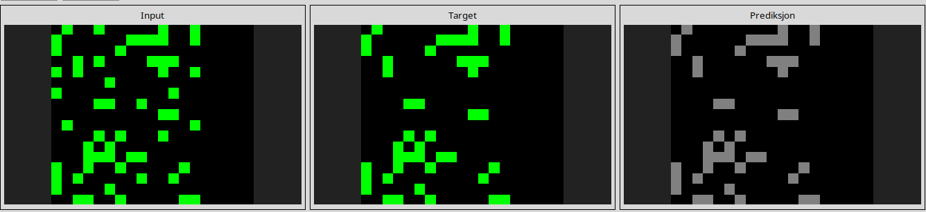
l
623ea044
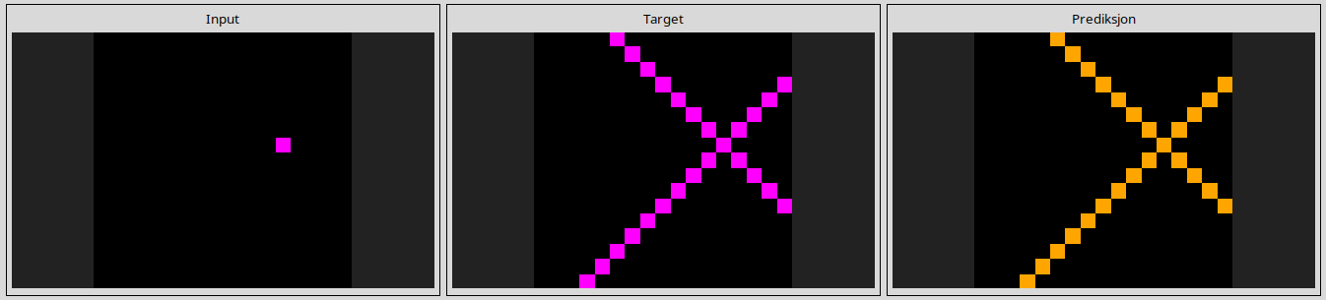
810b9b61
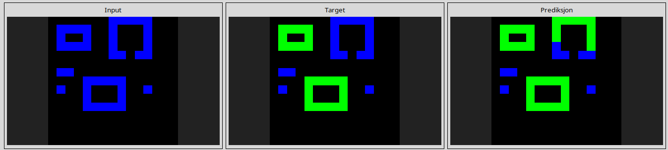
941d9a10
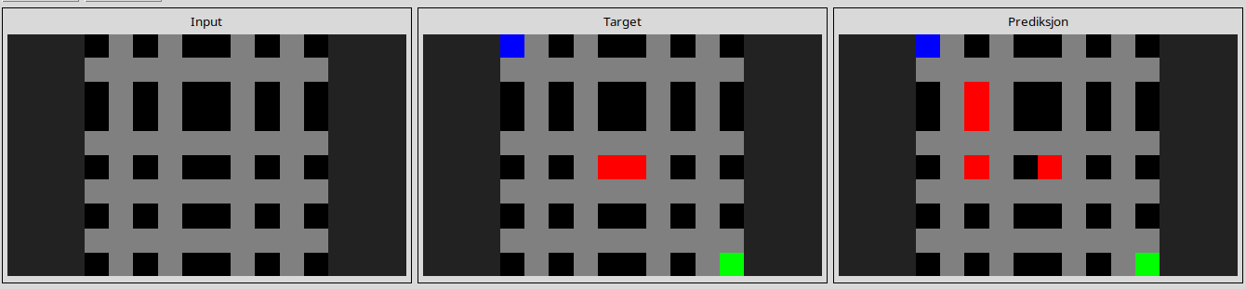
l
1190e5a7
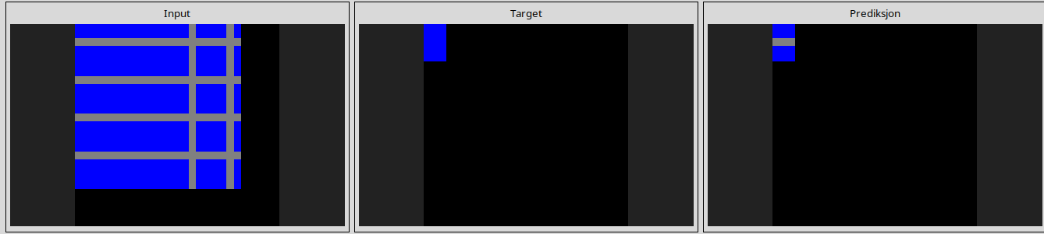
l
363442ee
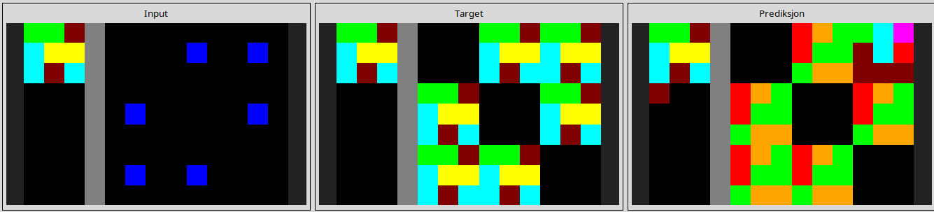
l
444801d8
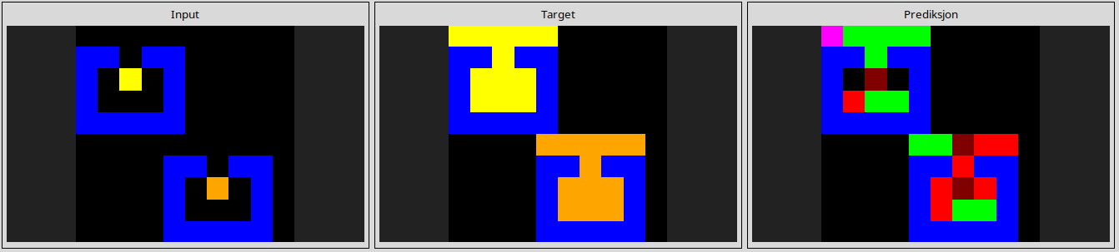
l
22168020
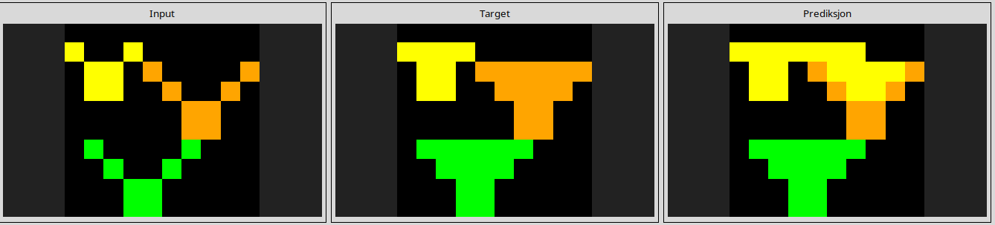
l
97999447
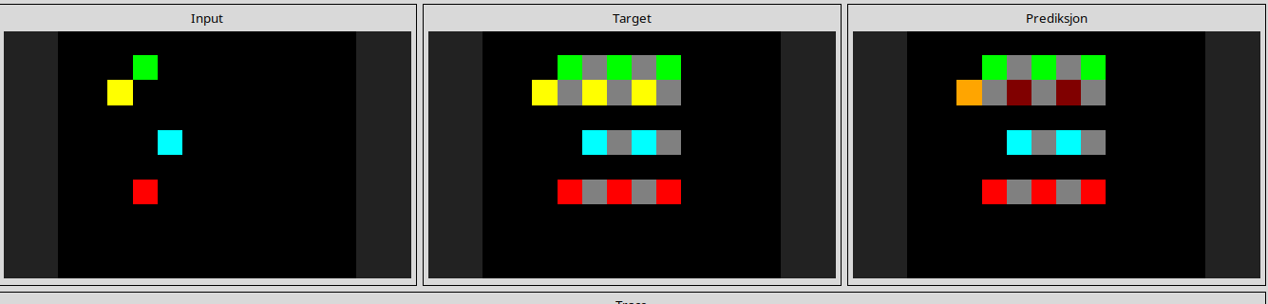
l
aabf363d
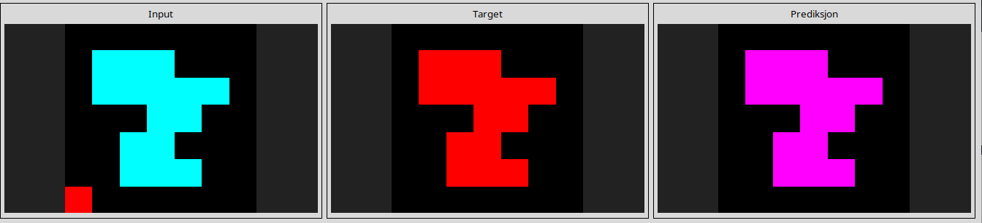
l
af902bf9
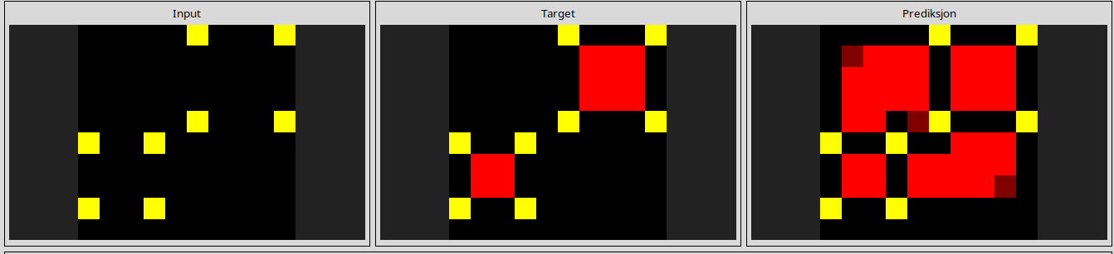
c3f564a4
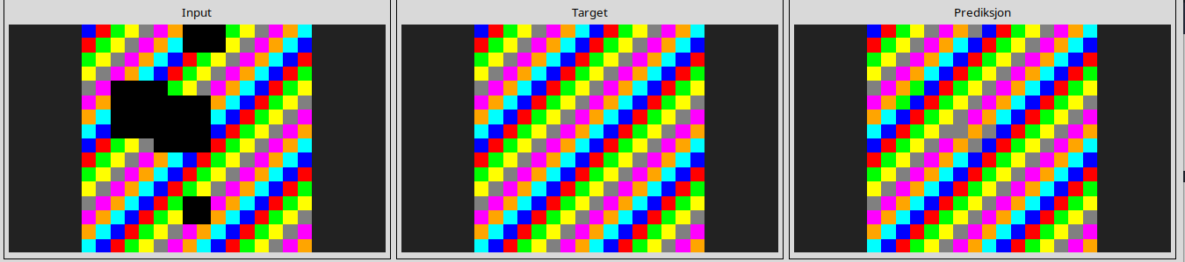
l
d4f3cd78
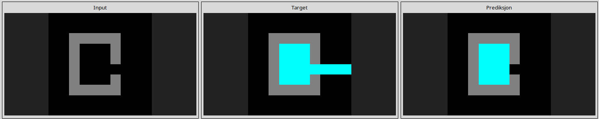
l
d13f3404
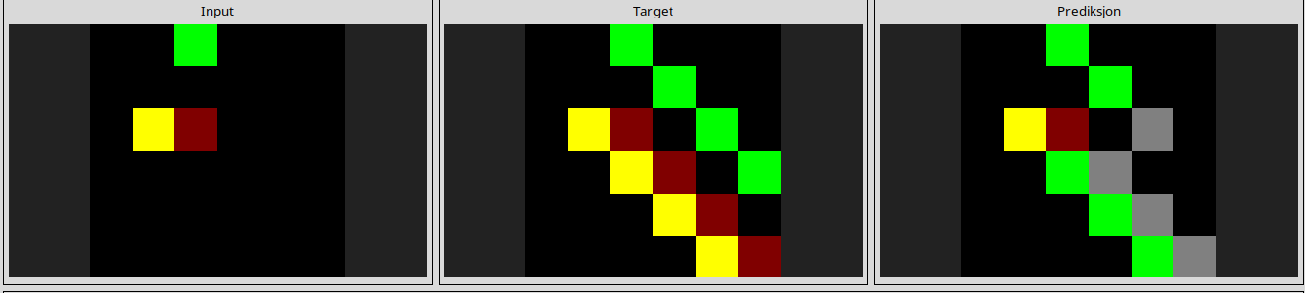
l
d631b094
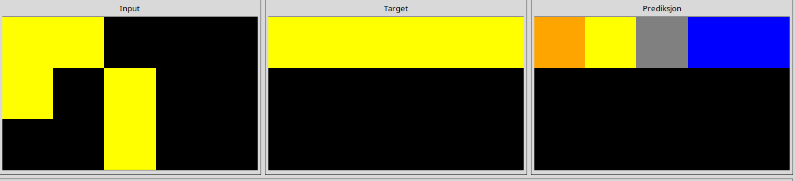
l
e9afcf9a
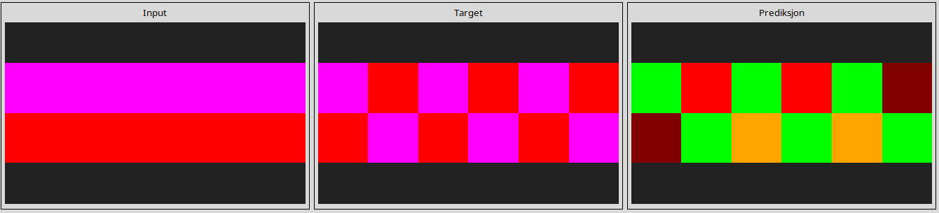
l
e73095fd
