Rotating Filter NCA_ARC1_train=58

0d3d703e
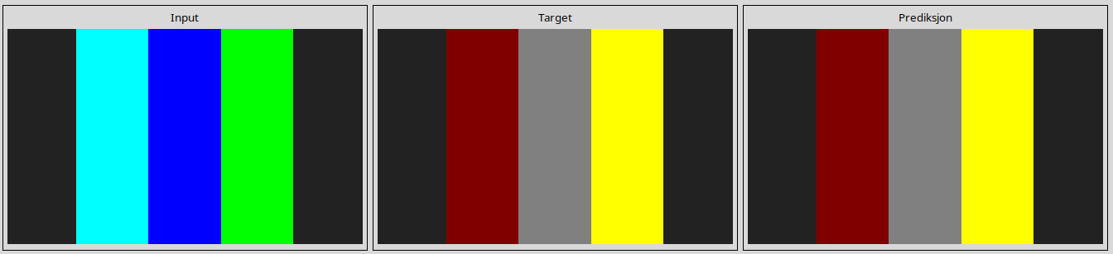
23581191
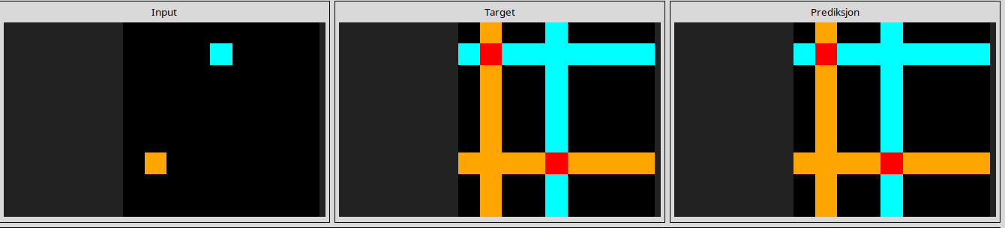
253bf280
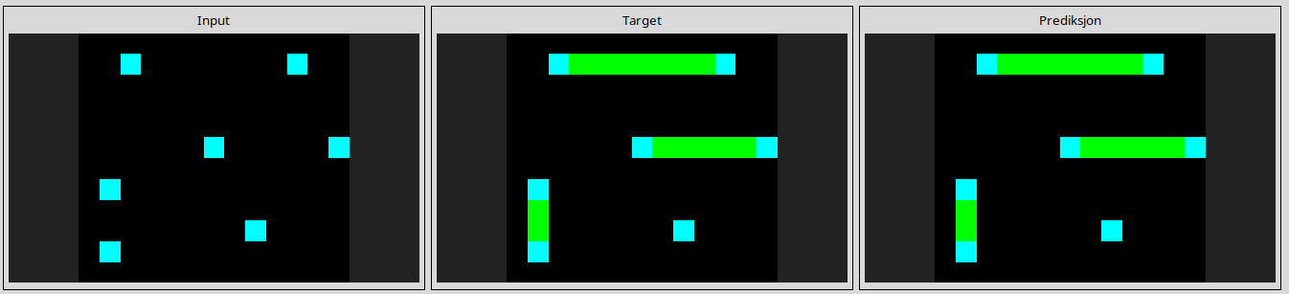
272f95fa
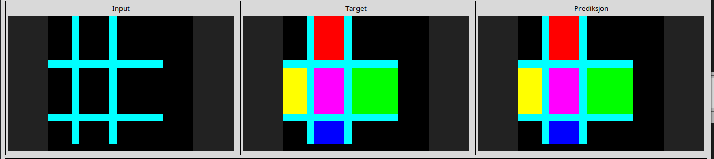
27a28665
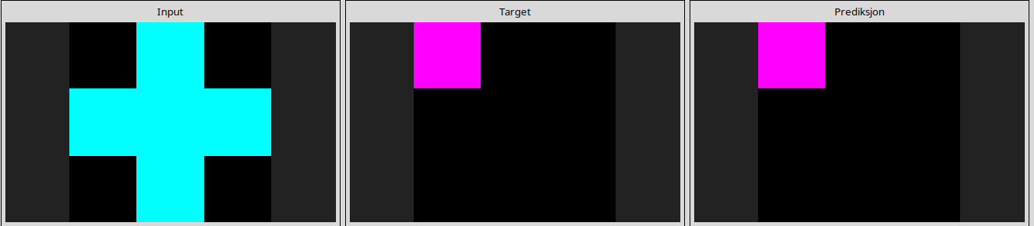
28e73c20
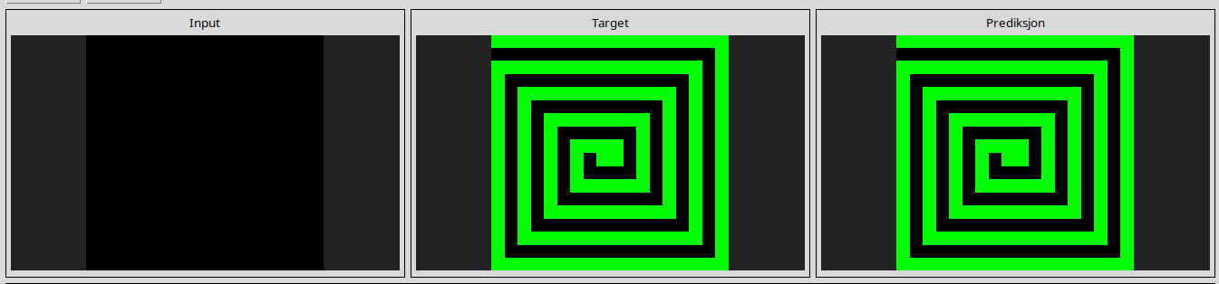
2dee498d
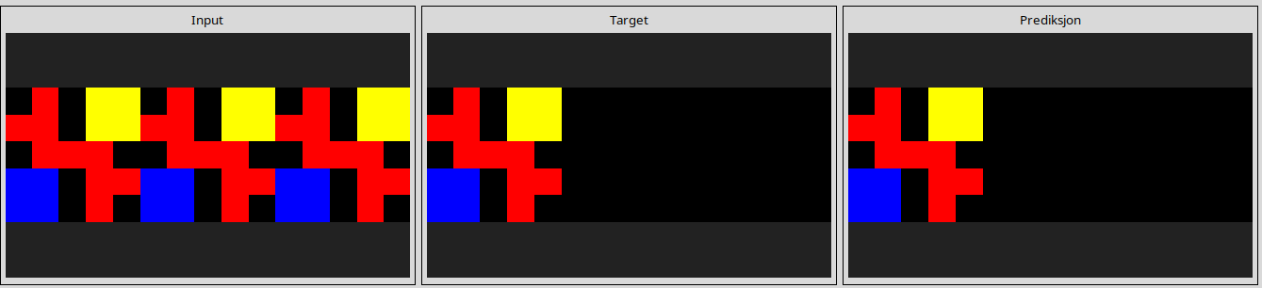
32597951
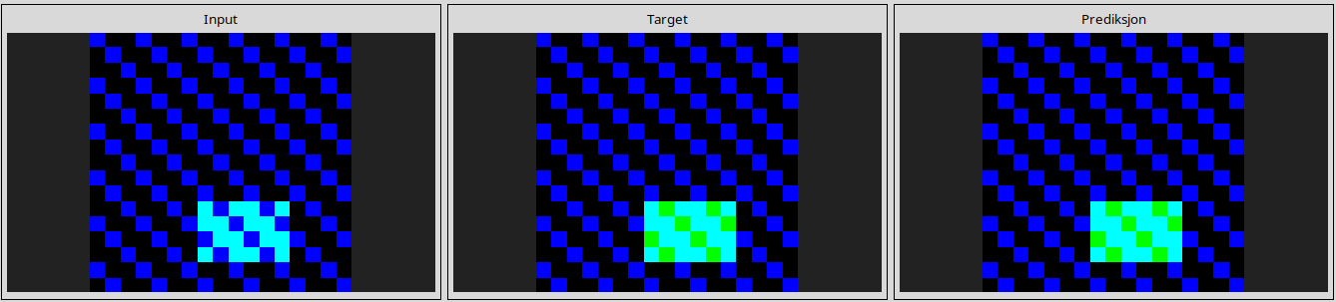
3618c87e
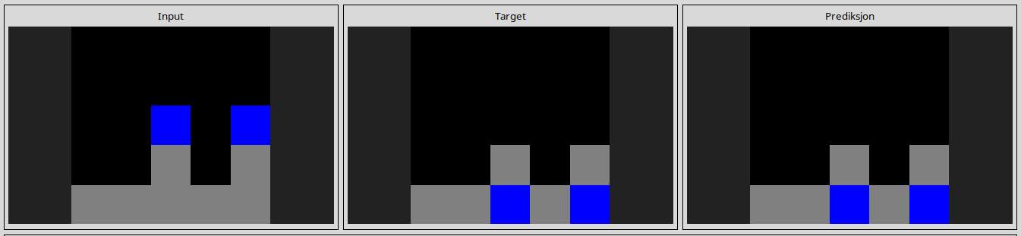
3aa6fb7a
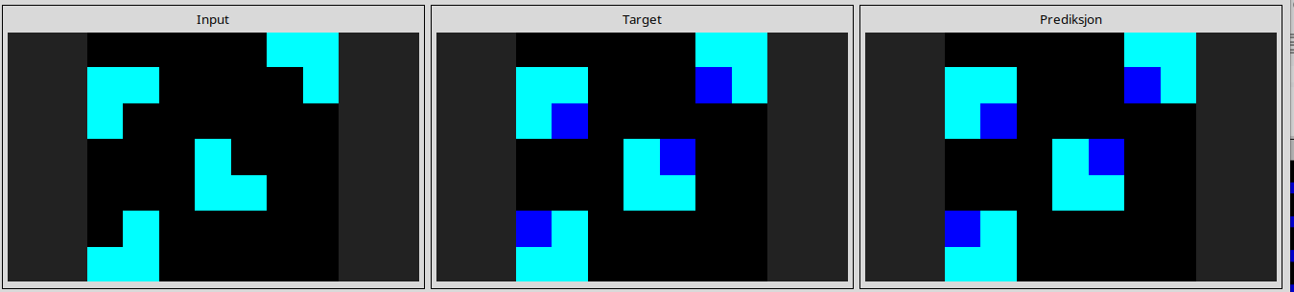
3bdb4ada
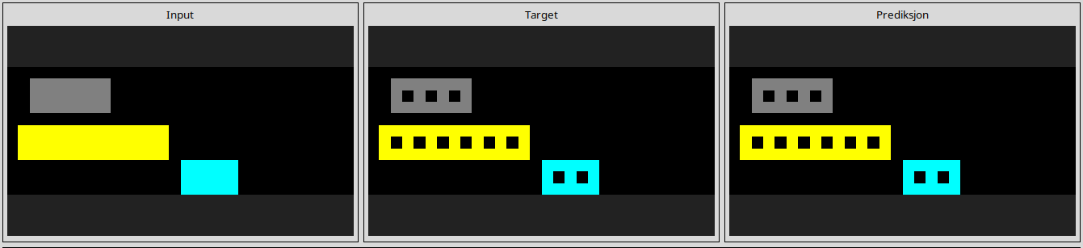
4258a5f9
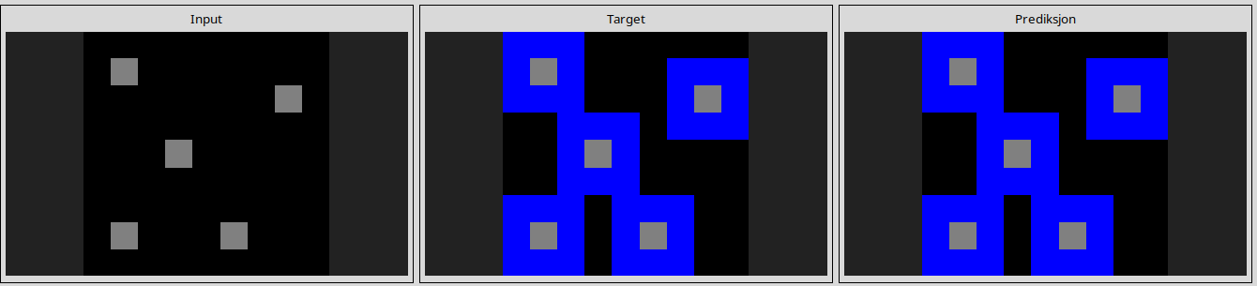
44f52bb0
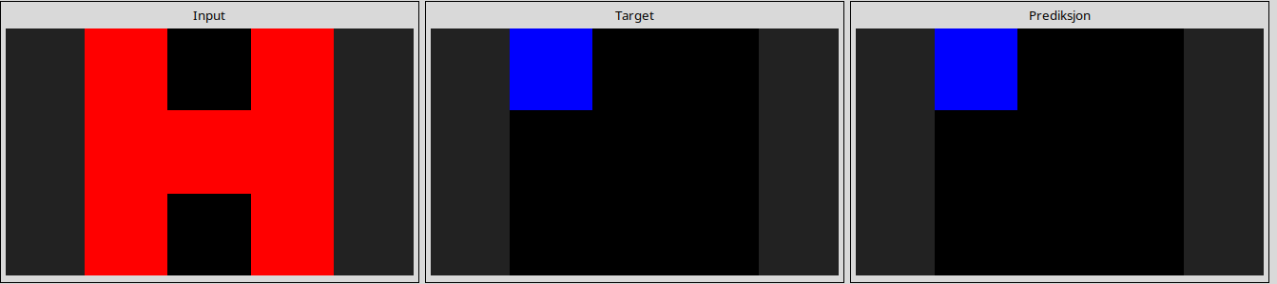
4612dd53
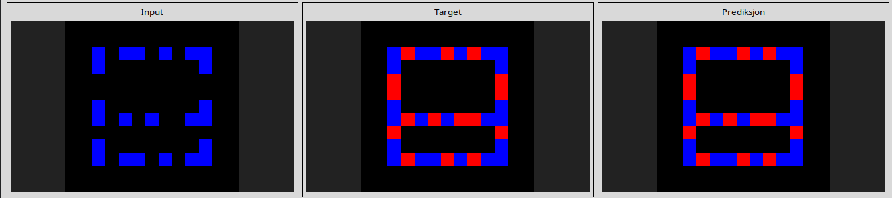
508bd3b6
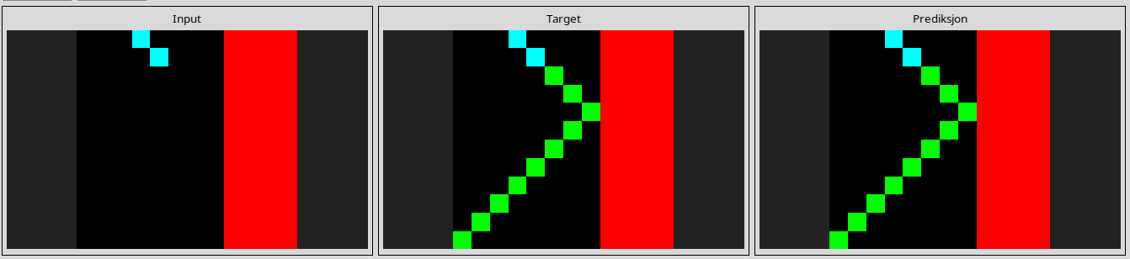
50cb2852
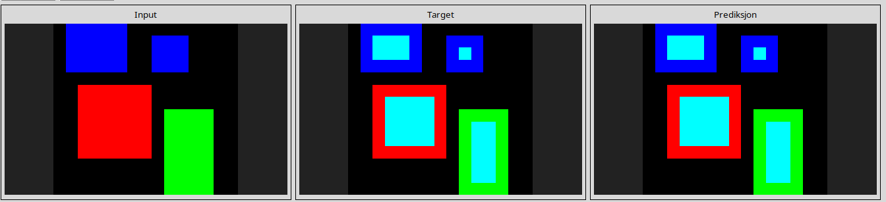
543a7ed5
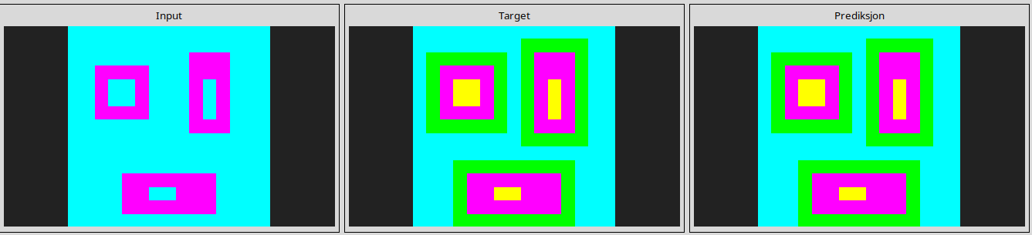
54d82841
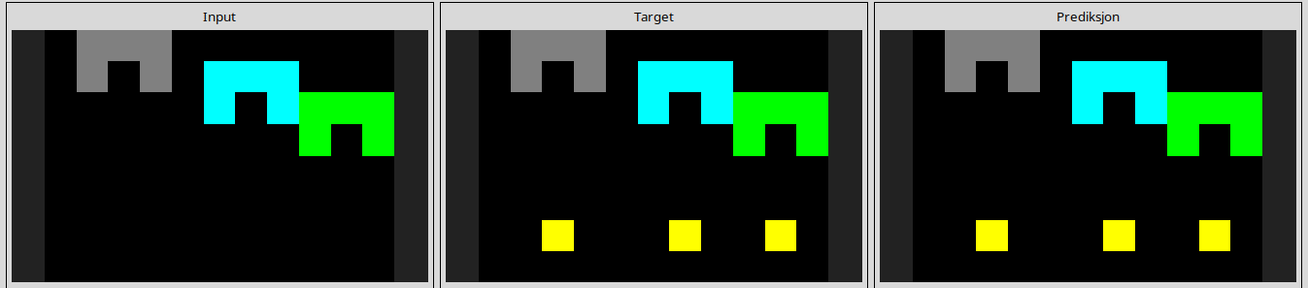
54d9e175
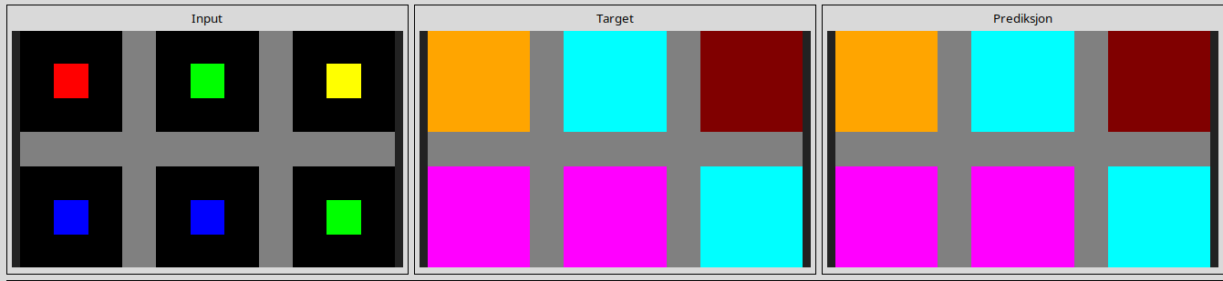
5c0a986e
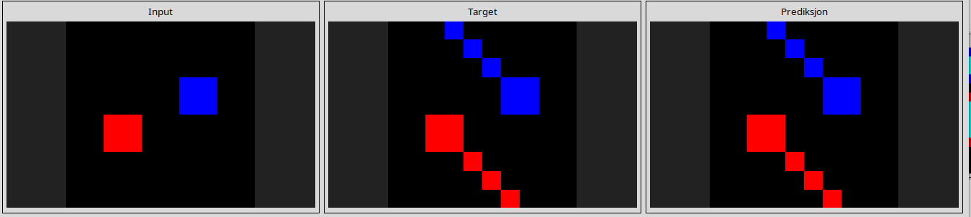
60b61512
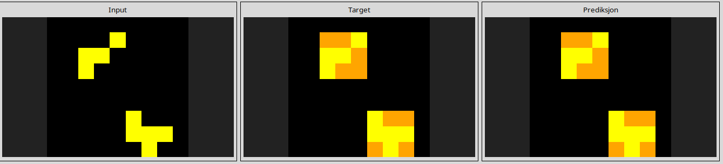
662c240a
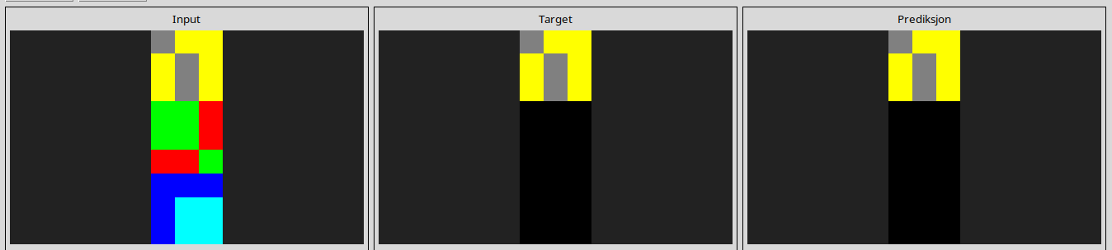
67385a82
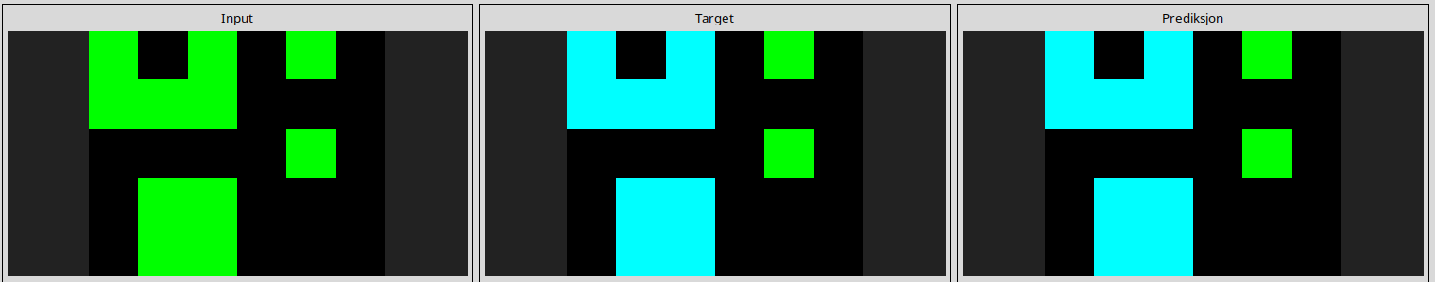
694f12f3
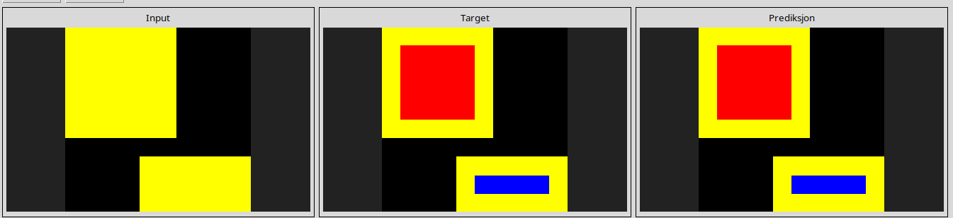
6c434453
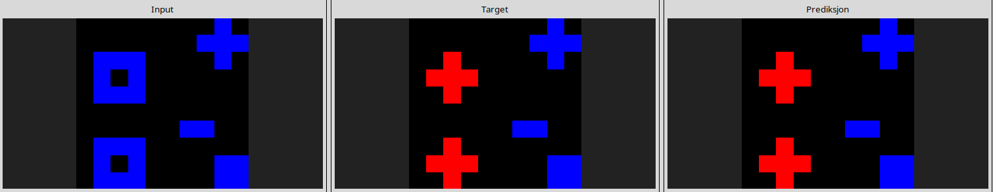
6cf79266
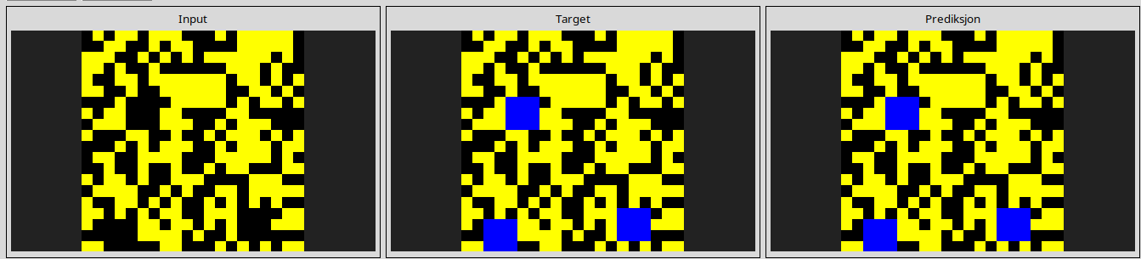
6f8cd79b
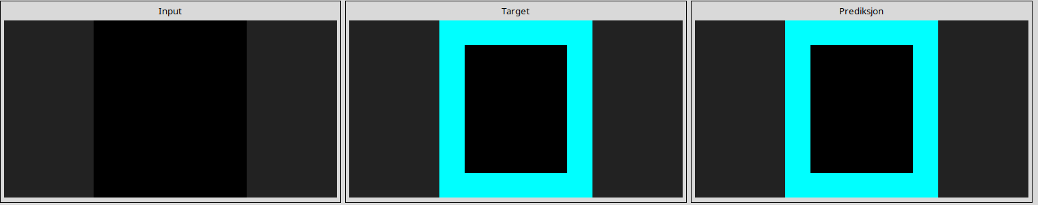
7b7f7511
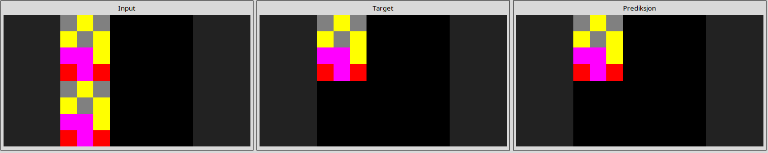
810b9b61
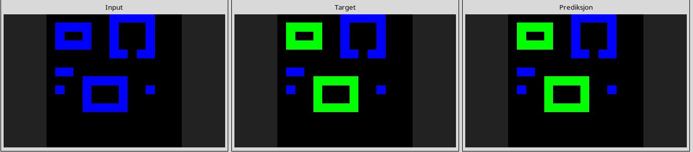
868de0fa
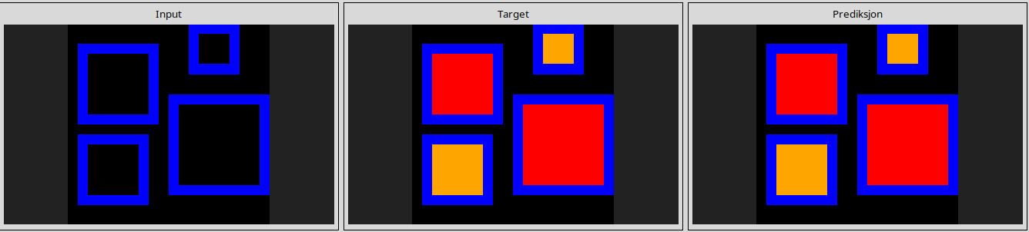
913fb3ed
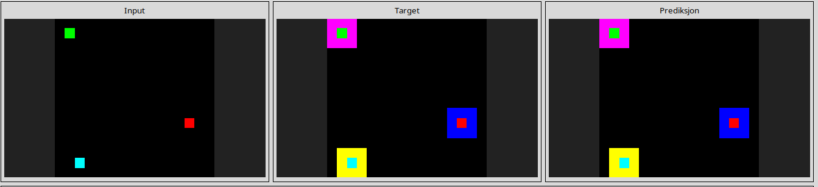
a5313dff
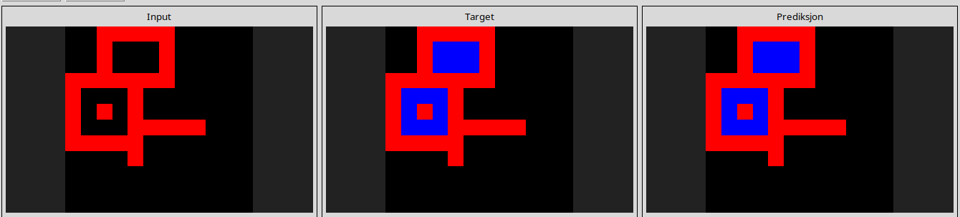
a65b410d
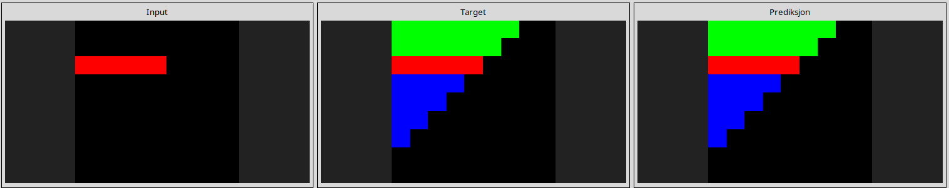
a8d7556c
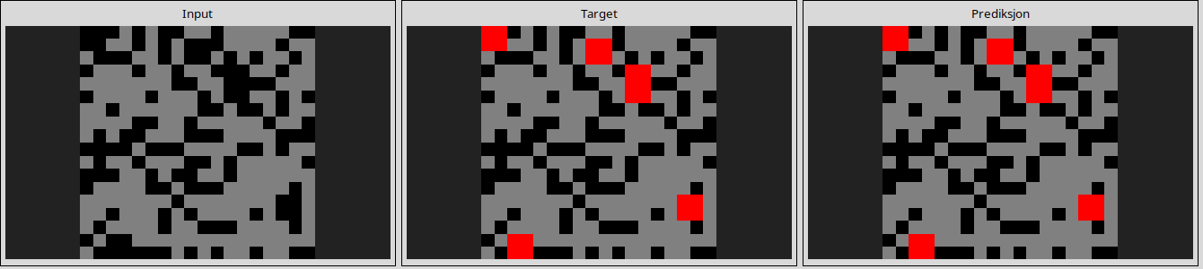
a9f96cdd
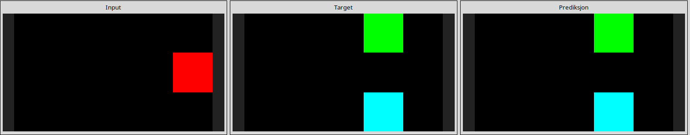
aedd82e4
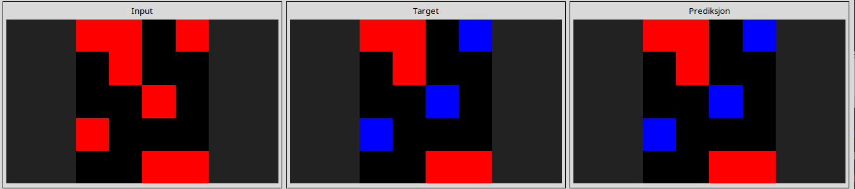
af902bf9
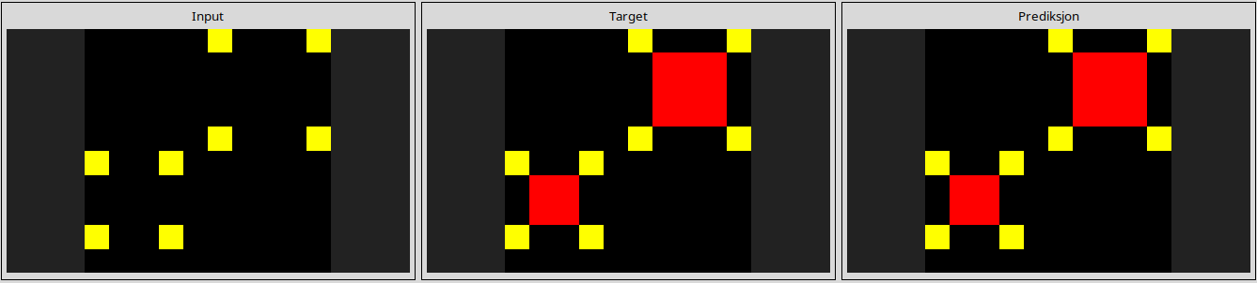
b1948b0a
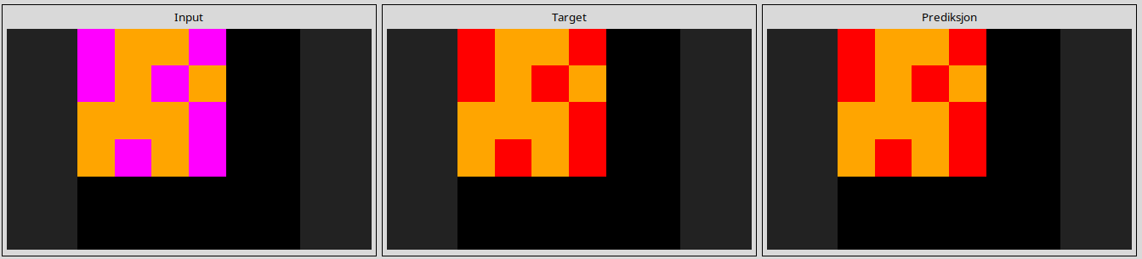
b60334d2
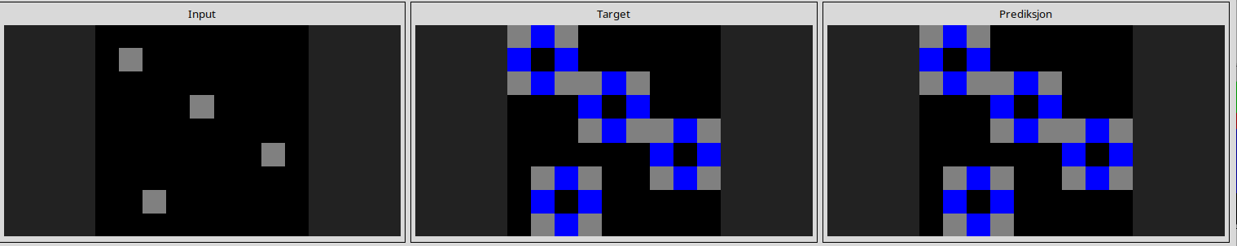
b6afb2da
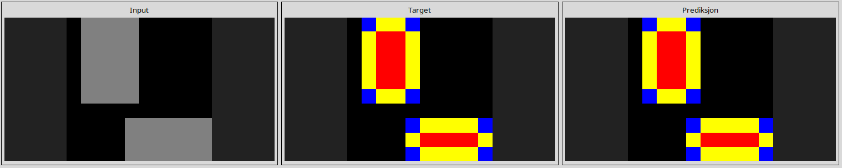
ba26e723
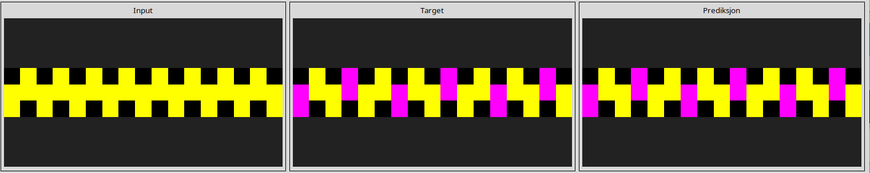
bb43febb
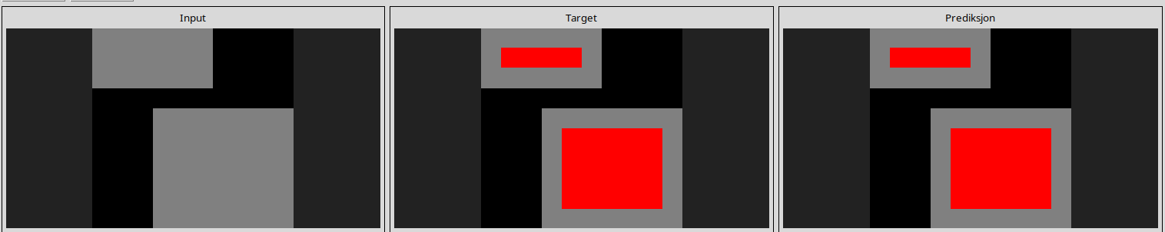
c0f76784
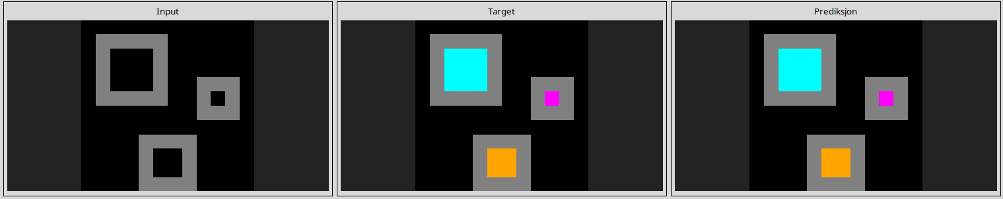
c8f0f002
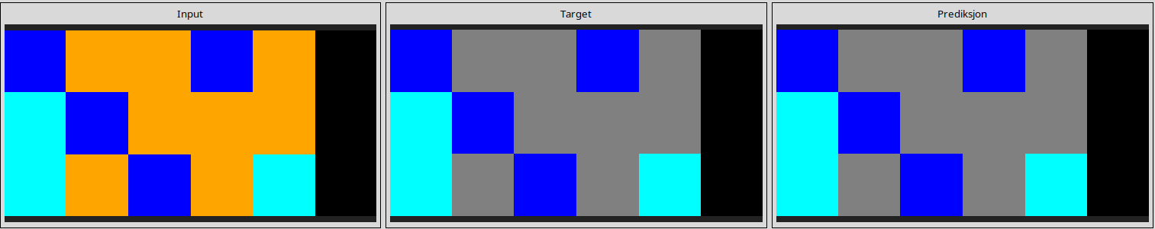
ce22a75a
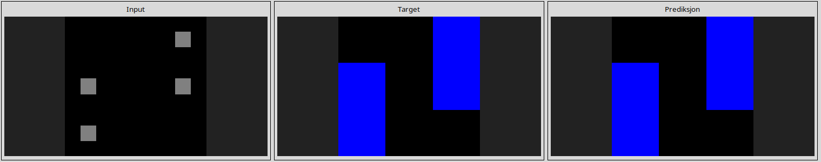
d06dbe63
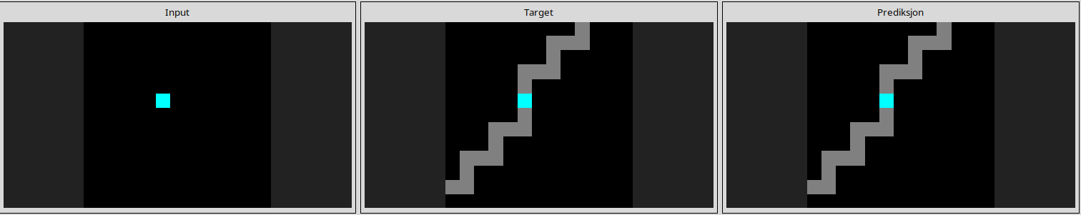
d10ecb37
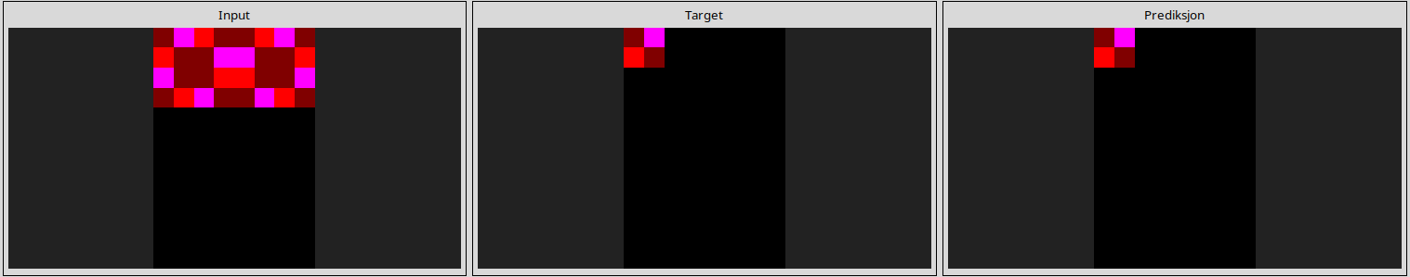
d364b489
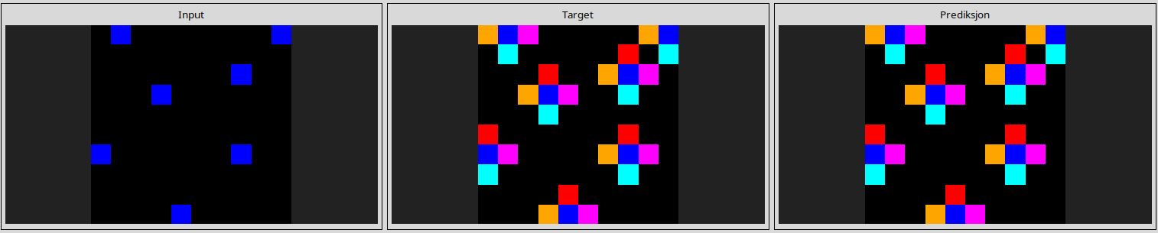
d4469b4b
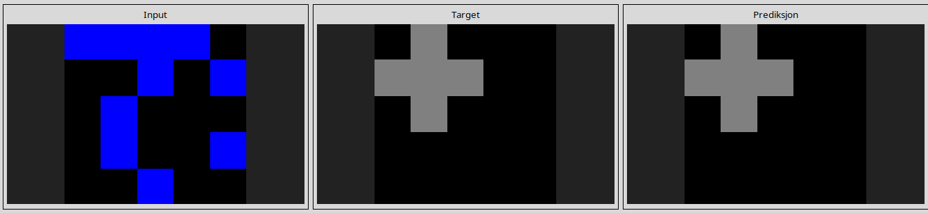
d4f3cd78
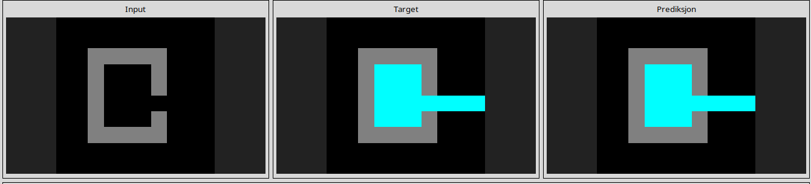
d6ad076f
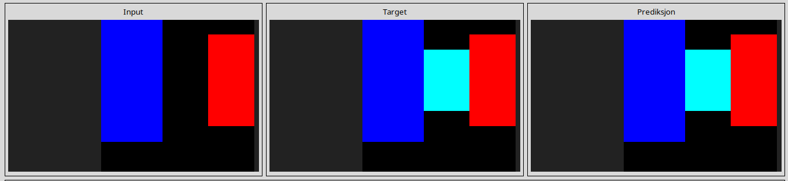
d90796e8
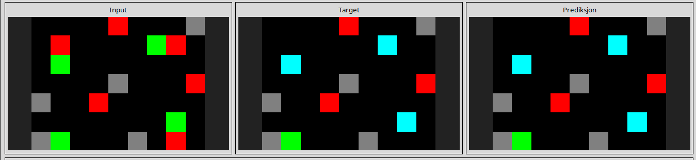
dc433765
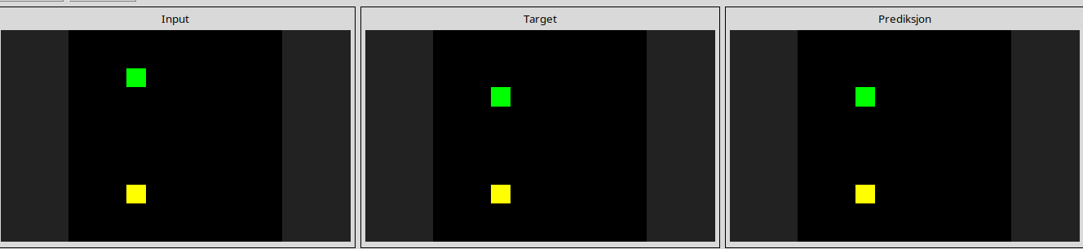
de1cd16c
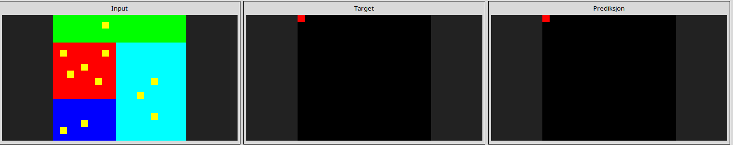
ded97339
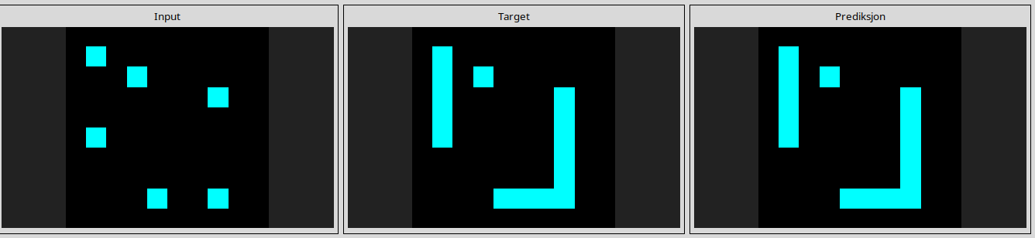
e73095fd
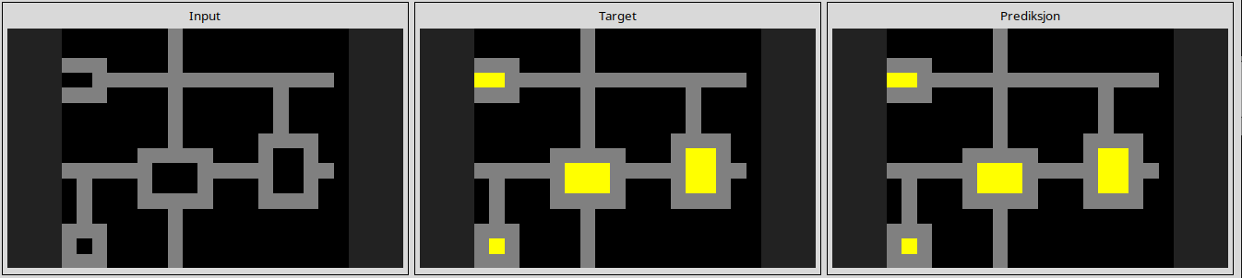
e8593010
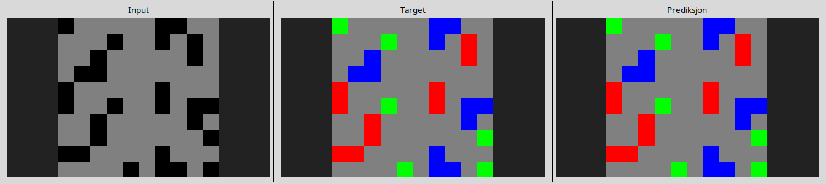
ecdecbb3
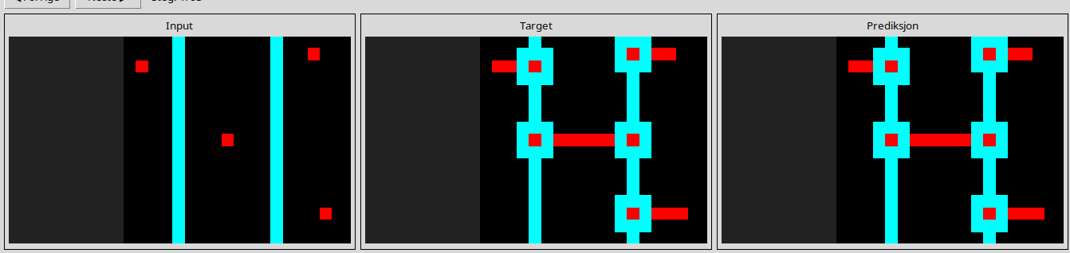
------------------------------------------------------------------------------------------------------------------------------------------------------------------------------------------------------------------------------------------------
Almost solved tasks

95990924
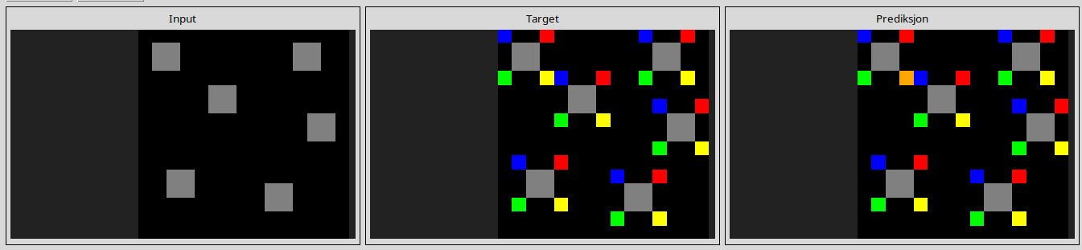
l
e509e548
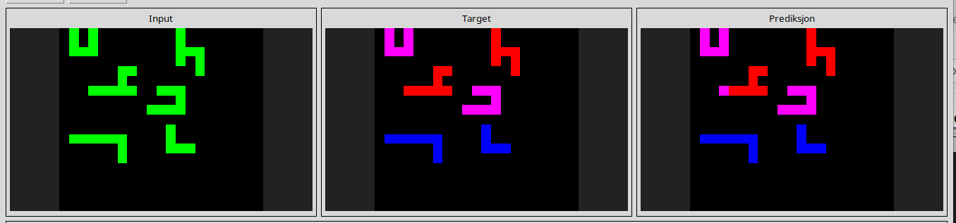
l
7b6016b9
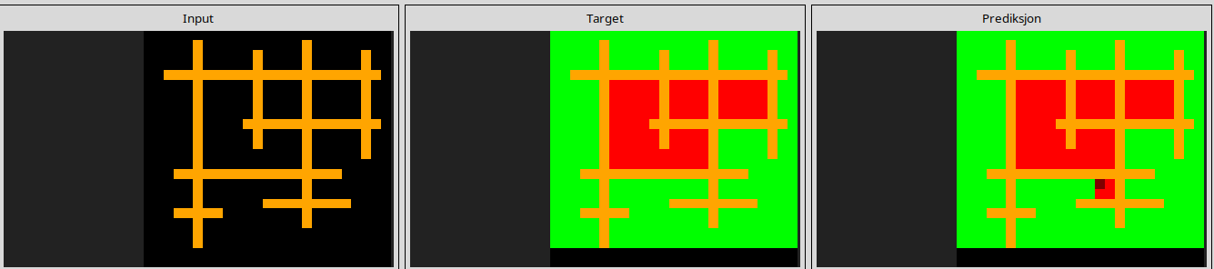
l
b27ca6d3
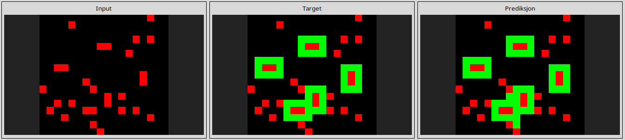
l
3bd67248
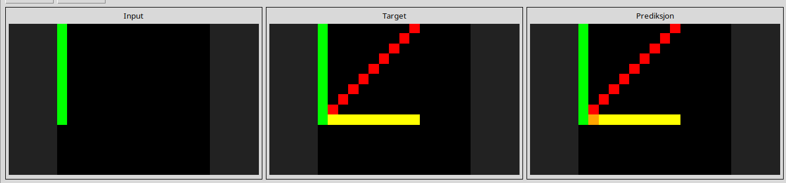
l
a699fb00
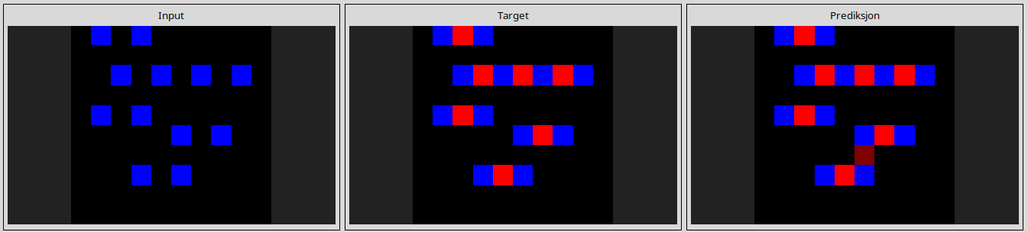
l
673ef223
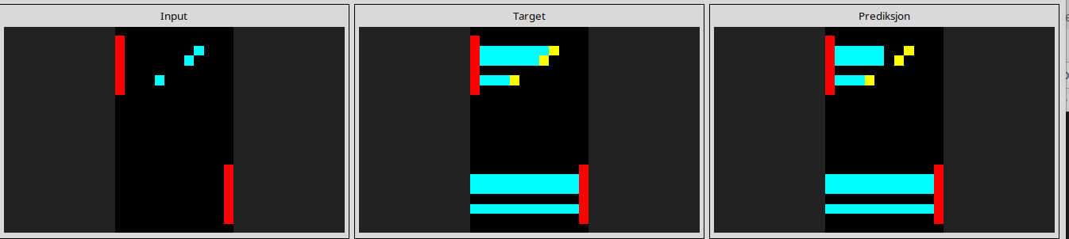
l
0ca9ddb6
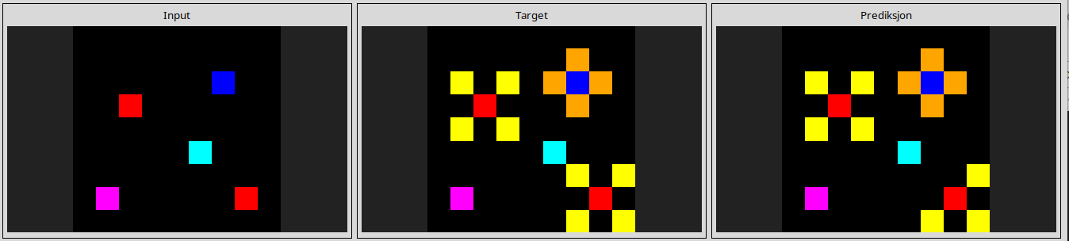
l
67a423a3
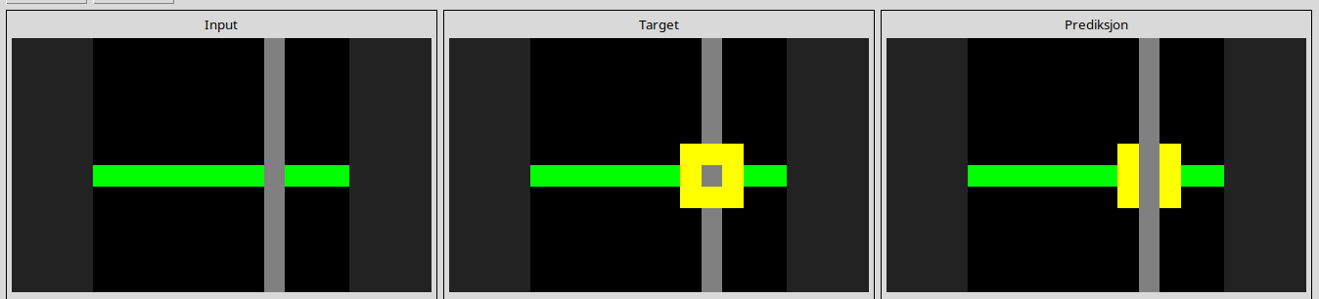
l
ec883f72
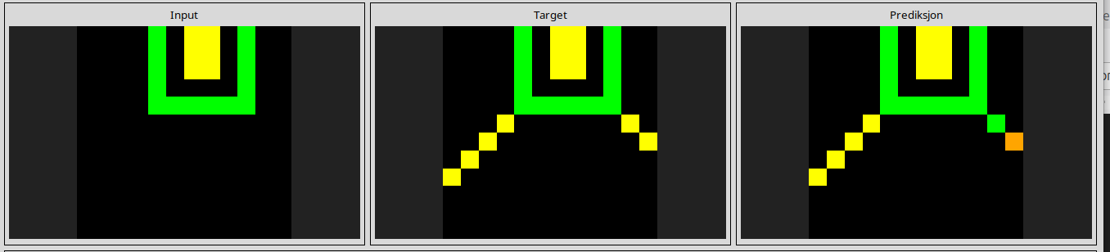
l
00d62c1b
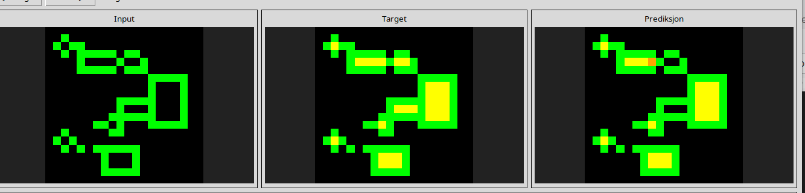
l
4093f84a
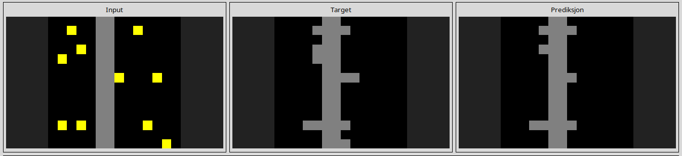
l
150deff5
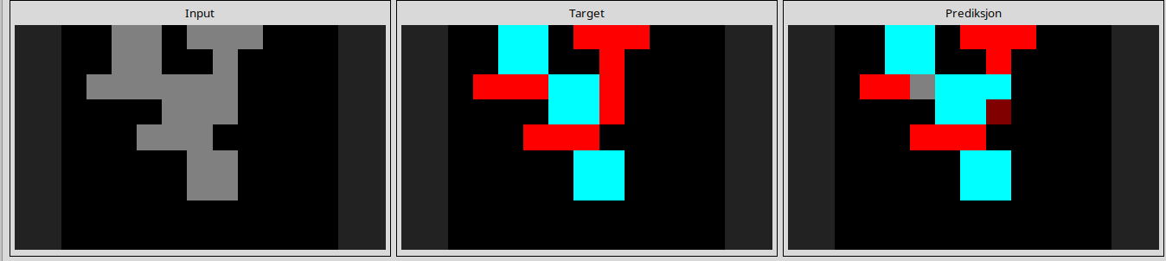
l
e9614598
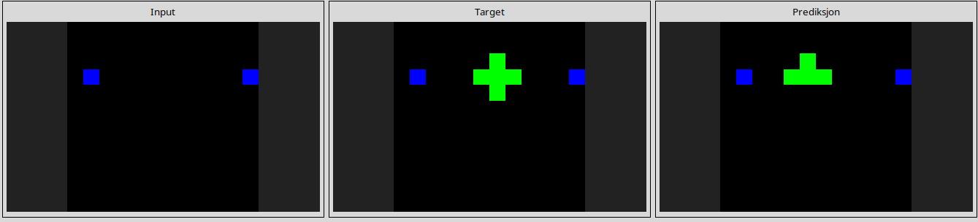
l
a79310a0
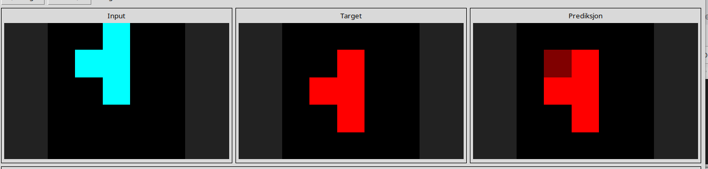
l
25d8a9c8

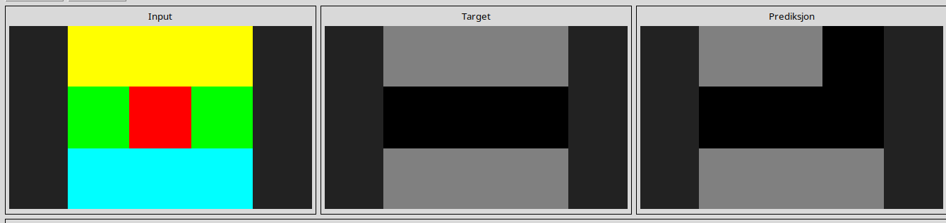
l
a2fd1cf0
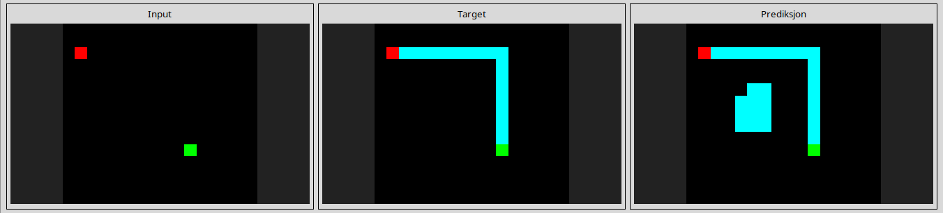
l
a64e4611
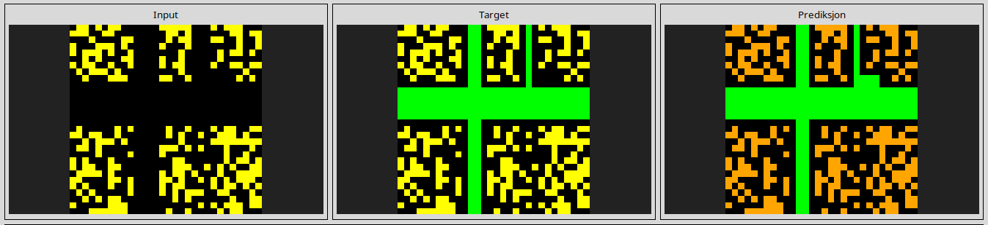
l
2281f1f4
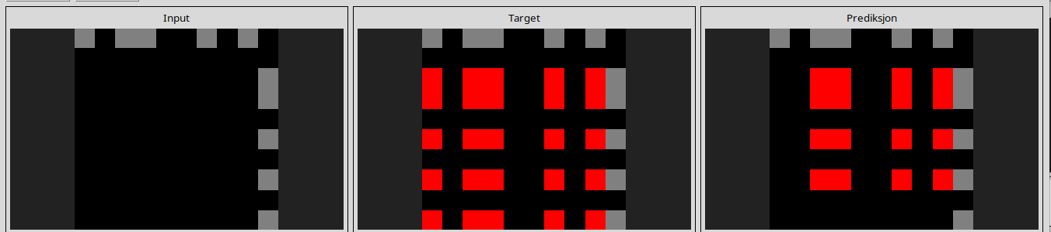
------------------------------------------------------------------------------------------------------------
Tasks that are ruined due to rotating filter operation

25ff71a9
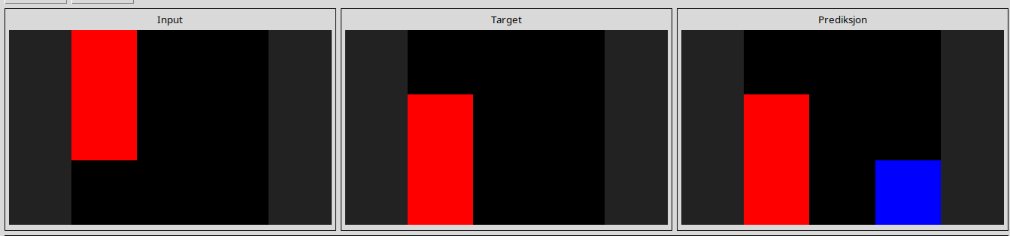
l

a85d4709

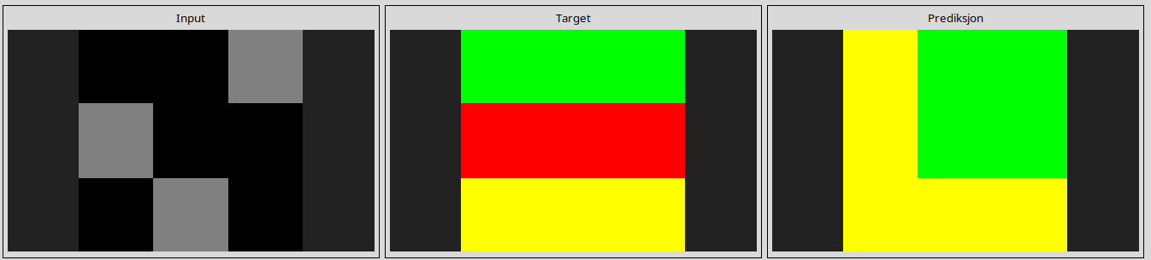
l
4347f46a
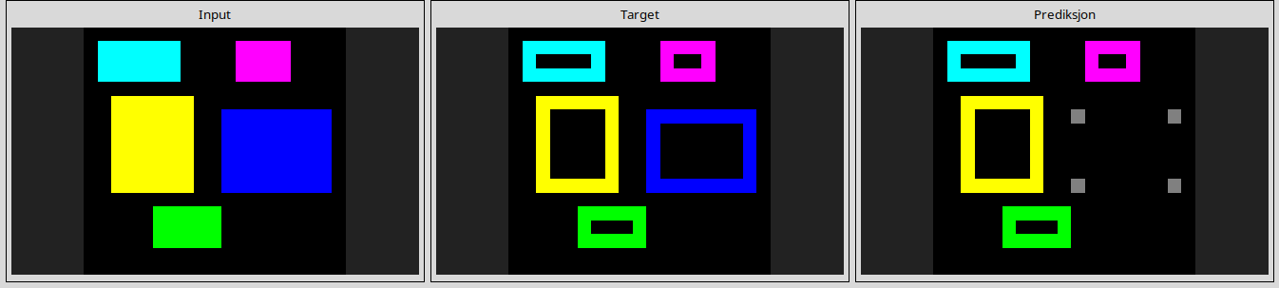
l
5168d44c
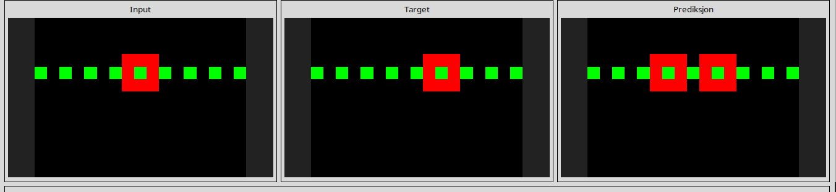
l
90f3ed37
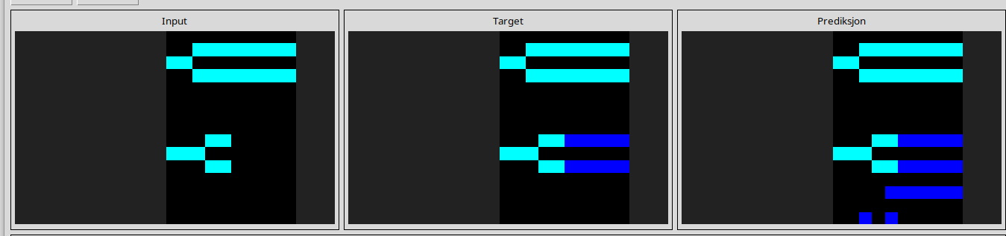
l

