# UI : ใบงาน React Native (Expo, JavaScript)

1. Student Data (Main Page)

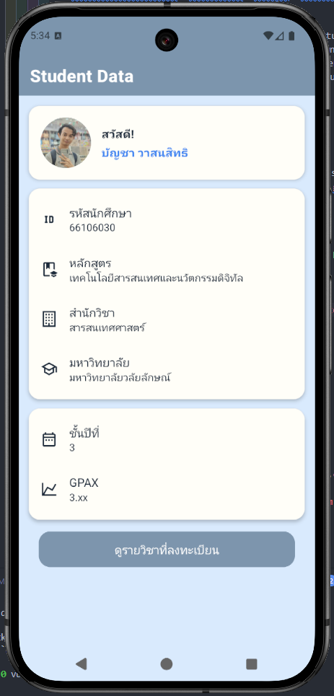

1. Registration Page

